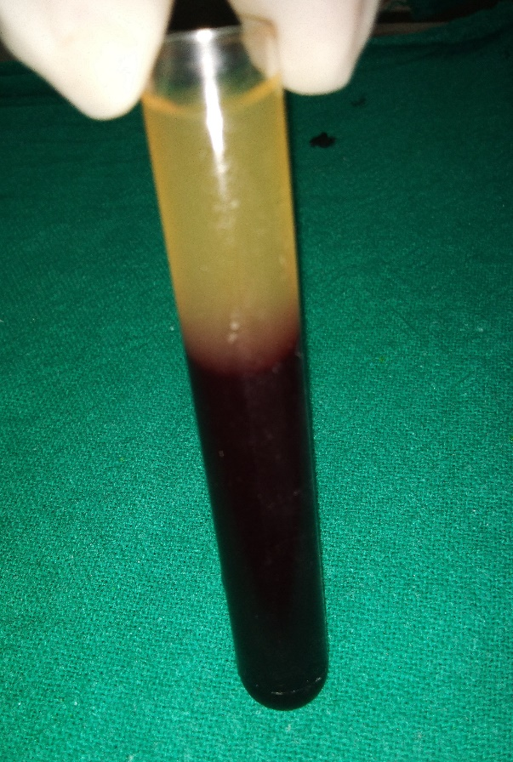
Figure 1- Test tube out of centrifuge showing 2 different layers – Uppermost AFG layer and the bottom red blood cells layer.
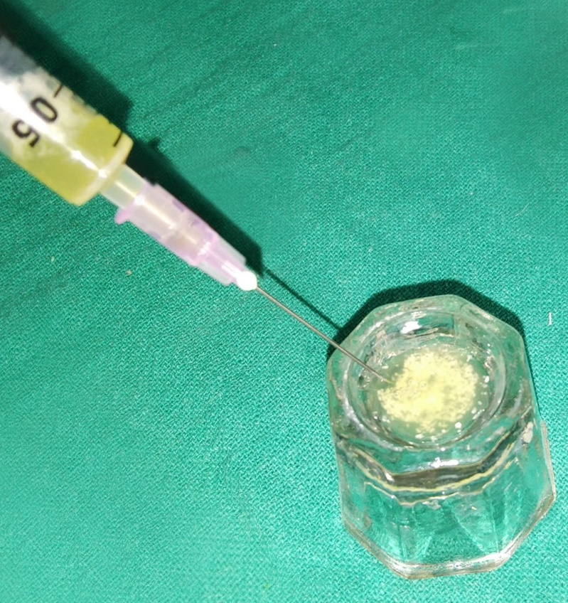
Figure 2-AFG layer obtained in syringe and immediately mixed withparticulate bone graft

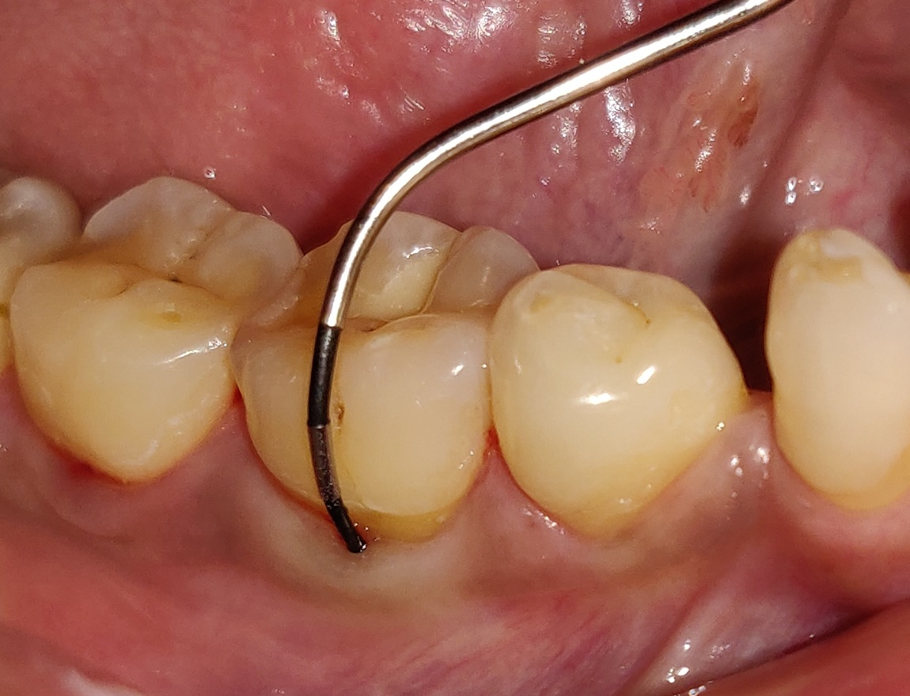

Figure 4a- Pre-surgical horizontal defect depth in sticky bone group
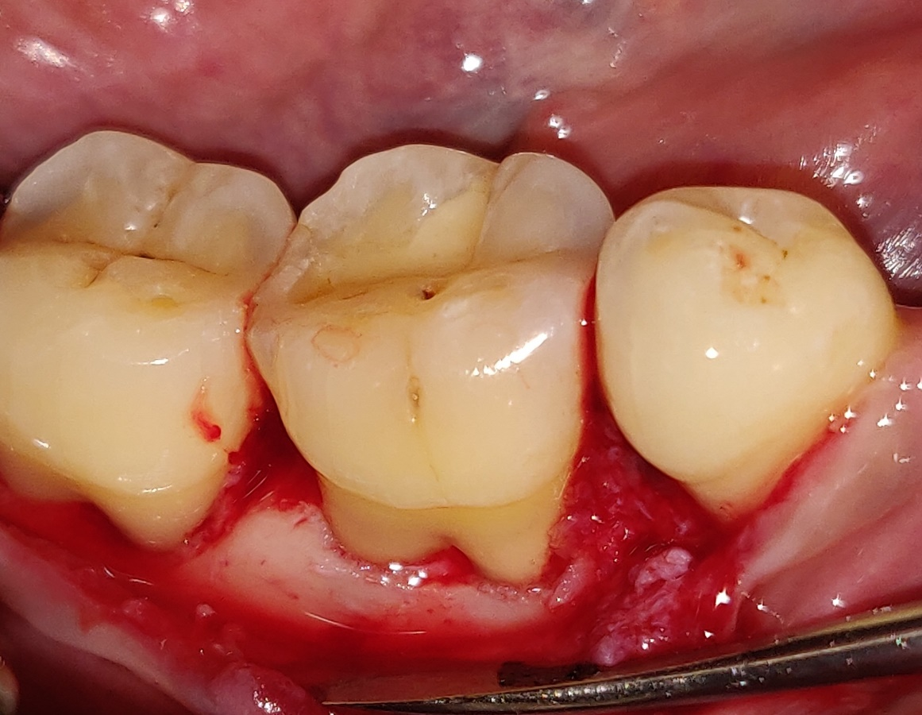
Figure 4b- Intra-surgical furcation defect in sticky bone group

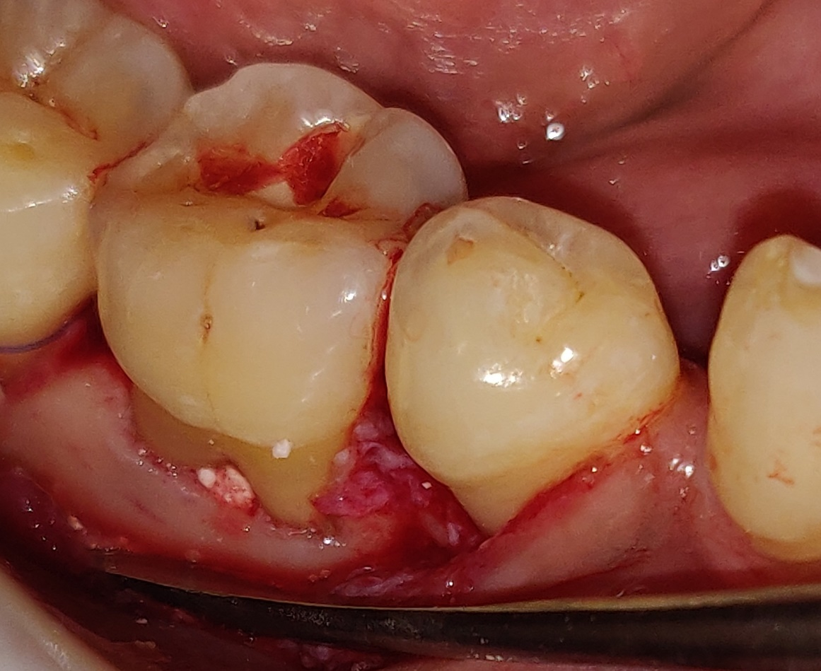
Figure 4c- Placement of sticky bone into furcation defect
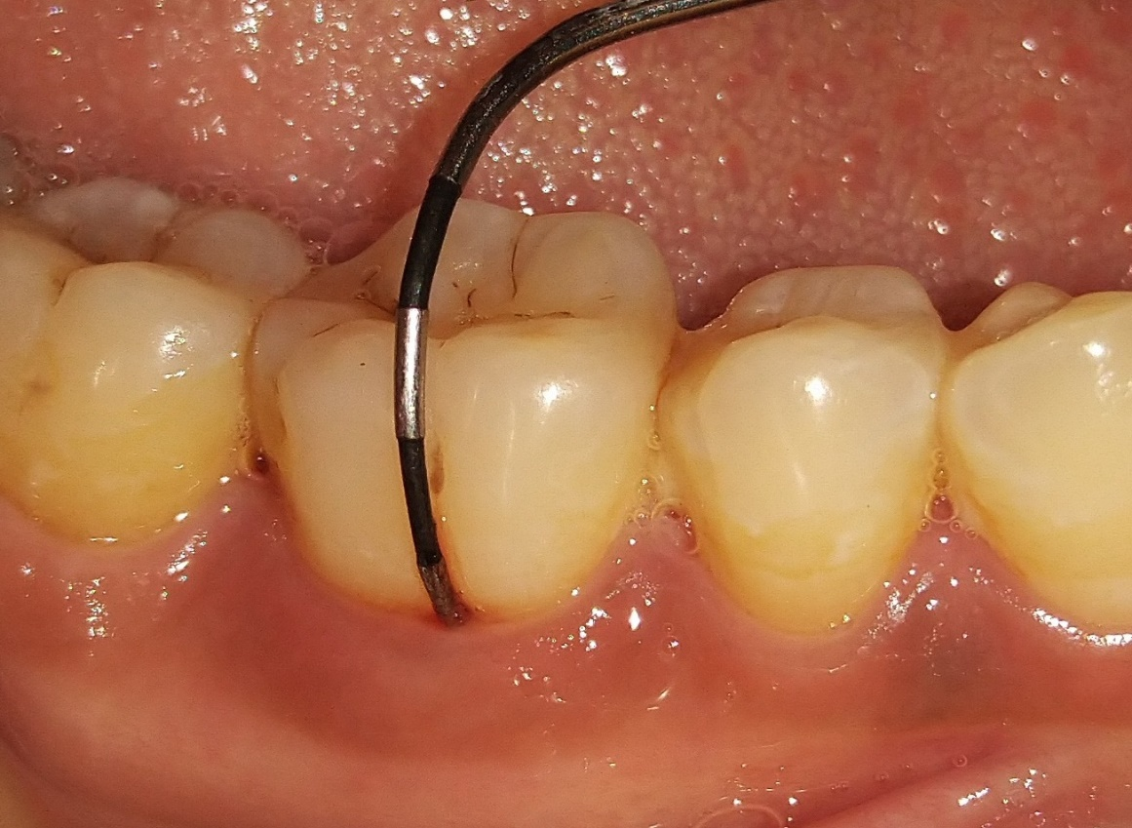
Figure 4d- Re-evaluation after 6 months
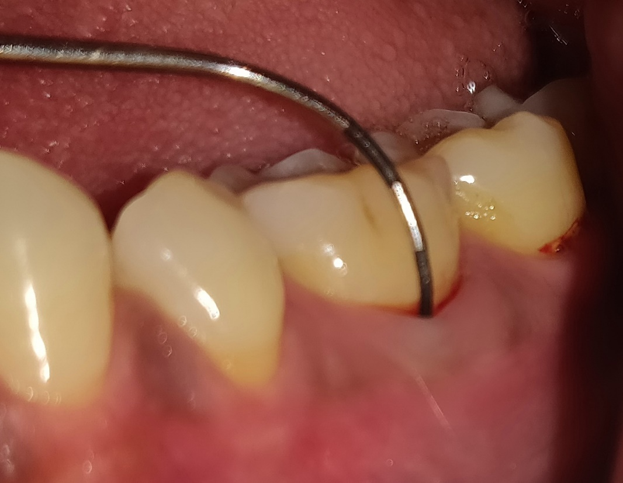
Figure 5a- Pre-surgical horizontal defect depth in HA/β-TCP + GTR group
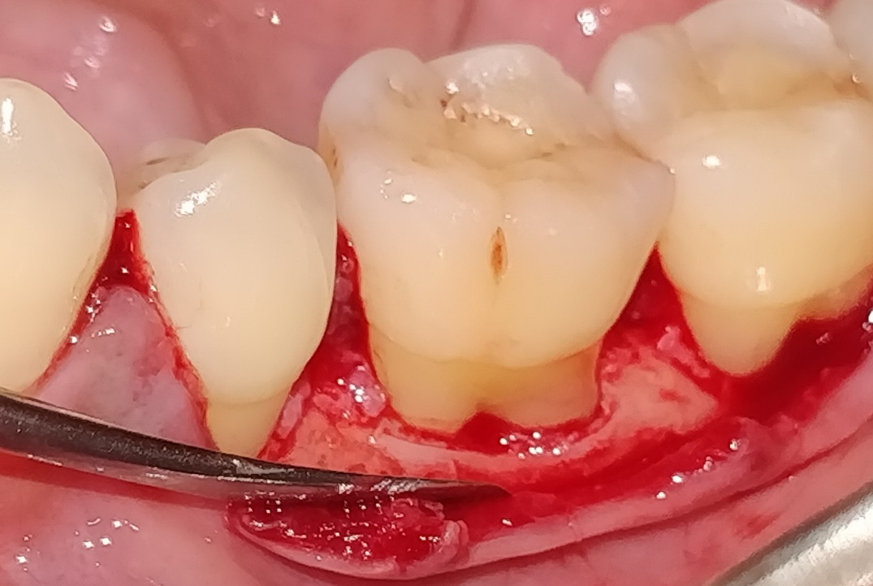
Figure 5b- Intra-surgical furcation defect in HA/β-TCP + GTR group

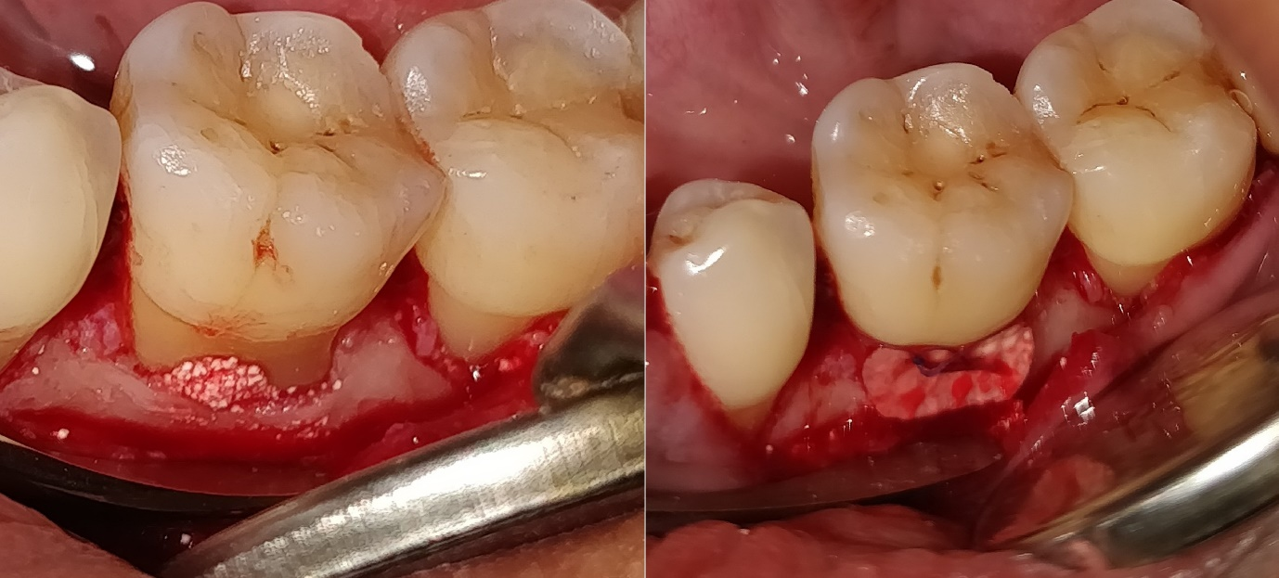
Figure 5c- Placement of bone graft followed by adaptation of PLA-PGA membrane
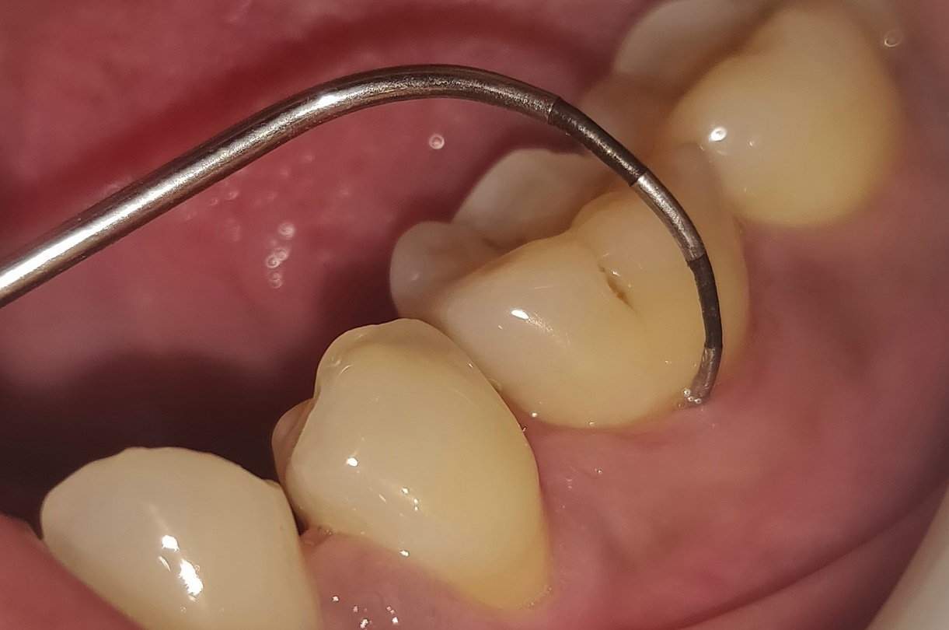
Figure 5d- Re-evaluation after 6 months of HA/β-TCP + GTR group

