Supplementary Figure Legends
Supplementary Figure 1. Oncoprint analysis of somatic mutations in OncoKB pan-cancer genes among NT2.5, NT2.5LM and NT2.5LV tumor cell lines. Rows depict gene names (n=20), while the columns identify the cell line. Gene mutations are color-coded with missense (green), nonsense (red), frameshift (purple), in-frame indel (range, and splice site (orange)). The bar plots (right) represent the total mutation counts per gene across the three cell lines. Analysis identifies several mutations shared among all three cell lines, while others are shared by the metastatic derivatives (NT2.5LM and NT2.5LV). In contrast, few mutations appear to be line-specific indicating clonal divergence during tumorigenesis.

Supplementary Figure 2. Clonal evolution reveals shared metastatic trunk.
a Phylogenetic tree based on PyClone-VI analysis. Ancestral clone (Clone 9) harbors Erbb2, Ksr2, Pclo mutations and Cdkn2a/b homozygous deletion present in all three cell lines. Metastatic trunk (Clones 0 and 3) carries Ercc5 and Fat4 alterations. Clone 7 is NT2.5-specific, Clones 2 and 10 are NT2.5LV-specific, and Clones 6 and 12 are NT2.5LM-specific.
b Heatmap depicting clonal trajectory per cell line. Rows: Clones 0-17. Columns: NT2.5, NT2.5LM, and NT2.5LV. Color scale depicts cellular prevalence with blue = 0, red = 1.0.
c Trajectory plot across cell lines. Each line represents one clone, which connect the cell lines. Important clonal expansions include Clone 2 in NT2.5LV and Clone 6 in NT2.5LM.
d Therapeutic vulnerabilities based on clonal evolution. Table summarizes various gene alterations with their associated clones, functional categories, affected pathways and predicted therapies. Important targetable alterations identified in NT2.5, NT2.5LM or NT2.5LV include Erbb2, Ercc5, and Atm.

Supplementary Figure 3. Transcriptional profiling identifies distinct gene expression programs in metastatic derivatives.
a Principal component analysis (PCA) of transcriptome gene expression. Each dot represents one biological replicate. NT2.5 (blue, n = 3), NT2.5LM (purple, n = 2), and NT2.5LV (gold, n = 3) form distinct clusters. Dashed ellipses indicate sample clusters.
b Differentially expressed genes (DEGs) across pairwise comparisons. Bar graphs showing significantly upregulated (red) or downregulated (blue) genes (FDR < 0.05, limma-voom).
c Heatmap of curated cancer-associated genes. 40 cancer-specific genes spanning cell cycle, HER2/EGFR, EMT, matrix metalloproteinases, metabolism, adhesion, and DNA damage response pathways. Color scale represents Z-score normalized expression (red = high, blue = low). Genes are hierarchically clustered. White vertical lines separate cell line groups.

Supplementary Figure 4. Differential gene expression between NT2.5 cell line derivates.
a-c Volcano plots showing the differential gene expression for (a) NT2.5LM vs NT2.5, (b) NT2.5LV vs. NT2.5, and (c) NT2.5LV vs. NT2.5LM. Top 5 differentially expressed genes are labeled in each panel. Differential gene analysis used limma-voom R package with empirical Bayes moderation of gene-wise variances. Dots represent genes with y-axis showing -log₁₀(P-value) and x-axis showing log₂Fold Change. The colored dots indicate significantly differentiated genes with FDR <0.05 and |log₂fold change| > 0.5. Purple dots denote genes differentially expressed in NT2.5LM, gold in NT2.5LV, and blue in NT2.5. Gray dots indicate genes with no significant difference. FDR is measured using Benjamini-Hochberg method. Gray vertical lines represent ±0.5 log₂FC threshold.

Supplementary Figure 5. Transcriptional characterization of organ-specific metastases.
a Integrin reprogramming in metastatic derivatives. Heatmap showing log₂ FC in integrin expression in NT2.5LM and NT2.5LV relative to NT2.5. Listed values represent differential expression between each metastatic cell line and NT2.5 calculated by edgeR with TMM normalization (see Methods). Asterisks (*) indicate statistical significance (FDR <0.05). Highlighted boxes represent differentially enriched integrins in NT2.5LM or NT2.5LV depending on associated color.
b Validation of metabolic gene upregulation in human breast cancer liver and lymph node (LN) metastases. Violin plots depict expression of LDHA, METTL7B (log₂FPKM) in liver metastases (n = 64, red) and lymph node (LN, n = 36, blue) from the MET500 cohort. Box plots identify the median and quartiles. Two-tailed student’s t-test was used to identify statistical significance. Analyzed p-values for LDHA = 1.25x10⁻⁶, METTL7B = 8.73x10⁻⁴. Asterisks denote statistical significance: *P < 0.05, **P < 0.01, ***P < 0.001, ****P < 0.0001.
c Mean expression (log₂ upper-quartile normalized) of key metabolic genes across metastatic sites in the AURORA cohort. Genes involved in oxidative phosphorylation, fatty acid metabolism, the TCA cycle, and one-carbon metabolism are shown. Color scale depicts absolute expression levels.
d Heatmap of differentially expressed genes in patient-matched primary breast tumors and metastases in the AURORA dataset (GSE209998). Top panel: primary versus liver metastasis pairs; bottom panel: primary versus lung metastasis pairs. Expression values are displayed as Z-scores across patient samples; columns represent individual patient, and rows represent genes selected by significance (paired differential expression analysis). Colored bars on the left indicate functional gene categories. Dashed lines separate upregulated (top) and downregulated (bottom) genes within each comparison.

Supplementary Figure 6. cGAS-STING pathway activation and T-cell checkpoint remodeling in NT2.5-cell lines.
a cGAS-STING pathway gene expression. Horizontal bar plots showing log₂ fold change of cGAS-STING pathway genes in NT2.5LM (purple) and NT2.5LV (gold) relative to parental NT2.5. Dashed vertical lines indicate log₂FC thresholds of ±0.5. Biological replicates: NT2.5 n=3, NT2.5LM n=2, NT2.5LV n=3.
b T-cell checkpoint and inhibitory ligand expression. Violin plots showing logCPM expression of Havcr2 (TIM-3), Tigit, Btla, Ceacam1, Cd274 (PD-L1), and Lag3 in NT2.5 (blue), NT2.5LM (purple), and NT2.5LV (gold). Individual data points represent biological replicates.

Supplementary Figure 7. Amino Acid sequence alignment of mouse Erbb2 (NT2.5LV) and human ERBB2 identifies conserved therapeutic targets.
Pairwise alignment between NT2.5LV mouse Erbb2 and human ERBB2 across the extracellular (ECD), transmembrane (TM), and intracellular domains (ICD) domains. Aligned regions are highlighted in purple, while unaligned amino acids are unshaded. Regions of therapeutic targets are colored with corresponding drug color. The intracellular domain incorporating the tyrosine kinase shows conserved TKI binding residues, including neratinib (Cys805, Val773), lapatinib (Leu726, Ala751, Arg849). Sequence alignment in ECD, TM, and ICD between NT2.5LV Erbb2 and human ERBB2 are 74%, 56%, and 92%, respectively. This high sequence alignment in the ICD domain between the two supports use of NT2.5LV as a preclinical breast tumor model to assess therapeutic efficacy of TKIs.

Supplementary Figure 8. Sensitivity of NT2.5-based breast tumor cell lines to targeted HER2 treatment.
a lapatinib dose-response in vitro assessment. Bar plots depicting cell viability of 4T1 (HER2-low or negative), NT2.5 and NT2.5LV (HER2⁺ murine cell lines) following 72-hours treatment with lapatinib at various concentrations as show. Cells (5,000 per well) were plated for 24 hours, then treated with vehicle control (0.1% DMSO) or lapatinib. Cell viability was determined using CellTiter-Glo luminescent assay. The data represent mean ±SEM from four independent biological replicates for each concentration and control. Statistical significance was assessed using one-way ANOVA at each concentration and control, followed by pairwise comparisons with Bonferroni correction for multiple testing (n=3 comparisons at each concentration). Significance brackets indicate comparisons between cell lines: *p<0.05, **p<0.01, ***p<0.001, ns = not significant.
b Neratinib dose-response in vitro assessment. Bar plots depicting cell viability of 4T1, NT2.5LM and NT2.5LV after 72-hr treatment with neratinib at indicated concentration. The experimental conditions and statistical testings were similar to a except the use of neratinib instead of lapatinib. The data show that NT2.5LM and NT2.5LV portray enhanced sensitivity to neratinib compared with 4T1, with highest sensitivity seen in NT2.5LV. Significance brackets indicate comparisons between cell lines: *p<0.05, **p<0.01, ***p<0.001, ns = not significant.
c Trastuzumab dose-response in NT2.5LV. Bar plots showing NT2.5LV viability when treated with various concentrations of trastuzumab for 72 hours. The experimental conditions and statistical testing were identical to a and b with the exception of the drug tested. NT2.5LV show minimal sensitivity to trastuzumab even at high concentration. Significance brackets indicate comparisons between cell lines: *p<0.05, **p<0.01, ***p<0.001, ns = not significant.

Supplementary Figure 9. Molecular characterization of ERBB family genes and TKI targets in 4T1 cells.
a log₂ copy number ratios of ERBB family genes derived from CNVkit analysis of whole-genome sequencing (n=2 biological replicates). Dashed lines indicate thresholds for copy number gain (log₂ = 1.0).
b ERBB family gene expression shown as read counts from public RNA-seq dataset SRR17179922, mapped to gene body regions (mm10).
c Gene expression of known neratinib and lapatinib kinase targets. Bar colors indicate drug specificity as shown in legend.

Supplementary Figure 10. NT2.5LM cells exhibit PARP inhibitor resistance despite a pro-apoptotic transcriptional profile consistent with BH3 priming.
a DNA damage response (DDR) pathway expression in NT2.5-derived cell lines. Horizontal bar plots showing pathway-level gene expression changes between NT2.5LM and NT2.5LV relative to parental NT2.5. Each bar represents the mean log₂ fold change in expression calculated across all genes within the indicated pathway. Bar direction to the right (positive) indicate upregulation, while left (negative) indicate downregulation. Complete gene lists and individual expression values are included in Supplementary Table 4.
b RNA expression of apoptosis-related genes in NT2.5, NT2.5LM, and NT2.5LV cell lines. Heatmaps show (Left) absolute expression levels (logCPM) and (right) expression changes (ΔlogCPM) relative to parental NT2.5 line. Genes are grouped by functional status: anti-apoptosis (BCL2, BCL-XL, cIAP2, SURVIVIN, MDM2), BH3-only pro-apoptosis (BIM, PUMA, NOXA, BAD, BIK, BMF, HRK), effectors (BAX, BAK, BOK), caspases (CASP3, CASP8, CASP9), and death receptor pathway components (FAS, FASL, TNF, TRAIL).
c Cell viability was assessed following 72-hour treatment with cisplatin, 6-day olaparib, or 72-hour combination therapy. Viable cells were assessed via CellTiter-Glo assay. IC₅₀ were determined using 4-parametric logistic regression. For treatments where viability did not reach 50% of the control, IC₅₀ is reported as >50 µM. For NT2.5LV, IC₅₀ was determined by linear interpolation between 25 µM (58%) and 50 µM (42.9%) viability. Data represent ±SEM of n=2-3 biological replicates.

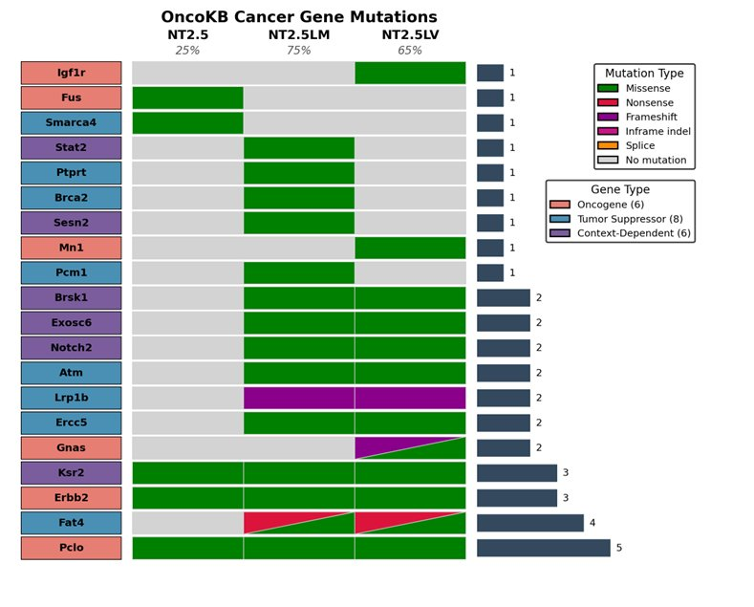

Supplementary Fig 1
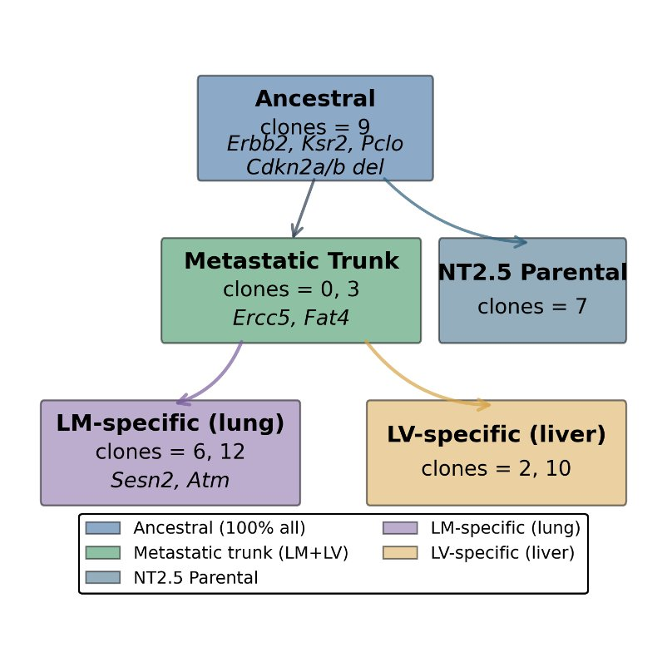
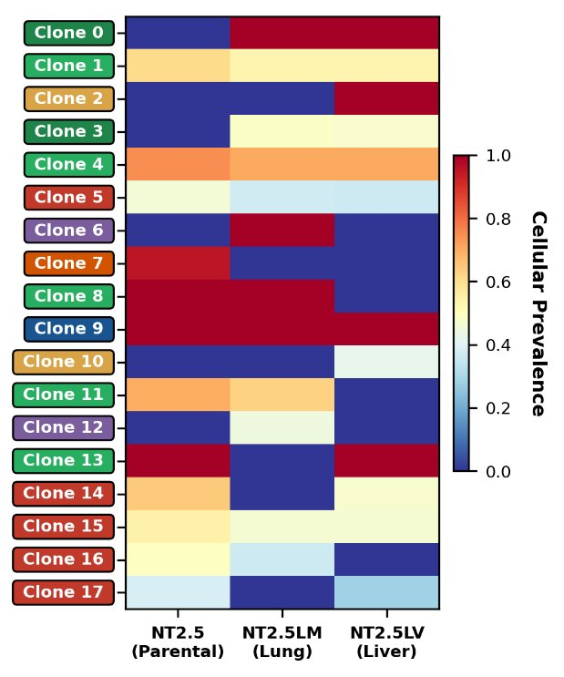
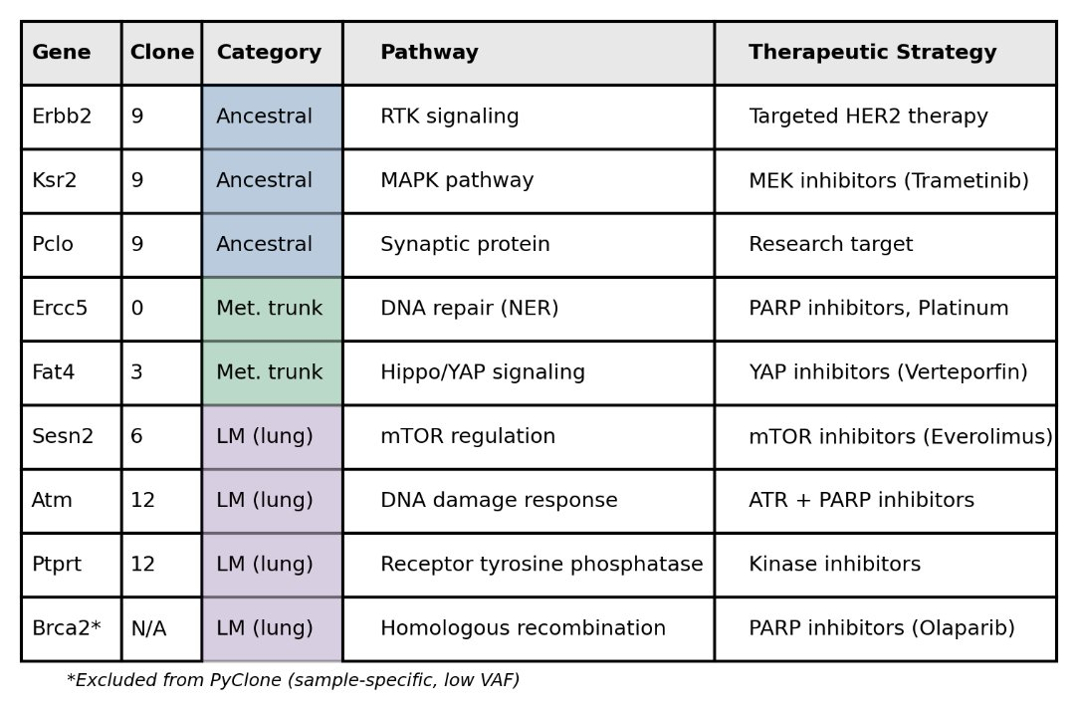
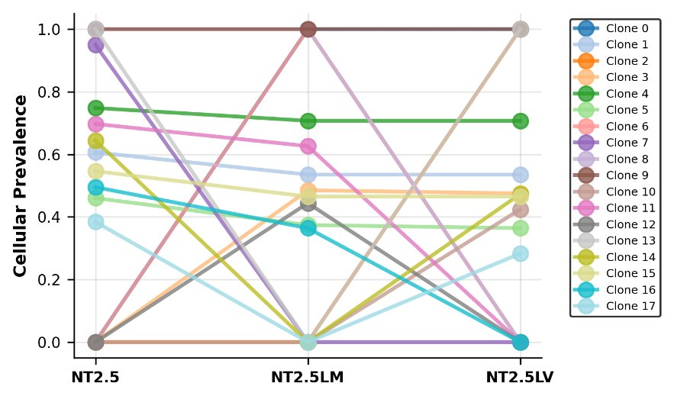
d
a
b
c

Supplementary Fig 2

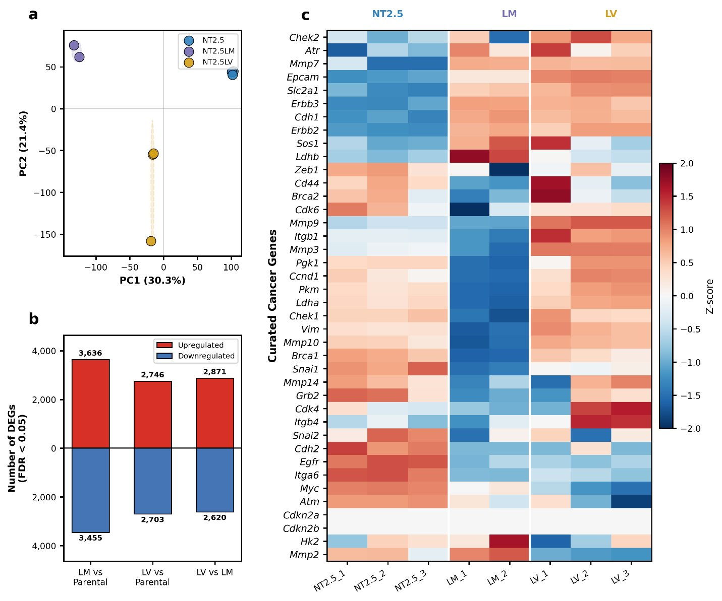

Supplementary Fig 3

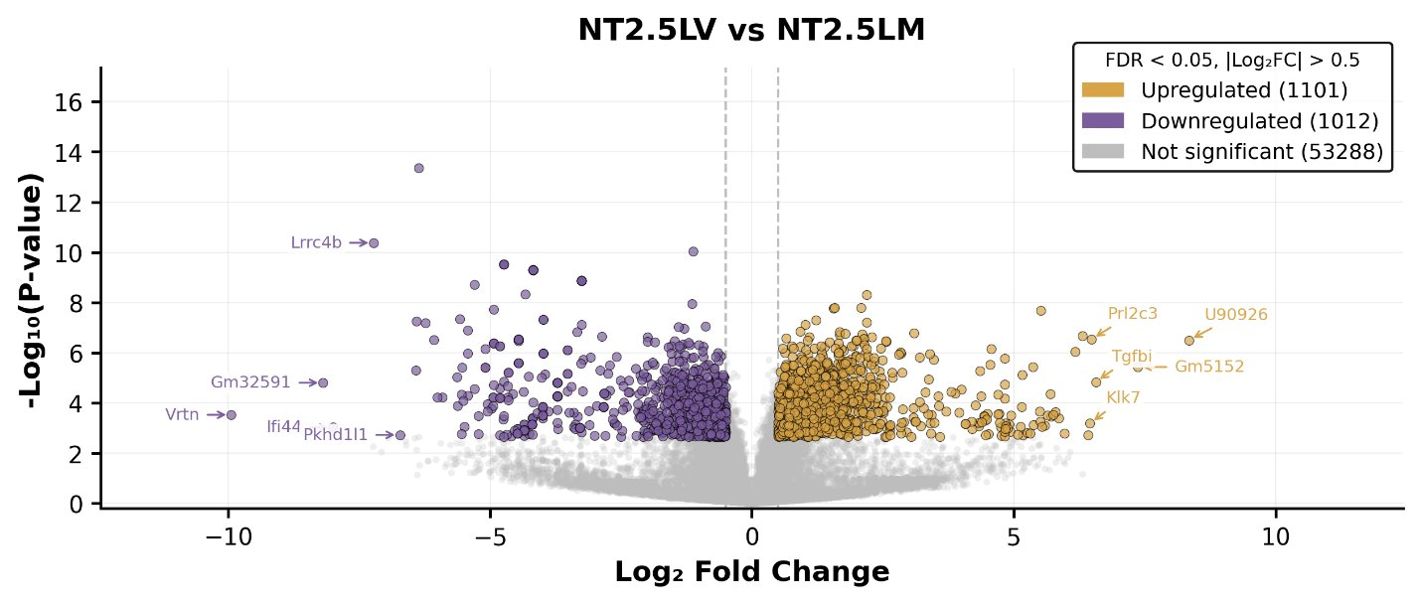
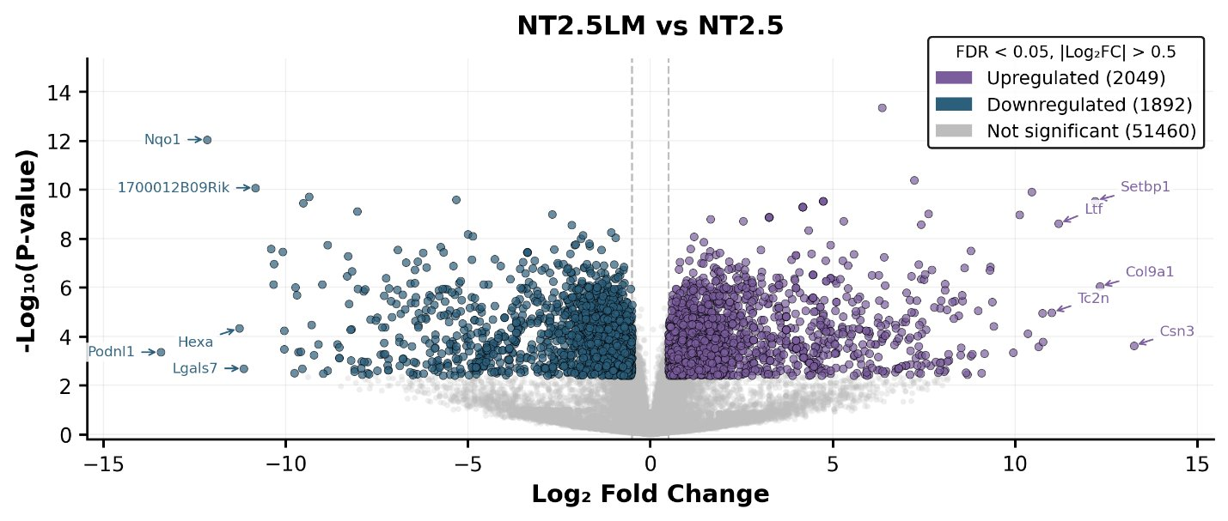
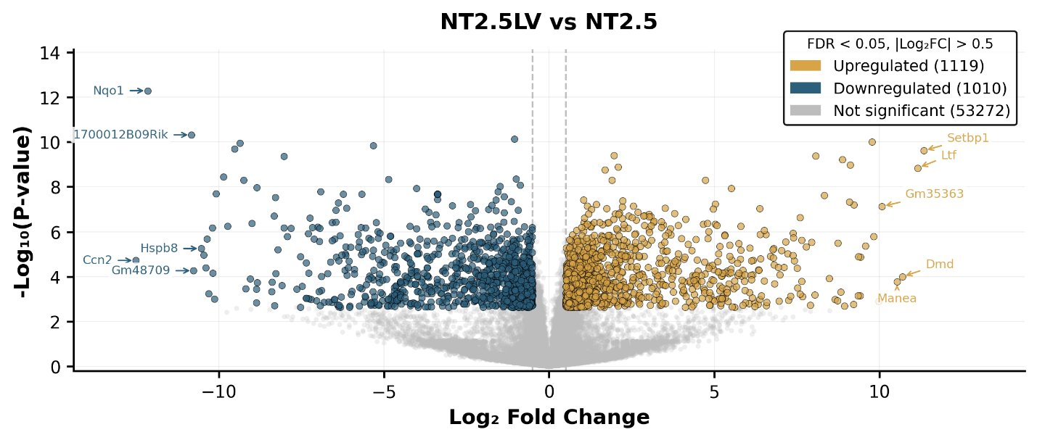
a

b

c

Supplementary Fig 4

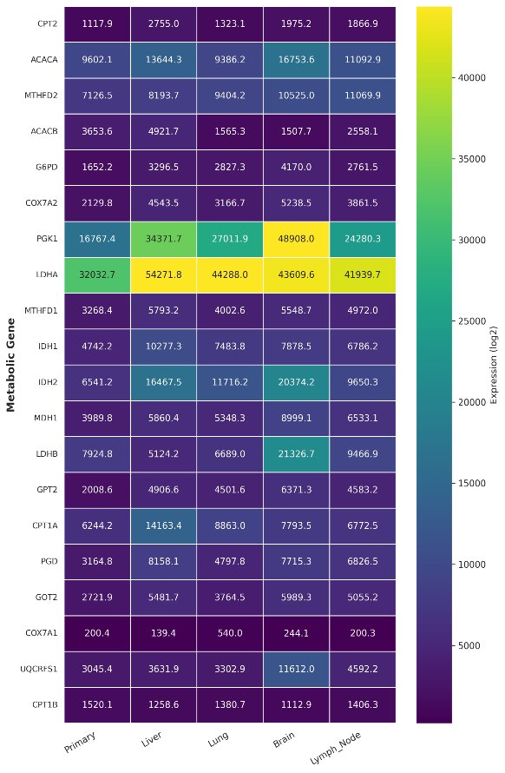
b
c
a
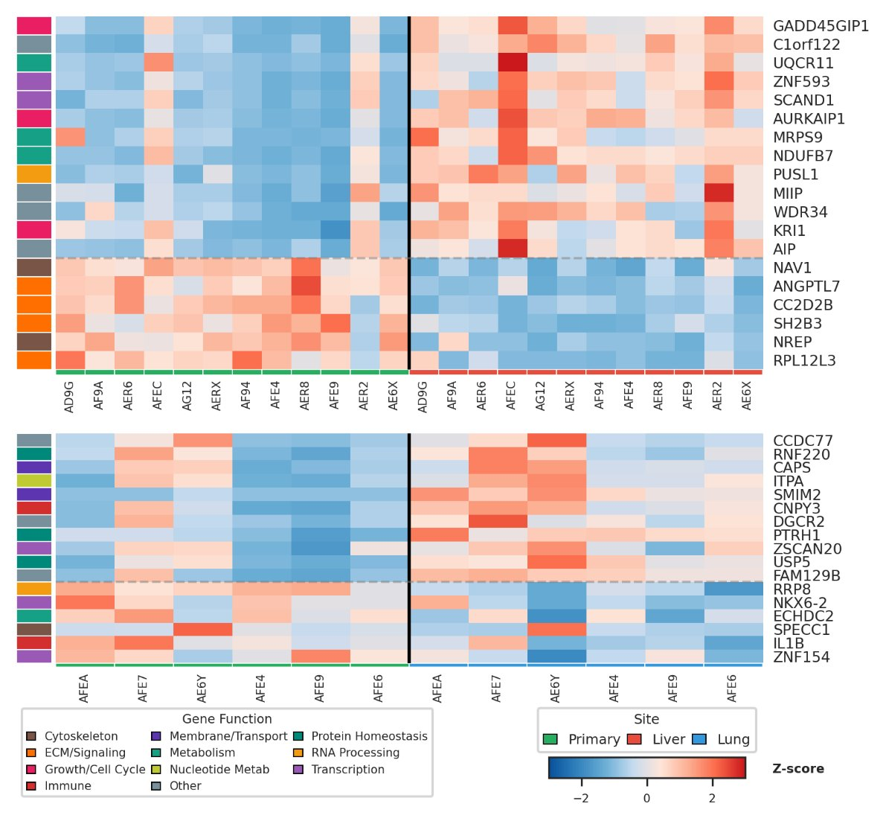
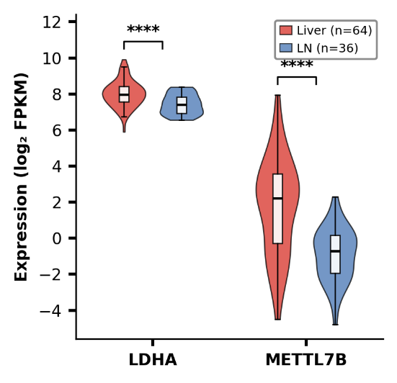
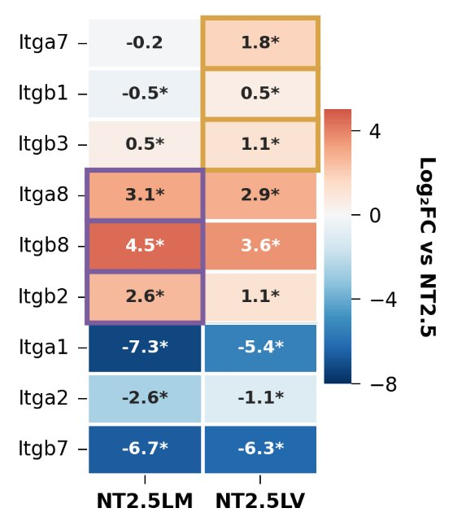
Supplementary Fig 5
d

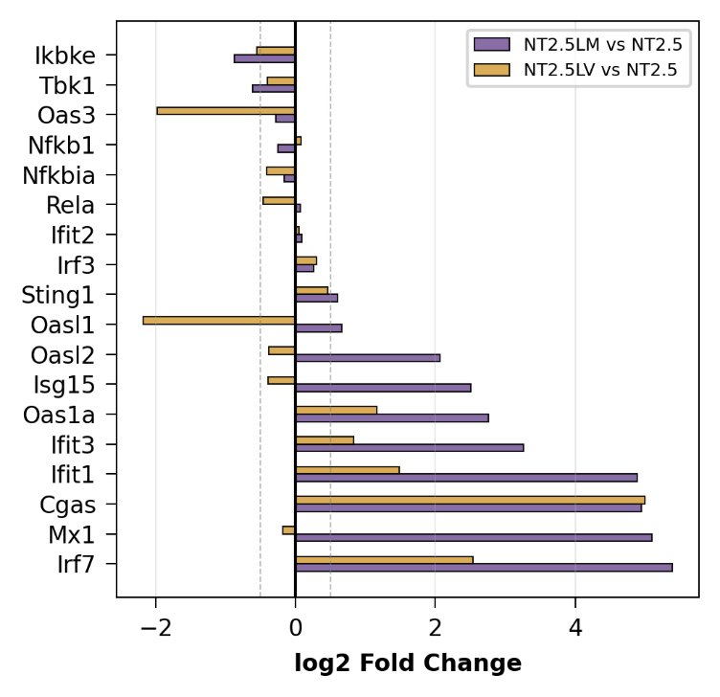
a
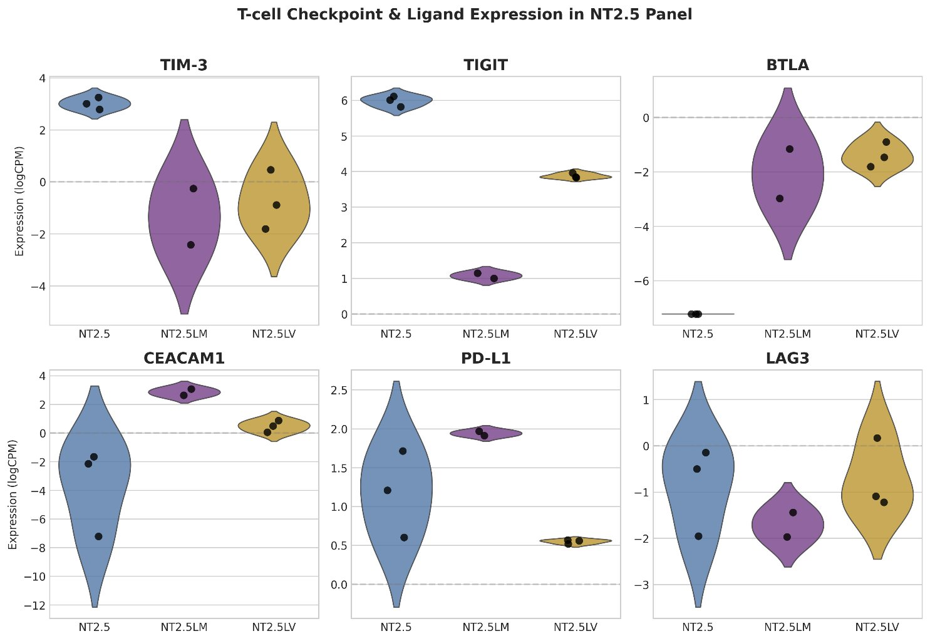
Supplementary Fig 6
b
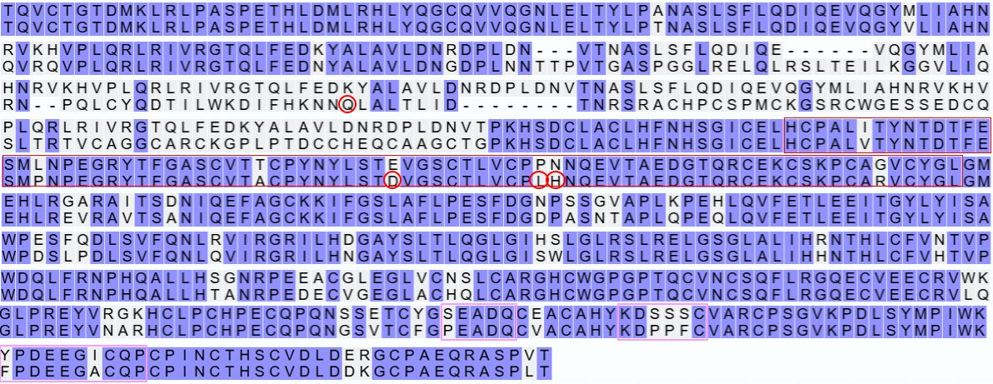
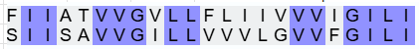
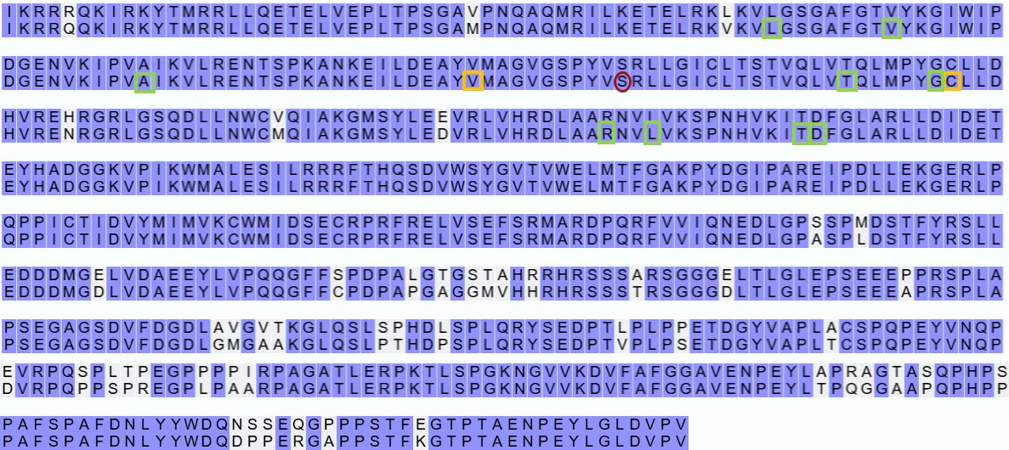
Supplementary Fig 7
Binding Sites
Pertuzumab (ECD-domain II)
Trastuzumab (ECD-domain IV)
Lapatinib (ICD)
Neratinib (ICD)
Tucatinib (ICD)
NT2.5LV
Human
NT2.5LV
Human
NT2.5LV
Human
NT2.5LV
Human
NT2.5LV
Human
NT2.5LV
Human
NT2.5LV
Human
NT2.5LV
Human
NT2.5LV
Human
NT2.5LV
Human
ECD
NT2.5LV
TM
Human
NT2.5LV
Human
NT2.5LV
Human
NT2.5LV
Human
NT2.5LV
Human
NT2.5LV
Human
NT2.5LV
Human
NT2.5LV
Human
NT2.5LV
NT2.5LV
Human
Human
ICD

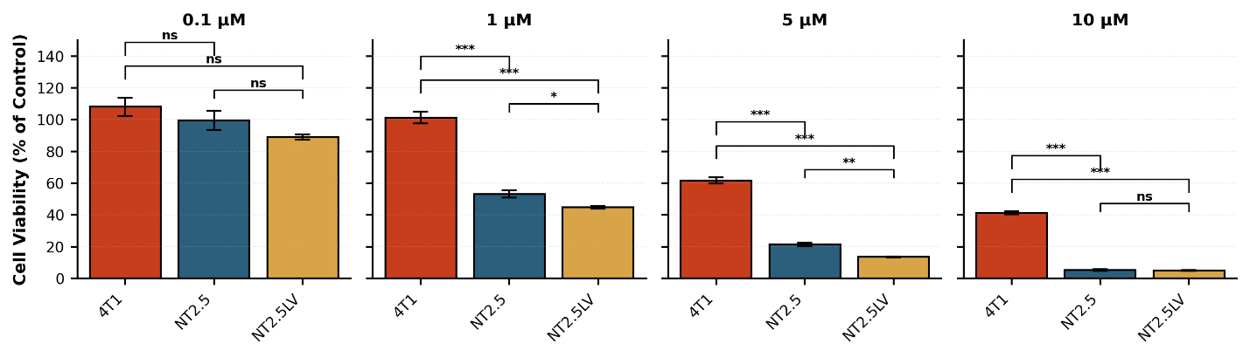
a Lapatinib
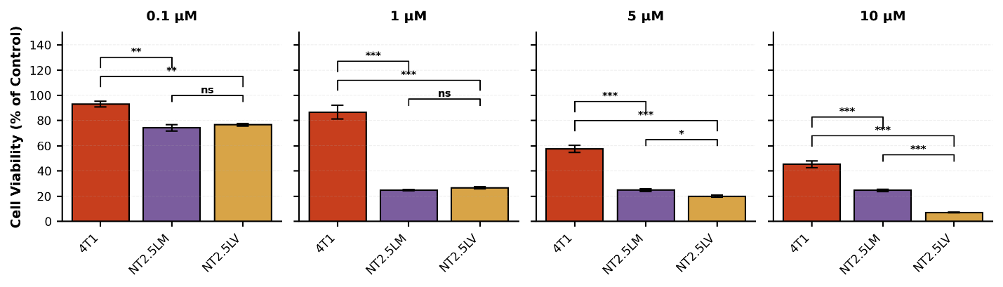
b Neratinib

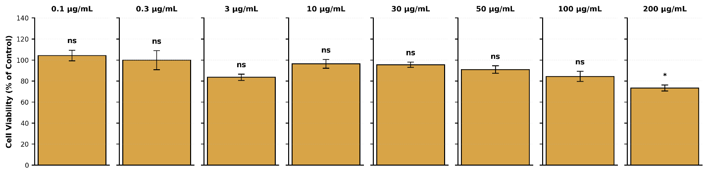
c Trastuzumab
Supplementary Fig 8

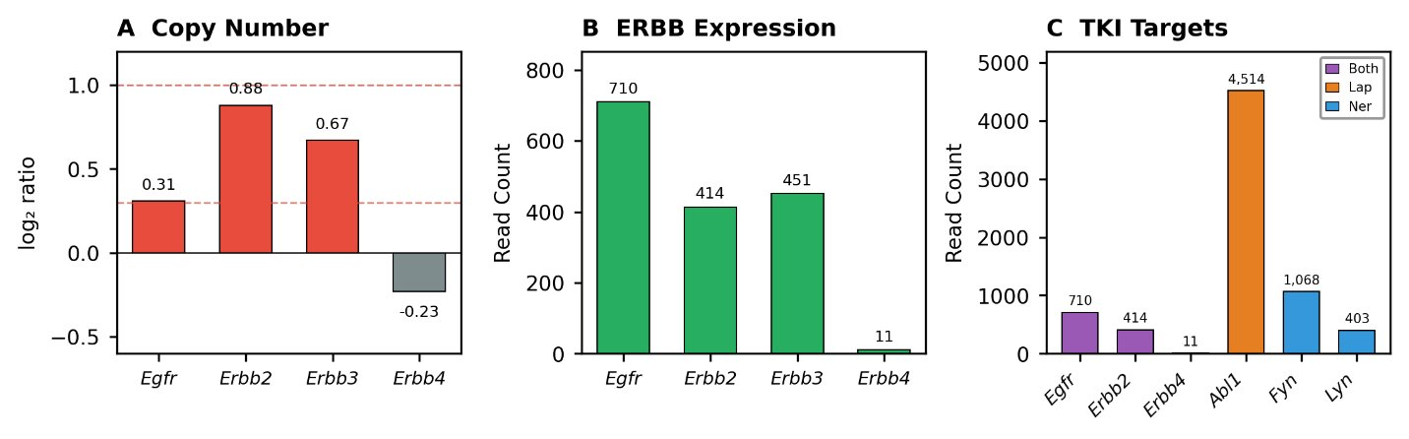

Supplementary Fig 9
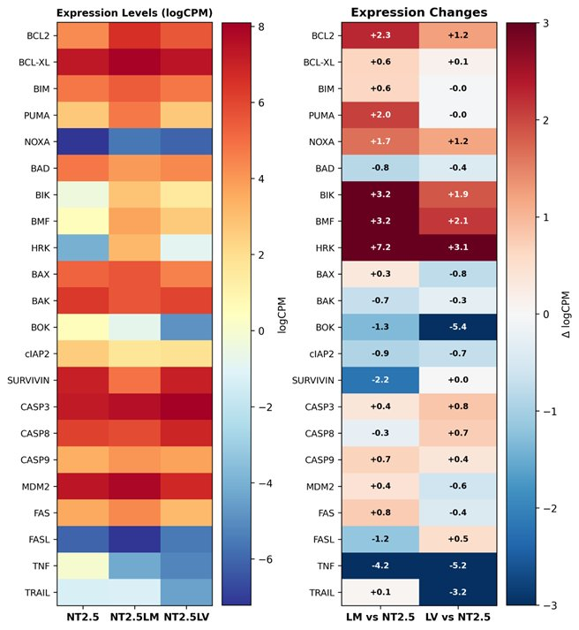
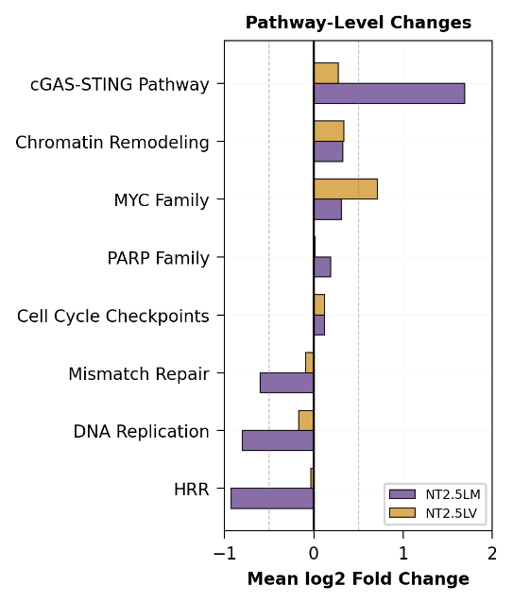
a
b

c
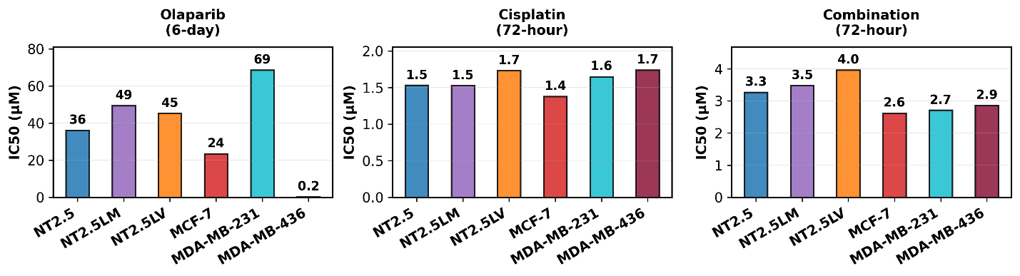

Supplementary Fig 10

