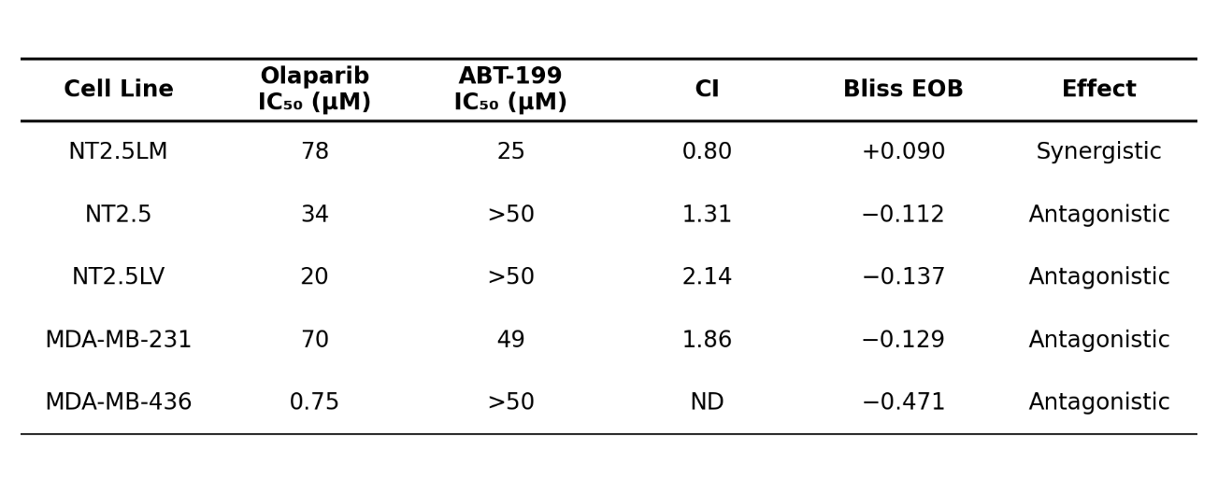
Table 1: Synergy analysis of ABT-199 and olaparib combination in vitro treatment

Table 1. Synergy analysis of ABT-199 and olaparib combination in vitro treatment.
IC₅₀ for olaparib (72-hour) and ABT-199 (72-hour) monotherapy, and drug synergy metrics for the combination treatment (25 µM olaparib + ABT-199 dose range) across five breast tumor cell lines. Combination therapy involved sensitization with ABT-199 for 24 hours followed by introduction of olaparib for additional 48 hours. Combination index (CI) was calculated using the Chou-Talalay method and Excess over Bliss (EOB) were calculated as described in Methods. NT2.5LM demonstrates synergistic interaction (CI=0.8, EOB=+0.09) consistent with BCL2 inhibition overcoming apoptotic resistance in olaparib-resistant, HRD-positive cells. ND, not determined.

