Supporting Information for
Engineering Ag@ZnO Hybrid Nanostructures for Catalytic Degradation of Dye and Pharmaceutical Pollutants in Aqueous Media
Demet Güzel¹, Sami Pekdemir^{,2,3}
¹ Department of Materials Science and Engineering, Erciyes University, Kayseri 38039, Turkiye
² Department of Aeronautical Engineering, Faculty of Aeronautics and Astronautics, Erciyes University, Kayseri, 38039, Turkey
³ ERNAM-Erciyes University Nanotechnology Application and Research Center, Kayseri, 38039, Türkiye
* Corresponding author: samipekdemir@erciyes.edu.tr

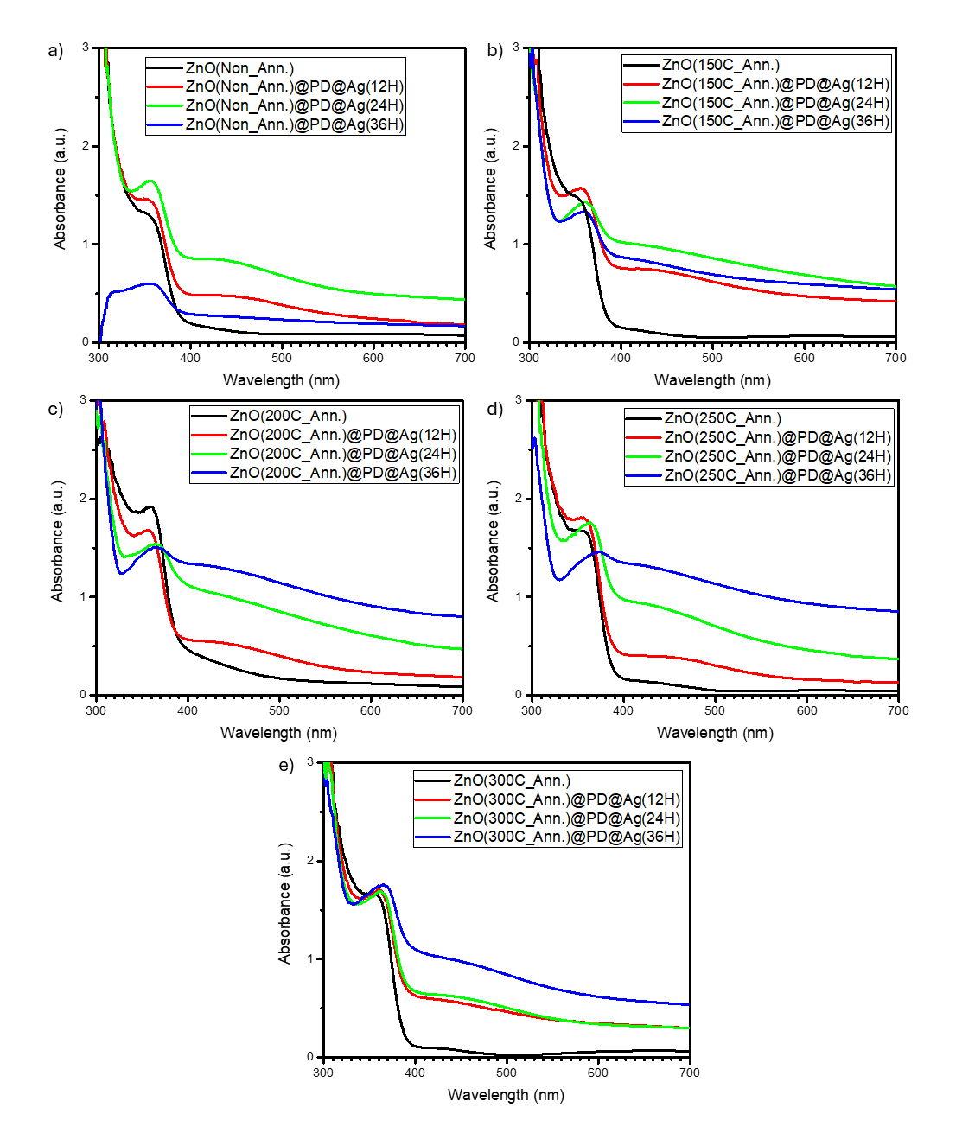Figure S1. Absorbance results of samples from UV-Vis spectrophotometer, a) Non annealed, b) Annealed at 150 ºC, c) Annealed at 200 ºC, d) Annealed at 250 ºC, e) Annealed at 300 ºC.

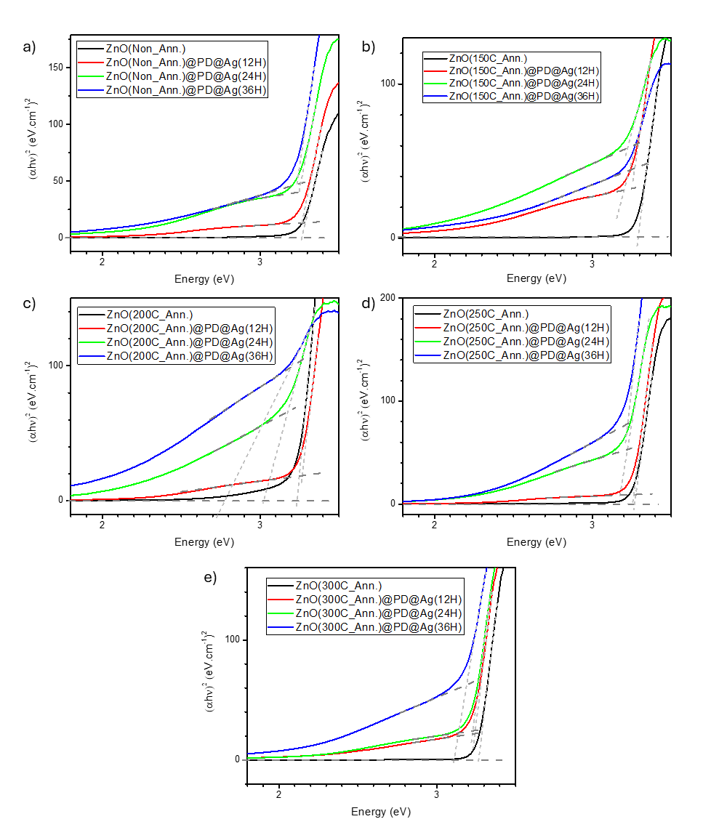
Figure S2. Tauc Plot of ZnO thin films and ZnO@PD@Ag Hybrid NSs, a) Non annealed, b) Annealed at 150 ºC, c) Annealed at 200 ºC, d) Annealed at 250 ºC, e) Annealed at 300 ºC.
Figure S3. UV-Vis measurements of Degredation of MO samples.
Figure S4. Calibration curve of IBU for UV-vis spectrometer measurement.

Figure S5. Kinetic plot for RhB photodegradation using ZnO thin films and ZnO@PD@Ag Hybrid NSs. a,b,c) Non annealed, d,e,f) Annealed at 150 ºC, g,h,i) Annealed at 200 ºC, j,k,l) Annealed at 250 ºC, m,n,o) Annealed at 300 ºC.

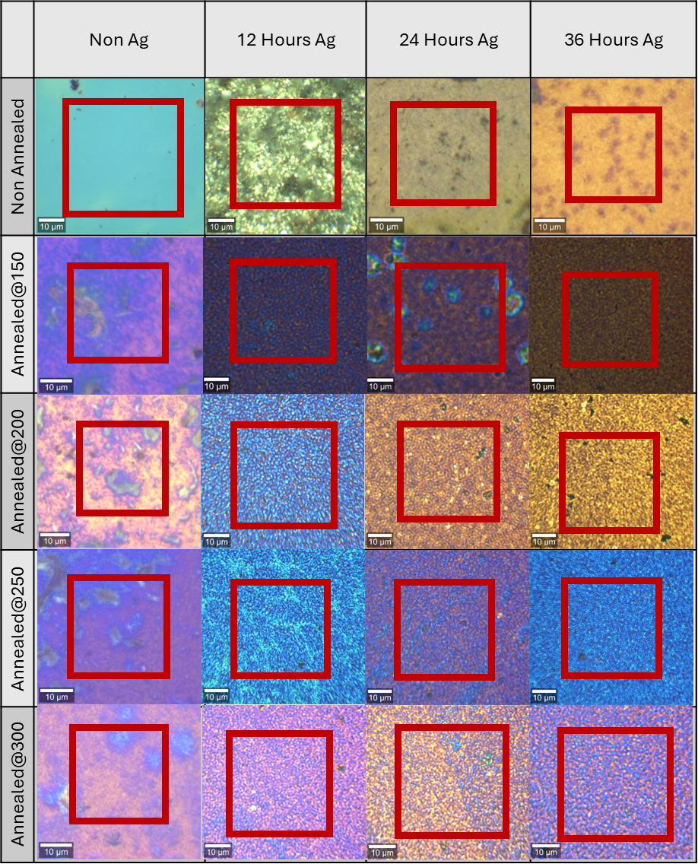
Figure S6. Optical images of Raman mapping areas.

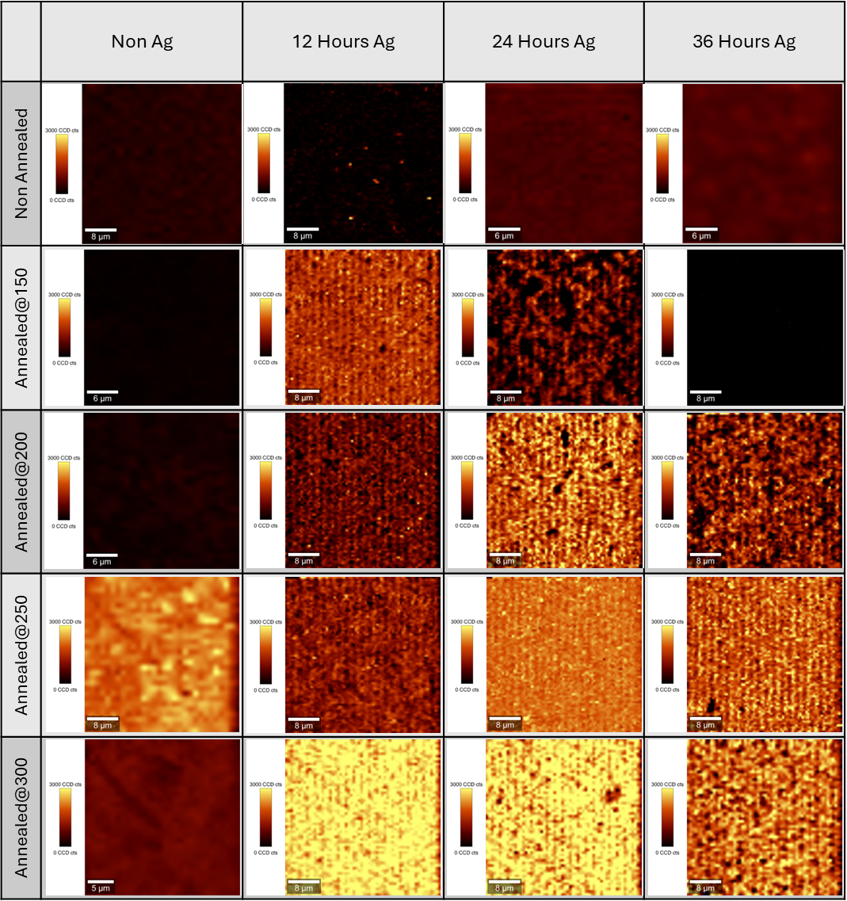
Figure S7. Raman mapping images of the samples. All images were generated from the Raman band at 1625 cm⁻¹ of MB.

