Supplementary materials to:

Bridging Capture Chemistry to Low-Energy Bio-Integrated CO₂-to-Methane

Mads Ujarak Sieborg^{1,2,†}, Kristian Ax^{2,3,†}, Therese Bundgaard Jensen¹, Pegah Nazari^{2,3}, Madhuni Madhushika Wijesooriya^{1,2}, Mads Andrup Jensen¹, Kim Daasbjerg^{2,3,4}, Michael Vedel Wegener Kofoed^{1,2,*}
¹ Department of Biological and Chemical Engineering, Aarhus University, Gustav Wieds Vej 10C, DK-8000 Aarhus C., Denmark
² The Novo Nordisk Foundation CO₂ Research Center (CORC), Aarhus University, Gustav Wieds Vej 10C, DK-8000, Denmark
³ Department of Chemistry, Aarhus University, Langelandsgade 140, 8000 Aarhus C, Denmark.
⁴ Interdisciplinary Nanoscience Center (iNANO), Gustav Wieds Vej 14, 8000 Aarhus C, Denmark.
† These authors contributed equally.
* Corresponding authors: Michael Vedel Wegener Kofoed (Mvk@bce.au.dk) and Kim Daasbjerg (Kdaa@chem.au.dk)

1. Bio-integrated carbon capture and utilization in industrial settings
Raw flue gas from a 625 kW biogas combustion engine was analyzed to understand what impurities industrial CO₂ sources expose to the capture agents and CO₂-utilizing methanogens. The flue gas contained 8.2% CO₂, 84.7% N₂, 7.1% O₂, 206.7 ppm NO_{X}, 83.2 ppm SO_{X} and 339.5 ppm CO, which could affect reaction equilibrium, microbiome stability, and biocompatibility. After CO₂ capture, the dissolved O₂ concentration averaged 4.04 ± 0.34 mg L⁻¹ (n = 8). Although microbial CO₂ conversion could mitigate thermally accelerated oxidative degradation by these impurities, the agents could still be vulnerable to microbial degradation. Some agents, such as piperazine (27), methyldiethanolamine (15), 2-amino-2-methyl-1-propanol (7), and 2-diethylaminoethanol (18), are recalcitrant carbon sources resistant to anaerobic biodegradation, whereas monoethanolamine (1) and diethanolamine (10) undergo microbial degradation ¹. However, stability in archaeal-dominated BICCU systems remains unexplored and requires long-term testing with repeated absorption-conversion cycles to assess their durability.
- 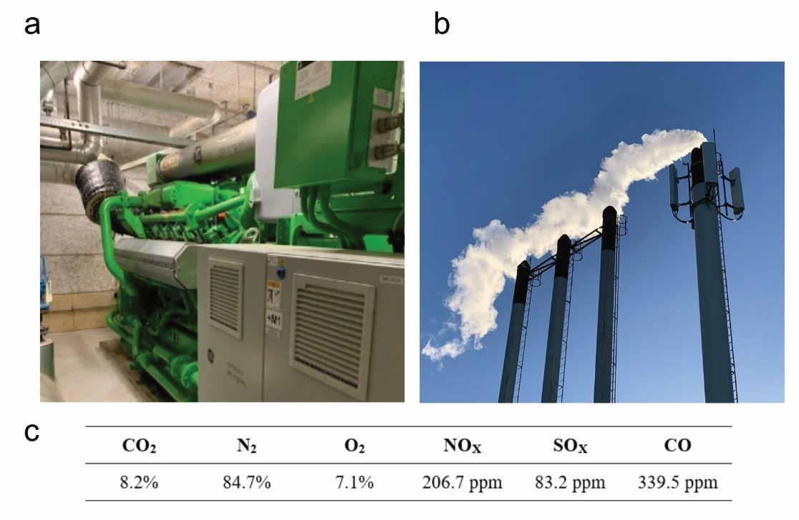
Figure S1: (a) Photograph of the 625 kW biogas engine and (b) exhaust stacks used for (c) analysing the dry composition of dilute CO₂ concentration and impurities of raw flue gas.

1. Chemical and physical characteristics of amine-based capture agents
Table S1: Overview of capture agents screened for biocompatibility with their chemical and physical properties.
Capture agent | Octanol-water partition  coefficient | Median lethal dose  [mg kg⁻¹] | Molar refractivity  [cm³ mol⁻¹] | Volatility  [atm m³ mol⁻¹] | Topological polar surface area  [Å²] | Molecular weight  [g mol⁻¹]
Primary amines
Monoethanolamine (1) | –1.3 | 1720 | 16.34 | 1.64 × 10^{–10} | 46.3 | 61.08
3-Amino-1-propanol (2) | –1.1 | 2779 | 20.91 | 4.88 × 10^{–10} | 46.3 | 75.11
4-Aminobutan-1-ol (3) | –1.1 | 1150 | 25.34 | 6.48 × 10^{–10} | 46.3 | 89.14
5-Aminopentan-1-ol (4) | –0.3 | 500 | 29.88 | 8.60 × 10^{–10} | 46.3 | 103.16
Benzylamine (5) | 1.1 | 552 | 34.43 | 1.39 × 10^{–5} | 26.0 | 107.15
Aniline (6) | 0.9 | 250 | 30.67 | 1.97 × 10^{–6} | 26.0 | 93.13
2-Amino-2-methyl-1-  propanol (7) | –0.8 | 2900 | 25.45 | 1.41 × 10^{–8} | 46.3 | 89.14
Secondary amines
Diethylamine (8) | 0.6 | 500 | 24.35 | 2.41 × 10^{–5} | 12.0 | 73.14
2-(Ethylamino)ethan-1-ol (9) | –0.5 | 1000 | 25.75 | 1.07 × 10^{–9} | 32.3 | 89.14
Diethanolamine (10) | –1.4 | 680 | 27.03 | 3.95 × 10^{–11} | 52.5 | 105.14
N,O-Dimethylhydroxyl  amine hydrochloride (11) | 1.0 | N/A | 30.69 | 4.90 × 10^{–6} | 21.3 | 97.54
Tertiary amines
N,N-Diisopropylethyl  amine (12) | 2.2 | 317 | 43.52 | 1.51 × 10^{–4} | 3.2 | 129.24
2-(Diisopropylamino)  ethanol (13) | 1.2 | 860 | 46.52 | 5.19 × 10^{–8} | 23.5 | 145.24
2-Dimethylamino  ethanol (14) | –0.4 | 2000 | 25.94 | 1.80 × 10^{–9} | 23.5 | 89.14
Methyldiethanol  amine (15) | –1.1 | 1945 | 31.97 | 3.08 × 10^{–11} | 43.7 | 119.16
N-Butyldiethanol  amine (16) | 0.1 | 4250 | 45.43 | 2.01 × 10^{–10} | 43.7 | 161.24
Triethylamine (17) | 1.4 | 460 | 33.86 | 1.39 × 10^{–4} | 3.2 | 101.19
2-Diethylamino  ethanol (18) | 0.3 | 1300 | 35.17 | 5.48 × 10^{–7} | 23.5 | 117.19
N-Ethyldiethanol  amine (19) | 0.2 | 4570 | 36.45 | 1.10 × 10^{–10} | 43.7 | 133.19
Triethanolamine (20) | –1.0 | 8000 | 37.91 | 7.05 × 10^{–13} | 63.9 | 149.19
Di/tri/tetra amines
Ethylenediamine (21) | –2.0 | 1000 | 18.25 | 1.70 × 10^{–9} | 52.0 | 60.10
N,N'-Bis(2-aminoethyl)-  1,3-propanediamine (22) | –2.2 | 654 | 48.60 | 1.23 × 10^{–16} | 76.1 | 160.26
1,1,4,7,10,10-Hexamethyl  triethylenetetramine (23) | 0.4 | 316 | 73.94 | 1.04 × 10^{–14} | 13.0 | 230.39
Tris(2-dimethyl  aminoethyl)amine (24) | 0.4 | 246 | 72.24 | 1.04 × 10^{–14} | 13.0 | 230.39
N,N,N',N'-Tetrakis(2-hydroxyethyl)ethylenediamine (25) | –2.4 | N/A | 58.36 | 1.34 × 10^{–16} | 87.4 | 236.31
N,N-Dimethyl-1,4-phenyl  diamine (26) | 1.8 | 50 | 44.49 | 3.03 × 10^{–8} | 29.3 | 136.19
Piperazine derivatives
Piperazine (27) | –1.5 | 1900 | 21.93 | 9.87 × 10^{–8} | 24.1 | 86.14
1-(2-Hydroxyethyl)  piperazine (28) | –1.1 | 5215 | 37.66 | 3.40 × 10^{–9} | 35.5 | 130.19
1,4-Bis(2-hydroxyethyl)  piperazine (29) | –1.3 | 4092 | 43.01 | 2.50 × 10^{–14} | 46.9 | 174.24
1-(2-Aminoethyl)  piperazine (30) | –1.3 | 2108 | 38.68 | 6.60 × 10^{–13} | 41.3 | 129.20
1-(2-Pyridyl)piperazine (31) | 0.7 | N/A | 51.74 | 1.48 × 10^{–11} | 28.2 | 163.22
1-(4-Pyridyl)piperazine (32) | 0.3 | N/A | 49.97 | 1.48 × 10^{–11} | 28.2 | 163.22

2. Molecular structural characteristics of amine-based capture agents
Table S2: Overview of capture agents screened for biocompatibility with their structural features.
Capture agent | Amine groups (1°/2°/3°) | Hydrogen  donors | Hydrogen  acceptors | Heavy  atoms | Ring  structure | Hydroxyl group
Primary amines
Monoethanolamine (1) | 1/0/0 | 2 | 2 | 4 | 0 | 1
3-Amino-1-propanol (2) | 1/0/0 | 2 | 2 | 5 | 0 | 1
4-Aminobutan-1-ol (3) | 1/0/0 | 2 | 2 | 6 | 0 | 1
5-Aminopentan-1-ol (4) | 1/0/0 | 2 | 2 | 7 | 0 | 1
Benzylamine (5) | 1/0/0 | 1 | 1 | 8 | 1 | 0
Aniline (6) | 1/0/0 | 1 | 1 | 7 | 1 | 0
2-Amino-2-methyl-1-  propanol (7) | 1/0/0 | 2 | 2 | 6 | 0 | 1
Secondary amines
Diethylamine (8) | 0/1/0 | 1 | 1 | 5 | 0 | 0
2-(Ethylamino)ethan-1-ol (9) | 0/1/0 | 2 | 2 | 6 | 0 | 1
Diethanolamine (10) | 0/1/0 | 3 | 3 | 7 | 0 | 2
N,O-Dimethylhydroxyl  amine hydrochloride (11) | 0/1/0 | 2 | 2 | 5 | 0 | 0
Tertiary amines
N,N-Diisopropylethyl  amine (12) | 0/0/1 | 0 | 1 | 9 | 0 | 0
2-(Diisopropylamino)  ethanol (13) | 0/0/1 | 1 | 2 | 10 | 0 | 1
2-Dimethylamino  ethanol (14) | 0/0/1 | 1 | 2 | 6 | 0 | 1
Methyldiethanol  amine (15) | 0/0/1 | 2 | 3 | 8 | 0 | 2
N-Butyldiethanol  amine (16) | 0/0/1 | 2 | 3 | 11 | 0 | 2
Triethylamine (17) | 0/0/1 | 0 | 1 | 7 | 0 | 0
2-Diethylamino  ethanol (18) | 0/0/1 | 1 | 2 | 8 | 0 | 1
N-Ethyldiethanol  amine (19) | 0/0/1 | 2 | 3 | 9 | 0 | 2
Triethanolamine (20) | 0/0/1 | 3 | 4 | 10 | 0 | 3
Di/tri/tetra amines
Ethylenediamine (21) | 2/0/0 | 2 | 2 | 4 | 0 | 0
N,N'-Bis(2-aminoethyl)-  1,3-propanediamine (22) | 2/2/0 | 4 | 4 | 11 | 0 | 0
1,1,4,7,10,10-Hexamethyl  triethylenetetramine (23) | 0/0/4 | 0 | 4 | 16 | 0 | 0
Tris(2-dimethyl  aminoethyl)amine (24) | 0/0/4 | 0 | 4 | 16 | 0 | 0
N,N,N',N'-Tetrakis(2-hydroxyethyl)ethylenediamine (25) | 0/0/2 | 4 | 6 | 16 | 0 | 4
N,N-Dimethyl-1,4-phenyl  diamine (26) | 1/0/1 | 1 | 2 | 10 | 1 | 0
Piperazine derivatives
Piperazine (27) | 0/2/0 | 2 | 2 | 6 | 1 | 0
1-(2-Hydroxyethyl)  piperazine (28) | 0/1/1 | 2 | 3 | 9 | 1 | 1
1,4-Bis(2-hydroxyethyl)  piperazine (29) | 0/0/2 | 2 | 4 | 12 | 1 | 2
1-(2-Aminoethyl)  piperazine (30) | 1/1/1 | 2 | 3 | 9 | 1 | 0
1-(2-Pyridyl)piperazine (31) | 0/1/2 | 1 | 3 | 12 | 2 | 0
1-(4-Pyridyl)piperazine (32) | 0/1/2 | 1 | 3 | 12 | 2 | 0

3. Molecular structural characteristics of amine-based capture agents (extended)
Table S3: Overview of capture agents screened for biocompatibility with molecular structural features.
Capture agent | H/C  ratio | H_{alkyl}/C  ratio | H/C  ratio per N | H_{alkyl}/C  ratio per N | H/C  ratio per heteroatom | H_{alkyl}/C ratio per heteroatom
Primary amines
Monoethanolamine (1) | 3.50 | 2.00 | 3.50 | 2.00 | 1.75 | 1.00
3-Amino-1-propanol (2) | 3.00 | 2.00 | 3.00 | 2.00 | 1.50 | 1.00
4-Aminobutan-1-ol (3) | 2.75 | 2.00 | 2.75 | 2.00 | 1.38 | 1.00
5-Aminopentan-1-ol (4) | 2.60 | 2.00 | 2.60 | 2.00 | 1.30 | 1.00
Benzylamine (5) | 1.29 | 1.00 | 1.29 | 1.00 | 1.29 | 1.00
Aniline (6) | 1.17 | 0.83 | 1.17 | 0.83 | 1.17 | 0.83
2-Amino-2-methyl-1-  propanol (7) | 2.50 | 2.33 | 2.50 | 2.33 | 1.25 | 1.17
Secondary amines
Diethylamine (8) | 2.75 | 2.50 | 2.75 | 2.50 | 2.75 | 2.50
2-(Ethylamino)ethan-1-ol (9) | 2.75 | 2.00 | 2.75 | 2.00 | 1.38 | 1.00
Diethanolamine (10) | 2.75 | 2.00 | 2.75 | 2.00 | 0.92 | 0.67
N,O-Dimethylhydroxyl  amine hydrochloride (11) | 4.00 | 3.50 | 4.00 | 3.50 | 2.00 | 1.75
Tertiary amines
N,N-Diisopropylethyl  amine (12) | 2.38 | 2.38 | 2.38 | 2.38 | 2.38 | 2.38
2-(Diisopropylamino)  ethanol (13) | 2.38 | 2.25 | 2.38 | 2.25 | 1.19 | 1.13
2-Dimethylamino  ethanol (14) | 2.75 | 2.25 | 2.75 | 2.25 | 1.38 | 1.13
Methyldiethanol  amine (15) | 2.60 | 2.20 | 2.60 | 2.20 | 0.87 | 0.73
N-Butyldiethanol  amine (16) | 2.38 | 2.13 | 2.38 | 2.13 | 0.79 | 0.71
Triethylamine (17) | 2.50 | 2.50 | 2.50 | 2.50 | 2.50 | 2.50
2-Diethylamino  ethanol (18) | 2.75 | 2.50 | 2.75 | 2.50 | 1.38 | 1.25
N-Ethyldiethanol  amine (19) | 2.50 | 2.17 | 2.50 | 2.17 | 0.83 | 0.72
Triethanolamine (20) | 2.50 | 2.00 | 2.50 | 2.00 | 0.63 | 0.50
Di/tri/tetra amines
Ethylenediamine (21) | 4.00 | 2.00 | 2.00 | 1.00 | 2.00 | 1.00
N,N'-Bis(2-aminoethyl)-  1,3-propanediamine (22) | 2.86 | 2.00 | 0.71 | 0.50 | 0.71 | 0.50
1,1,4,7,10,10-Hexamethyl  triethylenetetramine (23) | 2.50 | 2.50 | 0.63 | 0.63 | 0.63 | 0.63
Tris(2-dimethyl  aminoethyl)amine (24) | 2.50 | 2.50 | 0.63 | 0.63 | 0.63 | 0.63
N,N,N',N'-Tetrakis(2-hydroxyethyl)ethylenediamine (25) | 2.44 | 2.00 | 1.22 | 1.00 | 0.41 | 0.50
N,N-Dimethyl-1,4-phenyl  diamine (26) | 1.50 | 1.25 | 0.75 | 0.63 | 0.75 | 0.63
Piperazine derivatives
Piperazine (27) | 2.50 | 2.00 | 1.25 | 1.00 | 1.25 | 1.00
1-(2-Hydroxyethyl)  piperazine (28) | 2.33 | 2.00 | 1.17 | 1.00 | 0.78 | 0.67
1,4-Bis(2-hydroxyethyl)  piperazine (29) | 2.25 | 2.00 | 1.13 | 1.00 | 0.56 | 0.50
1-(2-Aminoethyl)  piperazine (30) | 2.50 | 2.00 | 0.83 | 0.67 | 0.83 | 0.67
1-(2-Pyridyl)piperazine (31) | 1.44 | 1.33 | 0.48 | 0.44 | 0.48 | 0.44
1-(4-Pyridyl)piperazine (32) | 1.44 | 1.33 | 0.48 | 0.44 | 0.48 | 0.44

4. Chemical capture agent characterization of CO₂ loading capacity and base dissociation constants
Table S4: Base dissociation constants and experimental CO₂ loading capacities of the evaluated 32 aqueous amine solutions.
Capture agents | CO₂ loading ª (mol_{CO2} mol_{CA}^{–1}) | Base dissociation constant (pK_{b})
Primary amines
Monoethanolamine (1) | 0.71 | 4.50 ²
3-Amino-1-propanol (2) | 0.86 | 4.04 ³
4-Aminobutan-1-ol (3) | 0.92 | 3.68 ^{b}
5-Aminopentan-1-ol (4) | 0.80 | 3.54 ^{b}
Benzylamine (5) | 0.71 | 4.67 ⁴
Aniline (6) | 0.10 | 9.40 ⁵
2-Amino-2-methyl-1-propanol (7) | 0.99 | 4.28 ⁶
Secondary amines
Diethylamine (8) | 0.75 | 2.96 ⁷
2-(Ethylamino)ethan-1-ol (9) | 0.91 | 4.15 ⁸
Diethanolamine (10) | 0.87 | 5.04 ⁹
N,O-Dimethylhydroxylamine hydrochloride (11) | 0.33 | 4.75 ¹⁰
Tertiary amines
N,N-Diisopropylethylamine (12) | 0.85 | 3.00 ^{b}
2-(Diisopropylamino)ethanol (13) | 0.61 | 3.20 ^{b}
2-Dimethylaminoethanol (14) | 0.68 | 4.77 ⁸
Methyldiethanolamine (15) | 0.73 | 5.48 ³
N-Butyldiethanolamine (16) | 0.78 | 5.11 ¹¹
Triethylamine (17) | 0.91 | 3.25 ¹²
2-Diethylaminoethanol (18) | 1.15 | 4.25 ⁸
N-Ethyldiethanolamine (19) | 0.55 | 5.08 ¹¹
Triethanolamine (20) | 0.65 | 6.24 ²
Di/tri/tetra amines
Ethylenediamine (21) | 1.14 | 4.07 ¹³
N,N'-Bis(2-aminoethyl)-1,3-propanediamine (22) | 2.26 | 3.80 ^{c}
1,1,4,7,10,10-Hexamethyltriethylenetetramine (23) | 2.01 | 4.80 ¹⁴
Tris(2-dimethylaminoethyl)amine (24) | 2.15 | 5.01 ^{c}
N,N,N',N'-Tetrakis(2-hydroxyethyl)ethylenediamine (25) | 0.79 | 5.62 ¹⁵
N,N-Dimethyl-1,4-phenyldiamine (26) | 0.73 | 7.41 ¹⁶
Piperazine derivatives
Piperazine (27) | 0.96 | 4.27 ¹⁷
1-(2-Hydroxyethyl)piperazine (28) | 0.97 | 4.91 ¹⁷
1,4-Bis(2-hydroxyethyl)piperazine (29) | 0.64 | 5.32 ^{d}
1-(2-Aminoethyl)piperazine (30) | 1.49 | 4.48 ^{b}
1-(2-Pyridyl)piperazine (31) | 0.91 | 5.10 ¹⁸
1-(4-Pyridyl)piperazine (32) | Solid formation | 5.05 ^{d}
ª CO₂ loading of the aqueous amine solutions (20 wt%) was measured at 40 °C under a pure CO₂ flow rate of 4 mL min^{–1}.
^{b} Compiled from publicly available chemical databases.
^{c} Predicted.
^{d} Measured in this work.

5. Characterization of (diethanolamine)₃triazine
¹H NMR (400 MHz, DMSO-d₆) δ (ppm): 4.69 (s, 6H), 3.54 (m, 24H). ¹³C NMR (100 MHz, DMSO-d₆) δ (ppm): 164.4, 59.5, 50.5. HRMS (ESI⁺) m/z calculated for C₁₅H₃₁N₆O₆⁺ [M+H]⁺: 391.2300; found: 391.2315.
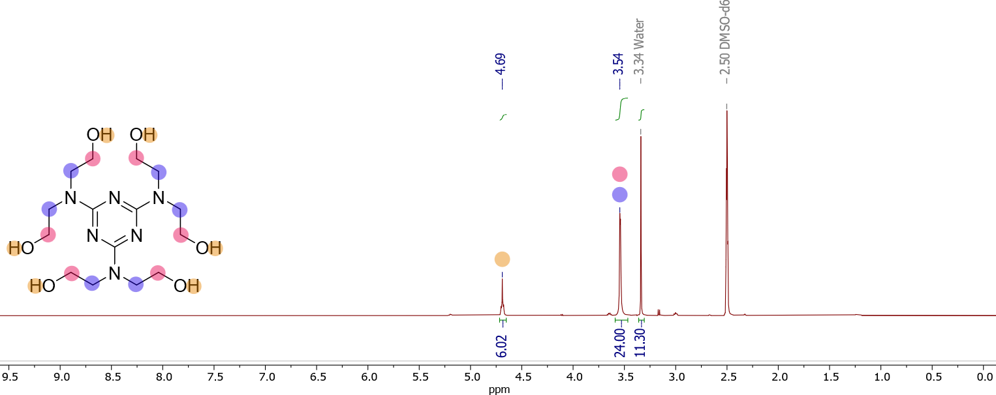
Figure S2: ¹H-NMR spectrum of (diethanolamine)₃triazine in DMSO-d6.

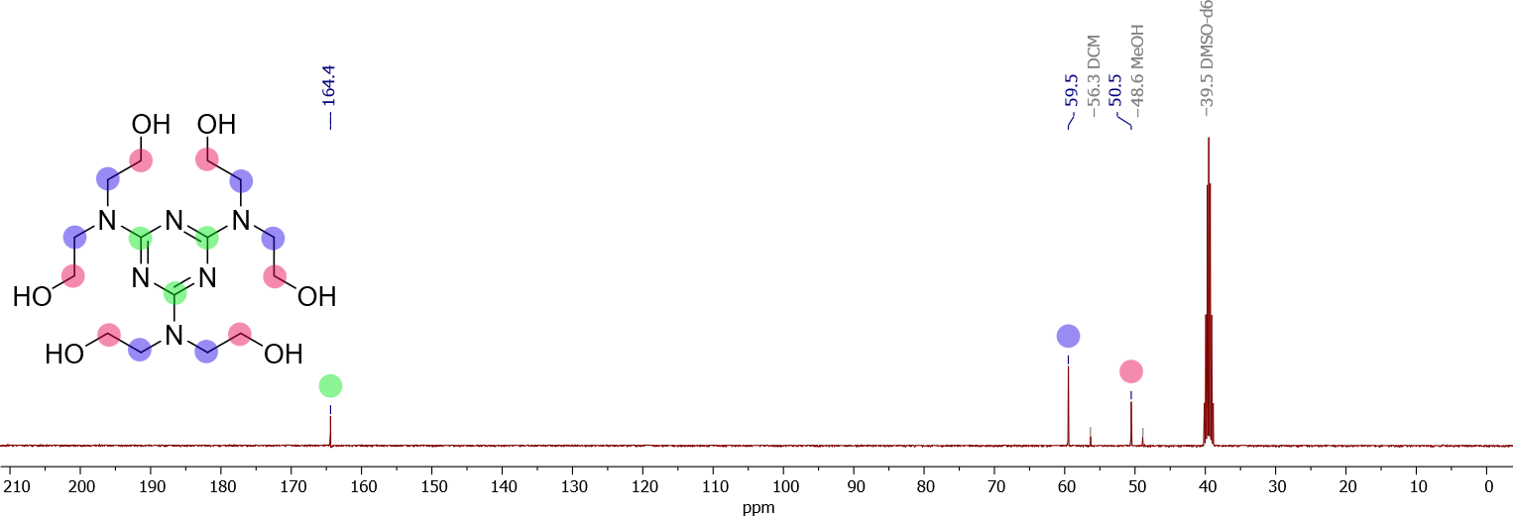
Figure S3: ¹³C-NMR spectrum of (diethanolamine)₃triazine in DMSO-d6.
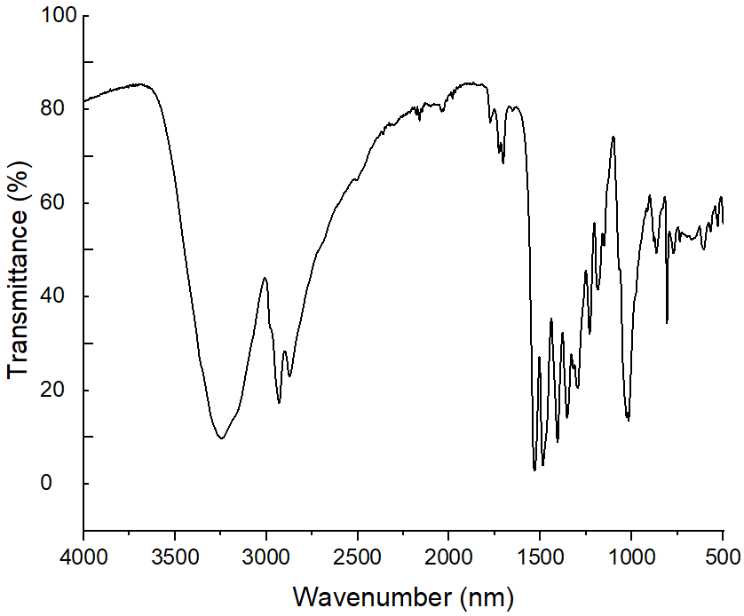
Figure S4: ATR-IR spectrum of (diethanolamine)₃triazine.

6. Biocompatible capture agents uphold microbiome stability by controlling microbial carryover
Fig. S5 compares the rationally designed capture agent (diethanolamine)₃triazine with melamine and monoethanolamine (1). The superior performance of the new agent supports a hydraulic retention time of 38.6 h−well above the microbial doubling time (~5 h under ideal conditions). This ensures stable retention of the methanogenic biocatalyst within the anaerobic bioreactor and prevents its unintended carryover into the O₂-rich absorber.
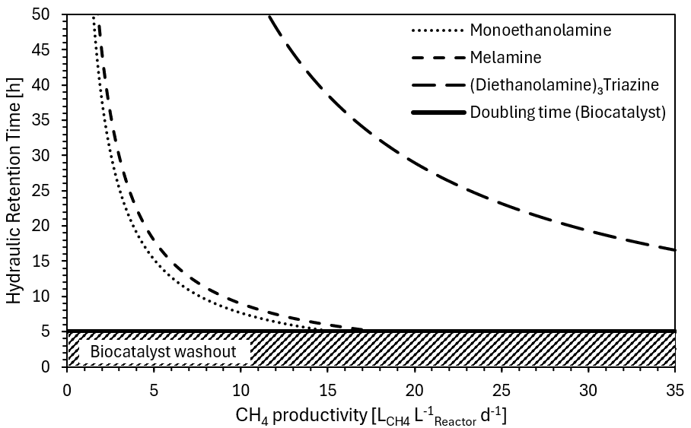
Figure S5: Improved biocompatibility and CO₂ loading capacity, enabling longer hydraulic retention times and stable retention of the methanogenic biocatalyst in the BICCU process.

7. References
1. Henry, I. A., Kowarz, V. & Østgaard, K. Aerobic and anoxic biodegradability of amines applied in CO2-capture. International Journal of Greenhouse Gas Control 58, 266–275 (2017).
2. Perry, D. D. Dissociation Constants of Organic Bases in Aqueous Solution. (Butterworth & Co Publishers Ltd, 1965).
3. Schwabe, K., Graichen, W. & Spiethoff, D. Physicochemical investigations on alkanolamines. Zeitschrift für Physikalische Chemie 20, 68–82 (1959).
4. Weast, R. C. Handbook of Chemistry and Physics. (1985).
5. Biggs, A. I. & Robinson, R. A. The ionisation constants of some substituted anilines and phenols: a test of the Hammett relation. J. Chem. Soc. 388–393 (1961).
6. Samuel, G. & Schram, A. F. The Basic Dissociation Constants of Some Aliphatic Hydroxyamines. J. Am. Chem. Soc. 69, 1213–1214 (1947).
7. Somerville, W. C. An investigation of the degrees of hydration of the alkyl amines in aqueous solution. J. Phys. Chem. 35, 2412–2433 (1931).
8. Douhéret, G. & Pariaud, J.-C. N° 125. — Ionisation et structure d’amino-éthanols N-substitués. Journal de Chimie Physique 59, 1013–1020 (1962).
9. Chremos, G. & Zimmerman Jr, H. K. Aminoalcohols as buffering agents. II. Protolysis equilibria of diethanolamine. Texas Journal of Science 59, 467–470 (1959).
10. Williams, R. pKa data compiled by R. Williams [Dataset]. Organic Chemistry Data https://organicchemistrydata.org/hansreich/resources/pka/pka_data/pka-compilation-williams.pdf (2022).
11. Chremos, G. N., Zimmerman, H. K., Cantrell, W., Meyer, R. B. & Zaetsch, E. H. Protolysis Equilibria of N-Substituted Diethanolamines. Zeitschrift für Physikalische Chemie 35, 129–132 (1962).
12. John, F. & Waldron, H. A. Patty’s Industrial Hygiene and Toxicology 4th Revised Edition. Volume II, Part D. (John Wiley, New York, 1994). doi:https://doi.org/10.1016/0003-4878(95)90005-5.
13. Everett, D. H. & Pinsent, B. W. R. The dissociation constants of ethylene diammonium and hexamethylene diammonium ions from 0° to 60° C. Proceedings of the Royal Society of London. A. Mathematical and Physical Sciences 215, 416–429 (1952).
14. Rometsch, R., Marxer, A. & Miescher, K. Dissoziationsregeln bei Polyaminen. Dissoziation und Quaternisierbarkeit. Helv. Chim. Acta 34, 1611–1618 (1951).
15. Rorabacher, D. B., Turan, T. S., Defever, J. A. & Nickels, W. G. Steric effects in chelation kinetics. Formation and dissociation of nickel(II) complexes with branched poly(amino alcohols) related to ethylenediaminetetraacetic acid. Inorg. Chem. 8, 1498–1506 (1969).
16. Hall, N. F. THE STRENGTH OF ORGANIC BASES IN GLACIAL ACETIC ACID SOLUTION1. J. Am. Chem. Soc. 52, 5115–5128 (1930).
17. Khalili, F., Henni, A. & East, A. L. L. pKa Values of Some Piperazines at (298, 303, 313, and 323) K. J. Chem. Eng. Data 54, 2914–2917 (2009).
18. Gaulton, A. et al. ChEMBL: a large-scale bioactivity database for drug discovery. Nucleic Acids Res. 40, D1100–D1107 (2012).

