Appendix

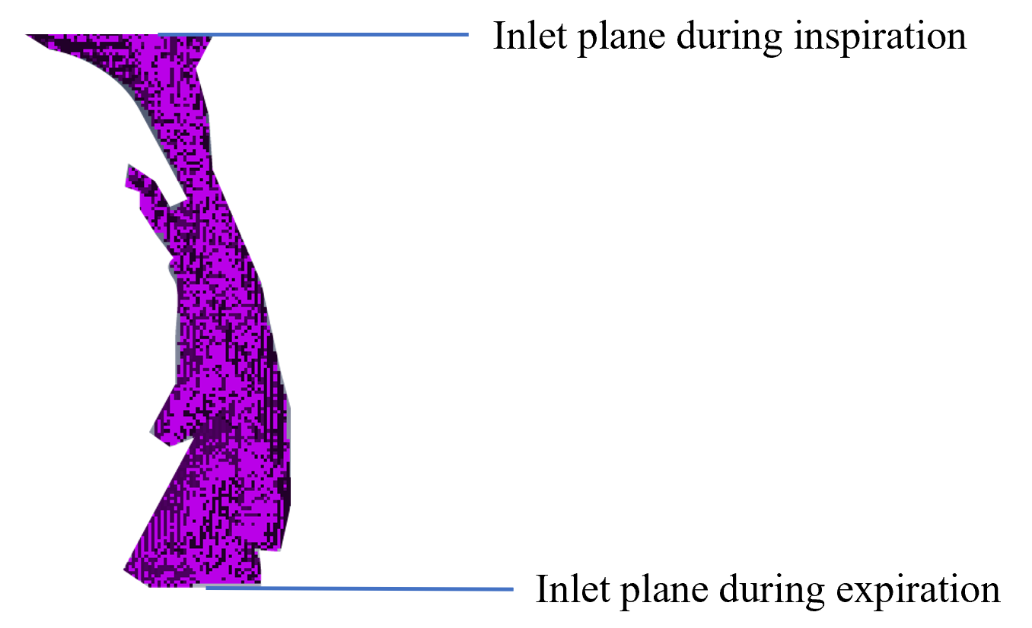
A
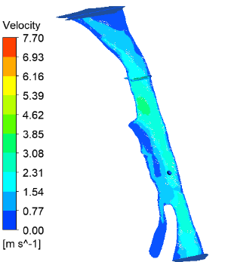
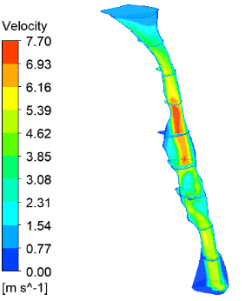
B C

Fig. 1S. The aerodynamic analysis of the upper airway. A. The upper airway model used for CFD analysis. B. Contours of velocity (m/s) at mid-sagittal plane of an OSA patient at baseline during inspiration. C. Contours of velocity (m/s) and at mid-sagittal plane of an OSA patient with iMAD in situ during inspiration.

