Supplementary materials for
Spatiotemporal and progression heterogeneity of Parkinson’s disease leveraging multimodal data
Zhining Li^{1, *}, Pei Lu^{2, *}, Hongyu Bi², Yumeng Liu², Dixia Cong¹, Can Li¹, Aiping Gong¹, Hua Yang¹, Liangqun Rong^{1, #}, Lishun Xiao^{1, #}
1 Department of Neurology, The Second Affiliated Hospital of Xuzhou Medical University, Xuzhou, Jiangsu, 221006, China
2 School of Public Health, Xuzhou Medical University, Xuzhou, Jiangsu, 221004, China

* These authors have contributed equally to this work and share first authorship.
# Corresponding authors: No. 209 Tongshan Road, Xuzhou Medical University, Xuzhou, Jiangsu Province, 221004, China (Lishun Xiao, E-mail: xiaolishun@xzhmu.edu.cn); No. 32 Meijian Road, Xuzhou, Jiangsu Province, 221006, China (Liangqun Rong; E-mail: zningdoctor@126.com).

- Supplementary methods
  - Specific parameters for image scanning
The oblique axial (OAx) T1-weighted images were acquired using a spin-echo based sequence with the following parameters: repetition time (TR) = 1750 ms, echo time (TE) = 24 ms, inversion time = 750 ms, and echo train length = 10. An echo spacing of 9.5 ms and a single echo per excitation were used. Spatial encoding was performed with a frequency encoding field of view (FOV) of 24.0 cm and a phase encoding FOV factor of 1.00, yielding an in-plane pixel size of 0.8 mm × 1.2 mm. Images were obtained with a slice thickness of 5.0 mm and an inter-slice gap of 1.5 mm, covering a total of 18 slices positioned obliquely between the start coordinates (right 8.4 mm, posterior 27.0 mm, inferior 54.3 mm) and end coordinates (right 11.6 mm, posterior 39.7 mm, superior 55.4 mm). The acquisition was performed twice to enhance signal averaging, providing a relative signal-to-noise ratio (SNR) of 100%. Additional settings included a receiver bandwidth of 31.25 kHz, corresponding to 195.3 Hz/pixel, and an auto-refocus flip angle of 111°. Intensity correction (SCIC) and automatic shimming were applied to ensure image uniformity, while fat shift was directed anteriorly. Specific absorption rates were recorded as 0.50 W/kg (whole-body) and 2.05 W/kg (head), with a transverse B₁⁺ RMS of 2.04 μT. Other relevant configurations included intensity filter A, preset RF drive mode, and phase correction turned off.
  - Specific steps for image preprocessing
The pipeline proceeded with intensity normalization, tessellation of the grey/white matter boundary, automated topological correction, and surface deformation. This deformation step is guided by intensity gradients to optimally position the grey/white and grey/cerebrospinal fluid (CSF) borders at locations of maximum intensity shift. Once the initial cortical models were generated, deformable procedures were employed, including surface inflation and registration to a spherical atlas, which utilizes individual cortical folding patterns to ensure accurate anatomical correspondence across subjects. This process enabled the parcellation of the cerebral cortex into distinct gyral- and sulcal-based anatomical regions of interest (ROIs).
Cortical thickness was then calculated at each vertex on the tessellated surface as the shortest distance between the grey/white matter boundary and the grey/CSF (pial) surface. Crucially, this calculation is based on spatial intensity gradients across tissue classes, making it robust to variations in absolute signal intensity. From the completed FreeSurfer output, we extracted the primary neuroanatomical metrics for our analysis: the average cortical thickness for each predefined cortical ROI and the volumes for each segmented subcortical structure.
  - Principle and implementation details of SuStaIn
The Subtype and Stage Inference (SuStaIn) algorithm reconstructs pseudo-longitudinal trajectories from cross-sectional data by modeling the accumulation of pathology as a distinct sequence of events. The method leverages the observation that if one biomarker becomes abnormal earlier than another, a subset of patients will exhibit abnormalities only in the former. We utilized the piecewise linear z-score SuStaIn implementation, which defines disease progression not as a binary switch, but as a continuous evolution where biomarkers cross specific severity thresholds. Each participant is probabilistically assigned to a subtype and a continuous disease stage based on the maximum likelihood fit of their biomarker profile¹. Individuals with no significant abnormalities (all z-scores < 1) are classified as stage 0.
To capture the granular progression of pathology, each biomarker’s abnormality was modeled using three z-score thresholds (Z = 1, 2, 3) ²representing mild, moderate, and severe deviations, respectively. A maximum z-score cap of 5 was applied to limit the influence of extreme outliers.
The algorithm was initialized using a multi-start strategy with 10 independent random starting points for the Expectation-Maximization (EM) procedure to mitigate local minima convergence. The optimal number of subtypes was determined data-drivenly by fitting models with increasing cluster numbers (k=1 to 5) and selecting the solution with the lowest Cross-Validation Information Criterion (CVIC). This selection process employed a 10-fold stratified cross-validation procedure ^{3,4} to balance model fit with complexity parsimony.
Uncertainty in subtype identification and event ordering was rigorously quantified using Markov Chain Monte Carlo (MCMC) sampling. We performed 1,000 iterations per chain, incorporating a 500-iteration burn-in period and a thinning factor of 10 to ensure sample independence. Convergence was assessed using Gelman-Rubin R-hat statistics (<1.1), effective sample size calculations (>100), and trace plot visualization.

- Supplementary tables and figures
Table S1 Candidate multimodal indicators in healthy controls and patients with Parkinson’s disease in the training set
Indicators | HC (n=40) | PD (n=107) | $$t/χ^{2}/U$$ | Missing rate | P | P for r | Included
Gender (male) | 19 (47.5) | 60 (56.1) | 0.55 | 0.00 | 0.458
Age | 62.00 [55.00, 70.25] | 70.00 [64.00, 75.00] | 1347.00 | 0.00 | 0.001
Height (cm) | 164.40 ± 7.92 | 164.55 ± 7.35 | -0.11 | 0.00 | 0.917
Thigh length (cm) | 47.00 [43.50, 49.00] | 43.00 [40.00, 46.00] | 2842.50 | 0.00 | 0.004
Calf length (cm) | 45.00 [42.75, 48.00] | 43.00 [41.00, 45.00] | 2700.50 | 0.00 | 0.067
eTIV | 1284747.45 [1214595.72, 1408208.08] | 1335937.12 [1202481.04, 1450566.09] | 1949.00 | 0.00 | 0.089
Straight walking-duration (2nd) (s) | 3.48 [2.94, 4.38] | 4.43 [3.21, 6.09] | 1352.00 | 0.03 | 0.003 | 0.037 | TRUE
Turning 180°-duration (s) | 1.87 [1.60, 2.22] | 3.01 [2.19, 4.30] | 686.00 | 0.03 | <0.001 | 0.032 | TRUE
Walking step length (cm) | 52.87 [43.48, 56.86] | 40.97 [30.13, 49.65] | 2846.00 | 0.03 | <0.001 | 0.003 | TRUE
Walking gait speed (m/s) | 0.85 ± 0.22 | 0.67 ± 0.25 | 3.93 | 0.03 | <0.001 | 0.031 | TRUE
FOG-longest duration (s) | 0.22 ± 1.39 | 1.74 ± 4.68 | 1755.50 | 0.00 | 0.008 | 0.001 | TRUE
Turning left 360°-duration (s) | 10.41 [8.16, 14.46] | 14.35 [11.04, 22.43] | 1318.00 | 0.00 | <0.001 | 0.003 | TRUE
Straight walking-step length (cm) | 51.32 [41.43, 56.12] | 39.72 [28.13, 50.45] | 2889.50 | 0.01 | <0.001 | 0.003 | TRUE
Straight walking-gait speed (m/s) | 0.75 ± 0.24 | 0.63 ± 0.25 | 2.56 | 0.01 | 0.011 | 0.012 | TRUE
Chair stand-total duration (s) | 4.79 [2.67, 14.16] | 18.48 [14.51, 22.93] | 705.50 | 0.05 | <0.001 | 0.035 | TRUE
Chair stand-mean duration (s) | 2.91 [2.49, 3.82] | 3.85 [2.90, 4.66] | 1288.50 | 0.05 | 0.005 | 0.019 | TRUE
SiSt-duration (s) | 1.08 [0.95, 1.24] | 1.37 [1.10, 1.66] | 1059.50 | 0.05 | <0.001 | 0.011 | TRUE
MMSE | 28.00 [26.50, 29.00] | 22.00 [19.00, 25.50] | 3643.00 | 0.01 | <0.001 | 0.005 | TRUE
Left cerebellum white matter | 14087.35 [12085.17, 15402.80] | 14100.90 [12798.10, 16202.70] | 2051.00 | 0.00 | 0.003 | 0.013 | TRUE
Brain stem | 19044.45 [17968.68, 20625.08] | 19676.10 [17807.95, 21370.15] | 2053.00 | 0.00 | 0.001 | 0.046 | TRUE
Right vessel | 7.70 [0.00, 15.05] | 0.00 [0.00, 12.70] | 2478.50 | 0.00 | 0.040 | 0.001 | TRUE
Right subparietal thickness | 2.67 [2.44, 3.01] | 2.66 [2.40, 2.88] | 2246.00 | 0.00 | 0.049 | 0.034 | TRUE
SiSt-mean duration (s) | 1.46 [1.08, 1.94] | 1.99 [1.54, 2.74] | 1207.50 | 0.02 | <0.001 | 0.182 | FALSE
Straight walking duration (1st) (s) | 4.35 [3.66, 5.57] | 5.57 [4.17, 8.18] | 1311.50 | 0.03 | <0.001 | 0.230 | FALSE
180°-duration(1st) (s) | 2.15 [1.83, 2.79] | 2.87 [2.22, 4.08] | 1142.50 | 0.03 | 0.008 | 0.126 | FALSE
Stsi-duration (s) | 1.90 [1.23, 2.44] | 2.24 [1.70, 3.07] | 1510.00 | 0.04 | 0.025 | 0.942 | FALSE
Walking step length (SD) (cm) | 3.58 [2.32, 4.74] | 3.13 [2.17, 4.47] | 2247.00 | 0.03 | 0.396 | 0.098 | FALSE
Walking-trunk right sway maximum (°) | 5.42 [2.90, 7.47] | 6.23 [2.67, 9.14] | 1907.00 | 0.03 | 0.677 | 0.097 | FALSE
Walking-trunk left sway maximum (°) | -0.16 ± 3.80 | 1.05 ± 4.99 | -1.38 | 0.03 | 0.123 | 0.111 | FALSE
Walking-trunk lean backward maximum (°) | -14.42 [-19.92, -5.97] | -21.12 [-27.49, -15.34] | 2874.00 | 0.03 | <0.001 | 0.761 | FALSE
Walking-trunk lean forward maximum (°) | -19.37 [-24.39, -11.20] | -25.46 [-32.28, -19.28] | 2844.00 | 0.03 | <0.001 | 0.790 | FALSE
Turning right duration | 8.54 [7.41, 11.78] | 13.09 [9.19, 21.85] | 1371.50 | 0.00 | 0.002 | 0.161 | FALSE
Walk duration (s) | 5.97 [5.15, 6.71] | 6.43 [5.18, 9.46] | 1656.00 | 0.01 | <0.001 | 0.194 | FALSE
Straight walking-step length (SD)(cm) | 4.04 [2.65, 5.79] | 4.04 [2.70, 5.40] | 2203.50 | 0.01 | 0.331 | 0.732 | FALSE
Straight walking-trunk right sway maximum (°) | 6.45 ± 5.10 | 5.22 ± 5.53 | 1.22 | 0.01 | 0.208 | 0.007 | FALSE
Straight walking-trunk left sway maximum (°) | 1.36 ± 4.73 | 0.96 ± 5.33 | 0.41 | 0.01 | 0.663 | 0.005 | FALSE
Straight walking-trunk backward lean maximum (°) | -11.71 ± 10.34 | -21.71 ± 10.92 | 5.00 | 0.01 | <0.001 | 0.442 | FALSE
Straight walking-trunk forward lean maximum (°) | -16.55 ± 10.25 | -25.92 ± 10.71 | 4.77 | 0.01 | <0.001 | 0.504 | FALSE
Straight walking-trunk sway maximum (°) | 4.90 [4.16, 5.89] | 4.09 [3.39, 4.80] | 2859.50 | 0.01 | 0.006 | 0.759 | FALSE
Standing (EO)-duration (s) | 10.72 [10.59, 10.82] | 10.61 [10.56, 10.68] | 2957.50 | 0.01 | 0.053 | 0.177 | FALSE
Standing (EO)-trunk sway maximum (°) | 2.86 [1.80, 5.18] | 2.60 [1.76, 3.34] | 2403.00 | 0.01 | 0.164 | 0.272 | FALSE
Standing (EC)-duration (s) | 10.61 [10.56, 10.66] | 10.62 [10.56, 10.68] | 2053.00 | 0.01 | 0.457 | 0.973 | FALSE
Standing (EC)-trunk sway maximum (°) | 2.42 [1.81, 3.22] | 2.37 [1.71, 3.21] | 2168.00 | 0.01 | 0.299 | 0.063 | FALSE
Times for chair stand (n) | 1.00 [1.00, 5.00] | 5.00 [5.00, 5.00] | 765.00 | 0.05 | <0.001 | 0.515 | FALSE
Left lateral ventricle | 9438.85 [7588.93, 16205.65] | 13463.60 [8454.75, 20863.95] | 1712.00 | 0.00 | 0.145 | 0.728 | FALSE
Left-inf-lat-vent | 293.00 [158.65, 563.95] | 355.90 [176.00, 1028.95] | 1949.50 | 0.00 | 0.179 | 0.446 | FALSE
Left cerebellum cortex | 43294.15 [39729.30, 45829.75] | 42909.60 [38077.90, 46801.10] | 2287.00 | 0.00 | 0.145 | 0.458 | FALSE
Left-thalamus | 6709.85 [6170.90, 7003.90] | 6422.50 [5714.95, 7063.85] | 2380.00 | 0.00 | 0.555 | 0.632 | FALSE
Left-caudate | 3250.35 [2967.20, 3686.88] | 3128.60 [2652.50, 3546.25] | 2513.50 | 0.00 | 0.053 | 0.213 | FALSE
Left-putamen | 4103.80 [3558.88, 4438.05] | 3674.10 [3300.70, 4310.80] | 2614.00 | 0.00 | 0.029 | 0.765 | FALSE
Left-pallidum | 1725.00 [1537.75, 1887.80] | 1551.50 [1394.50, 1772.10] | 2747.00 | 0.00 | 0.004 | 0.496 | FALSE
3rd-ventricle | 1287.55 [993.67, 1653.12] | 1615.10 [1195.65, 2077.85] | 1644.00 | 0.00 | 0.090 | 0.101 | FALSE
4th-ventricle | 1768.75 [1491.62, 2267.57] | 1692.80 [1425.15, 2140.40] | 2318.50 | 0.00 | 0.344 | 0.240 | FALSE
Left-hippocampus | 3826.15 [3533.80, 4034.30] | 3802.80 [3253.10, 4243.90] | 2166.50 | 0.00 | 0.566 | 0.242 | FALSE
Left-amygdala | 1435.25 [1330.72, 1642.33] | 1457.70 [1215.35, 1583.25] | 2354.00 | 0.00 | 0.227 | 0.094 | FALSE
CSF | 1198.50 [985.58, 1692.53] | 1558.90 [1309.00, 2060.40] | 1455.00 | 0.00 | 0.039 | 0.836 | FALSE
Left-accumbens-area | 237.95 [206.65, 290.85] | 257.60 [215.30, 303.95] | 1947.00 | 0.00 | 0.839 | 0.420 | FALSE
Left-ventralDC | 4061.60 [3675.67, 4324.75] | 4160.90 [3757.80, 4635.15] | 1900.00 | 0.00 | 0.745 | 0.110 | FALSE
Left-vessel | 0.00 [0.00, 18.05] | 0.00 [0.00, 18.90] | 2164.50 | 0.00 | 0.105 | 0.181 | FALSE
Left-choroid-plexus | 658.65 [536.05, 1136.55] | 996.60 [647.55, 1419.80] | 1593.00 | 0.00 | 0.017 | 0.895 | FALSE
Right-lateral-ventricle | 9077.85 [6121.95, 14452.55] | 11779.40 [7732.45, 18057.15] | 1706.00 | 0.00 | 0.155 | 0.715 | FALSE
Right-inf-lat-vent | 363.90 [303.48, 653.08] | 449.80 [247.10, 904.45] | 1981.50 | 0.00 | 0.637 | 0.513 | FALSE
Right cerebellum white matter | 13519.55 [12643.53, 16711.85] | 14034.60 [12155.00, 16726.20] | 2117.00 | 0.00 | 0.676 | 0.487 | FALSE
Right cerebellum cortex | 41052.10 [38804.32, 45263.85] | 42399.30 [37721.40, 46239.85] | 2229.00 | 0.00 | 0.277 | 0.879 | FALSE
Right-thalamus | 6456.65 [5837.28, 6925.85] | 6096.40 [5427.45, 6759.40] | 2438.00 | 0.00 | 0.492 | 0.857 | FALSE
Right-caudate | 3369.55 [3044.43, 3750.55] | 3155.70 [2677.70, 3738.90] | 2450.00 | 0.00 | 0.098 | 0.584 | FALSE
Right-putamen | 4004.10 [3595.45, 4699.88] | 3756.40 [3306.80, 4203.85] | 2631.00 | 0.00 | 0.005 | 0.738 | FALSE
Right-pallidum | 1652.50 [1450.70, 1847.60] | 1553.00 [1369.00, 1737.40] | 2599.50 | 0.00 | 0.026 | 0.800 | FALSE
Right-hippocampus | 4187.50 [3875.70, 4607.75] | 4047.70 [3614.25, 4471.20] | 2467.00 | 0.00 | 0.045 | 0.231 | FALSE
Right-amygdala | 1587.80 [1370.57, 1797.93] | 1563.90 [1327.35, 1755.55] | 2327.00 | 0.00 | 0.105 | 0.101 | FALSE
Right-accumbens-area | 351.95 [293.98, 441.85] | 344.20 [269.25, 405.90] | 2427.00 | 0.00 | 0.190 | 0.442 | FALSE
Right-ventralDC | 4051.20 [3790.45, 4550.68] | 4091.10 [3766.05, 4529.35] | 2131.00 | 0.00 | 0.666 | 0.505 | FALSE
Right-choroid-plexus | 727.25 [564.88, 1262.62] | 1040.90 [666.95, 1426.50] | 1722.50 | 0.00 | 0.107 | 0.505 | FALSE
5th-ventricle | 0.00 [0.00, 0.00] | 0.00 [0.00, 0.00] | 2135.00 | 0.00 | 0.595 | 0.271 | FALSE
WM-hypointensities | 7556.05 [4874.50, 10686.93] | 9840.60 [7046.20, 13197.30] | 1526.00 | 0.00 | 0.005 | 0.442 | FALSE
Left-WM-hypointensities | 0.00 ± 0.00 | 0.00 ± 0.00 |  | 0.00 |  |  | FALSE
Right-WM-hypointensities | 0.00 ± 0.00 | 0.00 ± 0.00 |  | 0.00 |  |  | FALSE
non-WM-hypointensities | 0.00 [0.00, 0.00] | 0.00 [0.00, 1.00] | 1636.00 | 0.00 | 0.132 | 0.859 | FALSE
Left-non-WM-hypointensities | 0.00 ± 0.00 | 0.00 ± 0.00 |  | 0.00 |  |  | FALSE
Right-non-WM-hypointensities | 0.00 ± 0.00 | 0.00 ± 0.00 |  | 0.00 |  |  | FALSE
Optic-Chiasm | 121.05 [81.97, 176.35] | 114.50 [75.85, 184.80] | 2199.50 | 0.00 | 0.833 | 0.762 | FALSE
CC_Posterior | 963.55 [846.35, 1091.03] | 970.30 [820.50, 1085.45] | 2157.50 | 0.00 | 0.392 | 0.255 | FALSE
CC_Mid_Posterior | 644.55 [537.98, 736.88] | 664.80 [563.35, 785.20] | 1998.50 | 0.00 | 0.976 | 0.604 | FALSE
CC_Central | 723.40 [571.12, 857.48] | 601.40 [525.50, 773.45] | 2559.00 | 0.00 | 0.055 | 0.525 | FALSE
CC_Mid_Anterior | 610.25 [535.95, 732.40] | 600.40 [472.90, 693.10] | 2320.50 | 0.00 | 0.182 | 0.781 | FALSE
CC_Anterior | 817.95 [704.02, 949.80] | 857.40 [706.35, 955.50] | 2060.00 | 0.00 | 0.414 | 0.167 | FALSE
BrainSegVol | 1004069.50 [938702.00, 1066415.00] | 997032.00 [904057.00, 1077714.00] | 2332.00 | 0.00 | 0.124 | 0.448 | FALSE
BrainSegVolNotVent | 967523.50 [924668.50, 1032719.75] | 951330.00 [855537.50, 1034402.50] | 2425.00 | 0.00 | 0.064 | 0.509 | FALSE
lhCortexVol | 196121.93 [181064.21, 212302.35] | 180292.63 [162948.78, 196541.28] | 3049.00 | 0.00 | <0.001 | 0.911 | FALSE
rhCortexVol | 198774.05 [180582.62, 211549.92] | 178532.56 [161555.75, 196393.39] | 3031.00 | 0.00 | <0.001 | 0.819 | FALSE
CortexVol | 394632.04 [367163.46, 426723.02] | 360345.06 [324699.11, 393705.41] | 3059.00 | 0.00 | <0.001 | 0.839 | FALSE
lhCerebralWhiteMatterVol | 206545.25 [192010.88, 215483.50] | 205929.00 [185087.25, 239684.50] | 2044.00 | 0.00 | 0.702 | 0.383 | FALSE
rhCerebralWhiteMatterVol | 203884.00 [194247.88, 218795.00] | 209102.50 [187646.00, 239920.25] | 2061.00 | 0.00 | 0.939 | 0.388 | FALSE
CerebralWhiteMatterVol | 409799.00 [385771.25, 431307.50] | 414854.00 [373045.50, 480634.50] | 2047.00 | 0.00 | 0.817 | 0.371 | FALSE
SubCortGrayVol | 52566.50 [49624.50, 56174.50] | 51758.00 [47982.00, 55717.00] | 2358.00 | 0.00 | 0.090 | 0.558 | FALSE
TotalGrayVol | 540887.28 [493258.72, 572444.30] | 499509.16 [453663.23, 535579.92] | 2929.00 | 0.00 | <0.001 | 0.951 | FALSE
SupraTentorialVol | 886307.50 [831675.50, 941146.25] | 881938.00 [795524.00, 957179.50] | 2322.00 | 0.00 | 0.132 | 0.476 | FALSE
SupraTentorialVolNotVent | 850060.00 [817152.00, 907722.50] | 842443.00 [751582.50, 908717.50] | 2438.00 | 0.00 | 0.064 | 0.524 | FALSE
MaskVol | 1451513.50 [1387994.75, 1564704.75] | 1459658.00 [1299856.00, 1597927.50] | 2273.00 | 0.00 | 0.313 | 0.659 | FALSE
BrainSegVol-to-eTIV | 0.78 [0.74, 0.80] | 0.76 [0.73, 0.79] | 2584.00 | 0.00 | 0.002 | 0.197 | FALSE
MaskVol-to-eTIV | 1.12 [1.10, 1.17] | 1.12 [1.09, 1.14] | 2457.00 | 0.00 | 0.011 | 0.936 | FALSE
lhSurfaceHoles | 92.50 [71.50, 114.25] | 81.00 [67.00, 103.50] | 2353.50 | 0.00 | 0.556 | 0.606 | FALSE
rhSurfaceHoles | 94.00 [73.50, 111.00] | 80.00 [66.00, 98.50] | 2498.50 | 0.00 | 0.433 | 0.886 | FALSE
SurfaceHoles | 175.50 [144.75, 224.00] | 166.00 [138.50, 200.00] | 2448.50 | 0.00 | 0.482 | 0.719 | FALSE
lh_G_and_S_frontomargin_thickness | 3.23 [2.88, 3.50] | 3.21 [2.81, 3.51] | 2106.50 | 0.00 | 0.673 | 0.882 | FALSE
lh_G_and_S_occipital_inf_thickness | 2.59 [2.45, 2.86] | 2.54 [2.31, 2.72] | 2474.00 | 0.00 | 0.241 | 0.463 | FALSE
lh_G_and_S_paracentral_thickness | 2.30 [2.17, 2.37] | 2.14 [1.91, 2.27] | 3055.50 | 0.00 | <0.001 | 0.600 | FALSE
lh_G_and_S_subcentral_thickness | 2.40 [2.31, 2.54] | 2.27 [2.09, 2.42] | 2865.50 | 0.00 | 0.012 | 0.775 | FALSE
lh_G_and_S_transv_frontopol_thickness | 3.15 ± 0.47 | 3.15 ± 0.49 | -0.09 | 0.00 | 0.924 | 0.878 | FALSE
lh_G_and_S_cingul-Ant_thickness | 3.09 [2.78, 3.29] | 3.10 [2.89, 3.28] | 2004.50 | 0.00 | 0.734 | 0.058 | FALSE
lh_G_and_S_cingul-Mid-Ant_thickness | 3.00 [2.58, 3.27] | 2.93 [2.63, 3.18] | 2272.50 | 0.00 | 0.314 | 0.886 | FALSE
lh_G_and_S_cingul-Mid-Post_thickness | 2.54 [2.40, 2.65] | 2.46 [2.32, 2.70] | 2468.50 | 0.00 | 0.064 | 0.156 | FALSE
lh_G_cingul-Post-dorsal_thickness | 2.91 [2.80, 3.10] | 2.82 [2.58, 3.15] | 2547.00 | 0.00 | 0.006 | 0.256 | FALSE
lh_G_cingul-Post-ventral_thickness | 2.48 [2.34, 2.67] | 2.50 [2.25, 2.70] | 2143.00 | 0.00 | 0.647 | 0.221 | FALSE
lh_G_cuneus_thickness | 2.12 ± 0.23 | 2.03 ± 0.24 | 2.01 | 0.00 | 0.046 | 0.166 | FALSE
lh_G_front_inf-Opercular_thickness | 2.53 [2.39, 2.65] | 2.46 [2.31, 2.56] | 2636.50 | 0.00 | 0.020 | 0.943 | FALSE
lh_G_front_inf-Orbital_thickness | 2.98 ± 0.33 | 2.99 ± 0.40 | -0.16 | 0.00 | 0.865 | 0.759 | FALSE
lh_G_front_inf-Triangul_thickness | 2.67 [2.49, 2.98] | 2.65 [2.41, 2.82] | 2523.00 | 0.00 | 0.032 | 0.295 | FALSE
lh_G_front_middle_thickness | 2.65 ± 0.23 | 2.55 ± 0.29 | 2.01 | 0.00 | 0.029 | 0.284 | FALSE
lh_G_front_sup_thickness | 2.91 [2.77, 3.01] | 2.75 [2.60, 2.92] | 2898.00 | 0.00 | <0.001 | 0.308 | FALSE
lh_G_Ins_lg_and_S_cent_ins_thickness | 2.81 ± 0.29 | 2.64 ± 0.45 | 2.56 | 0.00 | 0.012 | 0.905 | FALSE
lh_G_insular_short_thickness | 3.28 [3.15, 3.53] | 3.31 [3.02, 3.55] | 2250.00 | 0.00 | 0.142 | 0.092 | FALSE
lh_G_occipital_middle_thickness | 2.48 [2.32, 2.69] | 2.56 [2.31, 2.79] | 2123.50 | 0.00 | 0.713 | 0.753 | FALSE
lh_G_occipital_sup_thickness | 2.07 ± 0.32 | 1.99 ± 0.30 | 1.38 | 0.00 | 0.183 | 0.778 | FALSE
lh_G_oc-temp_lat-fusifor_thickness | 2.67 [2.46, 2.75] | 2.53 [2.26, 2.68] | 2768.50 | 0.00 | 0.004 | 0.268 | FALSE
lh_G_oc-temp_med-Lingual_thickness | 2.15 [2.05, 2.34] | 2.19 [2.04, 2.30] | 2101.50 | 0.00 | 0.976 | 0.540 | FALSE
lh_G_oc-temp_med-Parahip_thickness | 2.65 ± 0.23 | 2.43 ± 0.24 | 4.95 | 0.00 | <0.001 | 0.348 | FALSE
lh_G_orbital_thickness | 2.83 [2.69, 2.95] | 2.81 [2.68, 2.95] | 2137.50 | 0.00 | 0.662 | 0.257 | FALSE
lh_G_pariet_inf-Angular_thickness | 2.45 [2.32, 2.63] | 2.37 [2.16, 2.54] | 2545.00 | 0.00 | 0.241 | 0.369 | FALSE
lh_G_pariet_inf-Supramar_thickness | 2.46 [2.31, 2.56] | 2.33 [2.18, 2.44] | 2893.00 | 0.00 | <0.001 | 0.245 | FALSE
lh_G_parietal_sup_thickness | 2.29 [2.23, 2.36] | 2.18 [2.01, 2.35] | 2762.00 | 0.00 | 0.004 | 0.245 | FALSE
lh_G_postcentral_thickness | 2.05 ± 0.20 | 1.91 ± 0.31 | 3.25 | 0.00 | 0.002 | 0.793 | FALSE
lh_G_precentral_thickness | 2.52 ± 0.25 | 2.21 ± 0.34 | 5.25 | 0.00 | <0.001 | 0.792 | FALSE
lh_G_precuneus_thickness | 2.55 [2.48, 2.68] | 2.46 [2.32, 2.62] | 2723.00 | 0.00 | 0.003 | 0.789 | FALSE
lh_G_rectus_thickness | 2.85 ± 0.34 | 2.81 ± 0.37 | 0.60 | 0.00 | 0.534 | 0.640 | FALSE
lh_G_subcallosal_thickness | 2.34 [2.20, 2.48] | 2.33 [2.12, 2.48] | 2324.50 | 0.00 | 0.149 | 0.393 | FALSE
lh_G_temp_sup-G_T_transv_thickness | 2.28 [2.12, 2.48] | 2.33 [2.08, 2.46] | 2146.50 | 0.00 | 0.991 | 0.741 | FALSE
lh_G_temp_sup-Lateral_thickness | 2.82 ± 0.19 | 2.69 ± 0.28 | 3.32 | 0.00 | 0.001 | 0.623 | FALSE
lh_G_temp_sup-Plan_polar_thickness | 2.79 [2.52, 2.95] | 2.53 [2.32, 2.76] | 2955.00 | 0.00 | <0.001 | 0.919 | FALSE
lh_G_temp_sup-Plan_tempo_thickness | 2.42 [2.27, 2.53] | 2.29 [2.12, 2.42] | 2755.00 | 0.00 | 0.009 | 0.098 | FALSE
lh_G_temporal_inf_thickness | 2.91 [2.74, 3.03] | 2.82 [2.66, 2.98] | 2430.00 | 0.00 | 0.130 | 0.450 | FALSE
lh_G_temporal_middle_thickness | 3.00 [2.81, 3.12] | 2.90 [2.69, 3.09] | 2568.50 | 0.00 | 0.024 | 0.648 | FALSE
lh_Lat_Fis-ant-Horizont_thickness | 2.87 [2.38, 3.27] | 2.69 [2.45, 3.04] | 2250.00 | 0.00 | 0.487 | 0.398 | FALSE
lh_Lat_Fis-ant-Vertical_thickness | 2.20 [2.06, 2.35] | 2.19 [1.97, 2.34] | 2341.50 | 0.00 | 0.237 | 0.183 | FALSE
lh_Lat_Fis-post_thickness | 2.20 [2.07, 2.33] | 2.15 [1.94, 2.29] | 2476.00 | 0.00 | 0.130 | 0.963 | FALSE
lh_Pole_occipital_thickness | 2.13 ± 0.25 | 2.17 ± 0.29 | -0.82 | 0.00 | 0.379 | 0.556 | FALSE
lh_Pole_temporal_thickness | 3.30 [3.14, 3.49] | 3.27 [3.05, 3.48] | 2312.50 | 0.00 | 0.124 | 0.077 | FALSE
lh_S_calcarine_thickness | 2.07 [1.91, 2.21] | 2.05 [1.95, 2.21] | 2153.00 | 0.00 | 0.796 | 0.540 | FALSE
lh_S_central_thickness | 1.85 [1.78, 1.97] | 1.75 [1.63, 1.90] | 2858.50 | 0.00 | 0.003 | 0.655 | FALSE
lh_S_cingul-Marginalis_thickness | 2.26 [2.09, 2.36] | 2.16 [2.01, 2.30] | 2630.00 | 0.00 | 0.028 | 0.595 | FALSE
lh_S_circular_insula_ant_thickness | 2.80 [2.62, 2.98] | 2.71 [2.50, 2.92] | 2463.50 | 0.00 | 0.056 | 0.050 | FALSE
lh_S_circular_insula_inf_thickness | 2.32 [2.18, 2.55] | 2.16 [2.00, 2.36] | 2856.50 | 0.00 | 0.002 | 0.734 | FALSE
lh_S_circular_insula_sup_thickness | 2.39 [2.31, 2.49] | 2.41 [2.22, 2.55] | 2197.50 | 0.00 | 0.558 | 0.174 | FALSE
lh_S_collat_transv_ant_thickness | 2.30 [2.13, 2.45] | 2.30 [2.10, 2.47] | 2185.00 | 0.00 | 0.572 | 0.405 | FALSE
lh_S_collat_transv_post_thickness | 1.95 [1.73, 2.10] | 1.75 [1.56, 2.04] | 2704.00 | 0.00 | 0.030 | 0.835 | FALSE
lh_S_front_inf_thickness | 2.63 [2.31, 2.74] | 2.57 [2.34, 2.75] | 2097.00 | 0.00 | 0.856 | 0.314 | FALSE
lh_S_front_middle_thickness | 2.46 ± 0.36 | 2.45 ± 0.37 | 0.13 | 0.00 | 0.894 | 0.979 | FALSE
lh_S_front_sup_thickness | 2.34 [2.27, 2.44] | 2.28 [2.12, 2.40] | 2726.00 | 0.00 | 0.002 | 0.432 | FALSE
lh_S_interm_prim-Jensen_thickness | 2.23 [2.00, 2.55] | 2.20 [1.95, 2.66] | 2230.50 | 0.00 | 0.919 | 0.780 | FALSE
lh_S_intrapariet_and_P_trans_thickness | 2.21 [2.11, 2.34] | 2.19 [2.08, 2.31] | 2329.00 | 0.00 | 0.433 | 0.414 | FALSE
lh_S_oc_middle_and_Lunatus_thickness | 2.53 [2.19, 2.72] | 2.54 [2.23, 2.87] | 1887.50 | 0.00 | 0.213 | 0.961 | FALSE
lh_S_oc_sup_and_transversal_thickness | 2.17 [2.06, 2.37] | 2.16 [2.01, 2.36] | 2274.00 | 0.00 | 0.403 | 0.517 | FALSE
lh_S_occipital_ant_thickness | 2.55 [2.33, 2.65] | 2.64 [2.38, 3.01] | 1741.50 | 0.00 | 0.190 | 0.461 | FALSE
lh_S_oc-temp_lat_thickness | 2.43 [2.06, 2.60] | 2.33 [2.11, 2.60] | 2202.50 | 0.00 | 0.667 | 0.172 | FALSE
lh_S_oc-temp_med_and_Lingual_thickness | 2.15 [1.94, 2.26] | 2.04 [1.89, 2.18] | 2561.50 | 0.00 | 0.118 | 0.980 | FALSE
lh_S_orbital_lateral_thickness | 2.58 ± 0.55 | 2.65 ± 0.62 | -0.63 | 0.00 | 0.509 | 0.552 | FALSE
lh_S_orbital_med-olfact_thickness | 2.24 [2.15, 2.56] | 2.19 [2.00, 2.50] | 2572.50 | 0.00 | 0.041 | 0.865 | FALSE
lh_S_orbital-H_Shaped_thickness | 2.63 [2.40, 2.85] | 2.62 [2.45, 2.83] | 2164.00 | 0.00 | 0.721 | 0.566 | FALSE
lh_S_parieto_occipital_thickness | 2.13 [2.06, 2.23] | 2.06 [1.92, 2.15] | 2797.50 | 0.00 | 0.004 | 0.519 | FALSE
lh_S_pericallosal_thickness | 2.00 ± 0.25 | 1.94 ± 0.30 | 1.17 | 0.00 | 0.207 | 0.856 | FALSE
lh_S_postcentral_thickness | 2.07 [2.00, 2.16] | 2.06 [1.96, 2.16] | 2372.00 | 0.00 | 0.420 | 0.353 | FALSE
lh_S_precentral-inf-part_thickness | 2.49 [2.33, 2.57] | 2.39 [2.20, 2.59] | 2522.50 | 0.00 | 0.055 | 0.514 | FALSE
lh_S_precentral-sup-part_thickness | 2.25 [2.13, 2.37] | 2.07 [1.92, 2.23] | 2997.00 | 0.00 | <0.001 | 0.536 | FALSE
lh_S_suborbital_thickness | 3.49 [2.87, 3.96] | 3.62 [3.09, 3.89] | 1918.50 | 0.00 | 0.305 | 0.916 | FALSE
lh_S_subparietal_thickness | 2.55 [2.34, 2.75] | 2.58 [2.37, 2.88] | 1998.50 | 0.00 | 0.561 | 0.774 | FALSE
lh_S_temporal_inf_thickness | 2.93 [2.57, 3.14] | 2.88 [2.55, 3.15] | 2214.50 | 0.00 | 0.593 | 0.949 | FALSE
lh_S_temporal_sup_thickness | 2.53 [2.38, 2.63] | 2.48 [2.33, 2.61] | 2430.50 | 0.00 | 0.192 | 0.237 | FALSE
lh_S_temporal_transverse_thickness | 2.15 [1.85, 2.43] | 2.02 [1.79, 2.22] | 2509.00 | 0.00 | 0.173 | 0.948 | FALSE
lh_MeanThickness_thickness | 2.50 [2.39, 2.59] | 2.42 [2.32, 2.52] | 2693.00 | 0.00 | 0.003 | 0.272 | FALSE
BrainSegVolNotVent.1 | 967523.50 [924668.50, 1032719.75] | 951330.00 [855537.50, 1034402.50] | 2426.00 | 0.00 | 0.055 | 0.532 | FALSE
rh_G_and_S_frontomargin_thickness | 3.21 [2.93, 3.53] | 3.25 [2.96, 3.57] | 1983.50 | 0.00 | 0.535 | 0.489 | FALSE
rh_G_and_S_occipital_inf_thickness | 2.57 [2.37, 2.82] | 2.65 [2.40, 3.00] | 1956.00 | 0.00 | 0.553 | 0.656 | FALSE
rh_G_and_S_paracentral_thickness | 2.20 ± 0.19 | 2.05 ± 0.32 | 3.54 | 0.00 | 0.001 | 0.686 | FALSE
rh_G_and_S_subcentral_thickness | 2.36 [2.26, 2.46] | 2.31 [2.12, 2.47] | 2434.50 | 0.00 | 0.128 | 0.741 | FALSE
rh_G_and_S_transv_frontopol_thickness | 3.12 [2.78, 3.29] | 3.03 [2.80, 3.27] | 2230.50 | 0.00 | 0.778 | 0.895 | FALSE
rh_G_and_S_cingul-Ant_thickness | 3.20 [2.83, 3.41] | 3.22 [3.04, 3.34] | 2042.50 | 0.00 | 0.494 | 0.282 | FALSE
rh_G_and_S_cingul-Mid-Ant_thickness | 2.94 [2.64, 3.25] | 2.86 [2.67, 3.14] | 2344.00 | 0.00 | 0.283 | 0.270 | FALSE
rh_G_and_S_cingul-Mid-Post_thickness | 2.66 ± 0.29 | 2.56 ± 0.43 | 1.29 | 0.00 | 0.128 | 0.818 | FALSE
rh_G_cingul-Post-dorsal_thickness | 2.83 [2.70, 2.99] | 2.86 [2.64, 3.10] | 2145.50 | 0.00 | 0.307 | 0.586 | FALSE
rh_G_cingul-Post-ventral_thickness | 2.53 [2.36, 2.74] | 2.54 [2.27, 2.72] | 2350.50 | 0.00 | 0.204 | 0.528 | FALSE
rh_G_cuneus_thickness | 2.09 [1.89, 2.25] | 1.97 [1.85, 2.17] | 2499.50 | 0.00 | 0.122 | 0.274 | FALSE
rh_G_front_inf-Opercular_thickness | 2.51 [2.43, 2.60] | 2.42 [2.31, 2.54] | 2790.50 | 0.00 | 0.006 | 0.922 | FALSE
rh_G_front_inf-Orbital_thickness | 2.87 [2.68, 3.08] | 2.94 [2.70, 3.21] | 1910.50 | 0.00 | 0.686 | 0.067 | FALSE
rh_G_front_inf-Triangul_thickness | 2.63 [2.52, 2.85] | 2.64 [2.51, 2.82] | 2251.00 | 0.00 | 0.542 | 0.781 | FALSE
rh_G_front_middle_thickness | 2.62 [2.53, 2.75] | 2.58 [2.38, 2.75] | 2439.00 | 0.00 | 0.062 | 0.286 | FALSE
rh_G_front_sup_thickness | 2.85 ± 0.19 | 2.69 ± 0.25 | 3.79 | 0.00 | <0.001 | 0.434 | FALSE
rh_G_Ins_lg_and_S_cent_ins_thickness | 3.14 [2.83, 3.39] | 2.99 [2.70, 3.35] | 2448.00 | 0.00 | 0.050 | 0.594 | FALSE
rh_G_insular_short_thickness | 3.21 [3.02, 3.34] | 3.09 [2.90, 3.33] | 2513.00 | 0.00 | 0.022 | 0.553 | FALSE
rh_G_occipital_middle_thickness | 2.67 ± 0.32 | 2.62 ± 0.35 | 0.63 | 0.00 | 0.514 | 0.390 | FALSE
rh_G_occipital_sup_thickness | 2.00 ± 0.27 | 1.99 ± 0.31 | 0.19 | 0.00 | 0.837 | 0.371 | FALSE
rh_G_oc-temp_lat-fusifor_thickness | 2.43 [2.28, 2.63] | 2.41 [2.21, 2.60] | 2279.50 | 0.00 | 0.536 | 0.961 | FALSE
rh_G_oc-temp_med-Lingual_thickness | 2.07 [1.99, 2.25] | 2.12 [1.97, 2.22] | 2128.00 | 0.00 | 0.869 | 0.809 | FALSE
rh_G_oc-temp_med-Parahip_thickness | 2.65 [2.41, 2.81] | 2.45 [2.29, 2.57] | 2912.50 | 0.00 | <0.001 | 0.049 | FALSE
rh_G_orbital_thickness | 2.84 [2.68, 2.93] | 2.81 [2.66, 2.97] | 2160.00 | 0.00 | 0.596 | 0.383 | FALSE
rh_G_pariet_inf-Angular_thickness | 2.43 [2.29, 2.71] | 2.39 [2.19, 2.56] | 2528.50 | 0.00 | 0.118 | 0.618 | FALSE
rh_G_pariet_inf-Supramar_thickness | 2.50 [2.36, 2.60] | 2.31 [2.15, 2.44] | 3104.00 | 0.00 | <0.001 | 0.366 | FALSE
rh_G_parietal_sup_thickness | 2.22 [2.07, 2.38] | 2.13 [2.01, 2.29] | 2567.00 | 0.00 | 0.129 | 0.982 | FALSE
rh_G_postcentral_thickness | 2.00 [1.90, 2.17] | 1.86 [1.68, 2.01] | 2950.50 | 0.00 | <0.001 | 0.687 | FALSE
rh_G_precentral_thickness | 2.43 ± 0.28 | 2.17 ± 0.32 | 4.45 | 0.00 | <0.001 | 0.811 | FALSE
rh_G_precuneus_thickness | 2.52 [2.44, 2.67] | 2.41 [2.27, 2.52] | 2970.50 | 0.00 | <0.001 | 0.461 | FALSE
rh_G_rectus_thickness | 2.83 ± 0.31 | 2.79 ± 0.34 | 0.75 | 0.00 | 0.436 | 0.430 | FALSE
rh_G_subcallosal_thickness | 2.33 [2.17, 2.51] | 2.23 [2.11, 2.40] | 2576.00 | 0.00 | 0.044 | 0.641 | FALSE
rh_G_temp_sup-G_T_transv_thickness | 2.22 [2.10, 2.41] | 2.28 [2.07, 2.53] | 1906.50 | 0.00 | 0.302 | 0.198 | FALSE
rh_G_temp_sup-Lateral_thickness | 2.77 [2.60, 2.95] | 2.67 [2.48, 2.81] | 2778.50 | 0.00 | 0.002 | 0.191 | FALSE
rh_G_temp_sup-Plan_polar_thickness | 2.61 [2.45, 2.87] | 2.55 [2.37, 2.76] | 2490.50 | 0.00 | 0.058 | 0.790 | FALSE
rh_G_temp_sup-Plan_tempo_thickness | 2.27 [2.10, 2.41] | 2.15 [2.00, 2.38] | 2557.00 | 0.00 | 0.076 | 0.319 | FALSE
rh_G_temporal_inf_thickness | 2.93 [2.77, 3.08] | 2.86 [2.68, 3.06] | 2316.50 | 0.00 | 0.360 | 0.606 | FALSE
rh_G_temporal_middle_thickness | 3.03 [2.88, 3.24] | 2.94 [2.75, 3.17] | 2473.00 | 0.00 | 0.120 | 0.666 | FALSE
rh_Lat_Fis-ant-Horizont_thickness | 2.37 [2.17, 2.92] | 2.58 [2.34, 2.87] | 1856.00 | 0.00 | 0.636 | 0.745 | FALSE
rh_Lat_Fis-ant-Vertical_thickness | 2.16 [2.02, 2.33] | 2.06 [1.86, 2.30] | 2660.00 | 0.00 | 0.004 | 0.540 | FALSE
rh_Lat_Fis-post_thickness | 2.15 [1.98, 2.35] | 2.07 [1.92, 2.27] | 2485.50 | 0.00 | 0.098 | 0.695 | FALSE
rh_Pole_occipital_thickness | 2.15 [1.99, 2.30] | 2.12 [1.92, 2.29] | 2295.00 | 0.00 | 0.898 | 0.407 | FALSE
rh_Pole_temporal_thickness | 3.24 [3.06, 3.39] | 3.28 [3.05, 3.43] | 2147.50 | 0.00 | 0.213 | 0.161 | FALSE
rh_S_calcarine_thickness | 2.10 [1.88, 2.22] | 2.06 [1.90, 2.25] | 2162.50 | 0.00 | 0.803 | 0.312 | FALSE
rh_S_central_thickness | 1.82 ± 0.16 | 1.72 ± 0.22 | 2.64 | 0.00 | 0.003 | 0.903 | FALSE
rh_S_cingul-Marginalis_thickness | 2.29 [2.18, 2.44] | 2.24 [2.09, 2.41] | 2420.00 | 0.00 | 0.359 | 0.898 | FALSE
rh_S_circular_insula_ant_thickness | 2.95 [2.70, 3.12] | 2.88 [2.69, 3.17] | 2089.50 | 0.00 | 0.999 | 0.823 | FALSE
rh_S_circular_insula_inf_thickness | 2.23 [2.09, 2.35] | 2.13 [2.00, 2.29] | 2631.00 | 0.00 | 0.022 | 0.273 | FALSE
rh_S_circular_insula_sup_thickness | 2.37 [2.31, 2.58] | 2.37 [2.13, 2.53] | 2475.50 | 0.00 | 0.048 | 0.564 | FALSE
rh_S_collat_transv_ant_thickness | 2.38 [2.19, 2.51] | 2.34 [2.10, 2.60] | 2170.00 | 0.00 | 0.627 | 0.117 | FALSE
rh_S_collat_transv_post_thickness | 1.92 [1.71, 2.03] | 1.77 [1.58, 2.03] | 2512.50 | 0.00 | 0.421 | 0.919 | FALSE
rh_S_front_inf_thickness | 2.50 [2.31, 2.71] | 2.56 [2.35, 2.74] | 2031.00 | 0.00 | 0.612 | 0.874 | FALSE
rh_S_front_middle_thickness | 2.55 [2.23, 2.69] | 2.44 [2.26, 2.60] | 2439.50 | 0.00 | 0.204 | 0.332 | FALSE
rh_S_front_sup_thickness | 2.29 [2.17, 2.42] | 2.21 [2.03, 2.35] | 2735.00 | 0.00 | 0.006 | 0.353 | FALSE
rh_S_interm_prim-Jensen_thickness | 2.17 [2.03, 2.38] | 2.18 [1.92, 2.45] | 2197.00 | 0.00 | 0.902 | 0.480 | FALSE
rh_S_intrapariet_and_P_trans_thickness | 2.15 [2.09, 2.32] | 2.19 [2.05, 2.31] | 2124.00 | 0.00 | 0.579 | 0.844 | FALSE
rh_S_oc_middle_and_Lunatus_thickness | 2.64 [2.12, 2.90] | 2.51 [2.16, 2.86] | 2268.50 | 0.00 | 0.554 | 0.459 | FALSE
rh_S_oc_sup_and_transversal_thickness | 2.14 [2.06, 2.29] | 2.13 [1.97, 2.36] | 2332.00 | 0.00 | 0.831 | 0.973 | FALSE
rh_S_occipital_ant_thickness | 2.84 [2.28, 3.16] | 2.72 [2.34, 3.08] | 2181.50 | 0.00 | 0.628 | 0.986 | FALSE
rh_S_oc-temp_lat_thickness | 2.37 [2.11, 2.60] | 2.31 [2.04, 2.65] | 2238.00 | 0.00 | 0.722 | 0.971 | FALSE
rh_S_oc-temp_med_and_Lingual_thickness | 2.13 [1.98, 2.33] | 2.09 [1.91, 2.19] | 2543.50 | 0.00 | 0.132 | 0.509 | FALSE
rh_S_orbital_lateral_thickness | 2.51 [2.11, 2.93] | 2.62 [2.23, 2.95] | 1942.50 | 0.00 | 0.581 | 0.098 | FALSE
rh_S_orbital_med-olfact_thickness | 2.24 [2.13, 2.35] | 2.22 [1.99, 2.38] | 2326.50 | 0.00 | 0.413 | 0.435 | FALSE
rh_S_orbital-H_Shaped_thickness | 2.64 [2.45, 2.81] | 2.59 [2.37, 2.81] | 2320.00 | 0.00 | 0.412 | 0.659 | FALSE
rh_S_parieto_occipital_thickness | 2.14 ± 0.21 | 2.13 ± 0.27 | 0.35 | 0.00 | 0.692 | 0.085 | FALSE
rh_S_pericallosal_thickness | 2.10 ± 0.33 | 2.10 ± 0.29 | 0.13 | 0.00 | 0.899 | 0.440 | FALSE
rh_S_postcentral_thickness | 2.02 [1.92, 2.12] | 1.96 [1.84, 2.08] | 2516.00 | 0.00 | 0.083 | 0.222 | FALSE
rh_S_precentral-inf-part_thickness | 2.44 [2.30, 2.58] | 2.37 [2.19, 2.50] | 2542.00 | 0.00 | 0.028 | 0.718 | FALSE
rh_S_precentral-sup-part_thickness | 2.19 [2.04, 2.29] | 1.99 [1.84, 2.17] | 3141.50 | 0.00 | <0.001 | 0.249 | FALSE
rh_S_suborbital_thickness | 3.60 [3.04, 3.89] | 3.66 [3.33, 4.03] | 1810.50 | 0.00 | 0.139 | 0.864 | FALSE
rh_S_temporal_inf_thickness | 2.98 [2.56, 3.41] | 2.88 [2.58, 3.16] | 2320.50 | 0.00 | 0.330 | 0.951 | FALSE
rh_S_temporal_sup_thickness | 2.51 [2.36, 2.62] | 2.49 [2.34, 2.61] | 2280.00 | 0.00 | 0.404 | 0.758 | FALSE
rh_S_temporal_transverse_thickness | 2.07 [1.77, 2.39] | 2.04 [1.80, 2.38] | 2187.50 | 0.00 | 0.704 | 0.103 | FALSE
rh_MeanThickness_thickness | 2.46 [2.38, 2.53] | 2.41 [2.33, 2.51] | 2629.00 | 0.00 | 0.013 | 0.322 | FALSE
BrainSegVolNotVent.2 | 967523.50 [924668.50, 1032719.75] | 951330.00 [855537.50, 1034402.50] | 2426.00 | 0.00 | 0.055 | 0.532 | FALSE
Notes: Abbreviations: eTIV, estimated total intracranial volume; FOG, freezing of gait; HC, healthy control; MMSE, mini-mental state examination; SiSt, sit to stand; StSi, stand to sit; EO, eyes open; EC, eyes closed; 2nd, the second trial or return phase of the walking task; SD, standard deviation; Lean/Sway maximum, the maximum angular displacement of the trunk from the vertical position; (s), duration measured in seconds; (°), degree of angle. r represents the Spearman correlation coefficient. P values that less than 0.05 are given in bold.

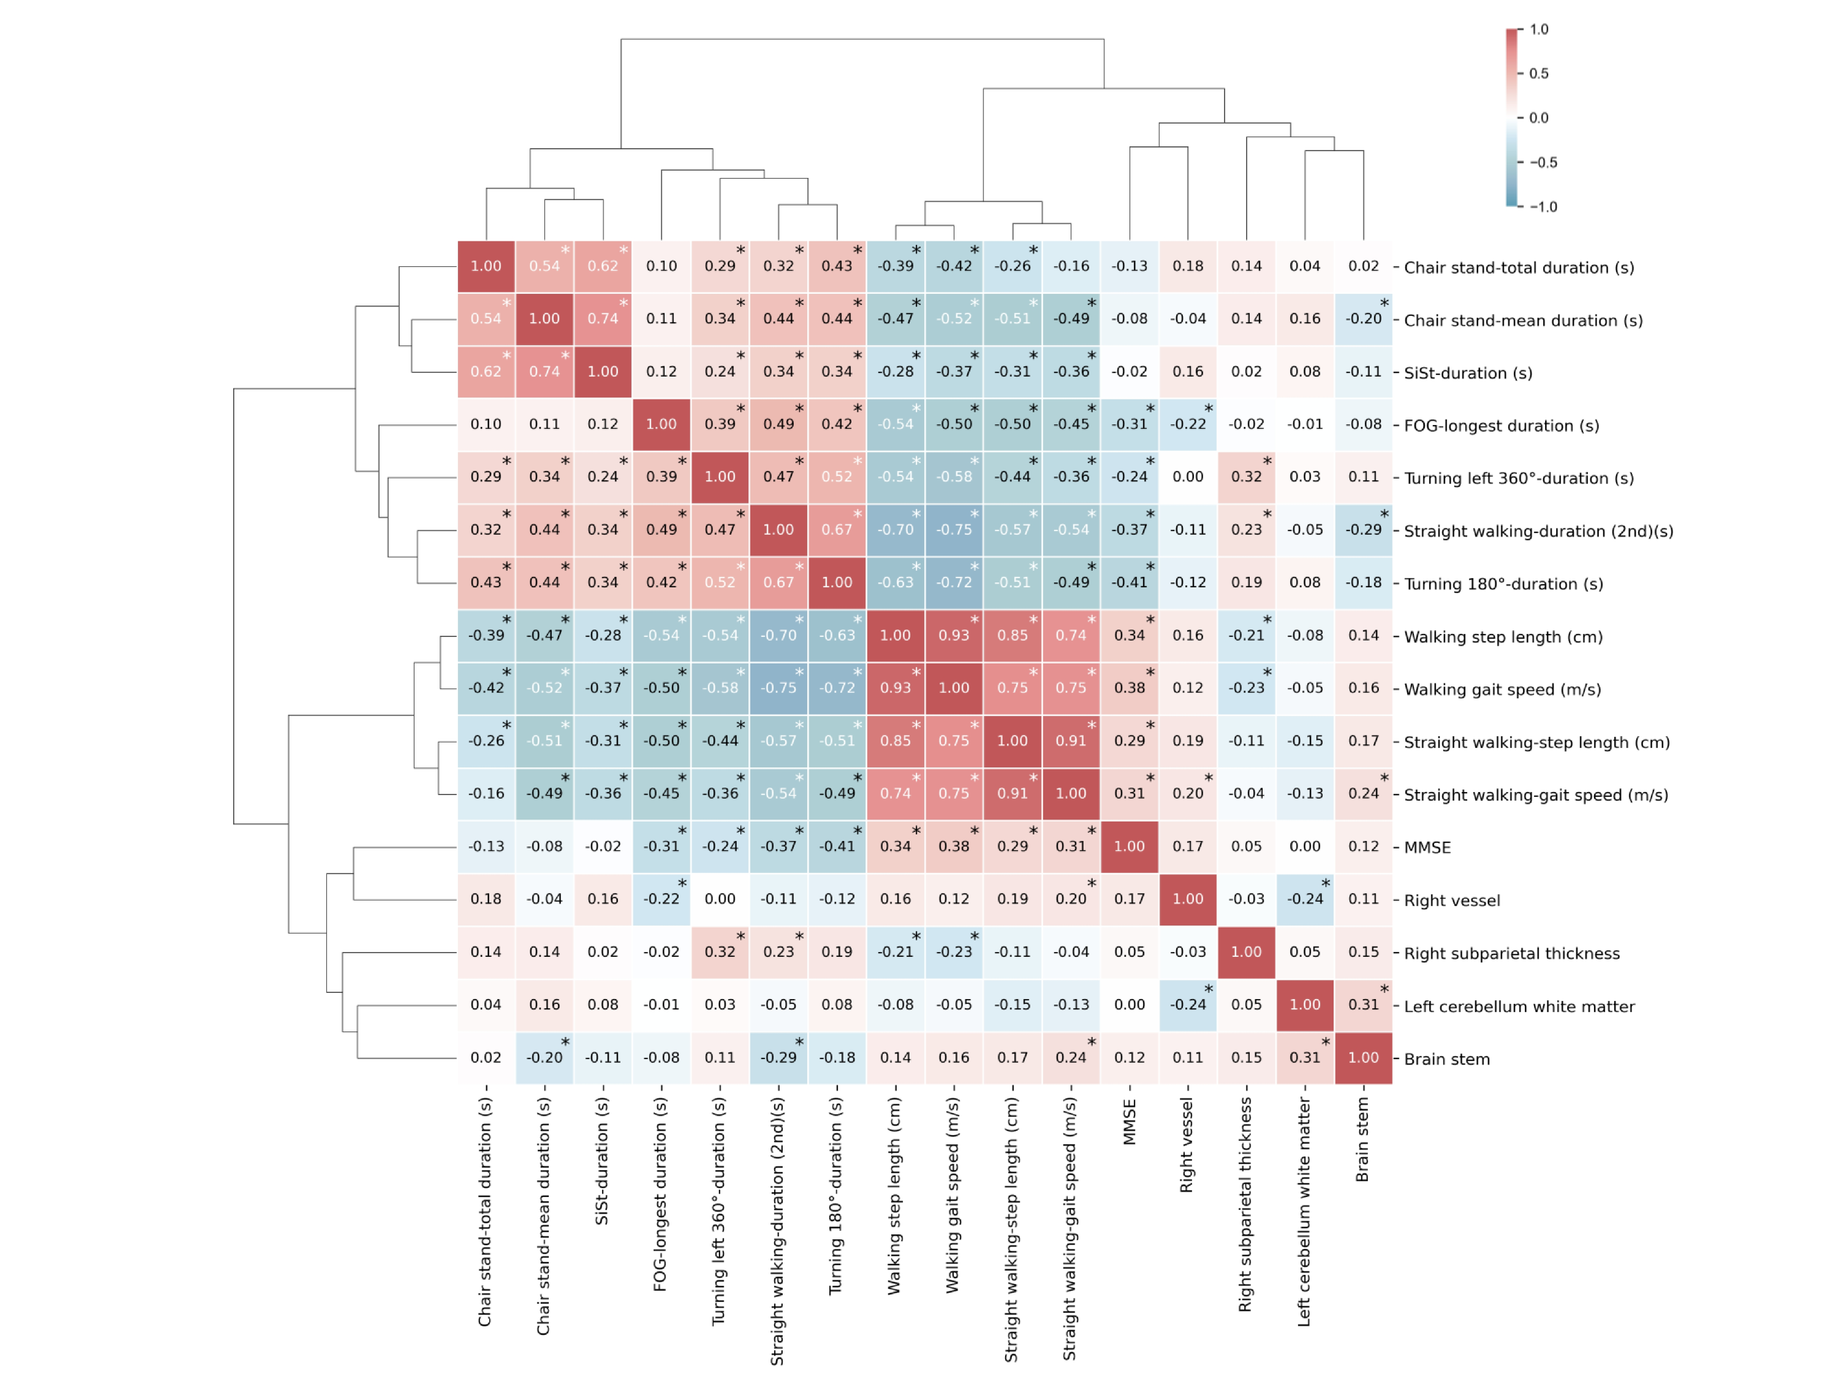
Figure S1 Correlation matrix and hierarchical clustering of the selected multimodal biomarkers. The heatmap displays Spearman’s correlation coefficients between all biomarker pairs, with color intensity indicating correlation strength (red: positive, blue: negative). Dendrograms illustrate biomarker clustering patterns based on their correlational structure. The symbol * represents the corresponding P value of Spearman’s correlation coefficient is less than 0.05.
Figure S2 Consistent biomarker distributions between training and test sets. Density distributions of the 16 selected multimodal biomarkers are compared across the training (n=74) and test (n=33) sets. Panels show comparable distribution patterns for all gait, cognitive, and neuroimaging biomarkers, with overlapping density curves indicating minimal distributional shift between the two datasets, supporting the model’s generalizability.

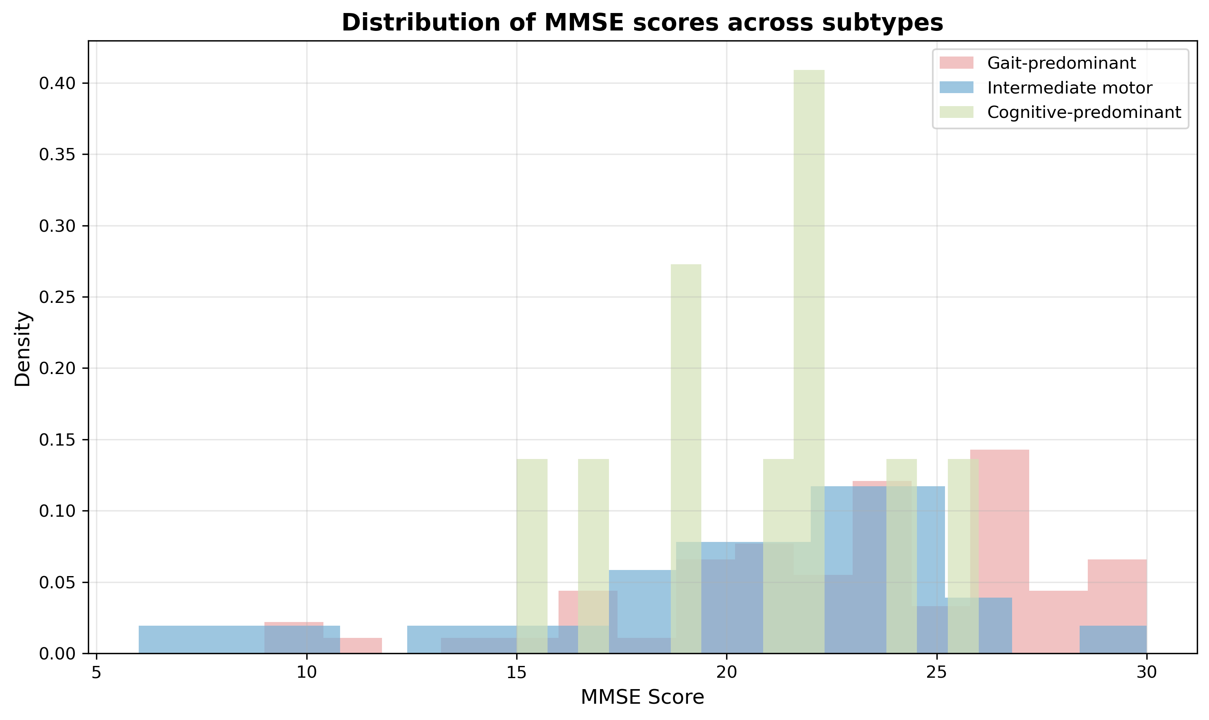
Figure S3 Distribution of standardized MMSE scores across SuStaIn-derived subtypes. The histogram illustrates the density distribution of standardized Mini-Mental State Examination (MMSE) scores for the three identified Parkinson’s disease subtypes. The gait-predominant subtype (pink) is primarily concentrated in the higher/normal score range. The intermediate motor subtype (blue) shows a moderate shift toward lower scores, while the cognitive-predominant subtype (green) displays a significant leftward skew with multiple peaks in the lower score range, reflecting more advanced cognitive impairment.

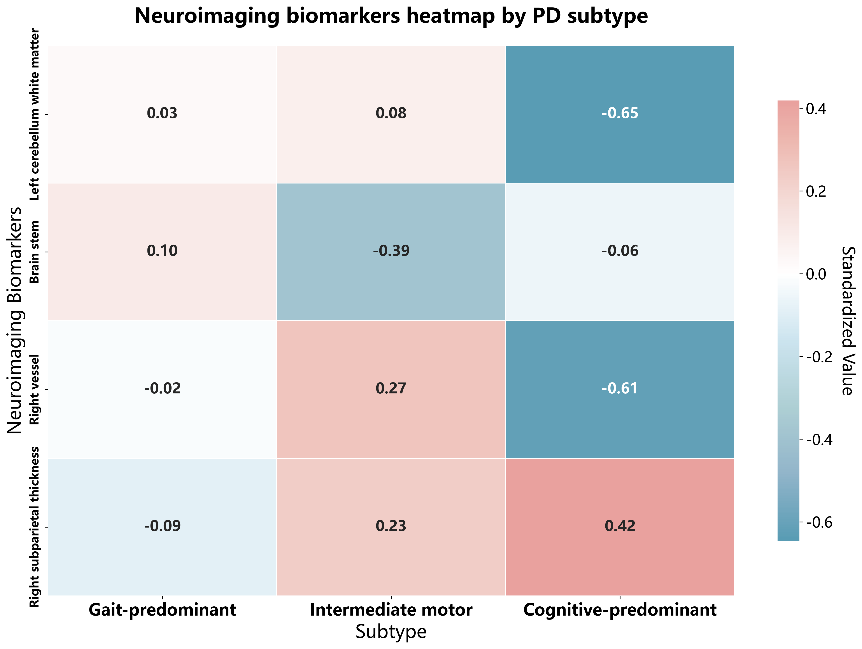
Figure S4 Heatmap of mean standardized neuroimaging biomarkers by PD subtype. The heatmap displays the average standardized values (z-scores) for four key neuroimaging markers across the three subtypes. Values are normalized relative to healthy controls (z=0). Red indicates values higher than the control mean, while blue indicates regional atrophy or volume reduction. The numerical values within each cell represent the mean z-score for that specific biomarker-subtype combination. The cognitive-predominant subtype exhibits the most severe atrophy in the left cerebellum white matter and right vessel volume, while the Intermediate motor subtype is characterized by prominent brainstem volume reduction alongside relative preservation or increase in subparietal thickness.

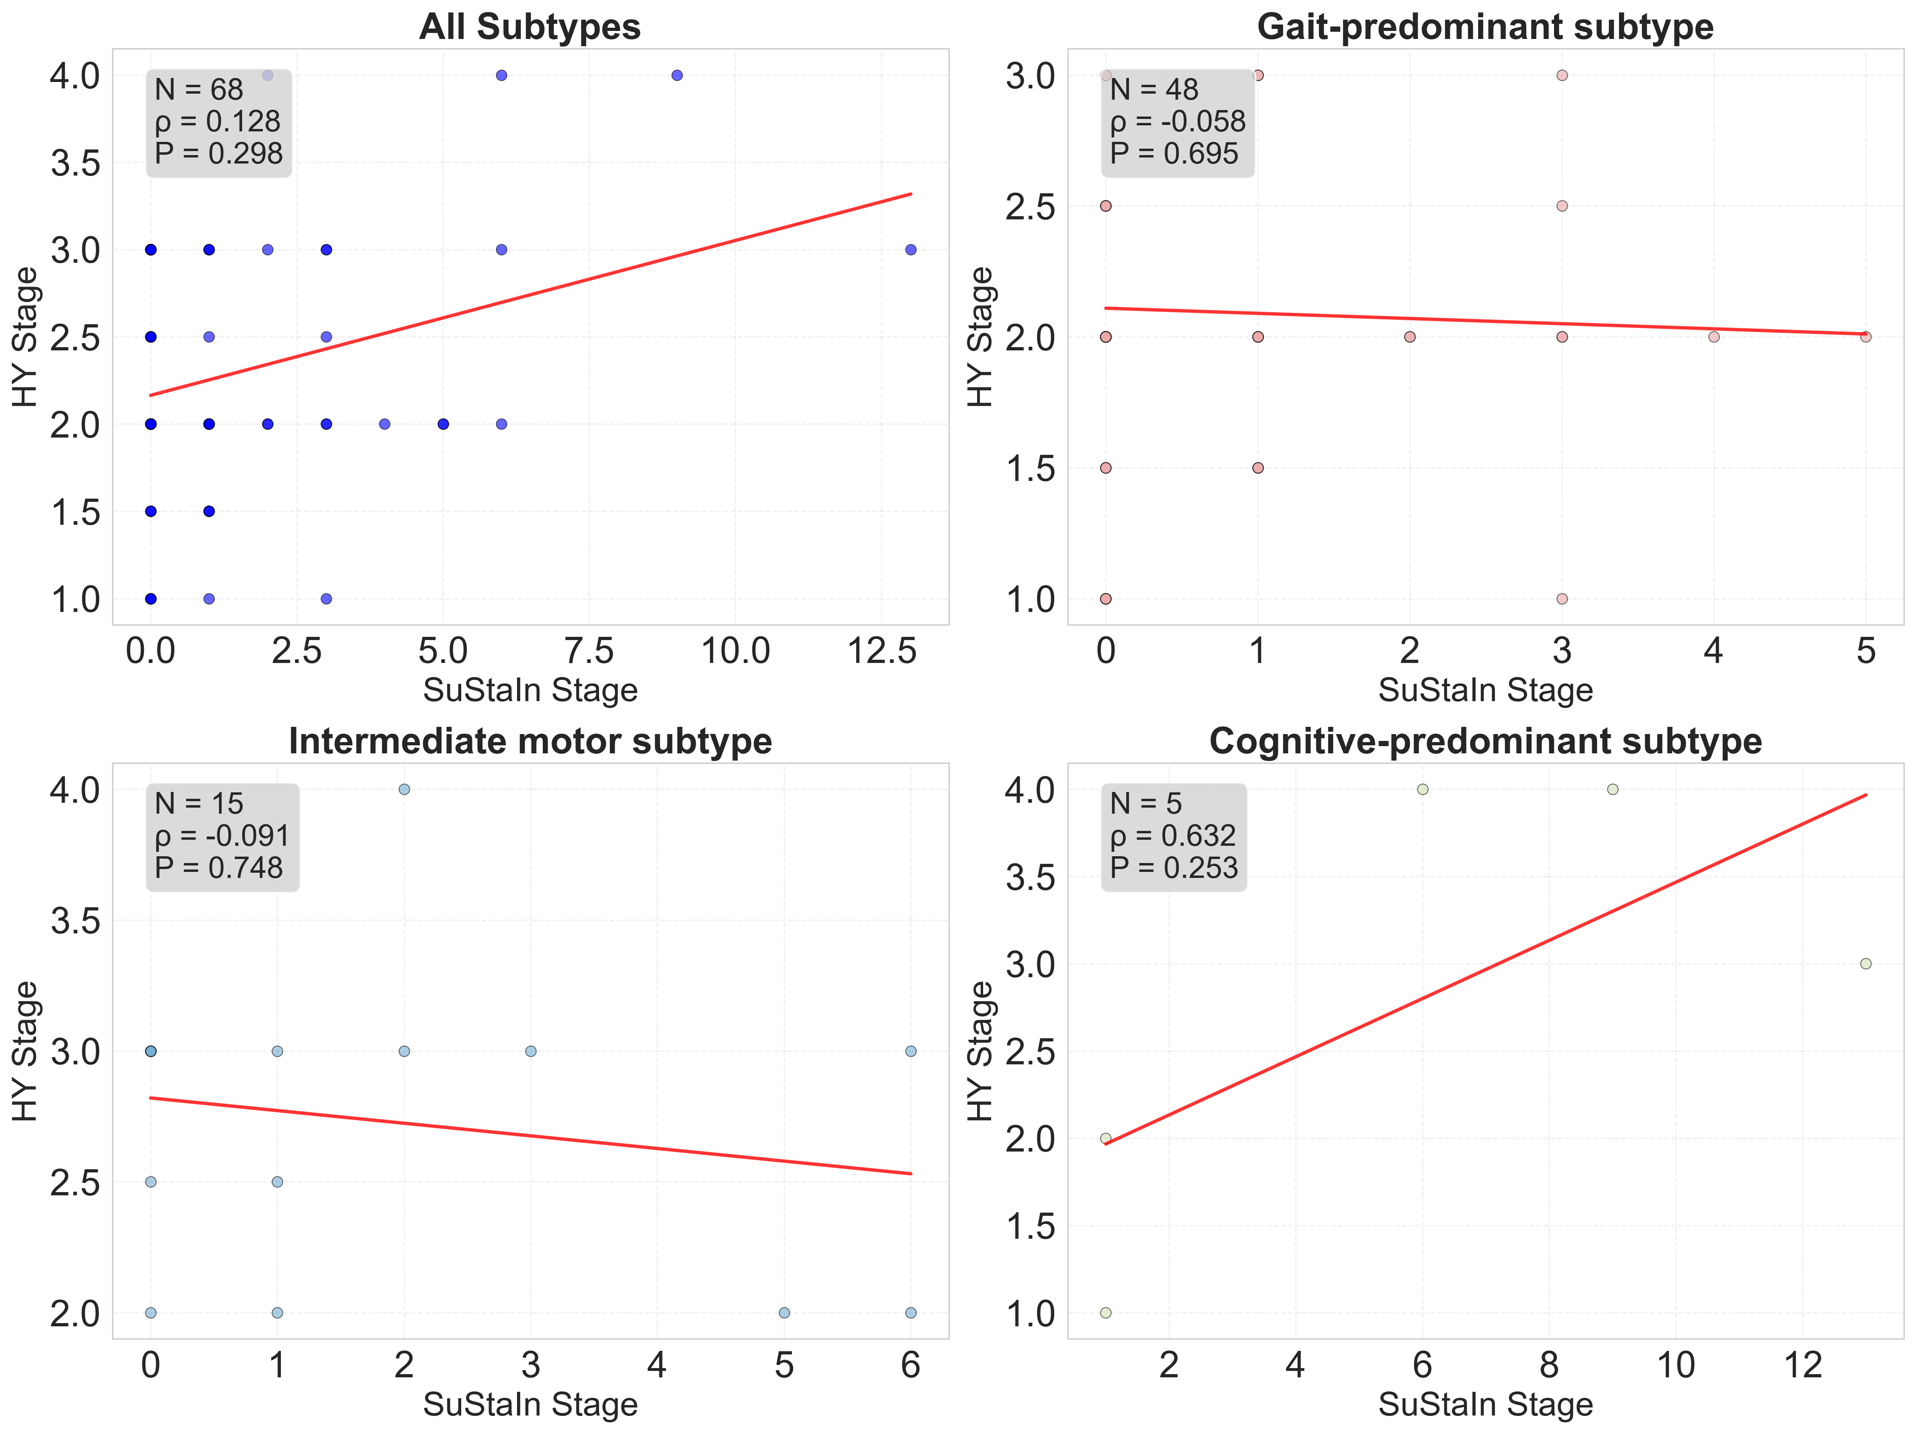
Figure S5 Correlation analysis between data-driven SuStaIn stages and clinical Hoehn & Yahr (H-Y) staging. Scatter plots illustrate the relationship between the inferred continuous SuStaIn stage (x-axis) and the ordinal H-Y stage (y-axis) across the PD cohort and within individual subtypes. The Spearman’s correlation coefficients ($ρ$) and P values indicate a lack of significant linear alignment, supporting the hypothesis that SuStaIn stages provide a more continuous and granular resolution of disease progression compared to the categorical H-Y scale.

References
1. Vogel, J. W. et al. Four distinct trajectories of tau deposition identified in Alzheimer’s disease. Nat. Med. 27, 871–881 (2021).
2. Archetti, D. et al. Inter-Cohort Validation of SuStaIn Model for Alzheimer’s Disease. Front. Big Data 4, 661110 (2021).
3. Young, A. L. et al. Characterizing the Clinical Features and Atrophy Patterns of MAPT-Related Frontotemporal Dementia With Disease Progression Modeling. Neurology 97, e941–e952 (2021).
4. Gelman, A., Hwang, J. & Vehtari, A. Understanding predictive information criteria for Bayesian models. Stat. Comput. 24, 997–1016 (2014).

