Appendices

Appendix A: Sources Local Impact by H Index
Table A1. Sources by local h-index
Source | h_index | TC | PY_start
SUSTAINABILITY (SWITZERLAND) | 17 | 1325 | 2018
AI AND SOCIETY | 16 | 1348 | 2016
COMPUTERS AND EDUCATION: ARTIFICIAL INTELLIGENCE | 10 | 933 | 2021
IEEE TECHNOLOGY AND SOCIETY MAGAZINE | 7 | 336 | 2016
FRONTIERS IN PSYCHOLOGY | 6 | 826 | 2020
FUTURES | 6 | 192 | 2015
SOCIAL SCIENCES | 6 | 223 | 2018
TECHNOLOGICAL FORECASTING AND SOCIAL CHANGE | 6 | 460 | 2016
COGENT EDUCATION | 5 | 61 | 2024
INTERDISCIPLINARY SCIENCE REVIEWS | 5 | 84 | 2018

Figure A1. Sources Local Impact by H Index
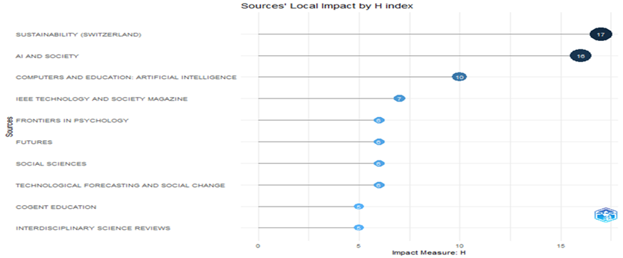

Sustainability Switzerland boasts the highest h-index of 17, accompanied by a cumulative citation count of 1,325 and an operational period since 2018. AI and Society, which boasts an h-index of 16 and a total citation count of 1,348, operational since 2016, follow this. Computers and Education: Artificial Intelligence boasts an h-index of 10 and a total citation count of 933, despite being operational since 2021. AI and Society boasts the longest operational period, while Computers and Education: Artificial Intelligence boasts the steepest rise in recent times since 2021, reflecting the recent rise in generative AI scholarship.

Appendix B: Sources Production Over Time
Figure B1. Sources Production Over Time
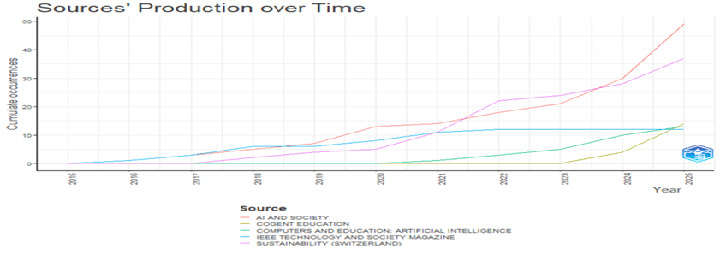
In addition, the trajectory of AI and Society has the longest history, beginning in 2016, and the trajectory of Sustainability shows accelerating growth, beginning in 2018. Computers and Education: Artificial Intelligence has the steepest recent growth trajectory, beginning in 2021, reflecting the recent explosion of generative AI research.

Appendix C: Authors Production over Time
Table C1. Most Authors Production over Time
Author | year | TI | SO | TC
REZAEV AV | 2025 | LOOKING AT HUMAN-CENTERED ARTIFICIAL INTELLIGENCE AS A PROBLEM AND PROSPECT FOR SOCIOLOGY: AN ANALYTIC REVIEW | CURRENT SOCIOLOGY | 10
TREGUBOVA ND | 2025 | LOOKING AT HUMAN-CENTERED ARTIFICIAL INTELLIGENCE AS A PROBLEM AND PROSPECT FOR SOCIOLOGY: AN ANALYTIC REVIEW | CURRENT SOCIOLOGY | 10
REZAEV AV | 2025 | AI TOOLS IN HIGHER EDUCATION THROUGH THE LENS OF THE SOCIAL-INSTITUTIONAL PARADIGM OF SOCIAL INTERCOURSE | VYSSHEE OBRAZOVANIE V ROSSII | 3
TREGUBOVA ND | 2025 | AI TOOLS IN HIGHER EDUCATION THROUGH THE LENS OF THE SOCIAL-INSTITUTIONAL PARADIGM OF SOCIAL INTERCOURSE | VYSSHEE OBRAZOVANIE V ROSSII | 3
REZAEV AV | 2023 | HUMAN-MACHINE INTERDEPENDENCE BEYOND AI DEVELOPMENT: THE CASE OF BITCOIN | RUSSIAN SOCIOLOGICAL REVIEW | 2
TREGUBOVA ND | 2023 | HUMAN-MACHINE INTERDEPENDENCE BEYOND AI DEVELOPMENT: THE CASE OF BITCOIN | RUSSIAN SOCIOLOGICAL REVIEW | 2
REZAEV AV | 2022 | ONCE AGAIN ABOUT SOCIOLOGY AND SOCIAL ANALYTICS IN THE AGE OF ARTIFICIAL INTELLIGENCE ADVANCEMENT | RUSSIAN SOCIOLOGICAL REVIEW | 1
TREGUBOVA ND | 2022 | ONCE AGAIN ABOUT SOCIOLOGY AND SOCIAL ANALYTICS IN THE AGE OF ARTIFICIAL INTELLIGENCE ADVANCEMENT | RUSSIAN SOCIOLOGICAL REVIEW | 1
REZAEV AV | 2021 | ARTIFICIAL INTELLIGENCE AND ARTIFICIAL SOCIALITY: NEW PHENOMENA AND CHALLENGES FOR THE SOCIAL SCIENCES | MONITORING OBSHCHESTVENNOGO MNENIYA: EKONOMICHESKIE I SOTSIAL'NYE PEREMENY | 7
TREGUBOVA ND | 2021 | ARTIFICIAL INTELLIGENCE AND ARTIFICIAL SOCIALITY: NEW PHENOMENA AND CHALLENGES FOR THE SOCIAL SCIENCES | MONITORING OBSHCHESTVENNOGO MNENIYA: EKONOMICHESKIE I SOTSIAL'NYE PEREMENY | 7

Rezaev, A.V., and Tregubova, N.D. have consistently co-authored publications from 2021 to 2025, with a focus on human-AI sociality and AI in higher education. Their latest publication (2025), on human-centered AI in sociology, has garnered 10 citations, reflecting their most impactful work to date. The co-authorship between these two authors is unique (TLS = 7).

Appendix D: country production over time
Table D.1 Most Country Production over Time
Articles | Year | Country
458 | 2025 | USA
269 | 2024 | USA
262 | 2025 | CHINA
234 | 2025 | UNITED KINGDOM
189 | 2023 | USA
169 | 2024 | UNITED KINGDOM
162 | 2024 | CHINA
139 | 2025 | GERMANY
132 | 2022 | USA
131 | 2023 | UNITED KINGDOM
106 | 2023 | CHINA
105 | 2025 | INDIA
101 | 2022 | UNITED KINGDOM
96 | 2021 | USA

Figure D1. Country production over time
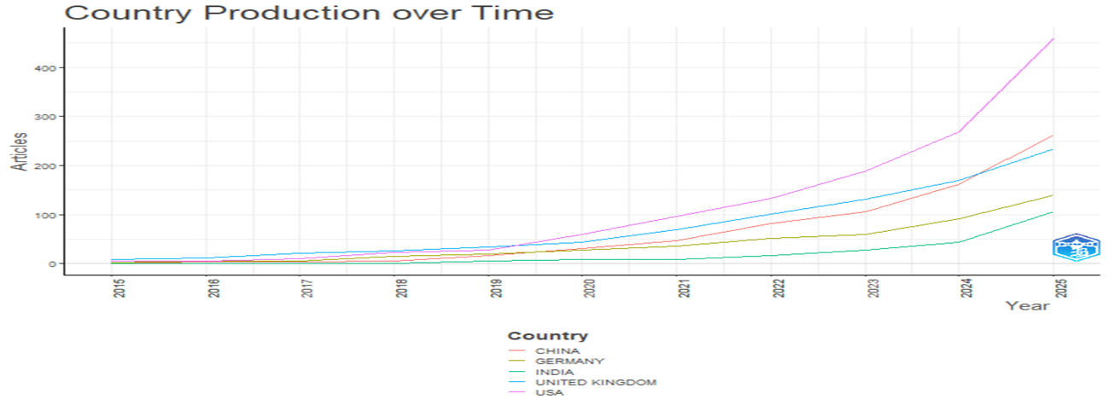
The following table describes the temporal pattern of publication rates for Generative AI from prominent countries. The dominance of the US in the number of publications remains consistent throughout, with a total of 458 publications in 2025 alone, while China and the UK reveal a growing rate of publications, especially from 2023 onward. This pattern reaffirms the long-lasting dominance of Anglo-American and Chinese studies in the development of Generative AI, with new publications from Germany and India indicating a growing global landscape.

