Supporting Information

Nitrogen-Doped Porous Carbon Derived from Bimetallic Zeolitic Imidazolate Frameworks for Electrochemical Li⁺/Na⁺ Storage

Shuai Dongª, Jiewu Cui^{a,b,c,*}, Dongbo Yu^{a,b,c,*}, Zhongnan Caoª, Cuiping Yuª, Yong Zhang^{a,b,c}, Yucheng Wu^{a,b,c}
ªSchool of Materials Science and Engineering, Hefei University of Technology, Hefei, 230009, P. R. China
^{b}Key Laboratory of Advanced Functional Materials and Devices of Anhui Province，Hefei, 230009, P. R. China
^{c}China International S&T Cooperation Base for Advanced Energy and Environmental Materials & Anhui Provincial International S&T Cooperation Base for Advanced Energy Materials, Hefei University of Technology, Hefei 230009, China
E-mail: dongboy@hfut.edu.cn, jwcui@hfut.edu.cn

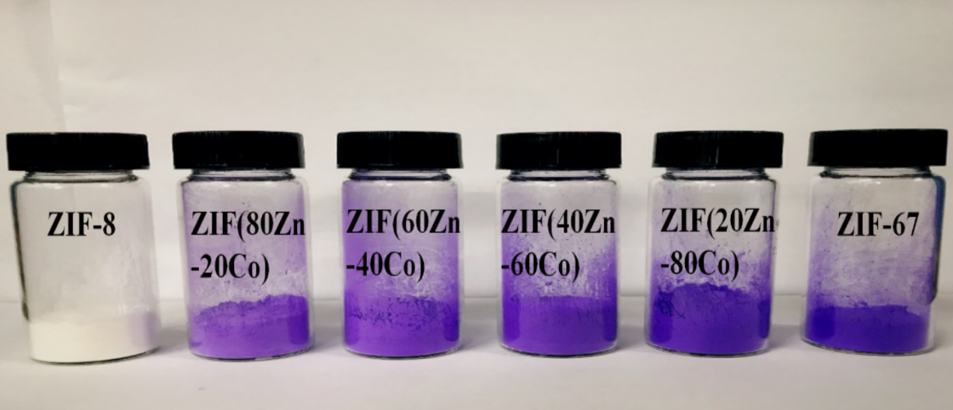
Fig. S1 Optical photograph of ZnCo-ZIF with different Zn/Co molar ratios.
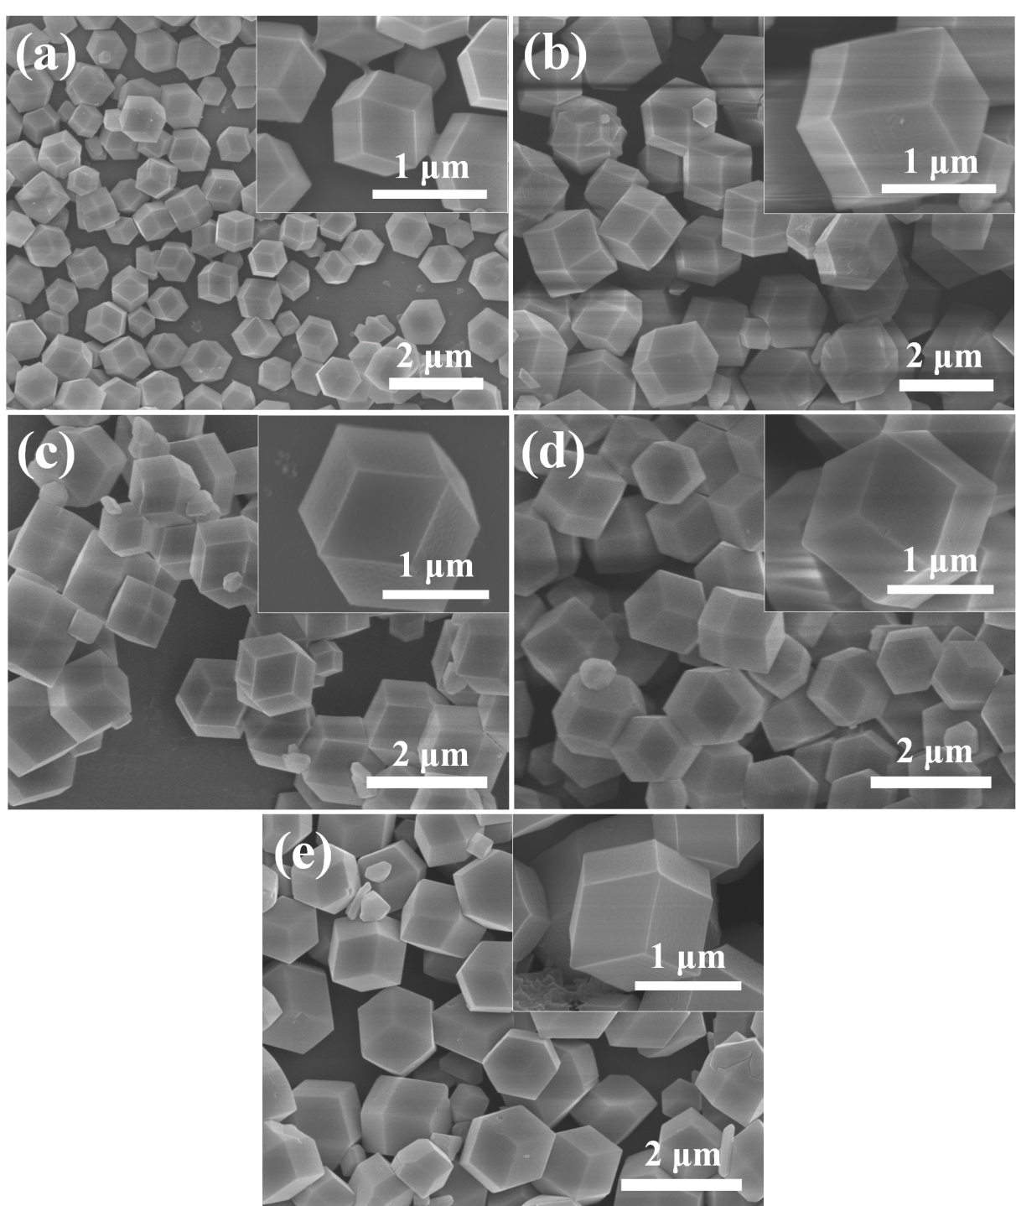
Fig. S2 SEM images of ZnCo-ZIFs with different Zn²⁺/Co²⁺ molar ratios: ZIF-8 (a), 80Zn20Co-ZIF(b), 60Zn40Co-ZIF (c), 40Zn-60Co-ZIF (d) and ZIF-67 (e).

Fig. S3 XRD patterns of ZIF-8, ZIF-67, 40Zn60Co-ZIF and 20Zn80Co-ZIF.
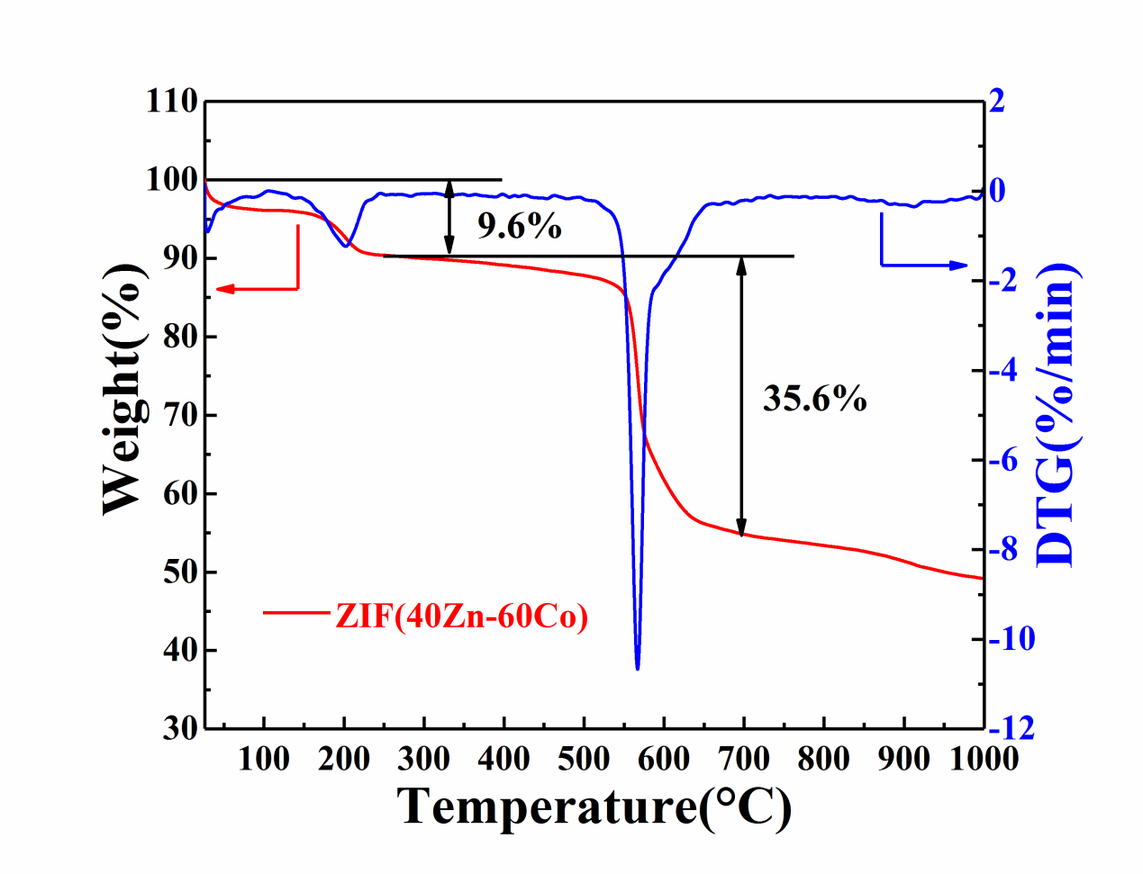
Fig. S4 TGA and DTG curves of 40Zn60Co-ZIF from 25 °C to 1000 °C with a rate of 5 °C min⁻¹ in N₂ atmosphere.
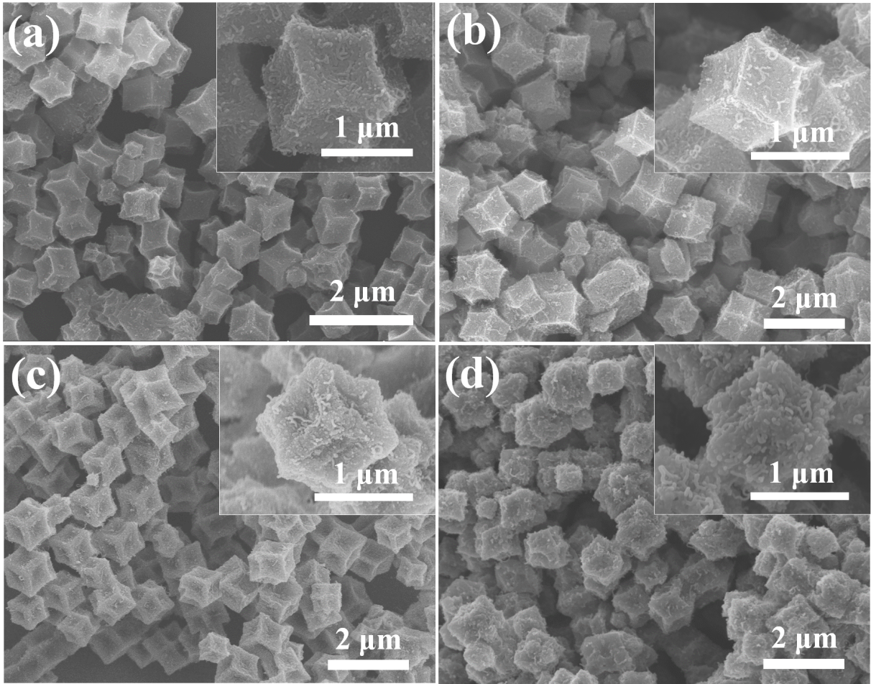
Fig. S5 SEM images of 40Zn60Co-ZIF calcinated at different temperatures: NPC(40Zn-60Co)-600°C (a), NPC(40Zn-60Co)-700°C (b), NPC(40Zn-60Co)- 800°C (c) and NPC(40Zn-60Co)-900°C (d) with subsequently etched in diluted HNO₃ at 80 °C for 24 h.
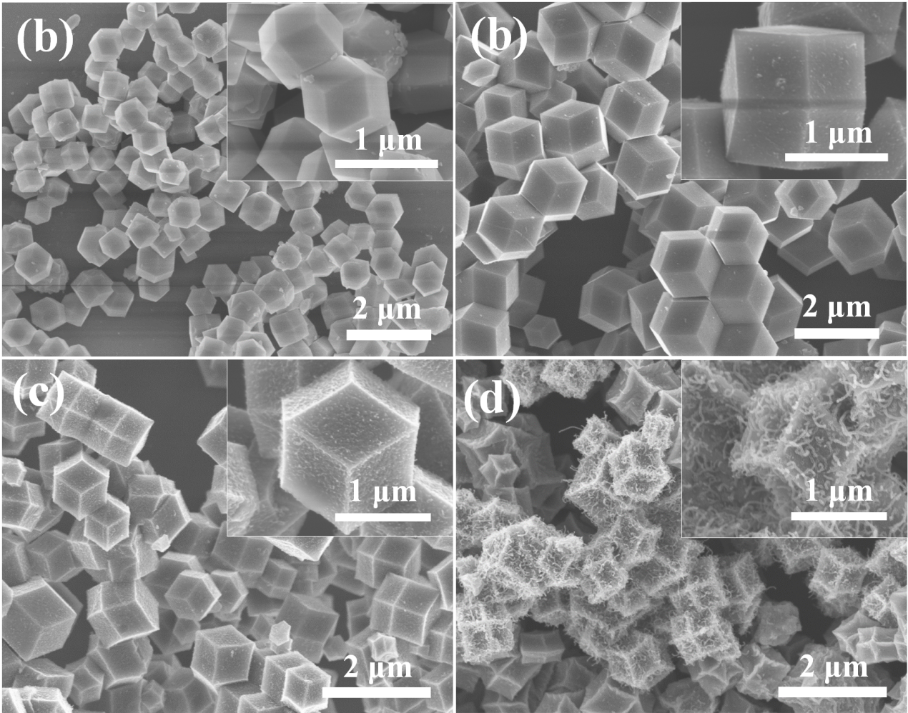
Fig. S6 SEM images of NPC(100Zn)-600°C (a), NPC(80Zn-20Co)-600°C (b), NPC(60Zn-40Co)-600°C (c) and NPC(100Co)-600°C (d).
Fig S7 Full XPS spectrum of NPC(40Zn-60Co)-600°C, NPC(40Zn-60Co)-700°C, NPC(40Zn-60Co)-800°C and NPC(40Zn-60Co)-900°C (a), C 1s spectrum of NPC(40Zn-60Co)-600°C (b), NPC(40Zn-60Co)-700°C (c), NPC(40Zn-60Co)-800°C (d) and NPC(40Zn-60Co)-900°C (e).
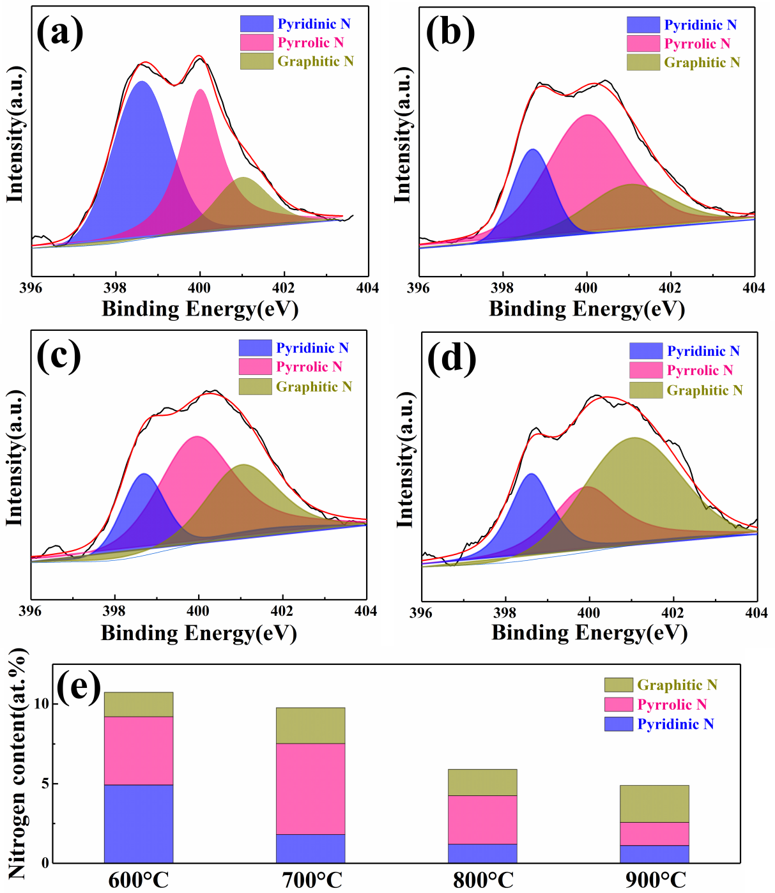
Fig S8 N 1s XPS spectrum of NPC(40Zn-60Co)-600°C (a), NPC(40Zn-60Co)-700°C (b), NPC(40Zn-60Co)-800°C (c) and NPC(40Zn-60Co)-900°C (d), nitrogen content of all 40Zn60Co-ZIF-derived NPC materials (e).

Table S1 Contents and ratios of Pyridinic N, Pyrrolic N and Graphitic N in NPC(40Zn-60Co)-600°C, NPC(40Zn-60Co)-700°C, NPC(40Zn-60Co)-800°C and NPC(40Zn-60Co)-900°C.
Samples | N content | Pyridinic N | Pyrrolic N | Graphitic N
NPC(40Zn-60Co)-600°C | 10.74% | 4.92% | 4.29% | 1.53%
NPC(40Zn-60Co)-700°C | 9.77% | 1.81% | 5.71% | 2.25%
NPC(40Zn-60Co)-800°C | 5.90% | 1.20% | 3.05% | 1.65%
NPC(40Zn-60Co)-900°C | 4.90% | 1.11% | 1.46% | 2.33%

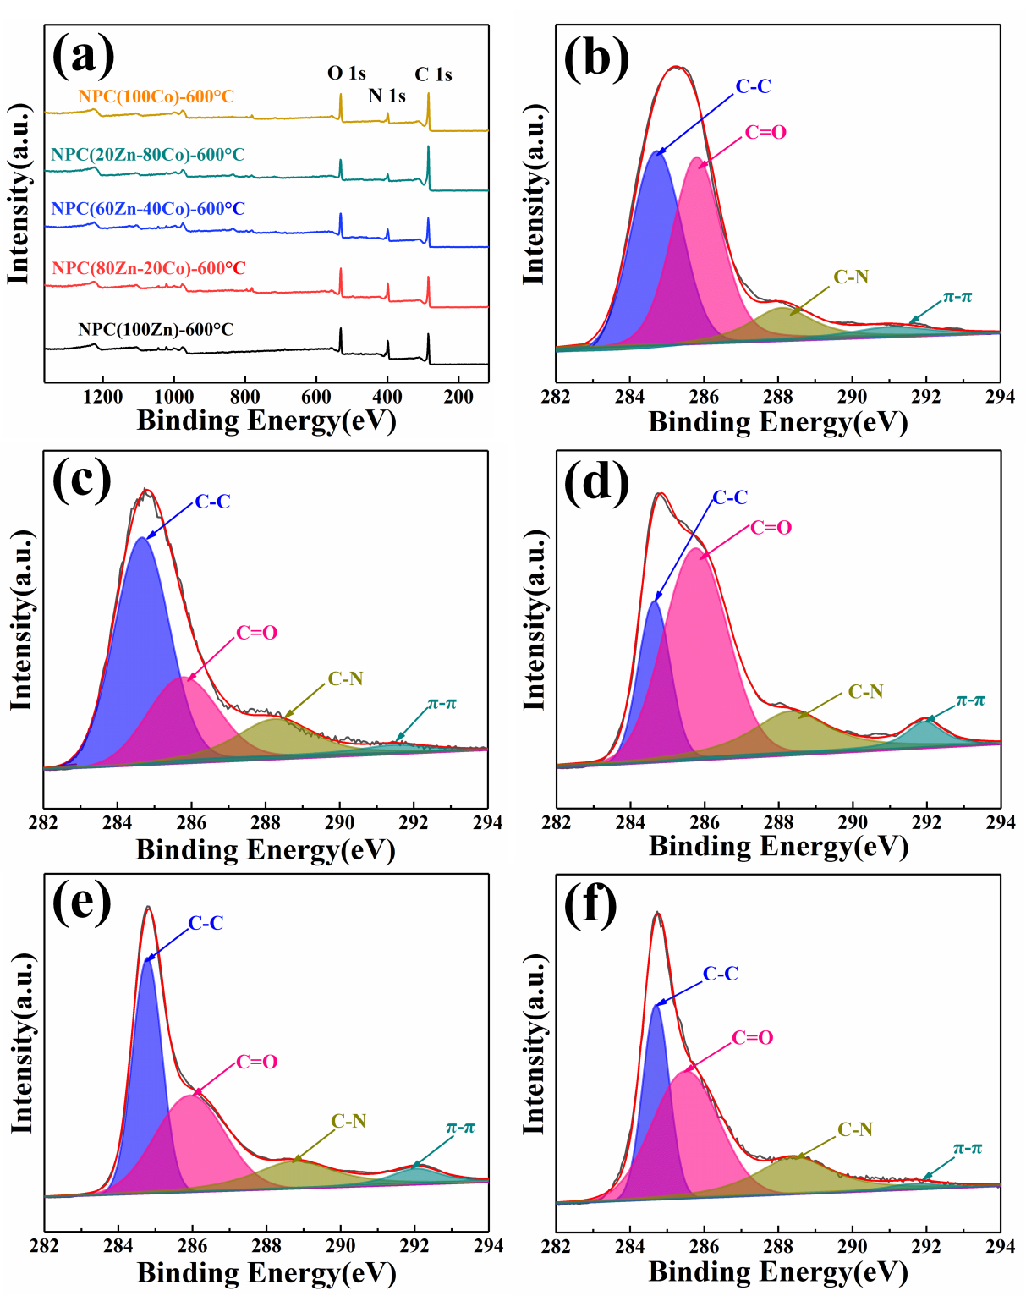
Fig. S9 Full XPS spectrum of all the samples (a), C 1s XPS spectrum of NPC(100Zn)-600°C (b), NPC(80Zn-20Co)-600°C (c), NPC(60Zn-40Co)-600°C (d), NPC(20Zn-80Co)-600°C (e) and NPC(100Co)-600°C (f).

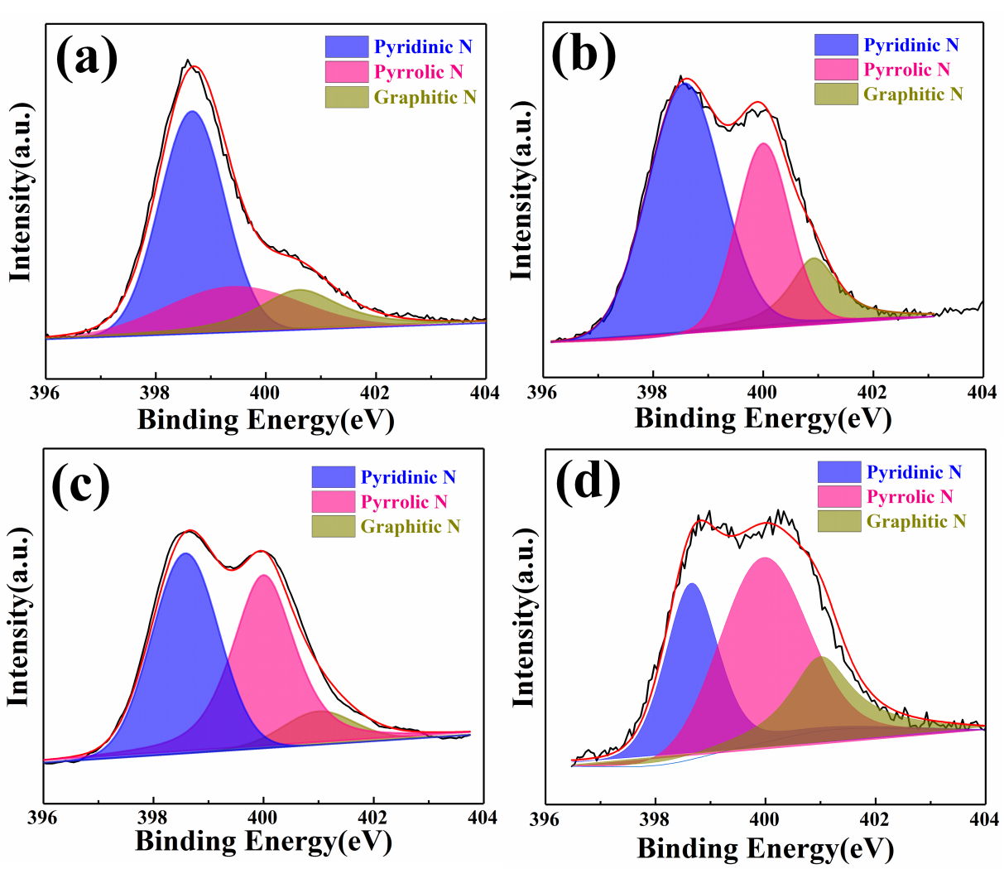
Fig. S10 N 1s spectrum of NPC(100Zn)-600°C (a), NPC(80Zn-20Co)-600°C (b), NPC(60Zn-40Co)-600°C (c) and NPC(100Co)-600°C (d).

Table S2 Contents and ratios of Pyridinic N, Pyrrolic N and Graphitic N in NPC(xZn-yCo)-600°C.
Samples | N content | Pyridinic N | Pyrrolic N |  | Graphitic N
NPC(100Zn)-600°C | 24.91% | 17.55% |  | 3.62% | 3.74%
NPC(80Zn-20Co)-600°C | 22.35% | 12.82% |  | 6.63% | 2.90%
NPC(60Zn-40Co)-600°C | 17.44% | 7.82% |  | 8.09% | 1.53%
NPC(40Zn-60Co)-600°C | 10.74% | 4.92% |  | 4.29% | 1.53%
NPC(20Zn-80Co)-600°C | 9.49% | 4.49% |  | 2.65% | 2.35%
NPC(100Co)-600°C | 13.26% | 4.33% |  | 6.33% | 2.60%

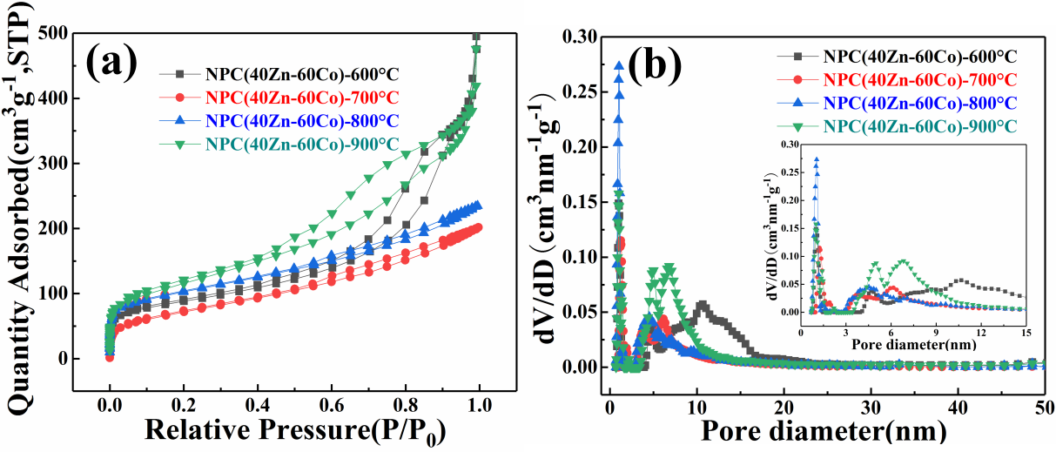
Fig. S11 N₂ adsorption/desorption isotherms (a) and pore size distributions (b) of the NPC(40Zn-60Co)-600°C, NPC(40Zn-60Co)-700°C, NPC(40Zn-60Co)-800°C and NPC(40Zn-60Co)-900°C measured at 77 K.
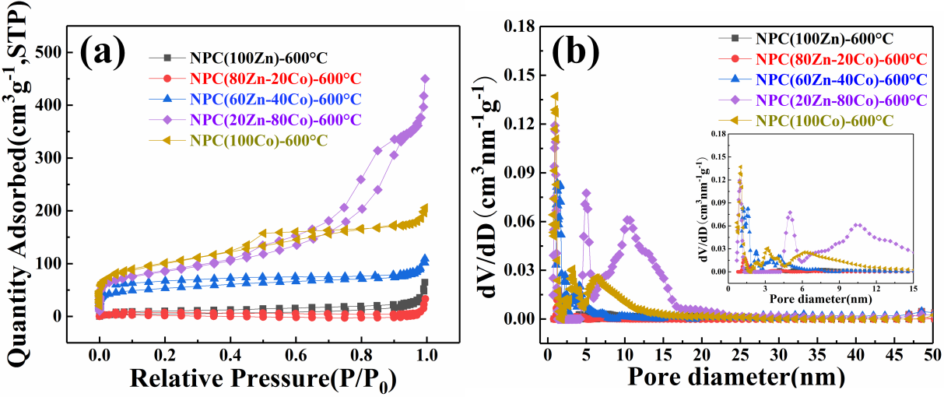
Fig. S12 N₂ adsorption/desorption isotherms (a) and pore size distributions (b) of the NPCs-600°C measured at 77 K.

Fig. S13 Li⁺ storage performance: The first three CV curves of NPC(20Zn-80Co)-600°C at scan rate of 0.1 mV s⁻¹ (a); rate capability of NPC(40Zn-60Co)-T at various current densities ranging from 0.1 to 5 A g⁻¹ (b); cycling performance of NPC(20Zn-80Co)-600°C electrodes at current density of 0.1 A g⁻¹ after 100 cycles (c); Nyquist plots of NPC(xZn-yCo)-600°C (d)
Table S3 Comparison of Li⁺ storage properties of NPC prepared in this work with other porous carbon materials.
Samples | Specific capacity | Rate capacity | Cycling stability | Ref.
N-doped porous carbon | 570 mAh g⁻¹ at 0.1 A g⁻¹ at first cycle | 370 mAh g⁻¹ at 0.5 A g⁻¹; 215 mAh g⁻¹ at 4 A g⁻¹ | 540 mAh g⁻¹ at 0.1 A g⁻¹ after 100 cycles | [1]
COFs-derived porous carbon | 505.7 mAh g⁻¹ at 0.1 A g⁻¹ after 5 cycles | 143 mAh g⁻¹ at 5 A g⁻¹ | 488 mAh g⁻¹ at 0.1 A g⁻¹ after 100 cycles | [2]
S/O co-doped porous carbon | 931 mAh g⁻¹ at 0.1 A g⁻¹ at first cycle | 312 mAh g⁻¹ at 1 A g⁻¹ | 504 mAh g⁻¹ at 0.2 A g⁻¹ after 200 cycles | [3]
Spheroidal carbon particles | 320 mAh g⁻¹ at 0.1 A g⁻¹ | - | 350 mAh g⁻¹ at 0.1 A g⁻¹ after 200 cycles | [4]
B-doped porous carbon | 697 mAh g⁻¹ at 0.1 A g⁻¹ after 10 cycles | 345 mAh g⁻¹ at 2 A g⁻¹ | 496 mAh g⁻¹ at 0.1 A g⁻¹ after 100 cycles | [5]
Egg yolk-derived carbon | 739 mAh g⁻¹ at 0.1 A g⁻¹ after 2 cycles | 321 mAh g⁻¹ at 1 A g⁻¹ | 711.6 mAh g⁻¹ at 0.1 A g⁻¹ after 100 cycles | [6]
N-doping hard carbon nanoshells | 395 mAh g⁻¹ at 0.1 A g⁻¹ after 15 cycles | 376 mAh g⁻¹ at 0.5 A g⁻¹;  257 mAh g⁻¹ at 1 A g⁻¹ | 245 mAh g⁻¹ at 1.5 A g⁻¹ after 300 cycles | [7]
N-doped carbon balls | 990 mAh g⁻¹ at 0.1 A g⁻¹ after 10 cycles | 209 mAh g⁻¹ at 1 A g⁻¹;  57 mAh g⁻¹ at 40 A g⁻¹ | 454 mAh g⁻¹ at 0.5 A g⁻¹ after 100 cycles | [8]
N-doped carbon nanosheets | 648 mAh g⁻¹ at 0.5 A g⁻¹ after 2 cycles | 683 mAh g⁻¹ at 0.2 A g⁻¹; 405 mAh g⁻¹ at 1 A g⁻¹ | 513 mAh g⁻¹ at 0.5 A g⁻¹ after 500 cycles | [9]
Ultrathin hollow carbon shell | 421 mAh g⁻¹ at 1 A g⁻¹ after 170 cycles | 621 mAh g⁻¹ at 0.2 A g⁻¹; 398 mAh g⁻¹ at 1 A g⁻¹ | 334 mAh g⁻¹ at 1 A g⁻¹ after 1000 cycles | [10]
ZIF-derived porous carbon | 876.5 mAh g⁻¹ at 0.1 A g⁻¹ at 2 cycle | 768.9 mAh g⁻¹ at 0.2 A g⁻¹; 480.9 mAh g⁻¹ at 2 A g⁻¹ | 591.5 mAh g⁻¹ at 1 A g⁻¹ after 500 cycles | This work

Fig. S14 Na⁺ storage performance of NPC(20Zn-80Co)-600°C: initial three CV curves at scan rate of 0.1 mV s⁻¹ (a); cycling performance at current density of 0.05 A g⁻¹ for 450 cycles (b). Nyquist plots of NPC(20Zn-80Co)-T (c).
Table S4 Comparison of Na⁺ storage properties of NPC prepared in this work with other porous carbon-based materials.
Samples | Specific capacity | Rate capacity | Cycling stability | Ref.
Soft carbon | 222 mAh g⁻¹ at 30 mA g⁻¹ | 135 mAh g⁻¹ at 0.3 A g⁻¹ | 170 mAh g⁻¹ at 0.3 A g⁻¹ after 200 cycles | [11]
3D amorphous carbon | 280 mAh g⁻¹ at 30 mA g⁻¹ | 66 mAh g⁻¹ at 9.6 A g⁻¹ | 188 mAh g⁻¹ at 0.3 A g⁻¹ after 600 cycles | [12]
N-rich mesoporous carbon | 434.6 mAh g⁻¹ at 30 mA g⁻¹ | 110 mAh g⁻¹ at 2 A g⁻¹ | 280.8 mAh g⁻¹ at 50 mA g⁻¹ after 300 cycles | [13]
N-rich porous carbon | 371.4 mAh g⁻¹ at 30 mA g⁻¹ | 174.2 mAh g⁻¹ at 1 A g⁻¹ | 255.9 mAh g⁻¹ at 0.5 A g⁻¹ after 3000 cycles | [14]
P-doped carbon nanofibers | 288 mAh g⁻¹ at 50 mA g⁻¹ | 103 mAh g⁻¹ at 2 A g⁻¹ | 253 mAh g⁻¹ at 50 mA g⁻¹ after 200 cycles | [15]
Mesoporous hard carbon | 375 mAh g⁻¹ at 20 mA g⁻¹ | 220 mAh g⁻¹ at 0.2 A g⁻¹ | 300 mAh g⁻¹ at 0.1 A g⁻¹ after 400 cycles | [16]
N-doping carbon nanoshells | 325 mAh g⁻¹ at 0.1 A g⁻¹ | 63 mAh g⁻¹ at 5 A g⁻¹ | 174 mAh g⁻¹ at 0.1 A g⁻¹ after 200 cycles | [17]
S-doped porous carbon | 313 mAh g⁻¹ at 20 mA g⁻¹ | - | 220 mAh g⁻¹ at 20 mA g⁻¹ after 50 cycles | [18]
Porous graphene grids carbon | 160 mAh g⁻¹ at 50 mA g⁻¹ | 109 mAh g⁻¹ at 0.14 A g⁻¹ | 112 mAh g⁻¹ at 1 A g⁻¹ after 1000 cycles | [19]
COFs-derived porous carbon | 239.5 mAh g⁻¹ at 50 mA g⁻¹ | 170 mAh g⁻¹ at 1 A g⁻¹ | 237.7 mAh g⁻¹ at 50 mA g⁻¹ after 100 cycles | [2]
Defective hard carbon | 308 mAh g⁻¹ at 20 mA g⁻¹ | - | 288 mAh g⁻¹ at 20 mA g⁻¹ after 210 cycles | [20]
ZIF-derived porous carbon | 416.1 mAh g⁻¹ at 0.02 A g⁻¹ | 206.6 mAh g⁻¹ at 0.2 A g⁻¹; 113 mAh g⁻¹ at 2 A g⁻¹ | 117.8 mAh g⁻¹ at 1 A g⁻¹ after 1000 cycles | This work

References
[1] V. Selvamani, R. Ravikumar, V. Suryanarayanan, D. Velayutham, S. Gopukumar, Garlic peel derived high capacity hierarchical N-doped porous carbon anode for sodium/lithium ion cell, Electrochim. Acta 190 (2016) 337-345.
[2] X.J. Zhang, G. Zhu, M. Wang, J.B. Li, T. Lu, L.K. Pan, Covalent-organic-frameworks derived N-doped porous carbon materials as anode for superior long-life cycling lithium and sodium ion batteries, Carbon 116 (2017) 686-694.
[3] P.Y. Zhang, Z.Y. Sui, E.J. Wang, Y.W. Liu, B.H. Han, Preparation of hierarchically porous sulfur- and oxygen-co-doped carbon for gas uptake and lithium-ion battery, Microporous and Mesoporous Materials 264 (2018) 118-124.
[4] K. Kim, R.A. Adams, P.J. Kim, A. Arora, E. Martinez, J.P. Youngblood, V.G. Pol, Li-ion storage in an amorphous, solid, spheroidal carbon anode produced by dry-autoclaving of coffee oil, Carbon 133 (2018) 62-68.
[5] D. Wang, Z. Wang, Y. Li, K. Dong, J. Shao, S. Luo, Y. Liu, X. Qi, In situ double-template fabrication of boron-doped 3D hierarchical porous carbon network as anode materials for Li- and Na-ion batteries, Applied Surface Science 464 (2019) 422-428.
[6] S. Wang, H. Wang, R. Zhang, L. Zhao, X. Wu, H. Xie, J. Zhang, H. Sun, Egg yolk-derived carbon: Achieving excellent fluorescent carbon dots and high performance lithium-ion batteries, Journal of Alloys and Compounds 746 (2018) 567-575.
[7] F. Zhao, X. Zhao, B. Peng, F. Gan, M. Yao, W. Tan, J. Dong, Q. Zhang, Polyimide-derived carbon nanofiber membranes as anodes for high-performance flexible lithium ion batteries, Chinese Chemical Letters 29 (2018) 1692-1697.
[8] A. Agrawal, K. Biswas, S.K. Srivastava, S. Ghosh, Effect of N-doping on hard carbon nano-balls as anode for Li-ion battery: improved hydrothermal synthesis and volume expansion study, Journal of Solid State Electrochemistry 22 (2018) 3443-3455.
[9] A.K. Mondal, K. Kretschmer, Y. Zhao, H. Liu, C. Wang, B. Sun, G. Wang, Nitrogen-Doped Porous Carbon Nanosheets from Eco-Friendly Eucalyptus Leaves as High Performance Electrode Materials for Supercapacitors and Lithium Ion Batteries, Chemistry 23 (2017) 3683-3690.
[10] P. Li, J. Liu, Y. Wang, Y. Liu, X. Wang, K.W. Nam, Y.M. Kang, M. Wu, J. Qiu, Synthesis of ultrathin hollow carbon shell from petroleum asphalt for high-performance anode material in lithium-ion batteries, Chemical Engineering Journal 286 (2016) 632-639.
[11] Y. Li, Y.S. Hu, X. Qi, X. Rong, H. Li, X. Huang, L. Chen, Advanced sodium-ion batteries using superior low cost pyrolyzed anthracite anode: towards practical applications, Energy Storage Materials 5 (2016) 191-197.
[12] P. Lu, Y. Sun, H. Xiang, X. Liang, Y. Yu, 3D Amorphous Carbon with Controlled Porous and Disordered Structures as a High-Rate Anode Material for Sodium-Ion Batteries, Adv. Energy Mater. 8 (2018) 1702434.
[13] H. Liu, M. Jia, S. Yue, B. Cao, Q. Zhu, N. Sun, B. Xu, Creative utilization of natural nanocomposites: nitrogen-rich mesoporous carbon for a high-performance sodium ion battery, Journal of Materials Chemistry A 5 (2017) 9572-9579.
[14] X. Hu, X. Sun, S.J. Yoo, B. Evanko, F. Fan, S. Cai, C. Zheng, W. Hu, G.D. Stucky, Nitrogen-rich hierarchically porous carbon as a high-rate anode material with ultra-stable cyclability and high capacity for capacitive sodium-ion batteries, Nano Energy 56 (2019) 828-839.
[15] F. Wu, R. Dong, Y. Bai, Y. Li, G. Chen, Z. Wang, C. Wu, Phosphorus-Doped Hard Carbon Nanofibers Prepared by Electrospinning as an Anode in Sodium-Ion Batteries, ACS Appl Mater Interfaces 10 (2018) 21335-21342.
[16] H. Zhu, F. Shen, W. Luo, S. Zhu, M. Zhao, B. Natarajan, J. Dai, L. Zhou, X. Ji, R.S. Yassar, T. Li, L. Hu, Low temperature carbonization of cellulose nanocrystals for high performance carbon anode of sodium-ion batteries, Nano Energy 33 (2017) 37-44.
[17] S. Huang, Z. Li, B. Wang, J. Zhang, Z. Peng, R. Qi, J. Wang, Y. Zhao, N-Doping and Defective Nanographitic Domain Coupled Hard Carbon Nanoshells for High Performance Lithium/Sodium Storage, Adv. Funct. Mater. 28 (2018) 1706294.
[18] S. Zhang, F. Yao, L. Yang, F. Zhang, S. Xu, Sulfur-doped mesoporous carbon from surfactant-intercalated layered double hydroxide precursor as high-performance anode nanomaterials for both Li-ion and Na-ion batteries, Carbon 93 (2015) 143-150.
[19] H. Zhang, H. Guo, A. Li, X. Chang, S. Liu, D. Liu, Y. Wang, F. Zhang, H. Yuan, High specific surface area porous graphene grids carbon as anode materials for sodium ion batteries, Journal of Energy Chemistry 31 (2019) 159-166.
[20] Z. Li, Y. Chen, Z. Jian, H. Jiang, J.J. Razink, W.F. Stickle, J.C. Neuefeind, X. Ji, Defective Hard Carbon Anode for Na-Ion Batteries, Chemistry of Materials 30 (2018) 4536-4542.

