Supplementary Materials for

Integrated Multi-omics Reveals Key Molecular Drivers and Therapeutic Strategies in a Spontaneous Cutaneous Squamous Cell Carcinoma Model of Macaques
Pan et al.
Correspondence author: heyonghan@mail.kiz.ac.cn;
lvlongbao@mail.kiz.ac.cn

This PDF file includes:

Figures. S1 to S8
Tables S1 to S4
Uncropped Western blots
Abbreviations used in this article

Supplementary Figures and Legends

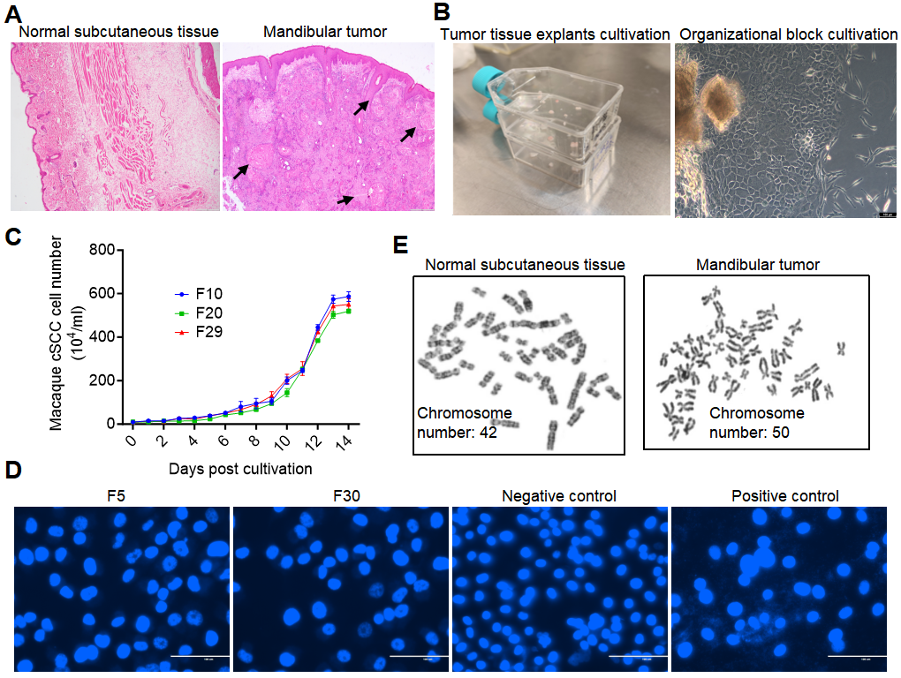
Fig. S1. Features of spontaneous cSCC and isolated cells. (A) H&E staining of skin and subcutaneous tissues (SST) and mandibular tumor. Black arrow indicates keratin pearl, a characteristic feature of squamous cell carcinoma. Scale bar: 100 μm. 4X. (B) Isolation and cultivation of tumor cells. (C) Growth curve of cSCC cells. (D) Mycoplasma detection in F5 and F30 generations of cSCC cells. Negative and Positive controls are also shown. (E) Representative karyotypic analysis of normal epithelial cells from rhesus (diploid chromosome number: 42) and karyotypic aberrations in primary tumor cell from rhesus spontaneous cSCC lesions (chromosome counts: 50).

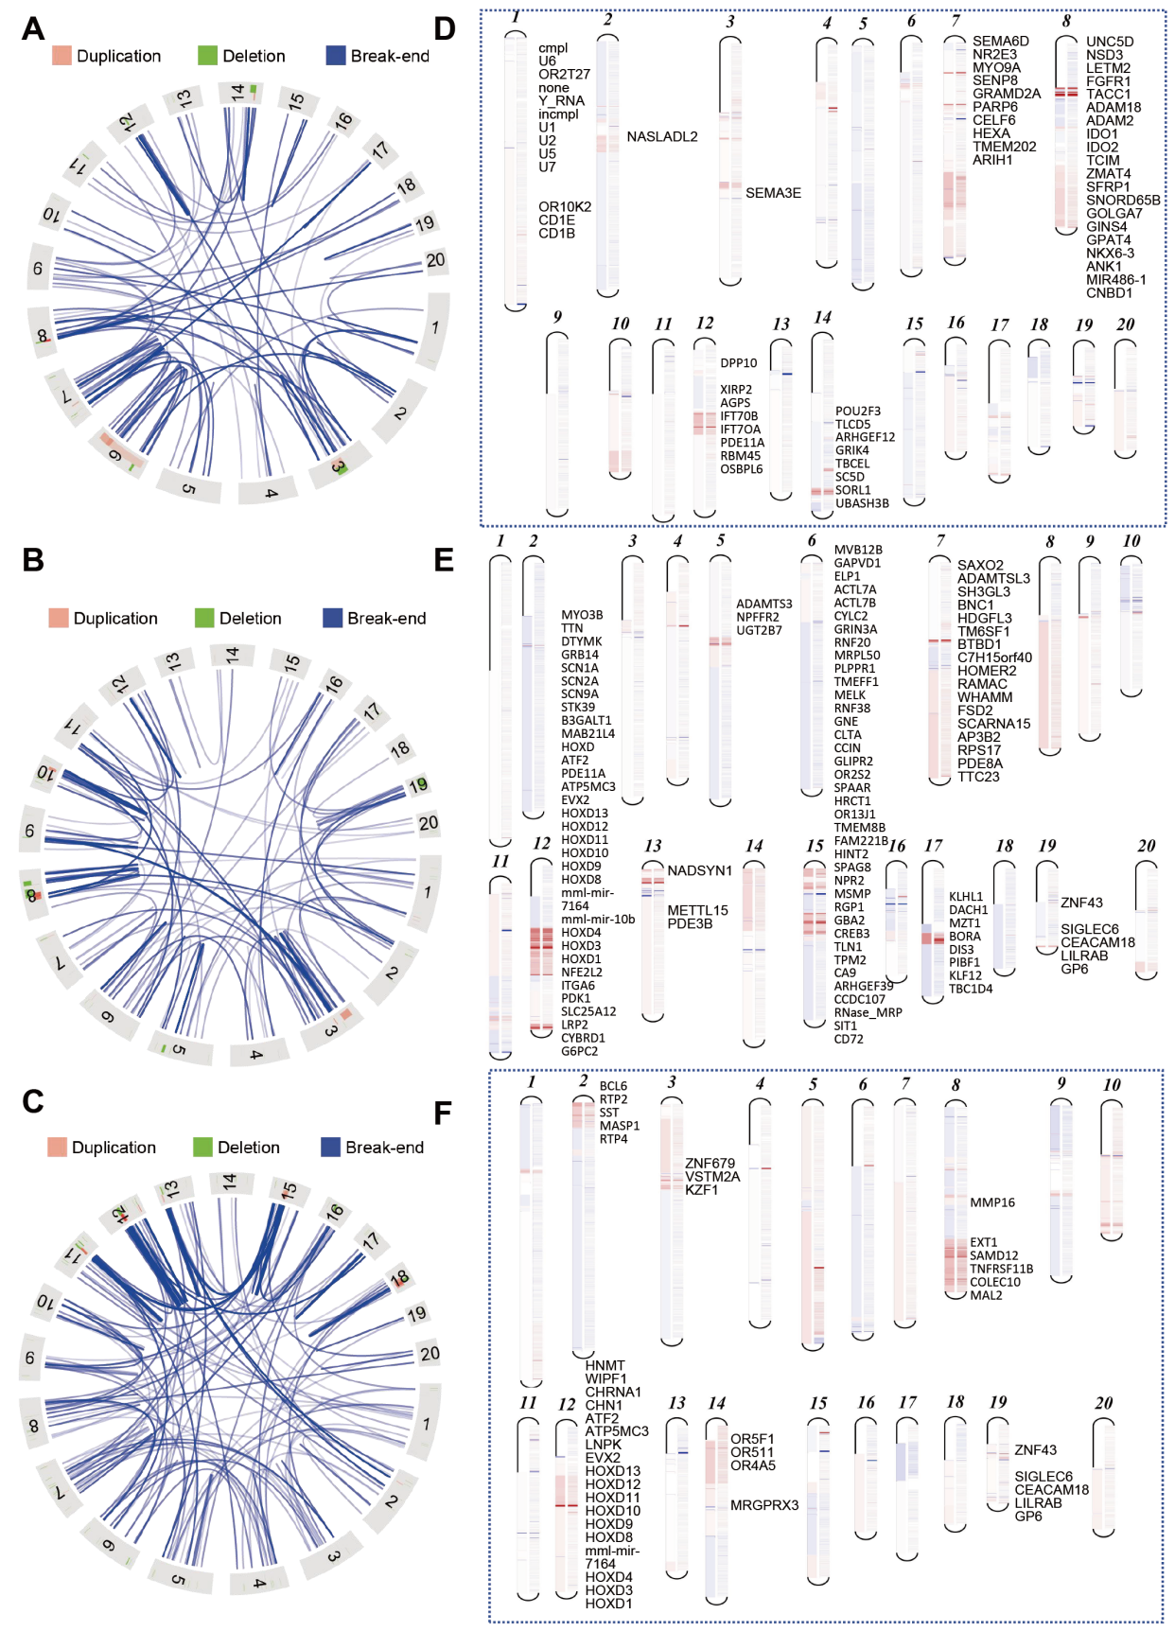
Fig. S2. Features of spontaneous cSCC and isolated cells. (A to C) Circos plots of large-scale structural variations in cSCC genomes. The plot depicts pervasive translocations and inversions across three cSCC tissue samples (CA-11454, CA-14422, CA-14397). (D to F) Chromosome-level copy number variation (CNV) profiles of cSCC samples. The profiles reveal widespread genomic imbalances, with recurrent copy number gains on chromosome 8 evident across tumor samples (CA-11454, CA-14397, CA-14422).

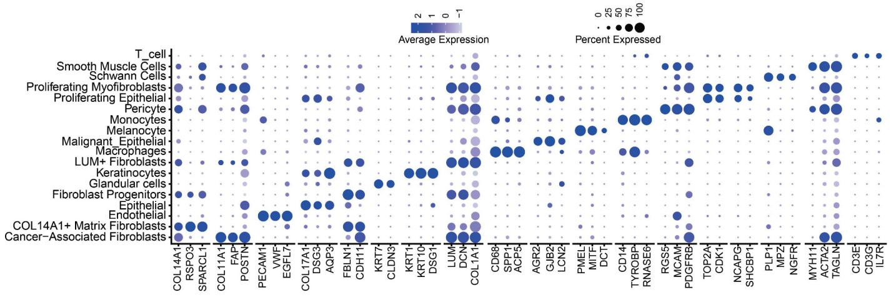
Fig. S3. Results of tumor single-cell transcriptome sequencing analysis. Bubble plot showing major cell populations and their canonical marker gene expression.

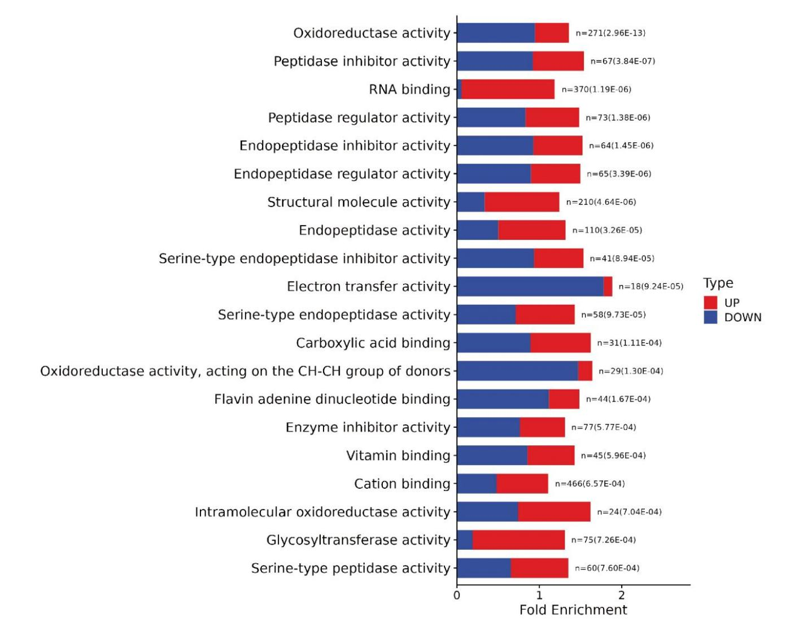
Fig. S4. GO enrichment analysis of the macaque cSCC proteome.

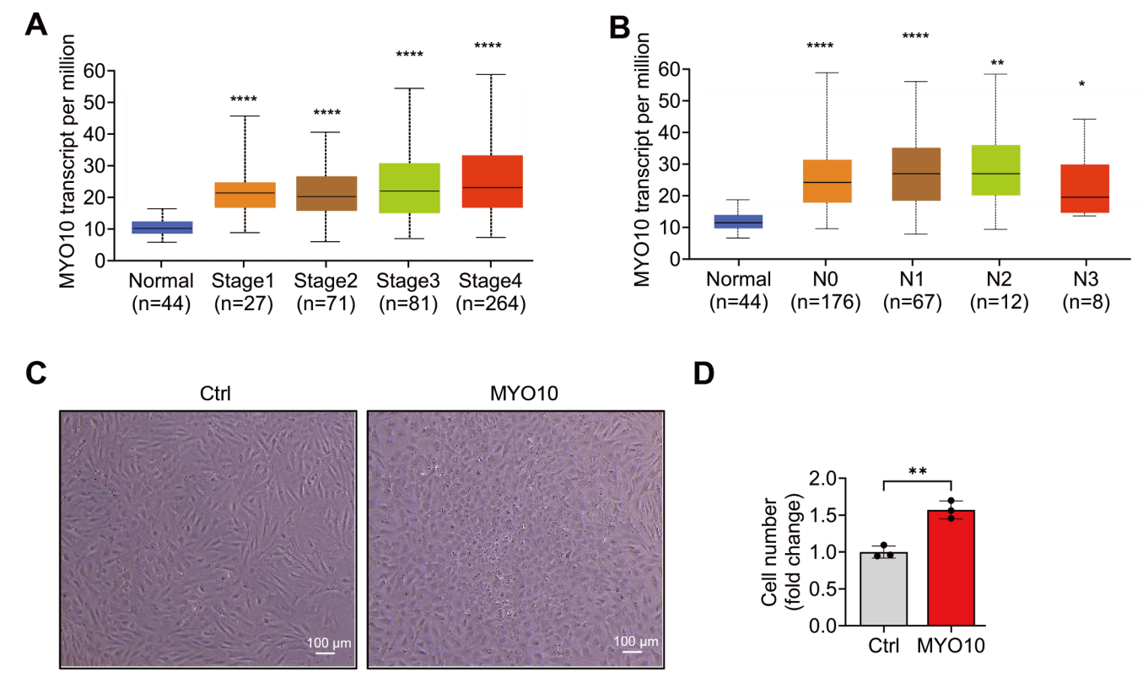

Fig. S5. Expression of MYO10 in head and neck squamous cell carcinoma (HNSC) and its functional impact. (A) Expression of MYO10 in HNSC based on individual cancer stages. (B) mRNA expression of MYO10 in HNSC based on nodal metastasis status. (C and D) Effects of MYO10 overexpression on the morphology and proliferation of HDF cells. HDF: human dermal fibroblasts. Scale bar: 100 μm.

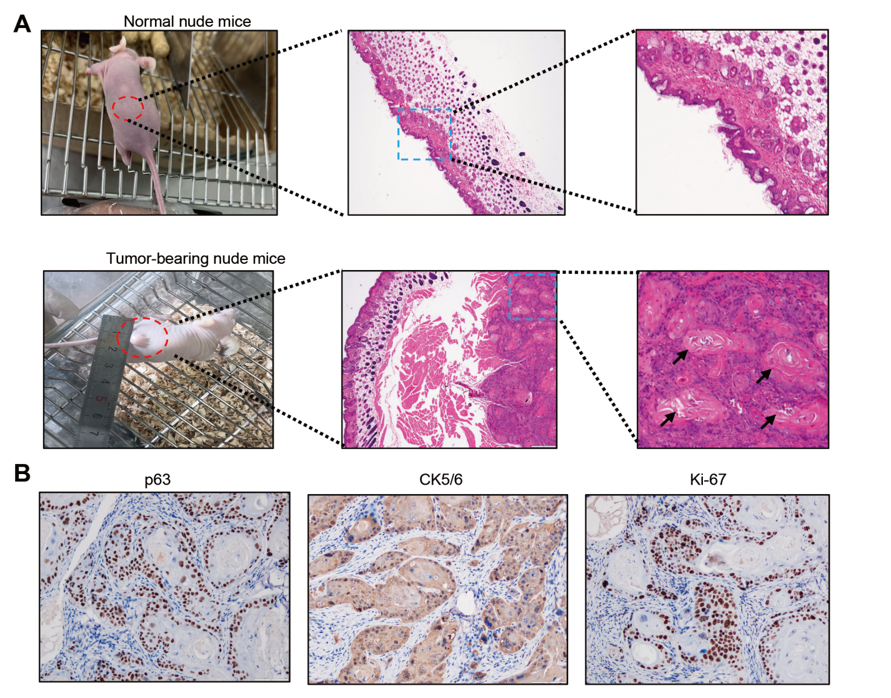
Fig. S6. Paclitaxel treatment and its effects on tumor development in nude mice. (A) H&E staining of tumor developed in nude mice. Black arrow indicates keratin pearl, a characteristic feature of squamous cell carcinoma. Scale bar: 100 μm. (B) IHC detection of p63, CK5/6, and Ki67 in transplanted tumors in nude mice. Scale bar: 100 μm.

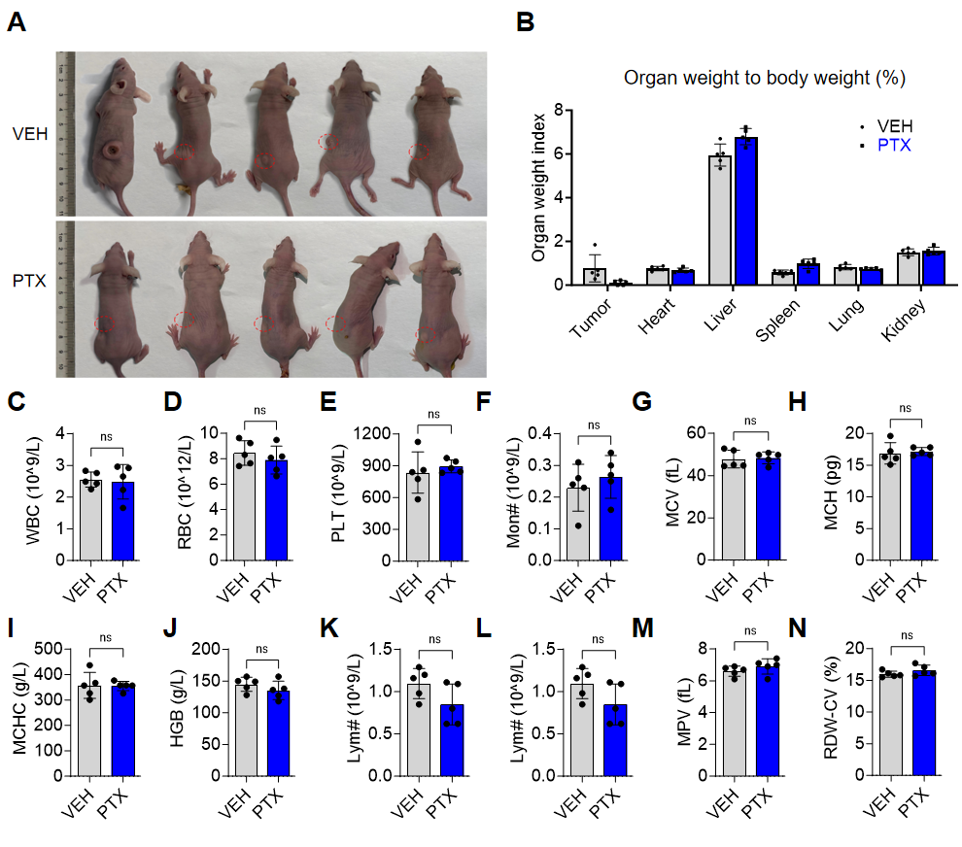

Fig. S7. Paclitaxel treatment and its effects on tumor development in nude mice. (A) Macroscopic views of xenograft tumors from mice treated with vehicle or paclitaxel, illustrating the impact of treatment on tumor size. (B) Organ weight measurements in nude mice after paclitaxel treatment. Data are expressed as mean ± SEM (n = 5 mice per group). No significant differences were observed. (C to N) Blood routine examination indicators of nude mice after paclitaxel treatment. No significant differences were observed.

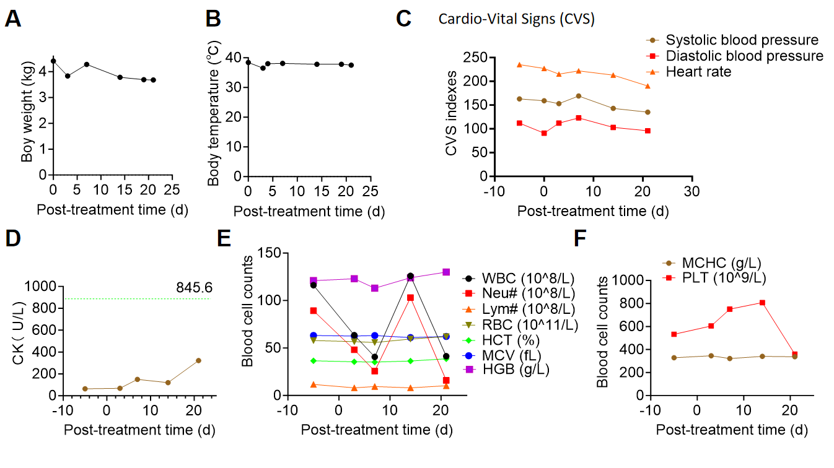

Fig. S8. Systemic safety and tolerability of paclitaxel treatment in a macaque model. (A) Body weight of the rhesus macaque before and after treatment initiation. A slight decrease was observed following paclitaxel administration, though substantial weight loss had already occurred before treatment. (B) Body temperature recordings throughout the treatment period. No obvious variations were detected. (C) Cardiovascular vital signs (CVS) were monitored during treatment. All parameters remained stable with no notable changes. (D) Serum creatine kinase (CK) levels following paclitaxel treatment. Values remained within the normal reference range for rhesus macaques (116.00–845.60 U/L), despite a mild elevation post-treatment. (E and F) Hematological parameters were assessed after paclitaxel administration. All blood cell counts remained within normal physiological ranges.

Table S1. Epidemiological characteristics of affected macaques.

Gender | Total macaques (n) | Affected (n) | Deaths (n) | Incidence rate  (per million) | Mortality rate  (per million)
Female | 1553 | 4 | 3 | 2575.66 | 1931.75
Male | 1199 | 1 | 1 | 834.03 | 834.03
Total | 2752 | 5 | 5 | 1816.86 | 1453.49

Table S2. Timeline from tumor onset to death for macaques with spontaneous cSCC.
Macaque ID | Date of onset | Age at onset (year, human-equivalent*) | Date of death | Time from diagnosis to death (d)
07350 | 2022.01.08 | 52.5 | 2022.09.05 | 241
07090 | 2024.10.21 | 59.5 | 2024.12.03 | 44
11454 | 2023.10.09 | 42 | 2024.01.30 | 114
14397 | 2022.10.28 | 28 | 2023.01.04 | 68
14422 | 2024.04.10 | 35 | 2024.09.20 | 164
*Human-equivalent age was calculated by multiplying macaque age by 3.0.

Table S3. List of qPCR primers used in this study.

Primers | Sequence (5' to 3')
rATM-F | ATTTGCTGCCGTCAACTAGAA
rATM-R | GATCTCGAATCAGGCGCTTAAA
rATR-F | GGCCAAAGGCAGTTGTATTGA
rATR-R | GTGAGTACCCCAAAAATAGCAGG
rIL6-F | ACTGACCTCTTCAGAACGAATTG
rIL6-R | CCTGAACCTTCCAAAGATGGCTG
rTNF-α-F | CCCCTCTCTAATCAGCCCTCTG
rTNF-α-R | GAGGACCTGGGAGTAGATGAG

Table S4. Antibodies used in this study.
Name in this article | Product name | Experiment | Manufacturer information | Item number | Dilution ratio
Caspase-3 | Caspase-3 Rabbit mAb | WB | Abclonal, Wuhan, China | A19654 | 1:1000
cCaspase3 | Cleaved Caspase-3 (Asp175) Antibody | WB | Cell Signaling Technology, MA,USA | 9661S | 1:1000
PARP/cPARP | PARP Antibody | WB | Cell Signaling Technology, MA, USA | 9542S | 1:1000
β-actin | β-Actin Rabbit Monoclonal Antibody | WB | Beyotime, Tianjin, China | AF5003 | 1:1000
γ-H2AX | Phospho-Histone H2AX-S139 Rabbit mAb | WB | Abclonal, Wuhan, China | AP0687 | 1:1000
MYO10 | MYO10 Rabbit Polyclonal Antibody | WB | Huabio, Shanghai, China | ER60875 | 1:1000
P-p65 | NFκB-p65 (phospho Ser468) Polyclonal Antibody | WB | UpingBiO, Hangzhou, CHINA) | YP-Ab-01269 | 1:1000
SCCA1 | Anti-SerpinB3/SCCA antibody | IF | Abcam，Cambridge, MA, USA | ab154971 | 1：100
Ki67 | Anti-Ki67 antibody | IF | Abcam，Cambridge, MA, USA | ab245113 | 1：100
CK | Anti-pan Cytokeratin antibody | IF | Abcam，Cambridge, MA, USA | ab7753 | 1：560
Vimentin | Anti-Vimentin antibody | IF | Abcam，Cambridge, MA, USA | ab92547 | 1：250
Goat Anti-Rabbit | Goat Anti-Rabbit IgG H&L | IF | Abcam，Cambridge, MA, USA | ab150079 | 1:200
Goat Anti-Mouse | Goat Anti-Mouse IgG H&L | IF | Abcam，Cambridge, MA, USA | ab150113 | 1:200
Ki67 | Anti-Ki67 antibody | IHC | MXB，Fuzhou，China | MXR002 | RTU
P63 | Anti-P63 antibody | IHC | MXB，Fuzhou，China | MX013 | RTU
CK5/6 | Anti-Cytokeratin5/6 antibody | IHC | MXB，Fuzhou，China | MX040 | RTU
MaxVision-HRP | MaxVision-HRP Mouse/Rabbit | IHC | MXB，Fuzhou，China | KIT-5030 | RTU

RTU: Ready-to-Use.

Uncropped Western blots for Fig. 4F

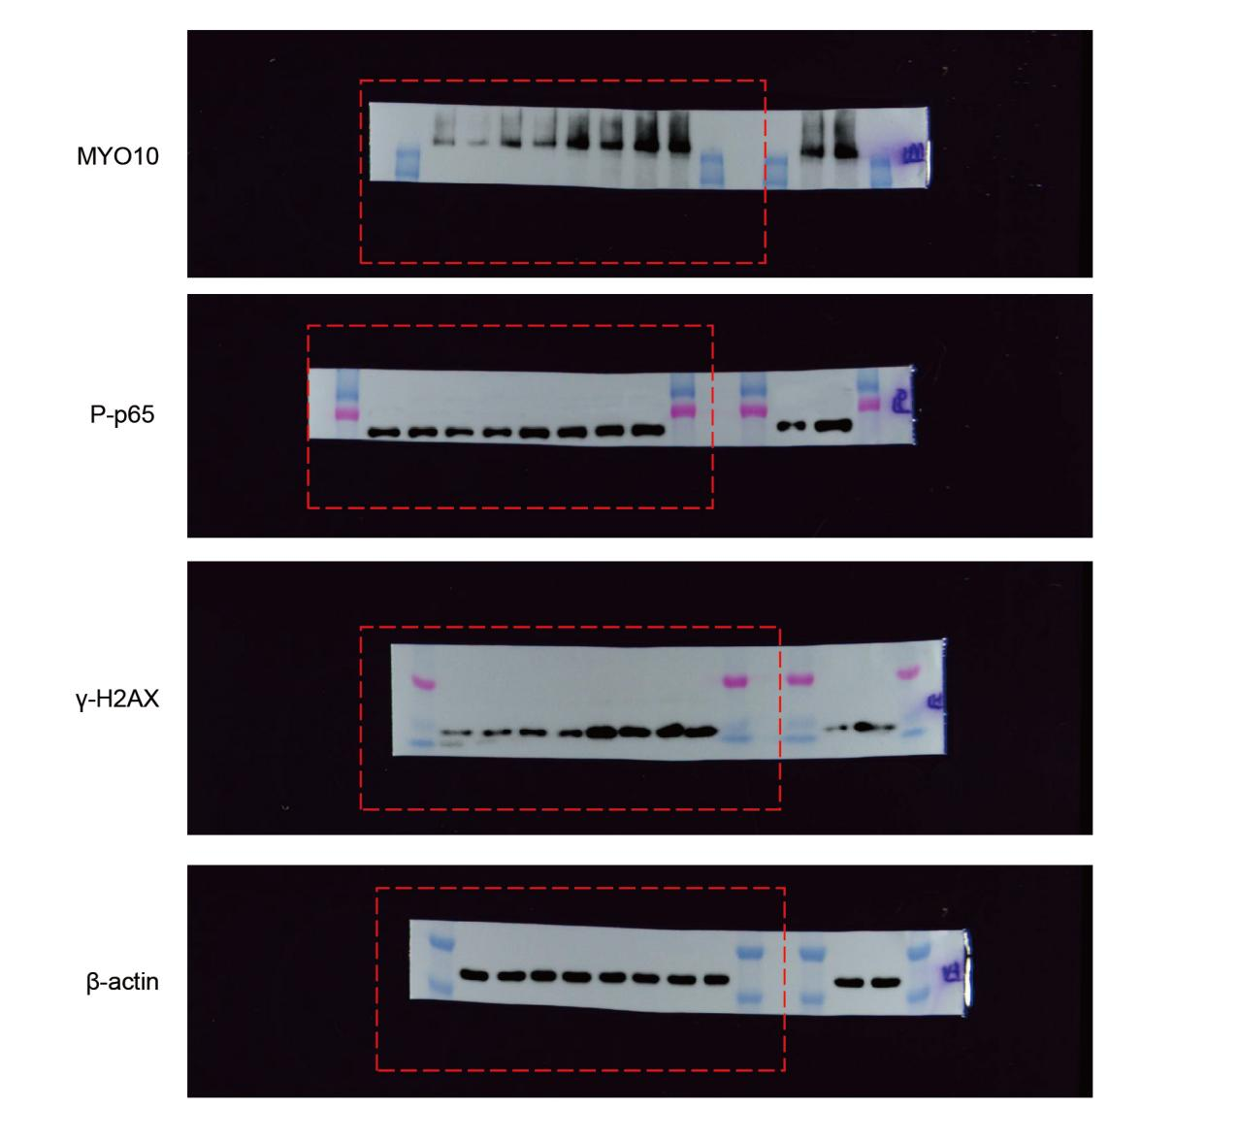

Uncropped Western blots for Fig.5, A and I 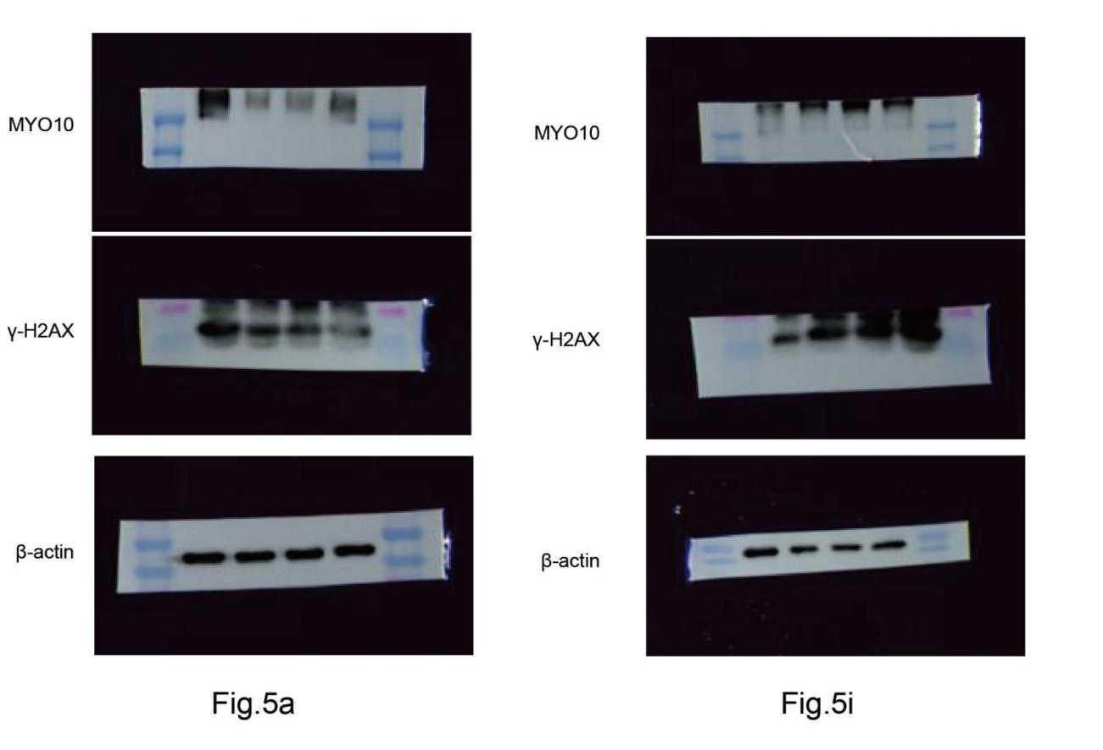

Uncropped Western blots for Fig. 6E
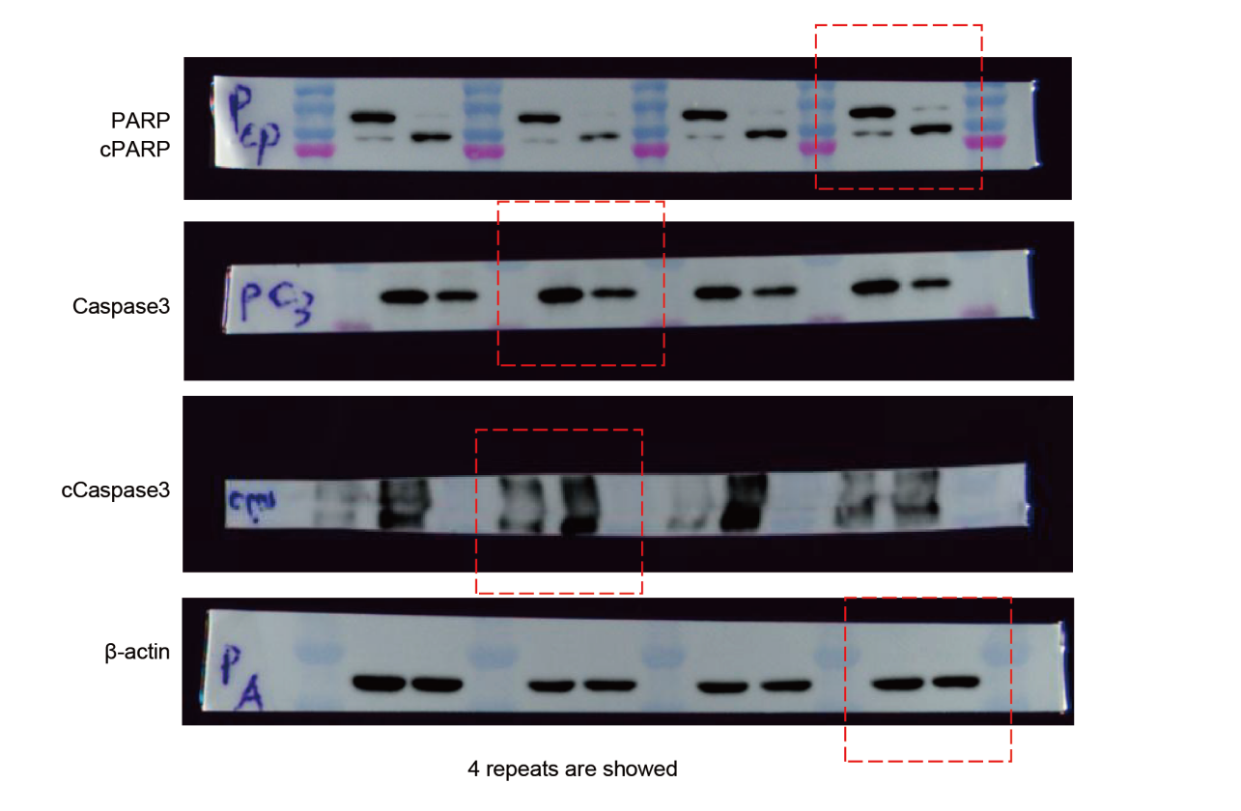

Uncropped Western blots for Fig. 7F
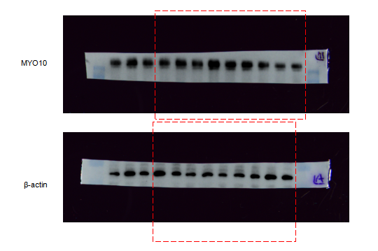

Abbreviations
cSCC: Cutaneous squamous cell carcinoma
UV: Ultraviolet
SNVs: Single-nucleotide variants
indels: Insertions and deletions
CNVs: Copy-number alterations
WGS: Whole-genome sequencing
ANT: Adjacent non-tumor tissues
ANT-C: Cells isolated from adjacent non-tumor tissues
MSCC: Macaque cutaneous squamous cell carcinoma (tissues)
MSCC-C: Macaque cutaneous squamous cell carcinoma cells
scRNA-seq: Single-cell RNA sequencing
UMAP: Uniform Manifold Approximation and Projection
DEGs: Differentially expressed genes
PCA: Principal component analysis
SNN: Shared nearest neighbor
qPCR: Quantitative Real-Time PCR
SASP: Senescence-associated secretory phenotype
RT: Reverse transcription
SDS-PAGE: Sodium dodecyl sulfate–polyacrylamide gel electrophoresis
PVDF: Polyvinylidene fluoride
TBS-T: Tris-buffered saline with Tween-20
H&E: Hematoxylin and eosin
DAB: 3,3′-diaminobenzidine
BSA: Bovine serum albumin
DAPI: 4′,6-diamidino-2-phenylindole
TUNEL: Terminal deoxynucleotidyl transferase dUTP nick end labeling
TdT: Terminal deoxynucleotidyl transferase
DIA: Data-independent acquisition
UHPLC: Ultra-high-performance liquid chromatography
MS1: Mass spectrometry level 1
SPF: Specific pathogen-free
IV: Intravenous
IM: Intramuscular
MRI: Magnetic resonance imaging
TR: Repetition time
TE: Echo time
ANOVA: Analysis of variance
SD: Standard deviation
SEM: Standard error of the mean
CK5/6: Cytokeratin 5/6
SCCA1: Squamous Cell Carcinoma Antigen 1
NF-κB: Nuclear factor kappa-light-chain-enhancer of activated B cells
HNSC: Head and neck squamous cell carcinoma
IC50: Half-maximal inhibitory concentration
VEH: Vehicle
ALT: Alanine aminotransferase
AST: Aspartate aminotransferase
CRE2: Creatinine
BUN: Blood urea nitrogen
CK: Creatine kinase
ELISA: Enzyme-linked immunosorbent assay
GO: Gene Ontology
KEGG: Kyoto Encyclopedia of Genes and Genomes
GSEA: Gene set enrichment analysis
ssGSEA: Single-sample gene set enrichment analysis
TCGA: The Cancer Genome Atlas

