- Serotype electrophoresis results (partial)

- Electrophoretic results of pilus islands genes
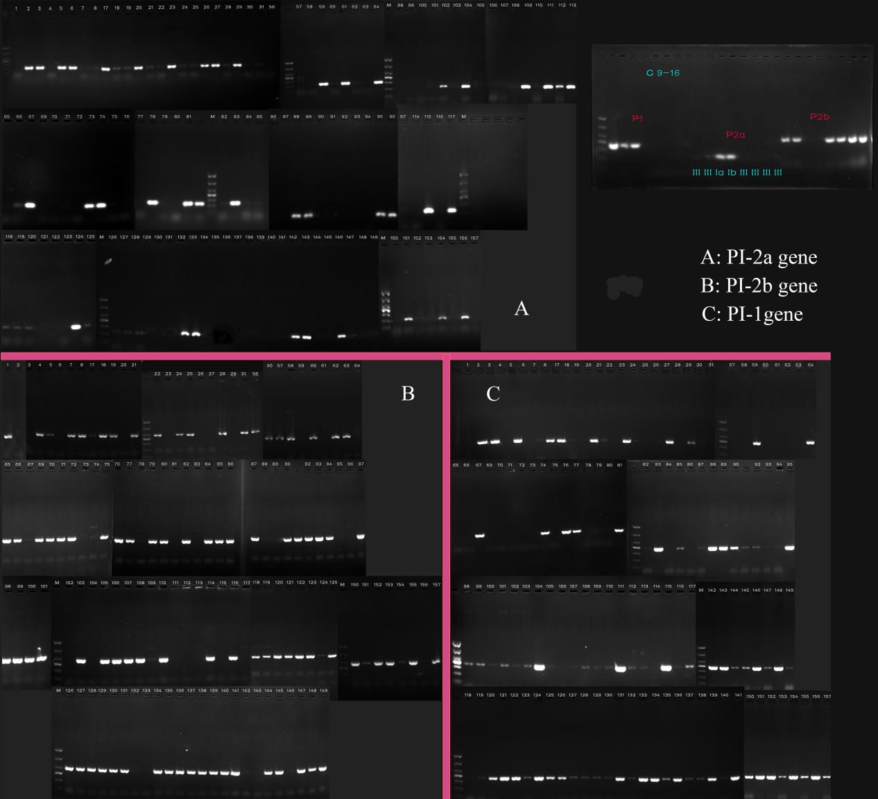

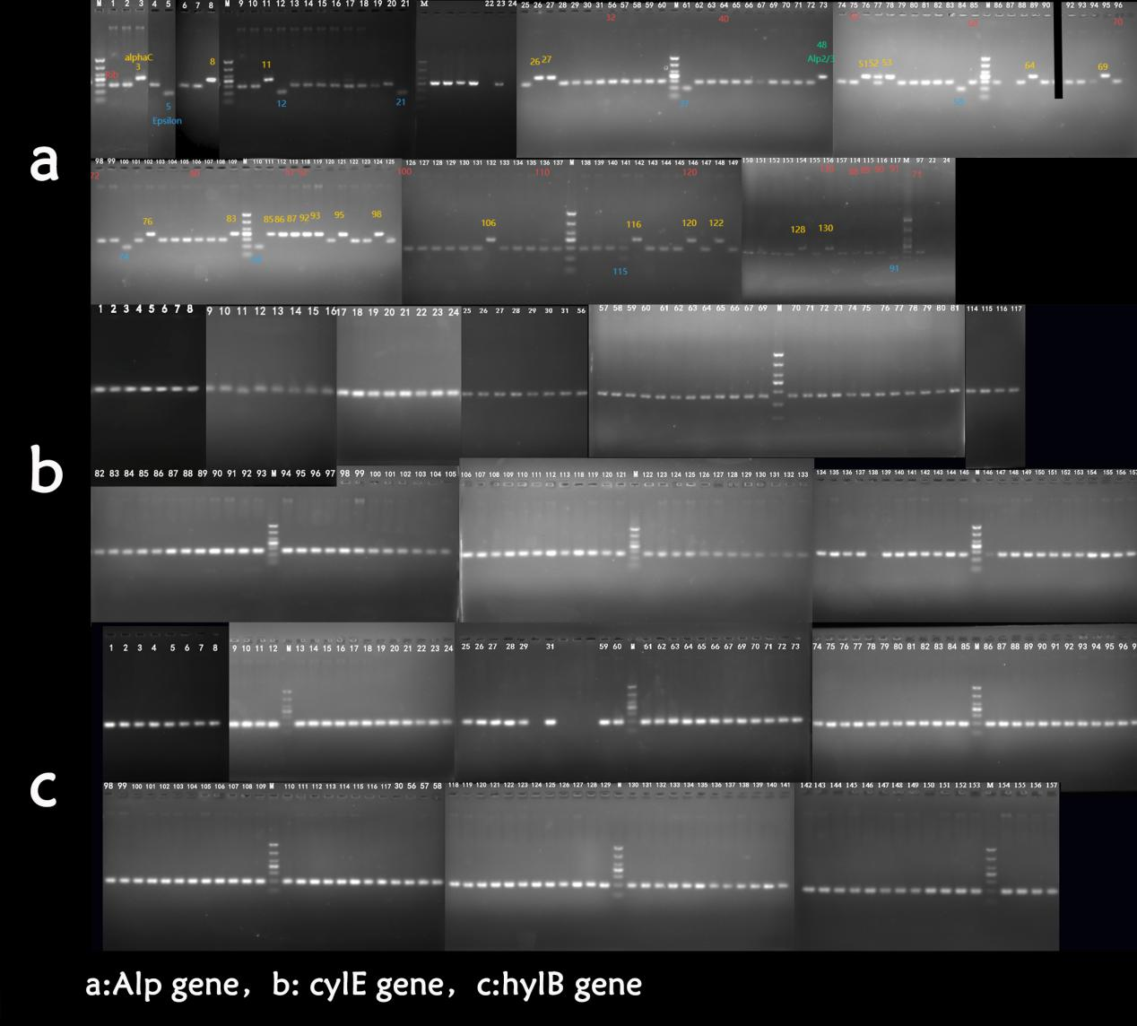
- Electrophoretic results of ALP protein family and virulence genes of cylE and hylB

