Supplementary Figures
Supplementary Figure 1. (A) White blood cell (WBC) count, C-reactive protein (CRP) concentration and max body temperature of Patient 1 prior to treatment in each course of Pembrolizumab. (B) Blood carcino-embryonic antigen (CEA) and carbohydrate antigen 199 (CA199) concentration of Patient 1 prior to treatment in each course of Pembrolizumab. (C) Summary of the diagnostic and therapeutic process of Patient 1.

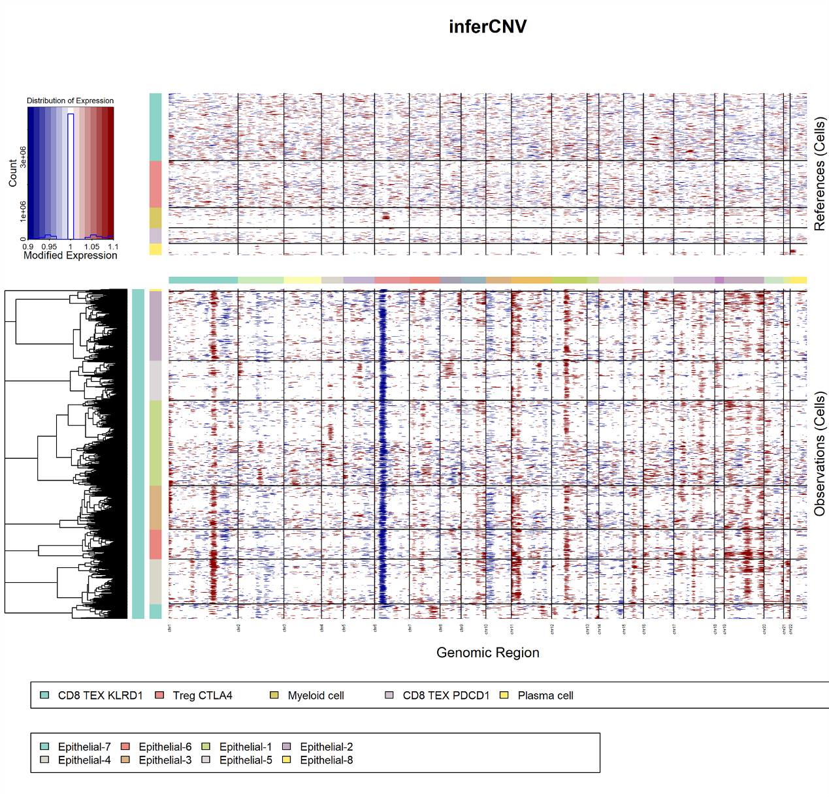
Supplementary Figure 2. The CNV landscape analysis of epithelial cells showed that most of the cells (Epithelial-1 to Epithelial-6, Epithelial-8) were malignant tumor cells, which were characterized by frequent copy number loss and deletion in several chromosomes, such as CNV at chromosomes 1 and 6. Immune cells were used as a control at the top of the figure.

Supplementary Figure 3. The expression level of immune cell marker genes in each cluster is shown using a violin plot. The immune cells were extracted and clustered using Seurat (v3) software. The cells were divided into six subtypes, including two Treg cell clusters (Treg CTLA4 and Treg FOXP3), two CD8 cell clusters (CD8 TEX KLRD1 and CD8 TEX PDCD1), a plasma cell cluster and a myeloid cell cluster. CD8 T cells were mainly exhausted cells expressing PDCD1 or KLRD, and CD4 T cells were mainly Treg cells characterized by FOXP3 expression with or without CTLA-4 expression. Myeloid cells were identified by high expression of PTPRC, C1QB, AIF, and LYZ. Plasma cells were identified by high expression of PTPRC, MZB1 and IGLL5.

Supplementary Figure 4. Predicted ligand-receptor interaction of chemokines and cytokines between subtypes of immune cells.

Supplementary Figure 5. Receiver operating characteristic (ROC) curve analysis was conducted to evaluate the diagnostic performance of the prognostic factors for ICI response. The AUC of having an inflammatory condition was 0.723 (P=0.005, 95% CI, 0.572~0.874), while the AUC of NLR>3 was 0.642 (P=0.071, 95% CI, 0.495~0.790). When two predictors were combined, the AUC was 0.758 (P=0.001, 95% CI, 0.618~0.897).

