Supplementary information for:
Integrated effects of light intensity, spectral composition and photoperiod fragmentation on duckweed growth and nutrient removal

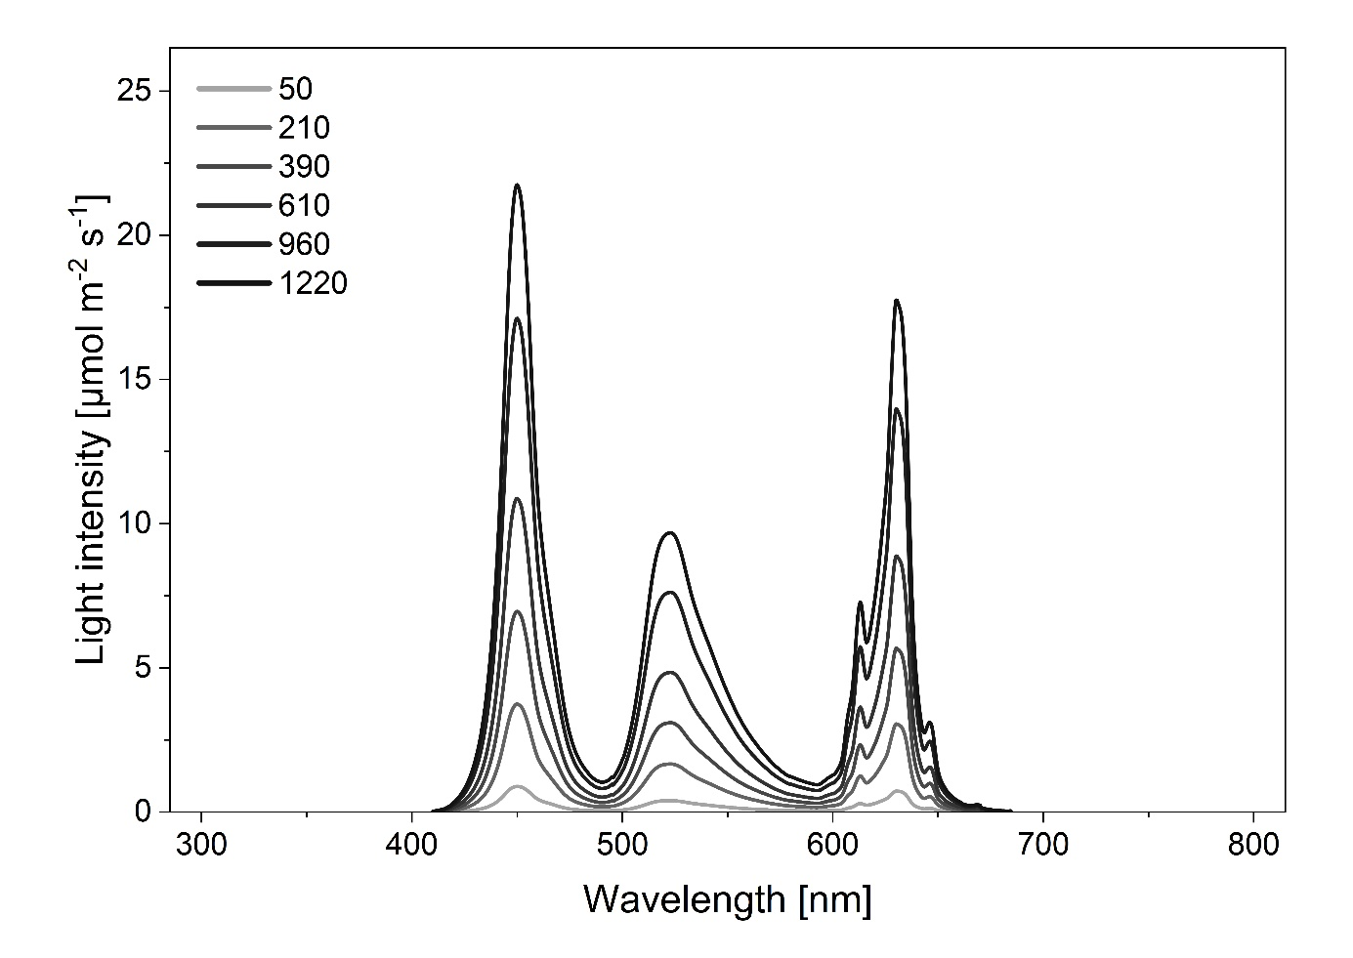
Figure S1. Emission spectra recorded at six PPFD levels (50–1220 µmol m⁻² s⁻¹) used in the light-intensity experiment.
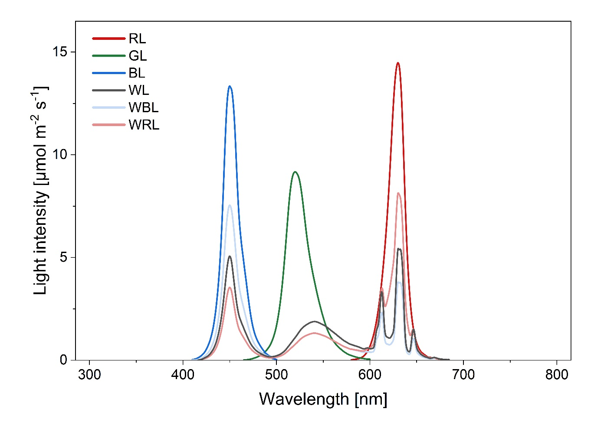
Figure S2. Emission spectra of the six spectral treatments used in the light-spectrum experiment: blue (BL), green (GL), red (RL), white (WL), white/blue split (WBL), and white/red split (WRL).

Table S1. Parameters of the Gompertz model fitted to the light-intensity response curves (estimate ± SD) for frond number- and frond surface area-based RGR, and dry biomass of L. minor, L. punctata, and S. polyrhiza, together with the coefficient of determination (R²).
Plant species | Frond number |  |  |  | Frond surface |  |  |  | Dry biomass
Plant species | RGR_{max} | x_{c} | k | R² | RGR_{max} | x_{c} | k | R² | DW_{max} | x_{c} | k | R²
L. minor | 0.448 ± 0.005 | -54.842 ± 23.474 | 0.006 ± 0.000 | 0.976 | 0.453 ± 0.009 | -159.212 ± 68.116 | 0.005 ± 0.002 | 0.928 | 12.890 ± 0.400 | 111.918 ± 8.475 | 0.007 ± 0.001 | 0.991
L. punctata | 0.367 ± 0,003 | 5.676 ± 10.101 | 0.008 ± 0.000 | 0.991 | 0.381 ± 0.001 | 8.475 ± 3.470 | 0.011 ± 0.000 | 0.998 | 11.760 ± 0.226 | 96.096 ± 7.506 | 0.007 ± 0.001 | 0.996
S. polyrhiza | 0.341 ± 0.004 | 12.970 ± 13.066 | 0.015 ± 0.002 | 0.939 | 0.328 ± 0.005 | 19.194 ± 7.734 | 0.012 ± 0.001 | 0.983 | 21.270 ± 1.420 | 90.866 ± 11.974 | 0.009 ± 0.001 | 0.979

