Table 6. Categories of Zhuang Brocade Patterns
Pattern Type | Sachet Design | Description
Geometric  Patterns | 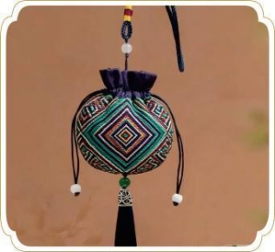 | Composed of repeated lines and shapes, conveying harmony and order.
Floral Patterns | 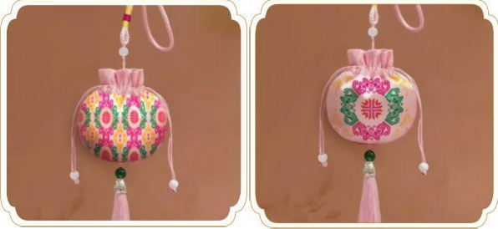 | Inspired by flowers and plants, symbolizing beauty and vitality.
Animal Motifs | 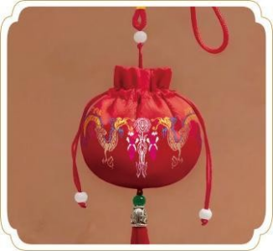 | Featuring animals such as birds or deer, often representing auspicious meanings.
Character (Calligraphic) Patterns | 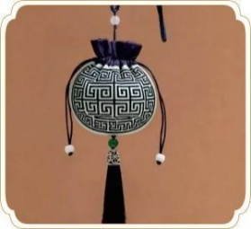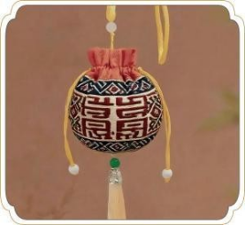 | Incorporates Chinese characters or seal scripts for symbolic or poetic meaning.
Symbolic & Auspicious Motifs | 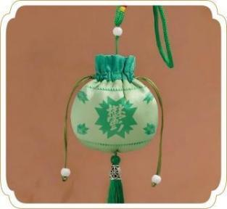 | Includes icons such as the swastika, the character “鬱(Yù)”, or other traditional symbols to express blessings, regional identity, and cultural heritage.
Note: Developed and designed by the authors based on the classification of traditional Zhuang brocade motifs and their application to the Yù fragrant sachet prototypes.

