SO₃H supported on NiFe₂O₄@SiO₂-AP nanoparticles as an efficient and heterogeneous reusable catalyst for synthesis of pyridine derivatives

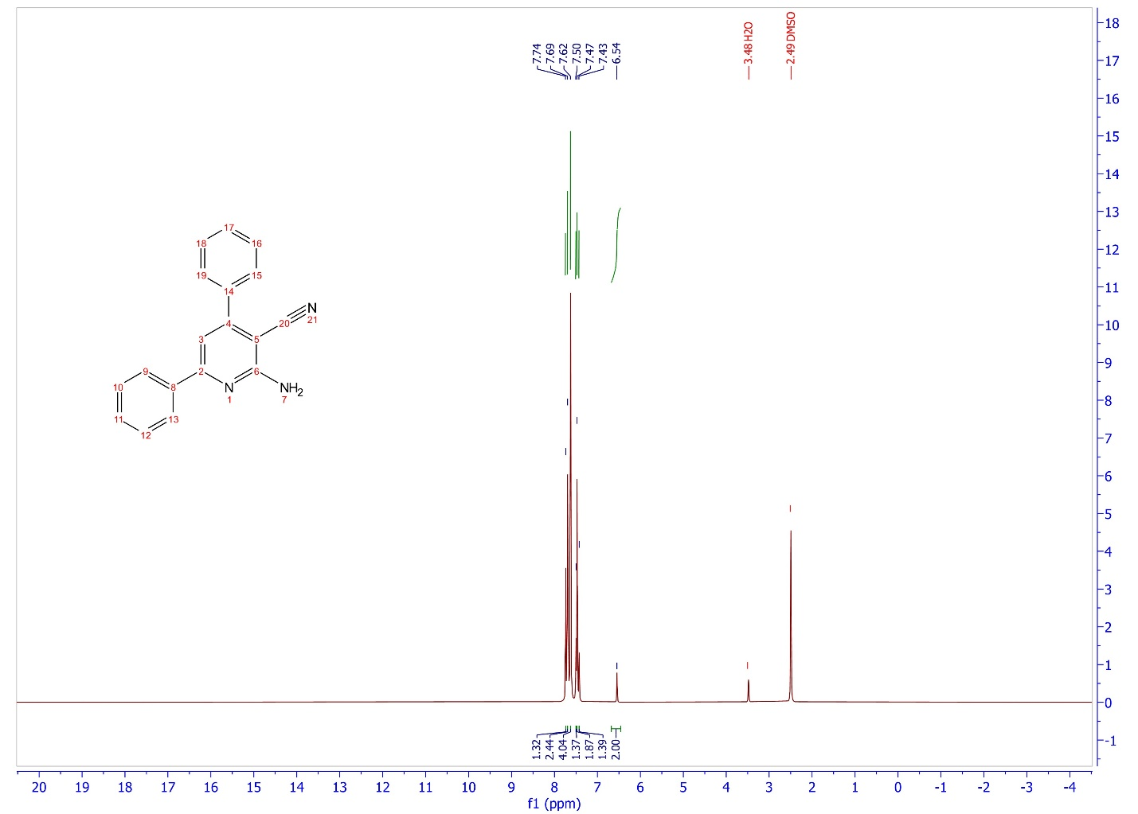
Figure S₁) 2-amino-4,6-diphenylnicotinonitrile
2-Amino-4,6-diphenylnicotinonitrile:¹H NMR (DMSO, 400 MHz): δ= 7.7 (m, 1H), 7.6 (m, 2H), 7.6 (m, 4H), 7.5 (m, 1H), 7.4 (m, 2H), 7.4(s, 1H), 6.5 (m, 2H) ppm.

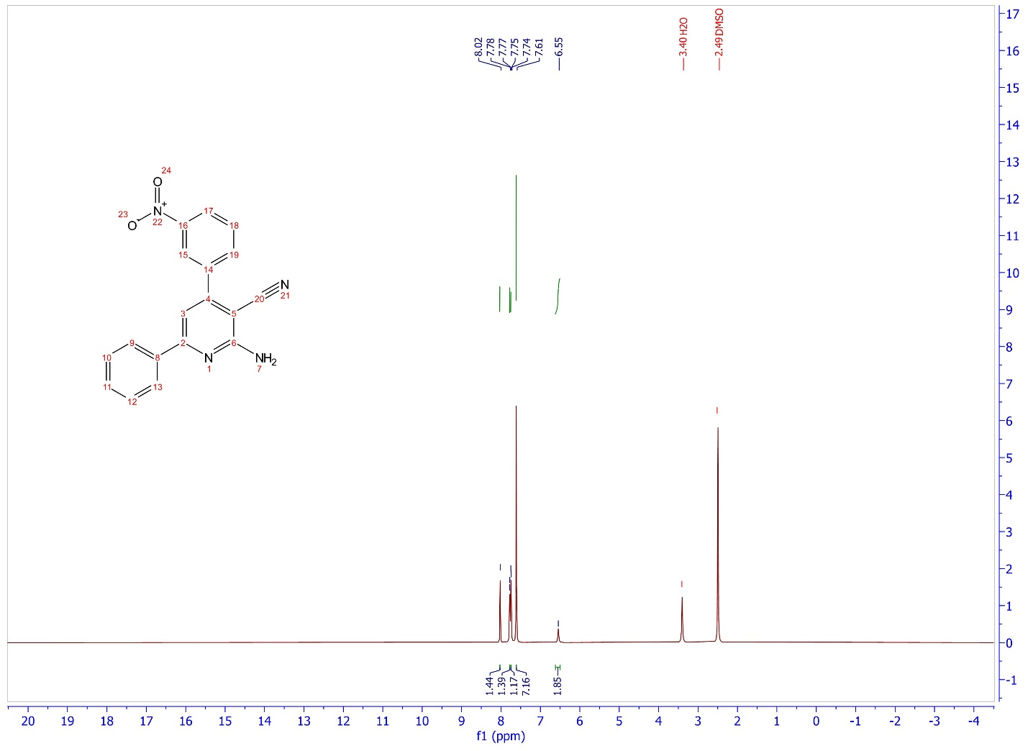
Figure S₂) 2-amino-4-(3-nitrophenyl)-6-phenylnicotinonitrile
2-Amino-4-(3-nitrophenyl)-6-phenylnicotinonitrile:¹H NMR (DMSO, 400 MHz): δ= 8.0 (s, 1H), 7.7 (m, 1H), 7.7 (m, 1H), 7.6 (m, 7H), 6.5 (m, 2H) ppm.

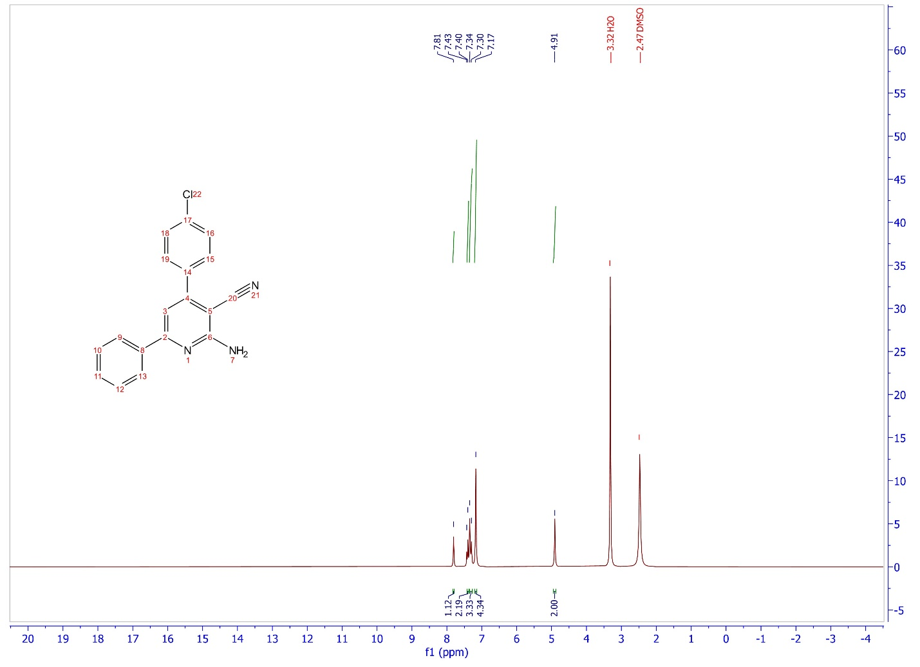
Figure S₃) 2-amino-4-(4-chlorophenyl)-6-phenylnicotinonitrile
2-Amino-4-(4-chlorophenyl)-6-phenylnicotinonitrile:¹H NMR (DMSO, 400 MHz): δ= 8.0 (s, 1H), 7.4 (m, 2H), 7.3 (m, 3H), 7.1 (m, 4H), 4.9 (s, 2H) ppm.

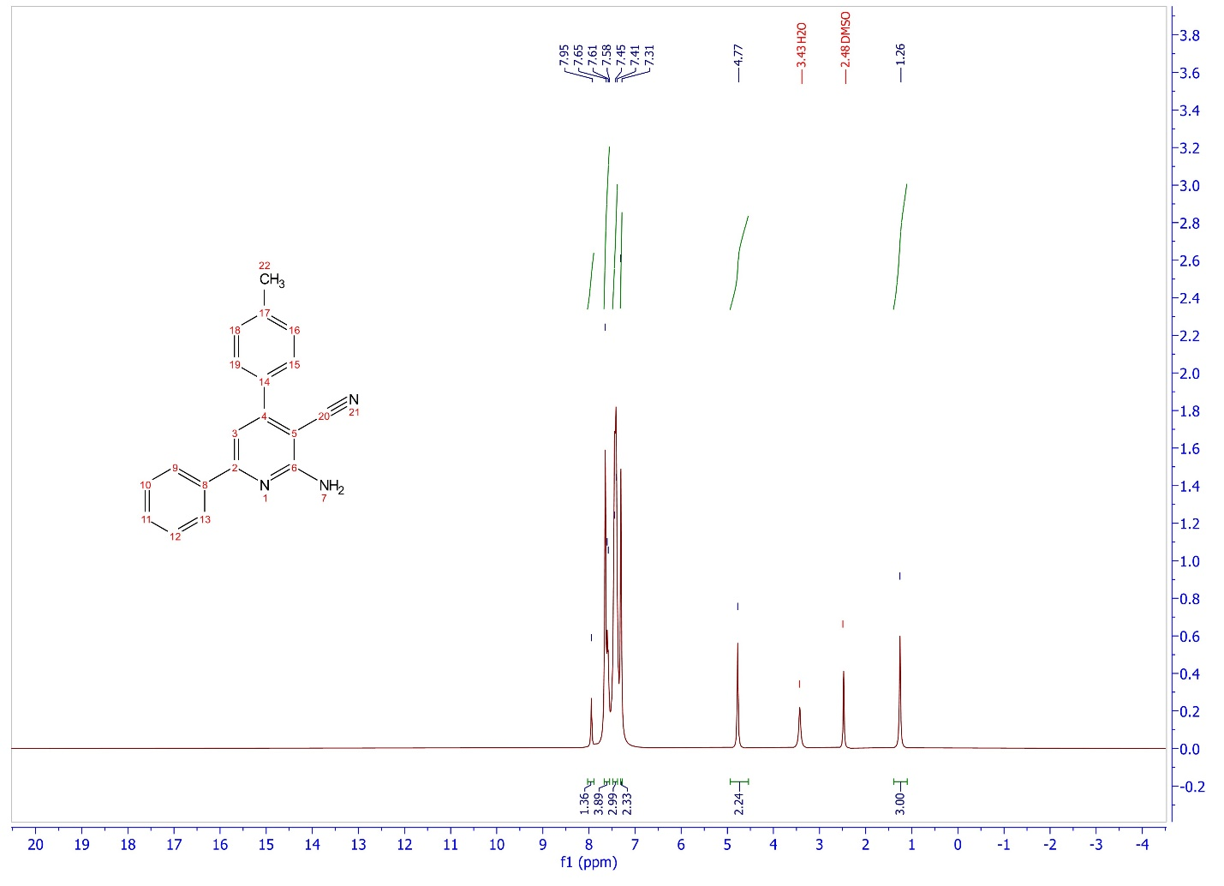
Figure S₄) 2-amino-6-phenyl-4-(p-tolyl)nicotinonitrile
2-Amino-6-phenyl-4-(p-tolyl)nicotinonitrile:¹H NMR (DMSO, 400 MHz): δ= 7.9 (s, 1H), 7.6 (m, 4H), 7.5 (m, 3H), 7.3 (m, 2H), 4.7 (s, 2H), 1.2 (s, 3H) ppm.

