Synergistic Antibiotic-Antibiotic and Antibiotic-Phage Approaches Against Biofilm-associated Staphylococcus aureus in Dual-Species Biofilm

Paria Mojarrad, Hanna Tiainen, Päivi Tammela, Timo Laaksonen, Saija J. Kiljunen, Zahra Gounani

- Comparison of the infectivity of Stab21 against S. aureus and the host S. xylosus on a solid surface and in liquid culture.
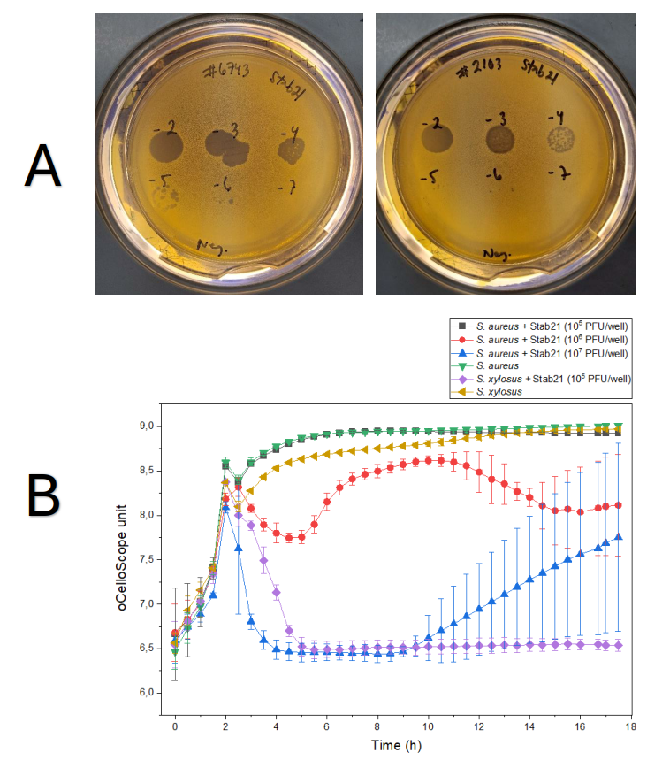

Figure S1. Comparison of the infectivity of Stab21 against S. aureus and the host S. xylosus on a solid surface and in liquid culture. In a drop test (1A), 5 µL of each phage stock in dilutions of 10⁻², 10⁻⁴, and 10⁻⁶ were added to LB soft agar containing an appropriate amount of bacteria, calculated as µL = 45 / A₆₀₀. Phage Stab21 showed strong lytic against S. aureus on a solid surface, with an EOP close to 1, although the plaques were smaller. Host strain S. xylosus acted as a positive reference. Bacterial growth curves in liquid culture were measured with an oCelloScope microscope after phage treatment (1B). 10 µL of phage lysate containing 10⁵ PFU, 10⁶ PFU or 10⁷ PFU and 200 µL of bacterial solution (1:20 dilution of A₆₀₀ = 0.035 in LB) were added to a microtiter plate. Positive control indicates bacterial growth without phage treatment. Monitoring bacterial growth for 18 hours at 37 °C without shaking showed that Stab21 did not infect S. aureus in liquid culture at 10⁵ PFU/well whereas its host strain S. xylosus, was infected. Increasing the phage titer to 10⁶ PFU/well resulted in modestly enhanced lytic activity, while 10⁷ PFU/well yielded the most pronounced lytic effect, although phage-resistance occurred after 10 hours.

2- Comparison of the infectivity of phage PA8P1 against the target P. aeruginosa (ATCC 33352) and its host P. aeruginosa (PA8) on a solid surface and in liquid culture.
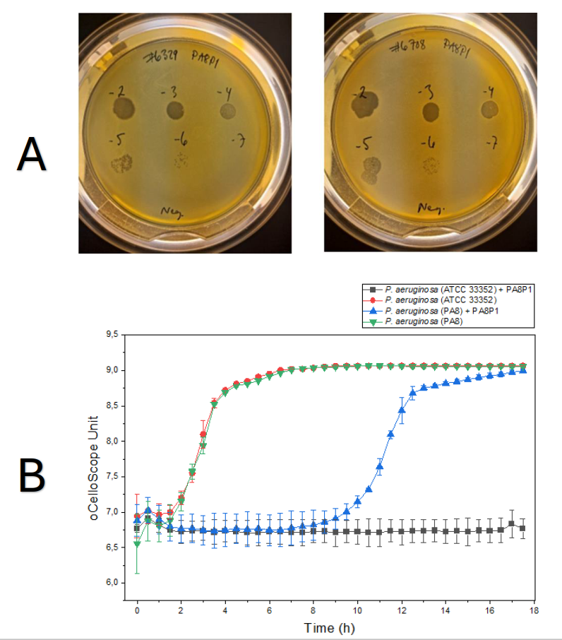
Figure S2. Comparison of the infectivity of phage PA8P1 against the target P. aeruginosa (ATCC 33352, #6708) and its host P. aeruginosa (PA 8, #6329) on a solid surface and in liquid culture. In a drop test (2A), 5 µl of phage stock in dilutions of 10⁻² to 10⁻⁷ were added to LB soft agar containing an appropriate number of bacteria, calculated as µl = 45 / A₆₀₀. PA8P1 showed strong infection against P. aeruginosa #6708 on a solid surface compared to the original host strain #6329 of phage PA8P1, which was selected as a positive reference. Bacterial growth curves in liquid culture were measured with an oCelloScope microscope after phage treatment (2B). 10 µl of phage lysate containing 10⁵ PFU and 200 µl of bacterial solution (1:10 dilution of A₆₀₀ = 0,035 in LB) were added to a microtiter plate. Positive control indicates bacterial growth without phage treatment. Monitoring bacterial growth for 18 hours at 37 °C without shaking showed that PA8P1 infected P. aeruginosa (ATCC 33352) in liquid culture and the bacterial load remained low, while the host strain PA8 developed phage resistance against PA8P1 after 10 hours of incubation.

3- Images of spotting S. aureus on MSA plates after co-culture with P. aeruginosa.
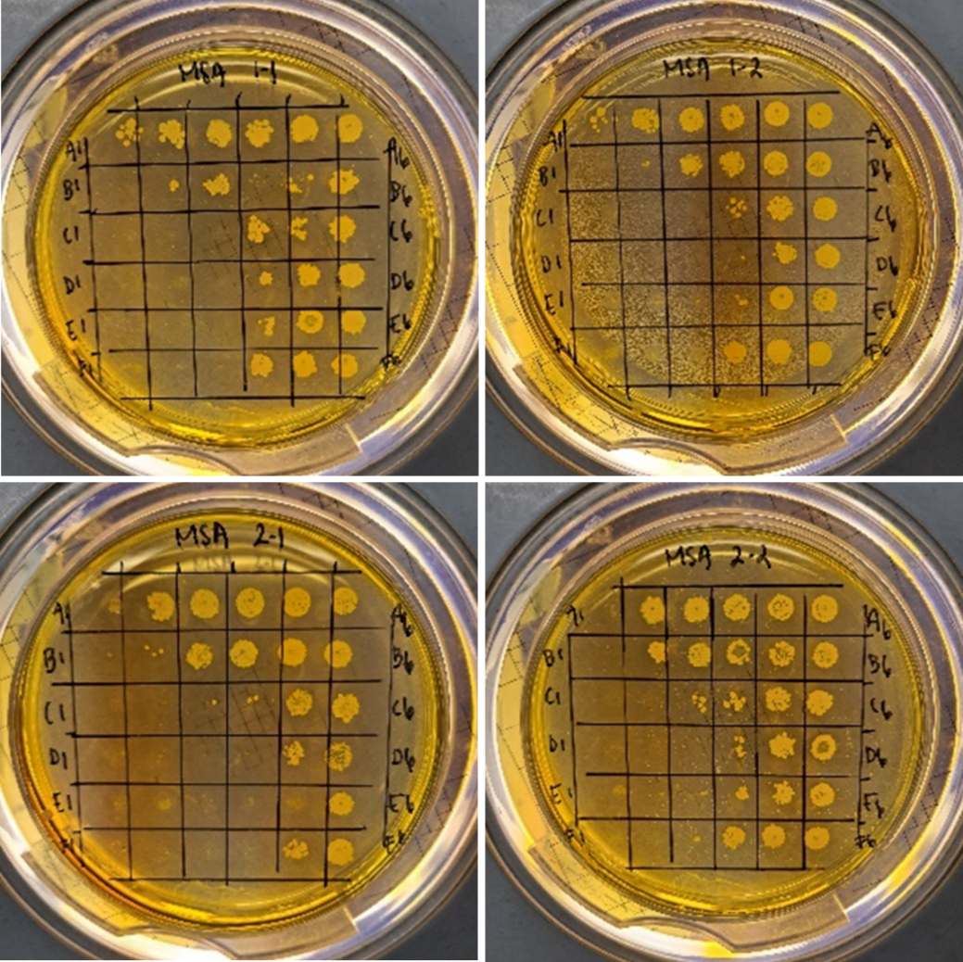
Figure S3. Experimental results demonstrate the synergistic effect of ciprofloxacin and vancomycin together with phage Stab21 in eradicating S. aureus biofilm in dual-species biofilm based on spotting samples on MSA plates. The concentration of vancomycin (in column 1) is 2048 μg/mL and serial twofold dilutions were performed, using enriched TSB, first from column 1 to 11. Next, ciprofloxacin was added in concentration of 32 μg/mL to row A, following twofold dilutions from A to row F in a 96-well plate. Of four technical replicates, only the first 6 columns from rows A to F are shown. Highest concentrations of vancomycin and ciprofloxacin could not eradicate S. aureus biofilm (well A1), however, 256 µg/mL of vancomycin and up to 1 µg/mL of ciprofloxacin (wells D3, E3, F3) successfully did.

Table S1. MBICs of ciprofloxacin and colistin alone and in combination with phage PA8P1 against P. aeruginosa in single-specious biofilm.
Treatment | MBIC (µg/ml)
Ciprofloxacin | 1.25
Colistin | 2.5
Ciprofloxacin-PA8P1 | 1.5
Colistin-PA8P1 | 2.5

Table S2. Interaction of the chosen combinations on the inhibition of the dual-species biofilms.
Antibiotics | P. aeruginosa |  |  | S. aureus
Antibiotics | FIC_{a} | FIC_{b} | ∑FICI | FIC_{a} | FIC_{b} | ∑FICI
Vancomycin-colistin | 4/>2048 | 6/64 | 0.095 | 47/>2048 | 4.47/>64 | 0.094
Vancomycin-gentamicin | 4/>2048 | 32/32 | 1.002 | 1536/>2048 | 21.12/>64 | 1.125
Vancomycin-ciprofloxacin | 88/>2048 | 2/7 | 0.313 | 102/>2048 | 0.33/>64 | 0.055
Vancomycin-levofloxacin | 4/>2048 | 3.75/5 | 0.752 | 43/>2048 | 2.5/40 | 0.083
Vancomycin-ofloxacin | 4/>2048 | 4/8 | 0.502 | 4/>2048 | 1/>64 | 0.034
Vancomycin-tobramycin | 4/>2048 | 19/19 | 1.002 | 4/>2048 | 8/>64 | 0.144
Teicoplanin-levofloxacin | 514/>2048 | 6/8 | 1.001 | 72/>2048 | 6/40 | 0.185
Penicillin-colistin | 264.5/>2048 | 40/64 | 0.754 | 24/>2048 | 24/>64 | 0.387
Penicillin-ciprofloxacin | 320/>2048 | 1.75/7 | 0.406 | 384/>2048 | 1.5/>64 | 0.211
Penicillin-levofloxacin | 8/>2048 | 2.56/5 | 0.516 | 4/>2048 | 20/40 | 0.502
Ampicillin-ciprofloxacin | 16/>2048 | 1.75/7 | 0.258 | 4/>2048 | 16/>64 | 0.252
Ampicillin-colistin | 768/>2048 | 12/64 | 0.562 | 8/>2048 | 16/>64 | 0.254
Ciprofloxacin-levofloxacin | 3.5/7 | 1.25/5 | 0.750 | 4/192 | 1/40 | 0.047
Rifampin-colistin | 7.5/>2048 | 18/64 | 0.285 | 3/48 | 2/>64 | 0.093
FIC_{a} is MBIC AB1 in combination with AB2 divided by MBIC AB1 alone; FIC_{b} is MBIC AB2 in combination with AB1 divided by MBIC AB2 alone. ∑FICI = FIC_{a} + FIC_{b.}

Table S3. Interaction of the chosen combinations on the eradication of the dual-species biofilms.
Antibiotics | P. aeruginosa |  |  | S. aureus
Antibiotics | FIC_{a} | FIC_{b} | ∑FICI | FIC_{a} |  | FIC_{b} | ∑FICI
Vancomycin-colistin | 16/>2048 | 64/>64 | 1.008 | 256/>2048 | 64/>64 |  | 1.125
Vancomycin-gentamicin | 4/>2048 | 64/>64 | 1.002 | 256/>2048 | 64/>64 |  | 1.125
Vancomycin-ciprofloxacin | 136/>2048 | 4.5/9 | 0.566 | 256/>2048 | 2/>64 |  | 0.156
Vancomycin-levofloxacin | 384/>2048 | 13.5/18 | 0.937 | 320/>2048 | 6/>64 |  | 0.250
Vancomycin-ofloxacin | 4/>2048 | 38/38 | 1.002 | 384/>2048 | 24/>32 |  | 0.199
Vancomycin-tobramycin | 4/>2048 | 48/48 | 1.002 | 192/>2048 | >64/>64 |  | 1.094
Teicoplanin-levofloxacin | 320/>2048 | 7/18 | 0.545 | 16/>2048 | 2.5/>64 |  | 0.047
Penicillin-colistin | 2007/>2048 | 64/>64 | 1.979 | 2007/>2048 | 64/>64 |  | 1.979
Penicillin-ciprofloxacin | 258/>2048 | 2.25/9 | 0.376 | 256/>2048 | 64/>64 |  | 1.125
Penicillin-levofloxacin | 1024/>2048 | 18/18 | 1.500 | 2007/>2048 | 64/>64 |  | 1.979
Ampicillin-colistin | 513/>2048 | 64/>64 | 1.250 | 1024/>2048 | 64/>64 |  | 1.500
Ampicillin-ciprofloxacin | 129/2048 | 3.38/9 | 0.438 | 2007/>2048 | 64/>64 |  | 1.979
Ciprofloxacin-levofloxacin | 11.25/9 | 1.4/18 | 1.328 | 768/>2048 | >64/>64 |  | 1.375
Rifampin-colistin | 2007/>2048 | 64/>64 | 1.979 | 512/>2048 | 32/>64 |  | 0.750
FIC_{a} is MBEC AB1 in combination with AB2 divided by MBEC AB1 alone; FIC_{b} is MBEC AB2 in combination with AB1 divided by MBEC AB2 alone. ∑FICI = FIC_{a} + FIC_{b.}

Table S4. The response of P. aeruginosa to the selected antibiotic combination in the inhibition of dual-species biofilm on cell-derived matrices (CDM).
Antibiotic combinations | MBIC AB1/AB2  (µg/mL) | Coefficient by which the MBIC of AB1 (Top Row) and AB2 (Bottom Row) is multiplied
Antibiotic combinations | MBIC AB1/AB2  (µg/mL) | 1 | 2 | 1 | 1 | 0.5 | 0.5 | 0.5 | 0.25 | 0.25 | 0.25 | 0.125 | 0.125 | 0.125 | 0.063
Antibiotic combinations | MBIC AB1/AB2  (µg/mL) | 2 | 1 | 1 | 0.5 | 1 | 0.5 | 0.25 | 0.5 | 0.25 | 0.125 | 0.25 | 0.125 | 0.063 | 0.125
Vancomycin-colistin | 4/16 | − | − | + | + | + | + | + | + | + | + | + | + | + | +
Vancomycin-ciprofloxacin | 4/1 | − | − | − | − | − | − | − | − | − | − | + | + | + | +
Vancomycin-levofloxacin | 43/2.5 | − | − | − | − | − | + | + | + | + | + | + | + | + | +
Vancomycin-ofloxacin | 64/51 | − | − | − | − | − | − | − | − | − | − | − | − | + | +
Penicillin-levofloxacin | 4/64 | − | − | − | − | − | − | − | + | + | + | + | + | + | +
Teicoplanin-levofloxacin | 72/6 | − | − | − | − | − | − | − | − | − | − | − | − | + | +
Column “MBIC AB1/AB2” indicates MBIC values of antibiotic 1 (AB1) and antibiotic 2 (AB2) when used in combination against P. aeruginosa in dual-species biofilm without CDM. The coefficients in columns 3-16 indicate the number by which MBIC values of each antibiotic are multiplied (upper row AB1 and bottom row AB2). For example, in the case of vancomycin-colistin, coefficients 2 (top) and 1 (bottom) indicate that vancomycin (AB1) is used at twofold of its MBIC (2×4=8 µg/mL), and colistin (AB2) at onefold of its MBIC (1×16=16 µg/mL). "+" indicates bacterial growth on MacConkey agar (MCA); "−" indicates no growth.

Table S5. The response of P. aeruginosa to the selected antibiotic combination in the eradication of dual-species biofilm on cell-derived matrices (CDM).
Antibiotic combinations | MBEC AB1/AB2  (µg/mL) | Coefficient by which the MBEC of AB1 (Top Row) and AB2 (Bottom Row) is multiplied
Antibiotic combinations | MBEC AB1/AB2  (µg/mL) | 1 | 2 | 1 | 1 | 0.5 | 0.5 | 0.5 | 0.25
Antibiotic combinations | MBEC AB1/AB2  (µg/mL) | 2 | 1 | 1 | 0.5 | 1 | 0.5 | 0.25 | 0.5
Vancomycin-colistin | 256/64 | + | + | + | + | + | + | + | +
Vancomycin-ciprofloxacin | 256/2 | − | − | − | − | − | − | + | +
Vancomycin-levofloxacin | 320/6 | − | + | + | + | + | + | + | +
Vancomycin-ofloxacin | 384/24 | − | − | − | − | − | − | + | +
Teicoplanin-levofloxacin | 16/2.5 | + | + | + | + | + | + | + | +
Column “MBEC AB1/AB2” indicates MBEC values of antibiotic 1 (AB1) and antibiotic 2 (AB2) when used in combination against P. aeruginosa in dual-species biofilm without CDM. The coefficient in columns 3-10 indicates the number by which MBEC values of each antibiotic are multiplied (upper row AB1 and bottom row AB2). For example, in the case of vancomycin-colistin, coefficients 2 (top) and 1 (bottom) indicate that vancomycin (AB1) is used at twofold of its MBEC (2×256 µg/mL), and colistin (AB2) at onefold of its MBEC (1×64 µg/mL). "+" indicates bacterial growth on MacConkey agar (MCA); "−" indicates no growth.

