Supplementary material: Factors associated with SARS-CoV-2 infection among healthcare workers: a European multicentre cohort study, May 2021–April 2024

Access to all VEBIS HCWs protocols
ECDC Web page

https://www.ecdc.europa.eu/en/publications-data/generic-protocol-ecdc-studies-covid-19-vaccine-effectiveness

Study protocols and main changes
- Generic protocol for ECDC studies of COVID-19 vaccine effectiveness against confirmed SARSCoV-2 using healthcare worker cohorts, v.1.0. Stockholm: ECDC; 2022. (October 2022)
  - This document outlines standardised methods for establishing the study, collecting data and undertaking analysis as well as allowing for necessary local adaptions.
  - Table 2. Data collection of common variables (key variables that should be collected) and questionnaires to be used
  - Annex 1: Questionnaires
https://www.ecdc.europa.eu/sites/default/files/documents/covid-19-generic-protocol-ECDC-studies-vaccine-effectiveness-healthcare-worker-cohorts-version-1-0%20NEW%20DECEMBER%2014.pdf

- Generic protocol for ECDC studies of COVID-19 vaccine effectiveness against confirmed SARSCoV-2 using healthcare worker cohorts, v.2.0. Stockholm: ECDC; 2022. (November 2022)
  - Table 3 highlight key variables to be collected and variables to switch to be optional
https://www.ecdc.europa.eu/sites/default/files/documents/covid-19-generic-protocol-ECDC-studies-vaccine-effectiveness-healthcare-worker-cohorts-version-2-0%20NEW%20DECEMBER%2014.pdf
- Generic protocol for ECDC studies of COVID-19 vaccine effectiveness against confirmed SARSCoV-2 infection using healthcare worker cohorts, v.3.0. Stockholm: ECDC; 2024 (January 2024)
  - Table 3 highlight key variables to be collected and variables to switch to be optional
  - Updates symptom list for ARI/ILI case definitions
  - New vaccine brands added
  - Community exposures removed (mask use, social distancing)
  - Close contact swished from 2 metres to 1 metre
  - Added loss to follow-up variables, reason and date
https://www.ecdc.europa.eu/sites/default/files/documents/Protocol-ECDC-COVID-19-vaccine-v3.pdf

Supplementary Figures and Tables

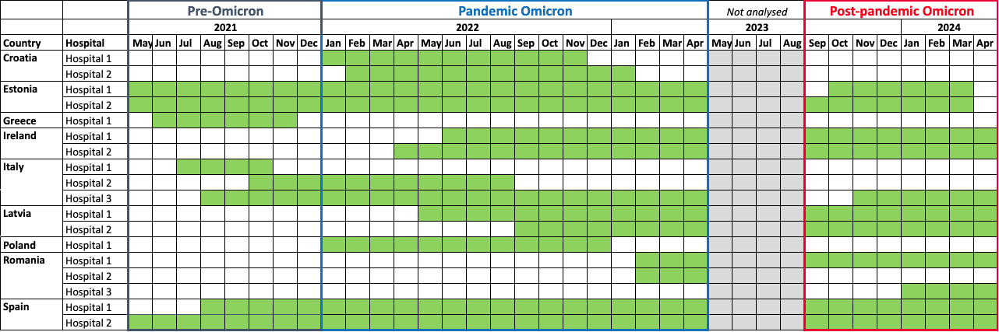
Figure S1: Recruitment periods for HCWs by participating hospitals. VEBIS-HCW European multi-centre COVID-19 study, May 2021–April 2024.

Table S1: Additional descriptive statistics of included HCWs at the start of each study period, according to infection status at the end of the period, VEBIS-HCW European multi-centre COVID-19 study, May 2021–April 2024.
Category | Pre-Omicron period |  | Pandemic Omicron period |  | Post-pandemic Omicron period
Category | Not infected (n=1342) | Infected (n=53) | Not infected (n=1456) | Infected (n=600) | Not infected (n=1005) | Infected (n=249)
Following IPC: General hand hygiene (only among patient-facing HCWs)
Not always | 68 (8%) | 0 (0%) | 84 (9%) | 23 (6%) | 78 (12%) | 14 (9%)
Always | 343 (39%) | 15 (56%) | 645 (68%) | 215 (60%) | 537 (83%) | 129 (85%)
Missing | 477 (54%) | 12 (44%) | 213 (23%) | 119 (33%) | 34 (5%) | 8 (5%)
Following IPC: Correctly wearing personal protective equipment (only among patient-facing HCWs)
Not always | 136 (15%) | 6 (22%) | 163 (17%) | 66 (18%) | 165 (25%) | 30 (20%)
Always | 731 (82%) | 20 (74%) | 761 (81%) | 286 (80%) | 465 (72%) | 118 (78%)
Missing | 21 (2%) | 1 (4%) | 18 (2%) | 5 (1%) | 19 (3%) | 3 (2%)
Following IPC: Standard precautions during patient contact (only among patient-facing HCWs)
Not always | 54 (6%) | 0 (0%) | 95 (10%) | 33 (9%) | 108 (17%) | 16 (11%)
Always | 328 (37%) | 10 (37%) | 624 (66%) | 200 (56%) | 505 (78%) | 128 (85%)
Missing | 506 (57%) | 17 (63%) | 223 (24%) | 124 (35%) | 36 (6%) | 7 (5%)
Wearing a mask indoors*
Always/Often | 1228 (92%) | 49 (92%) | 836 (57%) | 364 (61%) | - | -
Sometimes/Never/Rarely | 98 (7%) | 4 (8%) | 604 (41%) | 235 (39%) | - | -
Missing | 16 (1%) | 0 (0%) | 16 (1%) | 1 (0%) | - | -
Receiving visitors at home*
Never/Rarely | 786 (59%) | 29 (55%) | 996 (68%) | 388 (65%) | - | -
Occasionally | 446 (33%) | 19 (36%) | 380 (26%) | 174 (29%) | - | -
Everyday/Most of the time | 108 (8%) | 5 (9%) | 76 (5%) | 38 (6%) | - | -
Missing | 2 (0%) | 0 (0%) | 4 (0%) | 0 (0%) | - | -
Frequency of attending gatherings
Never | 661 (49%) | 32 (60%) | 554 (38%) | 206 (34%) | 307 (31%) | 71 (29%)
One to two times | 505 (38%) | 17 (32%) | 616 (42%) | 283 (47%) | 405 (40%) | 103 (41%)
Three or more | 169 (13%) | 3 (6%) | 276 (19%) | 110 (18%) | 282 (28%) | 73 (29%)
Missing | 7 (1%) | 1 (2%) | 10 (1%) | 1 (0%) | 11 (1%) | 2 (1%)
Frequency of taking public transport
Never | 787 (59%) | 31 (58%) | 740 (51%) | 283 (47%) | 382 (38%) | 75 (30%)
One to two times | 204 (15%) | 6 (11%) | 227 (16%) | 112 (19%) | 176 (18%) | 57 (23%)
Three or more | 348 (26%) | 16 (30%) | 485 (33%) | 204 (34%) | 436 (43%) | 115 (46%)
Missing | 3 (0%) | 0 (0%) | 4 (0%) | 1 (0%) | 11 (1%) | 2 (1%)
* Data not collected during post-pandemic period

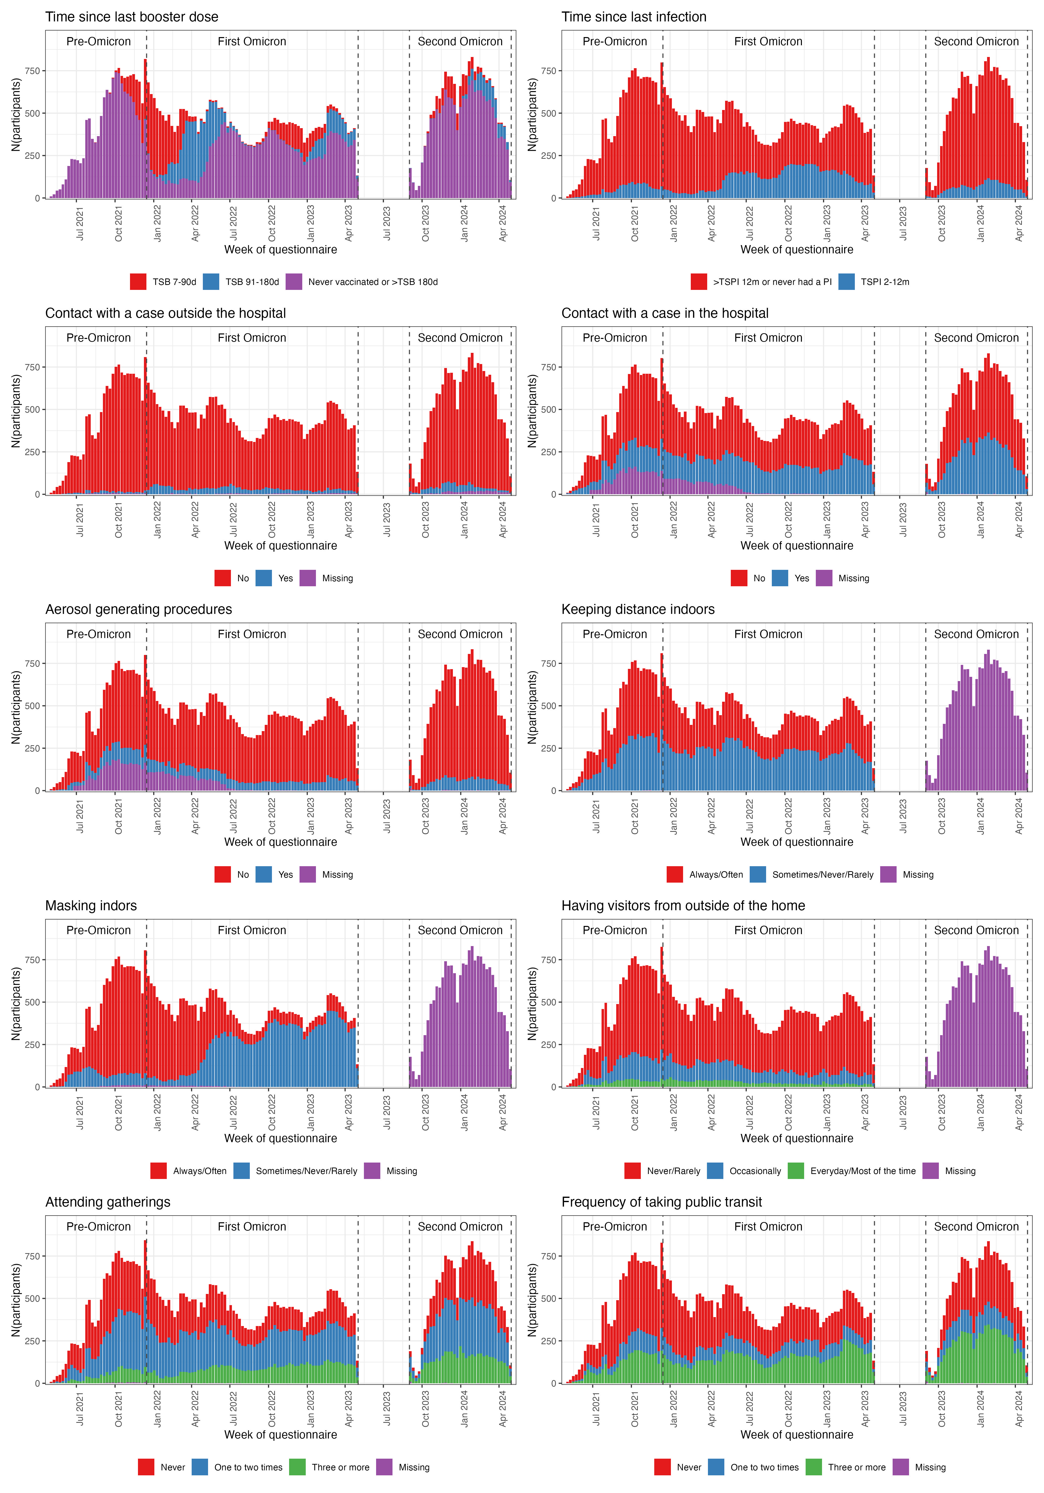Figure S2: Description of time-varying exposures over time. VEBIS-HCW European multi-centre COVID-19 study, May 2021–April 2024.

Table S2: Results from Cox proportion hazard models for additional variables, all three periods. VEBIS-HCW European multi-centre COVID-19 study, May 2021–April 2024. The number of included HCWs in each model as well as the events and person-time are listed for the crude models. These numbers can differ from the total number of included HCWs for each period either due to missing data in the assessed variable (lower number of included HCWs) or due to HCWs being included in multiple categories over the period for time-varying exposures.
Exposure | Response | N (HCWs) | N (events) | Person-time | Crude HR  (95% CI) | Adjusted HR (95% CI)
Pre-Omicron period
Smoking | Non-smoker | 1048 | 45 | 92313 | 1 (ref) | 1 (ref)
Smoking | Current smoker | 313 | 8 | 27193 | 0.62 (0.29; 1.35) | 0.56 (0.25; 1.26)
Alcohol consumption | Occasionally/Never | 146 | 4 | 12741 | 1 (ref) | 1 (ref)
Alcohol consumption | Weekly | 834 | 28 | 71886 | 1.21 (0.42; 3.46) | 1.22 (0.42; 3.53)
Alcohol consumption | Daily | 231 | 10 | 18874 | 1.83 (0.57; 5.89) | 1.71 (0.51; 5.72)
Hand hygiene: Before patient contact | Not always | 116 | 5 | 11628 | 1 (ref) | 1 (ref)
Hand hygiene: Before patient contact | Always | 636 | 19 | 53626 | 0.9 (0.31; 2.56) | 0.92 (0.32; 2.66)
Hand hygiene: Before antiseptic procedure | Not always | 39 | 0 | 3474 | 1 (ref) | 1 (ref)
Hand hygiene: Before antiseptic procedure | Always | 712 | 24 | 61779 | DNC | DNC
Hand hygiene: After body fluid contact | Not always | 22 | 0 | 2444 | 1 (ref) | 1 (ref)
Hand hygiene: After body fluid contact | Always | 731 | 24 | 62969 | DNC | DNC
Hand hygiene: After patient contact | Not always | 87 | 2 | 9005 | 1 (ref) | 1 (ref)
Hand hygiene: After patient contact | Always | 666 | 22 | 56299 | DNC | DNC
Hand hygiene: After patient environment | Not always | 170 | 7 | 16331 | 1 (ref) | 1 (ref)
Hand hygiene: After patient environment | Always | 582 | 17 | 48977 | 0.78 (0.3; 2.03) | 0.78 (0.3; 2.05)
Pandemic Omicron period
Smoking | Non-smoker | 1567 | 499 | 184213 | 1 (ref) | 1 (ref)
Smoking | Current smoker | 457 | 120 | 51197 | 0.9 (0.74; 1.11) | 0.91 (0.74; 1.12)
Alcohol consumption | Occasionally/Never | 320 | 115 | 37991 | 1 (ref) | 1 (ref)
Alcohol consumption | Weekly | 1357 | 425 | 160828 | 1.04 (0.83; 1.3) | 1.03 (0.83; 1.29)
Alcohol consumption | Daily | 308 | 80 | 34485 | 0.94 (0.7; 1.28) | 0.94 (0.69; 1.28)
Hand hygiene: Before patient contact | Not always | 167 | 48 | 19837 | 1 (ref) | 1 (ref)
Hand hygiene: Before patient contact | Always | 1033 | 292 | 113493 | 0.9 (0.65; 1.24) | 0.9 (0.65; 1.25)
Hand hygiene: Before antiseptic procedure | Not always | 78 | 18 | 8366 | 1 (ref) | 1 (ref)
Hand hygiene: Before antiseptic procedure | Always | 1106 | 319 | 123717 | 1.09 (0.67; 1.77) | 1.1 (0.67; 1.79)
Hand hygiene: After body fluid contact | Not always | 49 | 9 | 5044 | 1 (ref) | 1 (ref)
Hand hygiene: After body fluid contact | Always | 1144 | 330 | 127986 | 1.32 (0.68; 2.59) | 1.33 (0.68; 2.59)
Hand hygiene: After patient contact | Not always | 128 | 35 | 13348 | 1 (ref) | 1 (ref)
Hand hygiene: After patient contact | Always | 1073 | 305 | 120024 | 0.88 (0.61; 1.27) | 0.9 (0.63; 1.3)
Hand hygiene: After patient environment | Not always | 291 | 74 | 31439 | 1 (ref) | 1 (ref)
Hand hygiene: After patient environment | Always | 906 | 262 | 101806 | 1.01 (0.76; 1.35) | 1.01 (0.76; 1.34)
Post-pandemic Omicron period
Smoking | Non-smoker | 972 | 208 | 102669 | 1 (ref) | 1 (ref)
Smoking | Current smoker | 284 | 49 | 29916 | 0.81 (0.59; 1.13) | 0.8 (0.57; 1.11)
Alcohol consumption | Occasionally/Never | 174 | 33 | 20424 | 1 (ref) | 1 (ref)
Alcohol consumption | Weekly | 814 | 171 | 84041 | 1.04 (0.7; 1.55) | 1.08 (0.72; 1.62)
Alcohol consumption | Daily | 240 | 47 | 24634 | 1.07 (0.66; 1.72) | 1.08 (0.66; 1.76)
Hand hygiene: Before patient contact | Not always | 116 | 21 | 11026 | 1 (ref) | 1 (ref)
Hand hygiene: Before patient contact | Always | 676 | 134 | 71828 | 0.96 (0.59; 1.54) | 1 (0.61; 1.63)
Hand hygiene: Before antiseptic procedure | Not always | 55 | 11 | 5601 | 1 (ref) | 1 (ref)
Hand hygiene: Before antiseptic procedure | Always | 724 | 141 | 76347 | 0.96 (0.51; 1.79) | 1.04 (0.54; 2)
Hand hygiene: After body fluid contact | Not always | 41 | 7 | 4031 | 1 (ref) | 1 (ref)
Hand hygiene: After body fluid contact | Always | 744 | 147 | 78537 | 1.27 (0.59; 2.72) | 1.25 (0.58; 2.69)
Hand hygiene: After patient contact | Not always | 94 | 17 | 9287 | 1 (ref) | 1 (ref)
Hand hygiene: After patient contact | Always | 695 | 138 | 73376 | 0.99 (0.59; 1.67) | 1.03 (0.6; 1.77)
Hand hygiene: After patient environment | Not always | 175 | 28 | 17310 | 1 (ref) | 1 (ref)
Hand hygiene: After patient environment | Always | 613 | 126 | 65525 | 1.07 (0.68; 1.66) | 1.11 (0.7; 1.74)
DNC: model did not converge due too few events in one of the groups. CI confidence interval, HR hazard ratio, ref reference

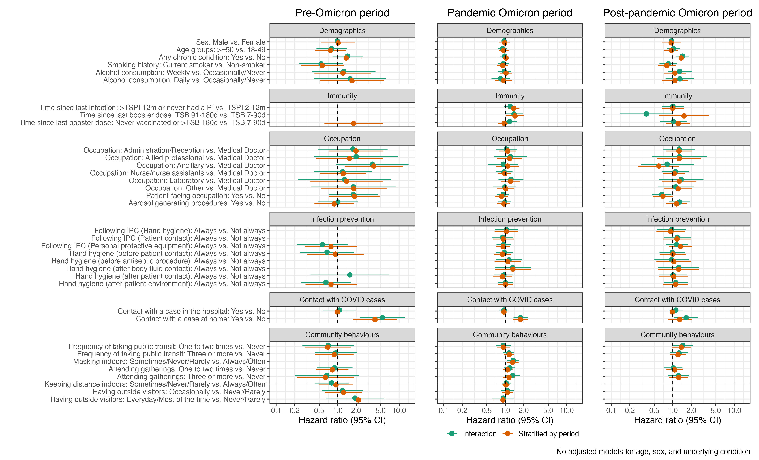
Figure S3: Comparison of introducing an interaction term for period and stratification by period. VEBIS-HCW European multi-centre COVID-19 study, May 2021–April 2024.
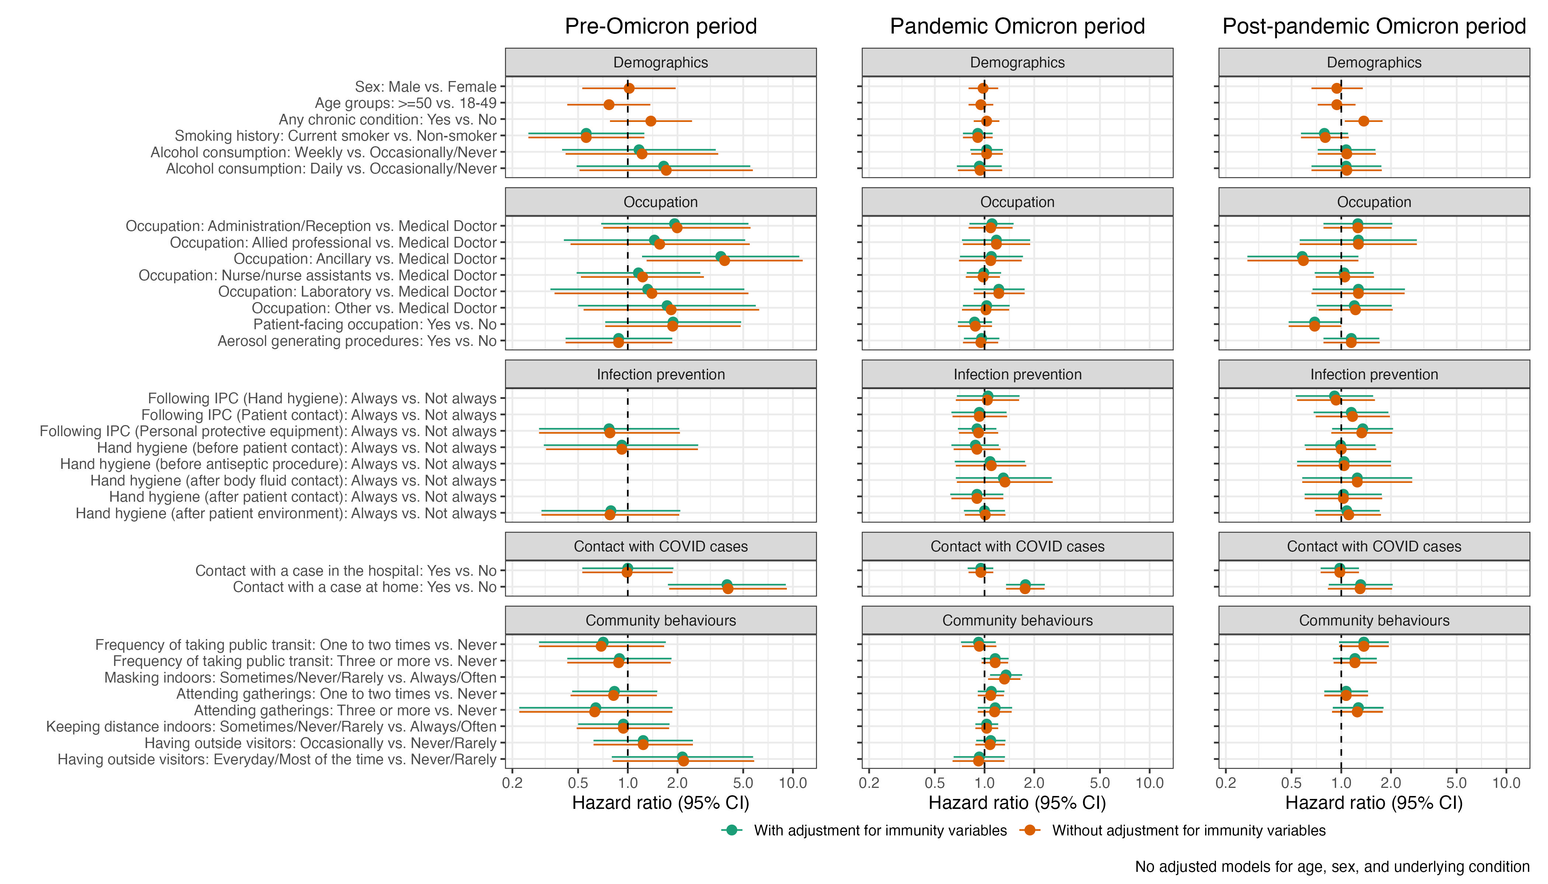
Figure S4: Comparison of adjusting for immunity variables vs. not adjusting for variables. VEBIS-HCW European multi-centre COVID-19 study, May 2021–April 2024

