Additional file 2: Split screen Compare case description and reference the guide

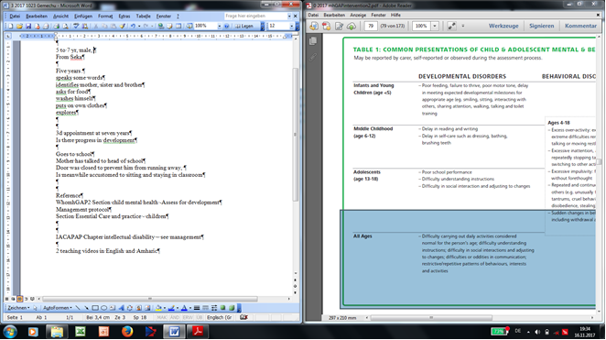

Left: Clinical case report Right: Compare to WHOmhGAP2 guide,
Section child mental health - table 1

