Fig. S1
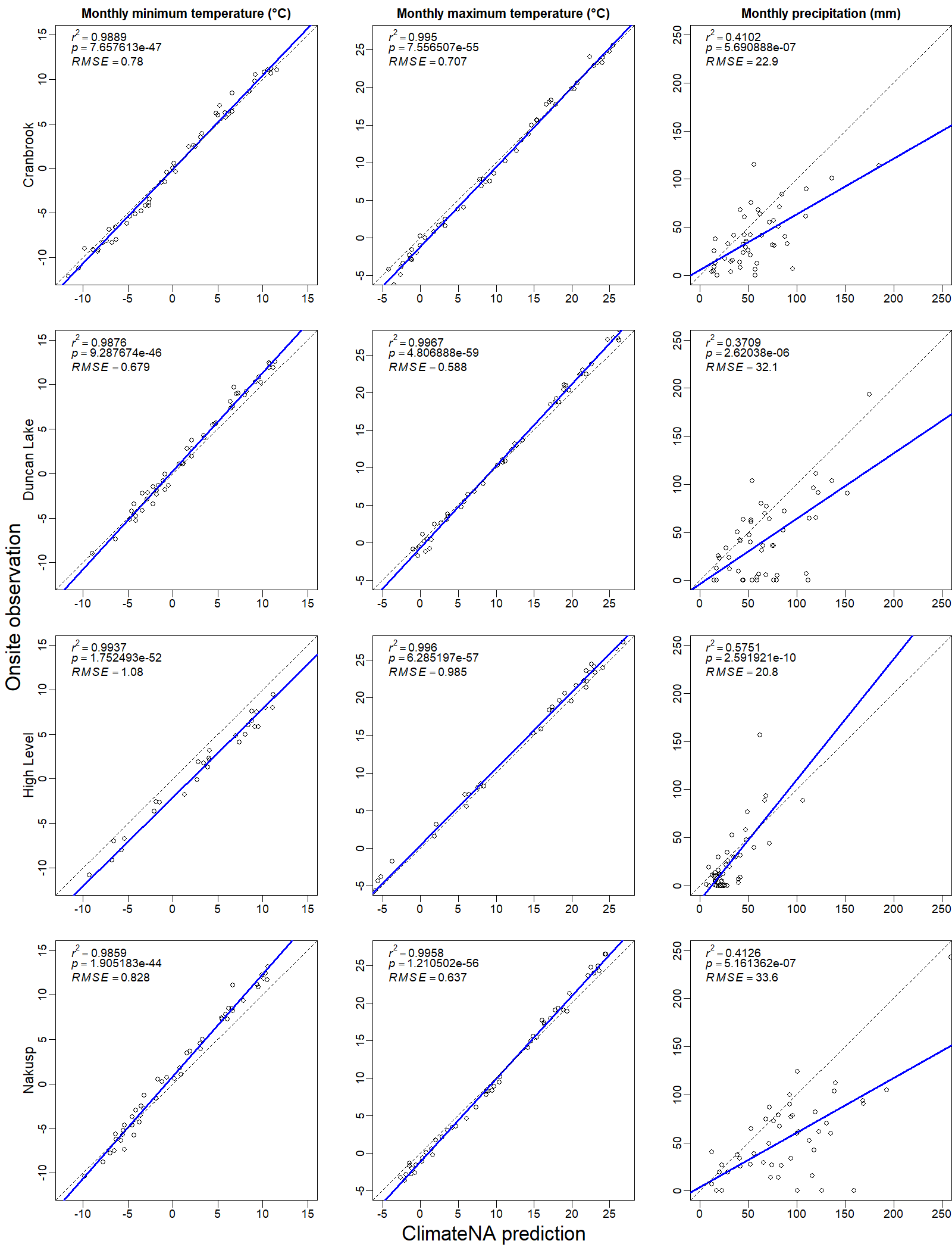
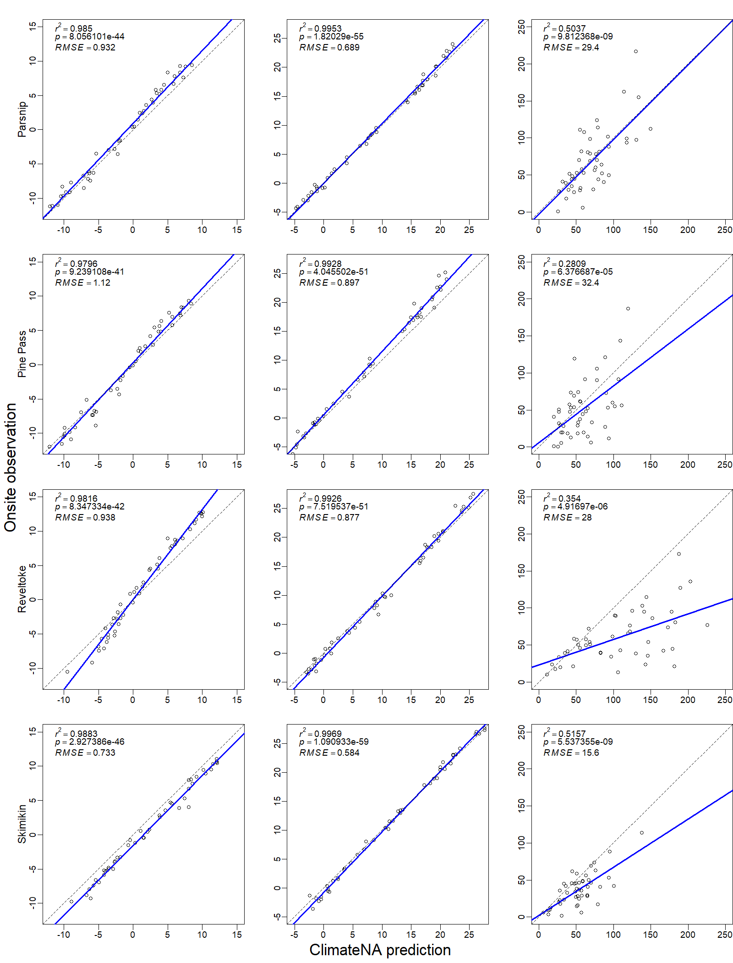

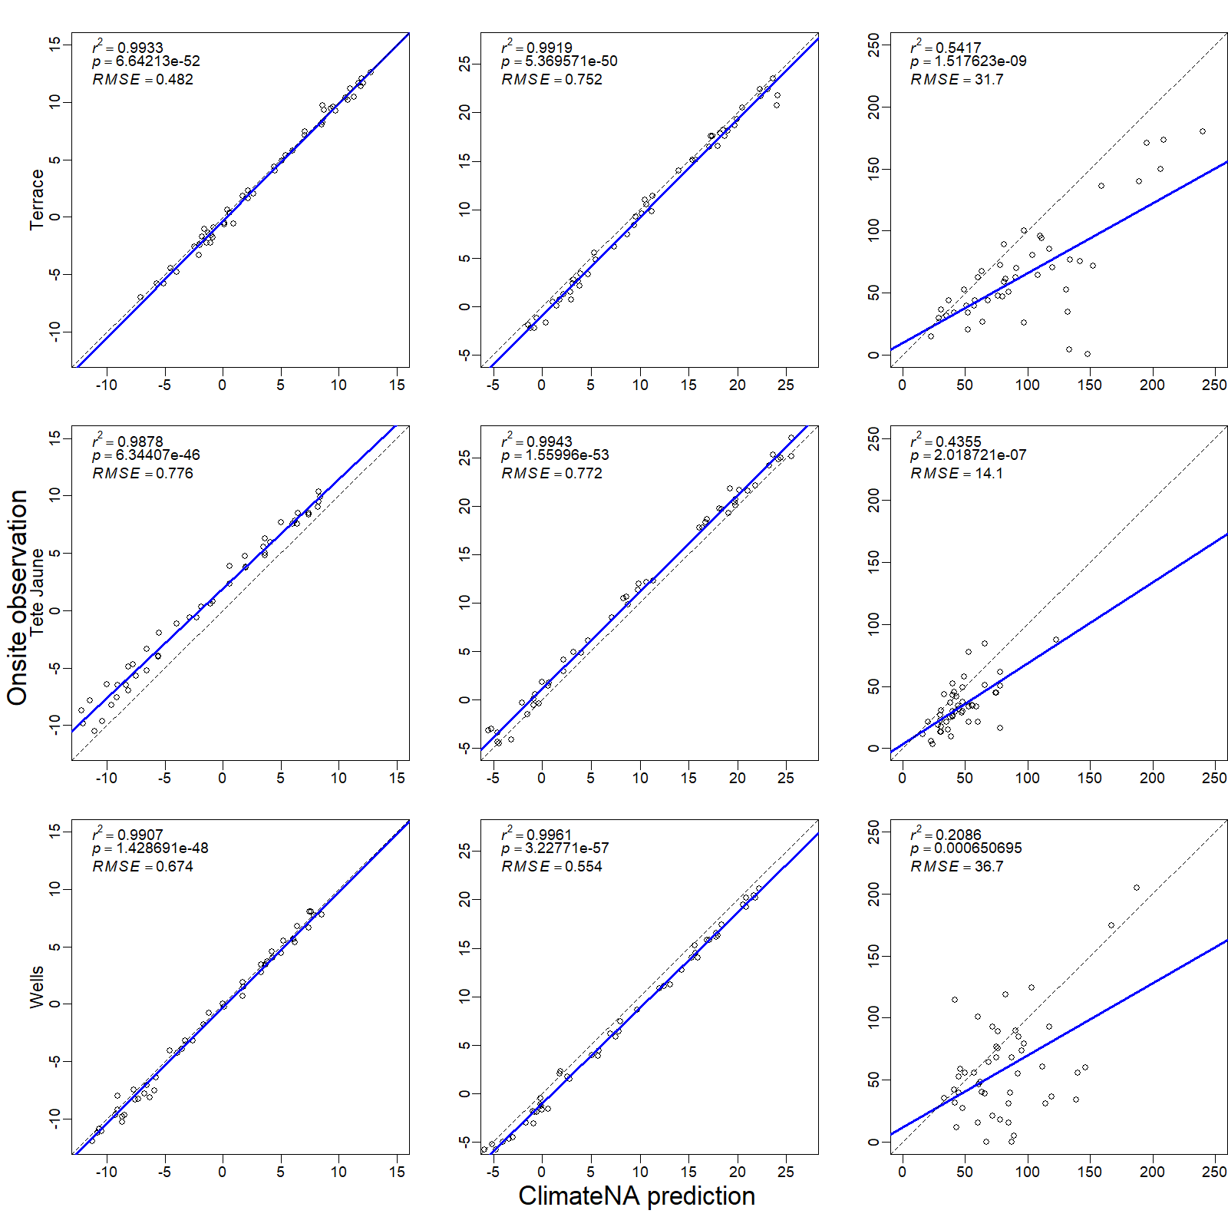
Relationships between observed and predicted (by ClimateNA) monthly minimum, monthly maximum, and monthly precipitation at all 11 test sites from 2011 to 2014. The blue lines are regression lines; the dashed lines are the 1:1 line. There are 48 (= 12 months X 4 years) points per scatterplot

