Novel hyaluronic acid-coated polymeric micelles with ROS scavenging to encapsulate statins for alleviating atherosclerosis
Dan Mu^{a *}, Jianhui Li^{b}, Yu Qi^{c}, Xuan Sun^{c}, Yihai Liu^{b}, Song Shen^{b}, Yuyu Li^{d}, Biao Xu^{c e *}, Bing Zhang^{a f *}
ªDepartment of Radiology, Affiliated Nanjing Drum Tower Hospital of Nanjing University Medical School, Nanjing, 210008, China.
^{b}Department of Cardiology, Nanjing Drum Tower Hospital, Clinical College of Nanjing Medical University, Nanjing, 210008, China.
^{c}Department of Cardiology, Affiliated Nanjing Drum Tower Hospital of Nanjing University Medical School, Nanjing, 210008, China.
^{d}Department of Cardiology, Nanjing Drum Tower Hospital, Medical School of Nanjing University, Nanjing, 210008, China.
^{e}State Key Laboratory of Pharmaceutical Biotechnology, Nanjing University, Nanjing, 210023, Jiangsu, China.
^{f}Institute of Brain Science, Nanjing University, Nanjing, Jiangsu, 210008, China.
*Correspondence to:
Dan Mu, Department of Radiology, Affiliated Nanjing Drum Tower Hospital of Nanjing University Medical School, Nanjing, 321 Zhongshan road, Nanjing, Jiangsu, China, 210008 (e-mail: mudan118@126.com).
Biao Xu, Department of Cardiology, Affiliated Nanjing Drum Tower Hospital of Nanjing University Medical School, Nanjing, 210008, China. State Key Laboratory of Pharmaceutical Biotechnology, Nanjing University, 321 Zhongshan road, Nanjing, Jiangsu, China, 210008 (e-mail: xubiao62@nju.edu.cn).
Bing Zhang, Department of Radiology, Affiliated Nanjing Drum Tower Hospital of Nanjing University Medical School, Nanjing, 210008, China. Institute of brain Science, Nanjing University, 321 Zhongshan road, Nanjing, Jiangsu, China, 210008 (e-mail: zhangbing_nanjing@nju.edu.cn).
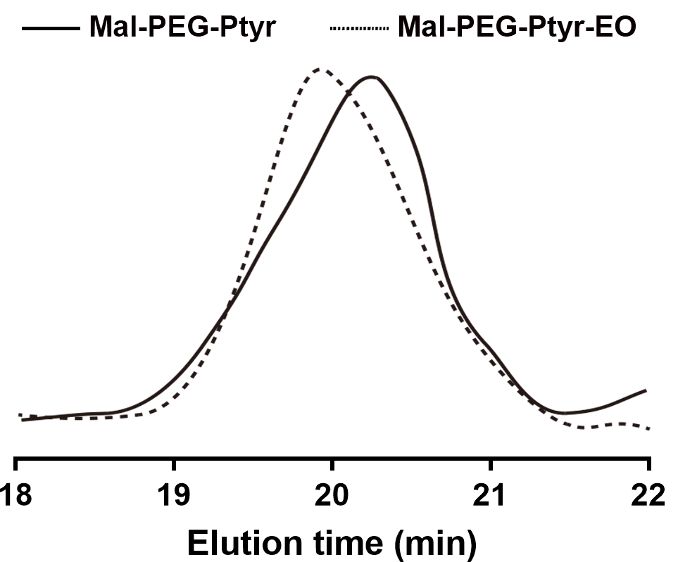
Figure S1. The GPC traces of Mal-PEG-Ptyr and Mal-PEG-Ptyr-EO.
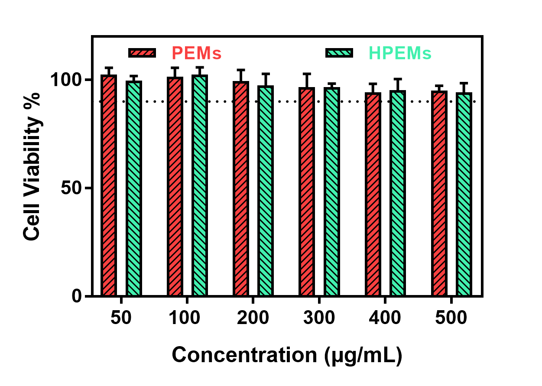
Figure S2. Cytotoxicity of LPS-induced RAW264.7 macrophage cells incubated with PEMs and HPEMs for 24 h.
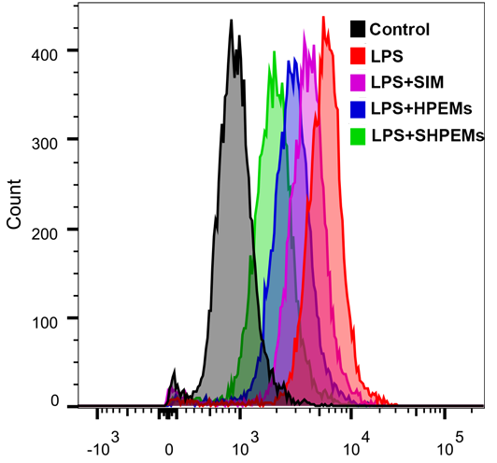
Figure S3. Flow cytometry analysis of ROS generation after treatment with different formulations.

