Supporting Information
Preparation and characterization of a NextelTM 720/ alumina ceramic composites via an improved prepreg process

Hao Liª, Bo-xing Zhang^{a,}*, Ying Guo^{b}, Weijian Han^{b}, Tong Zhao^{b}, Wenfeng Qiu ^{a,}*

ªSouth China Advanced Institute for Soft Matter Science and Technology, School of Molecular Science and Engineering, South China University of Technology, 381 Wushan Road, Tianhe District, Guangzhou 510640, China
^{b}Laboratory of Advanced Polymer Materials, Institute of Chemistry, Chinese Academy of Sciences, Zhongguancun North First Street 2, Beijing 100190, China

*Corresponding authors:
Bo-xing Zhang, email: bxzhang@scut.edu.cn
Wenfeng Qiu, email: wfqiu@scut.edu.cn

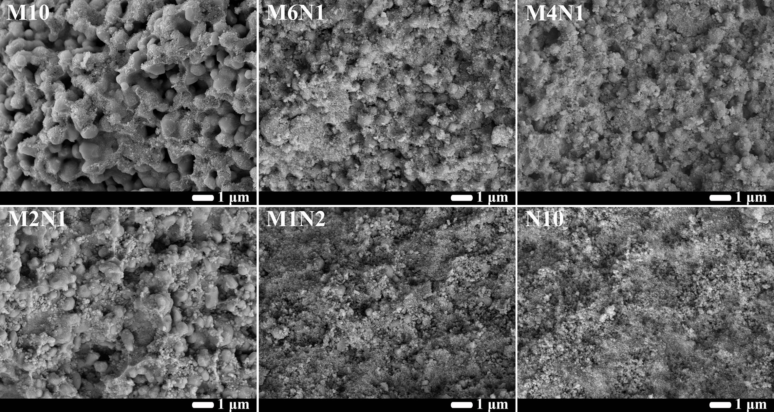
Fig. S1 Cross-sectional SEM images of bulk ceramic samples sintered at 800℃ for 2h.

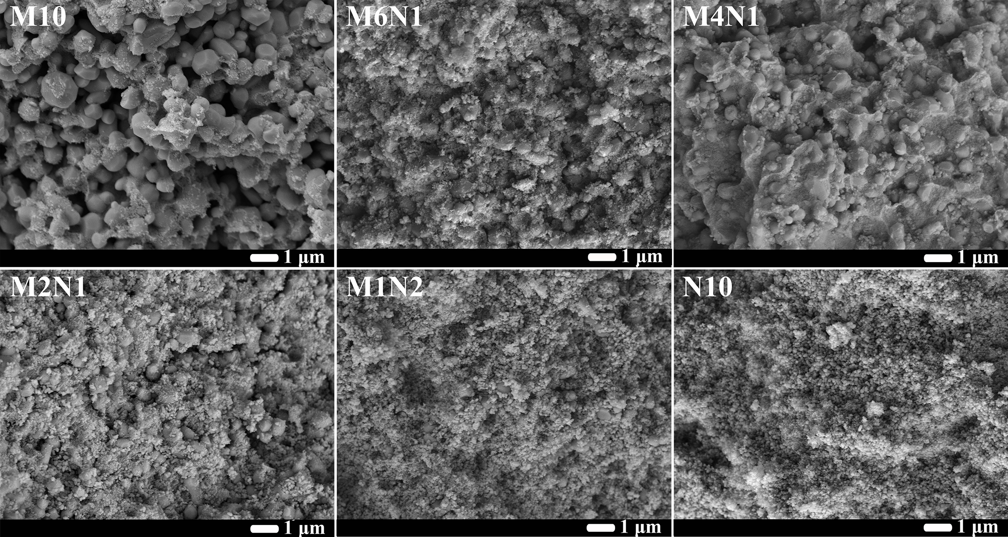
Fig. S2 Cross-sectional SEM images of bulk ceramic samples sintered at 1000℃ for 2h.

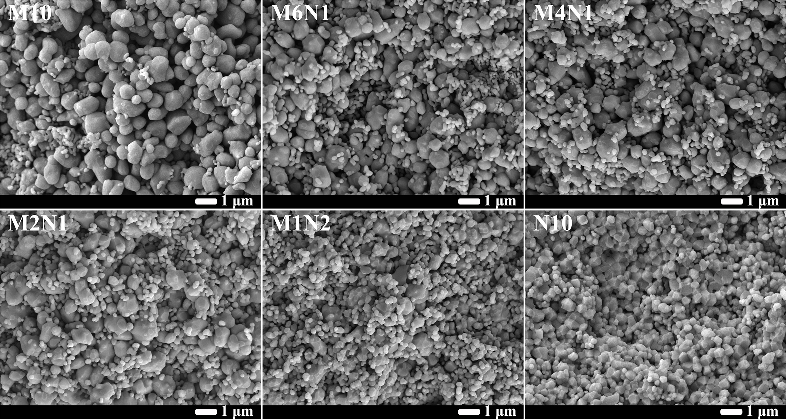
Fig. S3 Cross-sectional SEM images of bulk ceramic samples sintered at 1300℃ for 2h.

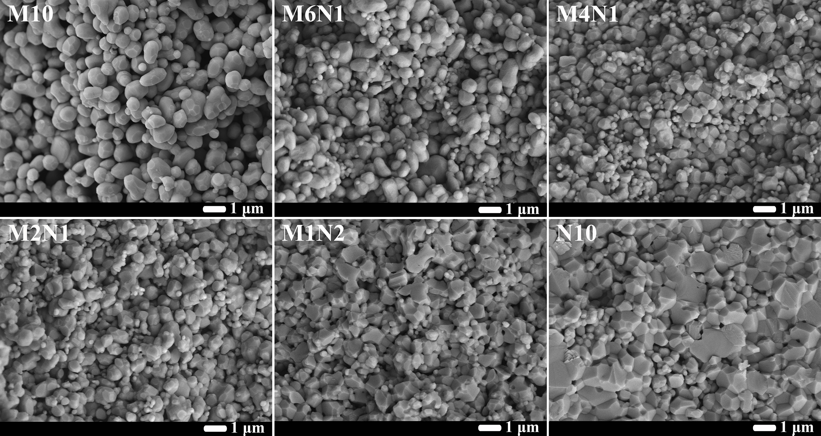
Fig. S4 Cross-sectional SEM images of bulk ceramic samples sintered at 1400℃ for 2h.

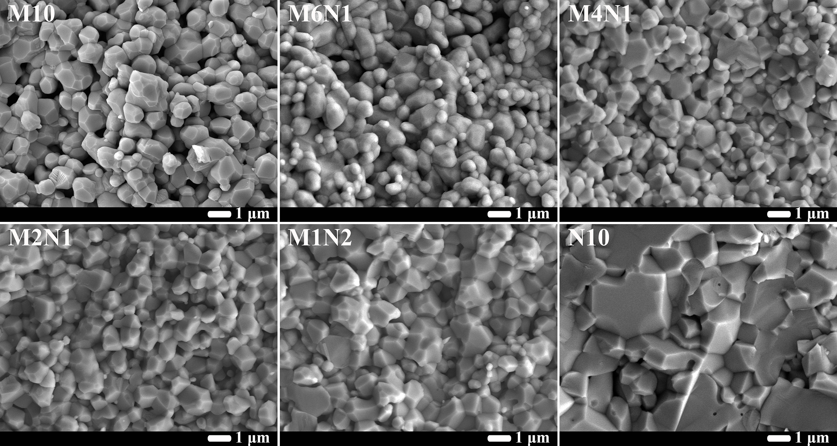
Fig. S5 Cross-sectional SEM images of bulk ceramic samples sintered at 1500℃ for 2h.

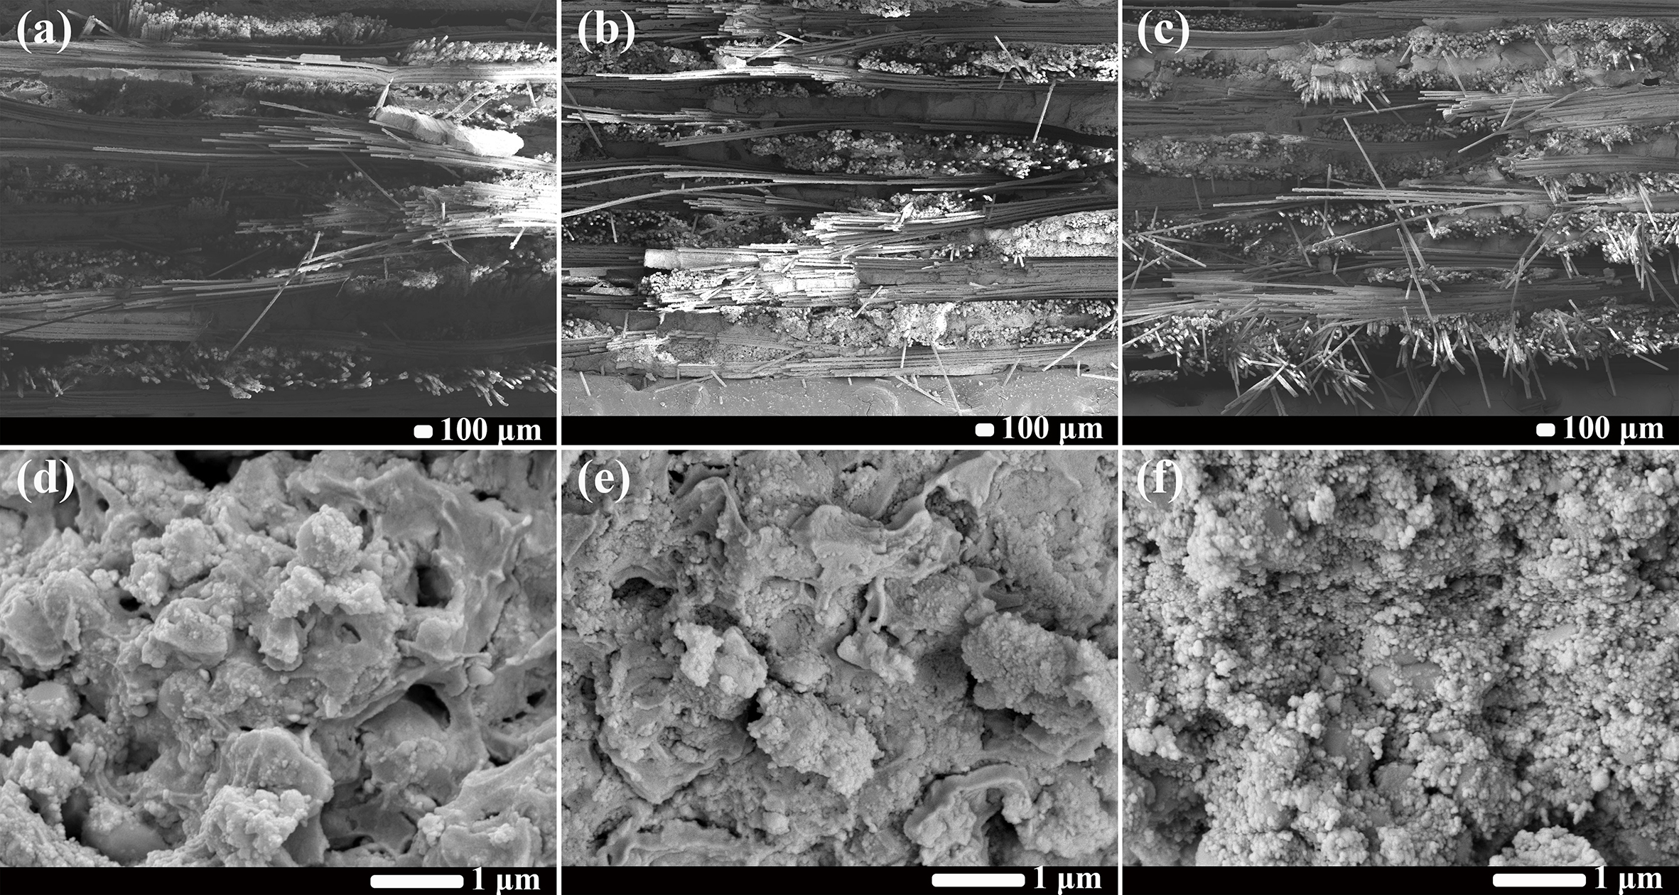
Fig. S6 Cross-sectional SEM images of M4N1 CMC samples after thermal exposure: (a) and (d) 1100℃ for 0 h, (b) and (e) 1100℃ for 12 h, (c) and (f) 1100℃ for 24 h.

