Efficient Degradation of Ketoprofen by MnO₂-Modified Biochar via Heterogeneous Catalytic Ozonation
Zhilun Liu ª, Lei Zhao ^{b,c,d,e*}, Tingting Dou ^{b,c}, Xu He ª, Shuang Lu ^{b,c}, Jun Ma ª, Xueyan Li ^{f}, Fuqiang Guo ^{e}

ª State Key Laboratory of Urban Water Resource and Environment, School of Environment, Harbin Institute of Technology, Harbin 150090, People’s Republic of China
^{b} Key Laboratory of Structures Dynamic Behavior and Control of the Ministry of Education, Harbin Institute of Technology, Harbin 150090, People’s Republic of China
^{c} Key Laboratory of Smart Prevention and Mitigation of Civil Engineering Disasters of the Ministry of Industry and Information Technology, Harbin Institute of Technology, Harbin 150090, People’s Republic of China
^{d} Institute for Eco-environment Research of Sanyang Wetland, Wenzhou University, Wenzhou 325035, People’s Republic of China
^{e} Xinjiang Key Laboratory of High Value Green Utilization of Low-rank Coal, Changji University, Changji 831100, People’s Republic of China
^{f} State of Environmental Science and Engineering, Suzhou University of Science and Technology, Suzhou 215009, People’s Republic of China

*Corresponding authors:
E-mail addresses: zhaolei999999@126.com (L. Zhao)

Text S1
The concentration of KTP was measured using high performance liquid chromatograph (HPLC, Waters 2695). The temperature of column was 30 ℃ and the mobile phase was a mixture of 35% MilliQ-water containing 0.1% acetic acid and 65% methanol with a flow rate of 1.0 mL/min.

Text S2
The Liquid Chromatography/Mass spectroscopy (LC/MS) was used to detect the oxidation intermediates with an electrospray ionization (ESI) source (HPLC/ESI-QqQMS, Agilent HPLC-ABSciex Qtrap 5500MS). Separation was performed on a C18 reverse-phase column (50×2.1 mm, 1.7 μm particle, Agilent). Injection volume was 10 uL. Elution was performed at a flow rate of 0.2 mL/min with 55% H2O containing 0.2% (v/v) formic acid as eluent A and 55% acetonitrile eluent B. The mass spectrometer was operated in positive ionization mode over the range m/z=50-600 [1].

Table 1 The solubility of ozone in the water at different temperatures
Temperature(℃) | 0 | 10 | 20 | 30 | 40 | 50
Solubility(mg) | 1.13 | 0.78 | 0.57 | 0.41 | 0.28 | 0.19

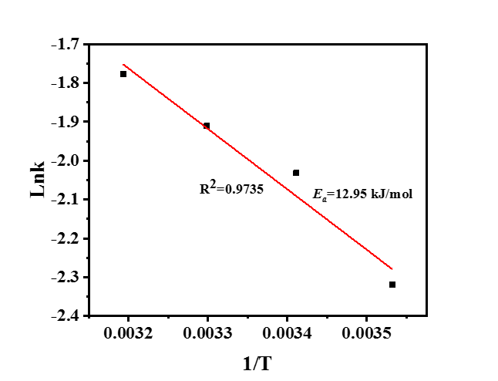
Fig. S1. The Fitted curve of •OH yield in catalytic degradation system

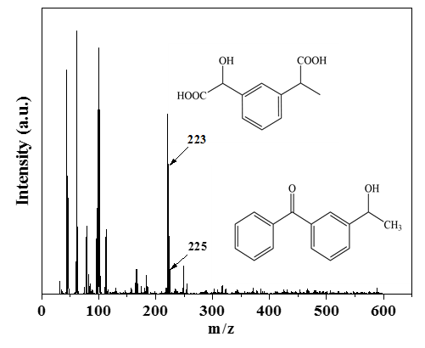
Fig. S2. MS data for several main intermediates products.

References
[1] Y.P. Feng, Q.Y. Song, G.G. Liu, Degradation of ketoprofen by sulfate radical-based advanced oxidation processes: Kinetics, mechanisms, and effects of natural water matrices, Chemosphere, 189 (2017) 643–651.

