Supplementary Material
Basalt derived from highly refractory mantle sources during early Izu-Bonin-Mariana arc development

He Li^{1,2,3,4*}, Richard J. Arculus⁴ , Osamu Ishizuka⁵, Rosemary Hickey-Vargas⁶, Gene M. Yogodzinski⁷, Anders McCarthy⁸, Yuki Kusano⁵, Philipp A. Brandl^{4,9}, Ivan P. Savov¹⁰, Frank J. Tepley III¹¹, Weidong Sun^{1,2,3*}.

1Center of Deep Sea Research, Institute of Oceanology, Chinese Academy of Sciences, Qingdao 266071, China. ²Laboratory for Marine Mineral Resources, Qingdao National Laboratory for Marine Science and Technology, Qingdao 266237, China. ³Center for Ocean Mega-Science, Chinese Academy of Sciences, Qingdao 266071, China. ⁴Research School of Earth Sciences, Australian National University, Canberra, ACT 2601, Australia. ⁵Geological Survey of Japan/AIST, Central 7 1-1-1 Higashi, Tsukuba, Ibaraki 305-8567, Japan. ⁶Department of Earth & Environment, AHC5-394, Florida International University, Miami, FL 33199, USA. ⁷Department of Earth & Ocean Sciences, University of South Carolina, Columbia, SC 29208, USA. ⁸Institute of Earth Sciences, University of Lausanne, CH-1015 Lausanne, Switzerland, now at School of Earth Sciences, University of Bristol, Wills Memorial Building, Queens Road, Clifton BS8 1RJ, UK. ⁹GEOMAR Helmholtz Centre for Ocean Research Kiel, Wischhofstrasse 1-3, 24148 Kiel, Germany. ¹⁰School of Earth & Environment, University of Leeds, Leeds LS2 9JT, UK. ¹¹College of Earth, Ocean, and Atmospheric Sciences, Oregon State University, Corvallis, OR 97331, USA.

Supplementary figures

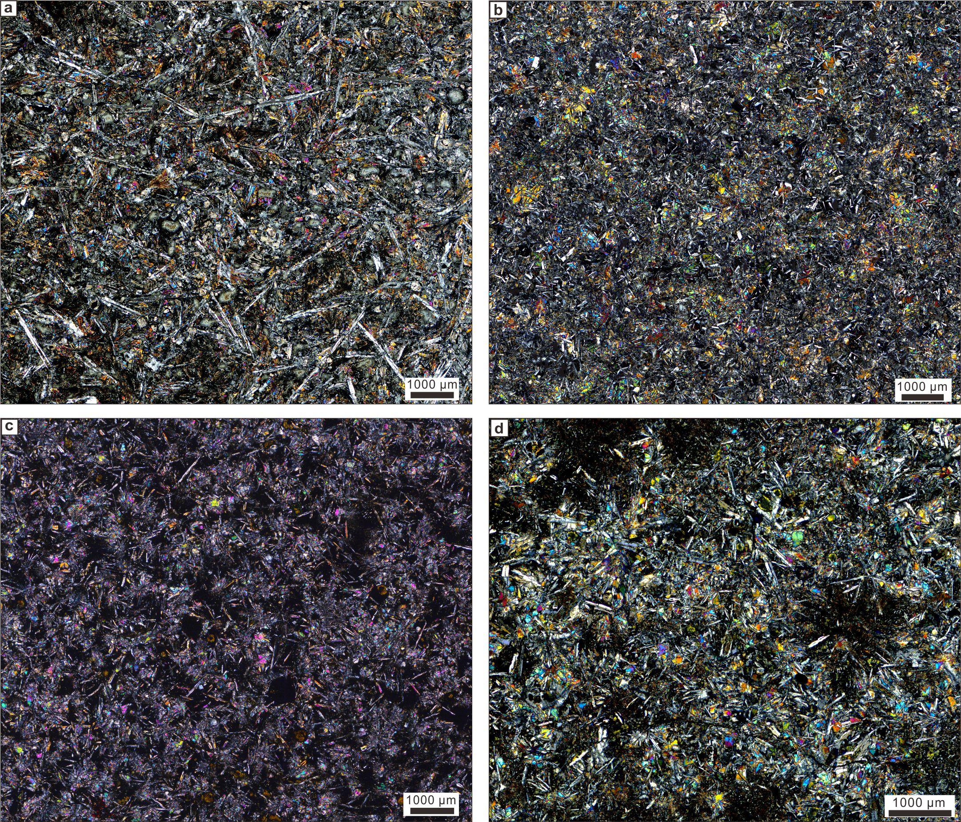Figure S1. Cross-polarized images of ASB basalt from subunits 1a, 1b, 1d and 1f. a, ASB basalt from subunit 1a (E71R2W90-94). b ASB basalt from subunit 1b (E72R1W83-85). c ASB basalt from subunit 1d (E81R1W54-57). d ASB basalt from subunit 1f (E88R1W139-145).

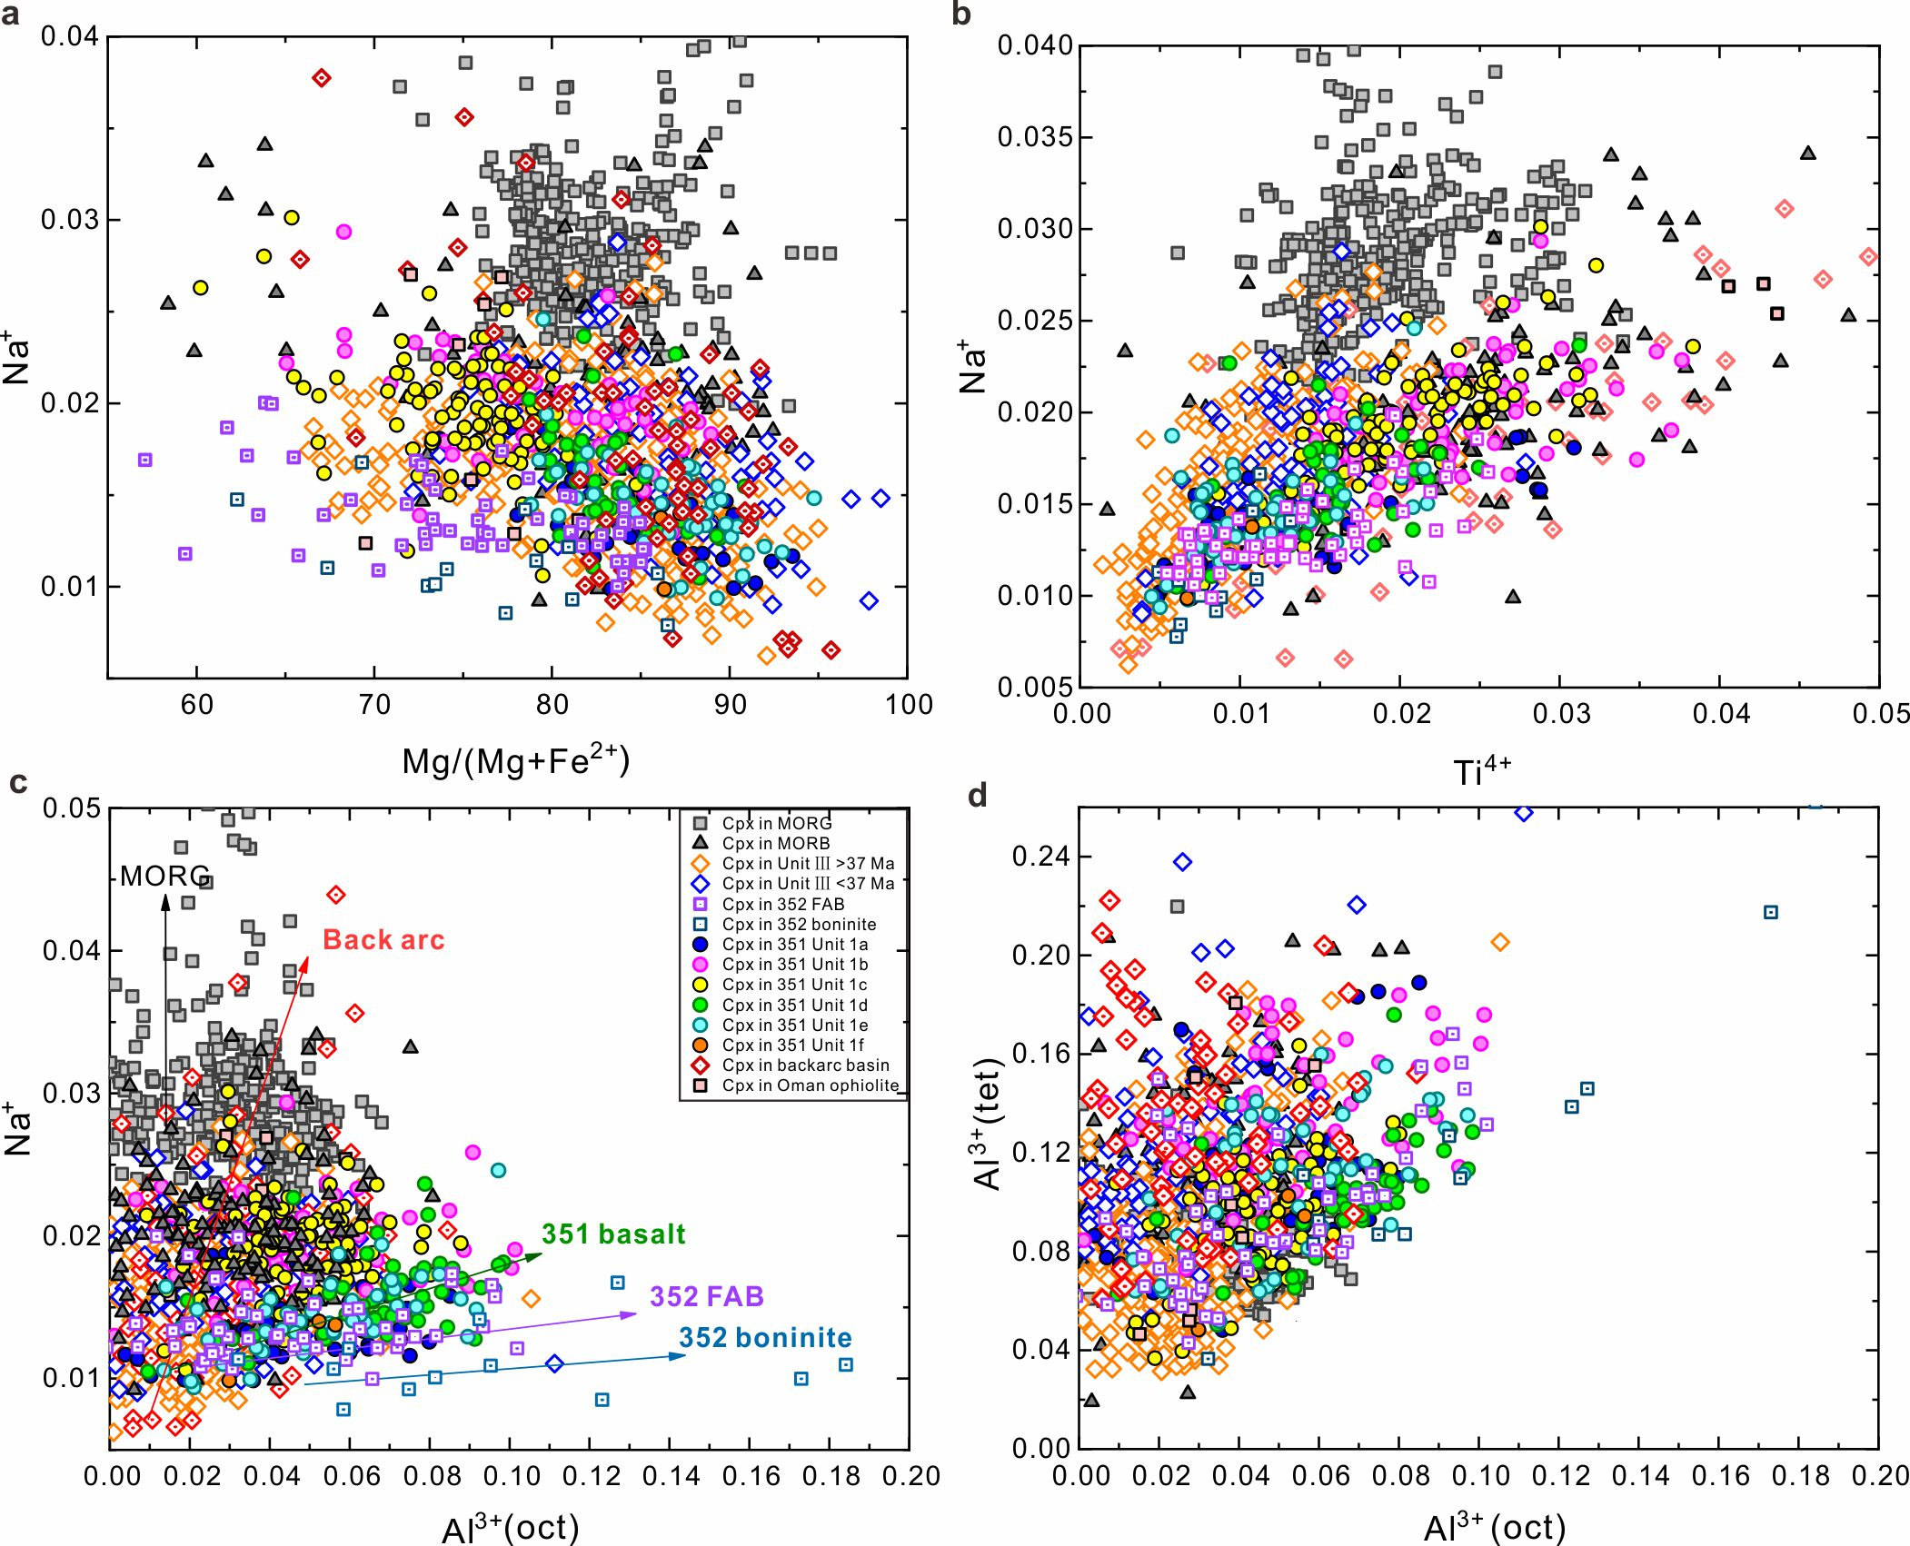
Figure S2. Clinopyroxene cations in subunits of Unit 1 ASB basalt compared with mid-ocean ridge basalt and gabbro (MORB/G), Unit III, IV³⁴, back arc, ophiolite³⁷, and 352 Fore arc basalt (FAB) and boninite³⁶. a, Na⁺ versus 100*Mg/(Mg+Fe²⁺). Unit III is subdivided into 2 groups, respectively >37Ma and <37Ma, as identified by Brandl et al. (2017)³⁵, Unit IV data are from Waldam et al.³⁴, As Mg number decreasing, Unit 1 clinopyroxene (solid circle) show different Na increasing tread with those of 352 FAB³⁶, back arc data from PetDatabase, MORB/G. Unit 1 clinopyroxene have higher Mg number than 352 FAB, especially subunit 1a and 1e. b, Na⁺ versus Ti⁴⁺. Positive corelationship between Na⁺ and Ti⁴⁺ indicates no Na loss during analysing process. c, Na⁺ versus octahedrally-coordinated Al³⁺. Clinopyroxne in 352 FAB and boninite have low Na cations and high octahedrally-coordinated Al indicating their enrichment of Al and crystallized at low temperature. Primitive clinopyroxne, i.e. subunit 1a and 1e, also have low Na cations and high octahedrally-coordinated, while subunit 1c have higher Na cations than other subunits at the same Al³⁺ (oct). d, Tetrahedrally-crotordinated versus octahedrally-coordinated Al³⁺ (Al³⁺ (tet) and Al³⁺ (oct) respectively). All cations calculated based on 4:6 cation:oxygen anions.

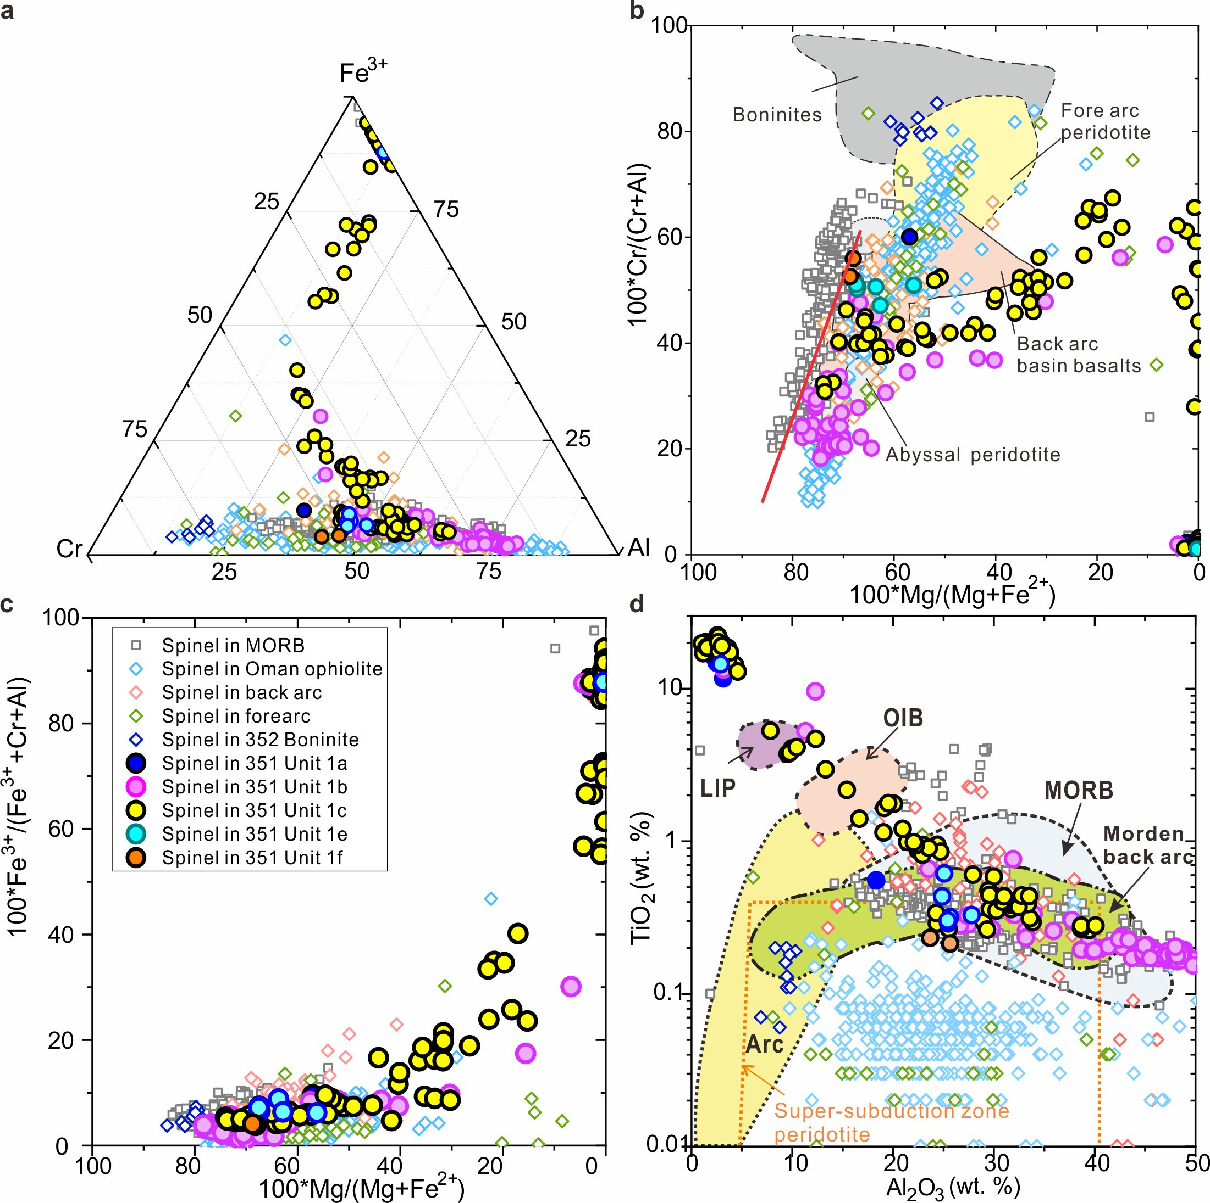Figure S3. Spinel compositions in subunits of 351 Unit 1 ASB basalt compared with those in MORB^{38,40}, Oman ophiolite, back arc, fore arc (data from PetDatabase website), and 352 Boninite³⁶. a. Cr-Al-Fe³⁺ proportions. Compositions of spinel in Unit1 ASB basalt show unique compositional plots and extend from Cr+Al rich to Fe rich, especially subunit 1c. b, 100*Cr/(Cr+Al) versus 100*Mg/(Mg+Fe²⁺). Spinels in subunit 1b and 1c show different trend with those in back arc, fore arc, boninite and ophiolite. Offsets to lower Mg number for a given Cr/(Cr+Al) are consistent with derivation from refractory peridotite sources. c, 100*Fe³⁺/(Fe³⁺+Cr+Al)) versus 100*Mg/(Mg+Fe²⁺). Primitive spinels with high Mg number have low Fe³⁺/(Fe³⁺+Cr+Al)) ratios indicating derived from reduced host magma. d TiO₂ (wt. %) versus Al₂O₃ (wt. %). Spinels in Unit 1 have higher TiO₂ and high Al₂O₃ content than in fore arc, ophiolite, boninite, and have different covariation trend with those in back arc samples. Various coloured solid circles for spinel in respective subunits; the gray solid square symbols for spinel in MORB.

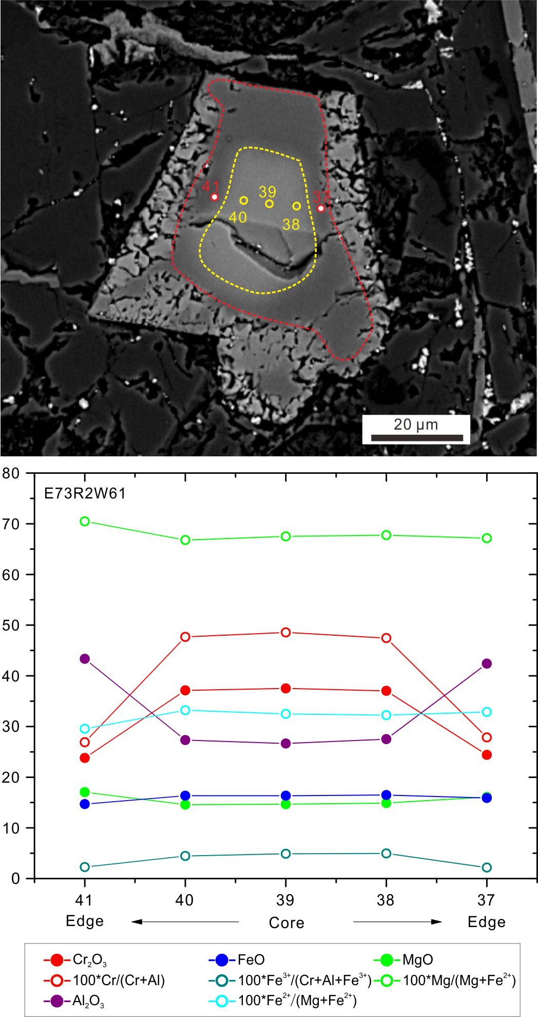
Figure S4. Back-scattered electron image and compositional traverse of spinel in subunit b sample 73R2 74-71. Compositions range from Cr-rich cores through Al-rich to magnetite on the rim. Y-axis values are the oxide percentages or 100* specific cation ratios. Position numbers on the x-axis are keyed to the image.

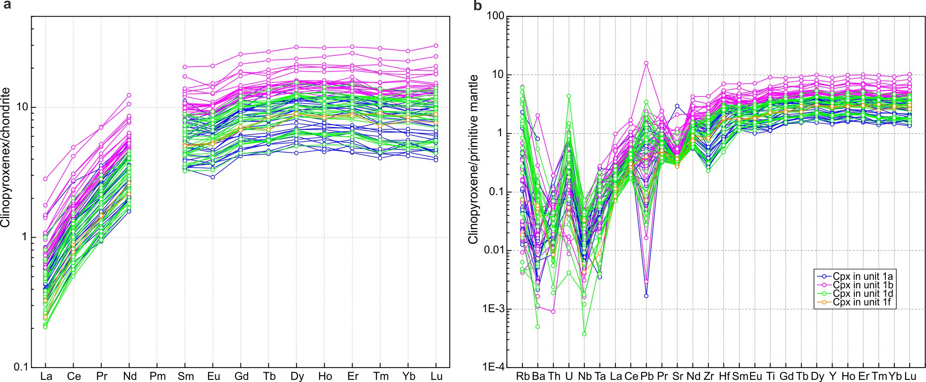Figure S5. Trace element abundances for clinopyroxene in subunits a, b, d, and f. a, chondrite-normalized⁴⁷ rare earth element abundances for clinopyroxene in subunits a, b, d, and f. b, primitive mantle-normalized⁴⁷ trace element abundances for clinopyroxene in subunits a, b, d, and f. Clinopyroxene in all subunit have depleted light rare earth element (REE) and positive Rb, U abnormal. Subunit 1b have higher REE concentrations.

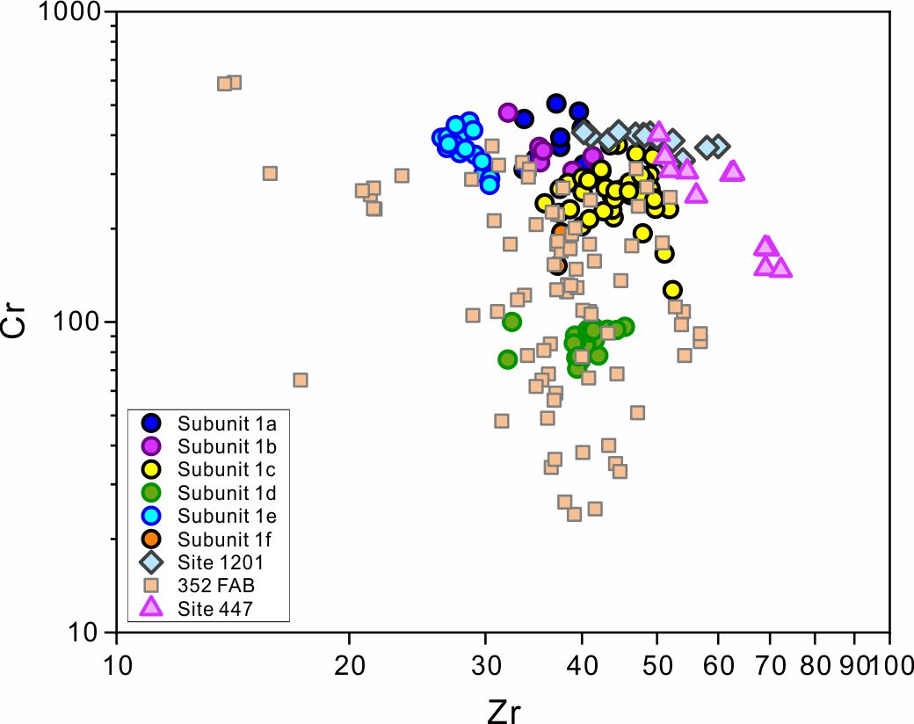
Figure S6. Cr vs. Zr diagram for whole rock from 351 Unit1 ASB basalt ²⁶, 352 FAB ^{59, 60}, Site 1201⁵² and Site 447 ⁵². At the same Zr concentration, 351 Unit 1 basalt has higher Cr concentrations than FAB.

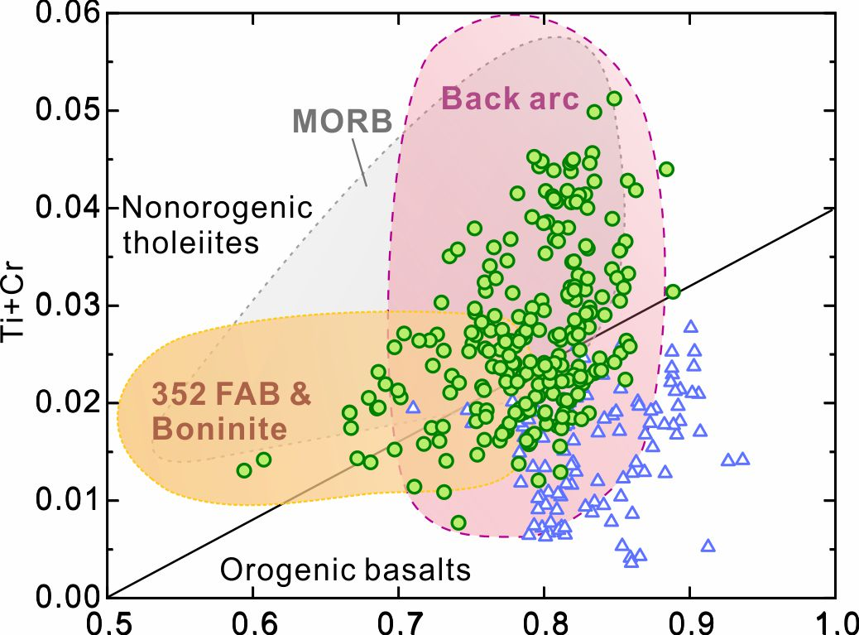
Figure. S7 Fig. 7. Ti+Cr vs. Ca cations in clinopyroxene from 351 Unit 1 ASB basalt. Data are compared with those in 351 Unit IV recording the nascent IBM arc, 352 FAB, 352 Bonininte, back arc basin, Oman ophiolite and MORB.

References for data sources used in construction of Figure 3 and Figure S2 for clinopyroxene in MORB/G

MORB
71. Allan, J.F., Batiza, R. & Lonsdale, P.F. Petrology and chemistry of lavas from seamounts flanking the East Pacific Rise axis, 21 degrees N: implications concerning the mantle source composition for both seamount and adjacent EPR lavas. AGU Geophys. Mon. 43, 255-282 (1987).
72. Batiza, R, Rosendahl, B.R. & Fishe, R.L. Evolution of oceanic crust 3. Petrology and chemistry of basalts from the East Pacific Rise and the Siqueiros Transform fault. J. Geophys. Res. 82, 265-276 (1977).
73. Batiza, R. et al. Petrology, geochemistry, and petrogenesis of Leg 142 basalts – synthesis of results. Proc. ODP Sci. Res. 142, 3-8 (1995).
74. Griffin, B.J., Neuser, R.D. & Schmicke, H.U. Lithology, petrography, and mineralogy of basalts from DSDP sites 482, 483, 484, and 485 at the mouth of the Gulf of California. Initial Rep. DSDP 65, 527-548 (1983).
75. Hekinian, R. & Walker, D. Diversity and spatial zonation of volcanic rocks from the East Pacific Rise near 21 degrees N. Contrib. Mineral. Petrol. 96, 265-280 (1987).
76. Hekinian, R. et al. Offset spreading centers near 12º 53’N on the East Pacific Rise: submersible observations and compositions of the volcanics. Mar. Geophys. Res. 7, 359-377 (1985).
77. Rowbotham, G. & Floyd, P.A. Mineral chemistry of primary and secondary phases in basaltic rocks, Leg 129. Proc. Ocean Drilling Prog., Sci. Results 129, 305-343 (1992).
78. Thompson, R.N. & Humphris, S.E. Silicate mineralogy of basalts from the East Pacific Rise, OCP Ridge, and Siqueiros Fracture Zone: Deep Sea Drilling Project Leg 54. Initial Rep. DSDP 54, 651-669 (1980).

MORG
79. Dick, H.J.B. et al. Primary silicate mineral chemistry of a 1.5-km section of very slow spreading lower ocean crust: ODP Hole 735B, Southwest Indian Ridge. Proc. ODP Sci. Res. 176, 1-61(2002).
80. Fujibayasi, N., Kagami, H. & Oishi, Y. Mineralogy and Sr- and Nd-isotopic composition of gabbroic oceanic crust recovered from holes 923A and 921E in the MARK area. In Karson, J.A., Cannat, M., Miller, D.J., & Elthon, D. (eds) Proc.Ocean Drill. Prog., Sci. Res. 153, 471-490 (1997).

