Supplementary Information
Table S1. Unit root tests for the variables at levels and first differences using the augmented Dickey–Fuller (ADF) test.
1st difference |  |  | Level |  |  | Definition | Variable
Stationarity status | Prob |  | Stationarity status | Prob |  | Definition | Variable
  t-Statistic
  t-Statistic
Stationary | 0.0004 | -4.94 | Non-stationary | 0.98 | 0.51 | Total Factor Productivity | LOG(TFP)
Stationary | 0.000 | -9.48 | Non-stationary | 0.98 | 0.33 | Higher Education Employment Share(% of Total Employment) | HE_SHARE
Stationary | 0.00 | -5.75 | Non-stationary | 0.21 | 2.22- | Inbound Tourists | LOG(INB_TOUR)
Stationary | 0.0007 | -4.77 | Non-stationary | 0.45 | -1.64 | Outbound Tourists | LOG(OUTB_TOUR)
Stationary | 0.000 | 7.14- | Non-stationary | 0.52 | .51- | Wage and Salary Earners Share (% of Total Employment) | WSE_SHARE
Stationary | 0.0002 | -5.16 | Non-stationary | 0.24 | -2.10 | Per Capita Income | LOG(PC_INC)
Notes: Author’s calculations using EViews 13.

Table S2. Results of the cointegration test for the ARDL model.
10.98 |  | F-statistic
Upper Bound (I1) | Lower Bound (I0) | Critical Values
3.858 | 2.578 | 10%
4.608 | 3.125 | 5%
6.370 | 4.537 | 1%

Table S3. Results of the t-test for the error correction term.
–3.247
  t-Statistic
Upper Bound (I1) | Lower Bound (I0) | Critical Values
–3.860 | –2.570 | 10%
–4.190 | –2.860 | 5%
–4.790 | –3.430 | 1%

Table S4. Error correction model estimates for short-run dynamics (dependent variable: Dlog(TFP)).
Variable | Coefficient | Std. Error | t-Statistic | P-value
LOG(TFP(-1))* | -0.304813 | 0.087042 | -3.501914 | 0.0027
HE_SHARE(-1) | -0.013773 | 0.006315 | -2.180842 | 0.0435
WSE_SHARE** | -0.010426 | 0.003420 | -3.049061 | 0.0073
LOG(INB_TOUR)** | 0.036906 | 0.013248 | 2.785817 | 0.0127
LOG(OUTB_TOUR(-1)) | -0.051255 | 0.019290 | -2.657020 | 0.0166
LOG(PC_INC)** | 0.249113 | 0.059551 | 4.183220 | 0.0006
DLOG(TFP(-1)) | -0.230212 | 0.135649 | -1.697111 | 0.1079
DLOG(TFP(-2)) | 0.257460 | 0.114098 | 2.256475 | 0.0375
D(HE_SHARE) | -0.000739 | 0.005192 | -0.142247 | 0.8886
DLOG(OUTB_TOUR) | -0.001377 | 0.018672 | -0.073752 | 0.9421
DUM_SANC | -0.170340 | 0.030012 | -5.675709 | 0.0000
DUM_GFC | -0.134734 | 0.036890 | -3.652332 | 0.0020
C | 1.479526 | 0.366594 | 4.035867 | 0.0009
Model diagnostics
Statistic | Value
R-squared | 0.904467
Adjusted R-squared | 0.837033
S.E. of regression | 0.030116
F-statistic | 13.41247 (p < 0.001)
Durbin-Watson stat | 2.401235
Akaike info criterion | -3.868831
Schwarz criterion | -3.261646
Hannan-Quinn criterion | -3.674587
Notes: *p-values are not computed based on the t-bounds critical values. ** Indicates a contemporaneous (zero-lag) variable.
Table S5. Error correction model estimates (dependent variable: Dlog(TFP)).
Variable | Coefficient | Std. Error | t-Statistic | P-value
COINTEQ* | -0.304813 | 0.033010 | -9.234036 | 0.0000
DLOG(TFP(-1)) | -0.230212 | 0.090319 | -2.548873 | 0.0183
DLOG(TFP(-2)) | 0.257460 | 0.077841 | 3.307535 | 0.0032
D(HE_SHARE) | -0.000739 | 0.003415 | -0.216229 | 0.8308
DLOG(OUTB_TOUR) | -0.001377 | 0.013442 | -0.102443 | 0.9193
DUM_SANC | -0.170340 | 0.022626 | -7.528622 | 0.0000
DUM_GFC | -0.134734 | 0.027640 | -4.874528 | 0.0001
C | 1.479526 | 0.162882 | 9.083412 | 0.0000

Model diagnostics
Statistic | Value
R-squared | 0.904467
Adjusted R-squared | 0.874071
S.E. of regression | 0.026474
F-statistic | 29.75539 (p < 0.001)
Durbin-Watson stat | 2.401235
Akaike info criterion | -4.202165
Schwarz criterion | -3.828512
Hannan-Quinn criterion | -4.082630
Note:
*COINTEQ represents the error correction term; p-values are incompatible with t-Bounds distribution.
Table S6. Breusch–Pagan–Godfrey test for heteroskedasticity.
Test Statistic | Value | Prob.
F-statistic | 1.2283 | 0.3402
Obs*R-squared | 13.9319 | 0.3051
Scaled explained SS | 3.0554 | 0.9951

Table S6. Breusch–Pagan–Godfrey test for heteroskedasticity. The dependent variable is the squared residuals. The model is estimated using ordinary least squares on 30 adjusted observations (1994–2023).
Variable | Coefficient | Std. Error | t-Statistic | Prob.
C | 0.005958 | 0.007109 | 0.8382 | 0.4136
LOG(TFP(-1)) | 0.004046 | 0.002216 | 1.8253 | 0.0856
LOG(TFP(-2)) | -0.004818 | 0.003021 | -1.5947 | 0.1292
LOG(TFP(-3)) | -0.000154 | 0.002212 | -0.0695 | 0.9454
HE_SHARE | -5.62E-05 | 0.000101 | -0.5586 | 0.5837
HE_SHARE(-1) | -9.59E-05 | 0.000106 | -0.9063 | 0.3774
WSE_SHARE | 5.58E-05 | 6.63E-05 | 0.8417 | 0.4116
LOG(INB_TOUR) | 0.000108 | 0.000257 | 0.4198 | 0.6799
LOG(OUTB_TOUR) | -0.000394 | 0.000362 | -1.0882 | 0.2917
LOG(OUTB_TOUR(-1)) | 0.000300 | 0.000331 | 0.9049 | 0.3782
LOG(PC_INC) | -0.001169 | 0.001155 | -1.0125 | 0.3255
DUM_GFC | -0.000174 | 0.000715 | -0.2432 | 0.8108
DUM_SANC | -0.000207 | 0.000582 | -0.3556 | 0.7265

Model diagnostics
Statistic | Value
R-squared | 0.4644
Adjusted R-squared | 0.0863
S.E. of regression | 0.000584
Sum squared resid | 5.80E-06
Log likelihood | 189.3208
Akaike info criterion | -11.7547
Schwarz criterion | -11.1475
Hannan-Quinn criter. | -11.5605
F-statistic | 1.2283
Prob(F-statistic) | 0.3402
Durbin-Watson stat | 2.8291

Table S7. Breusch–Godfrey LM test for serial correlation (null hypothesis: no serial correlation, up to 2 lags).
Test Statistic | Value | Prob.
F-statistic | 1.0133 | 0.3866
Obs*R-squared | 3.5706 | 0.1677
Table S7. Breusch–Godfrey LM test for serial correlation (up to 2 lags). The dependent variable is the residuals. The model is estimated using the ARDL method on 30 adjusted observations (1994–2023). Presample missing value lagged residuals are set to zero.
Variable | Coefficient | Std. Error | t-Statistic | Prob.
LOG(TFP(-1)) | 0.035575 | 0.125256 | 0.2840 | 0.7803
LOG(TFP(-2)) | -0.021523 | 0.174925 | -0.1230 | 0.9037
LOG(TFP(-3)) | -0.019697 | 0.122212 | -0.1612 | 0.8741
HE_SHARE | 0.000697 | 0.005224 | 0.1335 | 0.8956
HE_SHARE(-1) | -0.000437 | 0.005513 | -0.0792 | 0.9379
WSE_SHARE | -0.000530 | 0.003437 | -0.1542 | 0.8795
LOG(INB_TOUR) | 0.001570 | 0.013283 | 0.1182 | 0.9075
LOG(OUTB_TOUR) | -0.005613 | 0.019083 | -0.2941 | 0.7727
LOG(OUTB_TOUR(-1)) | 0.001873 | 0.017616 | 0.1063 | 0.9167
LOG(PC_INC) | 0.023539 | 0.062657 | 0.3757 | 0.7124
DUM_GFC | -0.008096 | 0.037947 | -0.2133 | 0.8339
DUM_SANC | 0.007171 | 0.030666 | 0.2338 | 0.8183
C | 0.018657 | 0.370551 | 0.0503 | 0.9605
RESID(-1) | -0.362200 | 0.286049 | -1.2662 | 0.2247
RESID(-2) | -0.257539 | 0.294515 | -0.8744 | 0.3957

Model diagnostics
Statistic | Value
R-squared | 0.1190
Adjusted R-squared | -0.7032
S.E. of regression | 0.030093
Sum squared resid | 0.013584
Log likelihood | 72.9333
Akaike info criterion | -3.8622
Schwarz criterion | -3.1616
Hannan-Quinn criter. | -3.6381
F-statistic | 0.1448
Prob(F-statistic) | 0.9996
Durbin-Watson stat | 2.0521

Fig. S1. CUSUM test for parameter stability.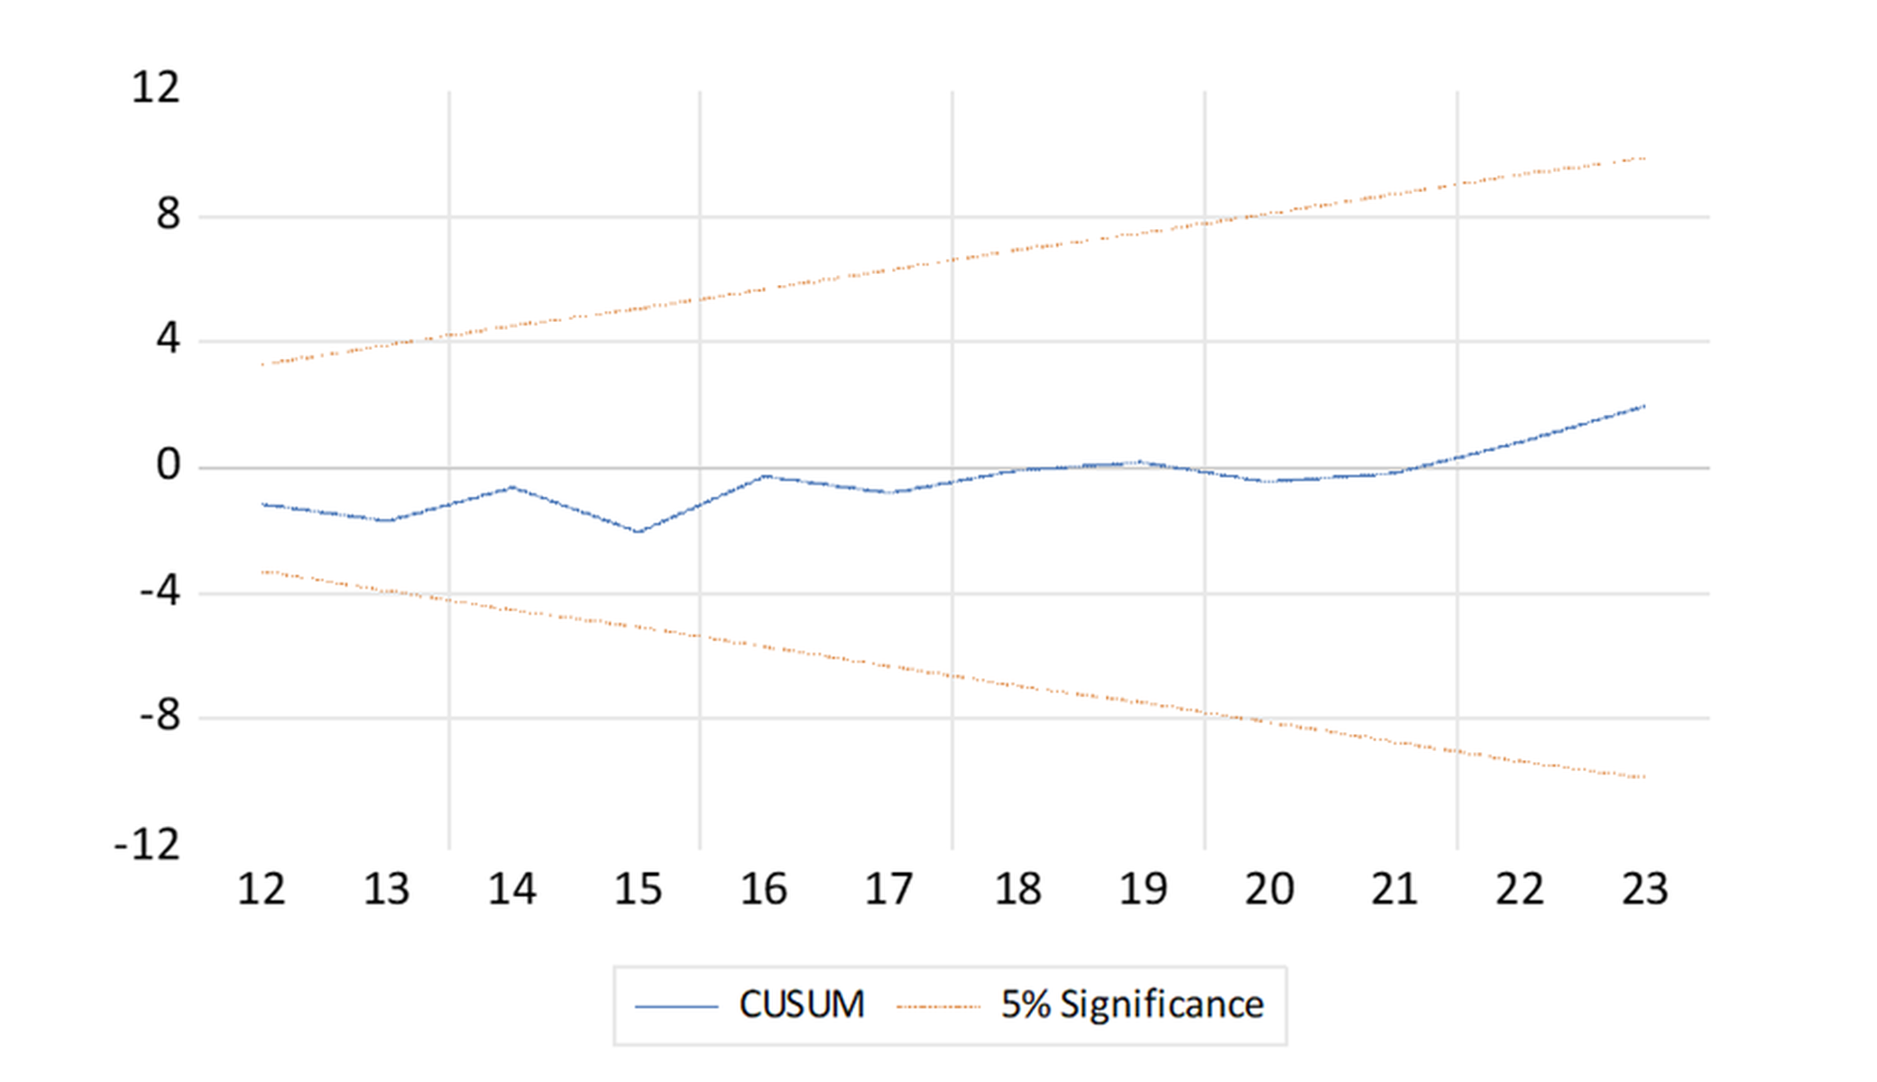
Notes: CUSUM (cumulative sum) test for parameter stability. Author’s calculations using EViews 13.

Fig. S2. CUSUMSQ test for parameter stability.
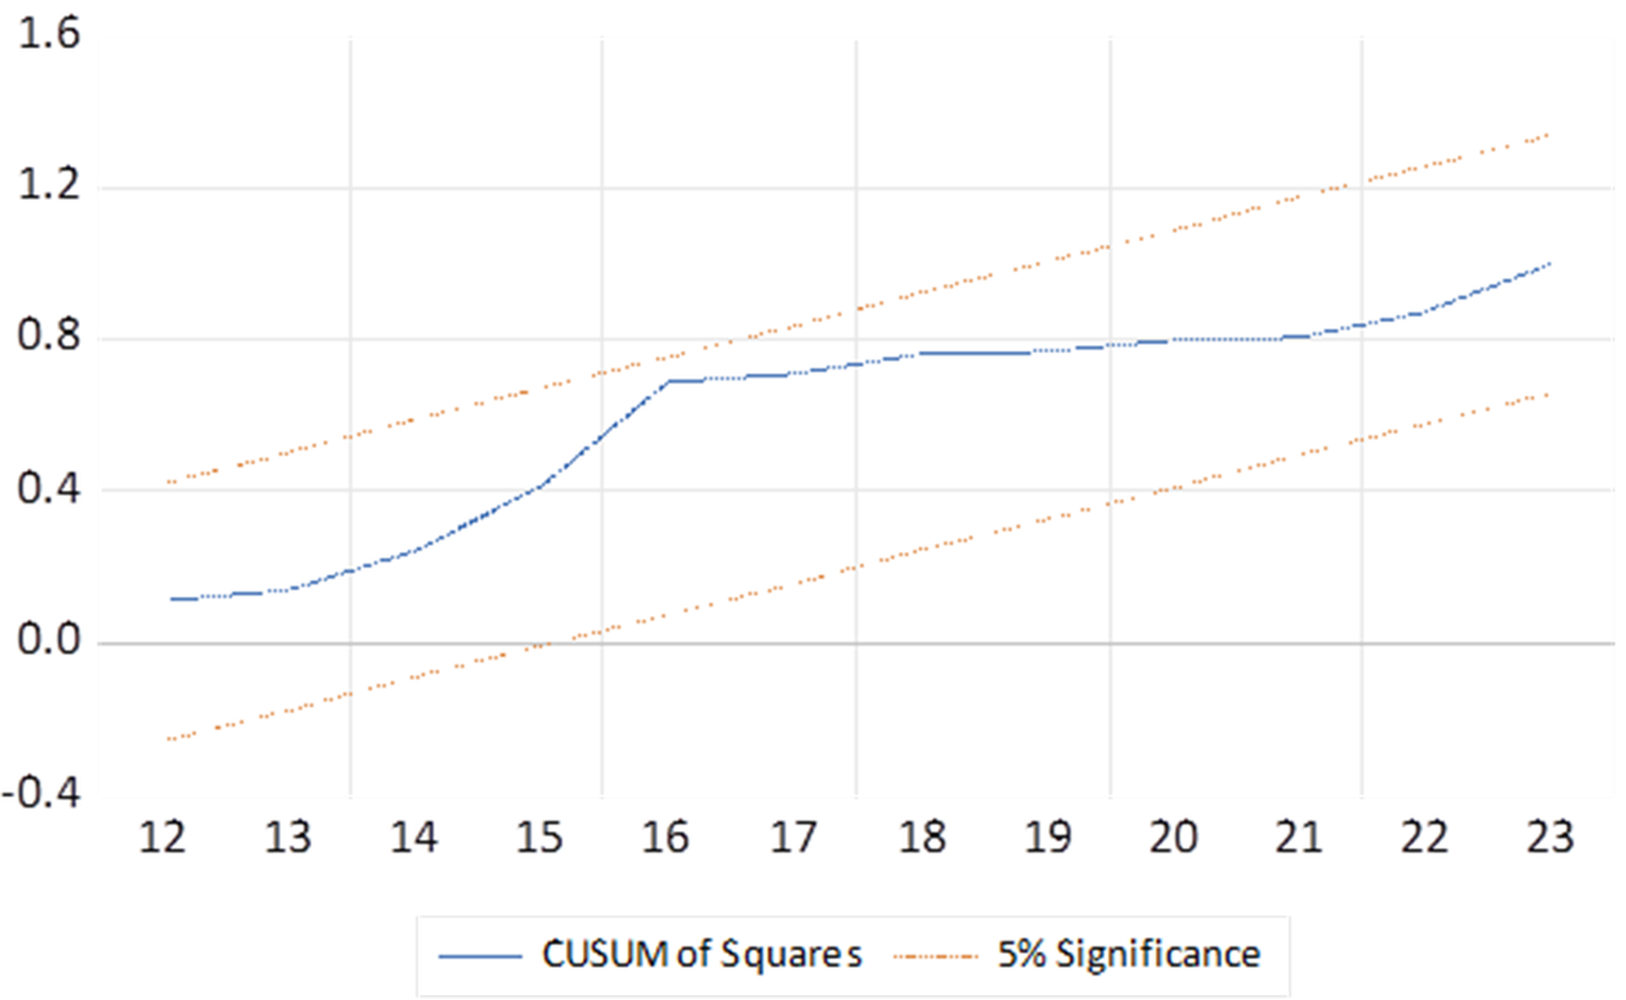
Notes: CUSUMSQ (cumulative sum of squares) test for parameter stability. Author’s calculations using EViews 13.
Fig. S3. Jarque–Bera test for normality of model residuals.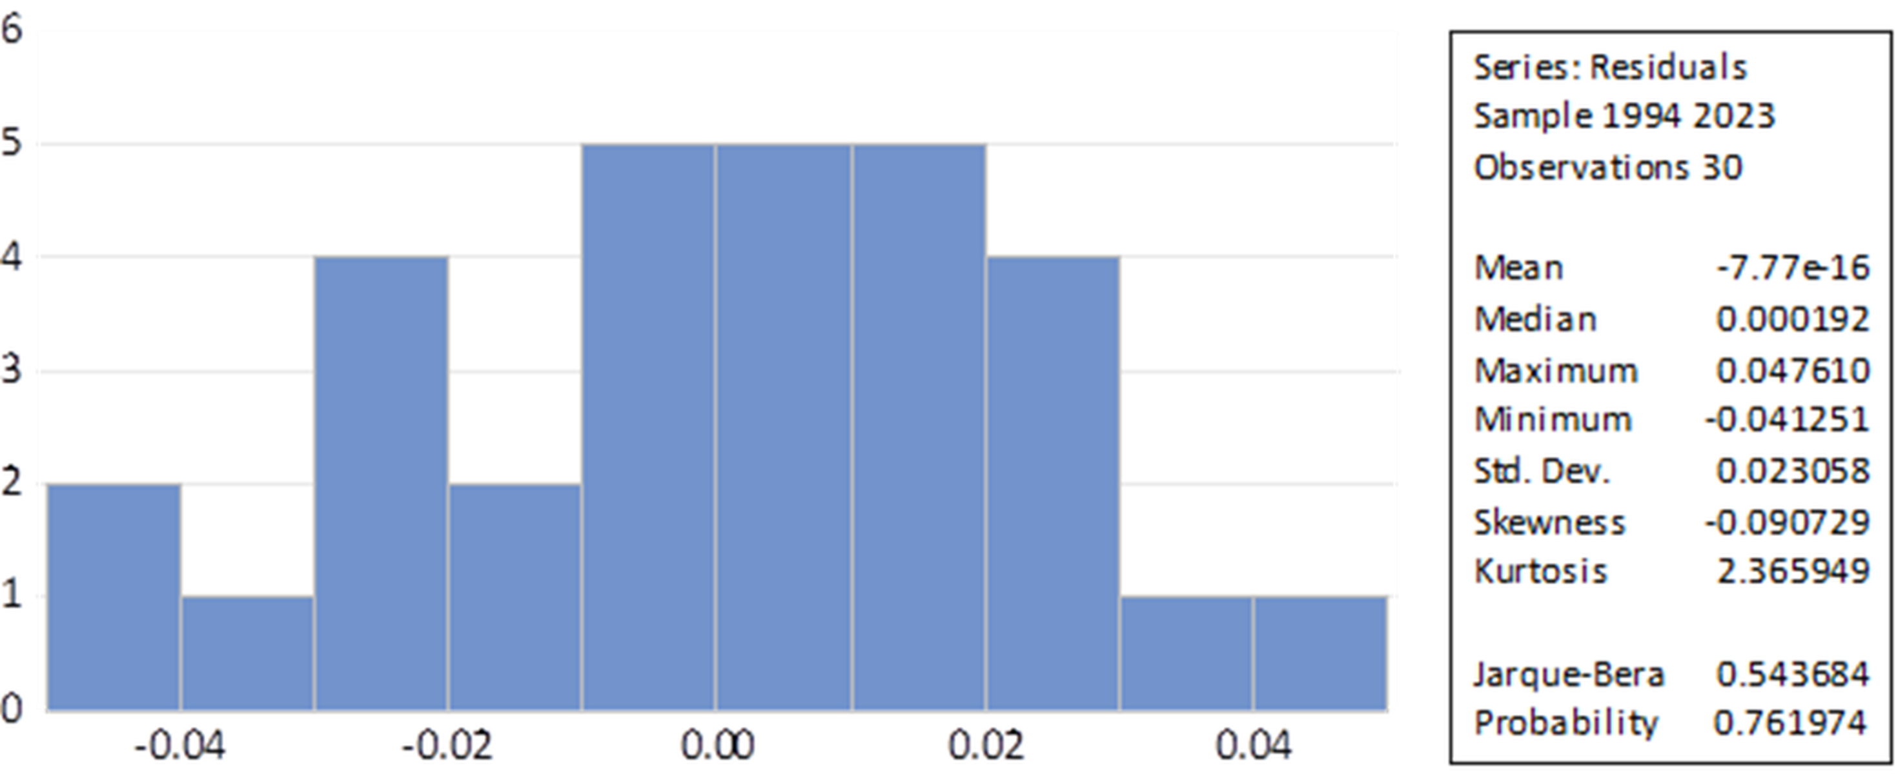
Notes: Jarque–Bera (JB) test for normality of residuals. Author’s calculations using EViews 13.

Table S8. Dynamic Ordinary Least Squares (DOLS) estimation results.
Variable | Coefficient | Std. Error | t-Statistic | Prob.
HE_SHARE | -0.019111 | 0.012181 | -1.568838 | 0.1511
WSE_SHARE | -0.066262 *** | 0.013046 | -5.078909 | 0.0007
LOG(INB_TOUR) | 0.410363 ** | 0.132842 | 3.089101 | 0.0129
LOG(OUTB_TOUR) | -0.333947 * | 0.168339 | -1.983776 | 0.0786
LOG(PC_INC) | 1.004550 *** | 0.209690 | 4.790635 | 0.0010
C | 4.215492 *** | 0.718366 | 5.868169 | 0.0002
Notes: Dependent variable is the logarithm of total factor productivity (LOG(TFP)). The DOLS estimation includes leads and lags of differenced regressors. Significance levels are indicated as follows: 1% (***), 5% (**), 10% (*). Author’s calculations using EViews 13.

