Supplementary material for the paper:

5D Built Environment, Subjective Environmental Perception and Adolescent Obesity Risk in the Environment-Psychology-Behavior Framework: A Study Based on Machine Learning and Network Analysis

1.Pearson correlation coefficient

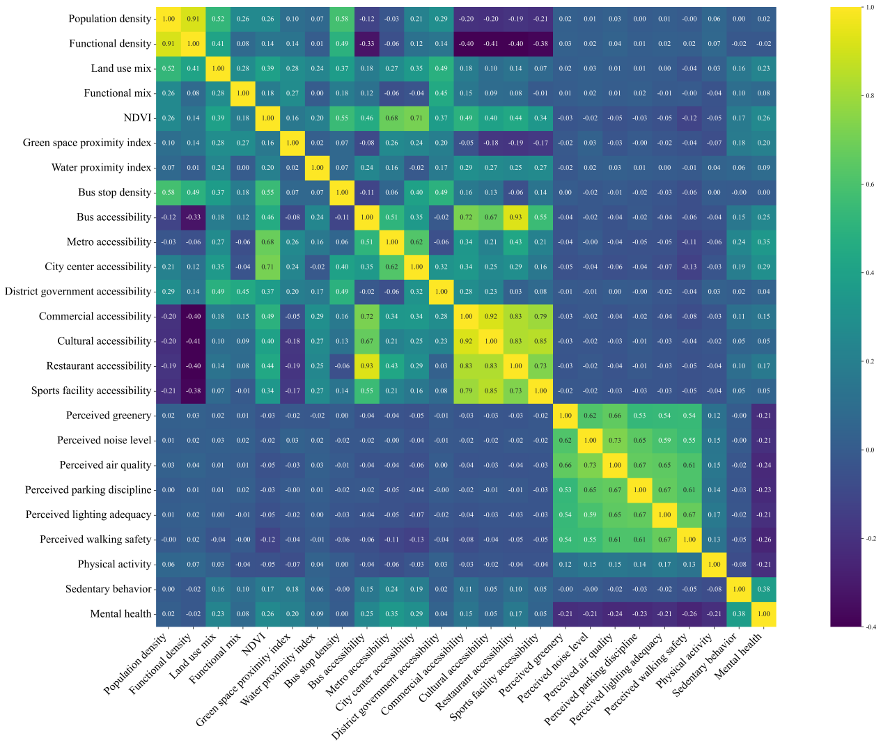

Figure S1 Pearson correlation coefficient between measured variables

2.The Guidelines for Screening Overweight and Obesity

Table S1 the Guidelines for Screening Overweight and Obesity in School-Aged Adolescents issued by the National Health Commission of China
Age | Male |  | Female
Age | Overweight (Kg/m2) | Obesity (Kg/m2) | Overweight (Kg/m2) | Obesity (Kg/m2)
10.0~ | 19.2 | 21.9 | 19.5 | 21.5
10.5~ | 19.6 | 22.5 | 20.0 | 22.1
11.0~ | 19.9 | 23.0 | 20.5 | 22.7
11.5~ | 20.3 | 23.6 | 21.1 | 23.3
12.0~ | 20.7 | 24.1 | 21.5 | 23.9
12.5~ | 21.0 | 24.7 | 21.9 | 24.5
13.0~ | 21.4 | 25.2 | 22.2 | 25.0
13.5~ | 21.9 | 25.7 | 22.6 | 25.6
14.0~ | 22.3 | 26.1 | 22.8 | 25.9
14.5~ | 22.6 | 26.4 | 23.0 | 26.3
15.0~ | 22.9 | 26.6 | 23.2 | 26.6
15.5~ | 23.1 | 26.9 | 23.4 | 26.9
16.0~ | 23.3 | 27.1 | 23.6 | 27.1
16.5~ | 23.5 | 27.4 | 23.7 | 27.4
17.0~ | 23.7 | 27.6 | 23.8 | 27.6
17.5~ | 23.8 | 27.8 | 23.9 | 27.8
18.0~ | 24.0 | 28.0 | 24.0 | 28.0
Note：The survey involved senior high school students, a small number of whom had already turned 18. Consequently, the study included a small group of 19-year-olds.Given that these students are still enrolled in high school, their learning environment and daily routines align with those of 18-year-old high school students. Therefore, the study calculates their BMI based on the 18-year-old category.

3. Model validation

Parameters tuning for the Gradient Boosting Decision Tree (GBDT) model was conducted by setting the number of estimators to {400}, the maximum tree depth to {2}, the minimum number of samples required to be at a leaf node to {30}, the subsample ratio to {0.7}, and the learning rate to {0.005}. A fixed random seed (random_state = 42) was used to ensure reproducibility.

Table S2 Parameters tuning for GBDT
Model | GBDT
n_estimators | 400
learning_rate | 0.005
max_depth | 2
min_samples_leaf | 30
random_state | 42
subsample | 0.7

Table S3 Predictive Performance of Seven Machine Learning Models
Model |  | Accuracy | Precision | Recall | F1-score
Model 1 | XGBoost | 0.5660 | 0.2727 | 0.6383 | 0.3822
Model 2 | Random Forest | 0.5570 | 0.2636 | 0.6170 | 0.3694
Model 3 | LightGBM | 0.5906 | 0.2741 | 0.5745 | 0.3711
Model 4 | CatBoost | 0.5749 | 0.2670 | 0.5851 | 0.3667
Model 6 | GBDT | 0.5861 | 0.2844 | 0.6383 | 0.3934
Model 7 | HistGBDT | 0.5638 | 0.2673 | 0.6170 | 0.3730

4.Network Analysis Robustness Test Results

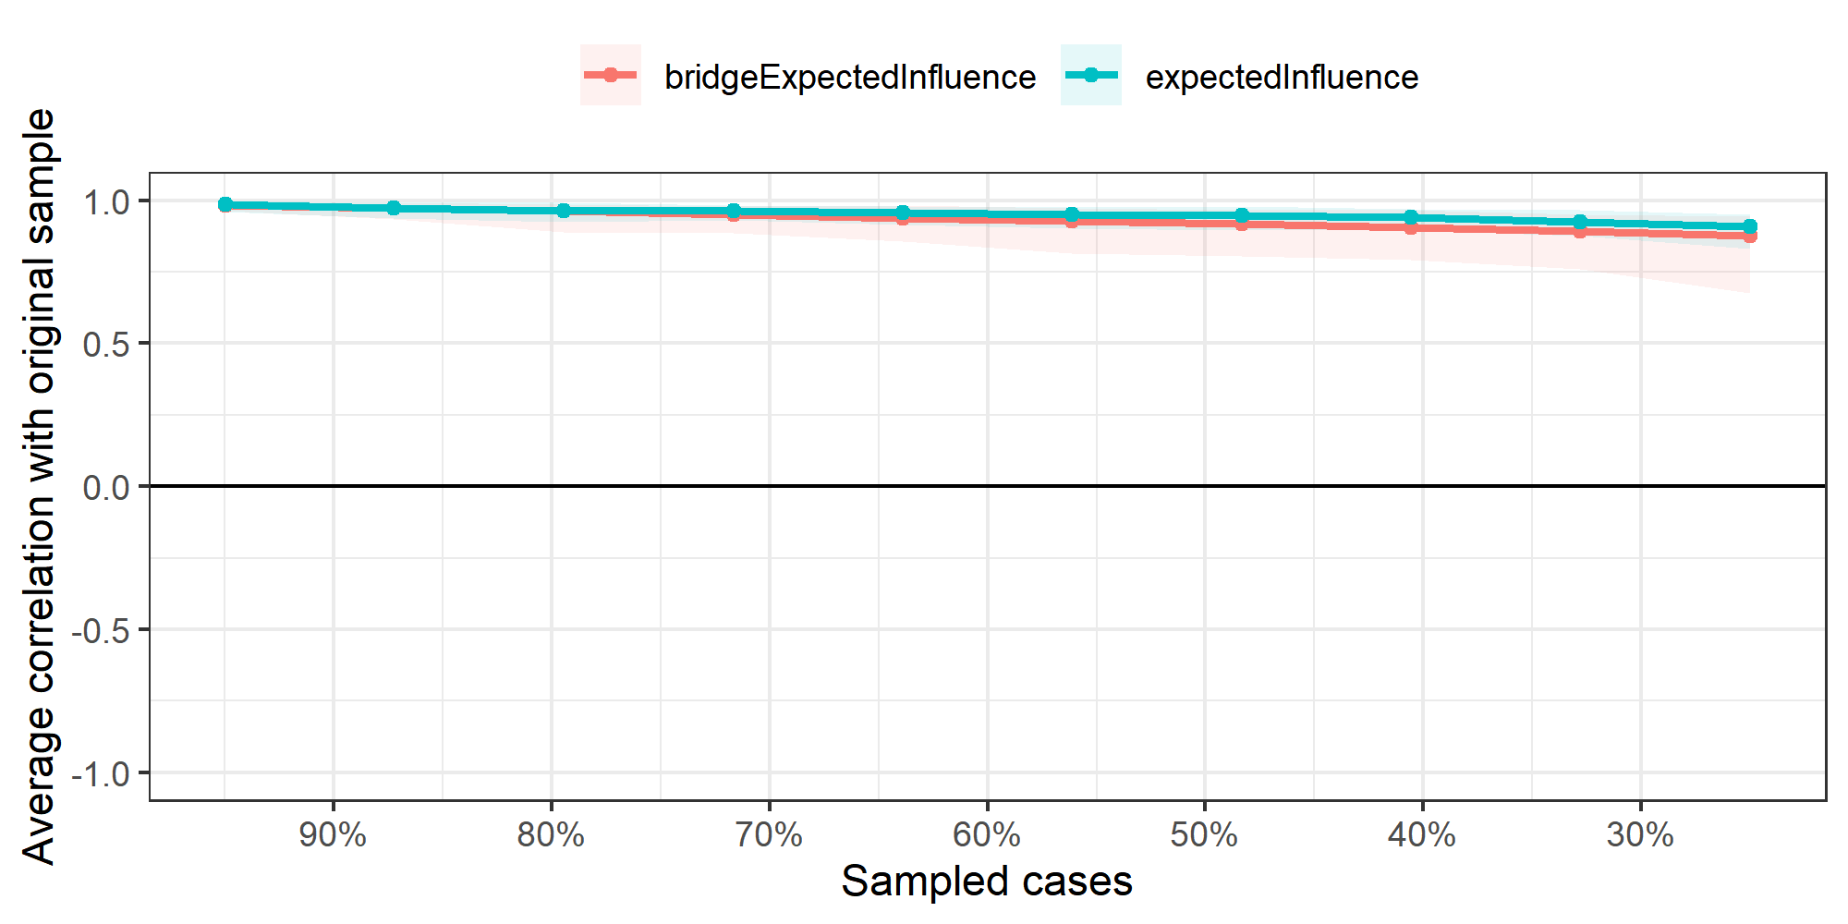

Figure S2 Robustness Test Results for the Expected Impact Index in Network Analysis

