Supplementary Figure S1. CBN modulates TNF-α– and IL-1β–induced permeability of HBMEC in Donor B.
HBMEC were treated with TNF-α or IL-1β (0.1 ng/mL) in the presence or absence of CBN (0.01–10 μM) for 10 h. TEER was normalized to time 0 and summarized as ΔAUC (0–10 h). Data are mean ± SEM (5–8 wells/condition; ≥3 independent experiments); one-way ANOVA with Tukey’s multiple-comparisons test. *p < 0.05, **p < 0.01, ***p < 0.001, ****p < 0.0001; ns, not significant.

Supplementary Figure S2. CBD abrogates TNF-α-induced, but augments IL-1β-induced HBMEC permeability in Donor B.
HBMEC were treated with TNF-α or IL-1β (0.1 ng/mL) with or without CBD (0.01–10 μM) for 10 h. TEER was normalized to time 0 and summarized as ΔAUC (0–10 h). Data are mean ± SEM (5–8 wells/condition; ≥3 independent experiments). One-way ANOVA with Tukey’s multiple-comparisons test. *p < 0.05, **p < 0.01, ***p < 0.001, ****p < 0.0001; ns, not significant.
Supplementary Figure S3. CBG augments HBMEC permeability induced by TNF-α- or IL-1β-induced in Donor B.
HBMEC were treated with TNF-α or IL-1β (0.1 ng/mL) in the presence or absence of CBG (0.01–10 μM) for 10 h. TEER was normalized to time 0 and summarized as ΔAUC (0–10 h). Data are mean ± SEM (5–8 wells/condition; ≥3 independent experiments). One-way ANOVA with Tukey’s multiple-comparisons test. *p < 0.05, **p < 0.01, ***p < 0.001, ****p < 0.0001; ns, not significant.

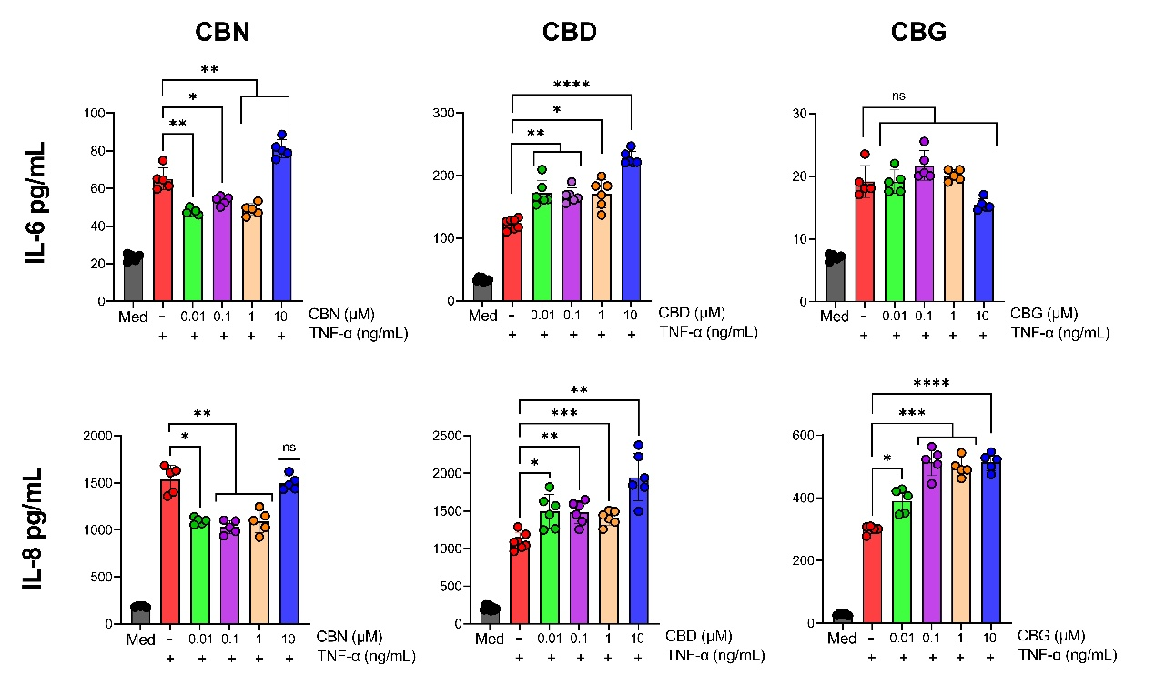
Supplementary Figure S4. Cannabinoids differentially modulate TNF-α–induced cytokine secretion by Donor B HBMEC.
HBMEC were treated with TNF-α (0.1 ng/mL) for 10 h in the presence of CBN, CBG, or CBD (0.01–10 μM). Supernatant IL-6 and IL-8 concentrations were quantified by ELISA. Data are mean ± SEM (≥3 independent experiments). One-way ANOVA with Tukey’s multiple-comparisons test. *p < 0.05, **p < 0.01, ***p < 0.001, ****p < 0.0001; ns, not significant.

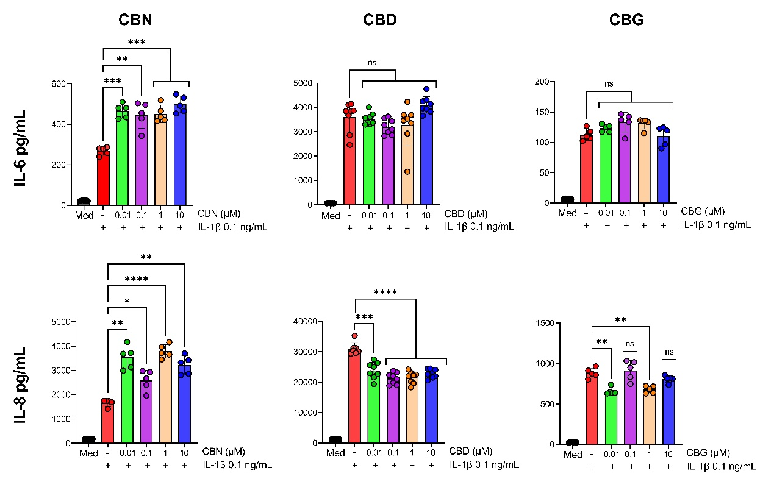
Supplementary Figure S5. Cannabinoids differentially modulate IL–1β–induced cytokine secretion by Donor B HBMEC.
HBMEC were treated with IL-1β (0.1 ng/mL) for 10 h in the presence of CBN, CBG, or CBD (0.01–10 μM). Supernatant IL-6 and IL-8 concentrations were quantified by ELISA. Data are mean ± SEM (≥3 independent experiments). One-way ANOVA with Tukey’s multiple-comparisons test. *p < 0.05, **p < 0.01, ***p < 0.001, ****p < 0.0001; ns, not significant.

