SUPPLEMENTAL INFORMATION FOR

A Custom Soil Electrochemical Profiling System for Detecting Electrochemical Activity Changes in Soil

Won-Jun Kim (won-jun.kim@wsu.edu) (0000-0003-3948-7672)^{a~}, Ibrahim Bozyel (ibozyel@wpi.edu) (0000-0002-2841-7890)^{a, b*~}, Suat Ay (say@wpi.edu)( 0000-0001-7640-4253)^{b}, Maren L. Friesen (friesen@wsu.edu) (0000-0002-4274-8928)^{c, d}, Haluk Beyenal (beyenal@wsu.edu) (0000- 0003-3931-0244)^{a,*}
ª The Gene and Linda Voiland School of Chemical Engineering and Bioengineering, Washington State University, Pullman, WA, USA
^{b*}Current address: Department of Electrical and Computer Engineering, Worcester Polytechnic Institute, Worcester, MA, USA
^{c} Department of Plant Pathology, Washington State University, Pullman, WA, United States
^{d} Department of Crop and Soil Sciences, Washington State University, Pullman, WA, United States

~ These authors contributed equally.

*Corresponding author: beyenal@wsu.edu
Address: The Gene and Linda Voiland School of Chemical Engineering and Bioengineering 1505 Stadium Way, Room 105, P.O. Box 646515, Washington State University, Pullman, WA 99164- 6515

Materials for Building Manipulator Stage
Table SI1. The items used to build Soil Electrochemical Profiling System (SEPS)
Item Name | Quantity | Unit Price | Link
RAMPS 1.4, 3D Printer RAMPS 1.4 Controller + R3 + A4988 with Heat Sink USB Cable Jumper Kit | 1 | $30.85 | https://www.amazon.com/RAMPS-Printer-Controller-MEGA2560-Jumper/dp/B07DFKC3RF/ref=sr_1_4?crid=163B3H1K92AZ2&dib=eyJ2IjoiMSJ9.9qcnq5cwi2Ron2rIcIirJ89_7yshBA1gZgSBMyzfaN6fNhqXPQnXLluwGJPe1XqKV4jz5O2ACqQcylyinImzIxaMxY8zXgMS0gwHImXO70Hphgbwx8bQmUu27p4SC6IkyW3mYyHHyAQSycZdPAj_0bAmjWx3FWFPQX3stUJTkMJ-WGSaio5TaIMbsIqu8YPKBIM1uqUxcnAigPEJkUCMScFjS8c4cJFDzxoKWahaObY.K-0WgjErt9rI_je_yWXIrWewM146mHJQd9f-AGgNGYw&dib_tag=se&keywords=ramps+1.4+%2B+arduino+mega+2560&qid=1733772986&sprefix=Arduino+Mega+2560+ramps%2Caps%2C170&sr=8-4
ALITOVE AC 110V/220V to DC 12V 30A 360W Universal Regulated Switching Power Supply Transformer Adapter LED Driver for LED Strip, CCTV Camera System, Radio | 1 | $25.99 | https://www.amazon.com/gp/aw/d/B06XJVYDDW/?_encoding=UTF8&pd_rd_plhdr=t&aaxitk=016c2921b05867aa4a168fd9d39cf82c&hsa_cr_id=2776961390401&qid=1708975005&sr=1-3-9e67e56a-6f64-441f-a281-df67fc737124&ref_=sbx_be_s_sparkle_mcd_asin_2_img&pd_rd_w=ZHCHu&content-id=amzn1.sym.417820b0-80f2-4084-adb3-fb612550f30b%3Aamzn1.sym.417820b0-80f2-4084-adb3-fb612550f30b&pf_rd_p=417820b0-80f2-4084-adb3-fb612550f30b&pf_rd_r=8TS4R8WSZTJQDD05NRVC&pd_rd_wg=fmngc&pd_rd_r=96178041-0886-42ba-8e31-dcfeeb9e2fa9&th=1
300mm Length Travel Linear Stage Actuator with Square Linear Rails Ballscrew SFU1605 with NEMA23 Stepper Motor for DIY CNC Router Parts X Y Z Axis | 1 | $118.80 | https://www.amazon.com/Befenybay-Actuator-Ballscrew-SFU1605-Stepper/dp/B08ZKC6DYS?source=ps-sl-shoppingads-lpcontext&ref_=fplfs&smid=A3C0HXP4AGBIOG&th=1
Stayhome Endstop Mechanical Limit Switches 3D Printer Switch for RAMPS 1.4 | 2 | $5.98 | https://www.amazon.com/Stayhome-Endstop-Mechanical-Switches-Printer/dp/B07PPFPDXL
Double Sided Foam Tape Strong Pad Mounting,Black Self-Adhesive Tape Include Square Round and Rectangular(60Pcs) | 1 | $6.39 | https://www.amazon.com/Double-Mounting-Self-Adhesive-Include-Rectangular%EF%BC%8860Pcs%EF%BC%89/dp/B0833W1S6P/ref=sr_1_4?dib=eyJ2IjoiMSJ9.7s7WP_uNoRgmGcJvrgCLcKXD1-4wATgeCNamphCuzbJlffeAT-gCYWZgSZrZwBJ95Jkm5S5AnDsMM-TvYFz1vUcm9PbrAAb9UIDS268NM3fsmHt0XLA9DkPnOz94TymBu9MS2MncsDUin1nr32c8wCcfpS6YllBK_ZKwROzZx9KF0V2s9sULzlyNYIpgaD_NP-P1t8I7b6nnKZwu-A3ESAwpZuJlS3GjR5WJOnVsrQ0.Z-8JnRVzZwhdc6AuNXkD7RGYDt930Sf4vAmiVNRSR58&dib_tag=se&hvadid=669966795078&hvdev=c&hvlocphy=9033767&hvnetw=g&hvqmt=e&hvrand=5229337413050163932&hvtargid=kwd-1936190899124&hydadcr=19430_13380056&keywords=double-sided+3m&mcid=d60f0612a78f3a49b89cfeffc54405a7&qid=1739478111&sr=8-4
Total Price |  | $193.99

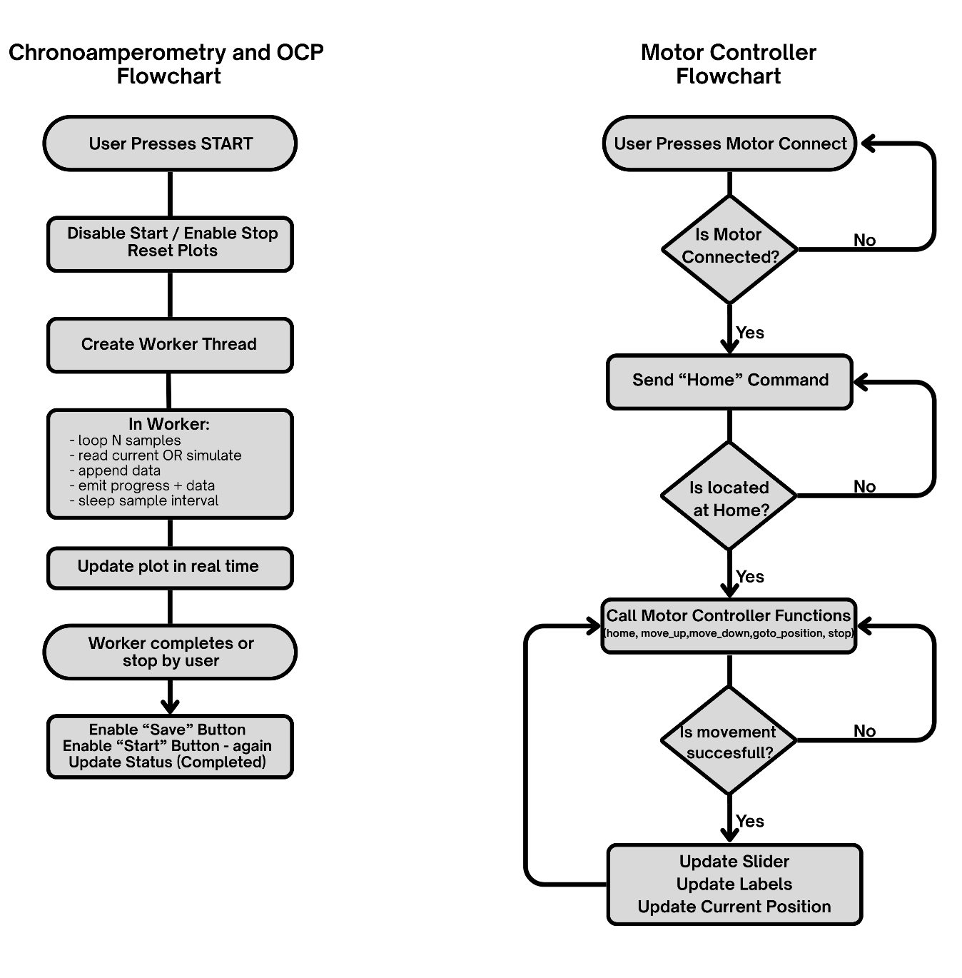
A
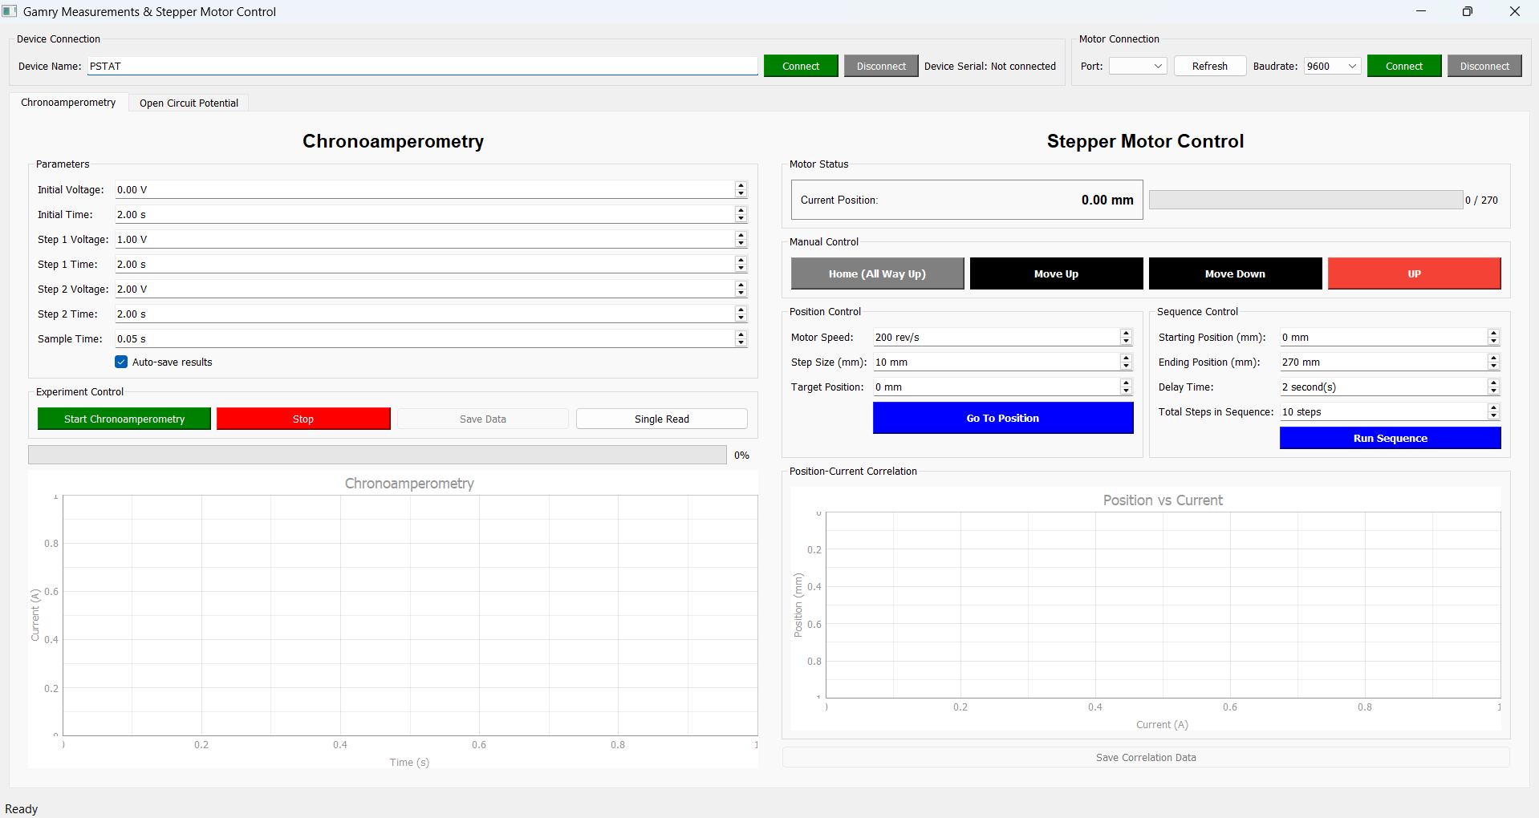
B
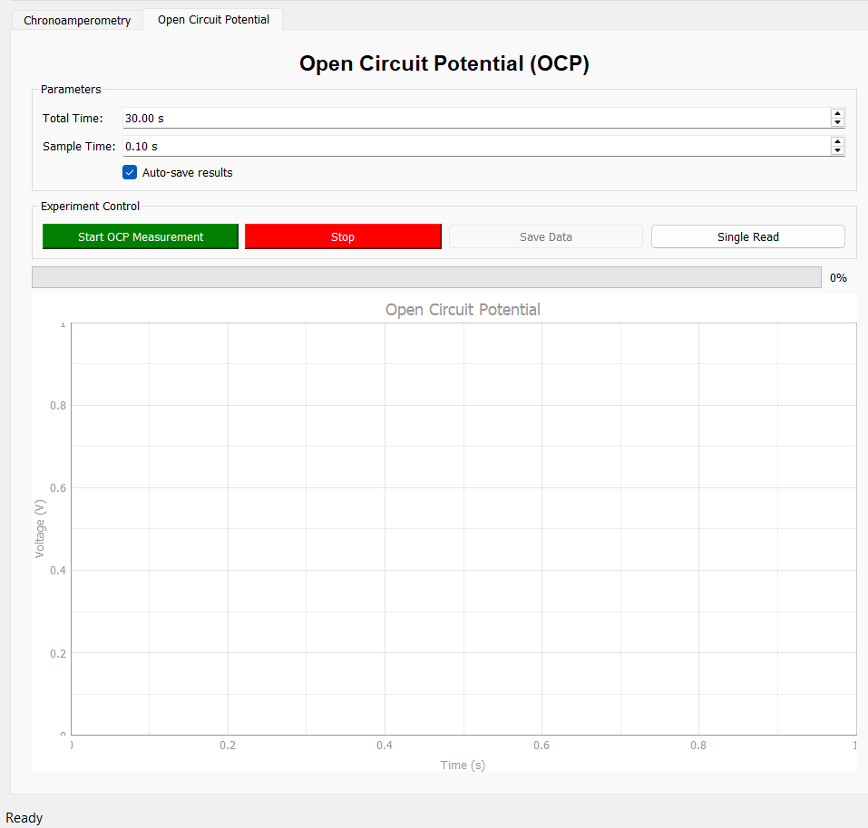
C

Figure SI1. A) Flowcharts of individual tabs of Python software developed for the SEPS measuring OCP and CA. The software initializes connections with both the Arduino-based manipulator and the Gamry potentiostat, performs automated microelectrode positioning, executes electrochemical measurements (OCP or CA), logs the data, and repeats the cycle until profiling is complete. B) A screenshot of the user interface with the “Chronoamperometry” tab open. C) A screenshot of the user interface with the “Open Circuit Potential” tab open.

Control Zobell
2 cm above Hydrogel Surface Level
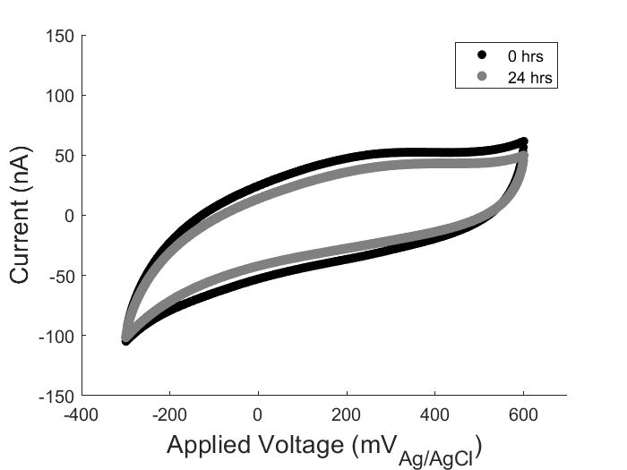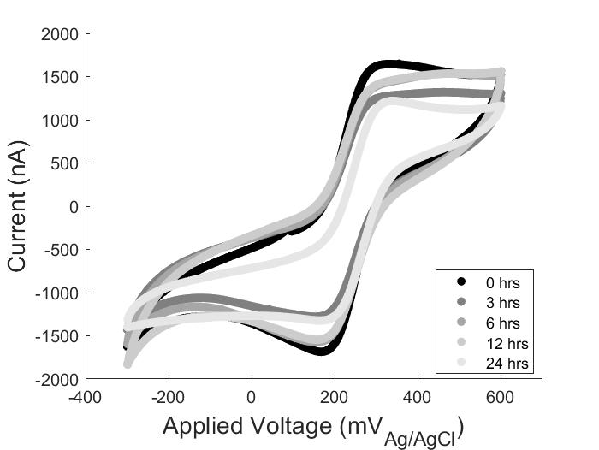0.5 cm above Hydrogel Surface Level
A
G
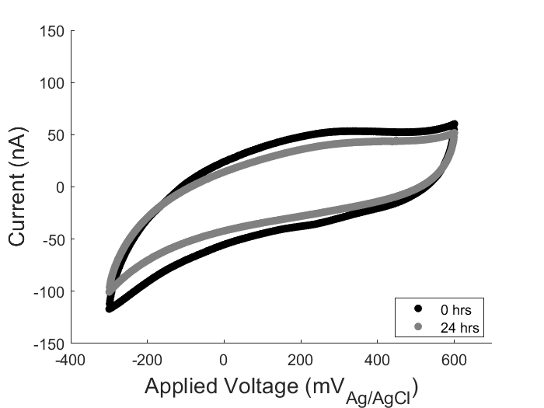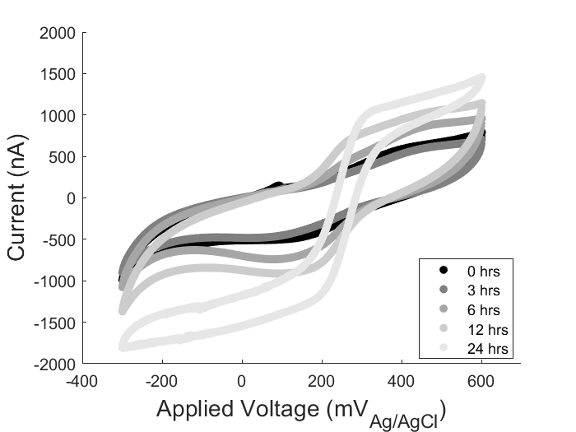
H
B
1 cm below Hydrogel Surface Level
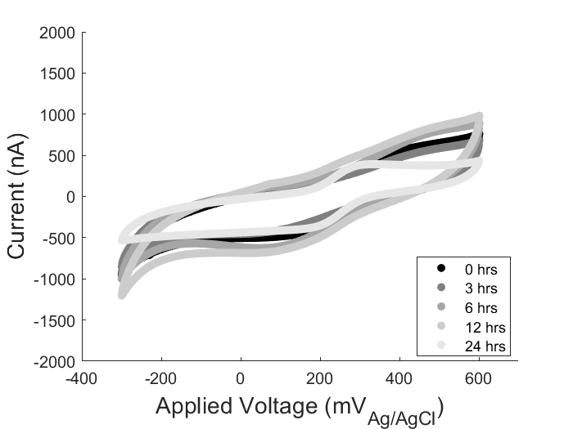
I
C
2.5 cm below Hydrogel Surface Level
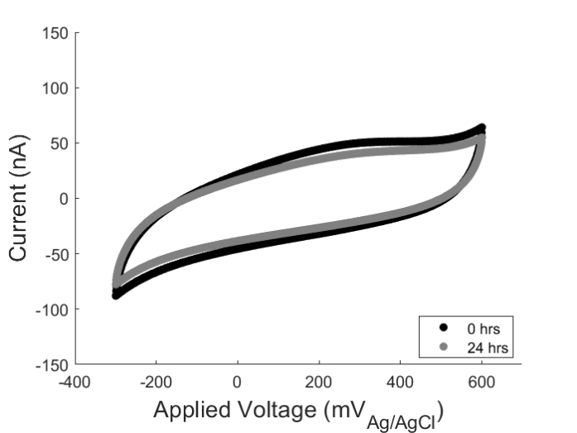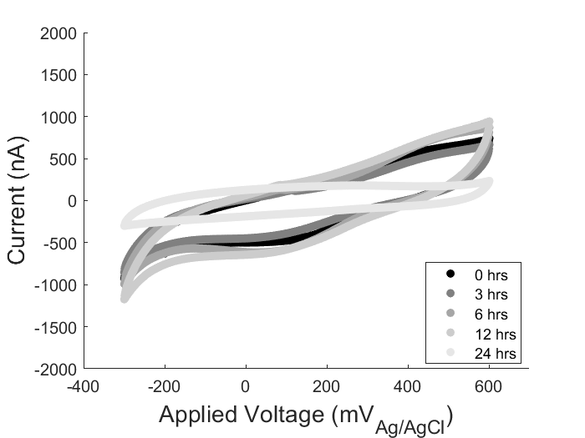
J
D
E
F
4 cm below Hydrogel Surface Level
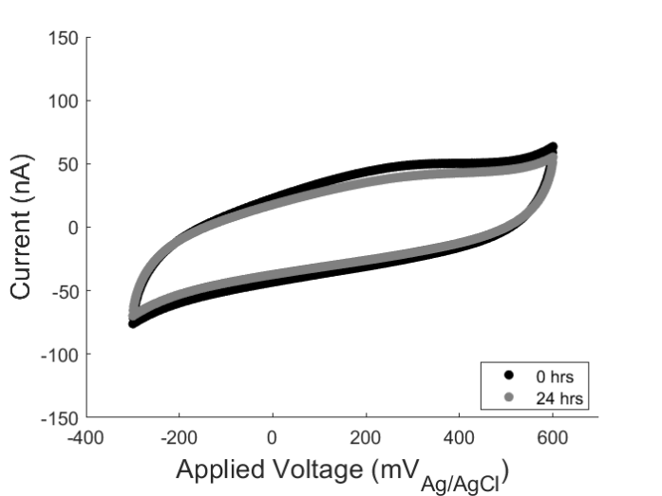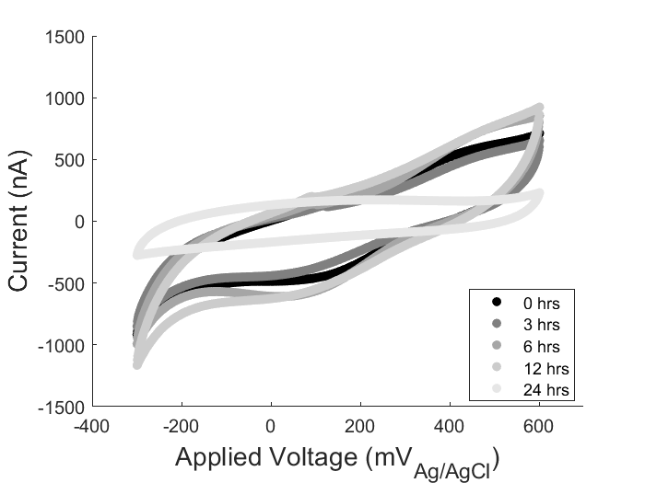
K
5.5 cm below Hydrogel Surface Level
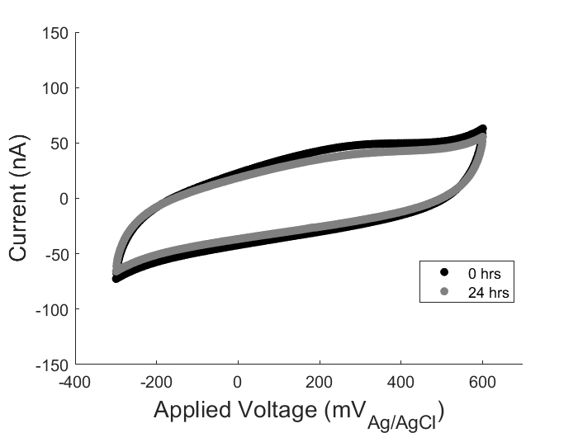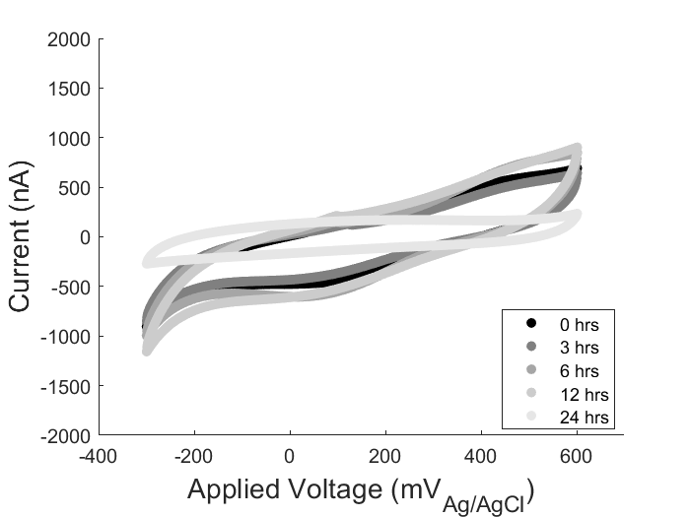
L
Fig SI2. Cyclic voltammetry of Zobell solution diffusing through hydrogel. (A–F) Control experiment showing cyclic voltammograms at 0 and 24 hours without Zobell solution above the hydrogel. (G–L) Cyclic voltammograms recorded during Zobell solution diffusion through the hydrogel at 0, 3, 6, 12, and 24 hours, illustrating temporal and spatial changes in redox behavior. At each time point, six measurements were taken at 1.5 cm intervals, from 2 cm above to 5.5 cm below the hydrogel surface.

2 cm above the Soil Surface Level 0.5 cm above the Soil Surface Level
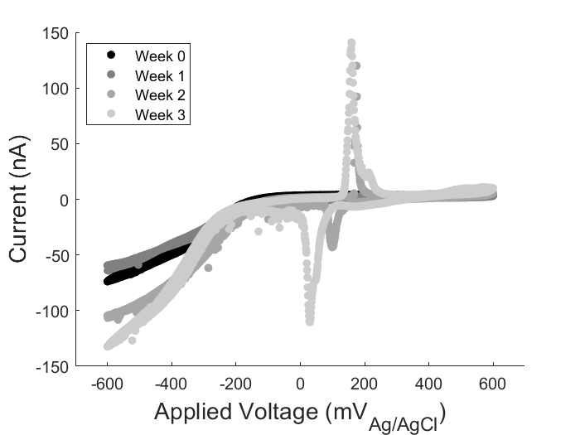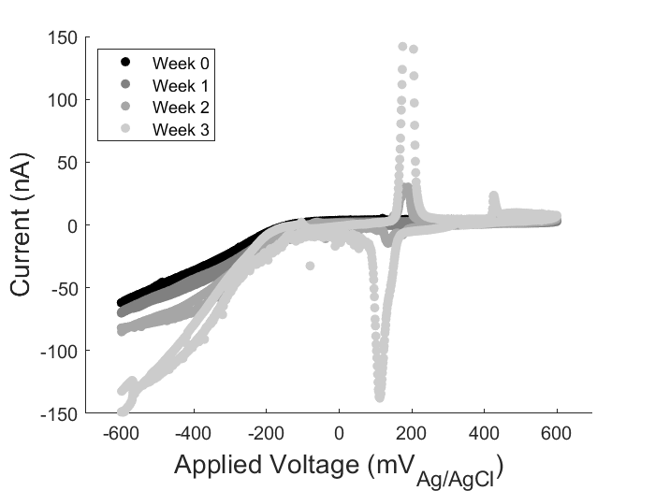
B
C
A
1 cm below the Soil Surface Level 2.5 cm below the Soil Surface Level
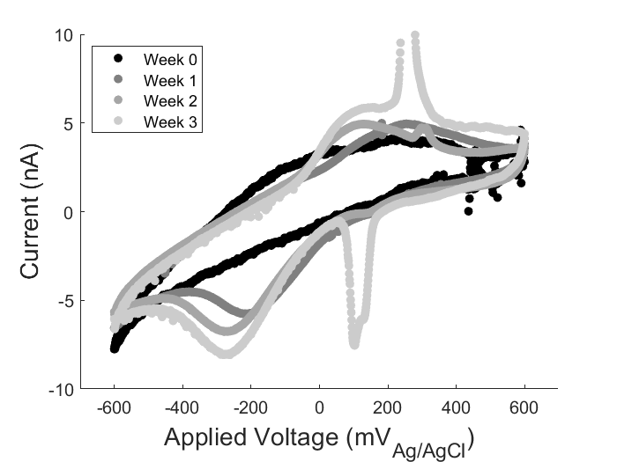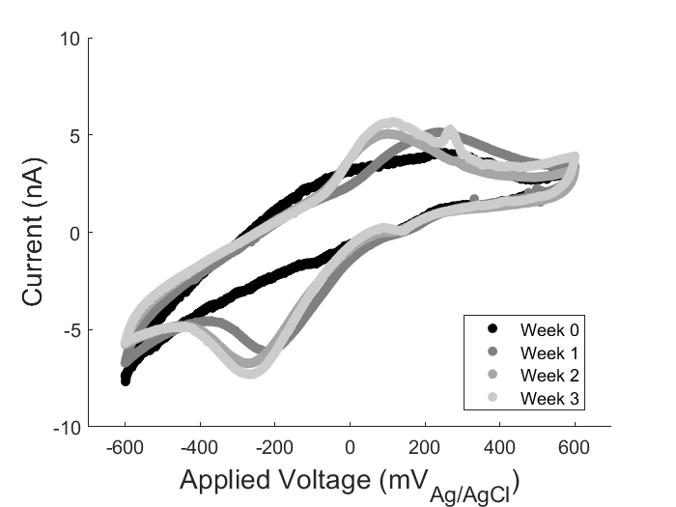
D
4 cm below the Soil Surface Level 5.5 cm below the Soil Surface Level
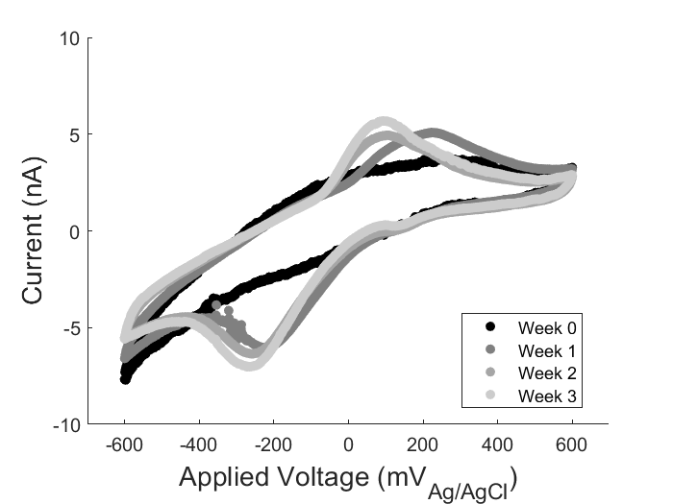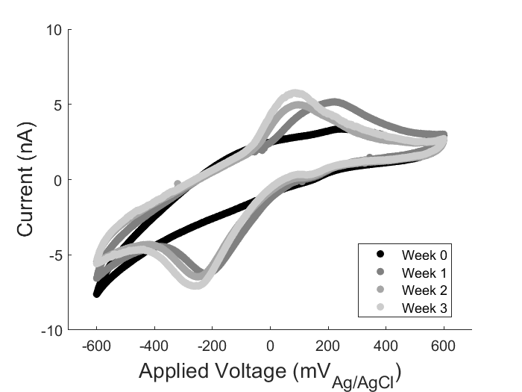
F
E
Fig SI3. Depth profiles of cyclic voltammograms in soil mesocosm reactors. (A-F) Cyclic voltammograms measured at different depths each week. For every sampling week, six measurements were taken at 1.5 cm intervals, starting from 2 cm above the soil surface to 5.5 cm below the surface.

