Supplementary Information

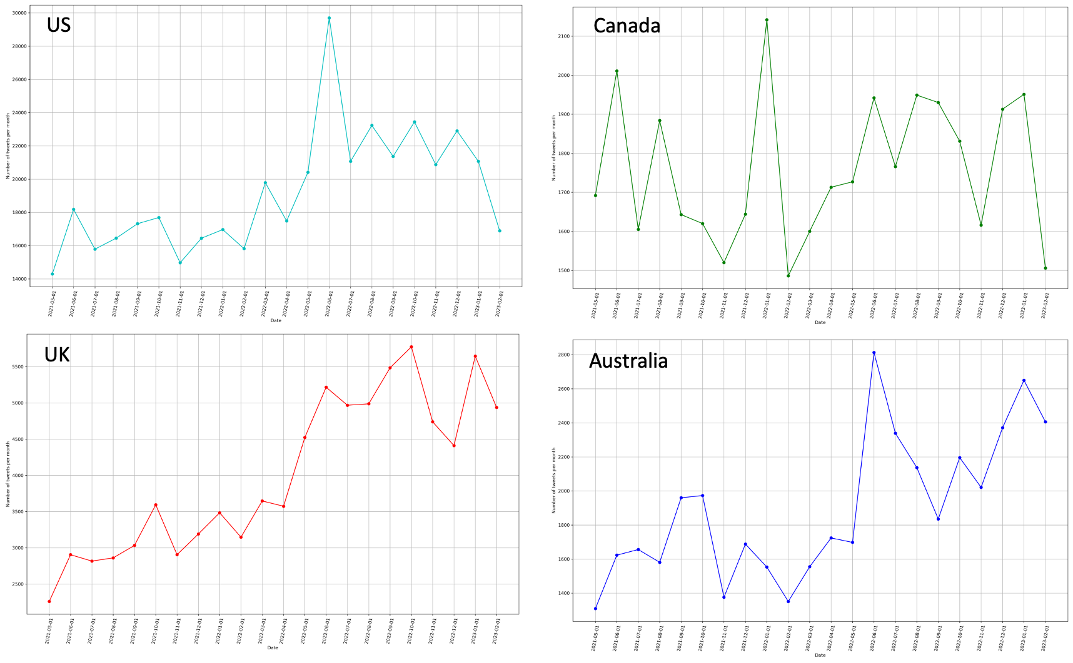
Fig S1. Temporal trend in the prevalence of e-cigarette-related tweets in four countries.

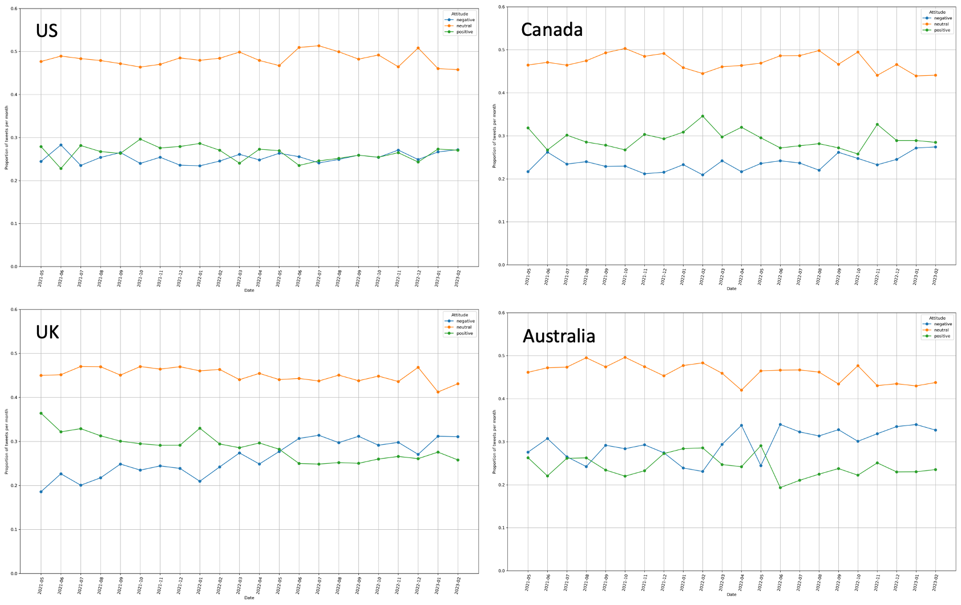
Figure S2. Temporal trend in the proportion of tweets with different sentiments toward e-cigarettes in four countries.

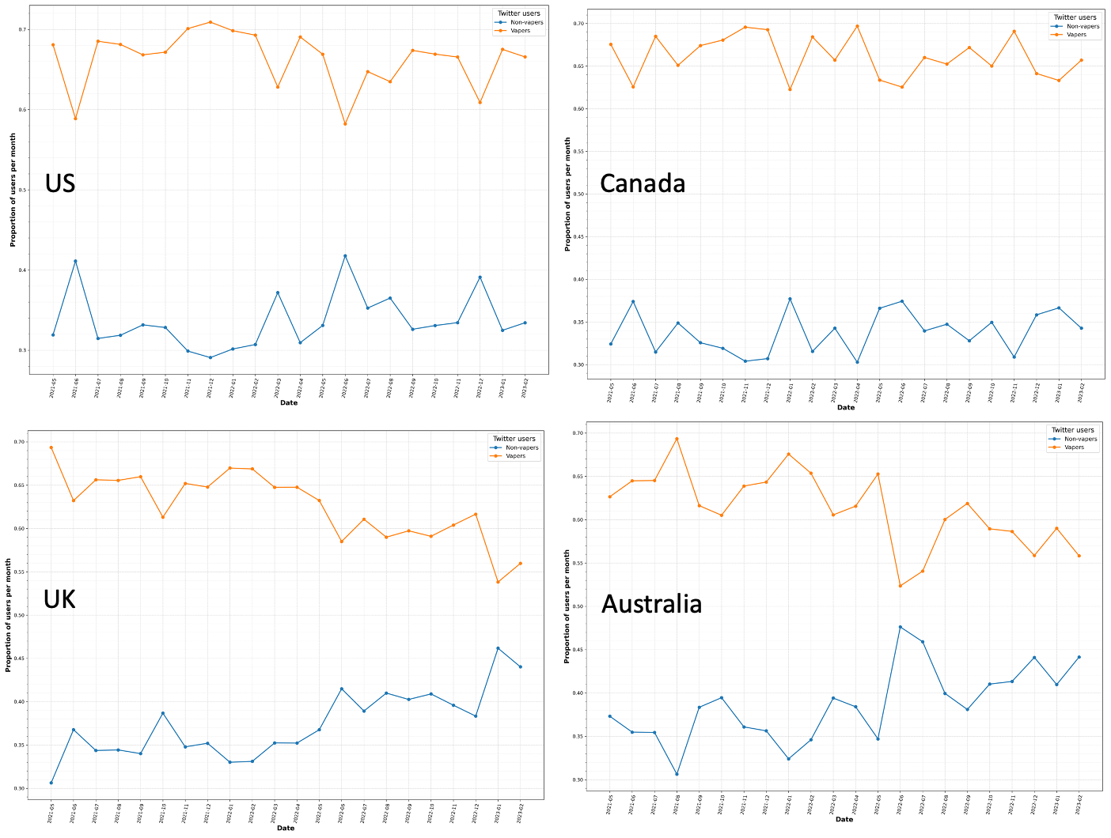
Figure S3. Relative prevalence of vapers and non-vapers among Twitter users posting e-cigarette-related tweets in four countries.

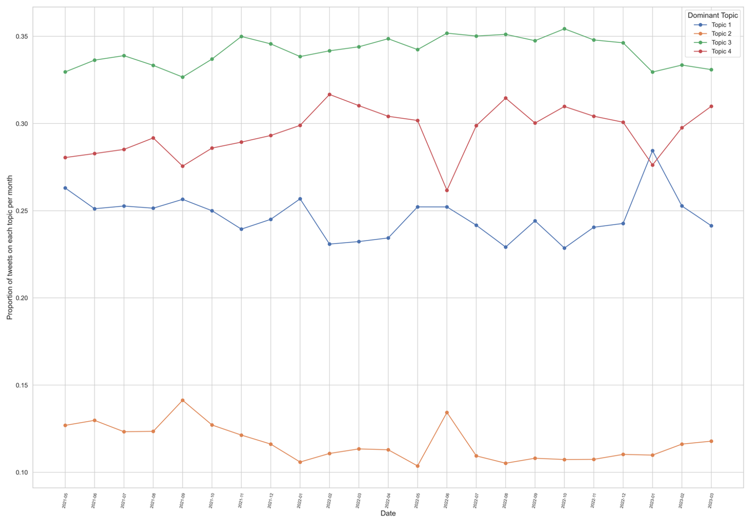
Figure S4. The relative prevalence of main topics in tweets with a positive sentiment.

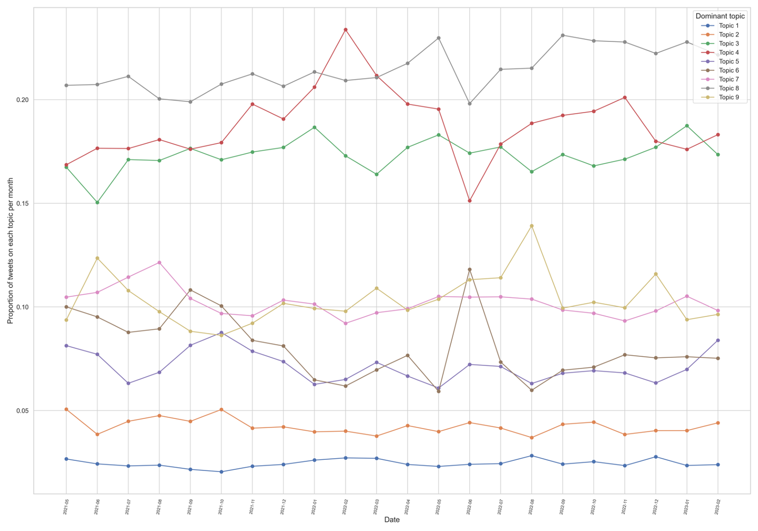
Figure S5. The relative prevalence of main topics in tweets with a negative sentiment.

