Structural Evolution and Sorption Performance of Fly Ash-Based Geopolymers for Trivalent Actinide Sequestration
Atanu Das ¹, Aishwarya S. Kar ^{1,2*}, Vaishali Arunachalam ³, Deepak Tyagi ^{2,4}, R. T. Parayil^{2,5}
¹ Radioanalytical Chemistry Division, Bhabha Atomic Research Centre, Mumbai – 400085
² Homi Bhabha National Institute, Anushaktinagar, Mumbai- 400094
³Tata Institute of Fundamental Research, Hyderabad – 500046
⁴Chemistry Division, Bhabha Atomic Research Centre, Trombay, Mumbai – 400085
⁵Radiochemistry Division, Bhabha Atomic Research Centre, Trombay, Mumbai - 400085

*Email: aishj@barc.gov.in

TGA curve of sodium metasilicate recorded from 25 °C to 800 °C at a heating rate of 10 °C/min under nitrogen atmosphere. A prominent weight loss (58.27%) is observed between 30 °C and 120 °C corresponding to the evaporation of physically adsorbed moisture and crystalline water. Form the TGA the effective molecular formula is found to be Na₂SiO₃.9H₂O and Na₂O and Si₂O mole ratio is 1:1.
SI Fig.1: TGA of sodium metasilicate

SI Table 1 summarizes Si/Al, H₂O/Na₂O, Na₂SiO₃/NaOH and S/L ratio for all synthesized geopolymers. For all the activator solutions the H₂O/Na₂O was maintained at 15 and Na₂SiO₃ ratio was varied from 1.5 to 3.5 and the solid to liquid ratio was maintained at 1 for each geopolymer synthesis.

SI Table 1: Formulations of activator solutions used for GP synthesis
Sorbent | Si/Al (wt) | s/l | H₂O/Na₂O (wt) | Na₂SiO₃/NaOH
FA | 2.17 | - | - | -
FA + AS 2 | 2.17 | 1 | 15 | 1.5
FA + AS 3 | 2.17 | 1 | 15 | 1.75
FA + AS 4 | 2.17 | 1 | 15 | 2
FA + AS 5 | 2.17 | 1 | 15 | 2.25
FA + AS 6 | 2.17 | 1 | 15 | 2.5
FA + AS 7 | 2.17 | 1 | 15 | 2.75
FA + AS 8 | 2.17 | 1 | 15 | 3
FA + Al₂O₃ + AS 6 | 1.81 | 1 | 15 | 3.5
Al₂O₃ | - | - | - | -

(a)
(b)

(c)
SI Fig.2: Fitting of SI Fig. 2 :²⁷Al MAS NMR spectra a) FA b) FA-GP c) FA-Al-GP

SI Fig. 3 shows the sorption efficiency of various geopolymers for Am (III) at a concentration of 1x10⁻⁵ M with sorbent dose of 1 g.L⁻¹.The FA + AS 6 (FA-GP) along with FA + Al₂O₃ + AS 6 (FA-GP-Al₂O₃) and Al₂O₃ synthesized form Al foil, exhibited the highest sorption capacity of 98%, indicating strong uptake, whereas the plain fly ash (FA) showed significantly lower sorption (10%).

SI Fig. 3: Sorption capacity of all synthesized geopolymers with sorbent dose of 1g.L⁻¹ and [Am(III)] = 10⁻⁵ M

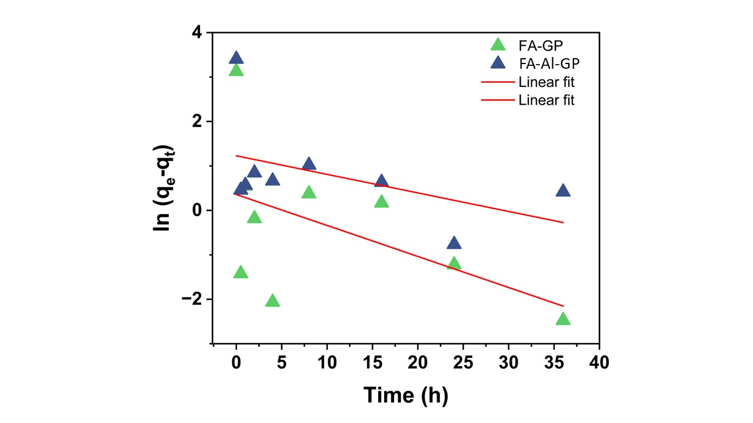
SI Fig. 4:PFO fit of sorption kinetics of Am(III)/Eu(III) on FA-GP and FA-Al-GP with sorbent dose of 1g.L-1 and [Am(III)] /Eu(III)]= 5x10⁻⁴ M

SI Fig. 5: Langmuir, Freundlich, Temkin, D-R and Sips isotherm fit with Van’t Hoff fit for FA-GP with sorbent dose 1 gL⁻¹at 298K, 313K and 328K at pH 6
f
d
c
b
a
SI Fig. 6: Langmuir, Freundlich, Temkin, D-R and Sips isotherm fit with Van’t Hoff fit for FA-Al-GP with sorbent dose 1 g L⁻¹at 298K, 313K and 328K at pH 6

SI Table 2. XPS binding energies (eV) of O 1s and Eu 4d regions for FA-GP and FA-Al-GP before and after Eu(III) sorption.

Region | Binding Energy (eV)
Region | FA-GP |  | FA-GP-Al₂O₃
Region | Blank | Eu (III) incorporated | Blank | Eu (III) incorporated
O1s | 530.0, 531.18 | 530.23, 527.18 | 530.26, 531.4 | 530.15, 530.446
Eu 4d |  | 141.101, 135.63 |  | 140.929, 135.529

