Supplementary table S1: Primers used throughout this study. The Populus tremula x Populus alba HAP1 v5.1 genome on Phytozome was used to obtain the poplar TPS16 gene sequence. For Laccaria bicolor genes, including HK genes, the Laccaria bicolor V2.0 genome on mycocosm was used.
Gene target | Protein ID # | Primer sequence (5’ 3’)
TPS16 | PtXaTreH.01G253600.1 | FW : CCAACTTGCTCCATTCCCTA  RV : TGCTTTGATCACGAGTTTCG
GH28a  (Zhang et al., 2021) | 613299 | FW : GCAAAGCAGGTTGCGGTAAA  RV : CAGTATGTTCGCGTTGCTGG
MiSSP7 | 298595 | FW : TCTCGCCTGCACTATCCTCT  RV : TTGGGCTCCGGTACTCTTCT
MiSSP17 | 332226 | FW : ACCGCCAATGGATGTGCATA  RV : CGGTGCAGTGTTGTGTCAAG
Catalase | 123238 | FW : TCAAAACCCAGAGTCGATCC  RV : CACAAAGGAACCGTCATCCT
Mn/Fe SOD1 | 635077 | FW : ATTCGTTGTTGAGGGAGTGG  RV : CGCACATATCAGCGAAAGAA
Mn/Fe SOD2 | 192586 | FW : AGGCAATTGAGCGTGACTTT  RV : AAGGATCCTGGTTTGCAGTG
Mn/Fe SOD3 | 291347 | FW : GGCCACATCAACCACTCTCT  RV : GTTATCGAGGCTACCGAACG
Mn/Fe SOD4 | 295682 | FW : CCAGGACCCACTTCTCCATA  RV : TCAAAGTTGATGACGGACCA
Mn/Fe SOD5 | 312019 | FW : CAGTTTGAAGCCAACAAGCA  RV : CCAGAACTGCCTCAACCATT
HK gene 1  (Pellegrin et al., 2019) | 611151 | FW : TGGTTTTGCGGCGTTCTTCT  RV : TATGTCGTGCCCTGTCCCAA
HK gene 2  (Pellegrin et al., 2019) | 313997 | FW : GAGCAGAGCGGGTACGAATG  RV : ACCCGGCCGTACTGGAATAA

Supplementary table S2: ANOVA output for L. bicolor S238N X P. tremula x alba 717-1B4 symbiosis marker gene expression and L. bicolor S238N antioxidant response gene expression. Expression was measured in presence or absence of a host plant under control and sublethal Cd (1 µM 3CdSO₄.8H₂O) growth conditions.
 | Cd x Host |  | Cd |  | Host
GH28a | F (1, 12) =14.68 | P=0.0024 | F (1, 12) =20.38 | P=0.0007 | F (1, 12) =10.79 | P=0.0065
MiSSP7 | F (1, 10) =6.198 | P=0.0320 | F (1, 10) =7.769 | P=0.0192 | F (1, 10) =4.184 | P=0.0680
MiSSP17 | F (1, 9) =7.855 | P=0.0206 | F (1, 9) =6.057 | P=0.0361 | F (1, 9) =52.45 | P<0.0001
CAT  Mn/Fe SOD1  Mn/Fe SOD2  Mn/Fe SOD3  Mn/Fe SOD4  Mn/Fe SOD5 | F (1, 12) =14.93  F (1, 14) =3.690  F (1, 14) =0.07289  F (1, 12) =11.02  F (1, 11) =5.807  F (1, 12) =13.96 | P=0.0023  P=0.0753  P=0.7911  P=0.0061  P=0.0346  P=0.0028 | F (1, 12) =35.24  F (1, 14) =1.128  F (1, 14) =2.787  F (1, 12) =28.33  F (1, 11) =24.15  F (1, 12) =2.697 | P<0.0001  P=0.3062  P=0.1172  P=0.0002  P=0.0005  P=0.1264 | F (1, 12) =19.55  F (1, 14) =0.6774  F (1, 14) =0.09062  F (1, 12) =19.65  F (1, 11) =1.288  F (1, 12) =3.279 | P=0.0008  P=0.4243  P=0.7678  P=0.0008  P=0.2805  P=0.0953

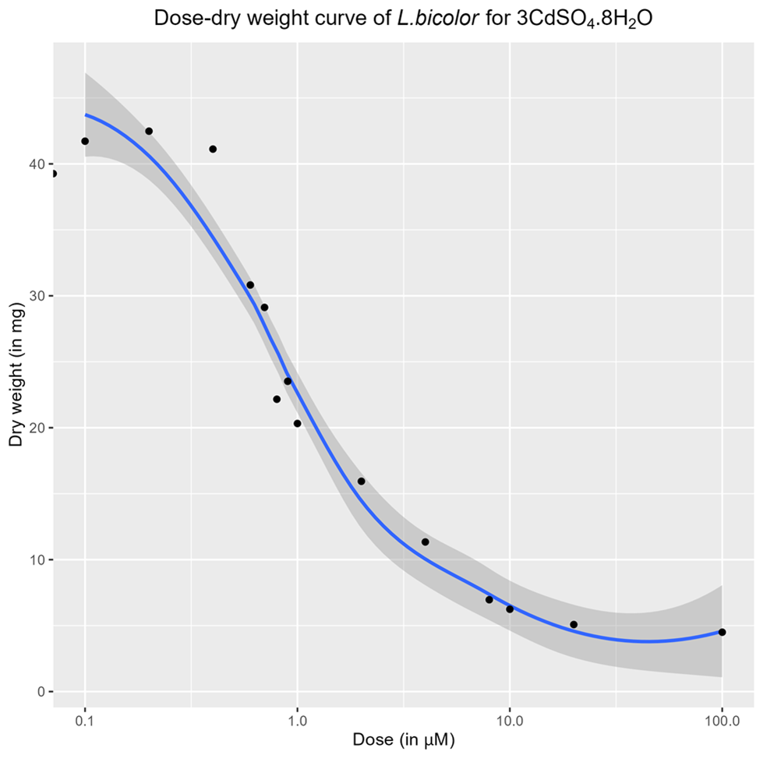
Supplementary Fig. S1: Dose-Response hermetic curve of L. bicolor S238N for 3CdSO₄.8H₂O. Free-living mycelium was cultured on P5 medium supplemented with 15 different 3CdSO₄.8H₂O concentrations between 0 (control) and 100 µM (n = 5). Mycelium was harvested and lyophilised after three weeks of incubation at 23°C. Using the dry weights, the 3CdSO₄.8H₂O EC50 value for L. bicolor S238N was calculated in R using the drc package.

Pellegrin, C., Daguerre, Y., Ruytinx, J., Guinet, F., Kemppainen, M., Frey, N. F. D., Puech-Pages, V., Hecker, A., Pardo, A. G., Martin, F. M., & Veneault-Fourrey, C. (2019). Laccaria bicolor MiSSP8 is a small-secreted protein decisive for the establishment of the ectomycorrhizal symbiosis. Environ Microbiol, 21(10), 3765-3779. https://doi.org/10.1111/1462-2920.14727
Zhang, F., Labourel, A., Haon, M., Kemppainen, M., Da Silva Machado, E., Brouilly, N., Veneault-Fourrey, C., Kohler, A., Rosso, M. N., Pardo, A., Henrissat, B., Berrin, J. G., & Martin, F. (2021). The ectomycorrhizal basidiomycete Laccaria bicolor releases a GH28 polygalacturonase that plays a key role in symbiosis establishment. New Phytol, 233(6), 2534-2547. https://doi.org/10.1111/nph.17940

