Table S1: Summary of disease-causing mutations in patients included in the study*
Mutations | Genetic ID | Clinical effect
c.374C>A (p.T125K) Heterozygous | Allele ID: 526918  Variant type: single nucleotide variant  Cytogenetic location: 12q24.11  Protein exchange: p.T125K  Genomic location:  12:110913124 (GRCh38) UCSC  12:111350928 8GRCh37) UCSC | Familial hypertrophic cardiomyopathy
c.1448T>C (rs421016) (p.L483P) Heterozygous | Allele ID: 19327  Variant type: single nucleotide variant  cytogenetic location:1q22  Protein exchange:  L483P, L396P, L434P  Genomic location:  1:155235252 (GRCh38) GRCh38 UCSC  1:155205043 (GRCh37) GRCh37 UCSC | Late onset Parkinson's  Gaucher Types I, II, III  Perinatal lethal Gaucher  Dementia
c.1223C>T (rs75548401) (p.T408M) Heterozygous | Allele ID: 99354  Variant type: single nucleotide variant  Cytogenetic location: 1q22  Protein exchange: T408M, T359M, T321M  Genomic location:  1:155236246 (GRCh38) UCSC  1:155206037 (GRCh37) UCSC | Mostly benign  Late onset Parkinson's  Rarely Perinatal Lethal Gaucher
*ClinVar

Table S2: Examination of family members (patient A)
Relatives | Age and gender | GBA level nmol/ml/h | Genetic Mutation type | Examined regions | Clinical effect of mutation
Mother | 26 years  female | 1,8 | c.374C>A (p.T125K) Heterozygous | GBA gene Exon 1,2,3,4,5,6,7,8,9,10,11 in HGMD database | Possibly harmful**1
Father | 27 years  male | 1.5 | Not Detected | GBA gene Exon 1,2,3,4,5,6,7,8,9,10,11 | -
Sister | 3 years  female | 3.8 | Not Detected | GBA gene Exon 1,2,3,4,5,6,7,8,9,10,11 | -
Mother’s father | 60 years male | 1.9 | Not Detected | GBA gene Exon 1,2,3,4,5,6,7,8,9,10,11
Mother’s mother | 58 years  female | 1 | c.374C>A (p.T125K) Heterozygous | GBA gene Exon 1,2,3,4,5,6,7,8,9,10,11 | No association of this mutation with disease in the HGMD database**2
Mother's brother 1 | 23 years Male | 2.2 | Not detected | GBA gene Exon 1,2,3,4,5,6,7,8,9,10,11 | -
Mother's brother 2 | 32 years Male | 2.8 | Not detected | GBA gene Exon 1,2,3,4,5,6,7,8,9,10,11 | -
Mother's brother 3 | 36 years Male | 2.8 | Not detected | GBA gene Exon 1,2,3,4,5,6,7,8,9,10,11 | -
**1 At position 374 of the coding sequence, the cytosine nucleotide was converted to adenine. This change caused the amino acid lysine to replace threonine at position 125 of the protein. The clinical significance of this finding, which is not included in the Clinvar database, is unknown.
**2 The cytosine nucleotide at position 374 of the coding sequence was converted to adenine. This change caused the amino acid lysine to replace threonine at position 125 of the protein. The clinical significance of this finding, which is not included in the Clinvar database, is unknown.

Gaucher’s disease
FMF Carrier
Dead Man
Dead WOMAN
FMF disease
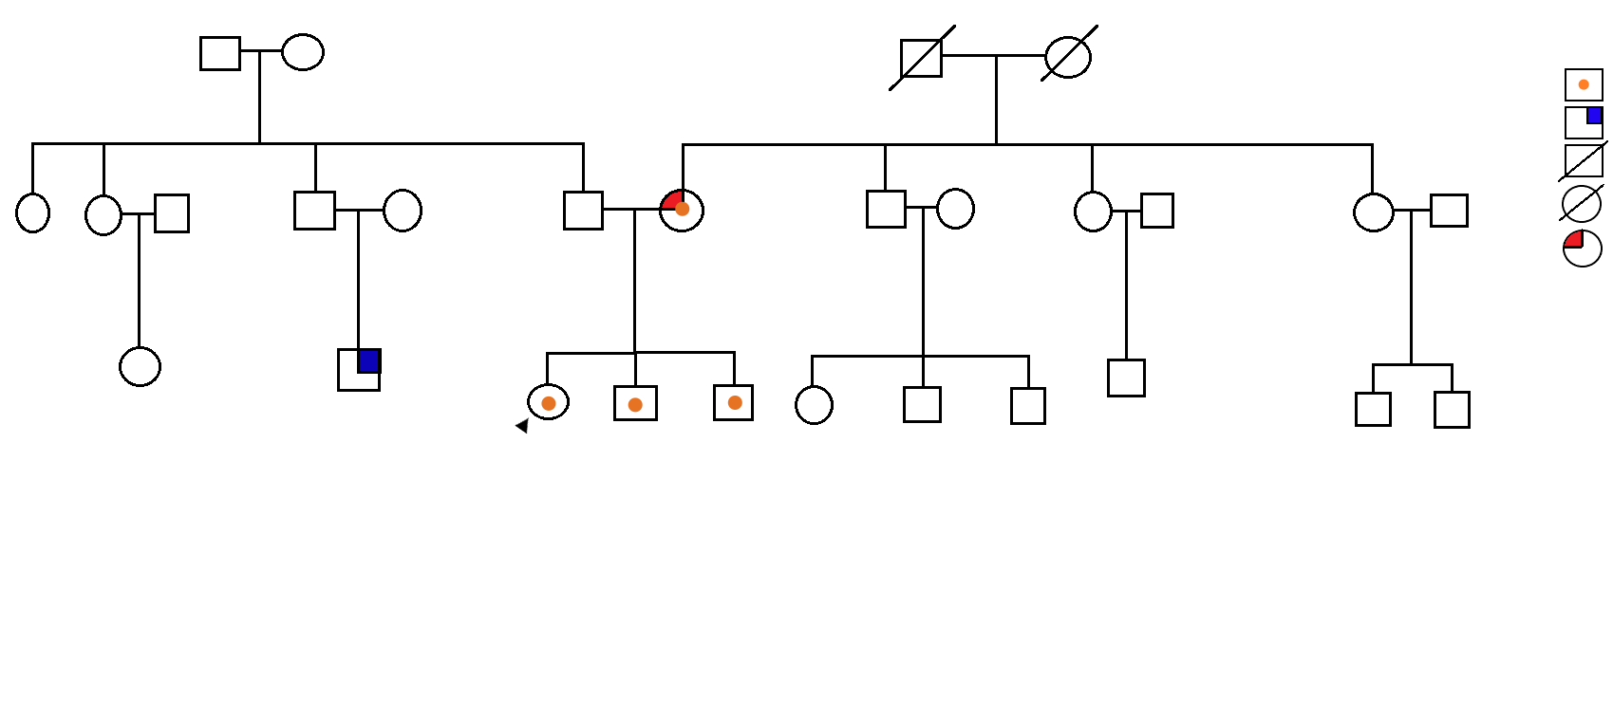

Figure S1. Pedigree tree for patient A with mutation

Table S3 . Examination of family members (patient B)
Relatives | Age and gender | GBA level nmol/ml/h | Genetic Mutation type | Examined regions | Clinical effect of mutation
Mother | 27 years, female | 2.4 | c.1448T>C (rs421016) (p.L483P) Heterozygous | GBA gene Exon 1, 2, 3, 4, 5, 6, 7, 8, 9, 10 .11 | Carrier for Gaucher disease
Father | 29 years, male | Not included in the study for social reasons
Brother 1 | 3 years, male | 2.90 | c.1448T>C (rs421016) (p.L483P) Heterozygous | GBA gene Exon 1, 2, 3, 4, 5, 6, 7, 8, 9, 10 .11 | Carrier for Gaucher disease
Brother 2 | 2 years, male | 2.7 | c.1448T>C (rs421016) (p.L483P) Heterozygous | GBA gene Exon 1, 2, 3, 4, 5, 6, 7, 8, 9, 10 .11 | Carrier for Gaucher disease
***Study could not be conducted on the individuals mentioned because the grandmother and mother's father died early.

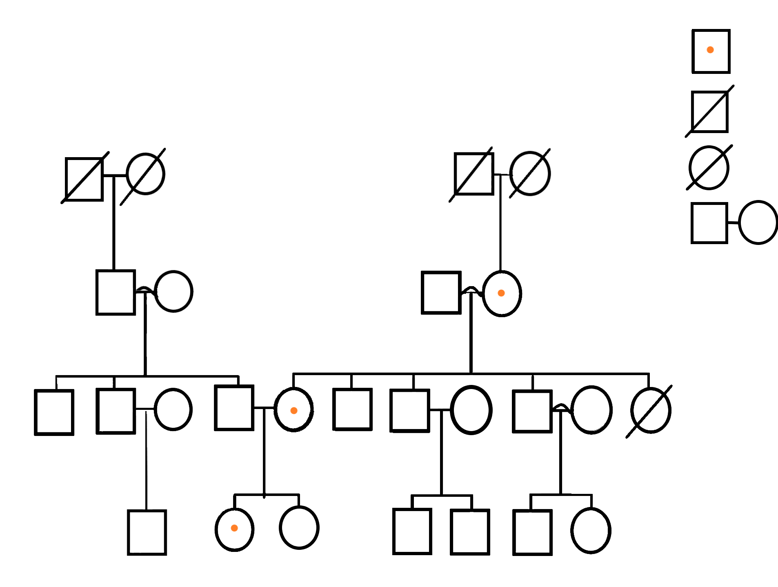
Gaucher heterozygous mutation

Dead Man

Dead Woman

Consanguineous marriage

Figure S2. Pedigree tree for patient B with mutation

Table S4: Comparison of newborn Gaucher screening: Hungary vs OMUFM

 | Hungary | OMUFM
Number screened | 40,021 | 107
GBA activity cutoff | 3.5 μmol/L/hour | <5 μmol/L/hour
Number below cutoff | 16 | 29
Enzyme activity in below-cutoff group | 3.26 μmol/L/hour | Mean 3.83 μmol/L/hour
Number with genetic testing | 16 | 11
Number with confirmed diagnosis (genetics) | 3 | 1
Number with detected mutations | 10 (total mutations); 2 heterozygous; 5 carriers; 3 diagnostic | 3 Gaucher / 2 Niemann-Pick
Detected mutations (confirmed Gaucher cases) | c.1448T>C (p.L483P) c.1483G>C (p.A495P) | c.1448T>C (rs421016) (p.L483P) heterozygous
Number of carriers | Total 7 | 2
Carrier-associated mutations | c.1223C>T (p.T408M) c.1226A>G (p.N409S) c.475C>T (p.R159W) | *c.374C>A (p.T125K) heterozygous; c.1223C>T (rs75548401) (p.T408M) heterozygous
Reported incidence | 1/13,341* | 3/107*

Table S5: Comparison of newborn Gaucher screening: China vs OMUFM
 | CHINA | OMUFM
Number screened | 80,844 | 107
GBA activity cutoff | 30.07 μmol/L/hour | <5 μmol/L/hour
Number below cutoff | 11 | 29
Enzyme activity in below-cutoff group | 2.64 μmol/L/hour | Mean 3.83 μmol/L/hour
Number with genetic testing | 3 | 11
Number with detected mutations | 1 | 3 Gaucher / 2 Niemann-Pick
Detected mutations | c.1448T>C (L483P) c.907C>A (L303I) | *c.374C>A (p.T125K) heterozygous; c.1448T>C (rs421016) (p.L483P) heterozygous; c.1223C>T (rs75548401) (p.T408M) heterozygous
Reported incidence | 1/80,855 | 3/107
*Mutations recorded for Gaucher.

