Linking water quality, health risks, and community responses in urban drinking water systems of a lower-middle-income city: Evidence from Bangladesh
Md. Inzamul Haque¹, Md. Anik Hossain^{1, *}, Abu Reza², Md. Asikur Rahman¹, Most. Atia Parvin¹, J S M Mahedi³, Md. Ashraful Islam Dewan¹
¹Dept. of Environmental Science and Geography, Islamic University, Kushtia-7003, Bangladesh
²Department of Genetic Engineering and Biotechnology, Daffodil International University, Dhaka-1216, Bangladesh
³International Centre for Diarrhoeal Disease Research (icddr,b), Dhaka 1212, Bangladesh
*Corresponding author: mahossain07.bd@gmail.com, mahossain@std.iu.ac.bd (M.A Hossain)
Supplementary files
Appendix A: Supplementary figures
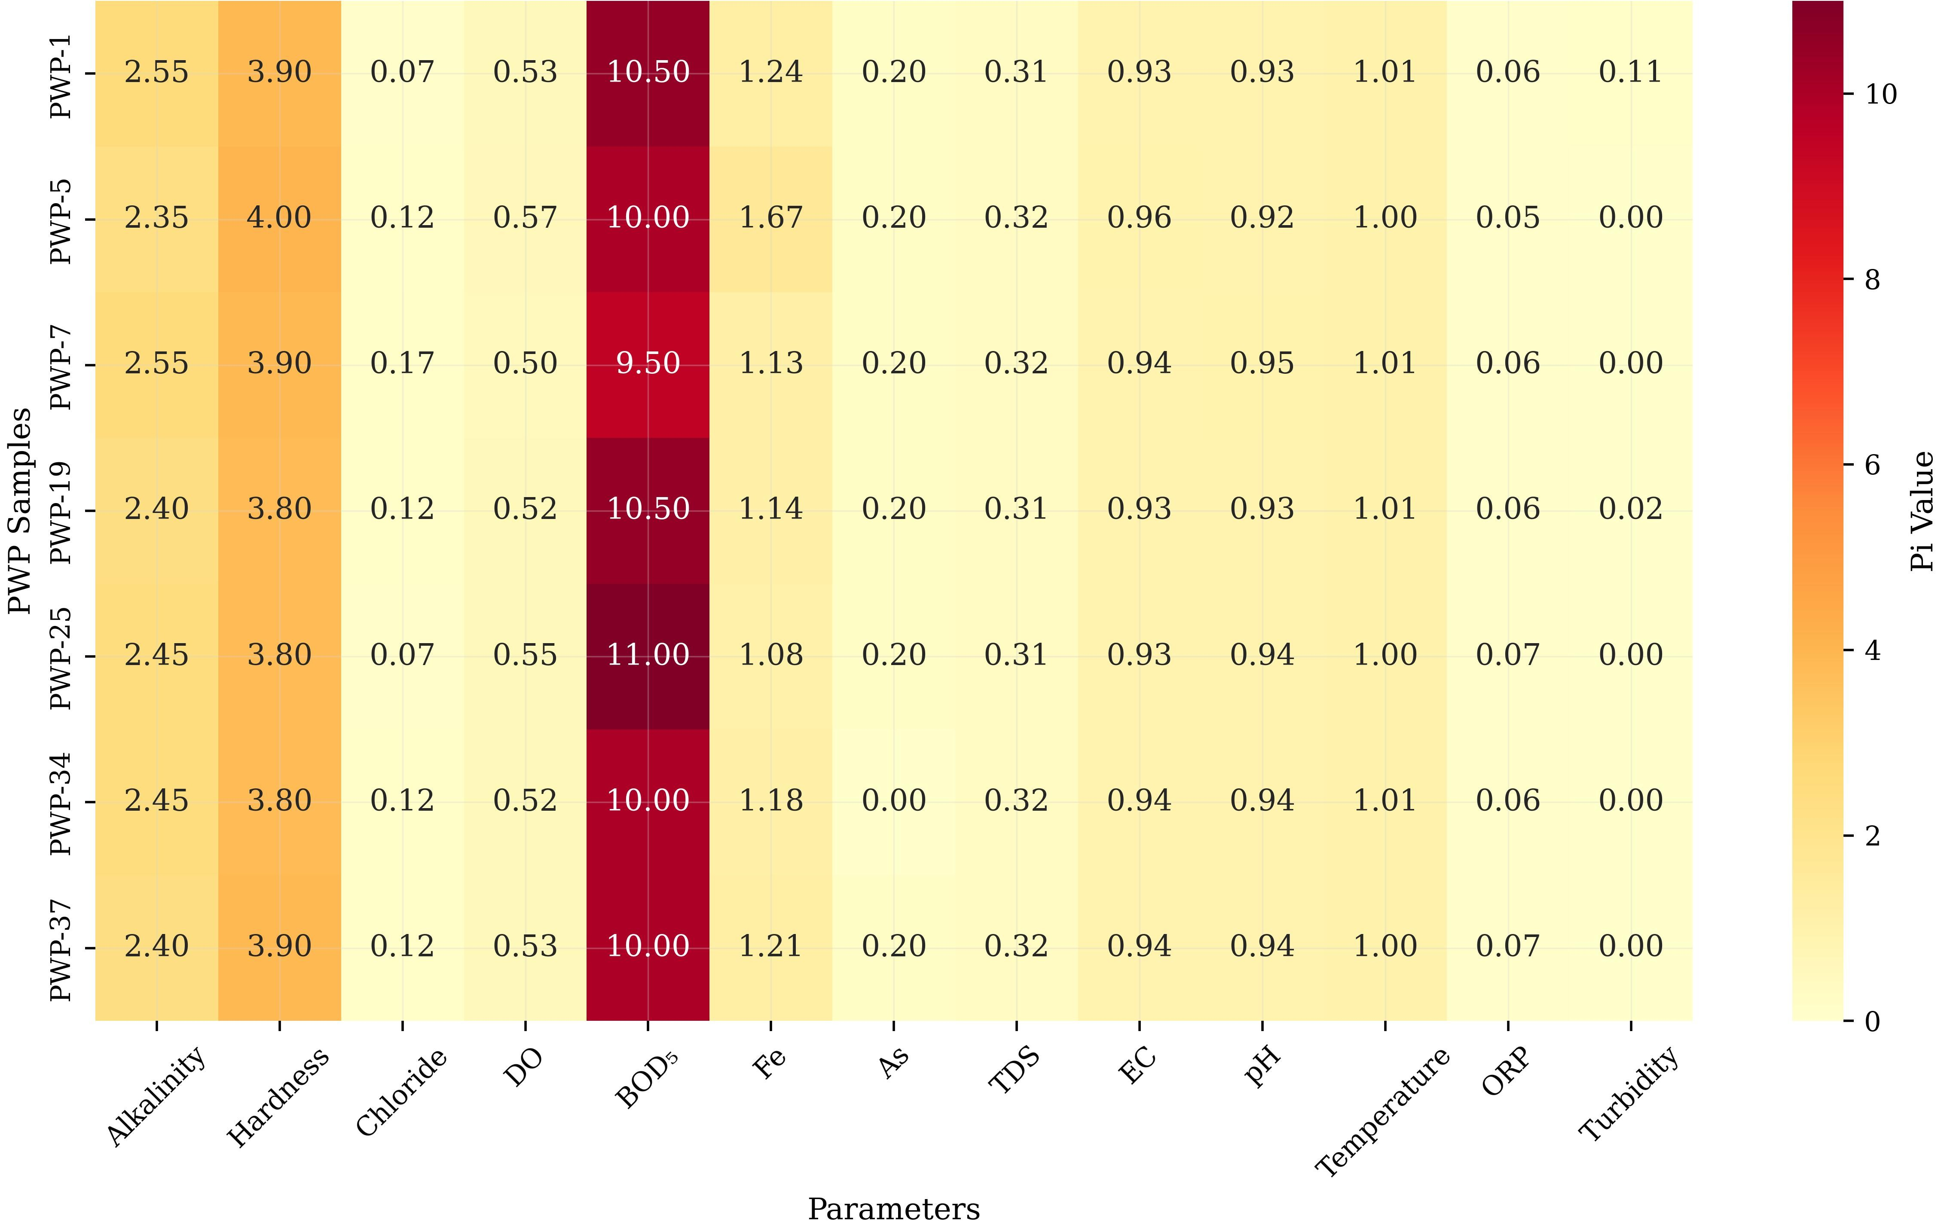
Fig. S1. Site-specific contributing pollutants at PWPs

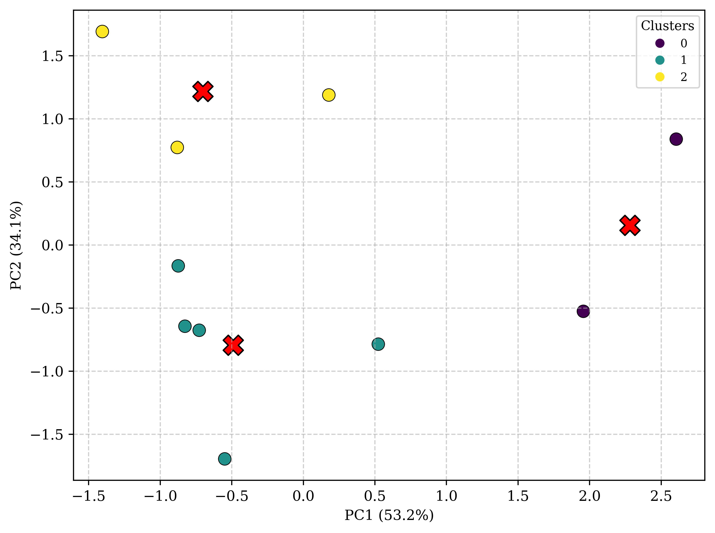
Fig. S2. PCA result showing the rank of the most influential factor for the combined KAP
Fig. S3. PWP in Kushtia Municipality is mostly situated near drains (Source: Field Survey, 2024)

Appendix B: Supplementary Tables
Table S1. Public water points (PWP) in Kushtia Municipality, Bangladesh (translated from the original document)

Serial no. | PWP no. | Ward no. | Location |  |  | Status
 |  |  | Absolute location |  | Relative Location
 |  |  | Latitude | Longitude
1 | 23 | 19 | 23.89241389 | 89.11125556 | Jhenaidah Road | Operational
2 | 19 | 5 | 23.8899 | 89.13191389 | Mujibur Rahman Road | Operational
3 | 20 | 5 | 23.89408333 | 89.12395278 | Mujibur Rahman Road | Operational
4 | 17 | 7 | 23.89799167 | 89.13157778 | Dr. Ainuddin Ahmed Road | Operational
5 | 25 | 6 | 23.89172222 | 89.13156111 | Housing C Block | Operational
6 | 18 | 6 | 23.88988333 | 89.13318056 | Housing C Expansion | Operational
7 | 37 | 12 | 23.88847778 | 89.14708056 | Dhaka Road, Lahini Battola | Operational
8 | 21 | 12 | 23.88836667 | 89.14647778 | Nur Uddin Ahmed Road | Operational
9 | 22 | 11 | 23.89791667 | 89.14444722 | Mohini Mahan Chakraborty Road | Operational
10 | 16 | 10 | 23.88456944 | 89.14238889 | Rajab Ali Khan Road | Operational
11 | 14 | 10 | 23.90301111 | 89.14349444 | Kabi Azizur Rahman Road | Operational
12 | 46 | 10 | 23.90213333 | 89.14551389 | Kabi Azizur Rahman Road | Operational
13 | 47 | 10 | 23.90149444 | 89.14687222 | Kabi Azizur Rahman Road | Operational
14 | 40 | 12 | 23.89911944 | 89.14616389 | Mohini Mahan Chakraborty Road | Operational
15 | 45 | 10 | 23.89643889 | 89.14917222 | Mil Line Quarter | Non-operational
16 | 36 | 10 | 23.89749444 | 89.15039167 | Lalon Shah Road | Operational
17 | 52 | 10 | 23.90185 | 89.14795556 | Char Milpara, Balur Ghat | Operational
18 | 39 | 10 | 23.90222222 | 89.14205833 | Bihari Colony | Operational
19 | 53 | 10 | 23.90243611 | 89.14217778 | Bihari Colony | Operational
20 | 43 | 9 | 23.90342222 | 89.1422 | Abdul Aziz Road | Operational
21 | 29 | 10 | 23.90460833 | 89.14161389 | Boro Bazar Baroyari Tola Road | Operational
22 | 27 | 8 | 23.90390556 | 89.14221944 | Sifatullah Biswas Road | Operational
23 | 31 | 3 | 23.90686111 | 89.13744444 | Bonku Bihari Road | Operational
24 | 54 | 1 | 23.90688611 | 89.13649167 | In front of Paurashava | Operational
25 | 33 | 3 | 23.90622222 | 89.13568333 | NS Road | Operational
26 | 32 | 3 | 23.90536389 | 89.13476667 | NS Road | Operational
27 | 9 | 3 | 23.90641944 | 89.13521944 | NS Road | Operational
28 | 4 | 1 | 23.91010278 | 89.12253056 | Chaudhari Kaushar Uddin Road | Operational
29 | 11 | 3 | 23.91113333 | 89.12273333 | Bonku Bihari Road | Operational
30 | 6 | 1 | 23.91191944 | 89.12248611 | Chad Mohammad Road | Operational
31 | 55 | 1 | 23.91240833 | 89.12231667 | Dr. Aminul Islam's Chamber | Operational
32 | 5 | 1 | 23.90989444 | 89.12366111 | NS Road | Operational
33 | 10 | 3 | 23.90888889 | 89.12717778 | NS Road | Operational
34 | 24 | 16 | 23.905225 | 89.106725 | A.K Mukherjee Road | Operational
35 | 2 | 1 | 23.91180833 | 89.11431389 | Dadapur Road | Operational
36 | 1 | 1 | 23.91054167 | 89.11617778 | Dadapur Road | Operational
37 | 56 | 10 | 23.90745 | 89.12141389 | Hanif Counter, Mozompur | Operational
38 | 13 | 10 | 23.90863611 | 89.12184167 | Mozompur Railgate | Operational
39 | 7 | 2 | 23.901 | 89.125 | Hospital Mor | Operational
40 | 3 | 1 | x | x | Chaudhari Kaushar Uddin Road | Non-operational
41 | 8 | 3 | x | x | Lutfar Munshi Road | Non-operational
42 | 12 | 10 | x | x | Dr. Qudrat-i-Khuda Road | Non-operational
43 | 15 | 9 | x | x | Bardakhanta Shah Road | Non-operational
44 | 26 | 9 | x | x | Bardakhanta Shah Road | Non-operational
45 | 28 | 8 | x | x | Ananda Mohan Bagci Road | Non-operational
46 | 30 | 10 | x | x | Shirish Chandra Banerjee Road | Non-operational
47 | 34 | 3 | x | x | Lutfar Munshi Road | Non-operational
48 | 35 | 10 | x | x | Dr. Qudrat-i-Khuda Road | Non-operational
49 | 38 | 12 | x | x | Lokai Mistri Road | Non-operational
50 | 41 | 10 | x | x | Mahashoshan Road | Non-operational
51 | 42 | 10 | x | x | Dr. Qudrat-i-Khuda Road | Non-operational
52 | 44 | 10 | x | x | Rabindra Sarani Road | Non-operational
53 | 48 | 9 | x | x | Debi Pharashad Chakravarti Road | Non-operational
54 | 49 | 9 | x | x | Rajab Ali Khan Road | Non-operational
55 | 50 | 9 | x | x | Chandramouli Syannal Street | Non-operational
56 | 51 | 9 | x | x | Chandra Charan Road | Non-operational

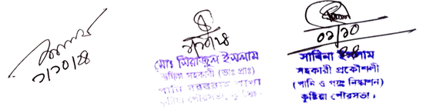

Table S2. Analytical parameters and methods for laboratory testing
Parameters | Analyzer | Model and brand | Analytical method | Standard values | References
Alkalinity | Test kit (LR and HR) | LH2018 and LH2019 (Lohand) | Acid-base titration method | 20–200 | Hossain et al., 2025
Hardness | Test kit | LH2013 (Lohand) | EDTA titration method | 80–100 | Hossain et al., 2025
Chloride | Test kit | LH2015 (Lohand) | Silver nitrate titration method | 150–600 | Hossain et al., 2025
DO | DO meter (Acc. ±0.4) | DO-5509 (Lutron) | Electrochemical reaction | 6 | Hossain et al., 2025
BOD₅ | BOD meter | BOD-PC02 (BIOBASE) | Respirometric (Incubation) | 0.2 | Hossain et al., 2025
Iron | Iron checker (Acc. ±0.04) | HI-721 (Hanna) | Colorimetric | 0.3–1.0 | Hossain et al., 2025
Arsenic | Test kit (LR) | Test Strip (Hach) | Colorimetric | 0.05 | Hossain et al., 2025
TDS | Multimeter (Acc. ±1%) | CON30 (CLEAN) | Electrochemical reaction | 1,000 | Hossain et al., 2025
EC | Multimeter (Acc. ±1%) | CON30 (CLEAN) | Electrochemical reaction | 700 | Hossain et al., 2025
pH | Multimeter (Acc. ±0.01) | PH-220 (BIOBASE) | Electrochemical reaction | 6.5–8.5 | Hossain et al., 2025
Temperature | Multimeter (Acc. ±0.5°C) | PH-220 (BIOBASE) | Electrochemical reaction | 20–30 | Hossain et al., 2025
ORP | Multimeter (Acc. ±1 mV) | PH-220 (BIOBASE) | Electrochemical reaction | Around 250 mV | Hossain et al., 2025
Turbidity | Turbidity meter | TU-2016  Lutron | Nephelometric method | 10 | Hossain et al., 2025

Table S3. Parameters and input assumptions, and values for calculating CDI via dermal absorption and ingestion for adults and children
Parameter | Ingestion |  | Dermal |  | Reference
 | Adult | Children | Adult | Children
Measured metal concentrations (Cw, µg/L) | - | - | - | - | -
Ingestion rate (IR, L/day) | 3.5 | 1.32 | - | - | Hossain et al., 2025
Dermal permeability coefficient (Kp, cm/h) | Fe: 1×10⁻³, As: 4×10⁻⁴ |  | - | - | Hossain et al., 2025
Exposure time (ET, h/event) | 0.58 | 1 | - | - | Hossain et al., 2025
Skin-surface area (SA, cm²) | 18000 | 6600 | - | - | Hossain et al., 2025
Exposure duration (ED, year) | 30 | 6 | 30 | 6 | Hossain et al., 2025
Exposure frequency (EF, day/years) | 365 |  |  |  | Hossain et al., 2025
Conversion factor (CF, L/cm³) | 0.001 |  | - | - | Hossain et al., 2025
Body weight (BW, kg) | 57.5 | 15 | 57.5 | 15 | Hossain et al., 2025
Average time (AT, day) | 10950 | 2190 | 10950 | 2190 | Hossain et al., 2025

Table S4. CDI values of Iron and Arsenic through ingestion and dermal exposure from different PWP samples
PWP | Ingestion (µg/kg/day) |  | Dermal (µg/kg/day)
PWP | Iron | Arsenic | Iron | Arsenic
PWP-1 | 33.97260 | 0.17734 | 0.27397 | 0.00143
PWP-5 | 45.75342 | 0.23883 | 0.27397 | 0.00143
PWP-7 | 30.95890 | 0.16161 | 0.27397 | 0.00143
PWP-19 | 31.23288 | 0.16304 | 0.27397 | 0.00143
PWP-25 | 29.58904 | 0.15445 | 0.27397 | 0.00143
PWP-34 | 32.32877 | 0.16876 | 0.00000 | 0.00000
PWP-37 | 33.15068 | 0.17305 | 0.27397 | 0.00143

Table S5. HQ values for Iron and Arsenic through ingestion and dermal exposure from different PWP samples
PWP | Ingestion |  | Dermal
PWP | Iron | Arsenic | Iron | Arsenic
PWP-1 | 0.04853 | 0.00025 | 0.91324 | 0.00477
PWP-5 | 0.06536 | 0.00034 | 0.91324 | 0.00477
PWP-7 | 0.04423 | 0.00023 | 0.91324 | 0.00477
PWP-19 | 0.04462 | 0.00023 | 0.91324 | 0.00477
PWP-25 | 0.04227 | 0.00022 | 0.91324 | 0.00477
PWP-34 | 0.04618 | 0.00024 | 0.00000 | 0.00000
PWP-37 | 0.04736 | 0.00025 | 0.91324 | 0.00477

Appendix C: Questionnaire

Department of Geography and Environment Islamic University  Kushtia-7003, Bangladesh |  | wRIMÖvdx GÛ এনভায়রনমেন্ট wefvM  Bmjvgx wek^we`¨vjq  Kzwóqv-7003, evsjv‡`k

Knowledge, Attitude, and Practice (KAP) Survey on Water, Sanitation, and Hygiene (WASH) in Free Tap Water Sources in Kushtia Municipality, Bangladesh
This survey is being conducted under the supervision and guidance of the Department of Geography and Environment, Islamic University, Kushtia-7003, Bangladesh. The collected data will only be used for academic and research purposes. The necessary ethical guidelines for human participation during the study will be followed strictly. No individual name or personal details will be shared with any entity without the respondents' proper consent.

Funding Organization: University Grant Commission (UGC)
Authorized by: Islamic University, Kushtia.
Ref. no.: 141/Edu/IU-2024/31
Fiscal Year: 2024-25
Name of the Principal Investigator/Supervisor: Md. Inzamul Haque, Assistant Professor, Dept. of Geography & Environment.

www.iu.ac.bd | chairman@ge.iu.ac.bd | Phone: +88-07162201-6/62005-6/62008 Ext: 2509 | Fax: +88-02477786705

(signed)
(signed)
(signed)
Seal and signature of
the Principal Investigator
Seal and signature of
the Principal Investigator
Seal and signature of
the Local Authority
Date:
Section A: Demographics

- PWP No.:

- Location:

- Name:

- Age:

- Gender-
- Male
- Female
- Prefer not to say

- Education Level-
- No formal education (Illiterate or can only sign their name)
- Primary education (Class 1–5)
- Secondary education (Class 6–10, SSC or equivalent)
- Higher secondary education (HSC or equivalent)
- Undergraduate and above (Bachelor’s, Master’s, or higher degrees)

- Occupation-
- Unemployed (students, homemakers)
- Day laborer
- Govt./private employee
- Self-employed/professional
- Retired
- Businessman
- Other

- Average Monthly Income: _________________

- Duration of residence in Kushtia Municipality: ______________________

- Secondary sources of water supply
- Tube well
- Surface water
- Bottle water
- Other (mention)__________________________________________________

- How long have you been using pipeline water?________________________

- How many people in your family/institution directly depend on PWP water?___________________

- Do you have children and other vulnerable groups in your family who depend on PWP water?
- Yes
- No

- What is the number of children and other vulnerable groups in your family/institution who depend on PWP water?____________________________

- What is the purpose of using PWP water?
- Drinking Water
- Bathing
- Household Use (cooking, cleaning)
- Commercial Use (businesses, hotels, etc.)
- Other

- In which of the following purposes can PWP water be used?
- Drinking
- Bathing
- Household Use (cooking, cleaning)
- Commercial Use (businesses, hotels, etc.)
- All possible uses

Understanding or awareness about PWP water uses

Section B: Knowledge
- Do you know how the water is treated before it reaches you?
- Yes
- No
- Maybe

- Do you think microbial contaminants (e.g., bacteria, viruses) might be present in PWP water?
- Yes
- No
- Maybe

- Do you think chemical contaminants (e.g., arsenic, lead, iron) might be present in PWP water?
- Yes
- No
- Maybe

- Do you think physical contaminants (e.g., sediment, rust) might be present in PWP water?
- Yes
- No
- Maybe

- As per your knowledge, how is the quality of your accessed water?


- Does the current supplied water fit for drinking?
- Yes
- No
- Maybe

- Are you aware of any water quality standards set by the government?
- Yes
- No
- Maybe

- Are you aware of any health risks associated with PWP water?
- Yes
- No
- Maybe

- Are you aware of the potential health risks for children and vulnerable people groups from exposure to high levels of iron and arsenic?
- Yes
- No
- Maybe

- Do you believe that your knowledge about water safety influences your practices?
- Yes
- No
- Maybe

- Do you know, who is responsible for maintenance, monitoring, and improving water quality in your area?
- Yes (mention)
- No
- Maybe
- ____________________________________________________________________
- Have you taken any steps to improve your knowledge about pipeline water safety?

- Yes
- No
- Maybe

Section C: Attitude
The feelings or mindset towards PWP water uses

- How satisfied are you with the quality of pipeline water?


- Do you believe pipeline water is safe to drink without further treatment?
- Yes
- No
- Maybe

- How important is it to you that the water you drink is free from contaminants?
- Very important
- Important
- Neutral
- Not important

- Do you trust the local authorities to provide safe drinking water?
- Yes
- No
- Maybe

- How willing are you to pay for improvements in the water supply system?
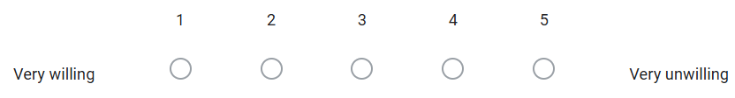
- Do you believe that the current water quality poses a health risk to you and your family?
- Yes
- No
- Maybe

- How concerned are you about the quality of your drinking water?
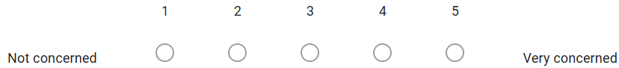

- How confident are you in protecting yourself from waterborne diseases?
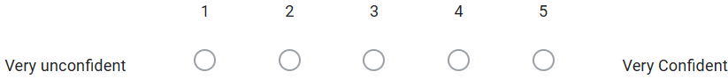

- How often do you discuss water safety with family or neighbors?
- Frequently
- Occasionally
- Rarely
- Never

- Do you think community awareness programs are effective in improving water safety practices?
- Yes
- No
- Maybe

The actual behavior or actions taken based on knowledge and attitude
Section D: Practice

- Do you use any additional filtration or treatment methods for pipeline water?
- Yes
- No

- Do you have an additional storage tank?
- Yes
- No

- How often do you clean the bottles or containers used for storing water from the pipeline?
- Regularly (At least once a week) (1)
- Frequently (Every 1–2 weeks) (0.75)
- Occasionally (Once a month) (0.5)
- Rarely (Less than once a month) (0.25)
Never (0)

- How do you ensure the cleanliness of the containers you use for storing water?
- Regularly clean with soap and water
- Occasionally rinse with water
- Clean only when visibly dirty
- Rarely clean the containers
- Never clean the containers

- Do you regularly check the color, taste, and smell of the water before using it?
- Yes
- No

- How do you react when your drinking water appears cloudy or has an unusual smell?
- Drink it anyway (0)
- Try to treat it (e.g., filter, boil) before drinking (0.5)
- Discard it and find another safe source (1)

- How often do you drink water directly from the pipeline without boiling or filtering it?
- Always
- Often
- Sometimes
- Rarely
- Never

- Have you ever reported a water quality issue to the local authorities?
- Yes
- No

- Do you actively educate others about water safety and hygiene practices?
- Yes
- No
- Maybe

- How often do you take action based on your concerns about water quality?
- Always
- Often
- Sometimes
- Rarely
- Never
- Have you ever participated in a community initiative or program designed to improve local water quality?
- Yes
- No

Section E: Challenges and Suggestions

- What challenges do you face in accessing safe drinking water from the pipeline?
- Irregular supply
- Low water pressure
- Poor water quality
- Lack of maintenance
- Odor
- Does prolonged use of PWP water through skin contact (e.g., bathing or washing) affect your health?
- Yes
- No
- Maybe

- If yes, what are the visible dermal effects?
- Rashes: Red, inflamed patches of skin
- Itching
- Blisters
- Dry or Flaky Skin
- Other (mention)_________________________________________________

- Have you faced any health issues from drinking or ingesting pipeline water?
- Yes
- No
- Maybe

- Observed health issues
- Gastrointestinal Issues: Diarrhea, vomiting, and stomach cramps
- Infectious Diseases: Cholera, dysentery, and typhoid fever
- Toxicity from Chemicals: Neurological problems, kidney damage
- Reproductive and Developmental Issues: Fertility, pregnancy outcomes, and child development
- Chronic Health Conditions: Cancer, liver damage, and immune system suppression

- Have you noticed any damage to household accessories (e.g., faucets, pipes, or dishes) from using pipeline water?
- Yes
- No
- Maybe

- How do you think the water supply system could be improved in Kushtia Municipality?
- Regular maintenance
- Ensuring water quality
- Increasing supply hours
- Improving water pressure
- Expanding coverage
- Other

- What additional measures do you think should be taken to ensure the safety of pipeline water?
- Regular water quality testing
- Upgrading treatment facilities
- Community awareness programs
- Prompt repair of leaks
- Introducing advanced filtration systems
- Don't know

- What role do you think the local government should play in improving water safety?
_______________________________________________________________________________________________________________________________________________________________________________________________________________

- How can local authorities improve communication with residents regarding water safety issues?
______________________________________________________________________________________________________________________________________________________________________________________________________________________________

- Would you be willing to participate in a community project focused on water safety?
______________________________________________________________________________________________________________________________________________________________________________________________________________________________

Signature of the surveyor Signature of the respondent

Checked by-

