Supporting Information

No hearts below the snow line: Snow loss and prey mismatch threaten alpine stoats under climate change

Mammal Research

Marco Granata^{1*}, Margherita Cattaneo^{1*}, Sonia Calderola², Maria Chiara Deflorian³, Laura Martinelli⁴, Luca Maurino⁵, Mirko Di Febbraro⁶, Sandro Bertolino¹

¹ Dipartimento di Scienze della Vita e Biologia dei Sistemi, Università degli Studi di Torino, via Accademia Albertina 13, 10123 Torino, Italy, marco.granata@unito.it
² Parco Nazionale Gran Paradiso, Via Pio VII 9, 10135 Torino, Italy
³ MUSE – Museo delle Scienze di Trento, Corso del Lavoro e della Scienza 3, 38122 Trento, Italy
⁴ Ente di gestione delle Aree Protette delle Alpi Marittime, Piazza Regina Elena 30, 12010 Valdieri, Cuneo, Italy
⁵ Ente di gestione delle Aree Protette delle Alpi Cozie, Via Fransuà Fontan 1, 10050 Salbertrand, Torino, Italy
⁶ EnviXLab, Dipartimento di Bioscienze e Territorio, Università degli Studi del Molise, Contrada Fonte Lappone, 80690 Pesche, Isernia, Italy
* These authors should be considered joint first authors

Table S1 Institutions contributing to data collection on stoat and snow vole occurrences in the Italian Alps
Institution | Type of institution
Regione Autonoma Friuli Venezia Giulia | Regional administration
Regione Piemonte | Regional administration
Parco Nazionale Dolomiti Bellunesi | National park
Parco Nazionale Gran Paradiso | National park
Parco Nazionale della Val Grande | National park
Aree Protette Alpi Cozie | Regional park
Aree Protette Alpi Marittime | Regional park
Aree Protette dell’Ossola | Regional park
Parco del Monviso | Regional park
Parco Naturale Mont Avic | Regional park
Museo Friulano di Storia Naturale | Museum
Museo Regionale di Scienze Naturali della Valle d’Aosta Efisio Noussan | Museum
Museo Civico di Storia Naturale di Morbegno | Museum
Museo Civico di Storia Naturale di Pordenone | Museum
MUSE – Museo delle Scienze di Trento | Museum
Museo di Scienze Naturali dell'Alto Adige | Museum
Associazione Teriologica Italiana (ATIt) | Association
Istituto per le Piante da Legno e l’Ambiente (IPLA) | Company

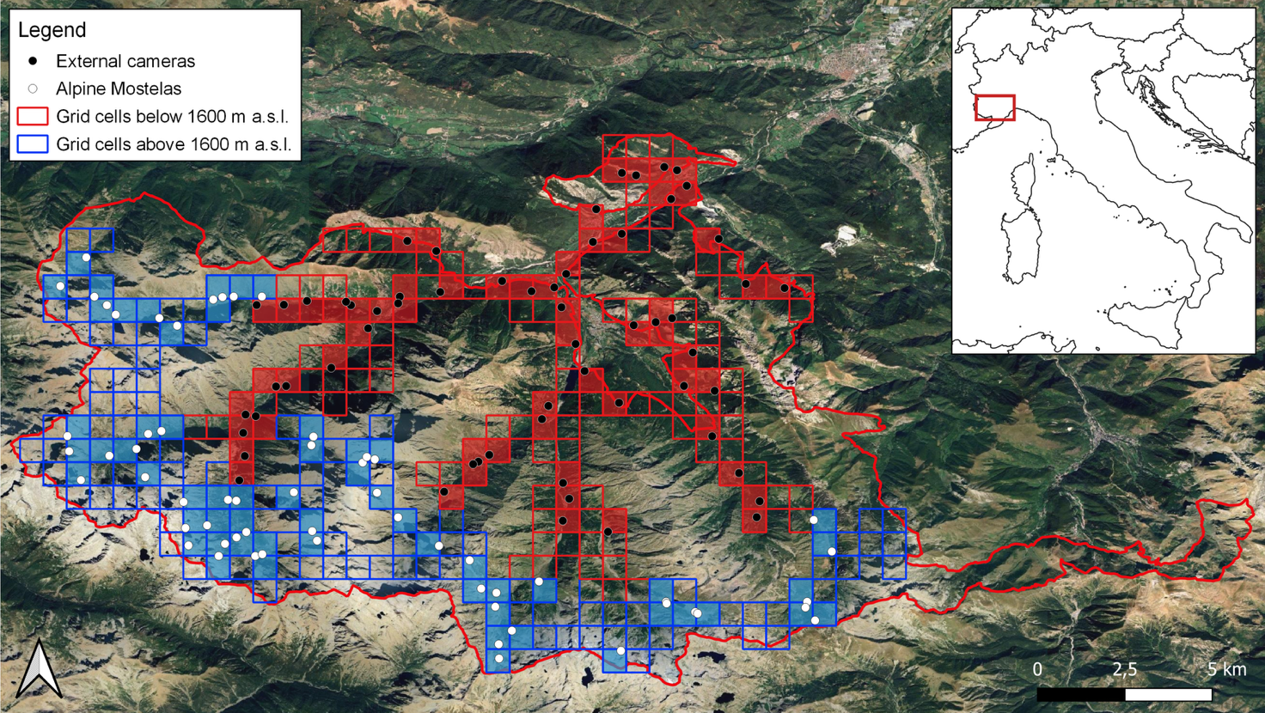
Fig. S1 Sampling design for the 2024 field season in the Alpi Marittime Natural Park (southwestern Alps). A 1 x 1 km grid was superimposed over the study area, and 120 cells were randomly selected: 60 located above 1600 m a.s.l. (blue squares) and 60 below this threshold (red squares). Based on previous results (Granata et al. submitted), high-altitude cells were surveyed using the Alpine Mostela (white dots), a closed camera trap system specifically designed for small mustelids. The Alpine Mostela consists of a 60 x 40 x 22 cm foldable plastic box, crossed by a 9 cm Ø PVC tube, and equipped with a trail camera (model: Browning Dark Ops Pro 1080). No bait was used inside or outside the device. Lower-altitude cells were surveyed with traditional trail cameras (black dots). Cameras (model: KeepGuard) were mounted on tree trunks or roots approximately 40 cm above the ground. Salmon oil was applied to cotton wool placed inside a tea ball diffuser as a bait. Both Mostela and traditional cameras were set to record 20-second videos with a 30-second delay. Flash settings were configured to Power Save mode for Mostelas and Long Range mode for trail cameras
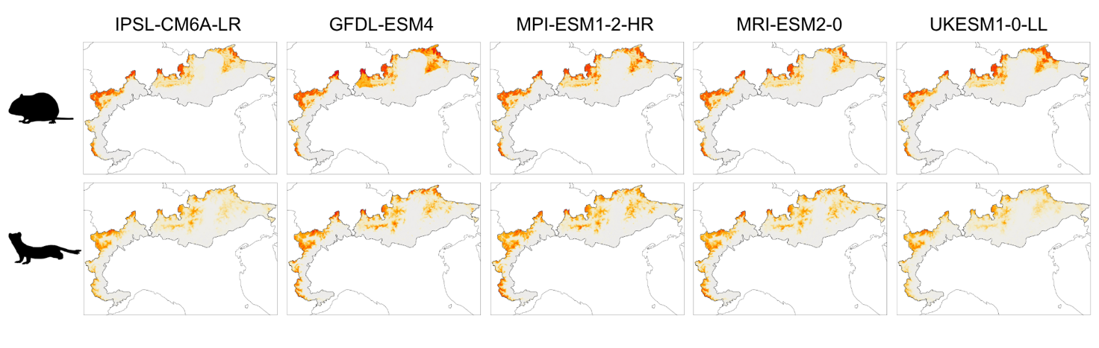
Fig. S2 Modelled current and future environmental suitability for the snow vole (top) and the stoat (bottom) in the Italian Alps, projected across five different GCMs. Suitability is represented using a sequential color scale ranging from white (low suitability) through yellow and orange to red (high suitability)
Fig. S3 Percent contribution of variables to the overall model for the snow vole, and the response curves showing stoat response to the environmental predictors used in the SDM. Response curves were smoothed using a loess function

Fig. S4 Percent contribution of variables to the overall model for the stoat, and the response curves showing stoat response to the environmental predictors used in the SDM. Response curves were smoothed using a loess function

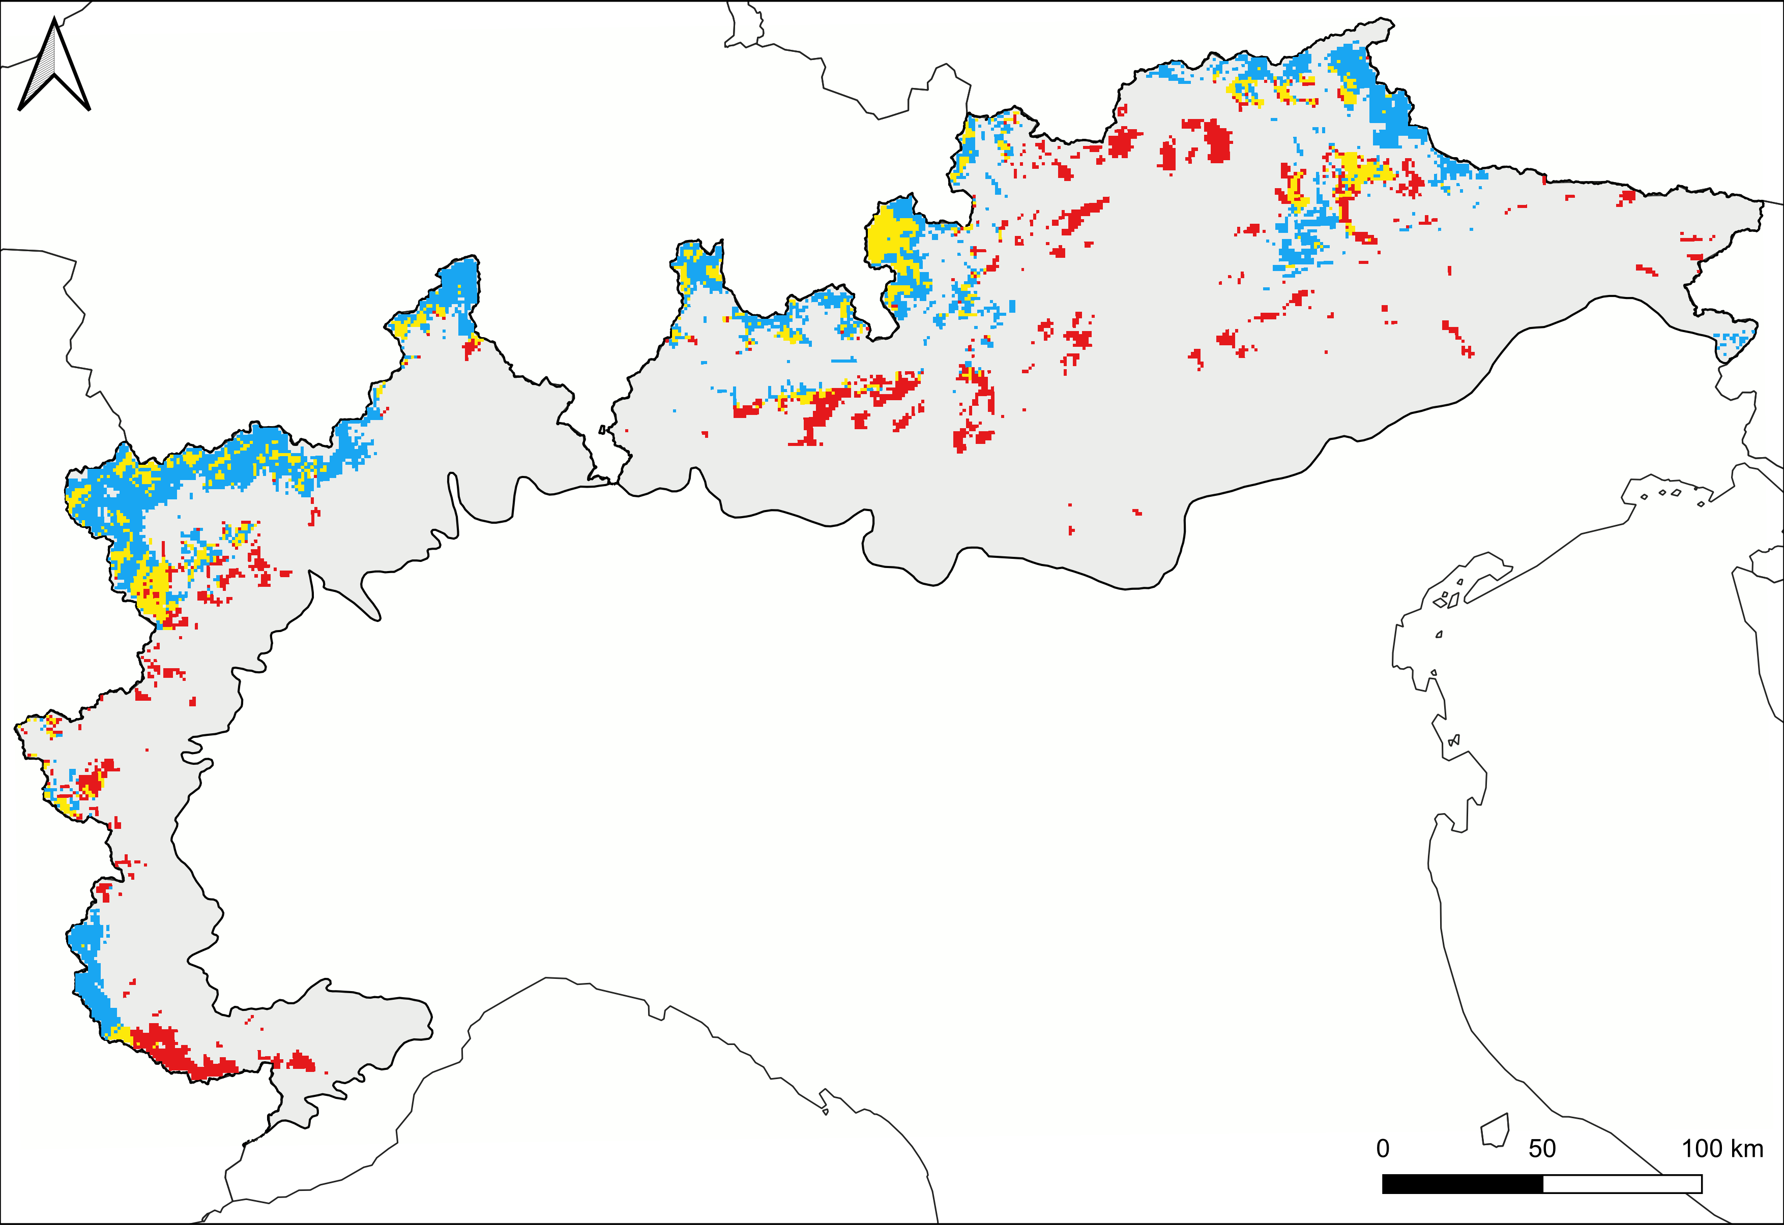
Fig. S5 Projected changes in the distribution range of the snow vole by 2100 under land use and climate change scenarios, based on RCP 8.5. Areas of projected range gain are shown in blue, stable range in yellow, and range loss in red. Predictions were generated using the IPSL-CM6A-LR global circulation model and the ‘maximize specificity and sensibility’ binarization threshold

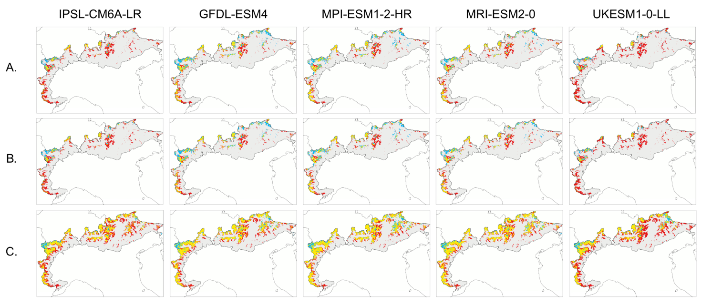
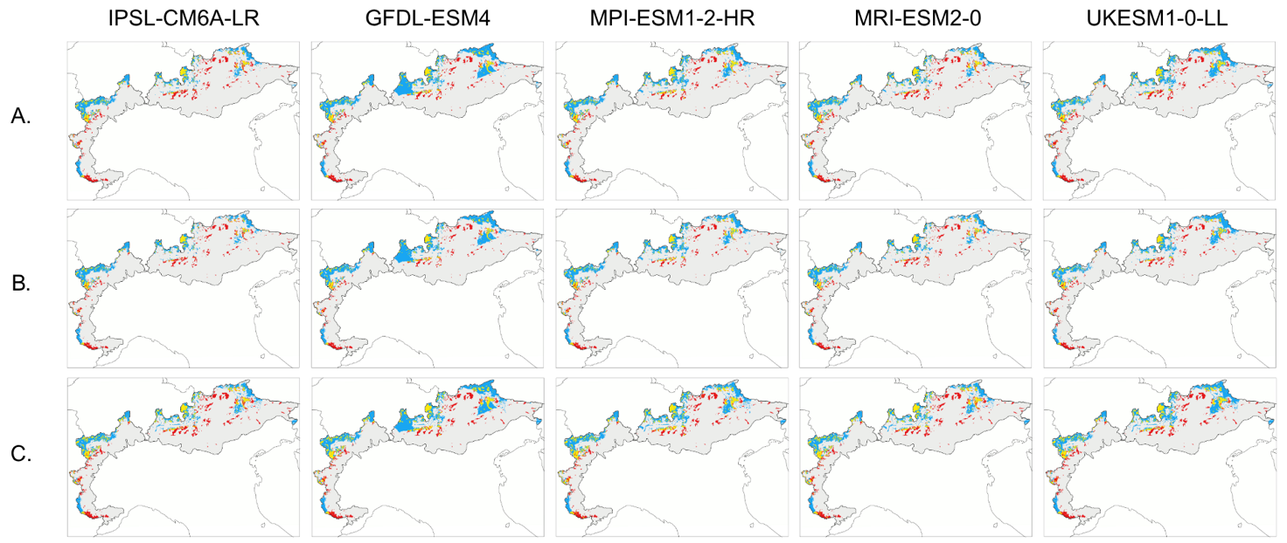
Fig. S7 Projected changes in the distribution range of the stoat by 2100 under land use and climate change scenarios (RCP 8.5), modeled across five GCMs. Maps show results using three different threshold criteria: (A) ‘maximize sensitivity and specificity’, (B) ‘equalize sensitivity and specificity’, and (C) ‘minimum training presence’
Fig. S6 Projected changes in the distribution range of the snow vole by 2100 under land use and climate change scenarios (RCP 8.5), modeled across five GCMs. Maps show results using three different threshold criteria: (A) ‘maximize sensitivity and specificity’, (B) ‘equalize sensitivity and specificity’, and (C) ‘minimum training presence’

