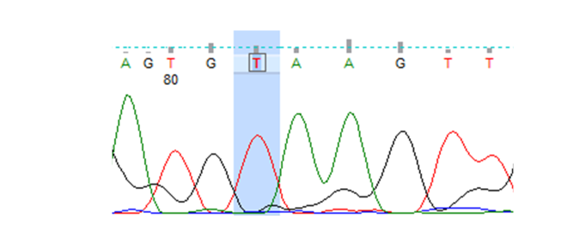

Figure S1: Representative Sanger sequencing of gDNA-GSCs KMT2C gene.

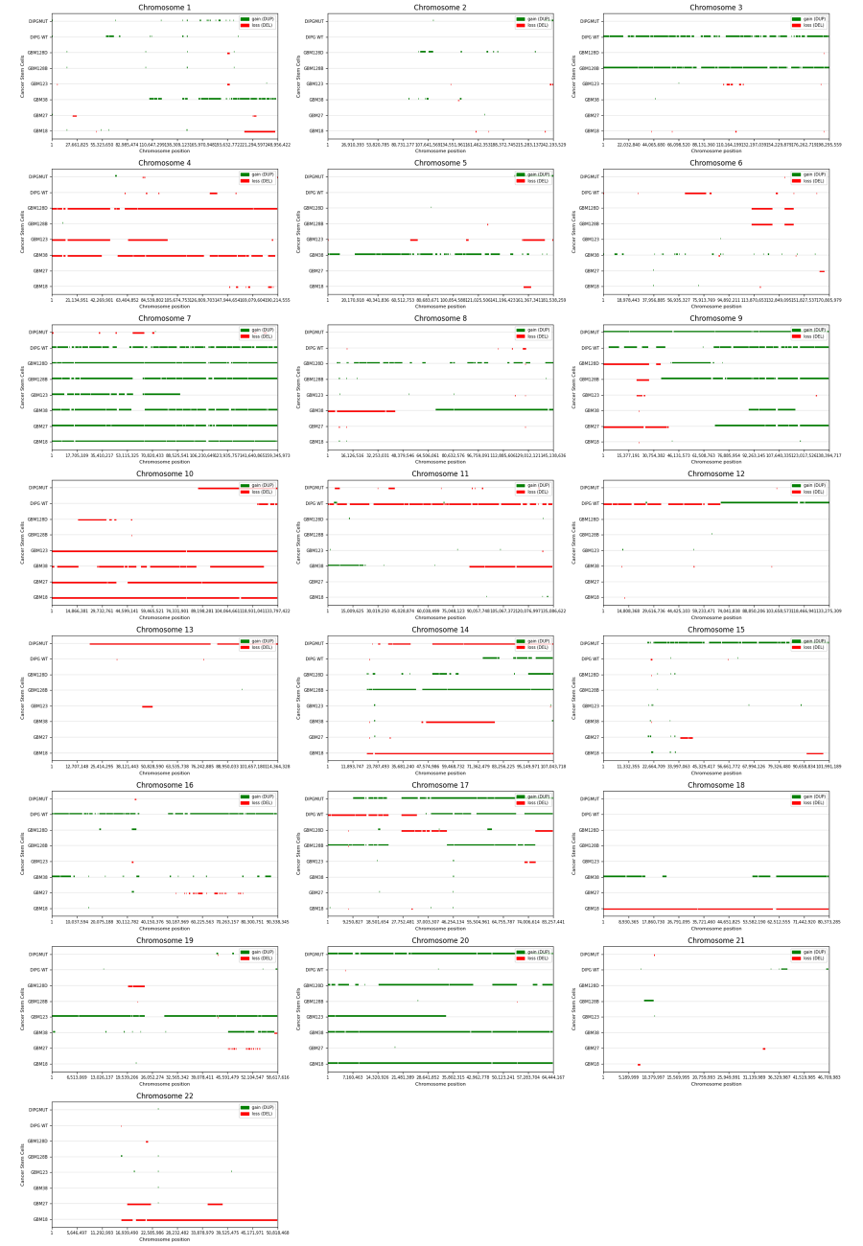

Figure S2: Expanded overview of CNV alterations across all chromosomes for each GSC (rows). Deletions are indicated by descending red bars, while amplifications are shown as ascending green bars.

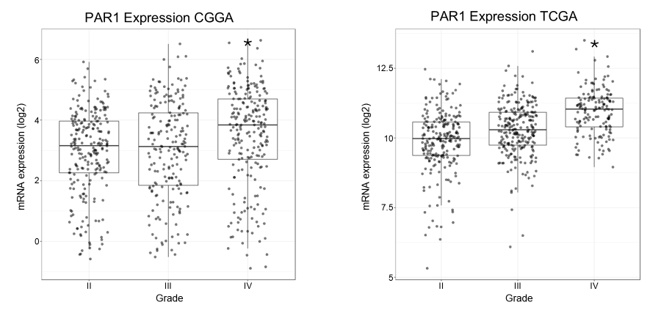
Figure S3: Boxplots of PAR1 expression in glioma patients (grades II-IV, from left to right) from CGGA (left) and TCGA (right) datasets. Each dot represents a patient, with median values and IQR shown. Patients are separated by histological grades. * p-value < 0.05.

