Table 1. Optimization of reaction conditions for spirocyclic γ-lactam synthesis.ª
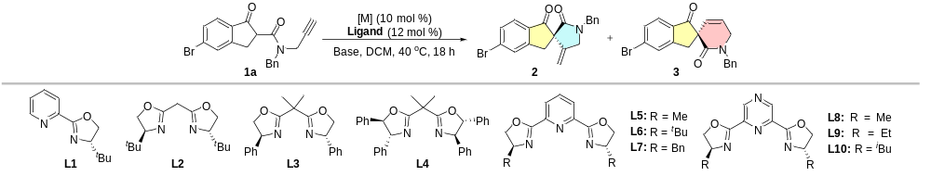
Entry | L | Base | [M] | Yield (%) | ee (%)
 |  |  |  | 2/3 | 2/3
1 | L1 | DIPEA | Cu(MeCN)₄PF₆ | 15/- | -6/-
2 | L2 | DIPEA | Cu(MeCN)₄PF₆ | 42/- | 8/-
3 | L3 | DIPEA | Cu(MeCN)₄PF₆ | 56/- | 26/-
4 | L4 | DIPEA | Cu(MeCN)₄PF₆ | 67/- | 34/-
5 | L5 | DIPEA | Cu(MeCN)₄PF₆ | 67/- | 70/-
6 | L6 | DIPEA | Cu(MeCN)₄PF₆ | 21/- | 18/-
7 | L7 | DIPEA | Cu(MeCN)₄PF₆ | 42/- | 54/-
8 | L8 | DIPEA | Cu(MeCN)₄PF₆ | 58/- | 70/-
9 | L9 | DIPEA | Cu(MeCN)₄PF₆ | 57/- | 76/-
10 | L10 | DIPEA | Cu(MeCN)₄PF₆ | 52/- | 68/-
11 | L9 | Et₃N | Cu(MeCN)₄PF₆ | 78/- | 88/-
12 | L9 | DABCO | Cu(MeCN)₄PF₆ | 81/- | 94/-
13 | L9 | DABCO | Cu(MeCN)₄BF₄ | 89/- | 94/-
14 | L9 | DABCO | Cu(MeCN)₄OTf | 80/- | 94/-
15 | L9 | DABCO | CuOTf | 68/- | 94/-
16^{b} | L9 | DABCO | Cu(MeCN)₄BF₄ | 92/- | 94/-
ªReaction conditions: 1a (0.1 mmol), metal salts (10 mol %), L (12 mol %), base (1.5 equiv.), DCM (2 mL), 40 °C, 18 h; isolated yields; ee values were determined by HPLC analysis. ^{b}Cu(MeCN)₄BF₄ (15 mol %), L9 (18 mol %). DIPEA: N,N-diisopropylethylamine, Et₃N: triethylamine, DABCO: triethylenediamine.

Table 2. Optimization of reaction conditions for spirocyclic δ-lactam synthesis.ª
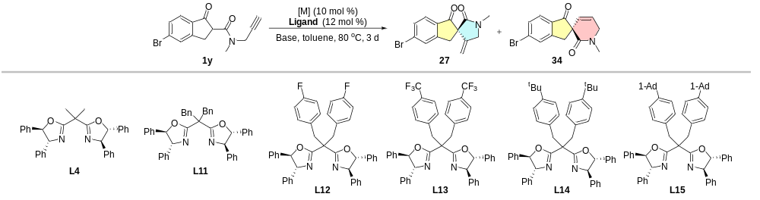
Entry | Base | L | [M] | Yield (%) | ee (%)
 |  |  |  | 27/34 | 27/34
1 | Et₃N | L4 | Ni(ClO₄)₂6H₂O | -/80 | -/74
2 | DIPEA | L4 | Ni(ClO₄)₂6H₂O | -/59 | -/74
3 | LiHMDS | L4 | Ni(ClO₄)₂6H₂O | -/25 | -/32
4 | Et₃N | L11 | Ni(ClO₄)₂6H₂O | -/66 | -/81
5 | Et₃N | L12 | Ni(ClO₄)₂6H₂O | -/53 | -/75
6 | Et₃N | L13 | Ni(ClO₄)₂6H₂O | -/50 | -/56
7 | Et₃N | L14 | Ni(ClO₄)₂6H₂O | -/87 | -/86
8 | Et₃N | L15 | Ni(ClO₄)₂6H₂O | -/83 | -/76
9 | Et₃N | L14 | Ni(BF₄)₂6H₂O | -/55 | -/88
10 | Et₃N | L14 | Ni(OTf)₂ | -/61 | -/80
11^{b} | Et₃N | L14 | Ni(BF₄)₂6H₂O | -/65 | -/88
12^{c} | Et₃N | L14 | Ni(BF₄)₂6H₂O | -/88 | -/90
ªReaction conditions: 1y (0.1 mmol), metal salts (10 mol %), L (12 mol %), base (1.0 equiv.), toluene (2 mL), 80 °C, 3 d; isolated yields; ee values were determined by HPLC analysis. ^{b}With H₂O (5 µL). ^{c}EtOAc as solvent with H₂O (5 µL). LiHMDS: lithium bis(trimethylsilyl)amide.

