FIGURE 2B
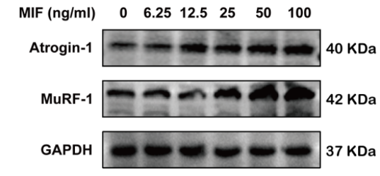



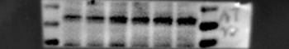
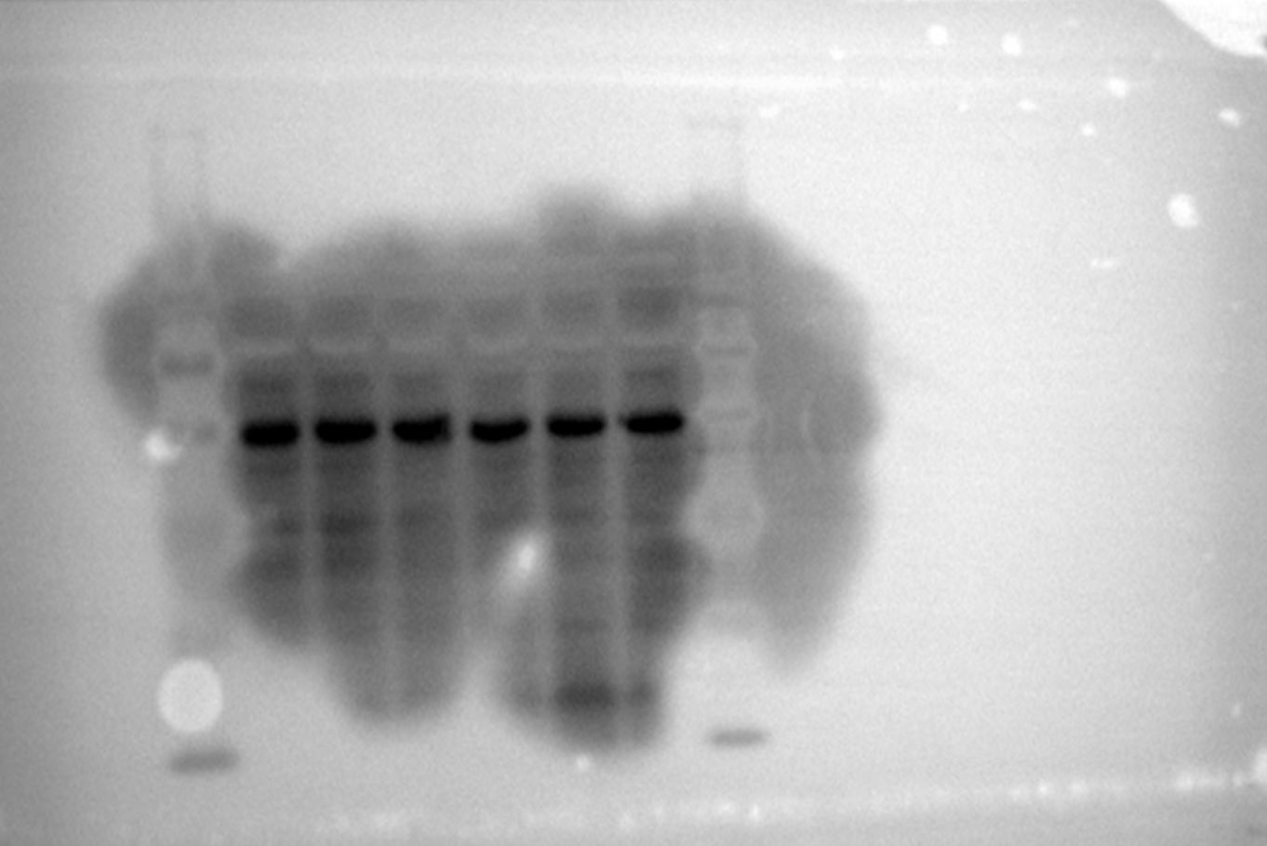
50 KDa
40 KDa
Atrogin-1
35 KDa

50 KDa
MuRF-1
40 KDa

35 KDa

50 KDa
40 KDa
GAPDH
35 KDa

25 KDa

20 KDa

FIGURE 3C

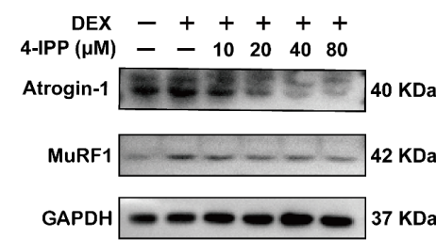

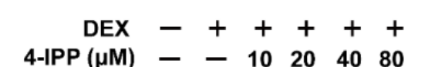

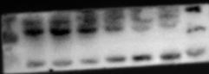
50 KDa

40 KDa
Atrogin-1
35 KDa

50 KDa
MuRF-1
40 KDa

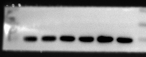
50 KDa

40 KDa
GAPDH
35 KDa

FIGURE 4C

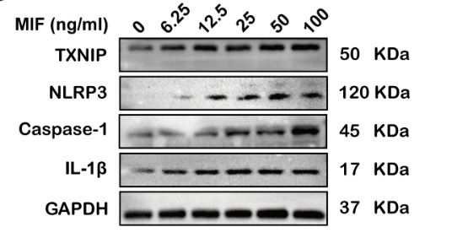
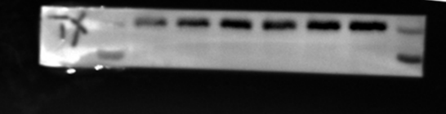
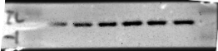
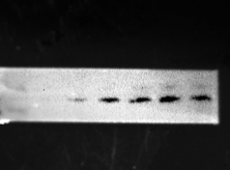
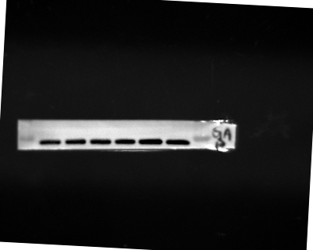
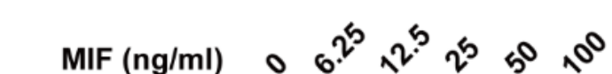

TXNIP
50 KDa
40 KDa

150 KDa
NLRP3

100 KDa

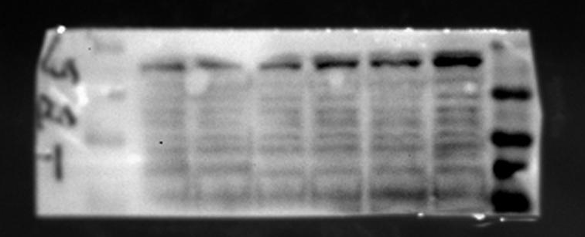
50 KDa
40 KDa
Caspase-1
35 KDa
25 KDa
20 KDa

20 KDa
IL-1β
15 KDa

35 KDa
GAPDH

FIGURE5C
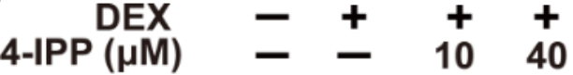
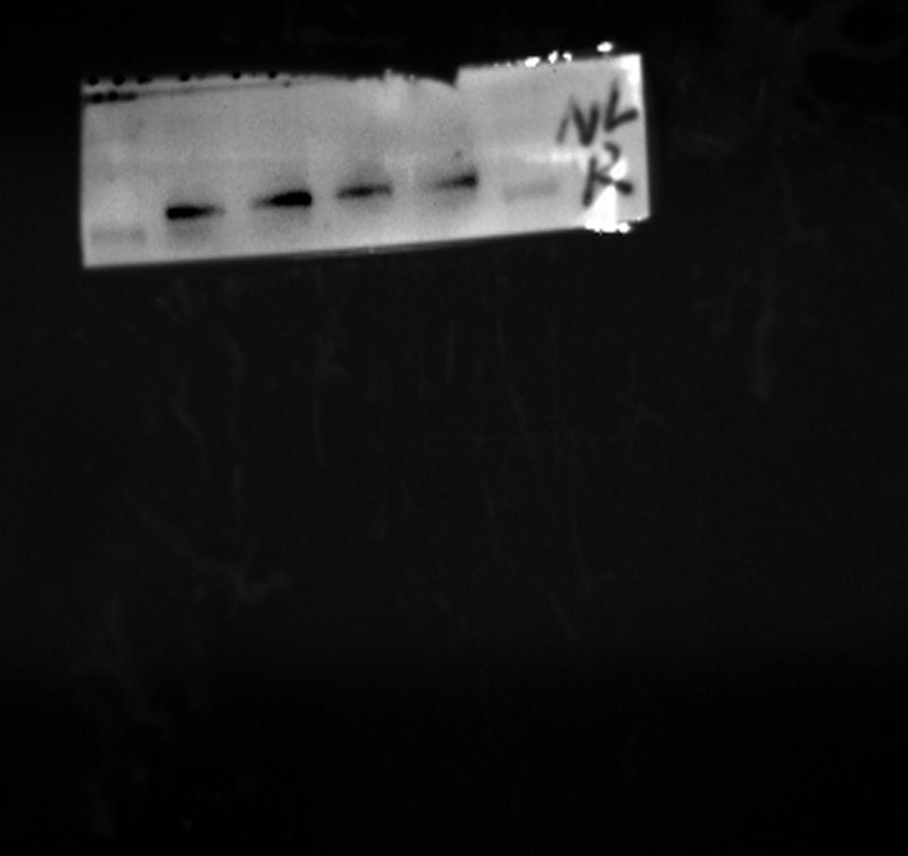
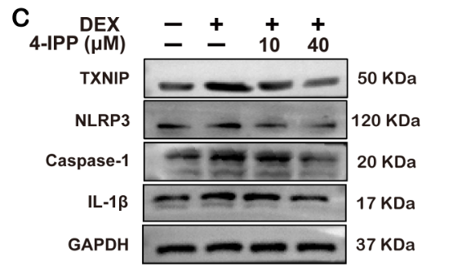
IL-1β
Caspase-1
GAPDH
TXNIP
NLRP3
35 KDa
20 KDa
15 KDa
40 KDa
35 KDa
25 KDa
20 KDa
70KDa
100 KDa
150 KDa
50 KDa

