In silico Evaluation of Deleterious nsSNPs in SOD1 and TARDBP Genes Associated with Amyotrophic Lateral Sclerosis
Manjunath B. Malshetty^{1#}, Sandeep Mallya^{1#}, Sudharshan Prabhu²*

¹ Department of Bioinformatics, Manipal School of Life Sciences, Manipal Academy of Higher Education, Manipal, Karnataka-576104
² Department of Cellular and Molecular Biology, Manipal School of Life Sciences, Manipal Academy of Higher Education, Manipal, Karnataka-576104

# Equal Contribution
Corresponding Author
Dr Sudharshan Prabhu,
Assistant Professor,
Department of Cell and Molecular Biology,
Manipal School of Life Sciences,
Manipal Academy of Higher Education,
Manipal, Karnataka-576104,
sudharshan.prabhu@manipal.edu
SUPPLEMENTARY DATA
FIGURES

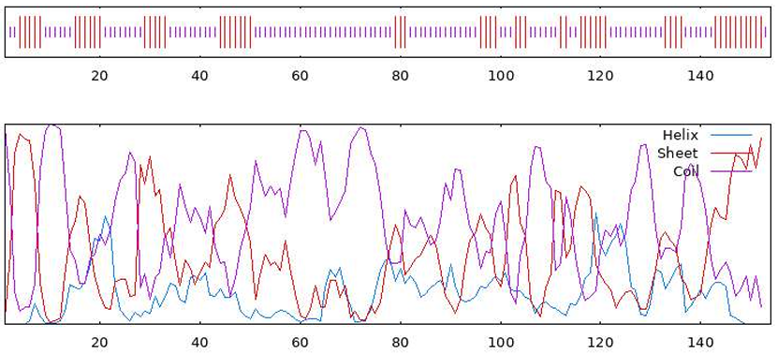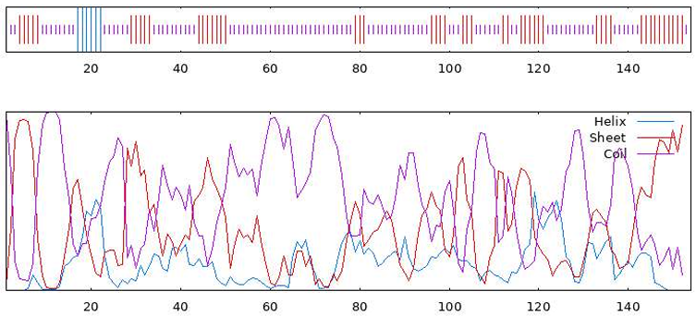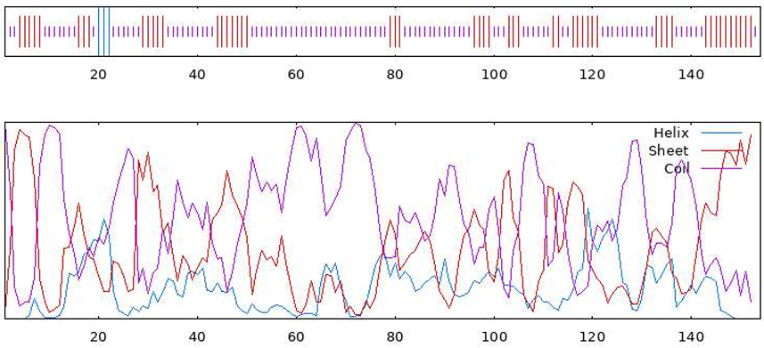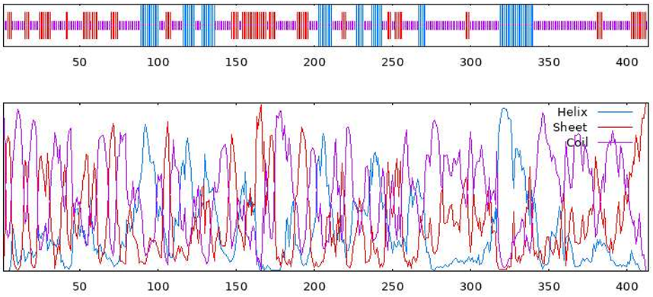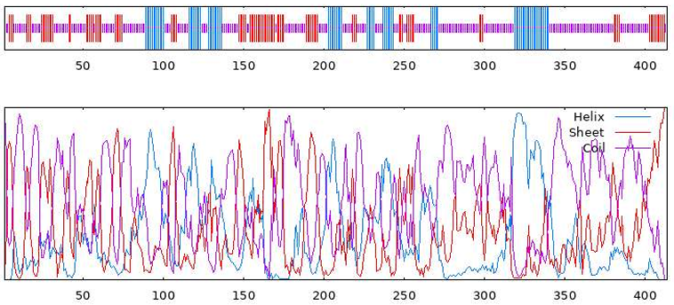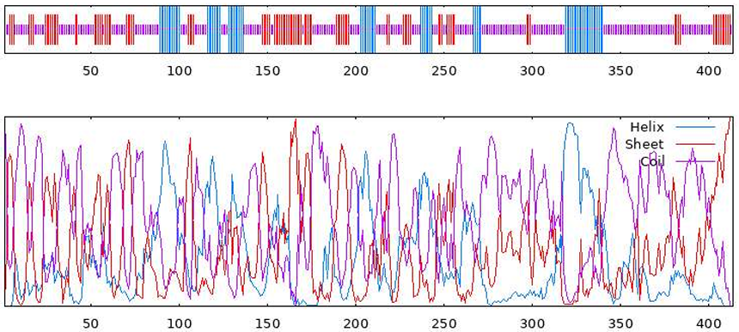
A
C
B
D
E
F
Figure S1. Secondary structure prediction of SOD1 and TARDBP using GOR4-based secondary structure profiles of wild-type and ALS-associated variants, illustrating residue-wise distributions of α-helix, β-sheet (extended strand), and random coil conformations. (A) SOD1 Wild Type, (B) SOD1_V15G (rs1202989817), and (C) SOD1_I19M (rs1182088847) (D) TARDBP Wild Type, (E) TARDBP_G335D (rs80356729), and (F) TARDBP_I222T (rs1570722030)

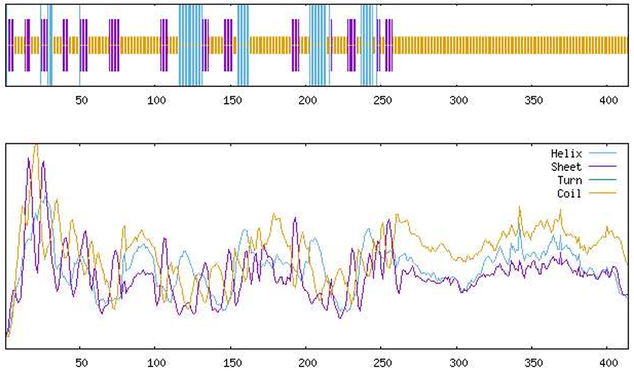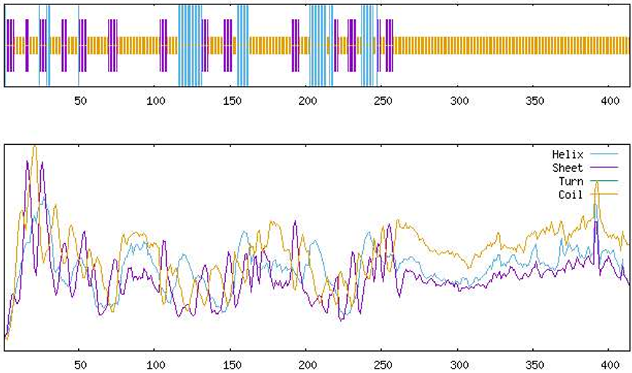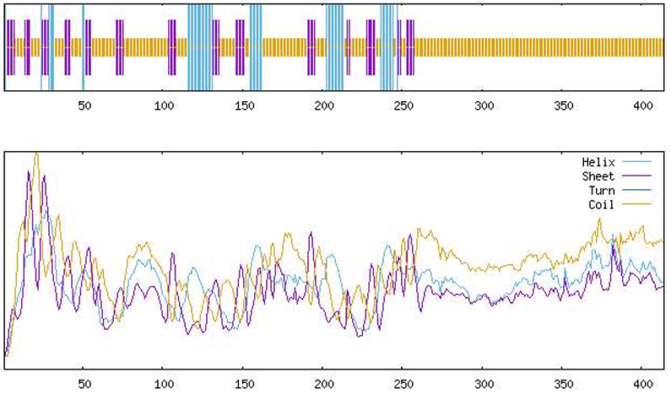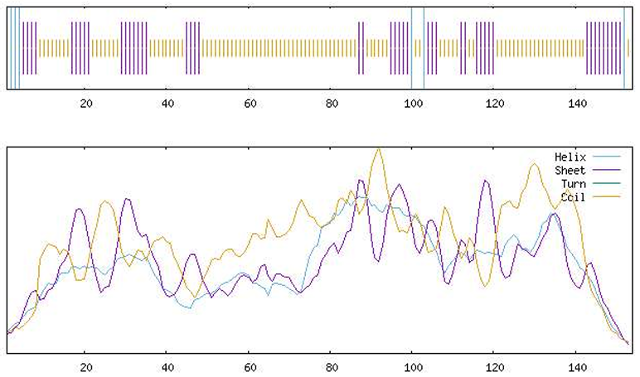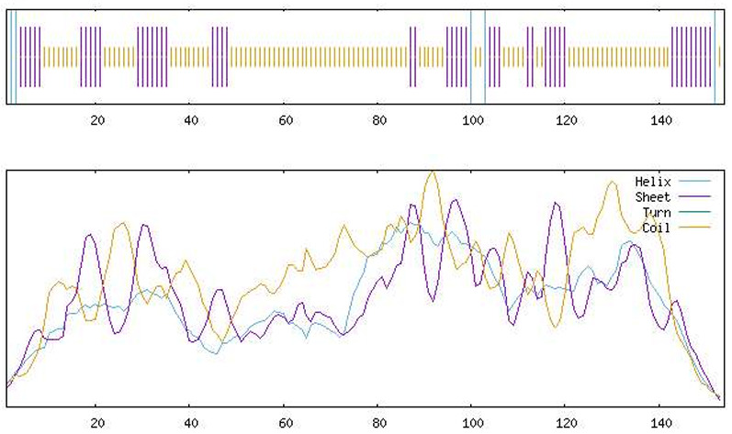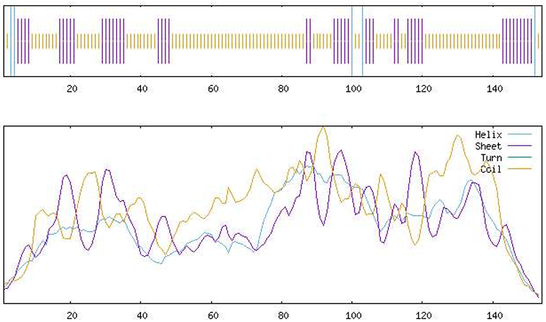
D
E
F
A
B
C

Figure S2. Secondary structure prediction of SOD1 and TARDBP using SOPMA-based secondary structure profiles. Residue-wise distributions of α-helix, β-sheet (extended strand), turn, and random coil are shown for (A) SOD1 Wild Type, (B) SOD1_V15G(rs1202989817), (C) SOD1_I19M(rs1182088847), (D) TARDBP Wild Type, (E) TARDBP_G335D(rs80356729), and (F) TARDBP_I222T(rs1570722030).

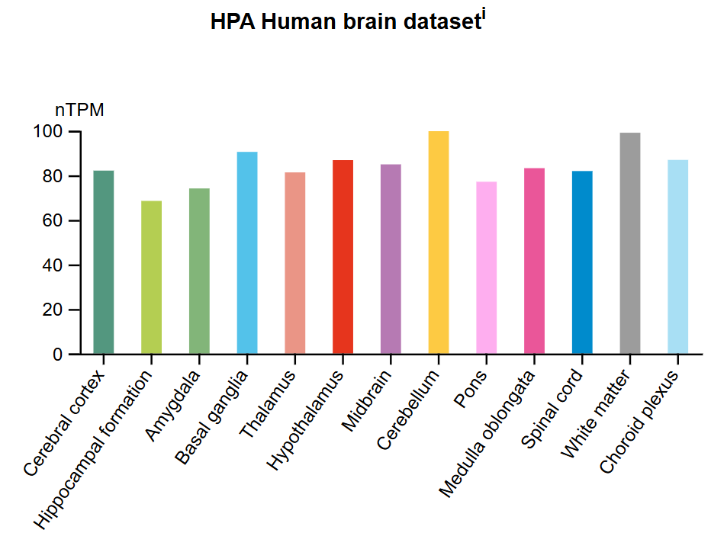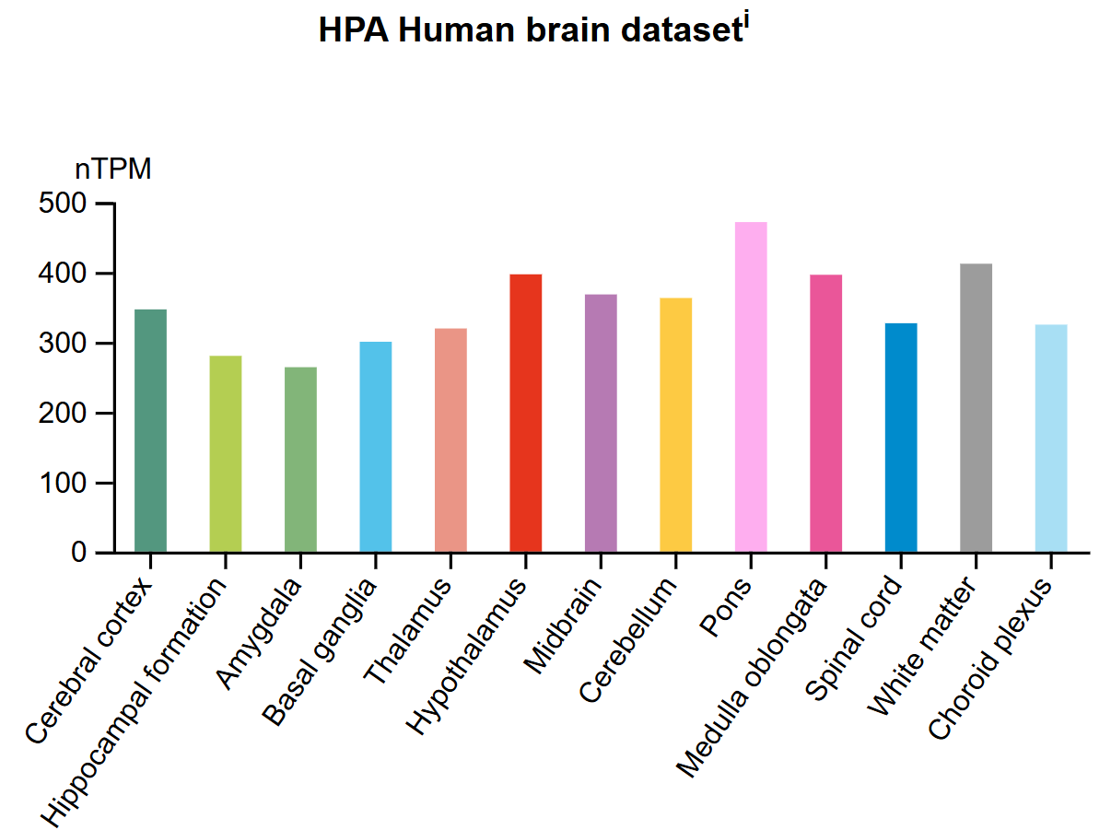
A
B

Figure S3. Transcript expression profile of SOD1 and TARDBP across human brain regions. (A) RNA expression of SOD1 across major brain regions from the HPA brain RNA-seq dataset. SOD1 shows broad and relatively high expression in the cerebral cortex, hippocampal formation, thalamus, hypothalamus, and cerebellum. (B) RNA expression levels of TARDBP across the same brain regions. TARDBP exhibits a similar widespread pattern, with relatively higher expression in cortical areas, the hippocampal formation, and the cerebellum

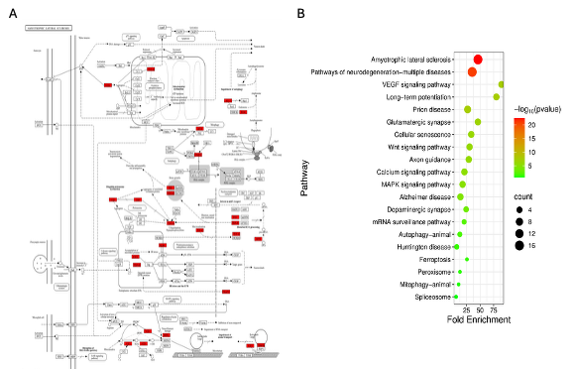
Figure S4. KEGG pathway mapping and enrichment of ALS-associated genes from the SOD1–TARDBP network. (A) KEGG ALS pathway map generated using ShinyGO, with study-identified genes highlighted in red, including SOD1, TARDBP, FUS, VCP, OPTN, CHCHD10, NEK1, C9orf72, and STRING-derived interactors.(B) KEGG pathway enrichment dot plot showing fold enrichment (x-axis), gene count (dot size), and –log10(p-value) (color scale), highlighting significant pathways such as ALS, neurodegeneration-related pathways, VEGF signaling, and ferroptosis.

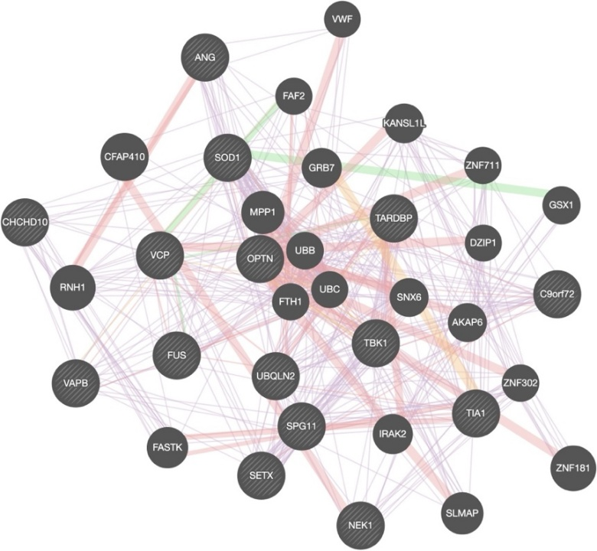
Figure S5. Gene-gene interaction network of SOD1 and TARDBP with ALS-associated genes generated using Gene MANIA. The network illustrates predicted functional relationships between SOD1, TARDBP, and other amyotrophic lateral sclerosis (ALS)-associated genes identified from the literature. Nodes represent individual genes; the striped nodes indicate the query genes (SOD1 and TARDBP). Edges denote functional associations integrated from Gene MANIA, including co-expression (purple), physical interactions (red), pathway connections (orange), co-localization (yellow), genetic interactions (green), and shared protein domains (light blue). Node size is proportional to Gene Mania’s relevance score, reflecting each gene’s contribution to the network prediction model. This network highlights central hubs such as OPTN, VCP, FUS, TBK1, UBQLN2, and C9orf72, showing strong functional connectivity with SOD1 and TARDBP.

TABLES
Table S1: Comprehensive dataset of nsSNPs in SOD1 and TARDBP genes retained following systematic inclusion and exclusion filtering criteria. (Provided as a separate Excel file containing detailed variant information and filtering status).

Table S2. Allele-specific ClinVar clinical annotation of prioritized SOD1 and TARDBP variants.
Gene | rsID | Ref > Alt | Protein change | ClinVar clinical significance | Associated condition(s)
SOD1 | rs1202989817 | T > G | p.Val15Gly | Likely pathogenic | ALS
SOD1 | rs1202989817 | T > C | – | Not reported | –
SOD1 | rs1182088847 | C > G | – | Not reported | –
TARDBP | rs1228733743 | T > C | – | Not reported | –
TARDBP | rs1228733743 | T > G | – | Not reported | –
TARDBP | rs80356715 | C > G | – | Not reported | –
TARDBP | rs80356715 | C > T | – | Not reported | –
TARDBP | rs1570722030 | T > C | – | Not reported | –
TARDBP | rs80356729 | G > A | – | Conflicting interpretations of pathogenicity | ALS

Table S3: Phosphorylation site conservation analysis for SOD1 and TARDBP.
Gene | Sequence Type | Position | Residue | Kinase | Score | Status
SOD1 | Wild-type/variants  rs1202989817(V15G)  rs1182088847(I19M) | 60 | S | CK1 | 0.1024 | Conserved
SOD1 | Wild-type/variants  rs1202989817(V15G)  rs1182088847(I19M) | 3 | T | TKL | 0.6789 | Conserved
SOD1 | Wild-type/variants  rs1202989817(V15G)  rs1182088847(I19M) | 59 | T | CK1 | 0.0690 | Conserved
SOD1 | Wild-type/variants  rs1202989817(V15G)  rs1182088847(I19M) | 60 | S | CK1 | 0.1024 | Conserved
SOD1 | Wild-type/variants  rs1202989817(V15G)  rs1182088847(I19M) | 89 | T | CK1 | 0.0698 | Conserved
SOD1 | Wild-type/variants  rs1202989817(V15G)  rs1182088847(I19M) | 60 | S | CK1 | 0.1024 | Conserved
TARDBP | Wild-type/variants  rs80356729(G335D)  rs1570722030(I222T) | 92 | S | CK1 | 0.4387 | Conserved
TARDBP | Wild-type/variants  rs80356729(G335D)  rs1570722030(I222T) | 183 | S | CK1 | 0.3848 | Conserved
TARDBP | Wild-type/variants  rs80356729(G335D)  rs1570722030(I222T) | 258 | S | CK1 | 0.1001 | Conserved
TARDBP | Wild-type/variants  rs80356729(G335D)  rs1570722030(I222T) | 273 | S | CK1 | 0.5974 | Conserved
TARDBP | Wild-type/variants  rs80356729(G335D)  rs1570722030(I222T) | 305 | S | CK1 | 0.2810 | Conserved
TARDBP | Wild-type/variants  rs80356729(G335D)  rs1570722030(I222T) | 317 | S | CK1 | 0.1308 | Conserved
TARDBP | Wild-type/variants  rs80356729(G335D)  rs1570722030(I222T) | 393 | S | CK1 | 0.4689 | Conserved
TARDBP | Wild-type/variants  rs80356729(G335D)  rs1570722030(I222T) | 395 | S | CK1 | 0.3442 | Conserved
TARDBP | Wild-type/variants  rs80356729(G335D)  rs1570722030(I222T) | 403 | S | CK1 | 0.5365 | Conserved
TARDBP | Wild-type/variants  rs80356729(G335D)  rs1570722030(I222T) | 404 | S | CK1 | 0.1085 | Conserved
TARDBP | Wild-type/variants  rs80356729(G335D)  rs1570722030(I222T) | 407 | S | CK1 | 0.2373 | Conserved
TARDBP | Wild-type/variants  rs80356729(G335D)  rs1570722030(I222T) | 409 | S | CK1 | 0.1674 | Conserved
TARDBP | Wild-type/variants  rs80356729(G335D)  rs1570722030(I222T) | 4 | Y | TK | 0.9951 | Conserved
TARDBP | Wild-type/variants  rs80356729(G335D)  rs1570722030(I222T) | 73 | Y | TK | 0.9093 | Conserved
TARDBP | Wild-type/variants  rs80356729(G335D)  rs1570722030(I222T) | 123 | Y | TK | 0.9397 | Conserved
TARDBP | Wild-type/variants  rs80356729(G335D)  rs1570722030(I222T) | 374 | Y | TK | 0.9042 | Conserved
TARDBP | Wild-type/variants  rs80356729(G335D)  rs1570722030(I222T) | 92 | S | CK1 | 0.4387 | Conserved
TARDBP | Wild-type/variants  rs80356729(G335D)  rs1570722030(I222T) | 183 | S | CK1 | 0.3848 | Conserved
TARDBP | Wild-type/variants  rs80356729(G335D)  rs1570722030(I222T) | 258 | S | CK1 | 0.1001 | Conserved
TARDBP | Wild-type/variants  rs80356729(G335D)  rs1570722030(I222T) | 273 | S | CK1 | 0.5974 | Conserved
TARDBP | Wild-type/variants  rs80356729(G335D)  rs1570722030(I222T) | 305 | S | CK1 | 0.2810 | Conserved
TARDBP | Wild-type/variants  rs80356729(G335D)  rs1570722030(I222T) | 317 | S | CK1 | 0.1308 | Conserved
TARDBP | Wild-type/variants  rs80356729(G335D)  rs1570722030(I222T) | 393 | S | CK1 | 0.4689 | Conserved
TARDBP | Wild-type/variants  rs80356729(G335D)  rs1570722030(I222T) | 395 | S | CK1 | 0.3442 | Conserved
TARDBP | Wild-type/variants  rs80356729(G335D)  rs1570722030(I222T) | 403 | S | CK1 | 0.5365 | Conserved
TARDBP | Wild-type/variants  rs80356729(G335D)  rs1570722030(I222T) | 404 | S | CK1 | 0.1085 | Conserved
TARDBP | Wild-type/variants  rs80356729(G335D)  rs1570722030(I222T) | 407 | S | CK1 | 0.2373 | Conserved
TARDBP | Wild-type/variants  rs80356729(G335D)  rs1570722030(I222T) | 409 | S | CK1 | 0.1674 | Conserved
TARDBP | Wild-type/variants  rs80356729(G335D)  rs1570722030(I222T) | 4 | Y | TK | 0.9951 | Conserved
TARDBP | Wild-type/variants  rs80356729(G335D)  rs1570722030(I222T) | 73 | Y | TK | 0.9093 | Conserved
TARDBP | Wild-type/variants  rs80356729(G335D)  rs1570722030(I222T) | 123 | Y | TK | 0.9397 | Conserved
TARDBP | Wild-type/variants  rs80356729(G335D)  rs1570722030(I222T) | 374 | Y | TK | 0.9042 | Conserved
TARDBP | Wild-type/variants  rs80356729(G335D)  rs1570722030(I222T) | 92 | S | CK1 | 0.4387 | Conserved
TARDBP | Wild-type/variants  rs80356729(G335D)  rs1570722030(I222T) | 183 | S | CK1 | 0.3848 | Conserved
TARDBP | Wild-type/variants  rs80356729(G335D)  rs1570722030(I222T) | 258 | S | CK1 | 0.1001 | Conserved
TARDBP | Wild-type/variants  rs80356729(G335D)  rs1570722030(I222T) | 273 | S | CK1 | 0.5974 | Conserved
TARDBP | Wild-type/variants  rs80356729(G335D)  rs1570722030(I222T) | 305 | S | CK1 | 0.2487 | Conserved
TARDBP | Wild-type/variants  rs80356729(G335D)  rs1570722030(I222T) | 317 | S | CK1 | 0.2124 | Conserved
TARDBP | Wild-type/variants  rs80356729(G335D)  rs1570722030(I222T) | 393 | S | CK1 | 0.4689 | Conserved
TARDBP | Wild-type/variants  rs80356729(G335D)  rs1570722030(I222T) | 395 | S | CK1 | 0.3442 | Conserved
TARDBP | Wild-type/variants  rs80356729(G335D)  rs1570722030(I222T) | 403 | S | CK1 | 0.5365 | Conserved
TARDBP | Wild-type/variants  rs80356729(G335D)  rs1570722030(I222T) | 404 | S | CK1 | 0.1085 | Conserved
TARDBP | Wild-type/variants  rs80356729(G335D)  rs1570722030(I222T) | 407 | S | CK1 | 0.2373 | Conserved
TARDBP | Wild-type/variants  rs80356729(G335D)  rs1570722030(I222T) | 409 | S | CK1 | 0.1674 | Conserved
TARDBP | Wild-type/variants  rs80356729(G335D)  rs1570722030(I222T) | 4 | Y | TK | 0.9951 | Conserved
TARDBP | Wild-type/variants  rs80356729(G335D)  rs1570722030(I222T) | 73 | Y | TK | 0.9093 | Conserved
TARDBP | Wild-type/variants  rs80356729(G335D)  rs1570722030(I222T) | 123 | Y | TK | 0.9397 | Conserved
TARDBP | Wild-type/variants  rs80356729(G335D)  rs1570722030(I222T) | 374 | Y | TK | 0.9042 | Conserved
Table S4: Ramachandran plot validation metrics for SOD1 and TARDBP mutant protein structures.
Gene | rsID | Mutations | MolProbity score | Clash score | Ramachandran favored (%) | Ramachandran outliers (%)
SOD1 | rs1202989817 | V15G | 0.62 | 0.00 | 97.37 | 0.00
SOD1 | rs1182088847 | I19M | 0.71 | 0.00 | 96.71 | 0.00
TARDBP | rs80356729 | G335D | 1.73 | 0.16 | 74.03 | 12.62
TARDBP | rs1570722030 | I222T | 1.76 | 0.16 | 74.27 | 12.38

Table S5. Network Topology Parameters of SOD1-TARDBP Cytoscape Interaction Network.
Gene | Target gene | Avg. Shortest Path Length | Clustering Coefficient | Closeness Centrality | Betweenness Centrality | Degree
TARDBP | TARDBP | 1.048 | 0.389 | 0.955 | 0.303 | 20.000
SOD1 | SOD1 | 1.095 | 0.427 | 0.913 | 0.227 | 19.000
C9orf72 | C9orf72 | 1.333 | 0.648 | 0.750 | 0.041 | 14.000
FUS | FUS | 1.333 | 0.648 | 0.750 | 0.041 | 14.000
NEFH | NEFH | 1.429 | 0.758 | 0.700 | 0.034 | 12.000
SETX | SETX | 1.476 | 0.891 | 0.677 | 0.006 | 11.000
ALS2 | ALS2 | 1.524 | 1.000 | 0.656 | 0.000 | 10.000
DCTN1 | DCTN1 | 1.524 | 1.000 | 0.656 | 0.000 | 10.000
FIG4 | FIG4 | 1.524 | 1.000 | 0.656 | 0.000 | 10.000
OPTN | OPTN | 1.524 | 1.000 | 0.656 | 0.000 | 10.000
VAPB | VAPB | 1.524 | 1.000 | 0.656 | 0.000 | 10.000
NEFL | NEFL | 1.714 | 0.933 | 0.583 | 0.001 | 6.000
PPP3CA | PPP3CA | 1.714 | 1.000 | 0.583 | 0.000 | 6.000
PPP3CB | PPP3CB | 1.714 | 1.000 | 0.583 | 0.000 | 6.000
PPP3CC | PPP3CC | 1.714 | 1.000 | 0.583 | 0.000 | 6.000
PPP3R1 | PPP3R1 | 1.714 | 1.000 | 0.583 | 0.000 | 6.000
PPP3R2 | PPP3R2 | 1.714 | 1.000 | 0.583 | 0.000 | 6.000
PRNP | PRNP | 1.762 | 1.000 | 0.568 | 0.000 | 5.000
SMN1 | SMN1 | 1.762 | 1.000 | 0.568 | 0.000 | 5.000
TMEM106B | TMEM106B | 1.905 | 1.000 | 0.525 | 0.000 | 3.000
RNF19A | RNF19A | 2.000 | 1.000 | 0.500 | 0.000 | 2.000
GSC | GSC | 2.000 | 0.000 | 0.500 | 0.000 | 1.000

Table S6. Key Hub Genes Identified in the SOD1-TARDBP GeneMANIA Network.
Gene | Approx. Network Importance | Key Role
UBB / UBC | Highest density | Ubiquitin-proteasome regulation
OPTN | Major hub | Autophagy & innate immunity
VCP | High connectivity | Protein degradation & ER stress
TBK1 | High signaling hub | Autophagy & inflammatory signaling
TARDBP | Central node | RNA metabolism
SOD1 | Connected to oxidative stress modules | ROS detoxification

Table S7. Functional modules enriched within the SOD1-TARDBP GeneMANIA interaction network.
Functional Category | Genes Involved | Biological Meaning
Autophagy & protein degradation | OPTN, TBK1, VCP, UBQLN2 | Clearance of misfolded proteins
RNA processing & splicing | TARDBP, FUS, SETX, TIA1 | Disturbed RNA homeostasis
Oxidative stress response | SOD1, FTH1 | ROS imbalance
Vesicle trafficking | VAPB, GRB7 | ER stress & axonal transport
Mitochondrial organization | CHCHD10, NEK1 | Bioenergetic dysfunction

Table S8. Key Hub Genes Identified in the GeneMANIA SOD1-TARDBP Interaction Network
Gene | Weighted Score | Primary Functional Category
C9orf72 | 0.756 | Autophagy regulation, vesicle trafficking
NEK1 | 0.727 | DNA damage response, microtubule stability
CHCHD10 | 0.697 | Mitochondrial cristae organization
VAPB | 0.671 | Vesicle trafficking, ER-mitochondria contact sites
SETX | 0.669 | DNA/RNA helicase activity, genome maintenance
SPG11 | 0.652 | Lysosomal function, autophagy
TARDBP | 0.646 | RNA metabolism, transcriptional regulation
TIA1 | 0.634 | Stress granule formation
VCP | 0.588 | DNA repair, autophagy, protein degradation
ANG | 0.587 | Protein kinase activity, angiogenesis
FUS | 0.551 | RNA binding, DNA repair
OPTN | 0.525 | Autophagy, TBK1 signaling
TBK1 | 0.517 | Autophagy, innate immune signaling
SOD1 | 0.51 | Oxidative stress response
UBQLN2 | 0.508 | Protein quality control, proteasomal degradation
SNX6 | 0.49* | Co-expression network partner (lower score)
IRAK2 | 0.48* | Innate immune signaling (lower score)
*Lower score interaction partners are still included due to relevance to ALS pathways.

