Synthetic allohexaploid Brassica are able to express best-parent traits in response to drought

Tiegist D. Abebe*, Angela Adjei, Helen Behn, Agim Ballvora, Annaliese S. Mason*
Plant Breeding Department, INRES, University of Bonn, Kirschallee 1, 53115 Bonn, Germany
*Corresponding authors: Tiegist Dejene Abebe and Annaliese S. Mason; Email addresses: abebe@uni-bonn.de and annaliese.mason@uni-bonn.de

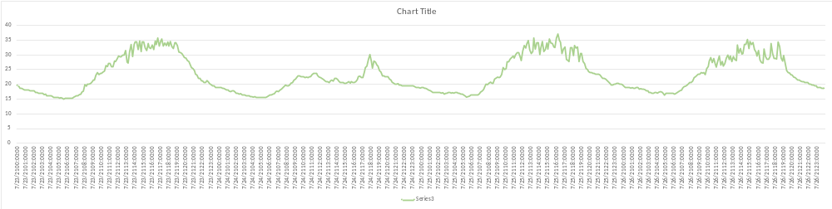
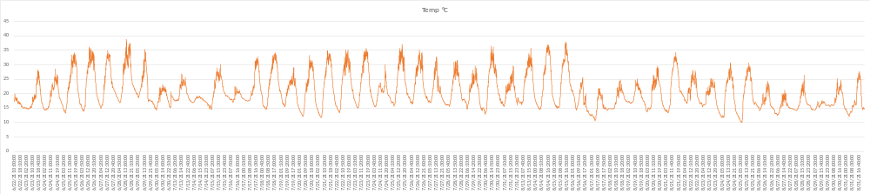
Figure S1. The air temperature inside the tunnel from 23.07 to 26.07.21 (Day 12 drought treatment) (above) and across the entire growth period (below)

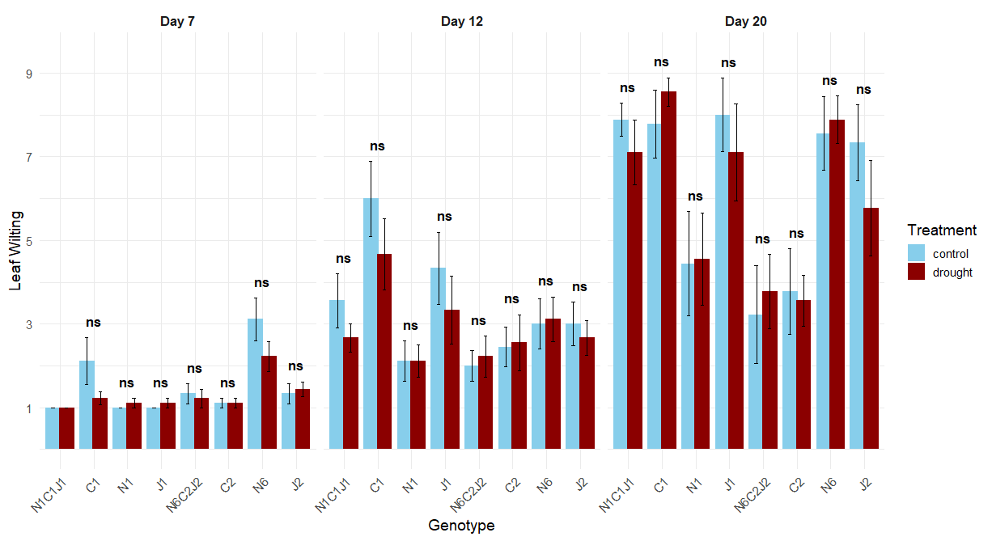
Figure S2. Weighted mean leaf wilting scores of different Brassica genotypes with standard errors. N1C1J1 and N6C2J2 are allohexaploid lines derived from the cross (B. napus × B. carinata) × B. juncea, N1 and N6 are their respective B. napus parents, J1 and J2 are their respective B. juncea parents, and C1 and C2 are their respective B. carinata parents. The genotypes were tested for Day 7, Day 12, and Day 20 under drought and control conditions. The leaf wilting score 1 = healthy and 9 = wilted. Different letters above violins denote significant differences among genotypes within each time point (p < 0.05).

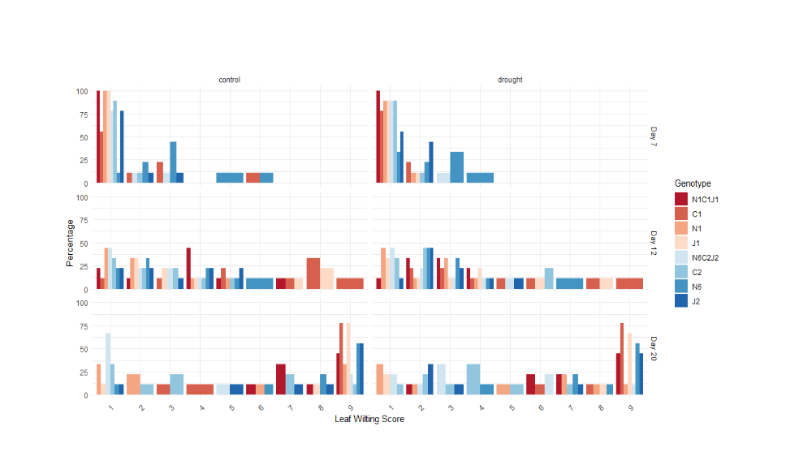
Figure S3. The percentage of wilting score by each Brassica genotype (allohexaploid N6C2J2 and its parents B. napus N6, B. carinata C2 and B. juncea J2; allohexaploid N1C1J1 and its parents B. napus N1, B. carinata C1 and B. juncea J1) under drought and control conditions starting from Day 7 to Day 20. At Day 3 all genotypes scored 1 which implies no wilting.

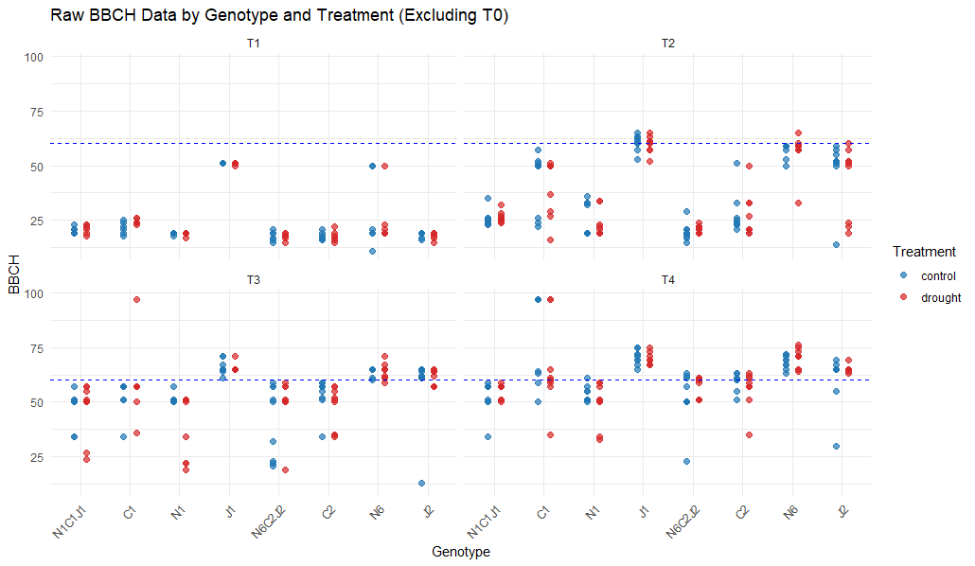

Figure S4. The BBCH 60 of the Brassica allohexaploid genotypes N6C2J2 and N1C1J1 and their parent allotetraploid genotypes starting from Day 3 to Day 20 under drought (approximately 20% soil water capacity) and well-watered control conditions. The blue broken line indicates BBCH 60 at the first flowering initiation.

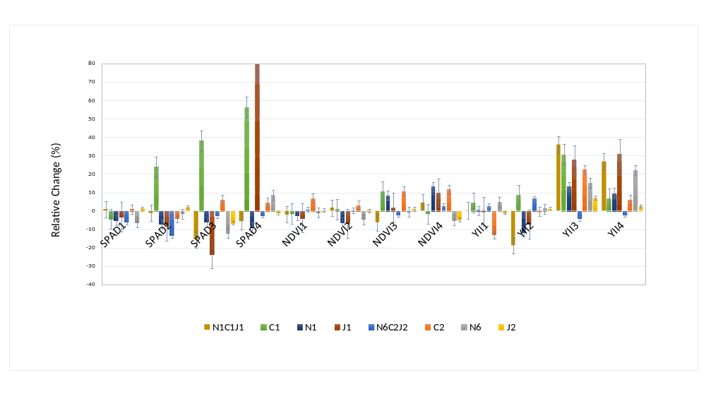Figure S5. Relative change (%) in physiological traits of allohexaploid Brassica genotypes N6C2J2 and N1C1J1, along with their respective parental lines, under different drought treatment durations compared to the control. Bars represent the relative change in each trait, with error bars indicating variability, and the x-axis shows measurements of chlorophyll content (SPAD), Normalized Difference Vegetation Index (NDVI), and chlorophyll fluorescence parameters at different time points, highlighting the physiological responses of each genotype to drought stress. The values are generated using IPASTIC web based tool

