Appendix RRE paper

Appendix 1. List of included publications and descriptive data
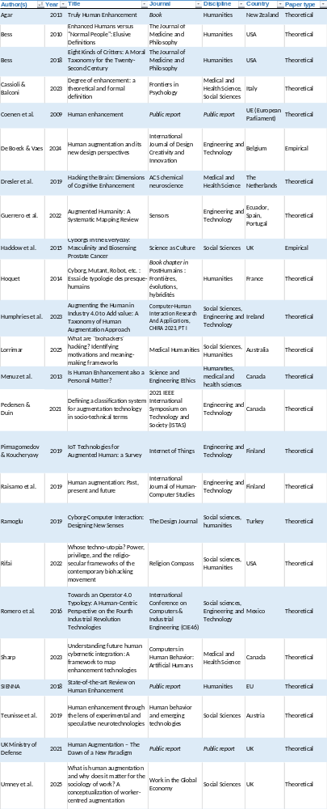

Appendix 2. Map of the different purposes and types of human augmentation in our typology
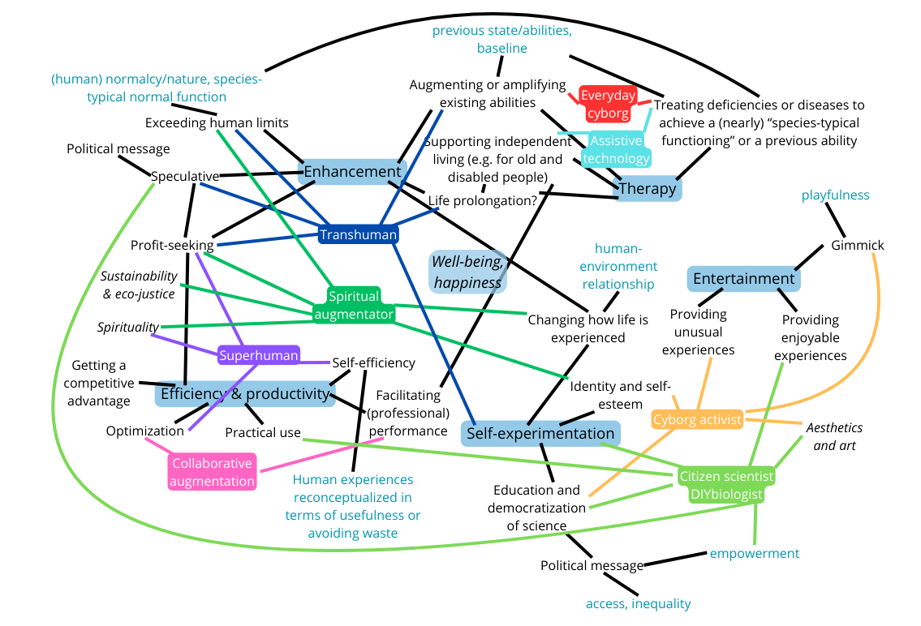

Appendix 3. Glossary of the different types of human augmentation in our typology, with the main authors we identified who conceptualize each type
- Augmented collaborator (Humphries et al., 2023): in this type of human augmentation, human and technology are both considered agents who collaborate on a task with a shared goal, to optimize and improve the person’s performance. The collaboration can occur locally or remotely. It implies a certain level of communication between agents (Humphries et al., 2023). The augmented collaborator can be human or non-human, such as a robot.
- Human-technology relationship: interdependence. They are both agents, but separate. They collaborate towards a common goal.

- Cyborg activist (Rifai, 2022): person who experiments with technologies in extravagant ways to live new experiences, and embraces this human-technology fusion and the new status that it gives them (Rifai, 2022, p. 5). Contrary to everyday cyborgs, cyborg activists self-identify as cyborgs: they “unabashedly embrace their more-than-human bodies, shedding any desire to be seen as ‘natural’ or ‘organic’.” (Rifai, 2022, p. 5) They openly share about their experience with others, often carrying a certain political message notably related to the democratization of science. Well-known cyborg activists are for example Kevin Warwick or Neil Harbisson.
- Human-technology relationship: intra-dependence. They self-identify as cyborgs and do not see themselves as “natural or organic” anymore. Their intra-action with the technology shapes them as agents. They only appear as themselves through their intra-action with the technology which makes part of them.

- DIY biologist (Rifai, 2022; Lorrimar, 2025): amateur researcher who does not have access to the research resources of institutions or to much scientific training but tries to democratize science by experimenting on themselves, with devices they design themselves, and publishing open-source to make healthcare accessible to all and empower ordinary citizens (Rifai, 2022). They have strong political convictions; through their experimentations, they generate utopic spaces and alternative futures, challenging social and political realities and extending the limits of what is possible. Their goal is an aesthetical and functional one, aside from recreation (Lorrimar, 2025). They do not have any commercial interest (Teunisse et al., 2019).
- Human-technology relationship: independence. Their use of technology serves a functional goal.

- Everyday cyborg (Rifai, 2022; Haddow et al., 2015): person who relies on technological devices to perform everyday tasks that they would otherwise not be able to perform because of an impairment, a disease, or old age. We can call these devices assistive technology: “rehabilitation technology that allows people with an impairment to participate more fully in society or prolongs the quality of life for the elderly.” (De Boeck & Vaes, 2024, p. 65). The technology operates by replacing or extending people’s abilities, and it can range from being simple to very complex (Rifai, 2022, p. 5). “the technology is automated and implanted (…) [the person] is not in control of the process of cyborgisation, which is often created and mediated by experts." (Haddow et al., 2015, p. 490) The outcome for their autonomy is ambivalent: it provides them with control over some aspects of their lives, but is detrimental to their autonomy in other aspects, as they for example rely on experts for the maintenance of the device (Haddow et al., 2015). The technology does not lead to total permanent recovery and are thus made to accompany the person for the rest of their life (De Boeck & Vaes, 2024). An everyday cyborg often does not self-identify as a cyborg, although external people would consider them to be a cyborg. Their hybridity becomes part of the ordinary for them, they do not like to be reminded of it and just endorse it because it is necessary for them to live. “the person may not always be aware of [the technology’s] presence and functioning” (Haddow et al., 2015, p. 490)
- Human-technology relationship: interdependence. Human and technology rely on each other but these people do not self-identify as cyborgs, which means that they do not consider their interaction with the technology as an intra-action, as defining their being.

- Spiritual augmentator (Lorrimar, 2025): this type of augmentation aligns with “New Age” spirituality. It is focused on grokking the mind-body connection to achieve enhanced mental and spiritual abilities, such as heightened states of consciousness, wellness, and serenity, outside of traditional religion. We can thus describe spiritual augmentators’ practices as a “merging of science and spirituality” (Lorrimar, 2025, p. 5). These people have diverse goals: they mainly have a concern for eco-justice and sustainability but there are also profiteering factions (e.g., selling luxury wellness products). They seek special experiences and to strengthen their identity and self-esteem. Contrary to superhumans, they are not against using technologies; they use a variety of techniques.
- Human-technology relationship: independence. Technology is a tool for them to experience new things.

- Superhuman (Rifai, 2022): person monitoring and analyzing their body and lifestyle to improve their bodies without technological devices. When technological devices are used, it is only as a tool to achieve peak optimization. The goal is not to become a human-machine hybrid but to become even more biological. They aim to optimize their abilities through self-care and spirituality and ultimately improve their productivity. It is a solitary practice and it is often profit-seeking. A well-known example is the Quantified Self movement (Lorrimar, 2025; Rifai, 2022).
- Human-technology relationship: independence. Superhumans mostly do not interact with technology and do not consider it as having agency on its own.

- Transhuman (The Transhumanist FAQ): person who advocates for and believes in the possibility to develop technologies to “eliminate aging and to greatly enhance human intellectual, physical, and psychological capacities.” (The Transhumanist FAQ as cited in Agar, 2013, p. 24) It includes a profit-seeking faction. Their ultimate goal is to transcend current human limitations and become “posthuman” through a fusion of human and technology (Wendykowska, 2014). This involves constant self-improvement thanks to (notably) self-experimentation and a subsidiary purpose of life extension. It entails a speculative approach (De Boeck & Vaes, 2024, p. 67). It also implies a certain technological determinism that states that the cyborgization of humanity is inevitable (Olarte-Pascual et al., 2021), as well as a belief in reason and progress.
- Human-technology relationship: independence as it is right now, because they consider technology as a tool to improve human abilities (More & Vita-More, 2013). The technology is chosen to fit the individual’s personal project (Gauttier, 2019). However, their objective is to reach the fusion of human and technology, which would enter the (currently speculative) category of transdependence.

References
- Agar, N. (2013). Truly Human Enhancement: A Philosophical Defense of Limits. The MIT Press. https://muse.jhu.edu/pub/6/monograph/book/28215
- De Boeck, M., & Vaes, K. (2024). Human augmentation and its new design perspectives. International Journal of Design Creativity and Innovation, 12(1), Article 1. https://doi.org/10.1080/21650349.2023.2288125
- Gauttier, S. (2019). Enhancing oneself with an exosense: Learning from users’ experiences. Human Behavior and Emerging Technologies, 1. https://doi.org/10.1002/hbe2.174
- Haddow, G., King, E., Kunkler, I., & McLaren, D. (2015). Cyborgs in the Everyday: Masculinity and Biosensing Prostate Cancer. Science as Culture, 24(4), 484–506. https://doi.org/10.1080/09505431.2015.1063597
- Humphries, J., de Ven, P. V., & Ryan, A. (2023). Augmenting the Human in Industry 4.0 to Add Value: A Taxonomy of Human Augmentation Approach. In H. P. DaSilva & P. Cipresso (Eds.), COMPUTER-HUMAN INTERACTION RESEARCH AND APPLICATIONS, CHIRA 2023, PT I (Vol. 1996, pp. 318–335). Springer International Publishing Ag. https://doi.org/10.1007/978-3-031-49425-3_20
- Lorrimar, V. (2025). What are ‘biohackers’ hacking? Identifying motivations and meaning-making frameworks. Medical Humanities. https://doi.org/10.1136/medhum-2025-013261
- More, M., & Vita-More, N. (2013). The transhumanist reader: Classical and contemporary essays on the science, technology, and philosophy of the human future. Wiley-Blackwell.
- Olarte-Pascual, C., Pelegrín-Borondo, J., & Arias-Oliva, M. (2021). From wearable to insideable: Is ethical judgment key to the acceptance of human capacity-enhancing intelligent technologies? Computers in Human Behavior, 114, 106559. https://doi.org/10.1016/j.chb.2020.106559
- Rifai, E. (2022). Whose techno-utopia? Power, privilege, and the religio-secular frameworks of the contemporary biohacking movement. RELIGION COMPASS, 16(11–12). https://doi.org/10.1111/rec3.12451
- Teunisse, W., Youssef, S., & Schmidt, M. (2019). Human enhancement through the lens of experimental and speculative neurotechnologies. Human Behavior and Emerging Technologies, 1(4), 361–372. https://doi.org/10.1002/hbe2.179
- Wendykowska, E. (2014). Approaching Transhumanism: On How Human Beings Transform in the 21st Century. Analyses/Rereadings/Theories, 2(2), Article 2. https://doi.org/10.18778/2353-6098.2.11

