Supplementary Information for:
Rapid global growth and intensification of dengue since 1990

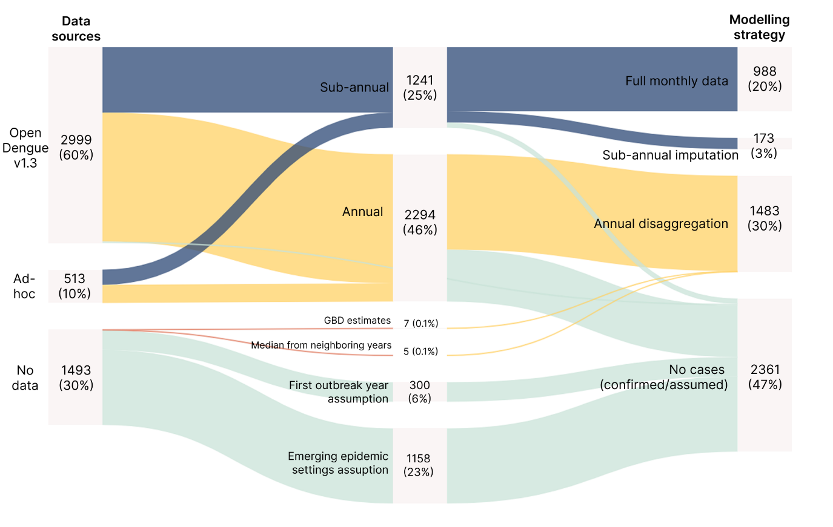
Supplementary Figure 1. Global dengue surveillance data availability and processing pipeline (1990-2024). Diagram showing the distribution of 5,005 country-years of dengue data across 143 countries, categorised by data type and processing needs. Link and node sizes are proportional to the number of country-years.

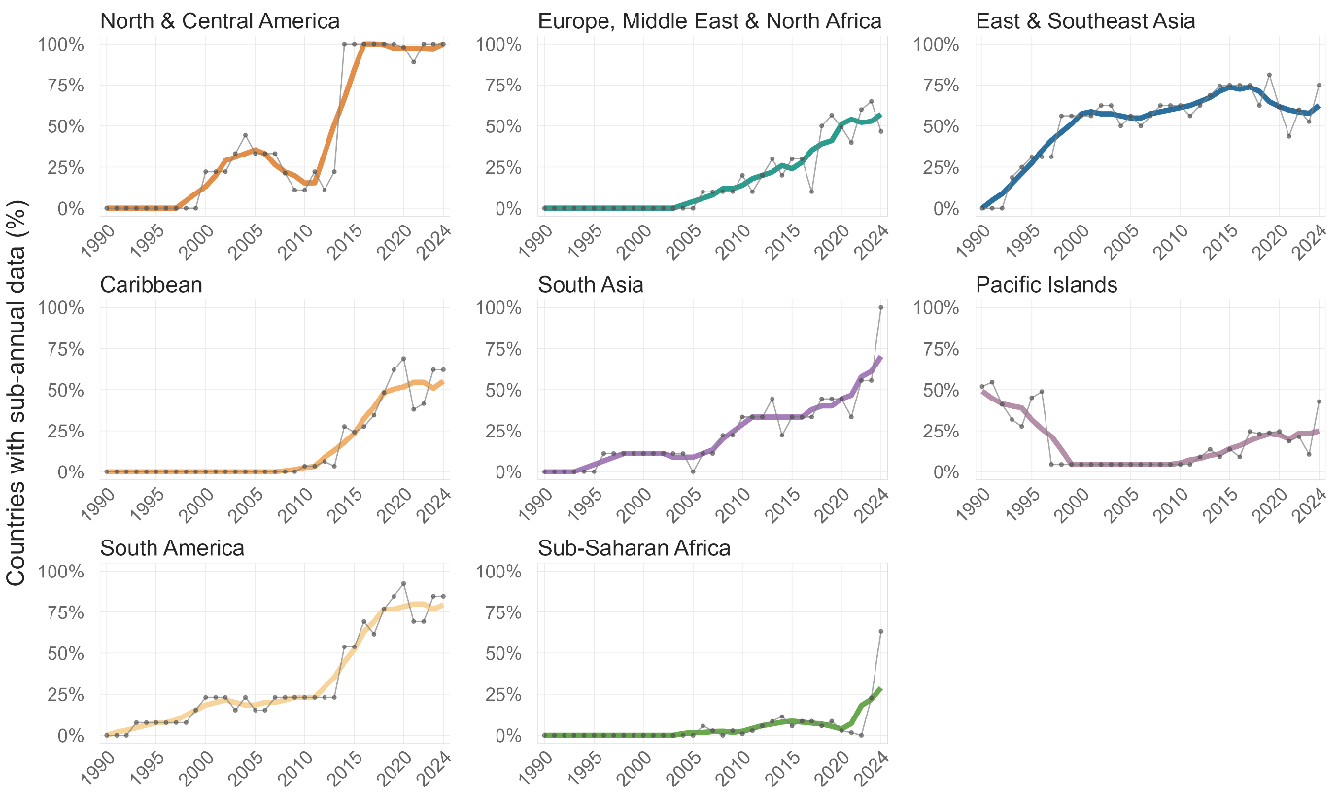
Supplementary Figure 2. Temporal trends in sub-annual dengue dengue data availability by region, 1990-2024. Proportion of countries with sub-annual (weekly or monthly) case data by year across geographic regions. Grey points show annual proportions; colored lines show 5-year rolling averages.

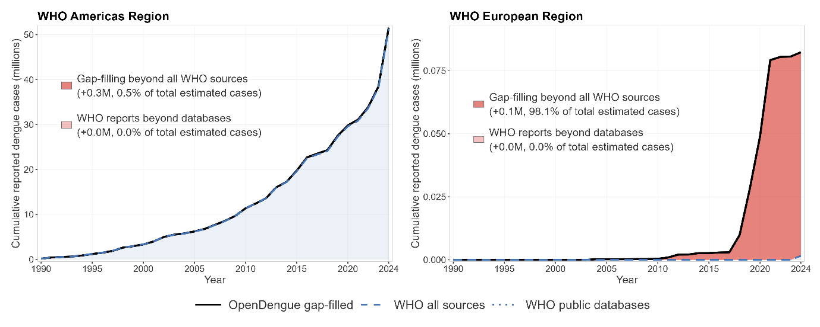
Supplementary Figure 3. Gap-filled dengue estimates compared with WHO surveillance data for the Americas and European regions, 1990-2024.

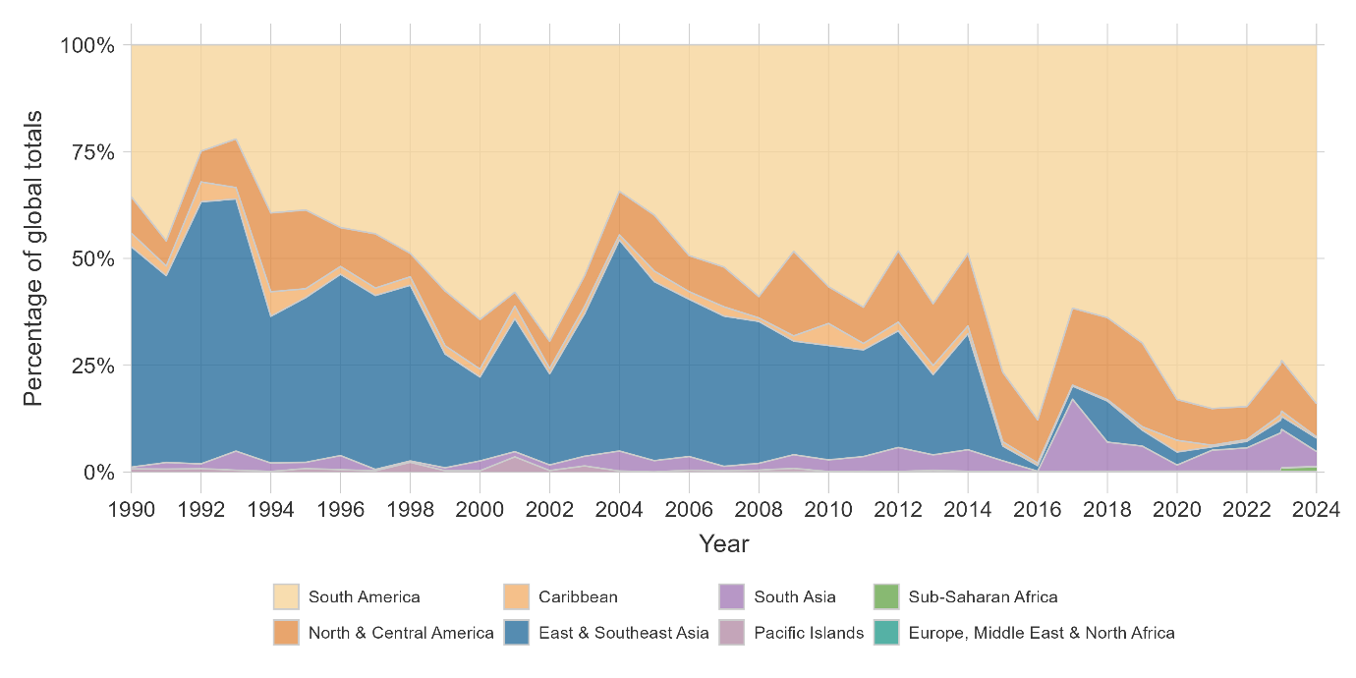
Supplementary Figure 4. Regional distribution of global dengue burden, 1990-2024. Stacked area charts showing regional proportions of global number of reported cases from WHO digitised databases.

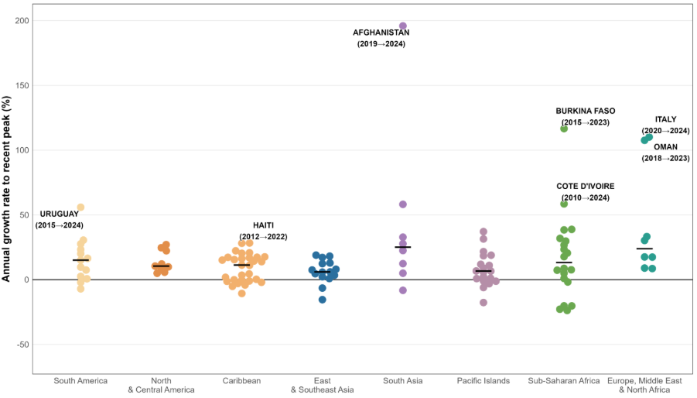
Supplementary Figure 5. Country-level dengue growth rates from emergence to recent peak, 2022-2024. Population-adjusted annual growth rates calculated from first year with recorded cases to the year with highest case load between 2022 and 2024 for each country. Each point represents one country (n=122 countries with ≥3 years of data and a recent peak since 2022); horizontal lines show regional medians. Countries are coloured by region labels indicate time windows (emergence to peak year).
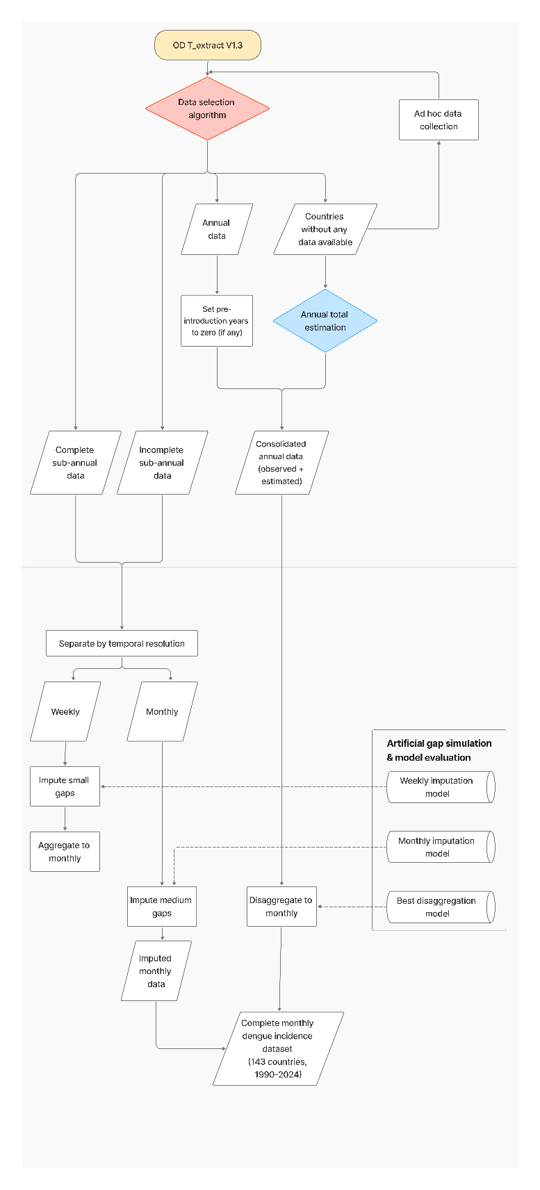
Supplementary Figure 6. Data processing pipeline and modelling workflow for global dengue case estimation.
Flowchart illustrating the sequential steps from raw data acquisition through final gap-filled estimates. The pipeline comprises four main stages: (1) data selection algorithm for reconciling multiple sources within the OpenDengue database; (2) annual total estimation for country-years without observed data; (3) temporal imputation for incomplete sub-annual time series; and (4) disaggregation of annual totals into monthly estimates. Arrows indicate data flow between processing stages. The final output is a complete monthly dengue incidence dataset covering 143 countries from 1990 to 2024.

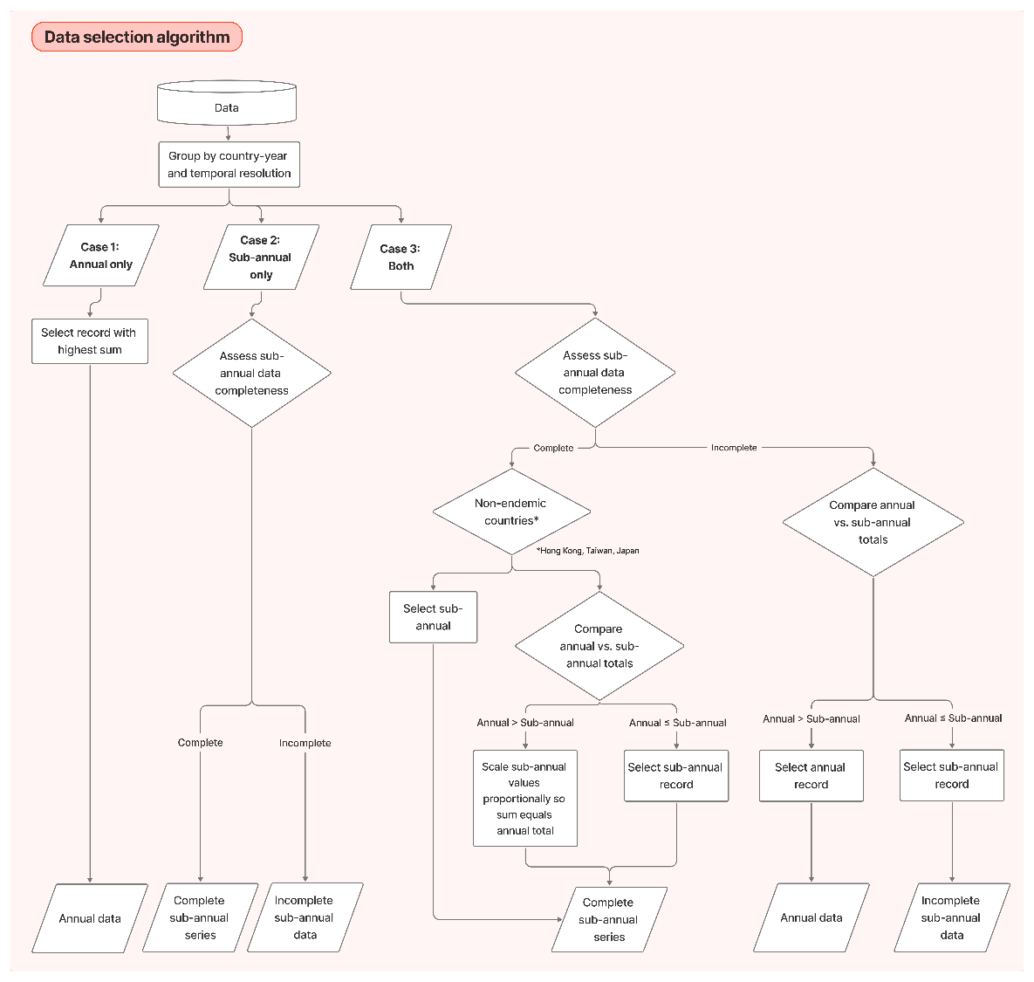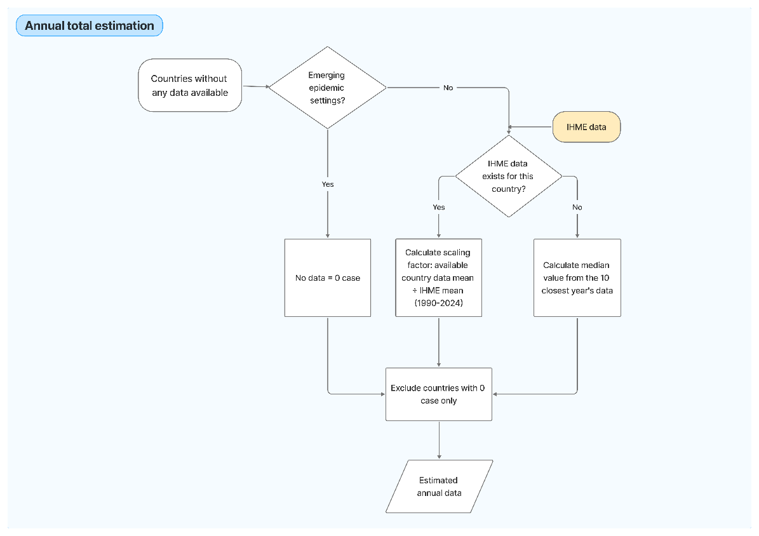
Supplementary Figure 7. Data selection algorithm and annual total estimation workflow.
Detailed decision trees for two key processing stages from Supplementary Figure 1. Top panel: Data selection algorithm for reconciling multiple data sources. Bottom panel: Annual total estimation procedure for country-years without observed data. Countries in emerging epidemic settings (Africa, Europe, Pacific/Caribbean islands, and selected Middle Eastern nations) are assigned zero cases for years without documented outbreaks. For endemic countries with missing data, annual totals are estimated using calibrated IHME scaling factors or median values from the ten temporally nearest observed years.

Supplementary Table 1. Distribution of data gaps by type, size, and geographic region (unit: number of gaps).
Region | Small gap  (1-4 weeks) |  | Medium gap  (2-11 months) |  | Annual disaggregation |  | Total
Region | Inter. | Extrap. | Inter. | Extrap. | Inter. | Extrap. | Total
Global | 543 | 5 | 97 | 51 | 337 | 55 | 1088
N & C America | 3 | 0 | 0 | 0 | 14 | 6 | 23
Caribbean | 2 | 0 | 1 | 0 | 106 | 23 | 132
S America | 0 | 0 | 0 | 0 | 15 | 8 | 23
Europe, Middle East & N Africa | 5 | 0 | 0 | 2 | 12 | 1 | 20
S Asia | 0 | 0 | 0 | 0 | 17 | 2 | 19
Sub-Saharan Africa | 1 | 0 | 2 | 15 | 64 | 1 | 83
E & SE Asia | 10 | 3 | 1 | 0 | 21 | 13 | 48
Pacific Islands | 522 | 2 | 93 | 34 | 88 | 1 | 740

Supplementary Table 2. Median duration of consecutive data gaps by type and geographic region (unit: months).
Region | Small gap  (1-4 weeks) |  | Medium gap  (2-11 months) |  | Annual dissagregation |  | Total
Region | Inter. | Extrap. | Inter. | Extrap. | Inter. | Extrap. | Total
Global | 0.2 | 0.8 | 2.9 | 5.0 | 30.0 | 48.0 | 12.6
N & C America | 0.2 | - | - | - | 60.0 | 138.0 | 60.0
Caribbean | 0.2 | - | 9.2 | - | 24.0 | 36.0 | 16.6
S America | - | - | - | - | 48.0 | 114.0 | 81.0
Europe, Middle East & N Africa | 0.5 | - | - | 5.0 | 12.0 | 12.0 | 8.5
S Asia | - | - | - | - | 60.0 | 204.0 | 132.0
Sub-Saharan Africa | 0.2 | - | 2.5 | 5.0 | 12.0 | 12.0 | 5.0
E & SE Asia | 0.3 | 0.7 | 2.0 | - | 36.0 | 60.0 | 2.0
Pacific Islands | 0.2 | 0.9 | 3.2 | 3.0 | 12.0 | 12.0 | 3.1

Supplementary Table 3. Final model performance for weekly imputation models (2 weeks). Comparison of GAM and INLA models under repeated three-fold cross-validation with artificial missingness.
Task | Model | N_test | Observed incidence | MAE | RMSE | nMAE | nRMSE | COV80 | CRPS
Interpolation | GAM | 32672 | 5.8 | 5.1 | 24.6 | 0.88 | 4.26 | 0.91 | 4.0
Interpolation | INLA | 32672 | 5.8 | 1.2 | 7.1 | 0.21 | 1.23 | 0.92 | 1.0
Extrapolation (backcast) | GAM | 1680 | 11.7 | 11.9 | 41.1 | 1.01 | 3.50 | 0.89 | 9.1
Extrapolation (backcast) | INLA | 1680 | 11.7 | 4.8 | 21.3 | 0.41 | 1.82 | 0.92 | 5.2
Extrapolation (forecast) | GAM | 1702 | 5.9 | 4.9 | 21.0 | 0.84 | 3.55 | 0.91 | 7.2
Extrapolation (forecast) | INLA | 1702 | 5.9 | 3.3 | 15.1 | 0.56 | 2.54 | 0.90 | 2.8

Supplementary Table 4. Final model performance for monthly imputation models (5 months). Comparison of GAM and INLA models under repeated three-fold cross-validation with artificial missingness.
Task | Model | N_test | Observed incidence | MAE | RMSE | nMAE | nRMSE | COV80 | CRPS
Interpolation | GAM | 13135 | 19.1 | 17.2 | 99.7 | 0.90 | 5.21 | 0.89 | 13.9
Interpolation | INLA | 13135 | 19.1 | 10.5 | 78.5 | 0.55 | 4.10 | 0.90 | 8.5
Extrapolation (backcast) | GAM | 5053 | 43.8 | 41.8 | 210.3 | 0.95 | 4.80 | 0.80 | 36.0
Extrapolation (backcast) | INLA | 5053 | 43.8 | 35.0 | 198.9 | 0.80 | 4.54 | 0.82 | 30.0
Extrapolation (forecast) | GAM | 5045 | 30.9 | 29.8 | 158.9 | 0.96 | 5.14 | 0.82 | 25.6
Extrapolation (forecast) | INLA | 5045 | 30.9 | 24.7 | 145.3 | 0.80 | 4.70 | 0.82 | 22.5

Supplementary Table 5. Final model performance for annual-to-monthly disaggregation. Comparison of Dirichlet-Multinomial (DM), unscaled INLA, and scaled INLA and models under repeated three-fold cross-validation using complete 12-month country-years.
Task | Model | N_test | Observed incidence | MAE | RMSE | nMAE | nRMSE | COV80 | CRPS
Interpolation | DM | 3648 | 18.2 | 13.5 | 78.9 | 0.74 | 4.33 | 0.95 | 9.6
Interpolation | INLA unscaled | 3648 | 18.2 | 13.6 | 76.2 | 0.75 | 4.19 | 0.87 | 11.8
Interpolation | INLA scaled | 3648 | 18.2 | 10.7 | 79.8 | 0.59 | 4.39 | 0.87 | 7.6
Extrapolation (backcast) | DM | 2412 | 28.0 | 31.7 | 262.0 | 1.13 | 9.34 | 0.86 | 27.2
Extrapolation (backcast) | INLA unscaled | 2412 | 28.0 | 26.6 | 187.8 | 0.95 | 6.70 | 0.76 | 24.4
Extrapolation (backcast) | INLA scaled | 2412 | 28.0 | 25.9 | 163.4 | 0.92 | 5.82 | 0.75 | 17.2
Extrapolation (forecast) | DM | 2400 | 43.6 | 38.5 | 186.3 | 0.88 | 4.27 | 0.85 | 29.2
Extrapolation (forecast) | INLA unscaled | 2400 | 43.6 | 38.9 | 159.7 | 0.89 | 3.66 | 0.75 | 33.3
Extrapolation (forecast) | INLA scaled | 2400 | 43.6 | 27.9 | 116.6 | 0.64 | 2.67 | 0.81 | 19.9

Supplementary Table 6. Temporal trends in wavelet power among dengue-endemic countries by broad geographic region, 1990-2024. Power was summarised in non-overlapping 5-year windows, and trends were estimated using log-linear mixed-effects models. Percent change per year is the multiplicative annual change in power on the original scale (derived from the log-scale time coefficient). P-values test whether the estimated time trend differs from zero within each geographic scope; the year*region term tests whether trends differ between regions. “% countries increasing” is the proportion of countries with positive slopes whose 95% confidence intervals exclude zero (from country-level regressions; see Methods and Supp. Text).
Geographic scope | Power start | Power end | % change per year (95% CI) | p-value | % countries increasing | Interaction p-value
Annual cycle (8-16 months)
Global | 0.35 | 0.98 | 3.48 ( 1.23 - 5.78) | <0.01 | 19 / 47 (40.4%) | -
Asia | 0.44 | 1.00 | 2.61 (-0.22 - 5.47) | 0.07 | 9 / 29 (31.0%) | 0.34
Americas | 0.21 | 0.95 | 4.91 ( 1.33 - 8.80) | <0.01 | 10 / 18 (55.6%) | 0.34
Multiannual cycle (>17 month)
Global | 1.57 | 2.73 | 1.77 ( 0.42 - 3.12) | <0.01 | 20 / 46 (43.5%) | -
Asia | 1.49 | 3.26 | 2.66 ( 0.94 - 4.45) | <0.01 | 14 / 28 (50.0%) | 0.11
Americas | 1.69 | 1.90 | 0.39 (-1.70 - 2.56) | 0.73 | 6 / 18 (33.3%) | 0.11

Supplementary Table 7. Temporal trends in pairwise synchrony among dengue-endemic countries by broad geographic pairing, 1990-2024. Synchrony was summarised in non-overlapping 5-year windows, and trends were estimated using logit-linear mixed-effects models. Percent change per year is the average annual relative change on the original 0-1 synchrony scale, computed from model-predicted start and end synchrony. P-values test whether the estimated time trend differs from zero within each pairing type; interaction terms test whether trends differ from the within-Americas reference. “% pairs increasing” is the proportion of pairs with positive slopes whose 95% confidence intervals exclude zero (from pair-level regressions; see Methods and Supp. Text).
Geographic scope | Synchrony start | Synchrony end | % change per year (95% CI) | p-value | % pairs increasing | Interaction p-value
Annual cycle (8-16 months)
Global | 0.19 | 0.22 | 0.59 ( 0.33 - 0.86) | <0.001 | 89 / 1081 (8.2%) | -
Asia | 0.19 | 0.24 | 0.70 ( 0.27 - 1.17) | <0.001 | 32 / 406 (7.9%) | 0.27
Americas | 0.17 | 0.23 | 1.22 ( 0.47 - 2.10) | <0.001 | 12 / 153 (7.8%) | 0.27
Multiannual cycle (>17 month)
Global | 0.30 | 0.34 | 0.49 ( 0.30 - 0.68) | <0.001 | 202 / 1035 (19.5%) | -
Asia | 0.29 | 0.33 | 0.47 ( 0.15 - 0.80) | <0.001 | 75 / 378 (19.8%) | 1.00
Americas | 0.35 | 0.39 | 0.43 ( 0.00 - 0.91) | 0.049 | 38 / 153 (24.8%) | 1.00

Supplementary Table 8. Hemisphere differences in mean pairwise synchrony for annual and multiannual dengue cycles. Pairs were classified as within-hemisphere (N-N or S-S) or between-hemisphere (N-S) based on country centroid latitude. Model mean synchrony values (0-1) and 95% confidence intervals are marginal estimates from the mixed-effects model; the “Within - Between” column reports the estimated difference with its 95% CI and p-value.
Pair group | N pairs | Model mean synchrony (95% CI) | Within - Between difference (95% CI) | p-value
Annual cycle (8-16 months)
Between | 420 | 0.15 (0.13-0.16) | - | -
Within | 661 | 0.31 (0.29-0.33) | - | -
Difference | - | - | 0.16 (0.14–0.18) | <0.001
Multiannual cycle (>17 month)
Between | 408 | 0.33 (0.30-0.32) | - | -
Within | 627 | 0.34 (0.32-0.37) | - | -
Difference | - | - | 0.011 (-0.01–0.03) | 0.235

Supplementary Table 9. First documented local dengue transmission dates and data sources for emerging epidemic countries.
Country | First documented local dengue transmission | Source | Criteria/notes
Brunei Darussalam | 1992 | ¹ | table 2 in this paper- longitudinal IgM sampling since 1992
Guam | 2019 | ^{2,3} | On September 9, 2019, a resident of Guam with no travel history experienced a dengue-like illness that was reported to the Guam Department of Public Health and Social Services (DPHSS). On September 10, 2019, the Guam Public Health Laboratory (PHL) detected dengue virus 3 (DENV-3) in the patient’s serum specimen by reverse transcription-polymerase chain reaction (RT-PCR). This was the first detection of a locally acquired dengue case on Guam since 1944 (1).
Hong Kong | 2002 | ^{4–6} | "Despite the successful dengue control measures introduced after the first local case was identified in Hong Kong in 2002"
Japan | 2014 | ⁷ | "In 2014, an autochthonous dengue fever outbreak occurred around the Yoyogi Park in Japan for the first time in 70 years.
Macau | 2001 | ⁸ | "In 2001, the first dengue fever outbreak occurred in Macau"
Pakistan | 1994 | ^{9,10} | "Pakistan first reported an epidemic of dengue fever in 1994"
Croatia | 2010 | ¹¹
France | 2010 | ¹¹
Italy | 2020 | ¹¹
Spain | 2018 | ¹¹
Portugal (Madeira) | 2012 | ¹¹
Cabo Verde | 2009 | ¹² | In the last three months of 2009, Cape Verde suffered its first outbreak of dengue.
Ethiopia | 2013 | ¹³ | In Ethiopia, DF was diagnosed only among travelers that return to countries to which dengue was not endemic but never reported as occurring locally (1, 14, 15) and it is also not included among the lists of national reportable diseases (16)."
Afghanistan | 2019 | ¹⁴ | Dengue fever is considered as an emerging disease in Afghanistan. Since the first outbreak was reported in 2019, other outbreaks have been reported in the following years.
Chad | 2023 | ¹⁵ | This is the first dengue outbreak reported in Chad
Oman | 2018 | ^{16,17} | Between 2001 and 2017, 173 cases were reported, and all were travel-related.  The country reported its first imported dengue fever cases in 2001. Since 2001, the number of travel-associated dengue fever cases were reported in the country on a regular basis.

Supplementary Table 10. Posterior summaries of key fixed effects and hyperparameters for the final weekly INLA imputation model.

Parameter | Type | Median | CI_0.025 | CI_0.975
(Intercept) | Fixed effect | 0.88 | 0.68 | 1.07
size for the nbinomial observations (1/overdispersion) | Hyperparameter | 21.45 | 19.52 | 23.61
Precision for time_seq | Hyperparameter | 0.31 | 0.28 | 0.34
AR(1) correlation (rho) for time_seq | Hyperparameter | 0.98 | 0.98 | 0.98
Precision for week_shared | Hyperparameter | 135.79 | 70.37 | 293.50
Precision for week_dev | Hyperparameter | 21.71 | 15.20 | 30.84
Precision for week_dev_country | Hyperparameter | 3.72 | 3.17 | 4.32
Precision for yearx | Hyperparameter | 1.39 | 1.08 | 1.76
AR(1) correlation (rho) for yearx | Hyperparameter | -0.14 | -0.28 | 0.05
Precision for countryx | Hyperparameter | 0.09 | 0.07 | 0.12

Supplementary Table 11. Posterior summaries of key fixed effects and hyperparameters for the final monthly INLA imputation model.
Parameter | Type | Median | CI_0.025 | CI_0.975
(Intercept) | Fixed effect | 1.98 | 1.80 | 2.15
size for the nbinomial observations (1/overdispersion) | Hyperparameter | 207.54 | 145.69 | 278.27
Precision for time_seq | Hyperparameter | 0.29 | 0.27 | 0.32
AR(1) correlation (rho) for time_seq | Hyperparameter | 0.93 | 0.92 | 0.93
Precision for month_shared | Hyperparameter | 142.98 | 43.33 | 490.76
Precision for month_dev | Hyperparameter | 9.08 | 4.21 | 13.99
Precision for month_dev_country | Hyperparameter | 2.22 | 1.93 | 2.55
Precision for yearx | Hyperparameter | 4.37 | 3.27 | 5.89
AR(1) correlation (rho) for yearx | Hyperparameter | -0.66 | -0.77 | -0.54
Precision for countryx | Hyperparameter | 0.09 | 0.07 | 0.11

Supplementary Table 12. Posterior summaries of key fixed effects and hyperparameters for the final INLA disaggregation model.
Parameter | Type | Median | CI_0.025 | CI_0975
(Intercept) | Fixed effect | -2.43 | -2.67 | -2.20
size for the nbinomial observations (1/overdispersion) | Hyperparameter | 218.64 | 161.64 | 306.32
Precision for time_seq | Hyperparameter | 0.31 | 0.27 | 0.35
AR(1) correlation (rho) for time_seq | Hyperparameter | 0.93 | 0.92 | 0.94
Precision for month_shared | Hyperparameter | 74.36 | 42.57 | 117.41
Precision for month_dev | Hyperparameter | 10.38 | 6.54 | 17.69
Precision for month_dev_country | Hyperparameter | 2.23 | 1.96 | 2.56
Precision for yearx | Hyperparameter | 0.05 | 0.05 | 0.06
AR(1) correlation (rho) for yearx | Hyperparameter | 0.89 | 0.87 | 0.90
Precision for countryx | Hyperparameter | 0.03 | 0.03 | 0.04
Supplementary Table 13. Convergence diagnostics for hierarchical Dirichlet-Multinomial model fits across cross-validation masks.
Mast type | N_fits | % fits with divergences | R-hat median | R-hat max | ESS bulk median | ESS bulk min | ESS tail median | ESS tail min
Interpolation | 9 | 0 | 1.03 | 1.04 | 218 | 159 | 263 | 201
Extrapolation (backcast) | 9 | 0 | 1.03 | 1.04 | 183 | 123 | 258 | 181
Extrapolation (forecast) | 9 | 0 | 1.03 | 1.05 | 205 | 152 | 249 | 162

Supplementary Table 14. Posterior summaries of key hierarchical scale and concentration hyperparameters for the Dirichlet-Multinomial model across cross-validation masks.
Mask type | Parameter | Median | CI_0.025 | CI_0.975
Interpolation | tau_country_month | 0.049 | 0.003 | 0.099
Interpolation | sigma_region_month_mean | 0.288 | 0.241 | 0.341
Interpolation | tau_region_year_mean | 0.118 | 0.051 | 0.208
Interpolation | log_concentration_mean | 1.690 | 1.680 | 1.700
Interpolation | total_concentration_mean | 5.947 | 5.881 | 6.012
Extrapolation (backcast) | tau_country_month | 0.048 | 0.003 | 0.099
Extrapolation (backcast) | sigma_region_month_mean | 0.289 | 0.243 | 0.341
Extrapolation (backcast) | tau_region_year_mean | 0.116 | 0.049 | 0.207
Extrapolation (backcast) | log_concentration_mean | 1.699 | 1.688 | 1.709
Extrapolation (backcast) | total_concentration_mean | 6.004 | 5.941 | 6.068
Extrapolation (forecast) | tau_country_month | 0.046 | 0.003 | 0.096
Extrapolation (forecast) | sigma_region_month_mean | 0.286 | 0.241 | 0.341
Extrapolation (forecast) | tau_region_year_mean | 0.117 | 0.049 | 0.208
Extrapolation (forecast) | log_concentration_mean | 1.698 | 1.688 | 1.708
Extrapolation (forecast) | total_concentration_mean | 5.998 | 5.931 | 6.061

Supplementary Table 15. Global and regional number of reported dengue cases in WHO publications. Compilation of dengue case counts from official WHO sources including technical reports, global strategy documents, regional meeting reports, and surveillance bulletins. These reference figures were used for comparison with gap-filled estimates in Figure 1 to quantify additional cases identified through data reconciliation and imputation.
Year | WHO Region | Reported cases | Source
2000 | Global | 505430 | ¹⁸
2008 | Global | 1279668 | ¹⁹
2009 | Global | 1451083 | ¹⁹
2010 | Global | 2400000 | ¹⁸
2019 | Global | 5200000 | ²⁰
2019 | Global | 5037403 | ²¹
2020 | Global | 2904920 | ²¹
2021 | Global | 1465348 | ²¹
2022 | Global | 3503550 | ²¹
1990 | South-East Asia | 121401 | ²²
1991 | South-East Asia | 78742 | ²²
1992 | South-East Asia | 63769 | ²²
1993 | South-East Asia | 98589 | ²²
1994 | South-East Asia | 90194 | ²²
1995 | South-East Asia | 106196 | ²²
1996 | South-East Asia | 102248 | ²²
1997 | South-East Asia | 139079 | ²²
1998 | South-East Asia | 218821 | ²²
1999 | South-East Asia | 54811 | ²²
2000 | South-East Asia | 63672 | ²³
2001 | South-East Asia | 211039 | ²²
2002 | South-East Asia | 188240 | ²²
2003 | South-East Asia | 140635 | ²²
2004 | South-East Asia | 152482 | ²²
2005 | South-East Asia | 179918 | ²²
2006 | South-East Asia | 189832 | ²³
2007 | South-East Asia | 250458 | ²³
2008 | South-East Asia | 281723 | ²³
2009 | South-East Asia | 257882 | ²³
2010 | South-East Asia | 355137 | ²⁴
2011 | South-East Asia | 190000 | ²⁵
2012 | South-East Asia | 257204 | ²⁶
2015 | South-East Asia | 451442 | ²⁷
2019 | South-East Asia | 684456 | ²⁸
2020 | South-East Asia | 275786 | ²⁸
2000 | Western-Pacific | 48034 | ²⁹
2004 | Western-Pacific | 160823 | ³⁰
2005 | Western-Pacific | 159847 | ³¹
2009 | Western-Pacific | 242424 | ³²
2010 | Western-Pacific | 353907 | ³³
2011 | Western-Pacific | 244880 | ³³
2012 | Western-Pacific | 356838 | ³⁴
2013 | Western-Pacific | 430023 | ³⁵
2014 | Western-Pacific | 376972 | ³⁵
2015 | Western-Pacific | 513574 | ³⁵
2016 | Western-Pacific | 458843 | ³⁵
2017 | Western-Pacific | 454231 | ³⁵
2018 | Western-Pacific | 479263 | ³⁵
2019 | Western-Pacific | 1050285 | ³⁵

Supplementary Text

Dengue data processing

Ad hoc supplementation
We targeted countries with sparse coverage in OpenDengue v1.3 (i.e. Africa, Middle East, and small island nations in the Pacific and Caribbean) and extracted sub-annual or annual counts from official surveillance bulletins and outbreak reports. These were standardised and merged with the OpenDengue extracts. Each record is assigned a unique identifier (UUID) that links to a supplementary data file (Supp. Data) documenting the source URL, extraction method, and the specific location within the source document (e.g., figure number, page reference, etc) from which case values were extracted.

Searches and extraction of data for African countries
To search for reported dengue data in Africa we conducted a two-stage hierarchical search. First a systematic PubMed search was conducted to identify previous reviews of dengue outbreaks in Africa using the terms “dengue AND Africa AND systematic AND review”. Studies that reported the number of confirmed or suspected cases reported in a defined geographical area over a finite period of time were included. Studies presenting case reports, travel-acquired cases and cases in military personnel were excluded on the grounds of ambiguous denominator population and studies presenting only seroprevalence data were excluded on the grounds of ambiguous temporal denominator. Our initial search yielded 104 results which was reduced to 8 after title screening then 3 after full text review.

As the most recent of the three reviews of dengue outbreaks in Africa, annual suspected cases for all countries over the time period covered by the review (2013-2023) were extracted from table 1 of Mwanyika et al. (2025)³⁶. Reports of outbreaks from the years 1993-2012 were sourced from the references cited in table 3 of Poungou et al. (2023)³⁷ then case count data extracted. For outbreaks prior to 1993 references cited by Mwanyika et al. (2021)³⁸ were retrieved and case count data extracted. For countries with no reported cases, the supplemental table 1 of Brady et al. (2012)³⁹ was consulted to identify any further evidence outbreaks. This resulted in 115 data points for annual case counts for African countries.

To identify sub-annual dengue case count data, primary references cited by each of the above reviews were inspected for tables, text descriptions of figures presenting any higher temporal resolution data than annual. Where no sub-annual data were found, supplementary searches were also conducted using Google Scholar for the specific outbreak using the search term “[country] AND dengue AND outbreak AND [year]”. This resulted in 1,092 sub-annual data points for African countries. Source data for these datapoints can be found in Supp. Data.

Models and candidate specifications

To select among candidate formulas, we performed a preliminary screening on a small subset of approximately 30 countries with eight consecutive years each, using three‑fold cross‑validation under both interpolation and extrapolation masks. Countries were sampled to span a wide range of dengue burden and data coverage, with guaranteed inclusion of series showing long gaps (≥52 weeks) and proportional sampling across low, medium, and high strata. For each selected country we then extracted the contiguous eight-year window with maximal observed coverage before constructing masks and folds. Model selection was based on MAE, RMSE, COV80, and CRPS. The winning specifications were then frozen and applied to the full dataset using the fixed masks described in the main text, with identical folds across models.

GAM candidates

To provide benchmark comparisons, we tested four GAM specifications that vary in their flexibility and country-specific modelling approaches while maintaining consistent temporal components. All GAM models share the structure:

$$y_{c,t}​∼NegBin\left(μ_{c},t​,ϕ\right)$$

$$\log\left(μ_{c,t}\right)=α_{c}+f_{1}\left({\text{Year}}_{t}\right)$$

where $f_{1}\left(Year\right)$are year random effects and $α_{c}$ are country random intercepts. The temporal components vary as follows:

Model 1: $f_{2}\left({\text{month}}_{t},k=2\right)+f_{3}^{shared}\left({\text{time}}_{t}\right)$

Model 2: $f_{2}\left({\text{month}}_{t},k=2\right)+f_{3}^{country}\left({\text{time}}_{t}\right)$

Model 3: $f_{2}\left({\text{month}}_{t},k=6\right)+f_{3}^{shared}\left({\text{time}}_{t},k=10\right)$

Model 4: $f_{2}\left({\text{month}}_{t},k=6\right)+f_{3}^{shared}\left({\text{time}}_{t},k=10\right)+f_{3}^{shrunk}\left({\text{time}}_{t},k=10, m=2\right)$

where $f_{3}\left(time\right)$ represents the global time index, $k$ indicates basis function dimensions.

Model 1 (Minimal baseline) uses a simple smooth seasonal term with $k=2$ and a global smooth trend over time (default thin-plate spline). Model 2 (Country-specific trends) adds country-specific smooths using “by” terms while maintaining the cyclic seasonal term. Model 3 (Moderate flexibility) increases flexibility by using a cyclic cubic spline for seasonality (bs = “cc” with basis dimensions increased to $k=6$) and a cubic regression spline for the shared global trend (bs = “cr” with $k=10$) capturing more complex seasonal and long-term structures. Model 4 (Shared + shrunk deviations) builds on Model 3 by adding country-specific trend deviations through factor-smooth interactions (bs = “fs”) with strong shrinkage ($m=2$ penalty order), allowing countries to deviate from the global trend when supported by data while being regularised toward the shared pattern. This progression tests whether increased flexibility and country-specific components improve model performance compared to simpler shared-pattern approaches.

Model 1 is the most reliable and slightly the most accurate. It matches or edges Model 3 on interpolation and is marginally better on extrapolation tasks (Table below). The other candidates are unstable in extrapolation (e.g., Model 2 and Model 4), so we retained Model 1 as the GAM baseline for its simplicity.

Supplementary Table 16 Cross-validation performance of candidate generalised additive models (GAMs) for temporal imputation.
Model | n_test | MAE | RMSE | COV80 | CRPS
Interpolation
Model 1 | 714 | 11.5 | 30.8 | 0.88 | 6.65
Model 2 | 714 | 11.7 | 31.9 | 0.84 | 6.94
Model 3 | 714 | 11.8 | 31.8 | 0.90 | 6.70
Model 4 | 714 | 12.2 | 32.8 | 0.84 | 6.91
Extrapolation (backcast)
Model 1 | 352 | 25.6 | 115.4 | 0.71 | 72.16
Model 2 | 352 | 5.83E+13 | 6.38E+14 | 0.67 | 11888.21
Model 3 | 352 | 25.9 | 116.5 | 0.70 | 62.42
Model 4 | 352 | 223.5 | 1266.9 | 0.67 | 270.54
Extrapolation (forecast)
Model 1 | 350 | 33.1 | 136.8 | 0.77 | 225.31
Model 2 | 350 | 4.10E+04 | 3.60E+05 | 0.62 | 39965.49
Model 3 | 350 | 33.1 | 137.4 | 0.77 | 202.94
Model 4 | 350 | 3.58E+12 | 3.00E+13 | 0.65 | 28636.18

INLA candidates

To evaluate different approaches to modelling seasonal patterns and information sharing across geographic scales, we tested four monthly INLA model specifications that maintain consistent core temporal components while varying the seasonal structure.

All models share the common structure:

$y_{c, t}​∼NegBin\left(μ_{c},t​,ϕ\right)$

$\log\left(μ_{c,t}\right)=β_{0}+α_{c}+ξ_{c,t}+\text{seasonal terms}+Y_{c,y\left(t\right)}$,

where $β_{0}$ is the global intercept, $α_{c}$ represents country random intercepts, $ξ_{c,t}$ ​ captures country-specific temporal autocorrelation, and $Y_{c,y\left(t\right)}$ models inter-annual variation. The seasonal components vary as follows:

Model 1: $\text{seasonal terms}=S_{c,m\left(t\right)}^{\left(country\right)}$

Model 2: $\text{seasonal terms}=S_{m\left(t\right)}^{\left(global\right)}+S_{c,m\left(t\right)}^{\left(country\right)}$

$$\text{Model 3:}\text{ seasonal terms}=S_{b\left(c\right),m\left(t\right)}^{\left(band\right)}+S_{c,m\left(t\right)}^{\left(country\right)}$$

Model 4: $\text{seasonal terms}=S_{m\left(t\right)}^{\left(global\right)}+S_{b\left(c\right),m\left(t\right)}^{\left(band\right)}+S_{c,m\left(t\right)}^{\left(country\right)}$

Model 1 (Country-specific) estimates completely separate seasonal curves for each country without any information sharing, using country-replicated cyclic RW1 terms with moderate shrinkage (precision = 2.0). Model 2 (Global shared) implements a two-level structure with a single global seasonal backbone shared across all countries plus country-specific deviations strongly shrunk toward zero (precision = 0.2). Model 3 (Regional shared) uses latitudinal band-level seasonal curves shared within bands, combined with country-specific deviations from their latitudinal band pattern (precision = 0.2). Model 4 (Three-level hierarchy) implements the full hierarchical decomposition described above, with global backbone, latitudinal band deviations (precision = 0.7), and country deviations from latitudinal patterns (precision = 0.25). High precision priors (0.2-0.25) on deviation terms strongly regularize the deviation terms, pulling them close to zero unless there is strong evidence in the data for country-specific departures from the shared seasonal pattern, effectively implementing partial pooling where countries borrow strength from the global or regional patterns.

We chose Model 4 for the analysis because it handles the more challenging forecast extrapolation slightly better while remaining competitive elsewhere. After dropping Models 1 and 3 (big bumps in MAE/RMSE in extrapolation tasks) the comparison comes down to Models 2 and 4. On the forecast task Model 4 delivers better probabilistic accuracy (CRPS 21.39 vs 22.10 for Model 2) with essentially identical point errors (MAE 57.3 vs 56.9; RMSE 272.5 vs 270.0) and similar calibration (COV80 roughly 0.82 for both).

Supplementary Table 17 Cross-validation performance of candidate INLA models for temporal imputation.
Model | n_test | MAE | RMSE | COV80 | CRPS
Interpolation
Model 1 | 714 | 9.3 | 36.9 | 0.89 | 4.73
Model 2 | 714 | 9.1 | 36.1 | 0.89 | 4.77
Model 3 | 714 | 9.3 | 38.2 | 0.89 | 4.77
Model 4 | 714 | 9.3 | 38.1 | 0.89 | 4.71
Extrapolation (backcast)
Model 1 | 352 | 58.3 | 264.4 | 0.83 | 21.57
Model 2 | 352 | 75.8 | 456.2 | 0.82 | 21.59
Model 3 | 352 | 100.4 | 652.4 | 0.82 | 22.60
Model 4 | 352 | 93.5 | 578.8 | 0.83 | 22.29
Extrapolation (forecast)
Model 1 | 350 | 75.9 | 351.8 | 0.83 | 21.77
Model 2 | 350 | 56.9 | 270.0 | 0.82 | 22.10
Model 3 | 350 | 56.8 | 269.8 | 0.83 | 21.93
Model 4 | 350 | 57.3 | 272.5 | 0.82 | 21.39

Dirichlet-Multinomial model candidates
We tested two Bayesian Dirichlet-Multinomial (DM) models for temporal disaggregation of annual counts into monthly distributions. The modelling framework requires: (1) historical data containing both annual totals and monthly breakdowns for training, (2) country-specific historical seasonal baselines, and (3) geographic hierarchy information (countries nested within latitudinal groups). The models aim to estimate monthly proportions $π_{c,y}$ that represent how annual cases are distributed across the 12 months for each country-year combination. These proportions are then used to predict monthly counts by multiplying with known annual totals, enabling seasonal disaggregation when only annual burden estimates are available.
We implemented two complementary Bayesian DM models that share a common likelihood structure but differ in their approach to distributing annual totals into monthly cases. Both models treat each country-year’s monthly counts as a Dirichlet-Multinomial draw from the observed annual total:
$$π_{c,y}=softmax\left(x_{c,y}\right)$$
$$α_{c,y}=κ_{c,y}π_{c,y}$$
$$y_{c,y}\sim DirichletMultinomial\left(n_{c,y},α_{c,y}\right)$$
where $x_{c,y}=\left(x_{c,y,1},…,x_{c,y,12}\right)$ represents the latent monthly logits for country $c$ in year $y$, $π_{c,y}$ are the corresponding monthly proportions, $κ_{c,y}$ is the concentration parameter, and $n_{c,y}​$ is the observed annual total. Both models anchor their seasonal patterns to historical baselines $h_{c,m}$ representing each country's long-term average logit seasonality.
Model 1 generates latent logits through a country-specific autoregressive process over the unfolded monthly timeline. For country-specific time index $t$ representing months across all years (where $t=1$ is January of first year, $t=13$ is January of second year):
$$x_{c,t}=μ_{c,t}+ρ_{c}\left[x_{c,t-1}-μ_{c,t}\right]+ε_{c,t}$$
$$μ_{c,t}=h_{c,m\left(t\right)}$$
$$ε_{c,t} ∼N\left(0,σ_{c}^{2}\right)$$
$$ρ_{c}∈\left(-0.8,0.8\right)$$
Where the country-specific autoregressive coefficient $ρ_{c}$ controls temporal dependence while country-specific innovation variance $σ_{c}^{2}$ captures unexplained month-to-month variation. The AR(1) process works as follows: if $x_{c,t-1}$ (previous month’s logit) was above its historical baseline $μ_{c,t-1}$, then $ρ_{c}\left[x_{c,t-1}-μ_{c,t}\right]$ adds a positive "momentum" term to the current month, but this is balanced against the pull toward the current month's historical target $μ_{c,t}$. The innovation $ε_{c,t}$ adds random variation. For example if January has unusually high cases ($x_{c,Jan}>h_{c,Jan}$), February will also tend to be elevated through the $ρ_{c}$term but pulled back toward its historical February pattern $h_{c,Feb}$. This temporal smoothing pools information across months within each country but treats each country's seasonal pattern as completely independent- a country's unusual seasonal behaviour doesn't influence its neighbours.
Model 2 generates the latent logits through hierarchical spatial pooling instead of temporal correlation:
$$x_{c,y,m}=h_{c,m}+g_{m}+d_{b\left(c\right),m}+c_{c,m}$$
$$g_{m} ∼N\left({0,0.3}^{2}\right)$$
$$r_{r,m}∼N\left(g_{m},τ_{r}^{2}\right), \text{where} τ_{r}∼HalfNormal\left(0.25\right)$$
$$c_{c,m}∼N\left(d_{b\left(c\right),m},τ_{c}^{2}\right), \text{where} τ_{c}∼\text{HalfNormal}\left(0.15\right)$$
$$ε_{c,y} ∼N\left(0,τ_{d\left(c\right)}^{2}\right)$$
where $g_{m}$ captures global-month-specific deviations from historical baselines that are shared by all countries worldwide. The region-month-specific offsets $r_{r,m}$ represents how that particular latitudinal region deviates from the global seasonal pattern. Individual countries then have their own month-specific deviations $c_{c,m}​$ from their regional pattern. The shrinkage parameters $τ_{r}$ and $τ_{c}$ control how much regional and country patterns can deviate from their parent levels- smaller values force more similarity. This hierarchical structure allows countries with sparse data to "borrow strength" from similar countries. For example, if a small country has limited data, its seasonal pattern will be influenced by: (1) global seasonal trends ($g_{m}$), (2) latitudinal band patterns shared with neighbouring countries ($d_{m}$), and (3) country-specific deviations ($c_{m}$) when sufficient data exists. Countries with rich data can override these shared patterns, while data-poor countries rely more heavily on the hierarchy.
Both models are trained on historical data where both annual totals and monthly breakdowns are observed. During evaluation, the models are presented with annual totals for held-out years but must predict the monthly distribution- a constrained disaggregation task where the sum of predicted monthly counts must equal the given annual total. This evaluation framework tests the models' ability to reconstruct seasonal patterns from learned historical relationships when only aggregate annual information is available.
For preliminary model selection runs, we used a lighter computational setup with a single chain of 500 tuning iterations and 500 draws maintaining the same target acceptance probability of 0.90 for consistency.

Supplementary Table 18 Cross-validation performance of candidate Dirichlet-Multinomial models for annual-to-monthly disaggregation.
Model | n_test | MAE | RMSE | COV80 | CRPS
Interpolation
Model 1 | 3408 | 8.7 | 66.7 | 0.72 | 6.4
Model 2 | 3408 | 9.6 | 78.4 | 0.95 | 8.1
Extrapolation (backcast)
Model 1 | 2292 | 15.6 | 78.2 | 0.68 | 11.7
Model 2 | 2292 | 17.7 | 87.4 | 0.88 | 13.8
Extrapolation (forecast)
Model 1 | 2316 | 31.7 | 128.8 | 0.64 | 23.5
Model 2 | 2316 | 33.3 | 139.2 | 0.86 | 25.9

Wavelet transform analysis

Country selection
We analysed gap-filled monthly dengue case time series from 1990-2024 at the country level. Monthly time was represented in continuous units and the analysis series was log-transformed as ln(cases + 1) before wavelet analysis. Countries were restricted to those with sustained transmission and sufficient temporal coverage to support reliable estimation of annual and multiannual dynamics. We defined an “active year” as a year with >20 reported cases; countries were eligible for annual cycle analyses if they had ≥10 active years and eligible for multiannual cycle analyses if they had ≥20 active years. To reduce artefactual trends driven by late-emerging time series with long early periods of near-zero transmission, we additionally required evidence of established transmission before 2000 i.e., at least one 10-year window starting no later than 2000 containing ≥7 active years.

Continuous wavelet transform and power extraction
For each country, we computed a Morlet continuous wavelet transform using the functions adopted from the Quandelacy et al. (2025), which implement Morlet(6) wavelets, padding, scale construction, and cone-of-influence (COI) calculations. Transforms were computed at monthly resolution (dt = 1 month) with scale resolution $dj = 1/4$ and minimum scale $s_{0}= 2dt$. Series were standardised (mean-centred and variance-scaled) prior to transformation. Wavelet power was calculated as $|W(t, s)|²$ and normalised by scale, following the corrected formulation of Liu (2007). COI masking was applied when summarising power to avoid edge artefacts.

We summarised power within two period bands consistent with Quandelacy et al. (2025): an annual band (8-16 months) and a multiannual band (≥17 months). COI masking was applied scale-by-scale when summarising power: at each scale, time points where the COI fell below the corresponding Fourier period were excluded, meaning multiannual scales are subject to stricter edge masking than annual scales. For each country and calendar year, we computed the yearly mean wavelet power by averaging COI-masked power across all months in that year and across all scales within the target band. Annual and multiannual power time series were then used for trend modelling.

Pairwise wavelet coherence, phase, and synchrony
For each unique unordered country pair, we computed wavelet coherence and phase difference using the adopted wavelet functions. These functions match transforms to a common time-scale grid, smooth the cross-wavelet spectrum, and compute coherence as the squared magnitude of the smoothed cross-spectrum divided by the product of smoothed individual spectra. We then defined a synchrony index (0–1) that integrates coupling strength and phase alignment by multiplying wavelet coherence by a phase-alignment weight $1-\frac{\left|\text{phase}\right|}{π}$; synchrony is highest when coherence is strong and the series are close to in phase, and lowest when coherence is weak or the series are strongly out of phase.

Non-overlapping 5-year windows
Power and synchrony estimates can be noisy at annual resolution and overlapping moving windows induce serial dependence. We therefore summarised power, coherence and phase in non-overlapping 5-year windows prior to trend analysis. For each pair and band, coherence was averaged within each 5-year window and phase was summarised within each window. Each window was represented by its midpoint year and treated as one observation for that pair in the subsequent trend models.

Regional definitions and hemisphere pairing analyses
For regional stratification, countries were grouped into broad Americas and Asia categories where Americas comprised North & Central America, the Caribbean, and South America, while Asia comprised East & Southeast Asia, South Asia, and the Pacific Islands. Hemisphere pairing effects were assessed by classifying countries as Northern or Southern hemisphere based on centroid latitude (lat ≥ 0 vs < 0), then categorising pairs as within-hemisphere (N-N or S-S) or between-hemisphere (N-S).

Trend models for wavelet power
We modelled trends in band-specific power using log-linear mixed-effects models with country-specific random intercepts and random slopes. The primary specification was:

$\log\left(\text{power}\right)∼\text{yea}{\text{r}}_{\text{c}}×\text{region}+\left( \text{yea}{\text{r}}_{\text{c}} ∣ \text{country} \right)$,

fitted by REML. Year was centred and scaled for estimation. We report effect sizes as multiplicative percent change per calendar year by converting the fixed-effect time coefficient to per-year units and applying $\text{\% change per year}=\left(\exp\left(β_{\text{year}}\right)-1\right)×100.$ This interpretation follows from modelling log(power); because power is proportional to amplitude squared, increasing power indicates increasing magnitude of variability at the corresponding timescale.

Trend models for synchrony
Synchrony is inherently pairwise, so the unit of analysis was country-pair x window midpoint. We modelled temporal trends using logit-linear mixed-effects models that account for repeated measurements of the same pair over time and shared contributions of individual countries across many pairs. The primary specification was:

$\text{logit}\left(\text{synchrony}\right)={\text{year}}_{\text{centered}}×{\text{pair}}_{\text{type}}+\left(1 ∣ \text{country A}\right)+\left(1 ∣ \text{country B}\right)+\left({\text{year}}_{\text{centered}} ∣ {\text{pair}}_{\text{id}}\right)$,

where pair_type indicated within-Americas, within-Asia, or cross-region (Americas-Asia) pairs. Country A and country B random intercepts were specified as crossed effects to account for countries contributing to many different pairs. Pair-specific random intercepts and slopes captured baseline heterogeneity and pair-specific temporal changes. Trend p-values for each pairing type were obtained from the fitted model, and we summarised effect sizes on the original 0-1 synchrony scale using model-predicted synchrony at the first and last window midpoints; the reported “% change per year” corresponds to the average annual relative change computed as $\frac{\left({\text{sync}}_{\text{end}}-{\text{sync}}_{\text{start}}\right)/\text{years}}{{\text{sync}}_{\text{start}}}×100$.

Hemisphere pairing analyses
Hemisphere pairing effects were assessed by classifying countries as Northern or Southern hemisphere based on centroid latitude (lat ≥ 0 vs < 0), then categorising pairs as within-hemisphere (N-N or S-S) or between-hemisphere (N-S). For hemisphere comparisons, synchrony was first averaged across all windows for each unordered pair to obtain one mean synchrony per pair, and we fitted a logit-linear mixed-effects model comparing within vs between hemisphere groups while accounting for country-level clustering via crossed random intercepts for the two countries in the pair. We report model-estimated mean synchrony by group on the 0-1 scale and the within-between difference; uncertainty for raw-scale differences was obtained via simulation from the fitted model’s fixed-effect variance-covariance matrix.

References
1. Osman, O., Fong, M. Y. & Devi, S. A preliminary study of dengue infection in Brunei. Jpn J Infect Dis 60, 205–208 (2007).
2. Kern-Allely, S., Pobutsky, A. & Hancock, W. T. Notes from the Field: First Evidence of Locally Acquired Dengue Since 1944 - Guam, 2019. MMWR Morb Mortal Wkly Rep 69, 387–388 (2020).
3. Ryff, K. R. et al. Epidemiologic Trends of Dengue in U.S. Territories, 2010-2020. MMWR Surveill. Summ. 72, 1–12 (2023).
4. Auyeung, T. W., Que, T. L., Lam, K. S., Ng, H. L. & Szeto, M. L. The first patient with locally acquired dengue fever in Hong Kong. Hong Kong Med. J. 9, 127–129 (2003).
5. Yuan, H.-Y. et al. The effects of seasonal climate variability on dengue annual incidence in Hong Kong: A modelling study. Sci. Rep. 10, 4297 (2020).
6. Auyeung, T. W., Que, T. L., Lam, K. S., Ng, H. L. & Szeto, M. L. The first patient with locally acquired dengue fever in Hong Kong. Hong Kong Med. J. 9, 127–129 (2003).
7. Kori, M. et al. The 2014 autochthonous dengue fever outbreak in Tokyo: A case series study and assessment of the causes and preventive measures. Respir. Med. Case Rep. 31, 101246 (2020).
8. Mao, A. & Ho, S. N. The Prevention Strategies for Dengue Fever in Macau. Epidemiology Bulletin 35, (2019).
9. Jahan, F. Dengue fever (DF) in pakistan. Asia Pac. Fam. Med. 10, 1 (2011).
10. Rasheed, S. B., Butlin, R. K. & Boots, M. A review of dengue as an emerging disease in Pakistan. Public Health 127, 11–17 (2013).
11. Historical data on local transmission of dengue in the EU/EEA. https://www.ecdc.europa.eu/en/all-topics-z/dengue/surveillance-and-disease-data/autochthonous-transmission-dengue-virus-eueea-previous-years (2024).
12. Lantz, P. Annual Report of the Resident/Humanitarian Coordinator on the Use of CERF Grants (Cape Verde). (2010).
13. The first acute febrile illness investigation associated with dengue fever in Ethiopia, 2013: A descriptive analysis | The Ethiopian Journal of Health Development. https://ejhd.org/index.php/ejhd/article/view/3351 (2014).
14. Tahoun, M. M. et al. Epidemiological pattern of dengue fever in Afghanistan in the period 2021-22. Eur. J. Public Health 35, i23–i26 (2025).
15. Dengue - Chad. https://www.who.int/emergencies/disease-outbreak-news/item/2023-DON491.
16. Al Awaidy, S. T. & Khamis, F. Dengue fever: an emerging disease in oman requiring urgent public health interventions. Oman Med. J. 34, 91–93 (2019).
17. WHO EMRO - Infectious disease outbreaks reported in the Eastern Mediterranean Region in 2018. https://www.emro.who.int/pandemic-epidemic-diseases/news/infectious-disease-outbreaks-reported-in-the-eastern-mediterranean-region-in-2018.html.
18. World Health Organization & Ministry of Health Democratic Republic of Timor-Leste. National Guideline for Clinical Management of Dengue 2022. https://www.who.int/timorleste/publications/national-guideline-for-clinical-management-of-dengue-2022 (2022).
19. World Health Organization. Global strategy for dengue prevention and control 2012-2020. (2012).
20. World Health Organization. Dengue- Global situation. https://www.who.int/emergencies/disease-outbreak-news/item/2023-DON498.
21. World Health Organization. Meeting of programme managers and the Regional Technical Advisory Group on dengue and other arboviruses in the South-East Asia Region. https://www.who.int/publications/i/item/SEA-CD-340 (2024).
22. World Health Organization. Regional Office for South-East Asia. Reported cases of DF/DHF in selected countries in SEA Region, 1985–2005. (2007).
23. World Health Organization. Regional Office for South-East Asia. Situation update of dengue in the SEA Region, 2010. (2010).
24. World Health Organization. Regional Office for South-East Asia. SEARO Dengue Situation Update, 24 September 2012. (2012).
25. World Health Organization. Regional Office for South-East Asia. Virtual Meeting of Regional Technical Advisory Group for Dengue and Other Arboviruses and Eminent Dengue Experts in the WHO South-East Asia Region. (2021).
26. World Health Organization. Regional Office for South-East Asia. Dengue cases reported from countries of the SEA Region, 2003–2012. (2017).
27. World Health Organization. Regional Office for South-East Asia. Dengue and severe dengue in the WHO South-East Asia Region. https://www.who.int/southeastasia/health-topics/dengue-and-severe-dengue (2025).
28. World Health Organization. Regional Office for South-East Asia. Meeting of Programme Managers and the Regional Technical Advisory Group on Dengue and Other Arboviruses in the WHO South-East Asia Region. (2023).
29. World Health Organization. Regional Office for the Western Pacific. Number of reported cases of dengue fever and dengue haemorrhagic fever (DF/DHF) in the WHO Western Pacific Region, 2000. (2000).
30. World Health Organization. Regional Office for the Western Pacific. Number of reported cases of dengue fever and dengue haemorrhagic fever (DF/DHF) in the WHO Western Pacific Region, 2004. (2004).
31. World Health Organization. Regional Office for the Western Pacific. Number of reported cases of dengue fever and dengue haemorrhagic fever (DF/DHF) in the WHO Western Pacific Region, 2005. (2005).
32. Arima, Y. & Matsui, T. Epidemiologic update on the dengue situation in the Western Pacific Region, 2010. Western Pacific Surveillance and Response Journal 2, 4–8 (2011).
33. Arima, Y., Edelstein, Z. R., Han, H. K. & Matsui, T. Epidemiologic update on the dengue situation in the Western Pacific Region, 2011. Western Pac. Surveill. Response J. 4, 47–54 (2013).
34. Arima, Y., Chiew, M., Matsui, T. & Emerging Disease Surveillance and Response Team, Division of Health Security and Emergencies, World Health Organization Regional Office for the Western Pacific. Epidemiological update on the dengue situation in the Western Pacific Region, 2012. Western Pac. Surveill. Response J. 6, 82–89 (2015).
35. Togami, E. et al. Epidemiology of dengue reported in the World Health Organization’s Western Pacific Region, 2013-2019. Western Pac. Surveill. Response J. 14, 1–16 (2023).
36. Mwanyika, G. O. et al. A decade of dengue disease burden in Africa (2013-2023): a systematic review. Travel Med. Infect. Dis. 67, 102897 (2025).
37. Poungou, N. et al. Mosquito-Borne Arboviruses Occurrence and Distribution in the Last Three Decades in Central Africa: A Systematic Literature Review. Microorganisms 12, (2023).
38. Mwanyika, G. O. et al. Dengue virus infection and associated risk factors in africa: a systematic review and meta-analysis. Viruses 13, (2021).
39. Brady, O. J. et al. Refining the global spatial limits of dengue virus transmission by evidence-based consensus. PLoS Negl. Trop. Dis. 6, e1760 (2012).
40. Quandelacy, T. M. et al. Synchronized dynamics of dengue across the Americas. Sci. Transl. Med. 17, eadq4326 (2025).

