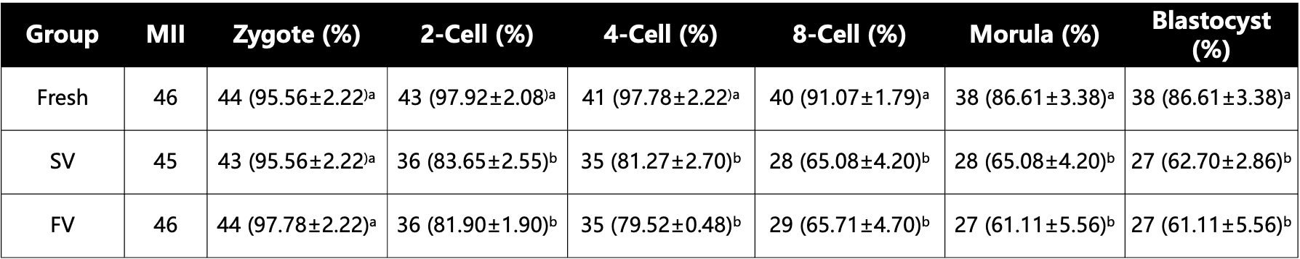
Table 1. Comparison of fertilization and embryonic development following oocytes vitrified by SV and FV procedures.

Fertilization rate = (No. of zygotes / No. of MII oocytes) × 100%;
2-Cell rate = (No. of 2-cell embryos / No. of zygotes) × 100%;
4-Cell rate = (No. of 4-cell embryos / No. of zygotes) × 100%;
8-Cell rate = (No. of 8-cell embryos / No. of zygotes) × 100%;
Morula rate = (No. of morulae / No. of zygotes) × 100%;
Blastocyst rate = (No. of blastocysts / No. of zygotes) × 100%.
Data are presented as Mean ± SEM (N = 3).
a,b within a column, values with different superscript letters are significantly different (P < 0.05).

