Optimization of the 5’ untranslated region and codon of the mRNA vaccines
Qiuji Wang^{1, 2}, Xiaorong Peng^{1, 2}, Yaqian Zeng², Xindeng Guo^{2,*}, Weineng Meng^{2,*}, Ning Deng^{1,*}
¹College of Life Science and Technology, Jinan University, Guangzhou, 510632, China.
²VectorBuilder China, Guangzhou, 510663, China
*Corresponding author: Xindeng Guo, jefferyguo@vectorbuilder.net; Weineng Meng, danielmeng@vectorbuilder.net; Ning Deng, tdengn@jnu.edu.cn.
SUPPLEMENTAL MATERIALS
Supplemental Table S1. The Sequences of Open Reading Frame Region in this study. In this study, the open reading frame (ORF) regions of mRNA encode firefly luciferase and the hemagglutinin (HA)-tagged fusion protein (F protein) of respiratory syncytial virus (RSV), respectively, with some sequences undergoing codon optimization. The luciferase ORF was used in the codon optimization and 5' untranslated region (5'UTR) screening experiments described in the main text; whereas the RSV F protein ORF was applied in the optimization study of the respiratory syncytial virus mRNA vaccine. The detailed data can be found in the Excel file.
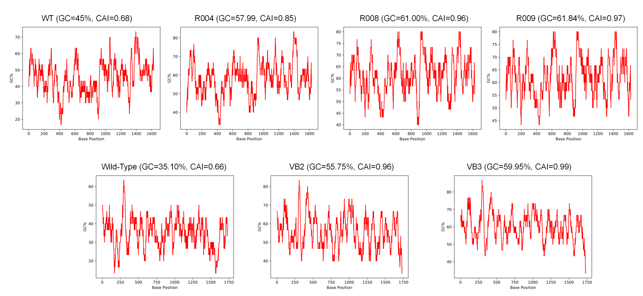
Supplemental Figure S1. Codon optimization improves GC content and CAI (Codon Adaptation Index). WT, R004, R008, and R009 encode luciferase. While Wild-type, VB2, and VB3 encode RSV-F protein.

Supplemental Table S2. Quality Control Test Results of LNP-mRNA. All LNP-mRNA formulations used for this study were independently prepared. Systematic quality inspections were conducted on all samples to ensure they met experimental standards.
Table S2. Quality control test results of LNP-mRNA.
Name | Particle size  (nm) | PDI | Zeta potential  (mV) | Encapsulation  Efficiency (%) | Endotoxins  (EU/mL)
WT, luciferase | 78 | 0.01737 | -9.165 | 96.9 | 2
R004 | 67 | 0.04020 | -6.939 | 97.0 | 2
R008 | 71 | 0.03731 | -8.302 | 96.9 | 2
R009 | 68 | 0.03774 | -5.795 | 96.9 | 2
5.0 | 69 | 0.02989 | -4.174 | 97 | 2
5.2 | 74 | 0.09556 | -10.23 | 97 | 2
5.7 | 67 | 0.0227 | -6.858 | 97 | 2
5.10 | 71 | 0.01501 | -6.159 | 97 | 2
7.0 | 68 | 0.1006 | -11.3 | 96 | 2
7.2 | 64 | 0.02869 | -10.94 | 96 | 2
7.7 | 68 | 0.04182 | -2.778 | 96 | 2
7.10 | 69 | 0.01256 | -5.786 | 97 | 2

Supplemental Figure S2. LC-MS Assays to Quantify the Capping Efficiency of mRNA. We employed an LC-MS-based method to quantify the capping efficiency of various mRNA samples. The results showed differences in capping rates: sample 5.0 showed 0% capping efficiency; 5.2 showed 91.5%; 5.7 showed 84.82%; 5.10 showed 98.55%. Samples from the 7-series showed superior capping efficiency: 7.0 at 99.86%, 7.2 at 99.63%, 7.7 at 99.90%, and 7.10 at 99.27%.
Figure S2. LC-MS Assays to Quantify the Capping Efficiency of mRNA.

Supplemental Figure S3. Denaturing gel electrophoresis for assessing mRNA integrity. All IVT RNA samples were analyzed using denaturing gel electrophoresis to assess their integrity.Specifically, the samples were loaded onto a 1% denaturing agarose gel pre-stained with GelRed. Electrophoresis was performed at a constant voltage. After electrophoresis, allgels were imaged using a Tanon MINI Space 2000 imager.

Figure S3. Denaturing gel electrophoresis for assessing mRNA integrity.

Supplemental Figure S4. Uncropped raw images of Western Blot for HA-tagged protein.
Figure S4. Uncropped raw images of Western Blot for HA-tagged protein.

