Supporting Information
In Vivo Chemotaxis System with Ultra-High Ionic Tolerance
Xue Xia¹†, Hangkai Qi²† (contribute equally), Jiaqi Hu², Jiabo Zhang¹, Liangcheng Gu¹, Jiangxing Chen^{2*}, Mimi Wan^{1*}
¹ Department of Vascular Surgery, Cardiovascular Medical Center, Nanjing Drum Tower Hospital, School of Chemistry and Materials Science, Nanjing Normal University, Nanjing, 210023, China.
² Department of Physics, Hangzhou Normal University, Hangzhou, 311121, China.
*Corresponding author Email: Jiangxing Chen: jxchen@hznu.edu.cn; Mimi Wan: wanmimi@njnu.edu.cn.
Experimental Method
Determination of $D_{eff}$. The effective diffusion coefficient is a physical parameter used to characterize the motility of particles or objects. In 2010, the Muddana group (1) observed that urease exhibits enhanced diffusion in substrate solutions. Subsequently, researchers designated enzyme molecules that display enhanced diffusion in substrate solutions as enzyme molecular motors, and elucidated the underlying mechanism of this phenomenon as the “enhanced diffusion mechanism”. Among these, the diffusion coefficient D can be employed to quantify the enhancement in the self-propelled behavior of enzyme molecular motors. The diffusion coefficient D of passively diffusing particles is calculated using the Stokes–Einstein equation:
$$\begin{aligned}D=\frac{K_{B}T}{6πηr}\#（1.1）\end{aligned}$$
In equation (1.1), K_{B} denotes the Boltzmann constant, T represents the thermodynamic temperature, ŋ stands for the fluid viscosity; and r is the hydrated radius of the particle. A strong correlation exists between the diffusion coefficient and the substrate concentration. A higher diffusion coefficient corresponds to a higher substrate concentration, which in turn gives rise to a greater extent of diffusion for the enzyme molecules. This enhancement in diffusion leads to the migration of the “center of mass” of enzyme molecules toward regions with a higher substrate concentration. Subsequently, this theory was not only confined to explaining phenomena associated with enzyme molecules but also extensively applied to interpreting the chemotactic behavior of non-enzymatic synthetic systems (2). In the study by Howse et al. (3), the
velocity and diffusion coefficient D of nanomotors were acquired by tracking multiple particles and calculating the mean squared displacement (MSD). They were able to distinctly observe the motion of the microparticles, which conforms to equation (1.2):
$$\begin{aligned}{〈ΔL〉}^{2}=4DΔt+\frac{v^{2}τ_{R}^{2}}{2}\left[\frac{2Δt}{τ_{R}}+e^{-\frac{2Δt}{τ_{R}}}-1\right]\#（1.2）\end{aligned}$$
Here, D denotes the diffusion coefficient, t represents time, $v$ is the velocity, and $τ_{R}$stands for the inverse rotational diffusion coefficient. In the short-time regime ($Δt≪τ_{R}$), studies have demonstrated that microparticles exhibit directed motion along a ballistic trajectory in a single direction, which conforms to a modified form of equation (1.2):
$$\begin{aligned}{〈ΔL〉}^{2}=4DΔt+v^{2}{Δt}^{2}\#（1.3）\end{aligned}$$
In the long-time regime ($Δt≫τ_{R}$), the motion of particles transitions from ballistic to diffusive, with a concomitant increase in the diffusion coefficient. At this time scale, the motion is better described by another modified form of equation (1.2):
$$\begin{aligned}{〈ΔL〉}^{2}=\left(4D+v^{2}τ_{R}\right)Δt-\frac{v^{2}τ^{2}}{2}\#（1.4）\end{aligned}$$
Only through such calculations can the nature of the motion of microparticles (whether it corresponds to ballistic motion or diffusive motion at the nanoscale) be determined. The term (​$4D+v^{2}τ_{R}$) in Equation (1.4) is defined as 4$D_{eff}$​, from which the explicit expression for the effective diffusion coefficient $D_{eff}$​ is derived as follows:
$$\begin{aligned}D_{eff}=D+\frac{v^{2}τ_{R}}{4}\#（1.5）\end{aligned}$$
$D_{eff}$enables a more straightforward comparison of the diffusion coefficients among various microparticles. Inspired by this, we hypothesize that the motion mechanism of the as-designed PMA nanomotors is analogous to the “enhanced diffusion mechanism”, which was verified by calculating and analyzing $D_{eff}$​. Studies have demonstrated that multiple approaches are available for measuring the diffusion coefficient of microparticles (3, 4). In this study, a fluorescence microscope was employed to record the motion trajectories of fluorescently labeled particles, and the $D_{eff}$of the nanoparticles was subsequently determined via first-order linear fitting.
Simulation model and methods
Detailed information regarding the particle‑based hybrid Molecular Dynamics‑Multi‑Particle Collision (MD‑MPC) simulations employed in this study is provided below: The active colloid was modeled as a spherical particle with an effective radius $R_{e}$=6.0. It was constructed as an assembled structure composed of $N_{surf}$=100 surface coarse‑grained beads and $N_{surf}$=100 internal particles. The surface beads were uniformly distributed on a three‑dimensional spherical surface with radius $R$=4.0, while the internal particles were positioned inside the sphere, as illustrated in Figure S33. Each surface bead has a radius $δ$=2.0 and a mass of $m_{surf}$=45.0, whereas each internal particle was modeled as a point with a mass of $m_{in}$=45.5. The surface beads represent the M‑Arg (substrate cluster) functionalization sites on the PMA nanomotor surface, serving as enzyme‑substrate catalytic interaction interfaces with iNOS. All beads and internal particles were interconnected via stiff harmonic bonds with a bond constant $K_{bond}$=300 ensuring structural integrity of the spherical assembly throughout the simulation. Meanwhile, the colloid as a whole was allowed to undergo stable translational and rotational motion. The colloid was placed in a three‑dimensional rectangular simulation box with dimensions $L_{x}$=45 and $L_{y}$=$L_{z}$=30. Periodic boundary conditions are applied along the y and z directions, while non‑periodic boundary conditions are adopted along the x direction.
All fluid particles in the simulation system are modeled as point particles with a mass of $m$=1.0 (Figure S34). The initial simulation system comprises five distinct particle species: iNOS, NADPH, solvent (S), positively charged ions (I_{p}⁺), and negatively charged ions (I_{n}⁻). The charge state of each species is defined as follows: iNOS and solvent (S) are electrically neutral, NADPH carries a charge of −4, I_{p}⁺ carries a charge of +4 and I_{n}⁻ carries a charge of −4. Here, I_{p}⁺ and I_{n}⁻ represent coarse-grained ionic species, which correspond to all other positively and negatively charged ions present in the solution (e.g., H⁺), respectively.
To mimic the experimental detail in which an agarose gel containing MCF-7 lysate is positioned on the right side of the channel, gradients of catalytically relevant enzyme species were imposed along the non-periodic x direction. In particular, both iNOS and NADPH were assumed to diffuse from the gel source, resulting in spatially varying concentrations across the channel. Accordingly, in the simulation, NADPH was initialized with a linear concentration gradient, $∇_{x}ρ$_{NADPH}=0.0444, along the x direction, increasing from $ρ$_{NADPH,1}=0 to $ρ$_{NADPH,r}=2 (per unit volume) from left to right. To compensate for this effect and ensure a uniform negative charge background, an oppositely directed gradient of negatively charged ions I_{n}⁻ with $∇_{x} ρ$_{In}⁻=−0.0444 was introduced, decreasing from $ρ$_{In}⁻_{,1}=2 to $ρ$_{In}⁻_{,r}=0 along the same direction. This counter-gradient guarantees that the total negative charge density remains spatially homogeneous throughout the simulation system. To further maintain global electroneutrality, positively charged ions I_{p}⁺ were distributed uniformly across the system at a constant number density of $ρ$_{Ip}⁺=2 (per unit volume). No concentration gradient was applied to the I_{p}⁺ species. In addition to NADPH, iNOS was also initialized with a linear concentration gradient, $∇_{x}ρ$_{iNOS}=$ρ$_{iNOS} /L_{x}, along the x direction, increasing from $ρ$_{iNOS,l}=0 to $ρ$_{iNOS,r}=$ρ$_{iNOS}, which represents their release from the agarose gel source. To preserve a uniform total particle density and avoid spurious density-driven flow, S was assigned a compensating counter-gradient, $∇_{x}ρ$_{S}=-$ρ$_{iNOS} /L_{x}, decreasing from $ρ$_{S,1}=6 to $ρ$_{S,r}=6−$ρ$_{iNOS}. As a result, the total particle number density was maintained at a constant value of $ρ$=10 per volume at all spatial locations, while both charge density and mass density remained homogeneous across the system. In the simulations, $ρ$_{iNOS} =0.1, 0.5, 1.0, 1.5 was employed to investigate the chemotactic behavior of the nanomotors under different iNOS gradient fields. Figure S34 schematically depicts the concentration gradients of all particle species described above, together with the complete simulation setup.
Experimentally, L-Arg molecules immobilized on the colloid surface are catalyzed by iNOS, consuming the cofactor NADPH and producing L-citrulline while converting NADPH into NADP⁺. To capture the essential features of this enzymatic process within a coarse-grained framework, a reaction event is triggered in the simulation when an iNOS particle enters a predefined reaction distance d from a surface bead on the colloid. If NADPH particles are simultaneously present within the same reaction neighborhood, a catalytic reaction is allowed to proceed. Once the reaction occurs, one NADPH particle is randomly selected from those within the neighborhood and converted to the product NADP⁺, thereby implementing the reaction step NADPH→NADP⁺. To maintain the system in a nonequilibrium state, analogous to many biological systems, a boundary-driven conversion protocol was employed to continuously remove reaction products and replenishes reactants while preserving the prescribed concentration gradients. Specifically, to mimic product clearance and cofactor recycling, the NADP+ particle that diffuses beyond a cutoff distance h from the colloid is converted back to NADPH, providing an effective negative feedback mechanism that prevents product accumulation near the catalytic surface and sustains cofactor availability, as shown in Figure S35a.
Second, to maintain stable macroscopic gradients along the non-periodic x-direction, particle exchange at the boundaries was enforced using local conversion rules within boundary regions of thickness ∆x adjacent to the left and right boundaries. These paired conversions conserve the total particle number and preserve local density. For species with a left-to-right increasing gradient, e.g., iNOS and NADPH, whenever an iNOS (or NADPH) particle enters the left boundary region (0≤x≤∆x), it is converted into a solvent particle S. Simultaneously, one solvent particle S randomly selected from the right boundary region (L_{x}−∆x≤x≤L_{x}) is converted into iNOS (or NADPH), respectively. Conversely, for I_{n}⁻, which follows a right-to-left gradient opposite to that of NADPH, the boundary rule was applied in the reverse direction: when an In- particle enters the right boundary region (L_{x} −∆x≤x≤L_{x}) is converted into S, and concurrently one S particle randomly selected from the left boundary region (0≤x≤∆x) is converted into In⁻. A schematic summary of all conversion and feedback rules described above is provided in Figure S35b.
The translational and rotational motion of the colloid was explicitly resolved using MD simulations. Interactions between the colloid and fluid particles were modeled using effective pair potentials, determined by the charge state of the fluid particles. The colloid was assigned an effective net negative charge, consistent with experimental measurements showing a negative zeta potential for the PMA nanomotors (Figure S3c). For neutral fluid particles, the interaction with the colloid was described by a repulsive Weeks-Chandler-Andersen (WCA) potential:
$$\begin{aligned}U_{WCA\left(r\right)}=\left\{\begin{aligned}4_{εα}\left[{\left(\frac{σ}{r}\right)}^{12}-{\left(\frac{σ}{r}\right)}^{6}+\frac{1}{4}\right], r≤2^{1/6}σ,\#\#\# \\ 0, r≤2^{1/6}σ.\end{aligned}\right.\#\left(2.1\right)\end{aligned}$$
where $α$=$\left\{iNOS，S\right\}$. We set $ε_{α}$=0.1 in the simulations. Besides, for charged species, a Lennard-Jones (LJ) potential combined with a Yukawa (screened Coulomb) potential was adopted to describe the electrostatic interactions under ionic screening conditions in solution, which can be expressed as:
$$\begin{aligned}U_{LJ+Yukawa\left(r\right)}=\left\{\begin{aligned}4_{εβ}\left[{\left(\frac{σ}{r}\right)}^{12}-{\left(\frac{σ}{r}\right)}^{6}\right]+A_{β}\frac{e^{-κr}}{r}, r≤r_{c},\#\#\# \\ 0, r≤r_{c}.\end{aligned}\right.\#\left(2.2\right)\end{aligned}$$
where $β$=$\left\{NADPH，{NADP}^{+}，I_{n}^{-}，I_{p}^{+}\right\}$. For all charged species, the Lennard-Jones (LJ) energy parameter is uniformly fixed at $ε_{β}$=0.05. The cutoff distance is set to $r_{c}$=5.0 to ensure that the reaction does not introduce any discontinuity into the colloid–fluid interaction potential or forces. Meanwhile, the conversion of NADPH to NADP⁺ was represented by a reduction in the effective charge from −4 to −3. Correspondingly, the interaction parameter A_{β}​ of the Yukawa potential is adjusted accordingly to reflect the change in electrostatic coupling strength before and after the reaction. For NADPH and I_{n}⁻, the interaction parameter is set as A_{β}​=4.0; for NADP⁺, the interaction parameter is set as A_{β}​​=2.0. In contrast, for the positively charged ions I_{p}⁺, the attractive electrostatic interaction between these ions and the negatively charged colloid is modeled by specifying a negative interaction parameter A_{β}​​​=−4.0.
To compare the chemotactic behavior of symmetric and asymmetric micromotors, we constructed asymmetric‑type colloidal sphere model under identical simulation environments and reaction rules. The asymmetric micromotor possesses the same geometric dimensions, mass distribution, interaction parameters, reaction criteria, and boundary‑driven mechanisms as the symmetric micromotor. The only difference lies in the spatial distribution of surface catalytic active sites: surface beads located within one hemispherical region (defined as the side toward which the normal vector n points) are designated as catalytically active sites and can participate in the iNOS‑NADPH catalytic reaction process, whereas the surface beads in the opposite hemisphere region are set as inert and do not participate in any catalytic reactions. This construction ensures that the difference in chemotactic behavior arises solely from the spatially asymmetric distribution of catalytic activity.
Meanwhile, the surrounding fluid particles are evolved using the MPC dynamics method, which is coupled with the MD motion of the colloid. This method advances the time evolution of the system by alternating streaming steps and collision steps. In the streaming step, for each time step $∆t$, fluid particles that are not interacting with the colloid update their positions according to classical Newtonian motion:
$$\begin{aligned}r_{i}\left(t+∆t\right)=r_{i}\left(t\right)+v_{i}\left(t\right)∆t\#(3.1)\end{aligned}$$
For fluid particles within the interaction potential range of the colloid, their motion is updated using the Velocity-verlet algorithm based on the forces. In the collision step, fluid particles are splited into cubic collision cells with a side length a=1.0 according to their instantaneous positions. Within each collision cell, the velocities of all fluid particles are updated collectively around the center-of-mass velocity of the cell. Specifically, the center-of-mass velocity of the cell $Γ$ is first calculated as:
$$\begin{aligned}{\vec{v}}_{cm}^{Γ}=\frac{\sum_{i=1}^{N^{Γ}}{\overset{→}{ν_{i}^{Γ}}}}{N^{Γ}}\#\left(3.2\right)\end{aligned}$$
Where $N^{Γ}$ is the instantaneous number of fluid particle in the cell $Γ$. Then relative velocity between each fluid particle i and the center-of-mass velocity is calculated as:
$$\begin{aligned}{\vec{V}}_{i}^{Γ}={\vec{v}}_{i}^{Γ}-{\vec{v}}_{cm}^{Γ}\#\left(3.3\right)\end{aligned}$$

Subsequently, a unit vector $\vec{R}$ is randomly selected, and the relative velocity $\vec{v_{i}}$ is rotated counterclockwise by an angle $φ$. The rotated velocity of each fluid particle i is then expressed as:
$$\begin{aligned}{\vec{V}}_{i}^{Γ}\left(t+∆t\right)={\vec{v}}_{cm}^{Γ}+{\hat{ω}}^{Γ}{\vec{v}}_{i}^{Γ}\#\left(3.4\right)\end{aligned}$$
Where ${\hat{ω}}^{Γ}$ denotes the rotation operator associated with cell $Γ$. This rule ensures the conservation of both energy and momentum. To guarantee Galilean invariance, the collision cell grid is randomly shifted by a value within the range [−a/2, a/2] before each collision step. During the time evolution of the coupled MD-MPC dynamics, one MPC collision is performed after every N step of MD integration steps. Within each MD step, the interaction forces between the colloid and fluid particles are fully evaluated, and the positions and velocities of both the colloid and fluid particles are updated accordingly. A catalytic reaction and energy injection are performed if the reaction criteria are satisfied. This hybrid MD-MPC scheme explicitly incorporates a large number of fluid particles and ensures the local conservation of mass, energy, and momentum. It is therefore suitable for describing complex fluids, enabling the accurate description of hydrodynamic behaviors, heat conduction, mass transport, thermal fluctuations, and catalytic reactions in our system. It provides an efficient description for capturing mesoscale hydrodynamic behavior while preserving the fundamental conservation laws of fluids.
Reduced units are adopted in our simulations. The units in the simulation are based on the length of a collision cell a, the mass of fliud particle m and the energy $ε$. The reduced unit of time is $τ={\left(ma^{2}/ε\right)}^{1/2}$. Temperature was reported in reduced form as $k_{B}$T/$ε$. The system temperature was set to T=2/3. The total mass of the colloid was given by $M_{c}=N_{surf}m_{out}+N_{in}m_{in}$. Besides, the colloid mass was also chosen to satisfy the neutral buoyancy condition, such that the effective colloid mass equals the mass of the displaced fluid, $M_{c}=4/3π{\left(R+σ\right)}^{3}ρ$, where $ρ$=10 is the uniform total fluid number density. The dynamics of colloid was integrated using the Velocity-verlet algorithm with a time step $τ_{MD}$=0.01. For MPC dynamics, the collision interval was defined as N=15, indicating that collision steps were implemented at a fixed interval of $τ_{MPC}$=0.15. The rotation angle was fixed at $φ$=$π$/2, the reaction distance at d=2^{1/6}$σ$, and the critical distance for negative feedback at h=5.0. The solution viscosity was $η$=3.759, the Schmidt number Sc=4.822, and the Reynolds number Re=0.024, under which the simulation method exhibited liquid-like dynamic characteristics (5, 6). To generate a steady initial concentration gradient and equilibrated flow field, simulations were first performed with the chemical reactions switched off and the colloid position fixed at its initial position x=10 along the non-periodic direction. This equilibration was carried out for 1.0×10⁵ simulation steps. After this initialization, the positional constrain on the colloid was released, chemical reaction was activated, and the colloid was allowed to undergo chemotactic motion along the x direction. Each production run was continued for a total of 1.5×10⁶ simulations steps. All results were statistically averaged over 20 independent simulation trajectories for each system.
To simulate the exothermic effects of the catalytic reaction, a small kinetic energy increment $∆u$ is assigned to the product particle NADP⁺ upon each reaction event of NADPH→NADP⁺. The exothermic behavior of PMA nanoparticles in MCF-7 lysate (1 mg mL⁻¹) was quantitatively characterized using ITC, and an instantaneous heat flow peak of 1.1 μJ s⁻¹ was recorded experimentally (Figure 5a). On the basis of the pronounced enthalpy change (ΔH=−1.5 kJ (mg·10⁵ cells)⁻¹) derived from the thermodynamic parameter table (Table S2) and the physical parameters of the nanoparticles, the steady-state exothermic rate of a single particle was determined to be 2.8×10⁻¹⁴ J s⁻¹. In the numerical model, taking into account the system temperature (T=2/3) and the collision frequency (number of reaction events) between iNOS and the colloid ($R_{e}$=6.0) within a unit time $τ$, the unit time scale was estimated as $τ$≈10 $μs$. The dimensionless energy injection $Δ_{u}$≈0.3 (energy per collision) was adopted in the simulation, which was calibrated to reproduce the experimentally measured heat release rate.
The time and length scales in the simulations were obtained by calibration against the experimental system. For PMA nanomotors with a radius of approximately 100 nm in the experiments, corresponding to the effective size of the colloid $R_{e}$=6.0 in the simulations, the unit length a=16 nm was derived. The time scale was calibrated based on the experimentally measured reaction exothermic power. As described above, the simulation time unit was estimated to be $τ$≈10 $μs$. The chemotactic velocities of the simulated colloids were obtained by fitting x-t curves (Figure 5g–q) and the average velocity values are summarized in Figure 5n–p. In the experiments, a concentration gradient of iNOS was established within the channel by adding MCF-7 lysate into region (ii) of the straight single-channel model. Assuming a linear spatial distribution of iNOS along the channel according to its concentration and the channel length, the corresponding concentration gradient can be converted. Since both simulations and experiments exhibit an approximately linear dependence of chemotactic velocity on the iNOS gradient within the investigated range , correspondence between two systems was established via velocity matching (equivalent to gradient strength matching). A comparison of the results indicates that in the experiments, the iNOS concentration at the rightmost side was measured to be 6.93 μM at a cell lysate concentration of 10⁵, with a chemotactic velocity of 1.672 μm s⁻¹. This corresponds to the condition of $ρ_{iNOS}$​=0.5 in the simulations, for which dimensionally converted chemotactic velocity (using the unit length a and time unit $τ$) was 1.697 μm s⁻¹. The chemotactic velocities obtained from the simulations and experiments are in good agreement.
Figure S1-S45:
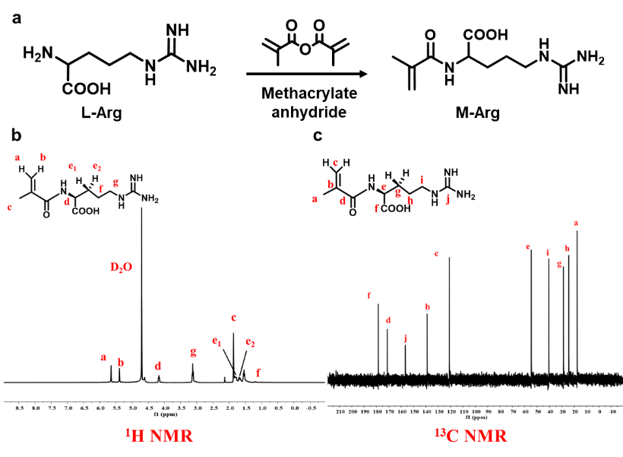
Figure S1. (a) Synthesis route of the M-Arg monomer. (b) ¹H NMR and (c) ¹³C NMR spectra of M-Arg in D₂O.
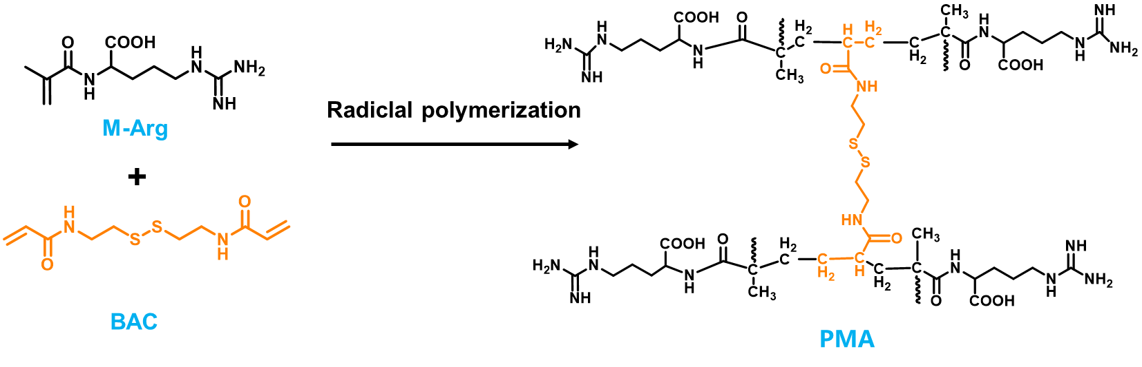
Figure S2. Schematic illustration of the synthesis of PMA nanomotors.
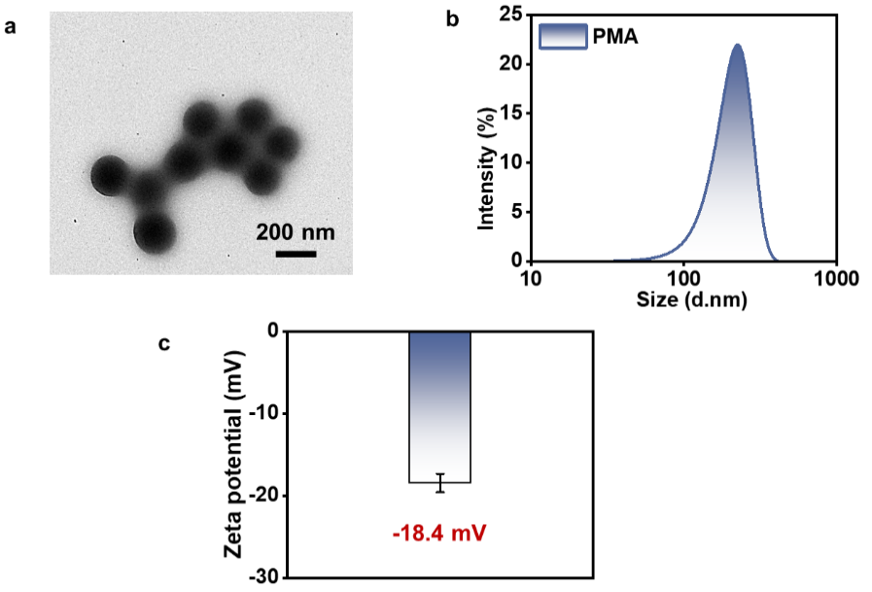
Figure S3. (a) TEM image (Scale bar: 200 nm), (b) hydrodynamic size distribution and (c) zeta potential of PMA nanomotors.

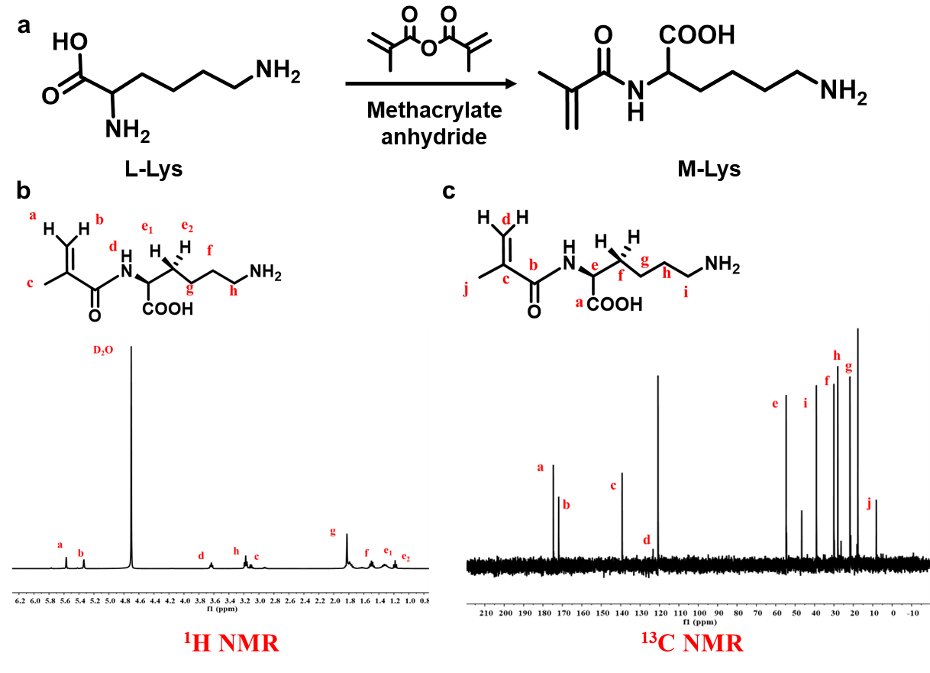
Figure S4. (a) Synthesis route of the M-Lys monomer. (b) ¹H NMR and (c) ¹³C NMR spectra of M-Lys in D₂O.
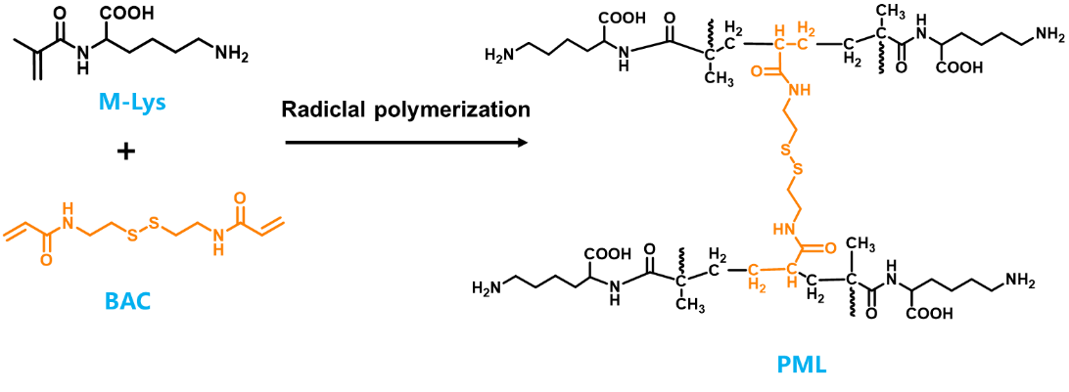
Figure S5. Schematic illustration of the synthesis of PML nanoparticles.
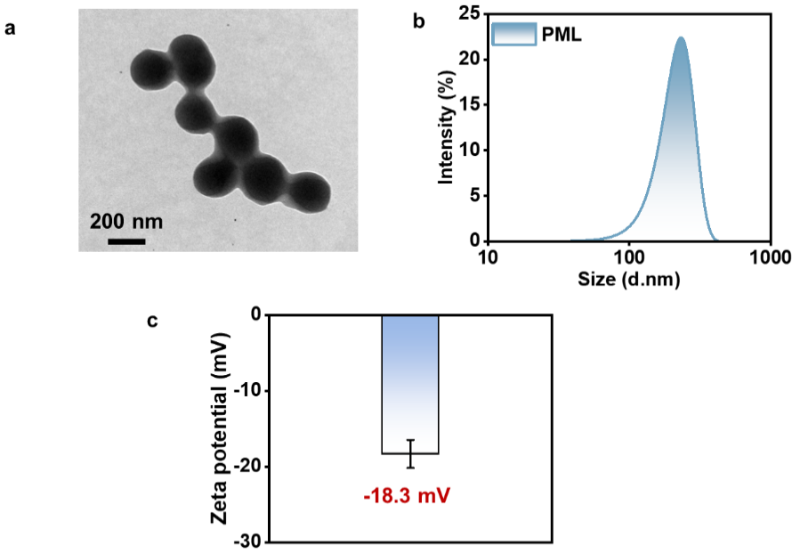
Figure S6. (a) TEM image (Scale bar: 200 nm), (b) hydrodynamic size distribution and (c) zeta potential of PML nanoparticles.
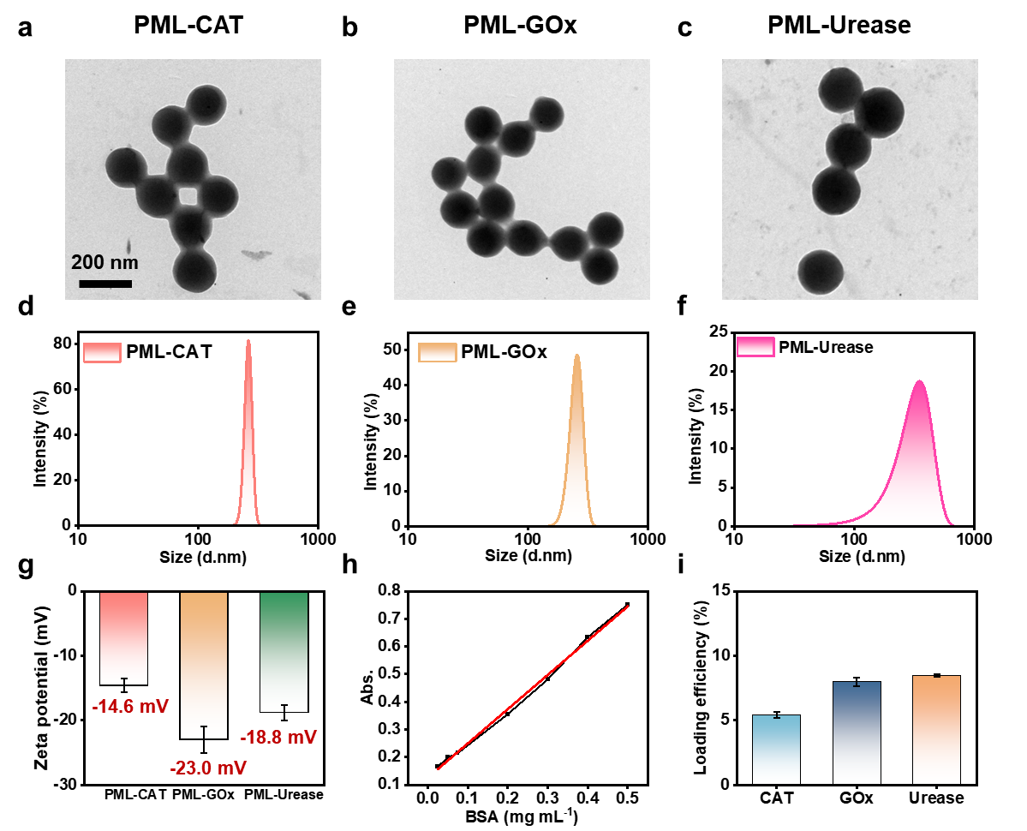
Figure S7. (a-c) TEM images (Scale bar: 200 nm), (d-f) hydrodynamic size distributions, (g) zeta potentials, (h) protein concentration standard curve and (i) enzyme loading efficiency of enzyme-loaded nanomotors (PML-CAT, PML-GOX, PML-urease).
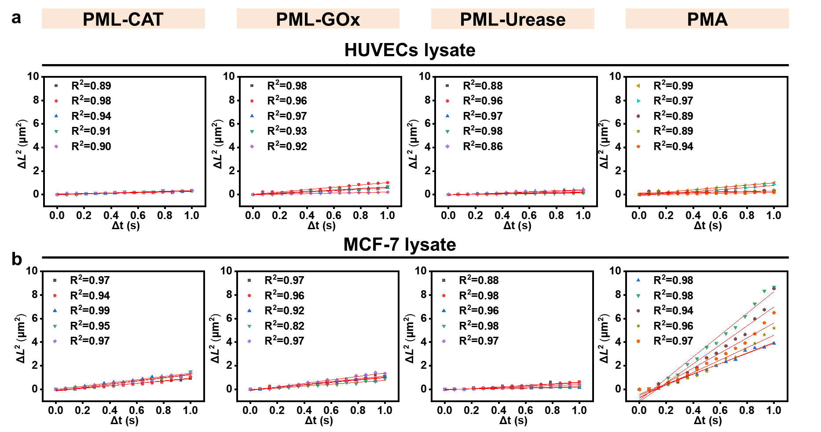
Figure S8. MSD fitting curves for enzyme-loaded nanomotors (PML-CAT, PML-GOX, PML-urease) and substrate-type nanomotors in (a) HUVECs lysate and (b) MCF-7 lysate (cell density: 10⁶ cells mL⁻¹).
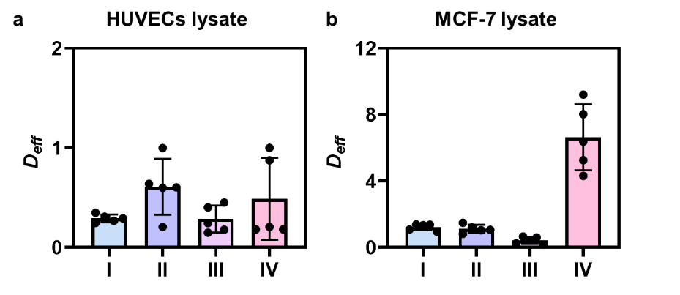
Figure S9. $D_{eff}$for enzyme-loaded nanomotors and substrate-type nanomotors in (a) HUVECs lysate and (b) MCF-7 lysate (cell density: 10⁶ cells mL⁻¹). (I: PML-CAT, II: PML-GOx, III: PML-urease, IV: PMA nanomotors).
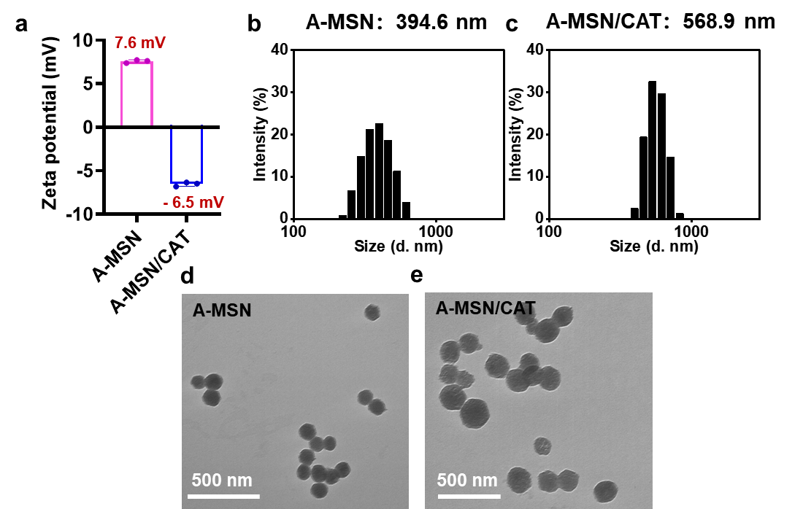
Figure S10. (a) Zeta potential, (b, c) hydrodynamic size distributions and (d, e) TEM images (Scale bar: 500 nm) of A-MSN and A-MSN/CAT.
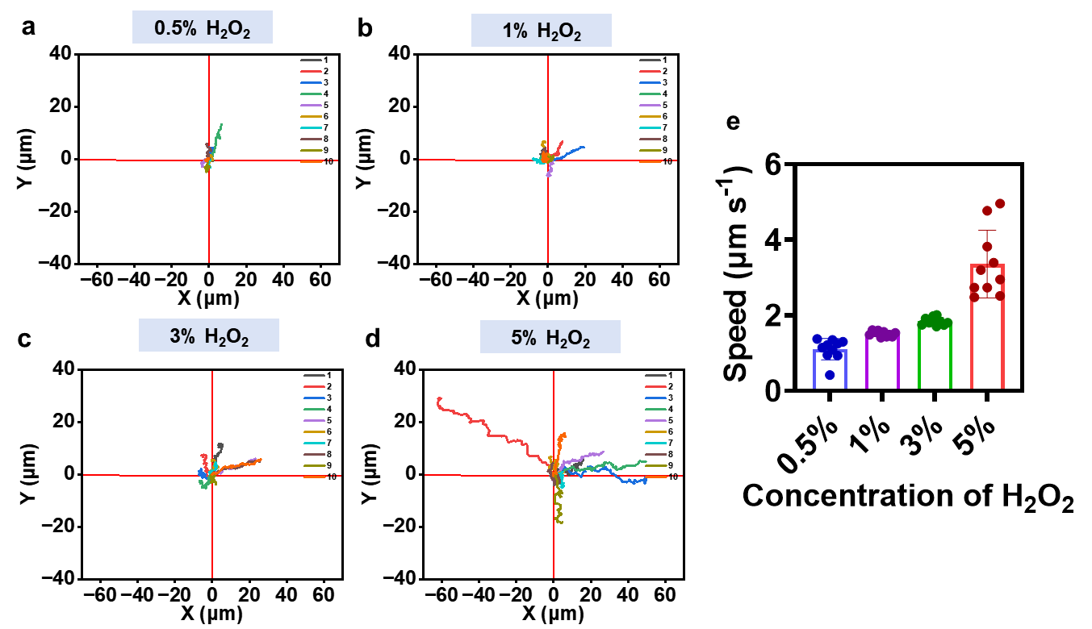
Figure S11. (a-d) Representative motion trajectories and (e) corresponding velocity histogram of A-MSN/CAT in H₂O₂ solutions with different concentrations.
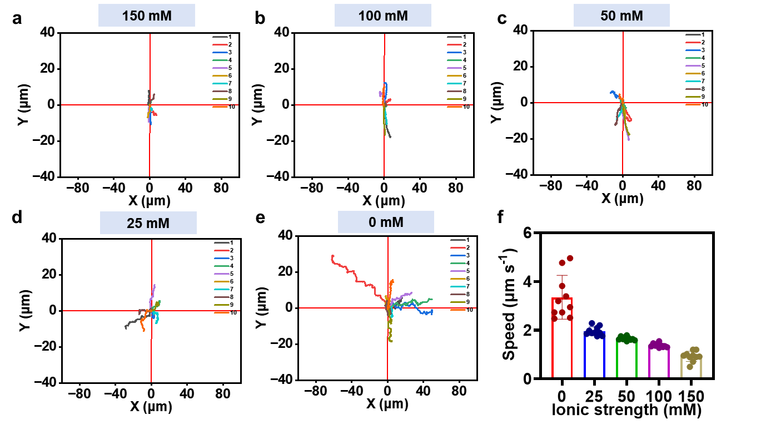
Figure S12. (a-e) Representative motion trajectories and (f) corresponding velocity histogram of A-MSN/CAT in H₂O₂ solutions with different ionic strengths.
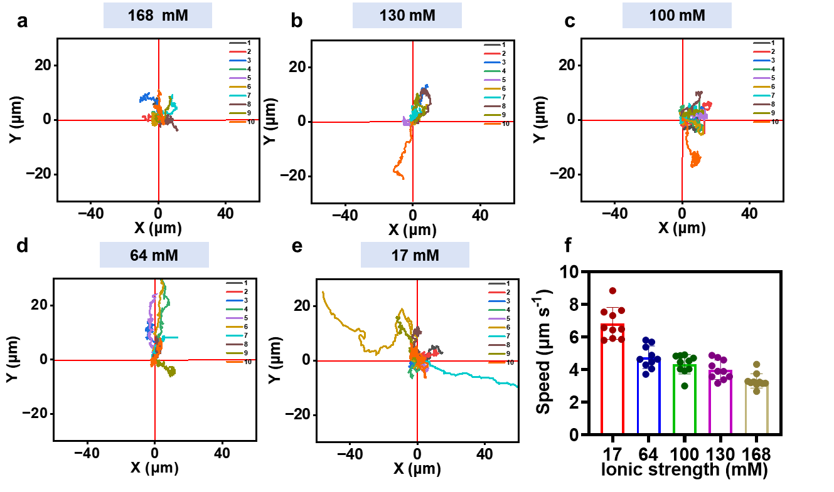
Figure S13. (a-e) Representative motion trajectories and (f) corresponding velocity histogram of PMA nanomotors in MCF-7 lysate with different ionic strengths (cell density: 10⁶ cells mL⁻¹).
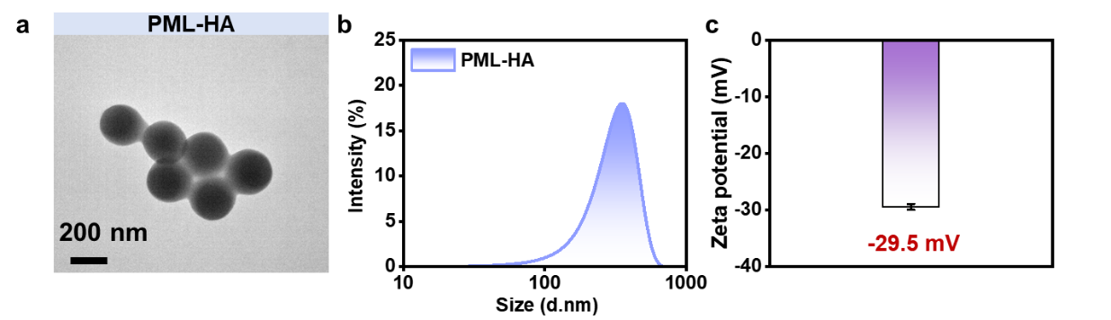
Figure S14. (a) TEM image (Scale bar: 200 nm), (b) hydrodynamic size distribution and (c) zeta potential of PML-HA nanoparticles.
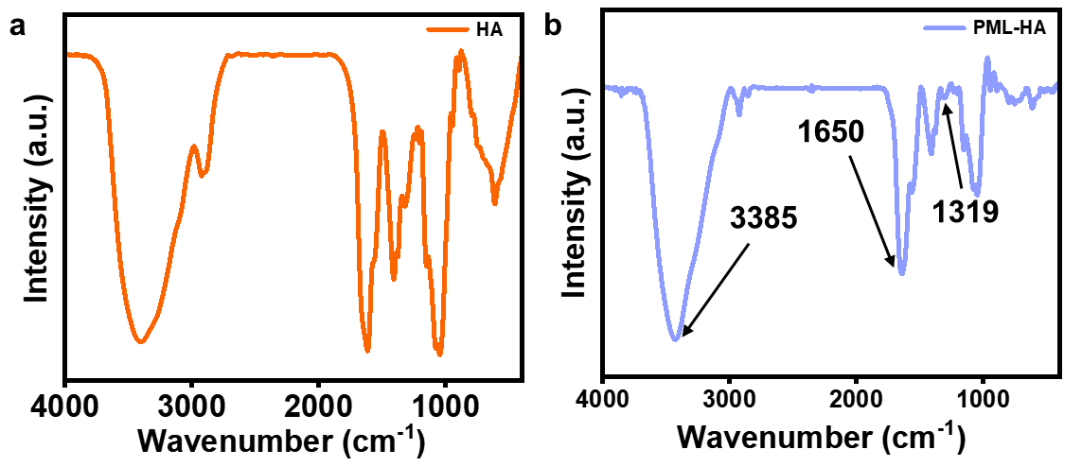
Figure S15. FT-IR spectra of (a) free HA and (b) PML-HA nanoparticles.
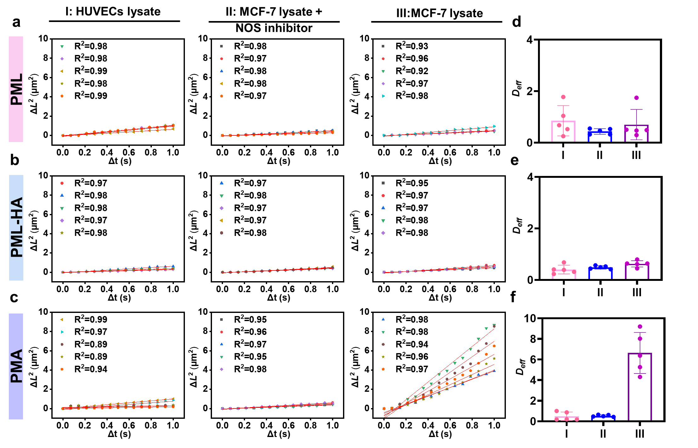
Figure S16. (a–c) MSD fitting results and (d–f) equivalent diffusion coefficient results of PML, PML-HA and PMA nanomotors in different conditions (n=5) (I: HUVECs lysate, II: MCF-7 lysate + NOS inhibitor, III: MCF-7 lysate, cell density: 10⁶ cells mL⁻¹).
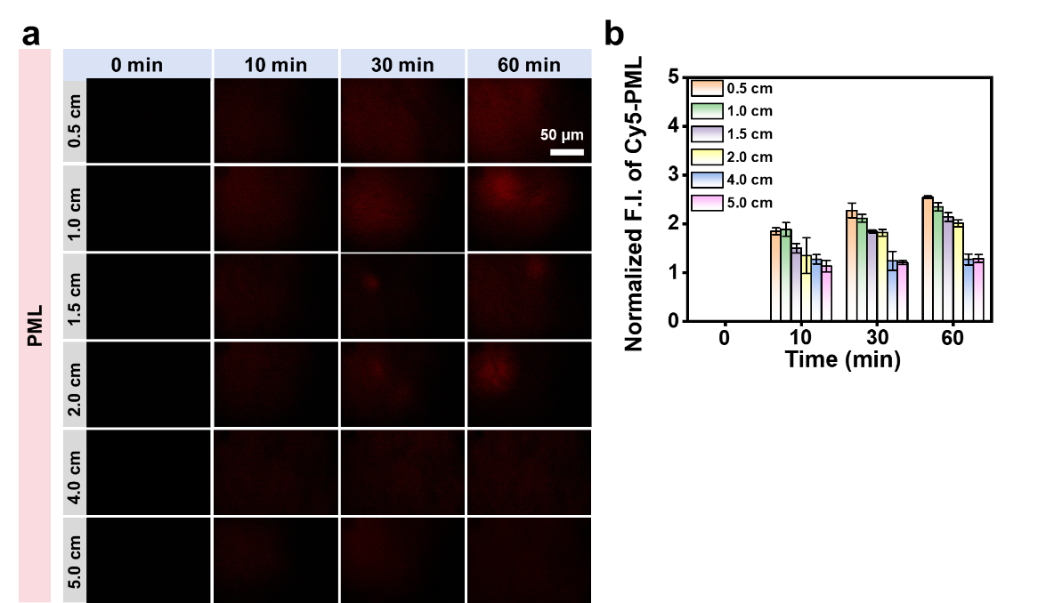
Figure S17. (a) Fluorescence images and (b) quantitative results of PML in single-channels with different lengths (Scale bar: 50 μm) (cell density: 10⁵ cells mL⁻¹).
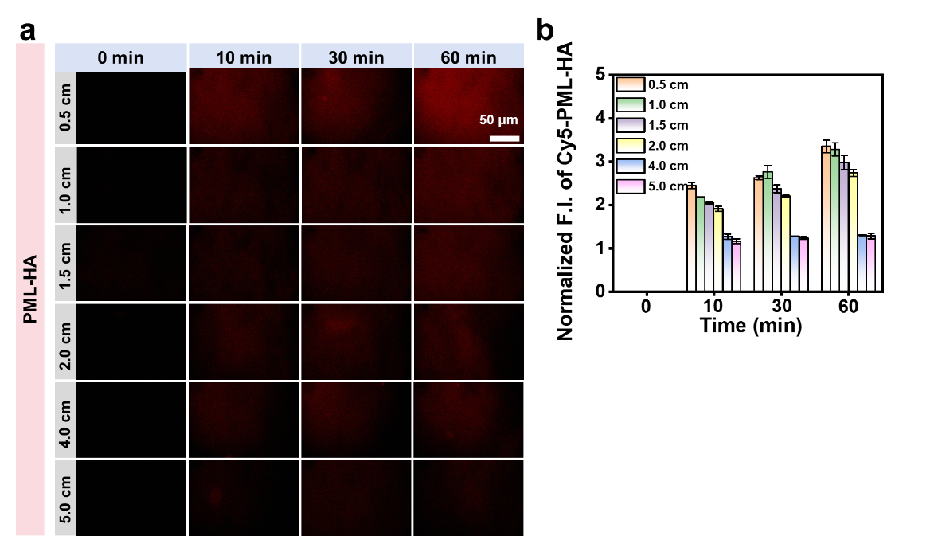
Figure S18. (a) Fluorescence images and (b) quantitative results of PML-HA in single-channels with different lengths (Scale bar: 50 μm) (cell density: 10⁵ cells mL⁻¹).
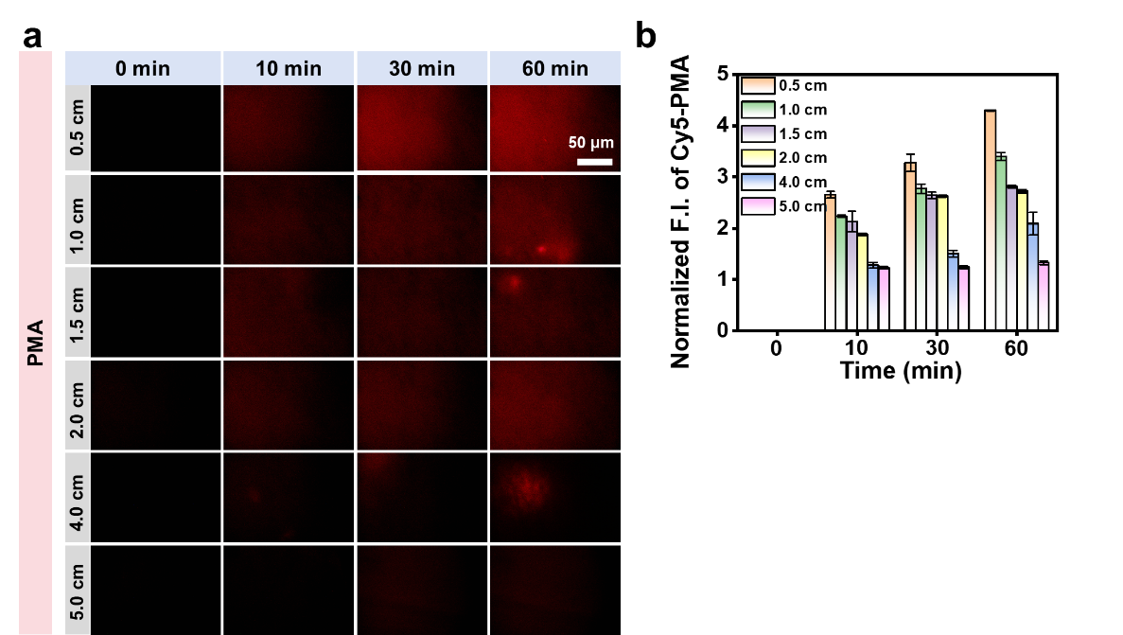
Figure S19. (a) Fluorescence images and (b) quantitative results of PMA nanomotors in single-channels with different lengths (Scale bar: 50 μm) (cell density: 10⁵ cells mL⁻¹).
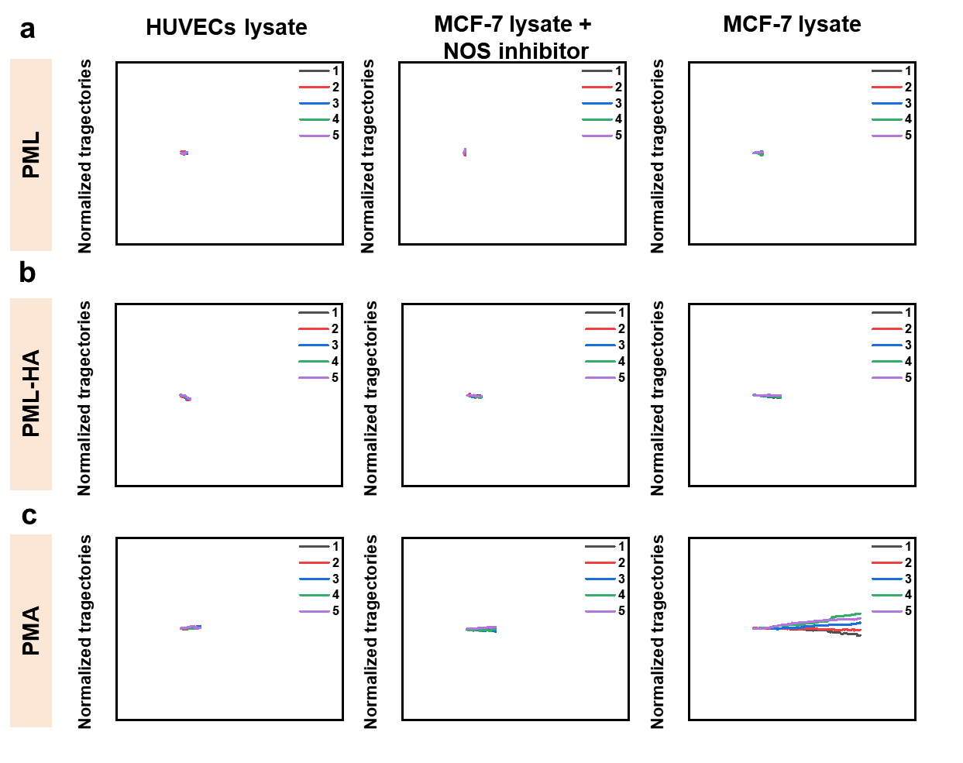
Figure S20. Normalized motion trajectories of (a) PML, (b) PML-HA and (c) PMA nanomotors in different lysate environments within the single-channel model (n=5) (cell density: 10⁵ cells mL⁻¹).
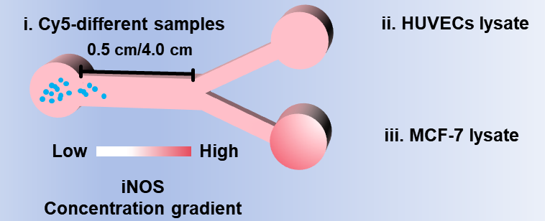
Figure S21. Schematic illustrations of Y-channel models with different main channel lengths (0.5/4.0 cm).
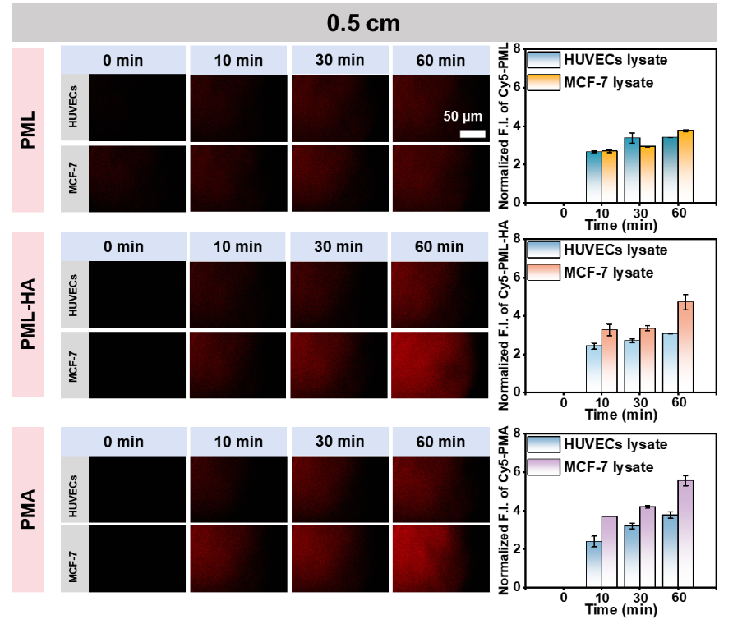
Figure S22. Chemotactic fluorescence images and corresponding fluorescence quantitation of PML, PML‑HA and PMA nanomotors in 0.5 cm‑long Y‑channel models under environments containing HUVECs lysate and MCF‑7 lysate (Scale bar: 50 μm, cell density: 10⁶ cells mL⁻¹).
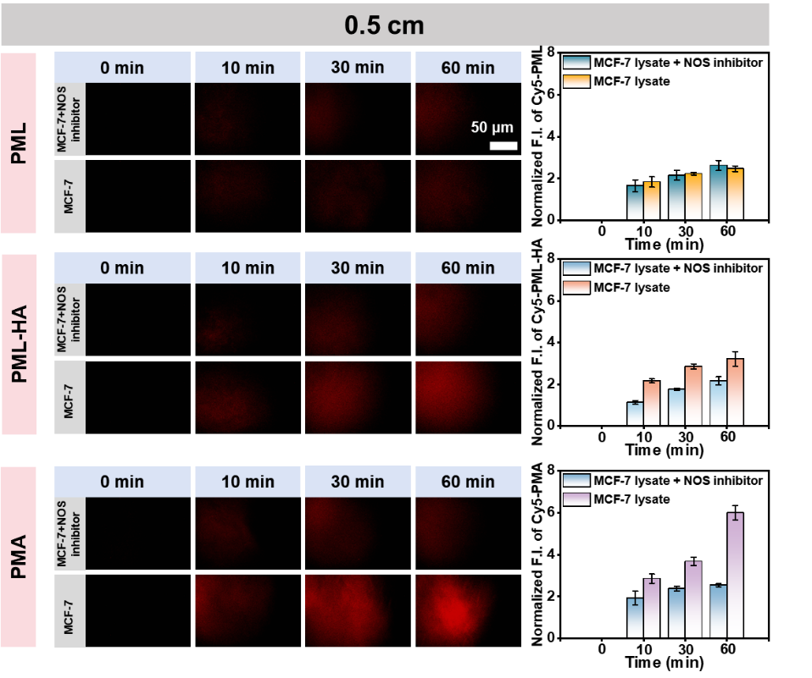
Figure S23. Chemotactic fluorescence images and corresponding fluorescence quantitation of PML, PML‑HA and PMA nanomotors in 0.5 cm‑long Y‑channel models under environments containing MCF‑7 lysate with NOS inhibitor and MCF‑7 lysate (Scale bar: 50 μm, cell density: 10⁶ cells mL⁻¹).
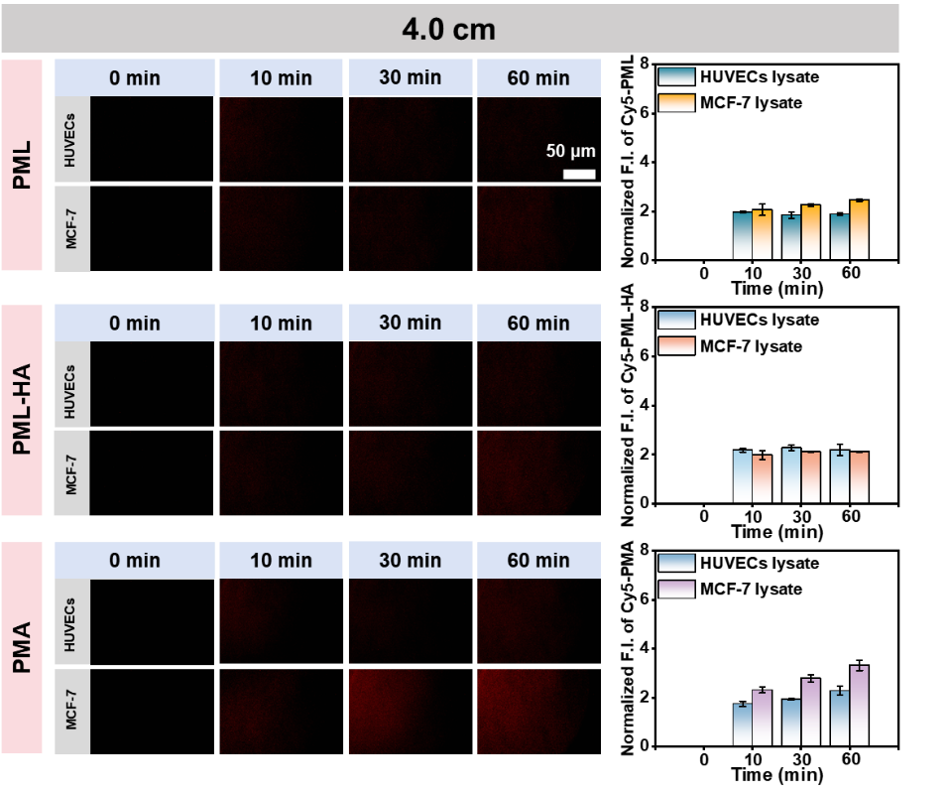
Figure S24. Chemotactic fluorescence images and corresponding fluorescence quantitation of PML, PML‑HA and PMA nanomotors in 4.0 cm‑long Y‑channel models under environments containing HUVECs lysate and MCF‑7 lysate (Scale bar: 50 μm, cell density: 10⁶ cells mL⁻¹).
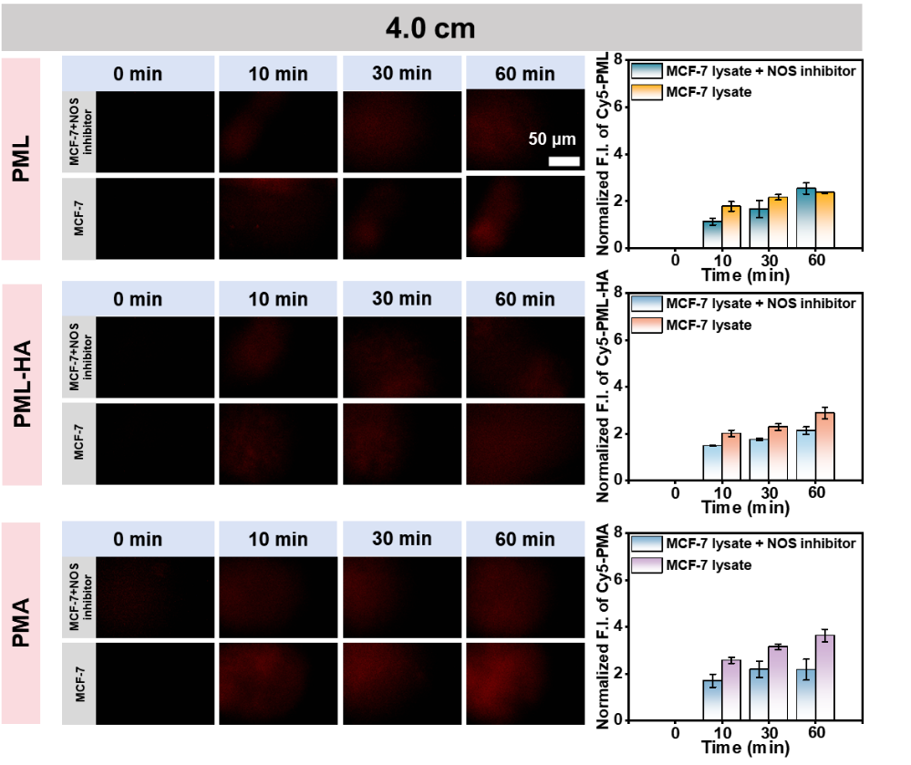
Figure S25. Chemotactic fluorescence images and corresponding fluorescence quantitation of PML, PML‑HA and PMA nanomotors in 4.0 cm‑long Y‑channel models under environments containing MCF‑7 lysate with NOS inhibitor and MCF‑7 lysate (Scale bar: 50 μm, cell density: 10⁶ cells mL⁻¹).
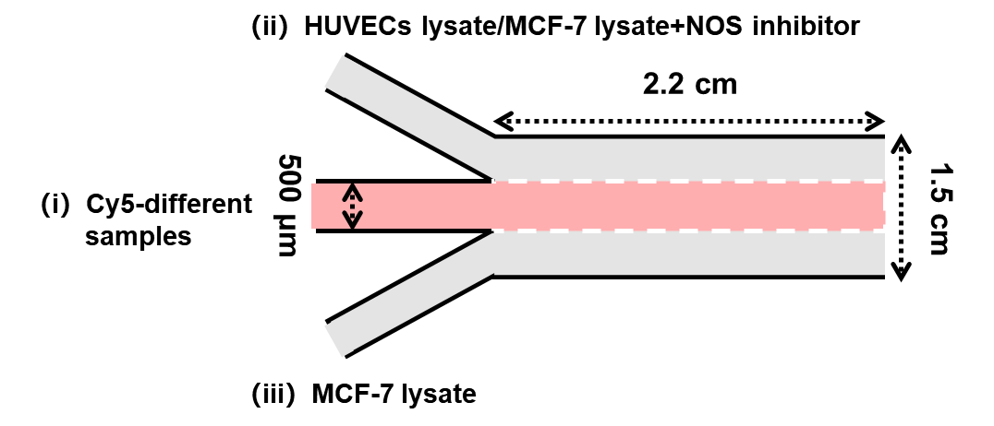
Figure S26. Schematic illustration of the Ψ-shaped microfluidic model.
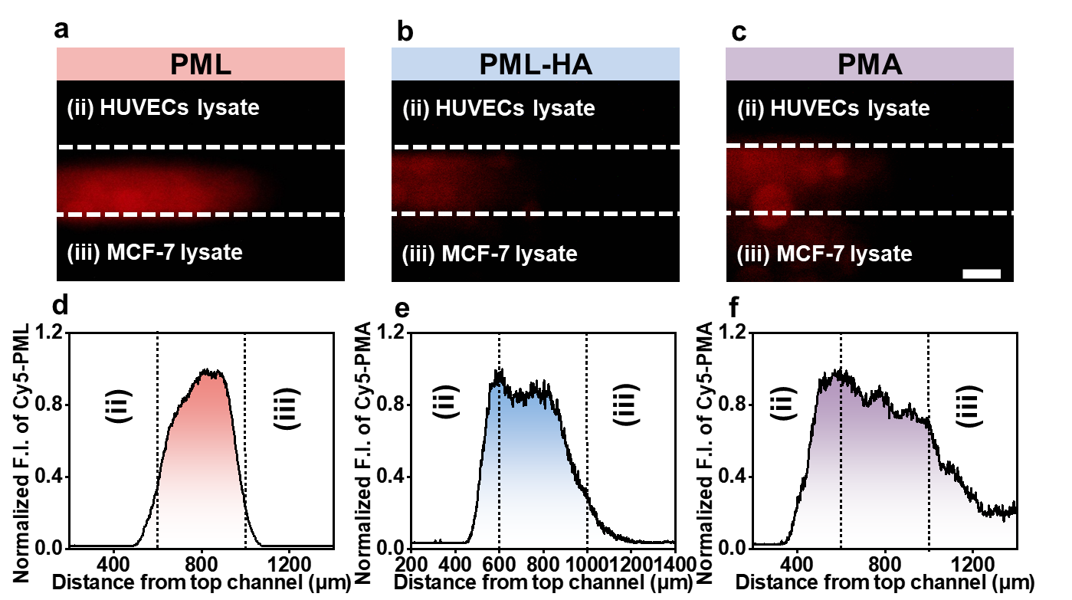
Figure S27. (a–c) Fluorescence images and (d–f) corresponding quantitative fluorescence results of PML, PML-HA, and PMA nanomotors in the microfluidic device (Scale bar: 500 μm, ii: HUVECs lysate, iii: MCF-7 lysate, cells density: 10⁶ cells mL⁻¹).
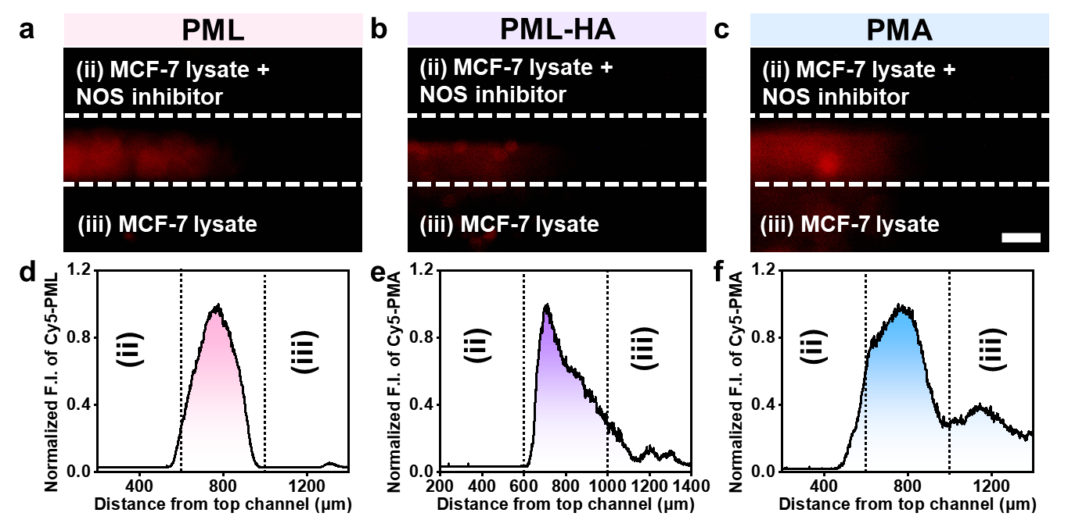
Figure S28. (a–c) Fluorescence images and (d–f) corresponding quantitative fluorescence results of PML, PML-HA, and PMA nanomotors in the microfluidic device (Scale bar: 500 μm, ii: MCF-7 lysate with NOS inhibitor, iii: MCF-7 lysate cell density: 10⁶ cells mL⁻¹).
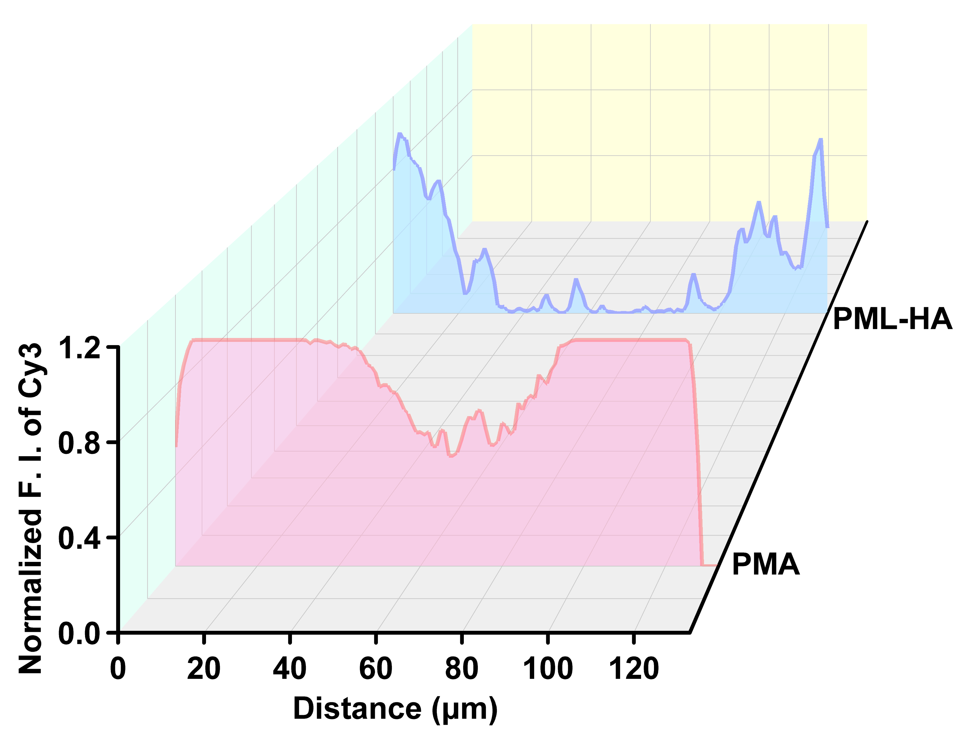
Figure S29. Normalized quantitative fluorescence images of PML-HA and PMA nanomotors at a depth of 120 μm from the spheroid surface after 12 h of co-incubation with 3D tumor spheroids.
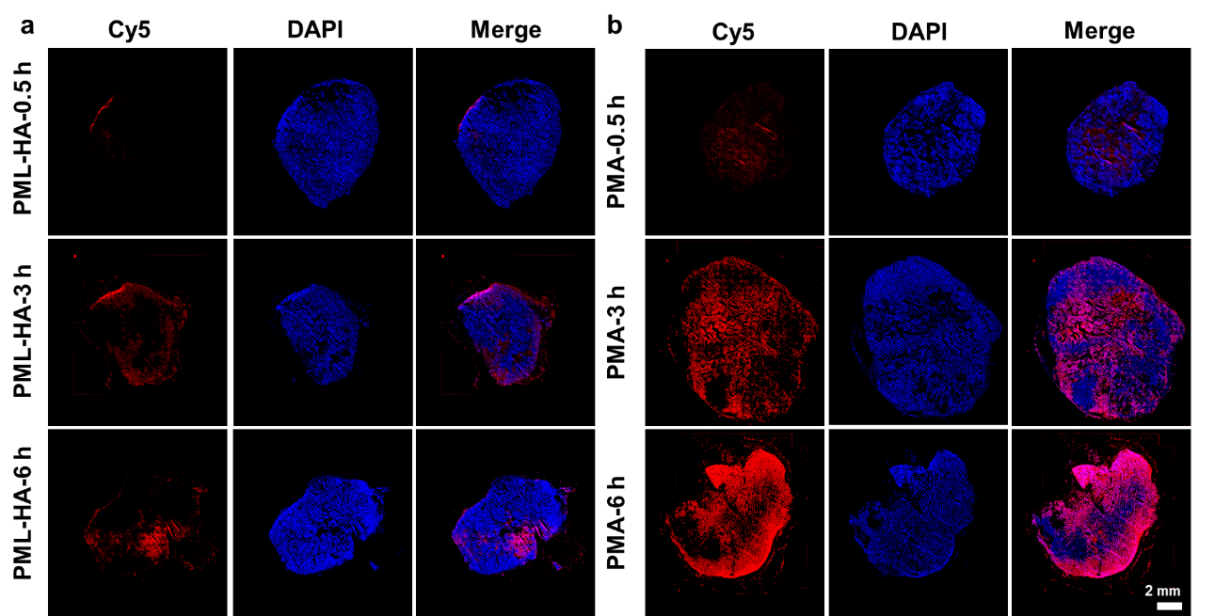
Figure S30. Tumor fluorescent section images at different time points (0.5, 3, 6 h) after peritumoral injection of PML-HA and PMA nanomotors in B16F10 tumor-bearing mice (the largest cross-section of the tumor was selected, scale bar: 2 mm).
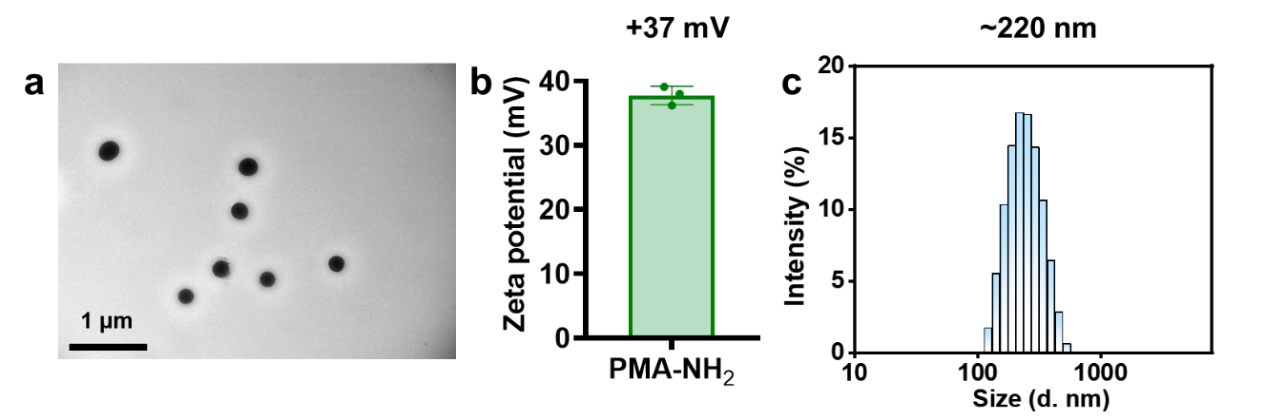
Figure S31. (a) TEM image (Scale bar: 1 μm), (b) hydrodynamic size distributions and (c) zeta potential of PMA-NH₂ nanomotors.
Figure S32. (a) Fluorescence images and (b) corresponding quantitative fluorescence intensity of PMA-NH₂ and PMA nanomotors at different time points (Scale bar: 50 μm, cell density: 10⁴ cells mL⁻¹).
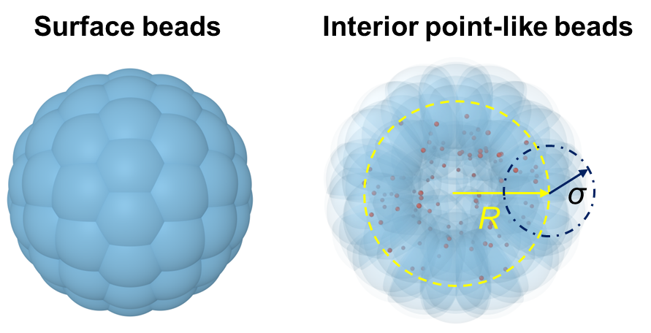
Figure S33. Schematic representation of the active colloid model. The colloid is constructed as a spherical assembly consisting of $N_{surf}$=100 blue surface beads, uniformly distributed on a spherical surface of radius $R$=4.0, together with $N_{in}$=100 orange interior point-like beads placed inside the sphere to ensure mechanical stability. Each surface bead has a radius $δ$=2.0, such that the effective hydrodynamic radius of the colloid is $R_{e}$=$R$+$δ$=6.0.

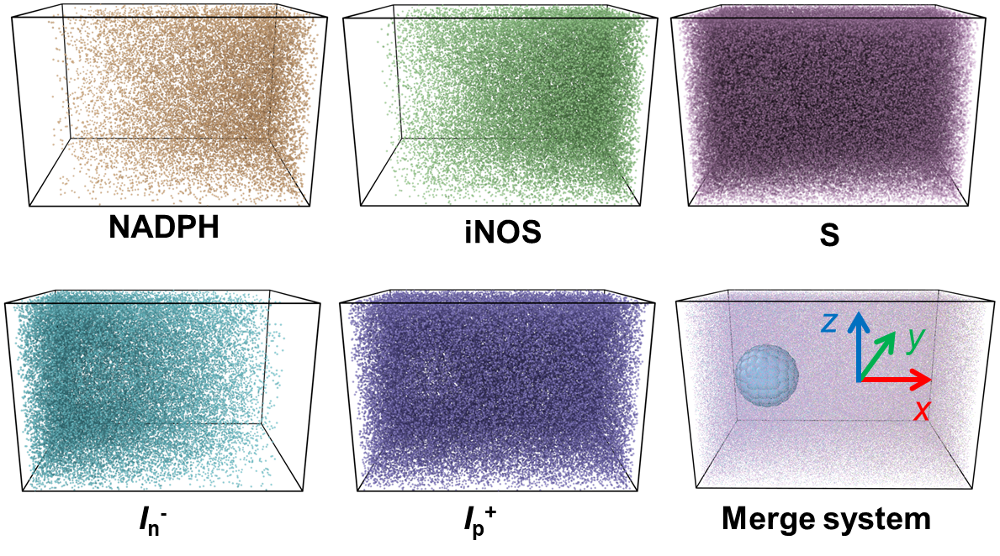
Figure S34. Schematic illustration of the spatial distributions of all fluid species. Linear concentration gradients of iNOS and NADPH are imposed along the non-periodic x-direction to mimic diffusion from an agarose gel source. Compensating counter-gradients of S and In⁻ together with a uniform distribution of Ip⁺, ensure constant total number density and global electroneutrality. The bottom panel shows the merged system with the active colloid immersed in the gradient field. Periodic boundary conditions are applied in the y and z directions.
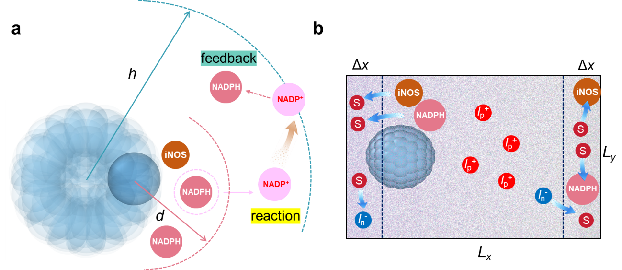
Figure S35. (a) Schematic illustration of the enzymatic reaction and feedback mechanism implemented in the simulation. A reaction event is triggered when an iNOS particle enters a predefined reaction distance d from a surface bead on the colloid and at least one NADPH particle is simultaneously present within the same distance. Upon reaction, one NADPH particle is selected and converted into NADP⁺. To prevent NADP⁺ accumulation and sustain cofactor availability, NADP⁺ particles diffusing beyond a cutoff distance h from the center of mass of colloid are converted back into NADPH, providing an effective negative feedback that maintains the system in a nonequilibrium state. (b) Schematic of the boundary-driven conversion protocol used to maintain stable macroscopic concentration gradients along the non-periodic x direction. Particle exchange is enforced within boundary regions of thickness ∆x adjacent to the left and right boundaries. For species with left-to-right increasing gradients (iNOS and NADPH), particles entering the left boundary region are converted into solvent S, while an equal number of S from the right boundary region are converted back into the corresponding species. For negatively charged ions I_{n}⁻, which follow an opposite gradient, the conversion rule is applied in reverse. Positively charged ions I_{p}⁺ are distributed uniformly.
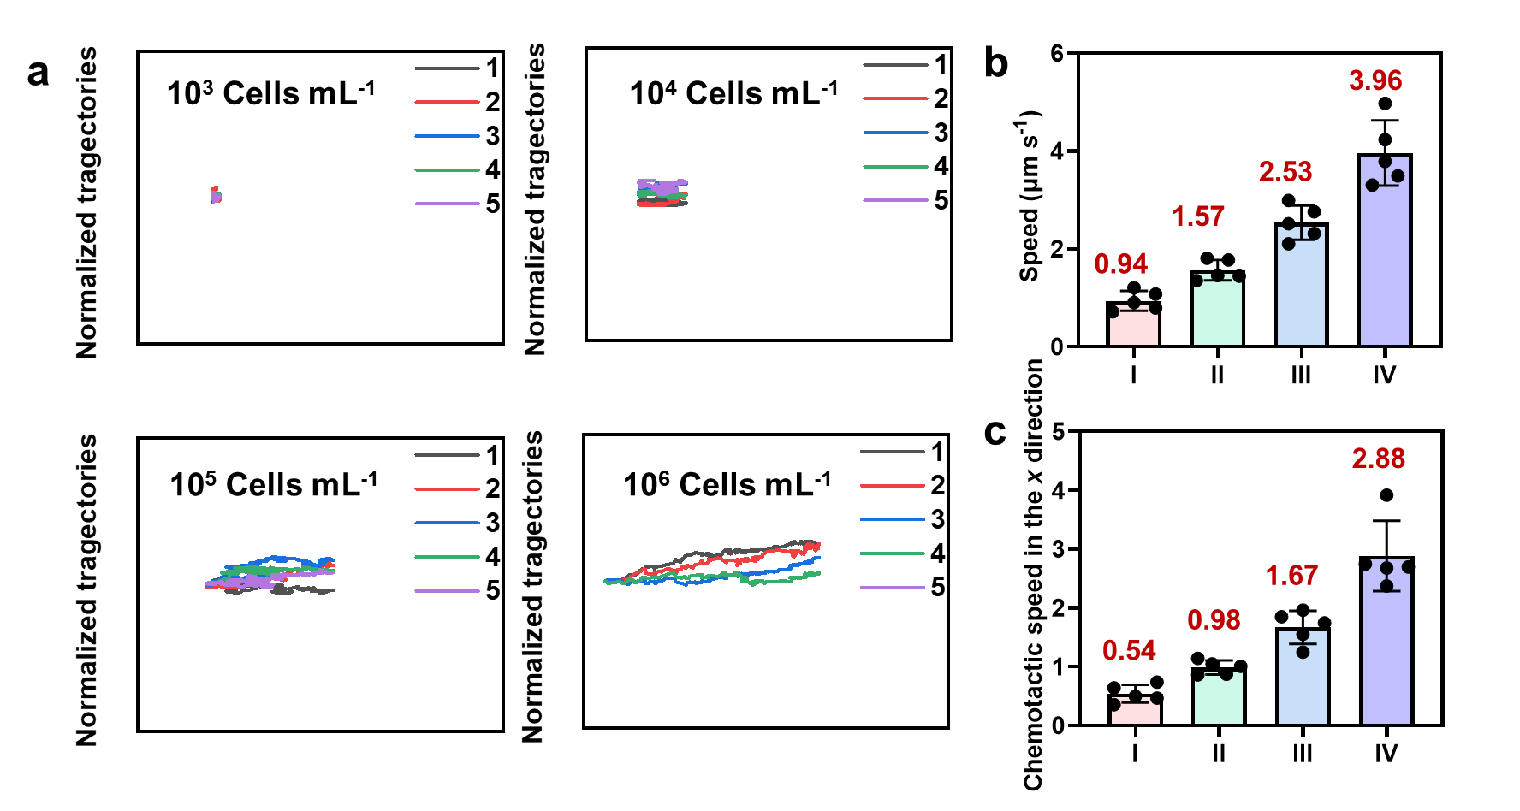
Figure S36. (a) Chemotactic trajectories, (b) chemotactic velocity and (c) chemotactic speed in the x direction of PMA nanomotors in MCF-7 lysate at different concentrations. (I: 10³ cells mL⁻¹, II: 10⁴ cells mL⁻¹, III: 10⁵ cells mL⁻¹, IV: 10⁶ cells mL⁻¹, start recording from the middle position of the single-channel model).
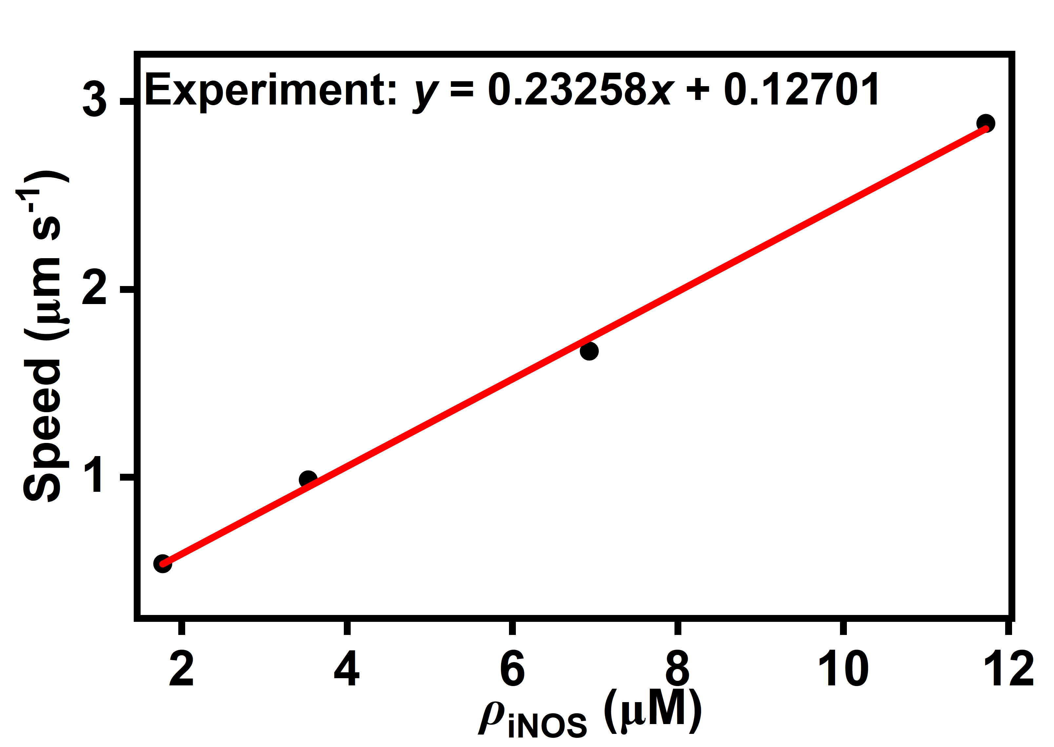
Figure S37. Relationship between the chemotactic speed of PMA nanomotors and iNOS concentration under different concentrations of MCF-7 cell lysate. The iNOS concentrations under different MCF-7 cell lysate conditions were extracted from the previous research (7). The straight lines represent fitted lines, indicating that the chemotactic speed of the nanomotors exhibits a linear relationship with the iNOS concentration.
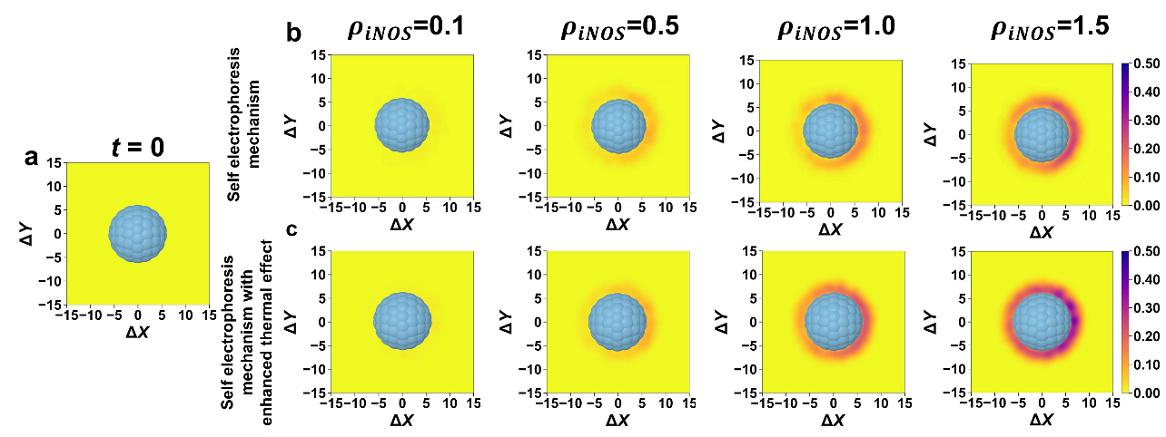
Figure S38. Distribution of NADP⁺ (red signal) in non-thermogenic/thermogenic systems at different iNOS concentrations. (a) Initial state of the system. (b) System governed by the pure self-electrophoresis mechanism. (c) Self-electrophoresis system with enhanced thermal effect (t=1000).

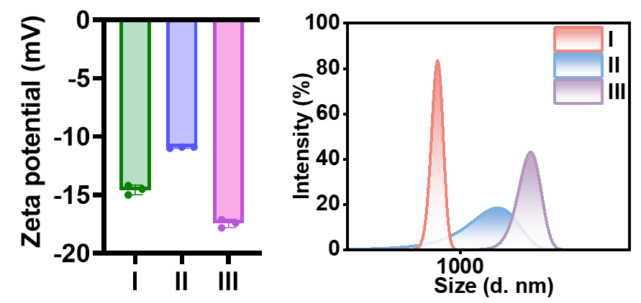
Figure S39. (a) Zeta potential and (b) hydrodynamic size distribution profiles of different samples (I: PLGA, II: asymmetric micromotor, III: symmetric micromotor).
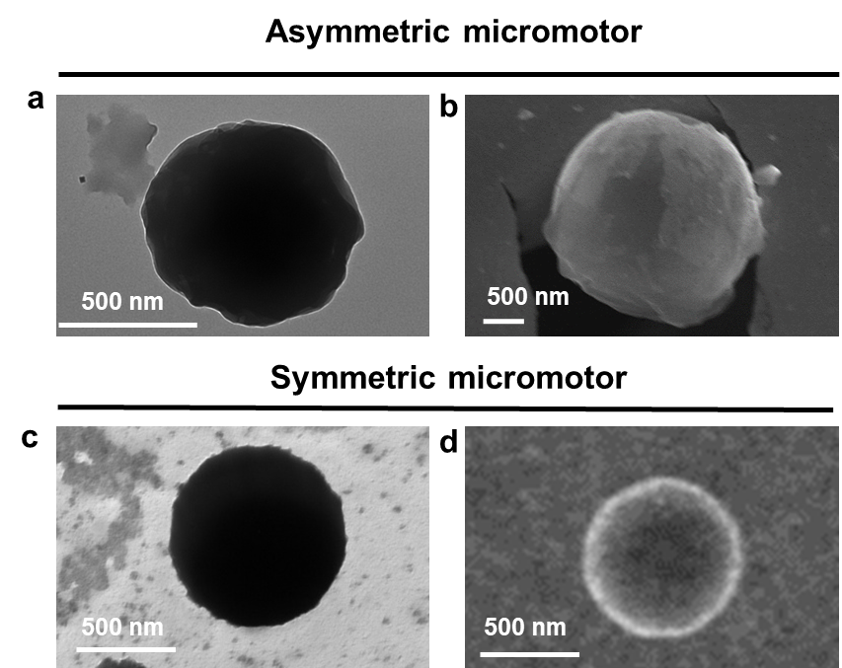
Figure S40. (a-c) TEM images and (b, d) SEM images of asymmetric micromotor and symmetric micromotor (Scale bar: 500 nm).
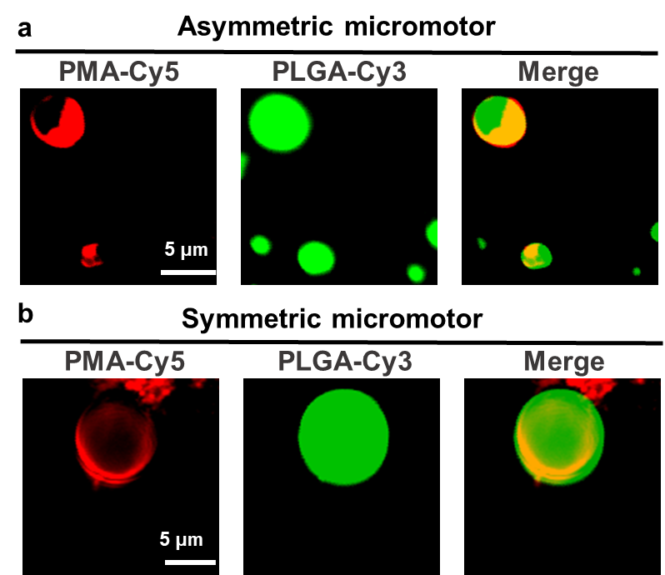
Figure S41. Fluorescence co-localization image of (a) asymmetric micromotor and (b) symmetric micromotor (PMA labeled with Cy5, PLGA labeled with Cy3, scale bar: 5 μm).
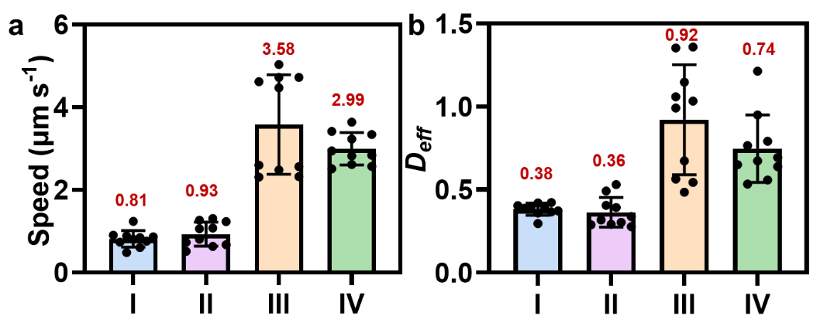
Figure S42. (a) Motion speed and (b) $D_{eff}$of different samples (I: asymmetric micromotor + HUVECs lysate, II: symmetric micromotor + HUVECs lysate, III: asymmetric micromotor +MCF-7 lysate, IV: symmetric micromotor + MCF-7 lysate). (cell density: 10⁵ cells mL⁻¹).
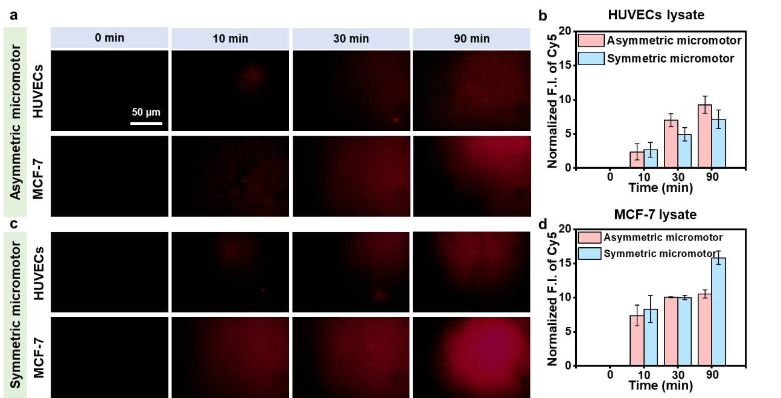
Figure S43. (a, c) Representative fluorescence images and (b, d) normalized quantitative results of asymmetric micromotors and symmetric micromotors in HUVECs/MCF-7 lysate environment. (Scale bar: 50 μm, cell density: 10⁵ cells mL⁻¹).
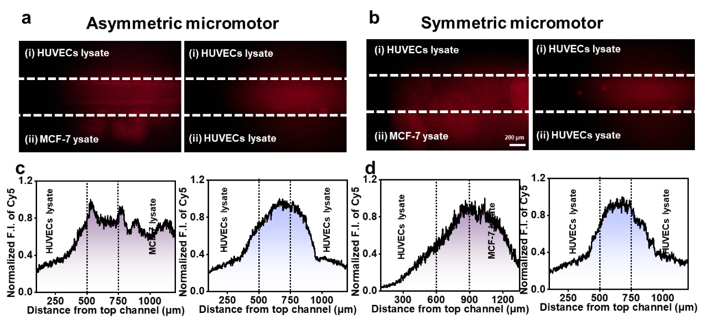
Figure S44. (a, b) Representative quantitative fluorescence images and (c, d) normalized quantitative results of asymmetric micromotors and symmetric micromotors in a dynamic microfluidic under environments containing HUVECs lysate and MCF‑7 lysate (Scale bar: 200 μm, cell density: 10⁵ cells mL⁻¹).
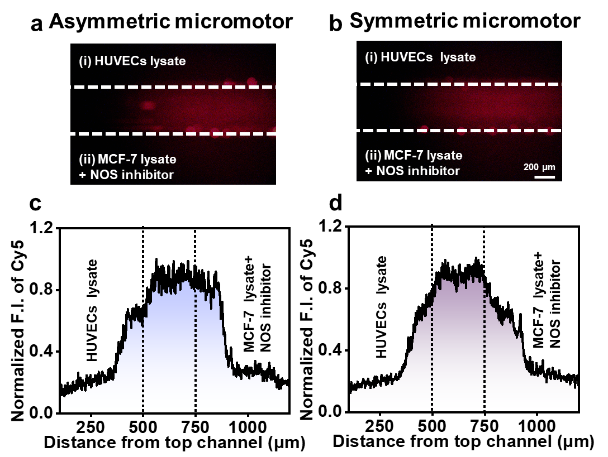
Figure S45. (a, b) Representative quantitative fluorescence images and (c, d) normalized quantitative results of asymmetric micromotors and symmetric micromotors in a dynamic microfluidic under environments containing HUVECs lysate and MCF‑7 lysate with NOS inhibitor (Scale bar: 200 μm, cell density: 10⁵ cells mL⁻¹).

Table S1-S3:
Table S1. The motion mechanisms and speeds/EI₅₀ of reported micro/nanomotors.
Micro/nanomotor | Driving mechanism | Speed/EI₅₀ | Ref.
TiO₂-Arg micromotors | Self-electrophoresis | ~3 μm s⁻¹(in RPMI-1640)  EI₅₀~15 mM | (8)
Pt NPs-modified flasklike colloidal motors | Autophoretic/Bubble Propulsion | ~4 μm s⁻¹(in FBS) | (9)
SPS-microswimmers | Self-electrophoresis | EI₅₀~0.028 mM | (10)
PHI-based organic microswimmers | Self-electrophoresis | ~20 μm s⁻¹(in DMEM) | (11)
Pt-Ni-Au  tubular microengines | Bubble recoil propulsion | ~183 μm s⁻¹ (in 1 M NaCl) | (12)
Bimetallic microswimmers | Self-electrophoresis | Maintain movement in 80 μM L⁻¹ NANO₃ | (13)
Urease-powered Janus-nanomotor | Self-propulsion | Maintain movement in 10 mM urea | (14)

Table S2. ITC results of PMA nanomotors titration of MCF-7 lysate.
Association constant Ka (mg⁻¹) | Stoichiometric ratio n | Enthalpy changes $∆H$  kJ (mg·10⁵ cells)⁻¹ | Entropy change $∆S$  J (mg·10⁵ cells K)⁻¹
25.1 | 0.5 | -1.5 | 9.1
Table S3. The types of enzyme-substrate, materials characteristics, symmetry/asymmetry of structure, chemotaxis mechanism, and verification level of reported micro/nanomotors
Enzyme and Substrate | Materials | Symmetry/Asymmetry | Chemotaxis mechanism | Horizontal verification | Ref.
DNase-DNA | SiO₂ | Asymmetry | Autodiffusion electrophoresis+  local thermal effect | In vitro solution environment | (15)
Urease-Urea | SiO₂+metal nanoparticles | Asymmetry | Switching from ion diffusion electrophoresis to microbubble recoil | In vitro solution environment | (16)
Urease-Urea | Metal nanoparticles | Asymmetry | Electrolyte self-diffusion electrophoresis | In vitro solution environment | (14)
CAT-H₂O₂  GOx-Glucose | Polymer nanoparticles | Asymmetry | Enhanced diffusion | Mouse infectious diabetes model | (17)
CAT-H₂O₂  GOx-Glucose  Urease-Urea | SiO₂ | Asymmetry | Enhanced diffusion | In vitro solution environment | (18)
GOx-Glucose | Polymer nanoparticles | Asymmetry | Self-diffusiophoresis | In vitro solution environment | (19)
GOx-Glucose | Polymer nanoparticles | Asymmetry | Self-diffusiophoresis | In vitro solution environment | (20)
GOx-Glucose | SiO₂+metal nanoparticles | Asymmetry | Self-diffusiophoresis | In vitro solution environment | (21)
F₀F₁-ATPase-ATP | Polymer nanoparticles | Asymmetry | Molecular motor | Mouse muscle atrophy model | (22)
iNOS-L-Arg | Polymer nanoparticles | Asymmetry | Enzyme-substrate affinity | In vitro solution environment | (23)
CAT-H₂O₂ GOx-Glucose | SiO₂ | Asymmetry | Enhanced diffusion | Mouse diabetes model | (24)
GOx-Glucose | SiO₂ | Asymmetry | Self-diffusiophoresis | In vitro solution environment | (25)
GGT-GSH | MOF | Asymmetry | Enzyme-substrate affinity | Mouse breast cancer model | (26)
Urease-Urea | SiO₂ | Symmetry | Electrophoretic diffusion | In vitro solution environment | (27)
CAT-H₂O₂  GOx-Glucose  Urease-Urea | Lipsome | Symmetry | Thermodynamically driven/Hoffmeister effect | In vitro solution environment | (28)
CAT-H₂O₂  GOx-Glucose | Polymer nanoparticles | Symmetry | Bubble recoil driven | In vitro solution environment | (29)
GOx-Glucose  CPO-HClO  CAT-H₂O₂ | Polymer nanoparticles | Symmetry | Enhanced diffusion | Mouse vascular graft infection model | (30)
iNOS-L-Arg | Polymer nanoparticles | Symmetry | Enzyme-substrate affinity | Mouse models (for tumor, acute lung injury, arthritis) | (7)
CBS-L-Cys | Polymer nanoparticles | Symmetry | Enzyme-substrate affinity | Mouse Parkinson's disease model | (31)
F₀F₁-ATPase-ATP | Lipsome | Symmetry | Molecular motor | In vitro solution environment | (32)
GOx-Glucose  iNOS-L-Arg | Polymer nanoparticles | Symmetry | Enhanced diffusion  +enzyme-substrate affinity | Mouse glioblastoma model | (33)
iNOS-L-Arg | Polymer nanoparticles | Symmetry | Enhanced diffusion + enzyme-substrate affinity | Mouse gastric cancer model | (34)
CBS-L-Cys | Polymer nanoparticles | Symmetry | Enhanced diffusion + enzyme-substrate affinity | Mouse Parkinson's disease model | (35)
Pb-binding urease-PbSe | MOF | Symmetry | Electrophoretic diffusion | In vitro solution environment | (36)
iNOS-L-Arg | Polymer nanoparticles | Symmetry | Enzyme-substrate affinity | Mouse atherosclerosis model | (37)
Urease-Urea  CAT-H₂O₂ | Polymer nanoparticles | Symmetry | Ion self-diffusion electrophoresis | In vitro solution environment | (38)
LOx-Lactic acid | metal nanoparticles | Symmetry | Enhanced diffusion | Mouse breast cancer model | (39)
Urease-Urea | Polymer + metal nanoparticles | Symmetry | Enhanced diffusion | Intravesical imaging in mouse | (40)
CAT-H₂O₂ | Metal nanoparticles | Symmetry | Bubble propulsion | In vitro solution environment | (41)
CAT-H₂O₂ | Polymer nanoparticles | Symmetry | Self-propelled swimming+enzyme-substrate affinity | In vitro solution environment | (42)
CAT-H₂O₂  GOx-Glucose | Polymer nanoparticles | Symmetry | Bubble propulsion | In vitro solution environment | (43)
CAT-H₂O₂  GOx-Glucose | Metal nanoparticles | Symmetry | Bubble propulsion +enzyme-substrate affinity | Mouse breast cancer model | (44)
PAO-biologically active amines | Polymer nanoparticles | Symmetry | Enhanced diffusion | Mouse breast cancer model | (45)
CAT-H₂O₂ | Graphene nanosheets | Symmetry | Bubble propulsion  +enzyme-substrate affinity | In vitro solution environment | (46)
Urease-Urea  Cytochrome C-Catechol | Polymer nanoparticles | Symmetry | Ion self-diffusion electrophoresis +enzyme-substrate affinity | In vitro solution environment | (47)
GOD-Glucose | SiO₂ | Symmetry | Bubble propulsion +enzyme-substrate affinity | In vitro solution environment | (48)
REFERENCES AND NOTES
1. H. S. Muddana, S. Sengupta, T. E. Mallouk, A. Sen, P. J. Butler, Substrate Catalysis Enhances Single-Enzyme Diffusion. J. Am. Chem. Soc., 132, 2110-2111 (2010).
2. F. Peng, Y. Tu, J. C. van Hest, D. A. Wilson, Self-Guided Supramolecular Cargo-Loaded Nanomotors with Chemotactic Behavior towards Cells. Angew. Chem., Int. Ed. 54, 11662-11665 (2015).
3. G. Dunderdale, S. Ebbens, P. Fairclough, J. Howse, Importance of particle tracking and calculating the mean-squared displacement in distinguishing nanopropulsion from other processes. Langmuir 28, 10997-11006 (2012).
4. D. Ernst, J. Kohler, Measuring a diffusion coefficient by single-particle tracking: statistical analysis of experimental mean squared displacement curves. Phys. Chem. Chem. Phys. 15, 845-849 (2013).
5. R. Kapral, Multiparticle Collision Dynamics: Simulation of Complex Systems on Mesoscales. Adv. Chem. Phys. 140, 89-146 (2008).
6. T. I. G. Gompper, D.M. Kroll, and R.G. Winkler, Multi-Particle Collision Dynamics: A Particle-Based Mesoscale Simulation Approach to the Hydrodynamics of Complex Fluids. Adv. Polym. Sci. 221, 1-87 (2009).
7. T. Li, Z. Liu, J. Hu, L. Chen, T. Chen, Q. Tang, B. Yu, B. Zhao, C. Mao, M. Wan, A Universal Chemotactic Targeted Delivery Strategy for Inflammatory Diseases. Adv. Mater. 34, e2206654 (2022).
8. J. Sun, Y. Ding, Y. Ye, F. Wang, H. Tian, J. Jiang, H. Li, J. Gao, H. Tan, F. Peng, J. Tang, Y. Tu, Amino acid coating enables micromotor operation in physiological conditions. Proc. Natl. Acad. Sci. U. S. A. 122, e2510091122 (2025).
9. S. Yuan, L. Yang, X. Lin, Q. He, Ultrasmall Pt NPs-modified flasklike colloidal motors with high mobility and enhanced ion tolerance. Nanoscale 15, 12558-12566 (2023).
10. X. Zhan, J. Wang, Z. Xiong, X. Zhang, Y. Zhou, J. Zheng, J. Chen, S. P. Feng, J. Tang, Enhanced ion tolerance of electrokinetic locomotion in polyelectrolyte-coated microswimmer. Nat. Commun. 10, 3921 (2019).
11. V. Sridhar, F. P. V. Sridhar, Y. Alapan, J. Kröger, L. Grunenberg, V. Kishore, B. V. Lotsch, M. Sitti, Light-driven carbon nitride microswimmers with propulsion in biological and ionic media and responsive on-demand drug delivery. Sci. Robot. 7, eabm1421 (2022).
12. M. C. K. M. Manesh, R. Yuan, M. Clark, D. Kagan,S. Balasubramanian, J. Wang, Template-Assisted Fabrication of Salt-Independent Catalytic Tubular Microengines. ACS Nano 4, 1799-1804.
13. C. Liu, C. Zhou, W. Wang, H. P. Zhang, Bimetallic Microswimmers Speed Up in Confining Channels. Phys. Rev. Lett. 117, 198001 (2016).
14. Z. Yang, L. Wang, Z. Gao, X. Hao, M. Luo, Z. Yu, J. Guan, Ultrasmall Enzyme-Powered Janus Nanomotor Working in Blood Circulation System. ACS Nano 17, 6023-6035 (2023).
15. Y. Ye, F. Tong, S. Wang, J. Jiang, J. Gao, L. Liu, K. Liu, F. Wang, Z. Wang, J. Ou, B. Chen, D. A. Wilson, Y. Tu, F. Peng, Apoptotic Tumor DNA Activated Nanomotor Chemotaxis. Nano Lett. 21, 8086-8094 (2021).
16. Y. Feng, Y. Yuan, J. Wan, C. Yang, X. Hao, Z. Gao, M. Luo, J. Guan, Self-adaptive enzyme-powered micromotors with switchable propulsion mechanism and motion directionality. Appl. Phys. Rev. 8, 011406 (2021).
17. J. Hu, L. Xu, J. Cao, J. Lin, C. Lian, J. Guan, Glucose-fueled cationic nanomotors for promoting the healing of infected diabetic wounds. J. Colloid Interface Sci. 679, 747-759 (2025).
18. X. Ma, A. Jannasch, U. R. Albrecht, K. Hahn, A. Miguel-Lopez, E. Schaffer, S. Sanchez, Enzyme-Powered Hollow Mesoporous Janus Nanomotors. Nano Lett. 15, 7043-7050 (2015).
19. C. C. A. Joseph, D. Cecchin, S. Nyberg, L. Ruiz-Perez, J. Gaitzsch, G. Fullstone, X. Tian, J. Azizi, J. Preston, G. Volpe, G. Battaglia, Chemotactic synthetic vesicles: Design and applications in blood-brain barrier crossing. Sci. Adv. 3, e1700362 (2017).
20. C. Zhou, C. Gao, Y. Wu, T. Si, M. Yang, Q. He, Torque-Driven Orientation Motion of Chemotactic Colloidal Motors. Angew. Chem., Int. Ed. Engl. 61, e202116013 (2022).
21. Y. Ji, X. Lin, Z. Wu, Y. Wu, W. Gao, Q. He, Macroscale Chemotaxis from a Swarm of Bacteria-Mimicking Nanoswimmers. Angew. Chem., Int. Ed. Engl.58, 12200-12205 (2019).
22. M. Liu, Z. Liu, X. Qiao, C. Chen, H. Guo, H. Gu, J. Li, T. Sun, An Endogenous Proton-Powered Adaptive Nanomotor for Treating Muscle Atrophy. Materials 18, 1351 (2025).
23. M. Sun, L. van Oss, C. Wan, D. A. Wilson, Communicative Nanomotors Reprogram Cancer Cell Death via Pyroptosis. Angew. Chem., Int. Ed. Engl. 64, e202510014 (2025).
24. J. Lin, C. Lian, L. Xu, Z. Li, Q. Guan, W. Wei, H. Dai, J. Guan, Hyperglycemia Targeting Nanomotors for Accelerated Healing of Diabetic Wounds by Efficient Microenvironment Remodeling. Adv. Funct. Mater. 35, 2417146 (2024).
25. S. Yang, Q. He, X. Lin, Dual chemotaxis of glucose oxidase-powered nanomotors towards the concentration gradients of both glucose and proton. Colloids Surf., A 721, 137240 (2025).
26. Z. Liu, T. Li, N. Li, Y. Wang, L. Chen, X. Tang, M. Wan, C. Mao, GSH-induced chemotaxis nanomotors for cancer treatment by ferroptosis strategy. Sci. China: Chem. 65, 989-1002 (2022).
27. J. Lin, S. Chen, F. Lezcano, Z. Li, L. Xu, J. Guan, S. Sanchez, Collective Dynamics of Urease-Based Nanomotors in a Chemical Gradient. Small 21, e2502212 (2025).
28. A. Somasundar, S. Ghosh, F. Mohajerani, L. N. Massenburg, T. Yang, P. S. Cremer, D. Velegol, A. Sen, Positive and negative chemotaxis of enzyme-coated liposome motors. Nat. Nanotechnol. 14, 1129-1134 (2019).
29. B. Kumar, A. J. Patil, S. Mann, Enzyme-powered motility in buoyant organoclay/DNA protocells. Nat. Chem. 10, 1154-1163 (2018).
30. W. Jiang, H. Xu, Z. Gao, Z. Wu, Z. Zhao, J. Wang, Y. Wu, H. Ke, C. Mao, M. Wan, M. Zhou, Artificial Neutrophils Against Vascular Graft Infection. Adv. Sci. (Weinh) 11, e2402768 (2024).
31. Z. Zhao, L. Chen, C. Yang, W. Guo, Y. Huang, W. Wang, M. Wan, C. Mao, J. Shen, Nanomotor-based H(2)S donor with mitochondrial targeting function for treatment of Parkinson’s disease. Bioact. Mater. 31, 578-589 (2024).
32. Q. Yang, X. Zhou, B. Lou, N. Zheng, J. Chen, G. Yang, An F(O)F(1)-ATPase motor-embedded chromatophore as a nanorobot for overcoming biological barriers and targeting acidic tumor sites. Acta Biomater. 179, 207-219 (2024).
33. T. Li, L. Chen, Y. Xue, X. Xiao, W. Dai, Y. Tan, R. T. Chen, Y. Tao, C. Mao, M. Wan, Chemotactic nanomotor for multimodal combined therapy of glioblastoma. Sci. China: Chem. 67, 1277-1288 (2024).
34. Y. Chen, Y. Zhang, W. Dai, Y. Xue, J. Li, K. Zhang, R. Tang, C. Mao, M. Wan, Dual responsive drug-loaded nanomotor based on zwitterionic materials for the treatment of peritoneal metastatic cancer. J. Colloid Interface Sci. 679, 868-878 (2025).
35. W. Wang, Z. Zhao, Z. Zhang, Z. Wu, Y. Zhang, K. Wang, M. Dai, C. Mao, M. Wan, Delivery of small interfering RNA by hydrogen sulfide-releasing nanomotor for the treatment of Parkinson’s disease. J. Controlled Release 377, 648-660 (2025).
36. Y. Ikezoe, J. Fang, T. L. Wasik, M. Shi, T. Uemura, S. Kitagawa, H. Matsui, Peptide-Metal Organic Framework Swimmers that Direct the Motion toward Chemical Targets. Nano Lett. 15, 4019-4023 (2015).
37. Z. Wu, M. Zhou, X. Tang, J. Zeng, Y. Li, Y. Sun, J. Huang, L. Chen, M. Wan, C. Mao, Carrier-Free Trehalose-Based Nanomotors Targeting Macrophages in Inflammatory Plaque for Treatment of Atherosclerosis. ACS Nano 16, 3808-3820 (2022).
38. K. K. Dey, X. Zhao, B. M. Tansi, W. J. Mendez-Ortiz, U. M. Cordova-Figueroa, R. Golestanian, A. Sen, Micromotors Powered by Enzyme Catalysis. Nano Lett. 15, 8311-8315 (2015).
39. Z. Zhang, H. Zhong, Y. Zhou, P. Ke, Q. Dai, Y. Lu, X. Zhong, Q. Yang, Y. Xia, X. Bao, L. Wu, M. Han, J. Gao, Lactate-driving Pt nanoflower with positive chemotaxis for deep intratumoral penetration. Nano Today 45, 101542 (2022).
40. D. Xu, J. Hu, X. Pan, S. Sanchez, X. Yan, X. Ma, Enzyme-Powered Liquid Metal Nanobots Endowed with Multiple Biomedical Functions. ACS Nano 15, 11543-11554 (2021).
41. T. Bhuyan, A. K. Singh, D. Dutta, A. Unal, S. S. Ghosh, D. Bandyopadhyay, Magnetic Field Guided Chemotaxis of iMushbots for Targeted Anticancer Therapeutics. ACS Biomater. Sci. Eng. 3, 1627-1640 (2017).
42. J. Wang, B. J. Toebes, A. S. Plachokova, Q. Liu, D. Deng, J. A. Jansen, F. Yang, D. A. Wilson, Self-Propelled PLGA Micromotor with Chemotactic Response to Inflammation. Adv. Healthc Mater. 9, e1901710 (2020).
43. P. Peschke, B. V. V. S. P. Kumar, T. Walther, A. J. Patil, S. Mann, Autonomous oscillatory movement of sensory protocells in stratified chemical media. Chem 10, 600-614 (2024).
44. W. Yu, R. Lin, X. He, X. Yang, H. Zhang, C. Hu, R. Liu, Y. Huang, Y. Qin, H. Gao, Self-propelled nanomotor reconstructs tumor microenvironment through synergistic hypoxia alleviation and glycolysis inhibition for promoted anti-metastasis. Acta Pharm. Sin. B11, 2924-2936 (2021).
45. H. Tan, Z. Hu, J. Miao, B. Chen, H. Li, J. Gao, Y. Ye, W. Xu, J. Jiang, H. Qin, H. Tian, F. Peng, Y. Tu, Enzymatic nanomotors with chemotaxis for product-based cancer therapy. J. Control Release 377, 288-300 (2025).
46. M. Mathesh, E. Bhattarai, W. Yang, 2D Active Nanobots Based on Soft Nanoarchitectonics Powered by an Ultralow Fuel Concentration. Angew. Chem., Int. Ed. Engl. 61, e202113801 (2022).
47. C. Ghosh, S. Ghosh, A. Chatterjee, P. Bera, D. Mampallil, P. Ghosh, D. Das, Dual enzyme-powered chemotactic cross beta amyloid based functional nanomotors. Nat. Commun. 14, 5903 (2023).
48. F. Ouyang, L. Zhang, Y. Liu, Q. Shuai, Environmentally responsive multistage gas/enzyme/NIR-driven chemotactic transport nanorockets for single wavelength procedural combination therapy. Mater. Today Chem. 30, 101533 (2023).

