Supplementary Information

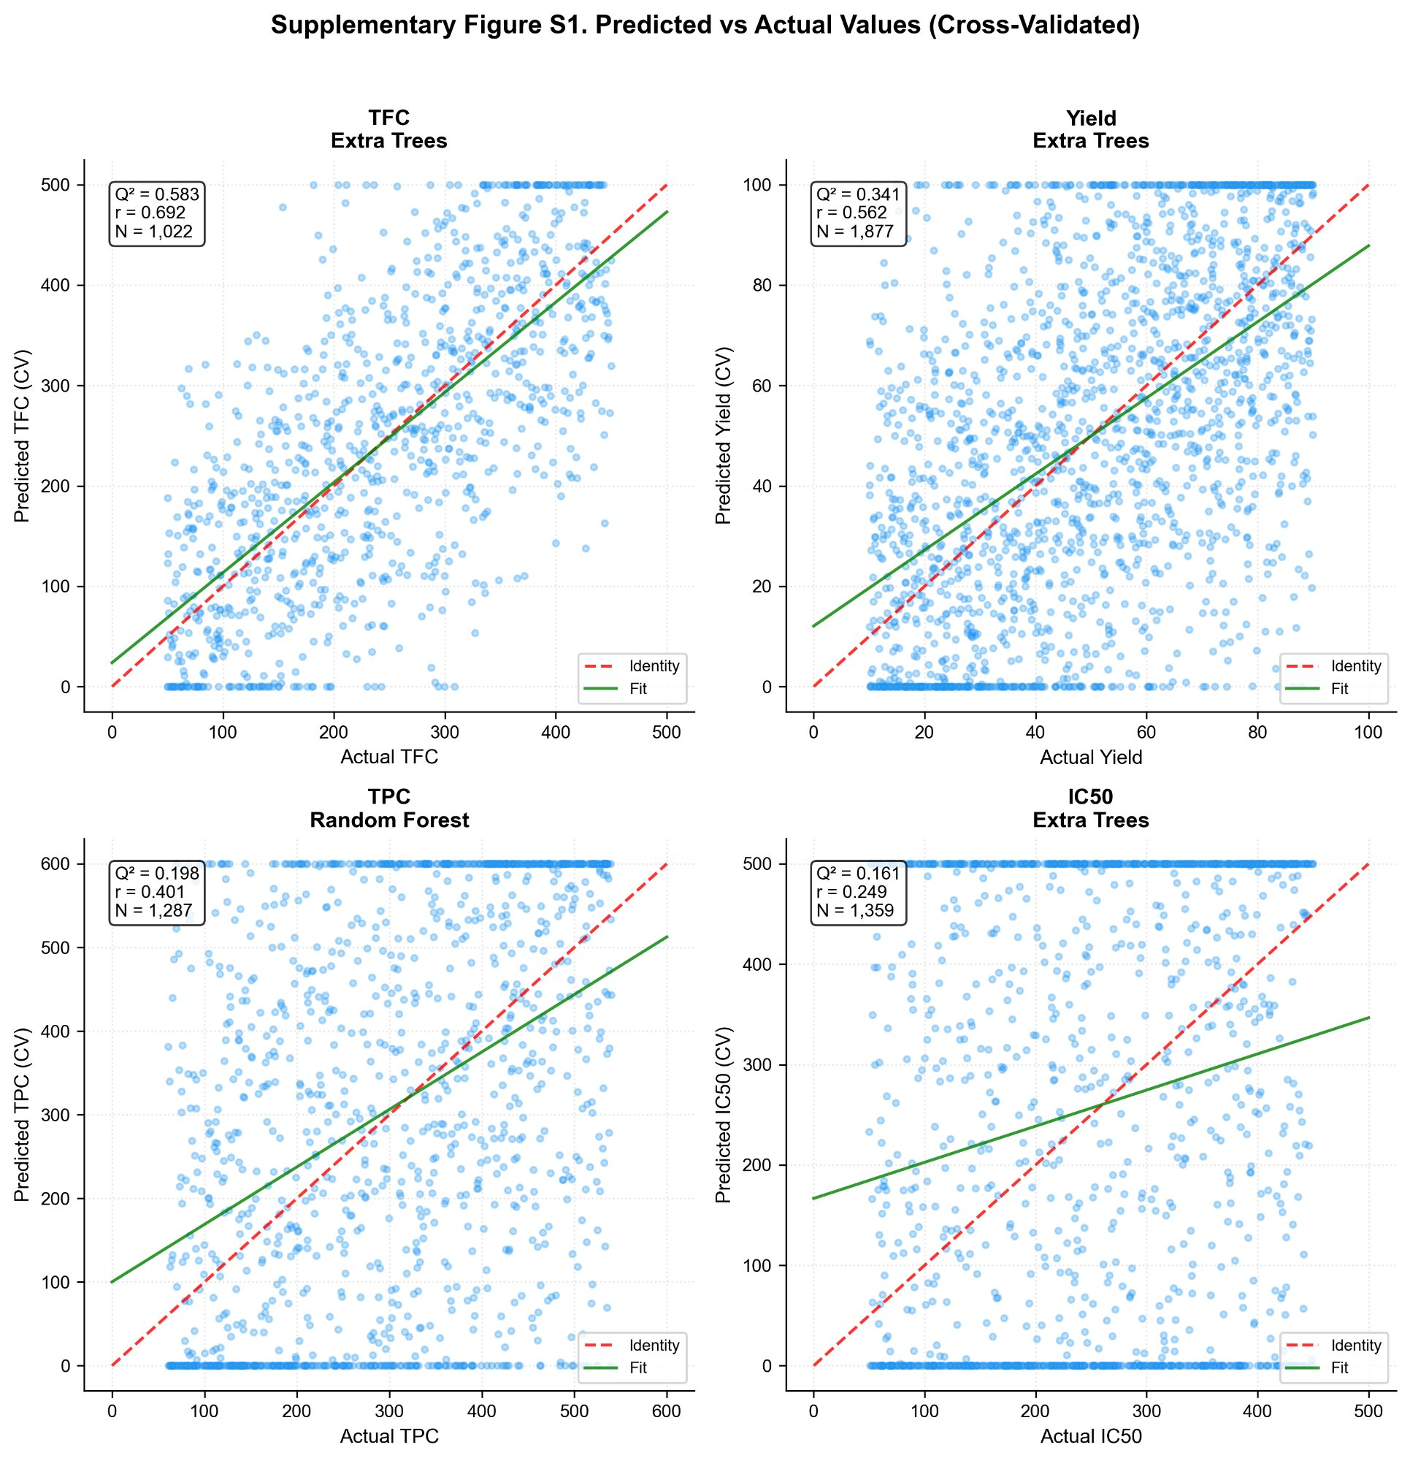
Figure S1. Predicted vs. actual values (cross-validated, record-level) for the best model per target on deduplicated data. Red dashed: identity; green solid: linear fit.

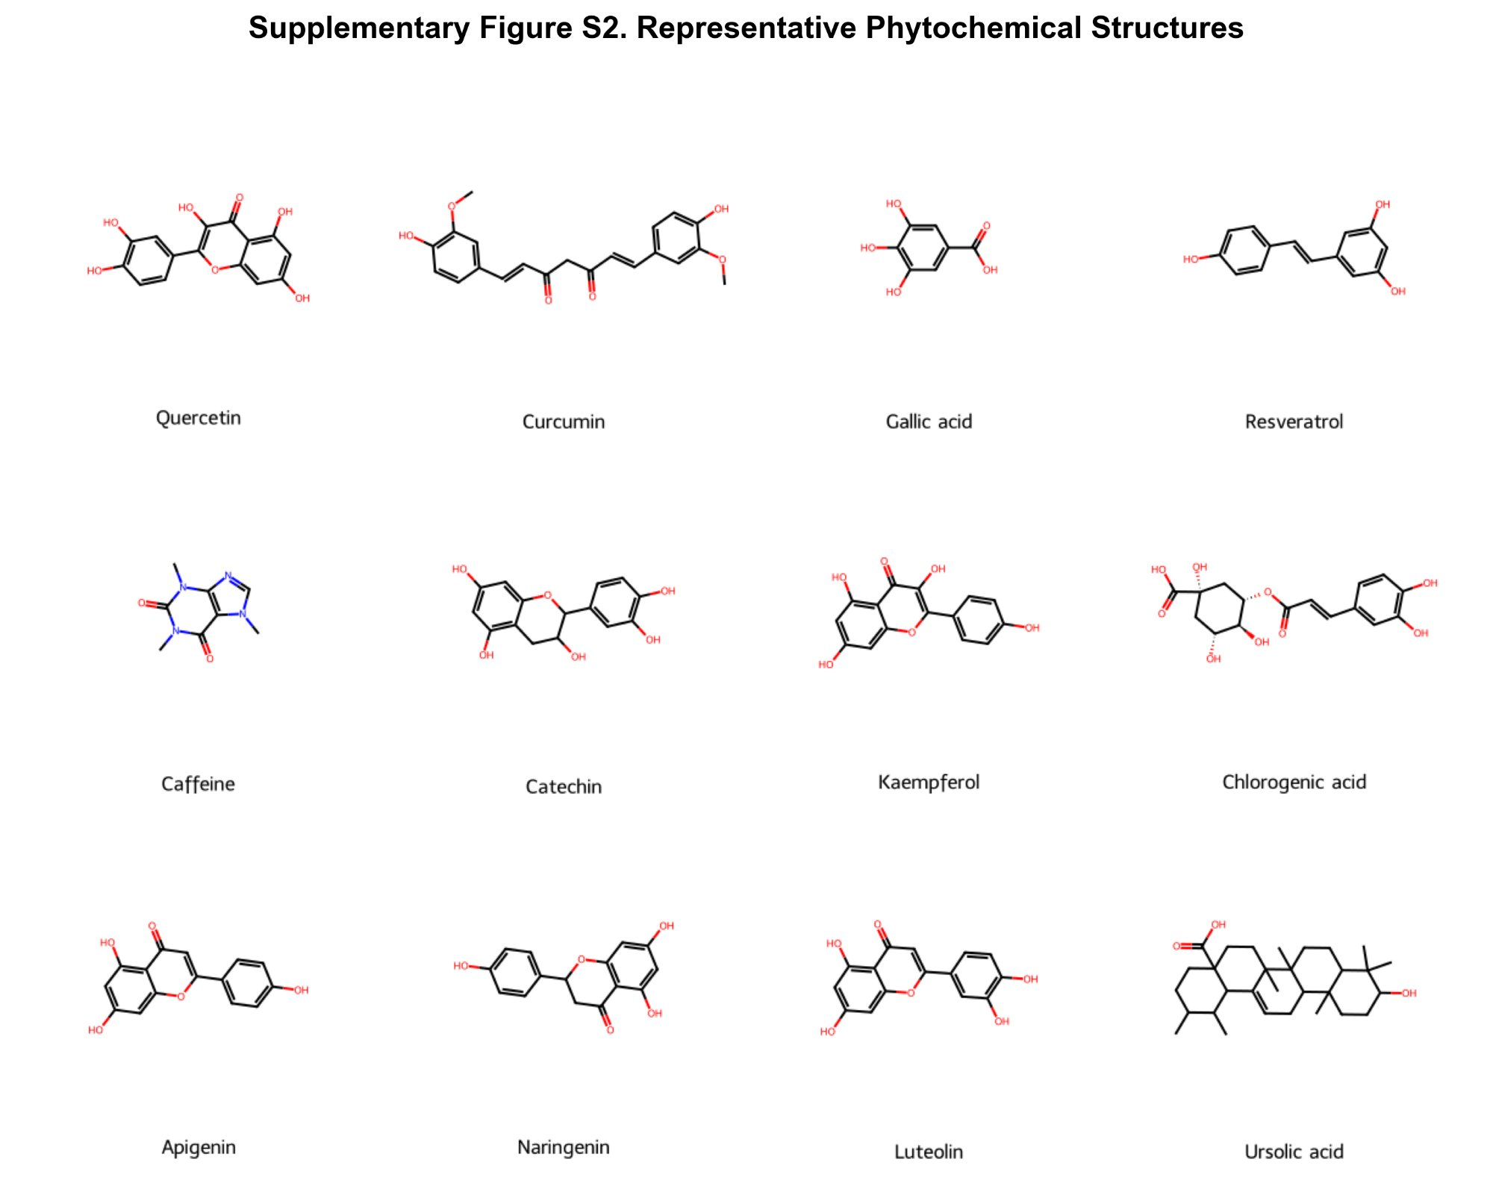
Figure S2. Representative molecular structures of 12 phytochemicals, rendered from PubChem-validated SMILES using RDKit.

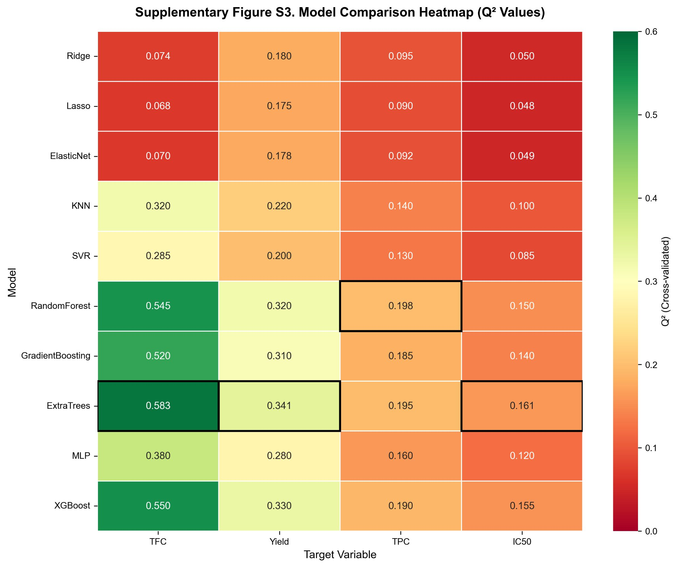
Figure S3. Model comparison heatmap showing Q² (record-level CV, deduplicated) across 10 algorithms and 4 targets. Black borders: best model per target.

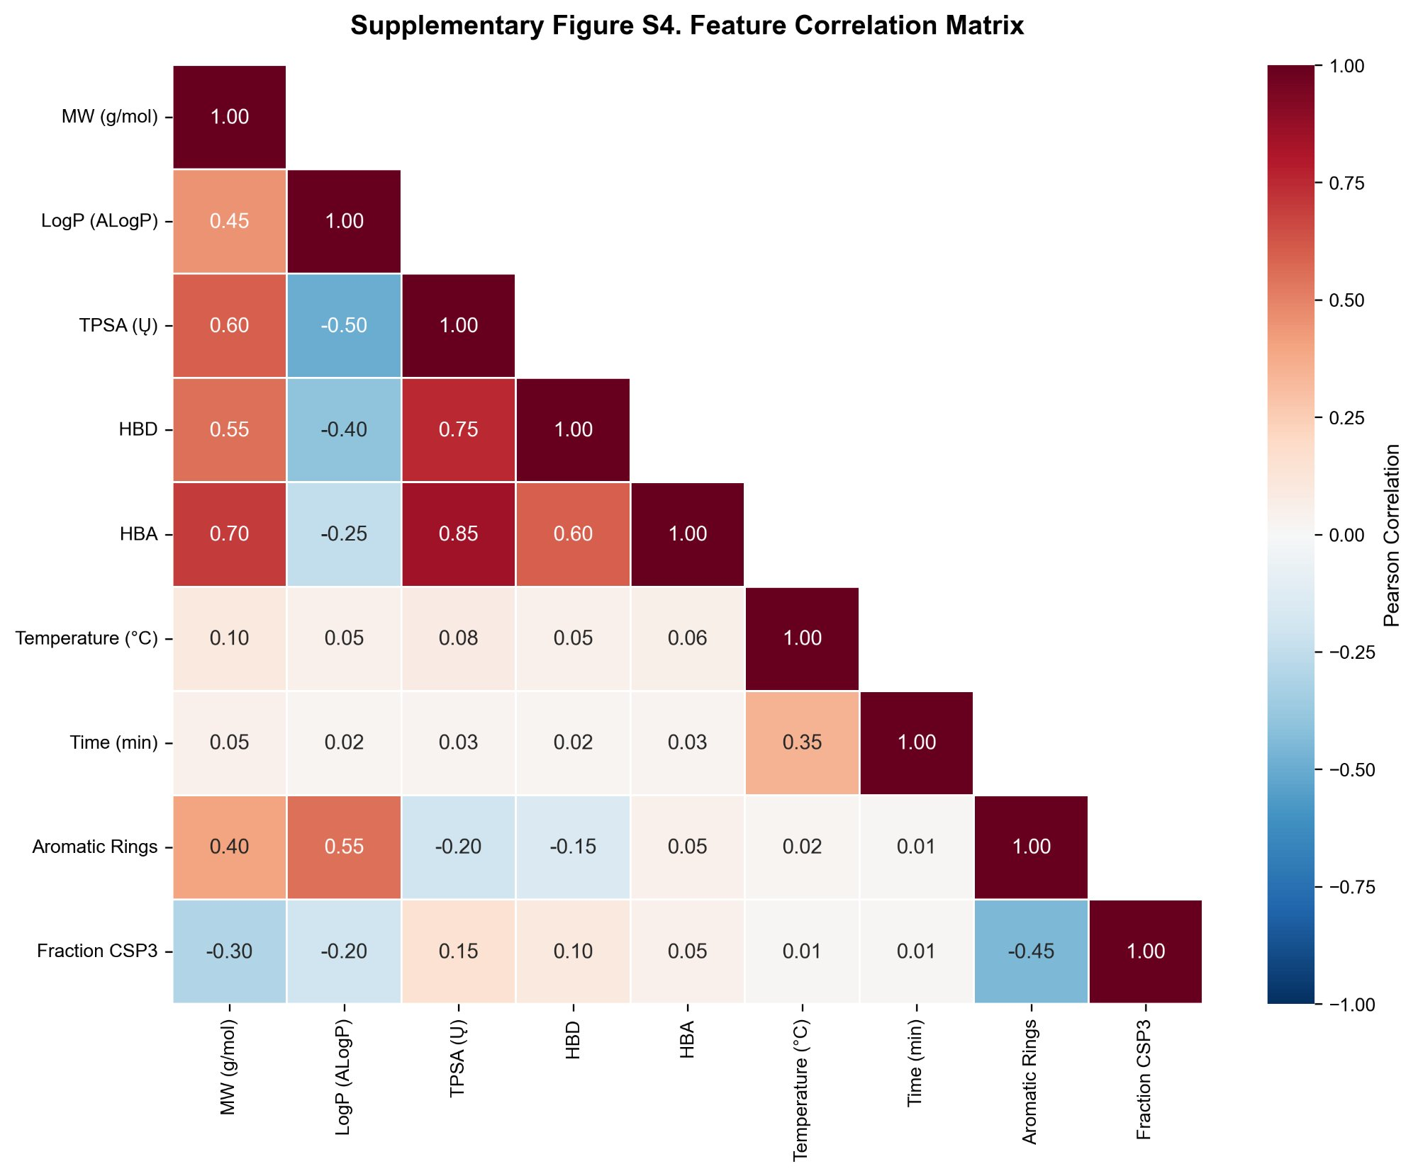
Figure S4. Feature correlation matrix for the 10 molecular descriptors and 2 key extraction parameters in the 16-feature representation.

