Supporting Information
Table S1 Antibodies used in this paper
Primary antibodies | Vendor | Dilution | Source
BMP2  GAPDH  SLC1A5 | ABclonal (A27101)  Affnity (AF7021)  ABclonal (A6981) | WB-1:1000  WB-1:2000  WB-1:1000 | Rabbit  Rabbit  Rabbit

Secondary antibodies | Vendor | Dilution
HRP-conjugated goat anti-rabbit IgG | Beyotime (A0258) | 1:2000

Table S2 Primers Used for Quantitative RT-PCR
Genes | Forward primer | Reverse primer
ERBB4 | CTGATGAGGATCGGGAGTGC | TGGCTTTGGGACCAGTTGTT
GAPDH | CCCCTAACTCACCCGTTCAC | TTGCCCCGCGATCTAATGTT
SLC1A5 | GACCCCTCGGACCCAAAAG | AAAAGCTCCAGACGACGACC
TGFBR3 | AGAAACAGGTCCAAGCACGA | CATCACGGTGAGTGTGTCCA
TSEN2 | GTCTATGCTCTGGGATGTCTG | TTCGGAAGTGATGGTAAGCC

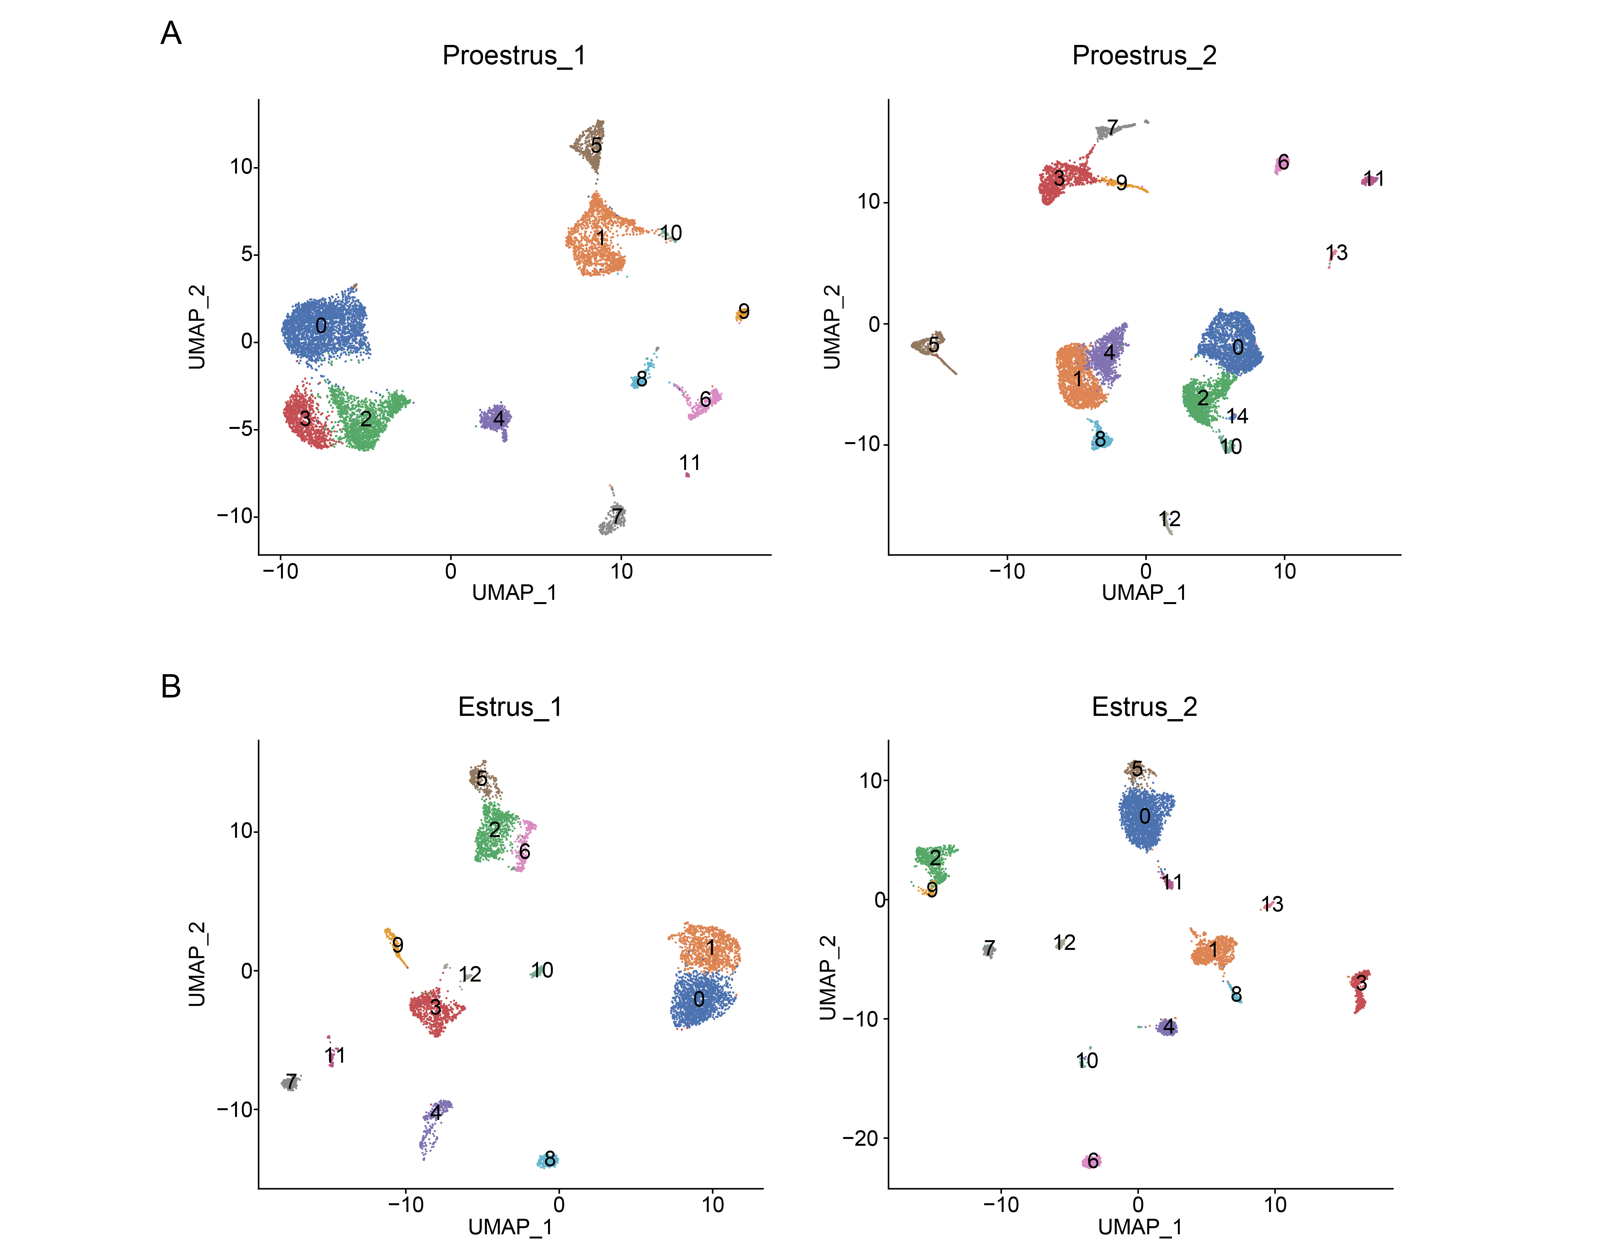 Figure S1
Preprocessing of porcine ovarian snRNA-seq data. A: UMAP plots illustrating the ovarian cell populations of two groups during the proestrus phase. B: UMAP plots illustrating the ovarian cell populations of two groups during the estrus phase.

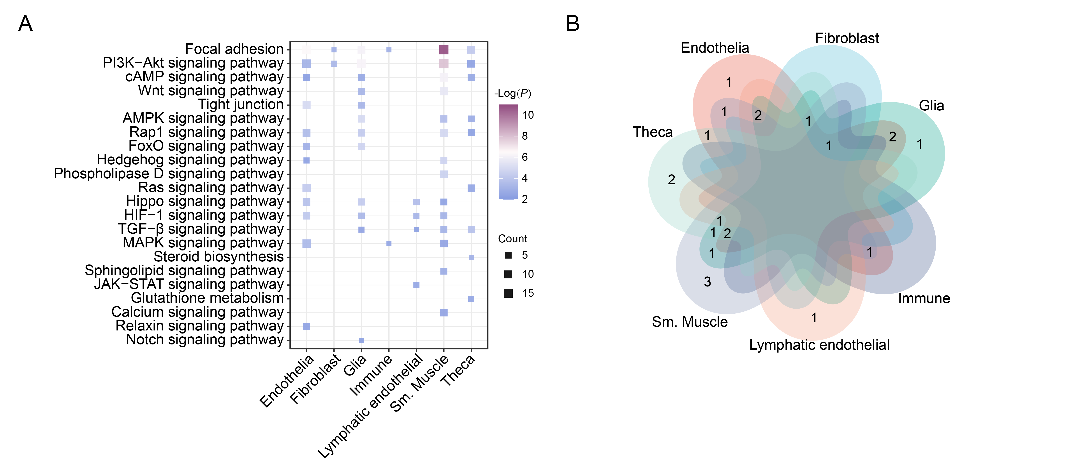 Figure S2
KEGG pathway enrichment and overlap analysis across ovarian cell types. A: KEGG enrichment analysis results for differentially expressed genes in various cell types. B: The Venn diagram illustrates the overlap in KEGG pathway enrichment results across different cell types.

