Supporting Information
Shrinkage-induced alignment within multiphoton 3D printed liquid crystal elastomers enables direct-write, arbitrary axis microactuators
Jeremy A. Herman,^{1,2} Zach Miller,¹ Emily Huntley,² Eric Nieto Gonzalez³, Holly M. Golecki,³ Bryan Kaehr,^{2*} and Devin J. Roach^{1*}
¹ School of Mechanical, Industrial, and Manufacturing Engineering, Oregon State University, Corvallis, OR 97331, USA
³ Advanced Materials Laboratory, Sandia National Laboratories, Albuquerque, NM 87106, USA
³ Bioengineering Department, Grainger College of Engineering, University of Illinois at Urbana-Champaign, Urbana, IL 61801, USA.

* Corresponding author: Dr. Bryan Kaehr, 1001 University Blvd SE, Albuquerque, NM 87106, USA
Email: bjkaehr@sandia.gov
* Corresponding author: Prof. Devin J. Roach, 204 Rogers Hall, Corvallis, OR 97331, USA
Email: devin.roach@oregonstate.edu

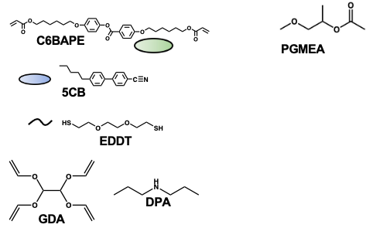
Figure S1. Chemical structures. C6BAPE is the liquid crystalline monomer used to formulate the 3D printed LCEs. 5CB is the non-reactive small molecule LC solvent that gets washed out during the processing and alignment. EDDT is included as a difunctional chain extending thiol. The thiol-Michael reaction is catalyzed with DPA. Photocrosslinking occurs between the excess thiols and the tetrafunctional vinyl crosslinker GDA. PGMEA is the solvent used to wash out the 5CB and align the printed LCEs. PGMEA also washes off any excess resin to examine the printed materials.
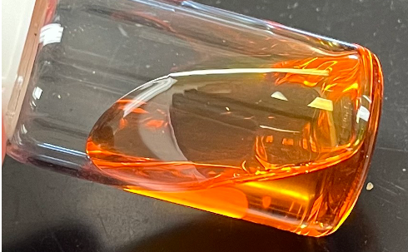
Figure S2. Viscous, optically transparent isotropic printing resin.

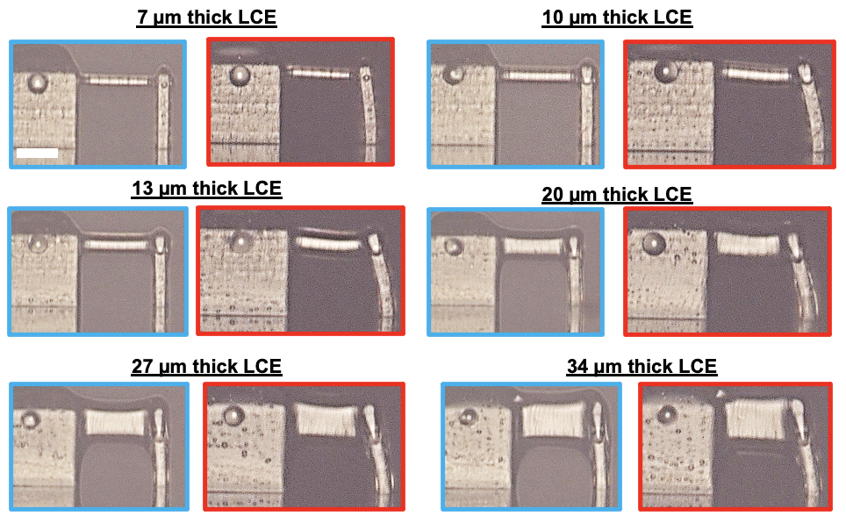
Figure S3. Pictures taken before and after heating for the LCEs where thickness is varied to study how it affects actuation and bending angle. Scale bar is 25 μm.

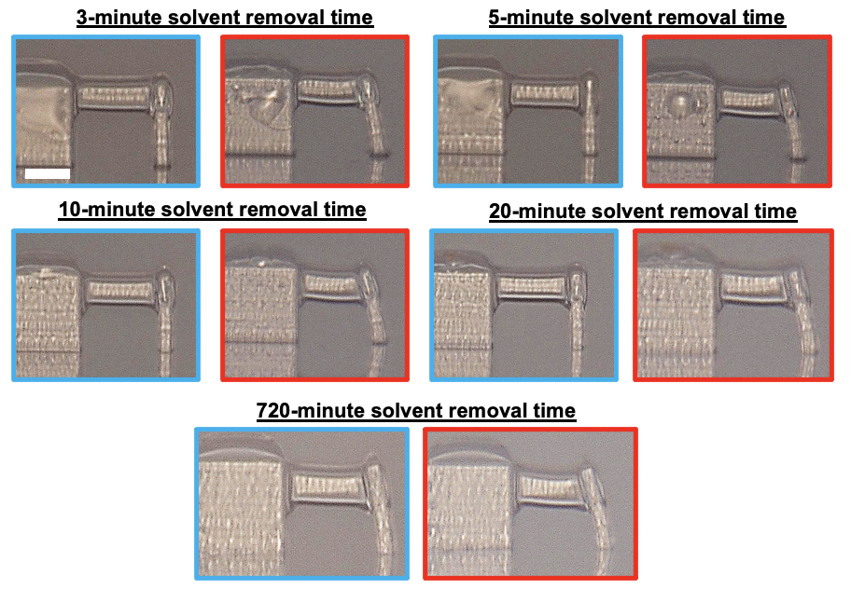
Figure S4. Pictures taken before and after heating for the LCEs where solvent removal time is varied to study how it affects actuation and bending angle. Scale bar is 25 μm.

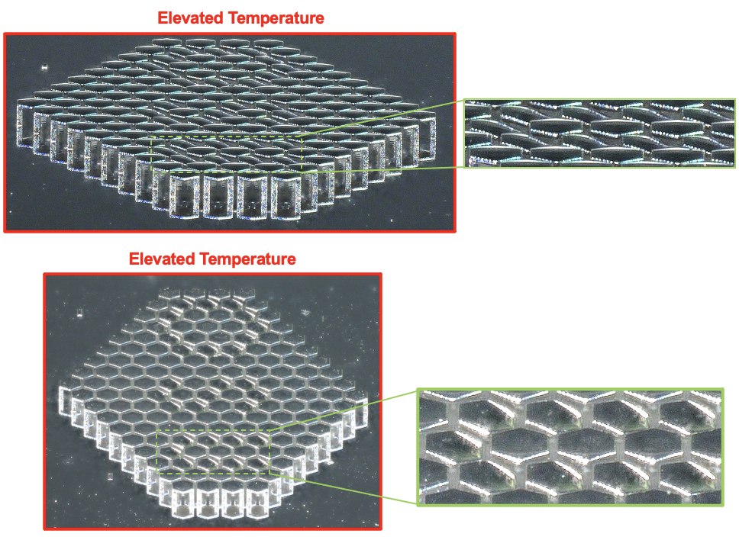
Figure S5. Additional 3D depth scans taken of the OSU hexagon array to show the heating-induced actuation and bending of the hexagon stages.
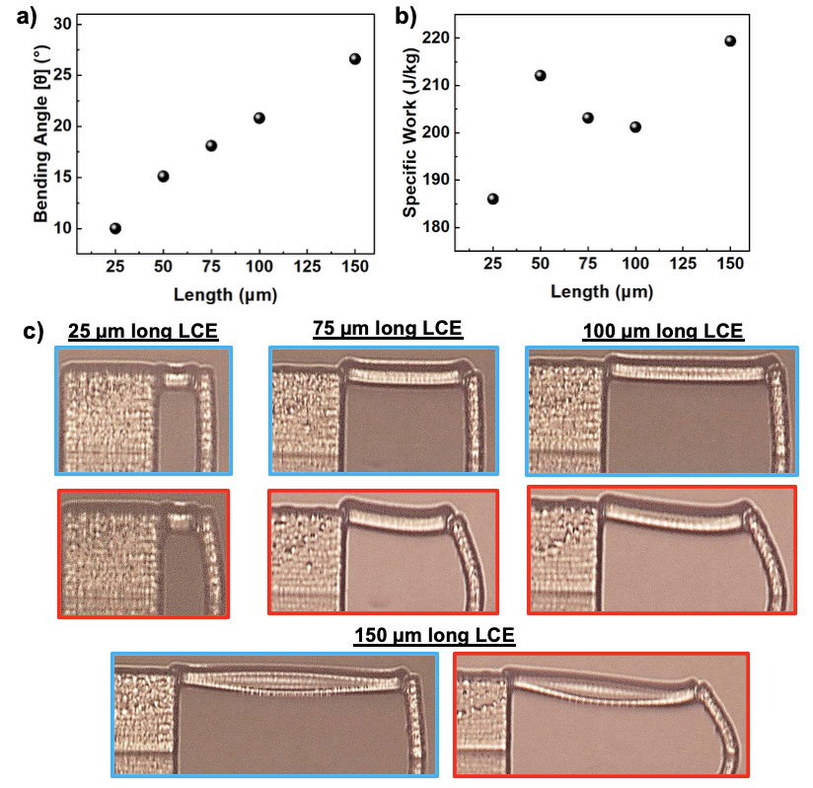
Figure S6. a) Measured bending angle of the LCEs where their length between supports is varied. b) Calculated specific work of the LCEs where their length between supports is varied. c) Images taken before and after heating of the LCEs where their length between supports is varied. Scale bar is 25 μm.

Additional Information for Force, Work, and Free Actuation Strain Calculations
To estimate the free strain in the constrained sample, the first step is to determine the force applied to the compliant block. To do this, Euler-Bernoulli beam theory is used giving the force as
$$f_{block}=\frac{2θEI}{h^{2}}$$
Equation 1
where $f_{block}$ (N) is the blocking force applied by the activated LCE sample, $θ$ (rad) is the angle of deflection of the compliant member, $E$ (MPa) is the modulus of elasticity of the compliant member, $I$ (mm^4) is the moment of inertia of the compliant member, and $h$ (mm) is the height at which the LCE attaches to the compliant member.
Upon solving for blocking force, we then solve for work which is represented by the elastic strain energy.
$$U= \frac{f_{block}^{2}h^{3}}{6EI}$$
Equation 2
Next we define the state of the LCE sample in the relaxed state as after development but before activation and the deformed state as the final actuated state of the LCE. Being that both the relaxed and deformed state are post development, a constancy of volume assumption is used. We define the coordinate system for the LCE as $z$ lying along the long axis, $x$ lying along the thickness, and $y$ lying along the width. Thus the uniaxial stretch is
$$λ=\frac{L_{z}}{L_{Z}}$$
and the deformation gradient in the deformed state is
$$F=\left(\begin{matrix}1/{\sqrt{λ}} & 0 & 0 \\ 0 & 1/{\sqrt{λ}} & 0 \\ 0 & 0 & λ \\ & & \end{matrix}\right)$$
we impose incompressibility, $J=detF=1$. We further set the director to
$$n=(0,0,1)^{⊺}$$
and define the uniaxial step length tensor as
$$l=l_{⟂}I+(l_{∥}-l_{⟂})n⊗n$$
giving the step length tensors in the relaxed state and deformed states as
$$l_{r}=\left(\begin{matrix}l_{⟂} & 0 & 0 \\ 0 & l_{⟂} & 0 \\ 0 & 0 & l_{∥}\end{matrix}\right)=\left(\begin{matrix}1-S & 0 & 0 \\ 0 & 1-S & 0 \\ 0 & 0 & 1+2S\end{matrix}\right), l_{f}=I$$
where $S$ is the scalar order parameter, and we have non-dimensionalized the step length as Terentjev such that $\text{Tr}(l)=3$.
Assuming neo-classical behavior, we use the free energy density in the form
$$F=\frac{1}{2}μ\text{ Tr}(F^{⊺}⋅l_{r}^{-1}⋅F⋅l_{f}^{-1})=\frac{1}{2}μ\text{ Tr}(F^{⊺}⋅l_{r}^{-1}⋅F)$$
giving the first Piola-Kirchhoff stress as
$$P=\frac{∂F}{∂F}-p\frac{∂J}{∂F}=μFl_{r}^{-1}-pF^{-⊺}$$
where $p$ is a Lagrange multiplier. For the simple case of uniaxial stretch, $P_{zz}=f/A_{0}$, so
$$P=\text{diag}(0,0,f_{block}/A_{0})$$
which gives a system of equations where lateral faces are traction-free. This system can be solved for the unknown Lagrange multiplier $p$ and the scalar order parameter $S$. For the nematic to isotropic transition upon heating, the spontaneous stretch along $n$ is
$$λ_{s}=(\frac{1-S}{1+2S})^{1/3}.$$

