Supplementary Material for:
Biochar enhances methane uptake in engineered green roof substrate

Imrul Kayes*^{1,2}, Md Abdul Halim^{1,3}, Wenxi Liao^{1,4}, Md Rezaul Karim¹, Melanie A. Sifton¹, Sean C. Thomas*¹
¹Institute of Forestry and Conservation, John H. Daniels Faculty of Architecture, Landscape and Design, University of Toronto, 33 Willcocks Street, Toronto, ON M5S 3B3 Canada
²School of the Environment, University of Toronto, 5 Bancroft Ave, Toronto, ON M5S 3J1, Canada
³CredoSense Inc., B114-3600 Steeles Ave. E, Markham, ON L3R 9Z7, Canada
⁴School of Environmental Sciences, University of Guelph, 50 Stone Road East, Guelph, ON, N1G 2W1, Canada
*Corresponding authors: Imrul Kayes (imrul.kayes@mail.utoronto.ca)
Sean C. Thomas (sc.thomas@utoronto.ca)

Figure S1. (a) Green Roof Innovation Testing Laboratory (GRIT Lab), University of Toronto, showing the design of the extensive green roof modules (Bioroof Systems Inc.) and, (b) substrate gas flux measurement set-up. In situ greenhouse gas fluxes were measured using a cavity ring-down gas analyzer (Los Gatos Research, San Jose, USA) coupled with a closed dynamic chamber system (LI-8100A, LI-COR Biosciences, Lincoln, USA).
Figure S2. Seasonal and interannual variation in CH₄ flux under biochar and no-biochar treatments from 2020 to 2024. Mean (± SE) CH₄ fluxes are shown for Spring, Summer, and Fall across years, separated by treatment type (left = Biochar; right = No Biochar). Different lowercase letters indicate significant differences among years within each season based on estimated marginal means pairwise comparisons (p < 0.05). Asterisks denote significant differences across seasons within the same treatment and year (p < 0.05, *p < 0.01). Negative values represent CH₄ uptake (net oxidation) by the substrate.

Figure S3. Seasonal and interannual variation in CO₂ flux under biochar and no-biochar treatments from 2020 to 2024. Mean (± SE) CO₂ fluxes are shown for Spring, Summer, and Fall across years, separated by treatment type (left = Biochar; right = No Biochar). Different lowercase letters indicate significant differences among years within each season based on estimated marginal means pairwise comparisons (p < 0.05). Asterisks denote significant differences across seasons within the same treatment and year (p < 0.05, *p < 0.01).

Figure S4. Seasonal and interannual variation in H₂O flux under biochar and no-biochar treatments from 2020 to 2024. Mean (± SE) H₂O fluxes are shown for Spring, Summer, and Fall across years, separated by treatment type (left = Biochar; right = No Biochar). Different lowercase letters indicate significant differences among years within each season based on estimated marginal means pairwise comparisons (p < 0.05). Asterisks denote significant differences across seasons within the same treatment and year (p < 0.05, *p < 0.01).

Figure S5. Relationships between substrate properties and CH₄ flux from Sedum green roof modules. Scatter plots with fitted linear regressions are shown for (a) biochar vs. no biochar treatments, (b) substrate moisture (%), (c) temperature (°C), (d) pH, and (e) electrical conductivity (EC, µS cm⁻¹). Regression equations include slope, coefficient of determination (R²), and associated p-values.

Figure S6. Piecewise structural equation model (SEM) showing all hypothesized causal pathways linking biochar addition, environmental drivers, and CH₄ flux from green roof substrates. Green arrows represent positive standardized path coefficients and red arrows represent negative standardized path coefficients, with arrow thickness proportional to effect size. Grey dashed arrows indicate non-significant causal paths (p > 0.05), retained here to show the full tested model structure. Numbers adjacent to paths are standardized coefficients. Endogenous variables are shown with their conditional R² values, representing variance explained by predictors. Model fit was strong (Fisher’s C = 11.17, df = 6, p = 0.083). Negative CH₄ flux values indicate CH₄ uptake.

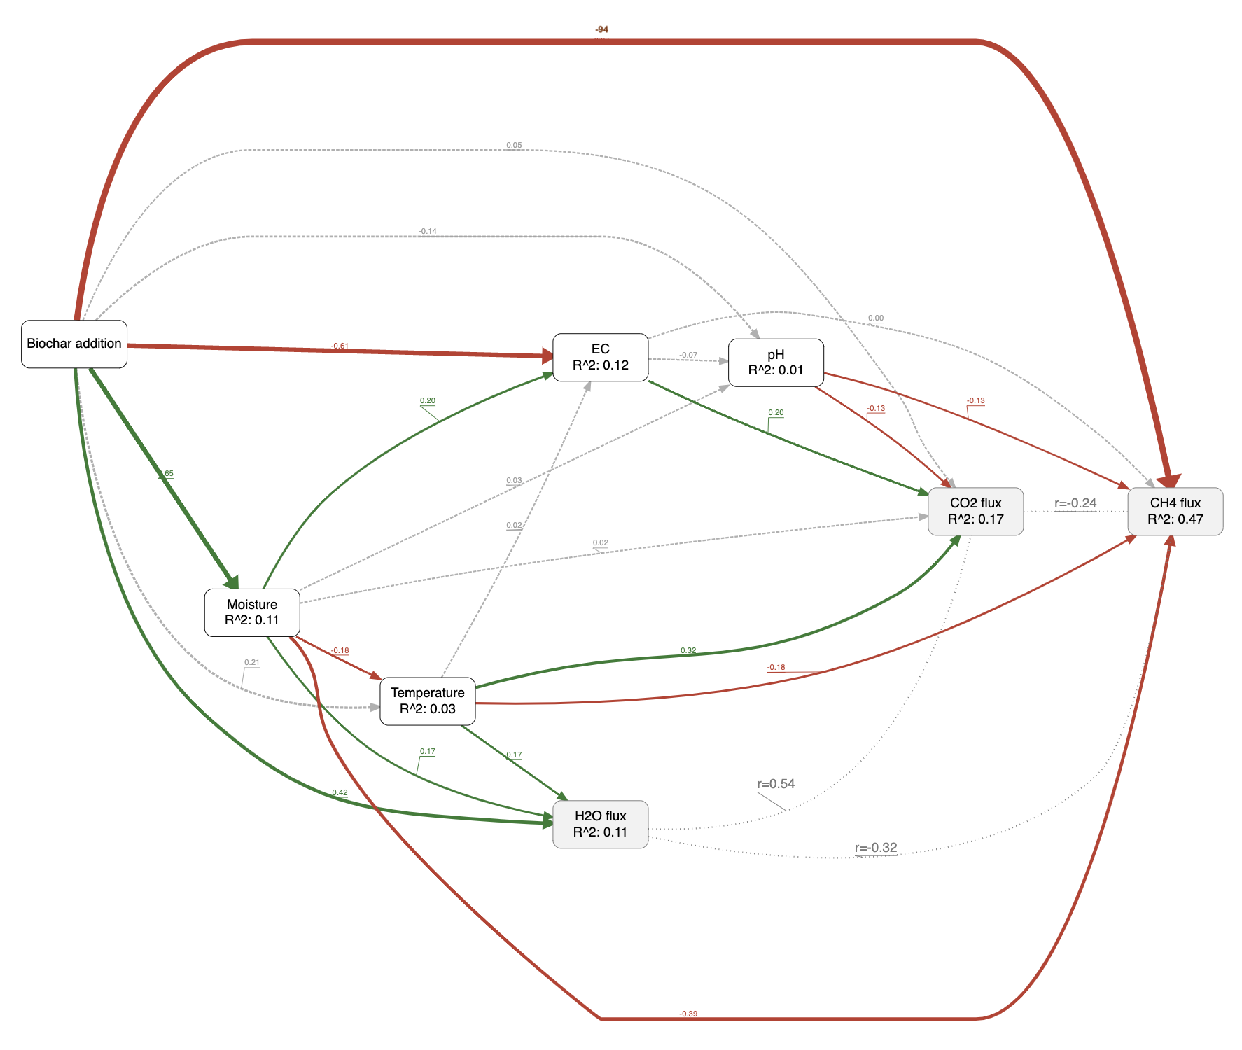

Figure S7. Example of slope calculation from the raw data stream process where (a) showing positive slope for CO₂ (emission) (b) negative slope for CH₄ (uptake) and, (c) positive slope for H₂O
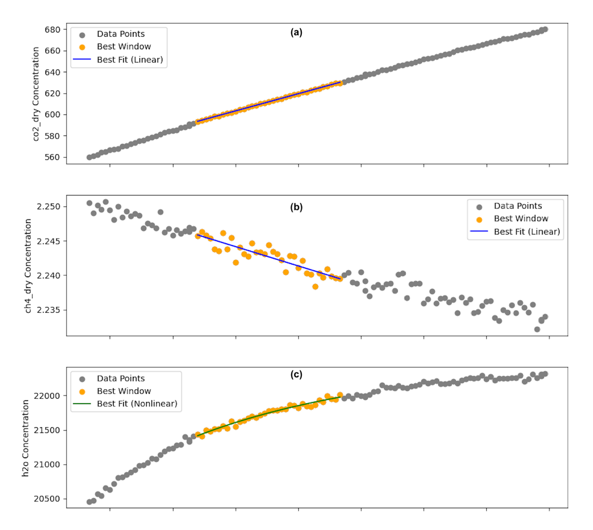

Table S1. Physicochemical properties of the biochar and green roof substrate. Means are listed with standard errors based on triplicate measurements.
Attribute | Biochar | Substrate
Bulk density (g/cm³) | 0.185 ± 0.000 | 0.169 ± 0.005
C/N ratio | 253.785 ± 5.222 | 36.588 ± 1.604
C (%) | 75.868 ± 0.102 | 35.213 ± 0.850
N (%) | 0.299 ± 0.006 | 0.965 ± 0.031
P (%) | 0.033 ± 0.001 | 0.118 ± 0.003
K (%) | 0.333 ± 0.009 | 0.513 ± 0.007
Ca (%) | 1.023 ± 0.003 | 3.563 ± 0.012
Mg (%) | 0.143 ± 0.003 | 0.473 ± 0.003
Na (%) | 0.056 ± 0.007 | 0.320 ± 0.006

Table S2. Seasonal mean (±SE) CH₄ fluxes (nmol·m⁻²·s⁻¹) from Sedum green roof substrates under Biochar (Sedum + Biochar), No Biochar (Sedum only), and Bare treatments, along with pairwise post hoc comparison p-values.
Measurement period (season-year) | Biochar (mean ± SE) | Control (mean ± SE) | Bare (mean ± SE)
Summer 2020 | -0.39 ± 0.06 | -0.15 ± 0.10 | 0.02 ± 0.18
Fall 2020 | -0.29 ± 0.05 | -0.18 ± 0.04 | -0.43 ± 0.06
Spring 2021 | -0.72 ± 0.16 | -0.16 ± 0.17 | 0.05 ± 0.07
Summer 2021 | -1.30 ± 0.20 | -0.20 ± 0.06 | 0.13 ± 0.14
Fall 2021 | -1.11 ± 0.17 | -0.09 ± 0.08 | -0.06 ± 0.12
Summer 2022 | -1.62 ± 0.35 | -0.23 ± 0.09 | 0.00 ± 0.06
Fall 2022 | -1.13 ± 0.11 | -0.20 ± 0.08 | -0.21 ± 0.17
Spring 2023 | -1.91 ± 0.25 | -0.40 ± 0.10 | 0.10 ± 0.09
Fall 2023 | -1.84 ± 0.50 | -0.14 ± 0.14 | -0.02 ± 0.16
Spring 2024 | -1.29 ± 0.24 | -0.57 ± 0.14 | 0.02 ± 0.03
Summer 2024 | -1.26 ± 0.17 | -0.03 ± 0.19 | 0.14 ± 0.04
Fall 2024 | -0.34 ± 0.18 | 0.07 ± 0.16 | -0.05 ± 0.15

Table S3. Seasonal mean (±SE) CO₂ fluxes (µmol·m⁻²·s⁻¹) from Sedum green roof substrates under Biochar (Sedum + Biochar), No Biochar (Sedum only), and Bare treatments, along with pairwise post hoc comparison p-values.
Measurement period (season-year) | Biochar  (mean ± SE) | Control  (mean ± SE) | Bare substrates (mean ± SE)
Summer 2020 | 8.68 ± 1.08 | 8.31 ± 0.79 | 5.55 ± 0.37
Fall 2020 | 3.68 ± 0.68 | 4.12 ± 0.42 | 5.89 ± 0.25
Spring 2021 | 8.89 ± 0.67 | 10.06 ± 0.57 | 7.89 ± 0.59
Summer 2021 | 9.07 ± 0.66 | 8.99 ± 0.94 | 6.69 ± 0.84
Fall 2021 | 1.23 ± 0.20 | 1.34 ± 0.15 | 0.62 ± 0.07
Summer 2022 | 4.92 ± 0.67 | 4.27 ± 0.42 | 1.43 ± 0.29
Fall 2022 | 11.38 ± 1.64 | 15.67 ± 1.16 | 9.69 ± 0.77
Spring 2023 | 8.83 ± 1.16 | 7.12 ± 0.65 | 7.56 ± 0.62
Fall 2023 | 4.00 ± 0.58 | 5.12 ± 0.55 | 0.64 ± 0.09
Spring 2024 | 10.85 ± 2.31 | 9.24 ± 0.96 | 7.79 ± 0.49
Summer 2024 | 6.80 ± 1.21 | 9.06 ± 1.20 | 1.08 ± 0.15
Fall 2024 | 1.84 ± 0.19 | 1.59 ± 0.11 | 8.97 ± 0.62

Table S4. Seasonal mean (±SE) H₂O fluxes (mmol·m⁻²·s⁻¹) from Sedum green roof substrates under Biochar (Sedum + Biochar), No Biochar (Sedum only), and Bare treatments, along with pairwise post hoc comparison p-values.
Measurement period (season-year) | Biochar  (mean ± SE) | Control  (mean ± SE) | Bare substrates  (mean ± SE)
Summer 2020 | 564.49 ± 25.22 | 305.90 ± 2.81 | 51.79 ± 8.60
Fall 2020 | 360.98 ± 16.84 | 124.77 ± 1.70 | 62.71 ± 4.43
Spring 2021 | 488.37 ± 68.86 | 631.15 ± 95.32 | 307.38 ± 49.00
Summer 2021 | 584.81 ± 110.04 | 291.22 ± 61.28 | 51.64 ± 7.19
Fall 2021 | 368.93 ± 50.57 | 248.26 ± 52.90 | 93.64 ± 14.24
Summer 2022 | 596.72 ± 210.68 | 270.32 ± 61.83 | 81.02 ± 17.19
Fall 2022 | 481.31 ± 57.29 | 216.32 ± 29.63 | 221.65 ± 31.97
Spring 2023 | 1211.10 ± 192.32 | 528.48 ± 63.20 | 308.35 ± 74.17
Fall 2023 | 229.52 ± 36.15 | 287.35 ± 48.31 | 79.65 ± 11.77
Spring 2024 | 962.41 ± 183.30 | 570.48 ± 78.99 | 299.75 ± 32.04
Summer 2024 | 832.90 ± 89.33 | 390.28 ± 65.23 | 52.96 ± 13.60
Fall 2024 | 182.90 ± 22.17 | 169.67 ± 27.01 | 175.69 ± 9.07

Table S5. Seasonal mean (±SE) of substrate properties under Biochar and No Biochar treatments from Summer 2020 to Fall 2024. Values are shown for soil moisture (%), temperature (°C), electrical conductivity (µS cm⁻¹), and pH.

 | Moisture (%) |  | Temperature (°C) |  | EC (µS/cm) |  | pH
 | Biochar | Control | Biochar | Control | Biochar | Control | Biochar | Control
Summer 2020 | 4.70 ± 0.57 | 3.09 ± 0.37 | 21.96 ± 0.50 | 23.51 ± 0.54 | 159.38 ± 13.01 | 157.96 ± 14.19 | 7.34 ± 0.02 | 7.36 ± 0.03
Fall 2020 | 23.23 ± 1.59 | 19.55 ± 2.77 | 12.09 ± 0.19 | 12.01 ± 0.26 | 173.62 ± 10.16 | 169.60 ± 13.24 | 7.53 ± 0.05 | 7.52 ± 0.06
Spring 2021 | 7.68 ± 1.50 | 5.25 ± 0.84 | 19.11 ± 0.53 | 19.56 ± 0.36 | 231.17 ± 17.12 | 244.18 ± 26.44 | 7.00 ± 0.06 | 7.01 ± 0.09
Summer 2021 | 21.15 ± 3.31 | 15.44 ± 2.35 | 25.62 ± 1.13 | 24.12 ± 1.09 | 229.15 ± 12.80 | 232.39 ± 13.32 | 7.26 ± 0.04 | 7.17 ± 0.10
Fall 2021 | 24.82 ± 1.06 | 20.73 ± 1.04 | 12.87 ± 0.16 | 12.76 ± 0.16 | 210.48 ± 20.72 | 259.86 ± 11.98 | 7.24 ± 0.02 | 7.29 ± 0.04
Summer 2022 | 18.73 ± 2.99 | 7.27 ± 2.15 | 26.12 ± 1.03 | 25.83 ± 0.82 | 258.05 ± 29.96 | 270.34 ± 28.30 | 7.34 ± 0.02 | 7.37 ± 0.06
Fall 2022 | 24.58 ± 1.29 | 20.92 ± 0.95 | 17.88 ± 0.18 | 17.62 ± 0.17 | NA | 448.83 ± 12.85 | NA | NA
Spring 2023 | 27.17 ± 2.27 | 23.58 ± 1.23 | 19.18 ± 0.53 | 18.57 ± 0.56 | 332.50 ± 17.68 | 401.29 ± 11.54 | 7.53 ± 0.05 | 7.52 ± 0.03
Fall 2023 | 35.02 ± 3.14 | 16.77 ± 1.77 | 14.63 ± 0.73 | 15.29 ± 0.73 | 306.96 ± 13.38 | 314.17 ± 12.59 | 7.00 ± 0.07 | 7.03 ± 0.05
Spring 2024 | 22.13 ± 2.50 | 21.38 ± 2.72 | 19.03 ± 0.18 | 17.92 ± 0.37 | 298.08 ± 13.09 | 368.75 ± 13.85 | 6.57 ± 0.04 | 6.63 ± 0.06
Summer 2024 | 31.64 ± 0.66 | 20.49 ± 2.98 | 24.37 ± 0.37 | 23.96 ± 0.39 | 274.33 ± 14.72 | 366.83 ± 18.53 | 6.74 ± 0.03 | 6.80 ± 0.03
Fall 2024 | 18.32 ± 2.11 | 14.34 ± 1.36 | 16.48 ± 0.12 | 16.30 ± 0.21 | 247.28 ± 7.76 | 293.07 ± 12.03 | 6.83 ± 0.03 | 6.96 ± 0.04

