Supplementary information for:
The potential of rooftop PV for prosumer
energy provision globally

Supplementary Tables 2
Supplementary Table 1: Average rooftop PV self-sufficiency rates across different regions and topologies in 2020 2
Supplementary Table 2: Average rooftop PV self-sufficiency rates across different regions and topologies in Net Zero 2050 3
Supplementary Figures 4
Supplementary Figure 1: Average rooftop PV self-sufficiency rates across different seasons in 2020 4
Supplementary Figure 2: Average rooftop PV self-sufficiency rates across different seasons in Net Zero 2050 5
Supplementary Figure 3: Global rooftop photovoltaic sufficiency patterns in 2020 6
Supplementary Figure 4: Global distribution of city-level rooftop PV self sufficiency in net zero 2050 7
Supplementary Figure 5: Definition and boundary of the study area 8
Supplementary Figure 6: Regional urban energy resilience regimes in 2020 9
Supplementary Figure 7: Regional urban energy resilience regimes in Net Zero 2050 10
Supplementary Figure 8: Model performance evaluation against historical benchmarks 11

Supplementary Tables

Supplementary Table 1: Average rooftop PV self-sufficiency rates across different regions and topologies in 2020. All statistics represent weighted averages based on cities’ annual electricity demand. Following the Northern Hemisphere calendar, seasons are defined as: Spring (March–April–May), Summer (June–July–August), Autumn (September–October–November), and Winter (December–January–February). The city topologies (Development first, Urban planning first, Mitigation first, and Mega all-in) refer to a data-driven global classification based on structural characteristics such as demographic scale, socioeconomic capacity, and biophysical energy demand.
Self sufficiency rate in 2020
Group | Spring | Summer | Autumn | Winter | Annual
Global | 71% | 72% | 57% | 44% | 61%
Africa | 72% | 70% | 67% | 64% | 68%
Asia | 73% | 71% | 60% | 50% | 64%
Europe | 71% | 86% | 44% | 21% | 56%
North America | 68% | 70% | 52% | 34% | 56%
South America | 76% | 75% | 79% | 78% | 77%
Oceania | 33% | 28% | 37% | 38% | 34%
Emerging | 87% | 83% | 82% | 80% | 83%
Rapidly growing | 83% | 82% | 71% | 61% | 74%
Established | 73% | 76% | 53% | 36% | 60%
Large and Megacities | 62% | 60% | 49% | 41% | 53%

Supplementary Table 2: Average rooftop PV self-sufficiency rates across different regions and topologies in Net Zero 2050. All statistics represent weighted averages based on cities’ annual electricity demand. Following the Northern Hemisphere calendar, seasons are defined as: Spring (March–April–May), Summer (June–July–August), Autumn (September–October–November), and Winter (December–January–February). The city topologies (Development first, Urban planning first, Mitigation first, and Mega all-in) refer to a data-driven global classification based on structural characteristics such as demographic scale, socioeconomic capacity, and biophysical energy demand.
Self sufficiency rate in Net Zero 2050
Group | Spring | Summer | Autumn | Winter | Annual
Global | 53% | 52% | 42% | 33% | 45%
Africa | 39% | 35% | 35% | 34% | 36%
Asia | 53% | 50% | 42% | 35% | 45%
Europe | 65% | 81% | 39% | 18% | 51%
North America | 59% | 60% | 44% | 30% | 49%
South America | 48% | 47% | 54% | 55% | 51%
Oceania | 31% | 25% | 36% | 38% | 32%
Emerging | 49% | 43% | 42% | 40% | 43%
Rapidly growing | 64% | 63% | 52% | 43% | 55%
Established | 61% | 63% | 43% | 30% | 49%
Large and Megacities | 42% | 40% | 34% | 29% | 37%

Supplementary Figures

Supplementary Figure 1: Average rooftop PV self-sufficiency rates across different seasons in 2020. Cities are aggregated into 3°×3° grid cells. Bubble size represents the total seasonal electricity demand within each grid cell, while bubble color indicates the average self-sufficiency rate weighted by the seasonal electricity demand of the constituent cities. Following the Northern Hemisphere calendar, seasons are defined as: Spring (March–April–May), Summer (June–July–August), Autumn (September–October–November), and Winter (December–January–February).
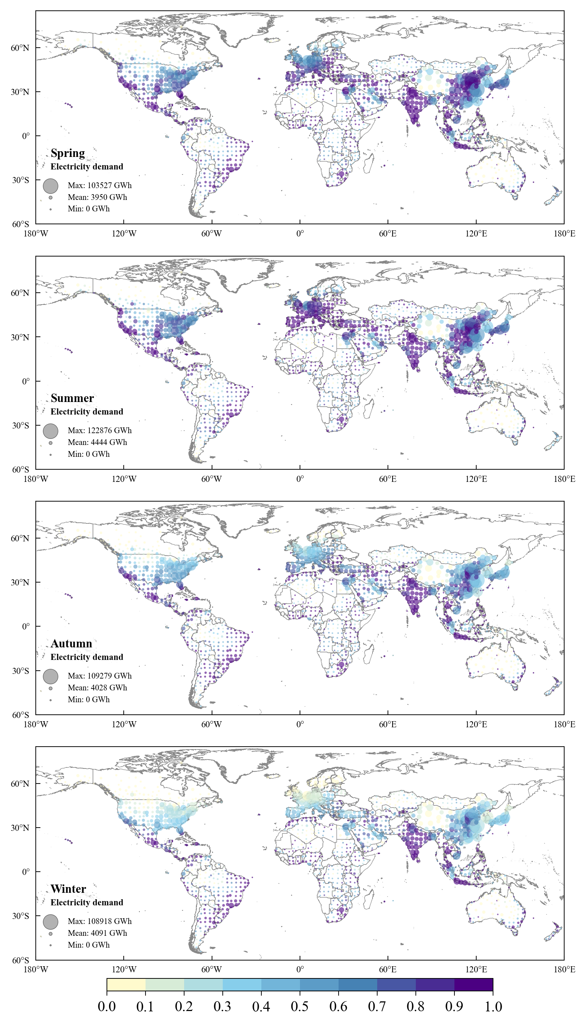

Supplementary Figure 2: Average rooftop PV self-sufficiency rates across different seasons in Net Zero 2050. Cities are aggregated into 3°×3° grid cells. Bubble size represents the total seasonal electricity demand within each grid cell, while bubble color indicates the average self-sufficiency rate weighted by the seasonal electricity demand of the constituent cities. Following the Northern Hemisphere calendar, seasons are defined as: Spring (March–April–May), Summer (June–July–August), Autumn (September–October–November), and Winter (December–January–February).
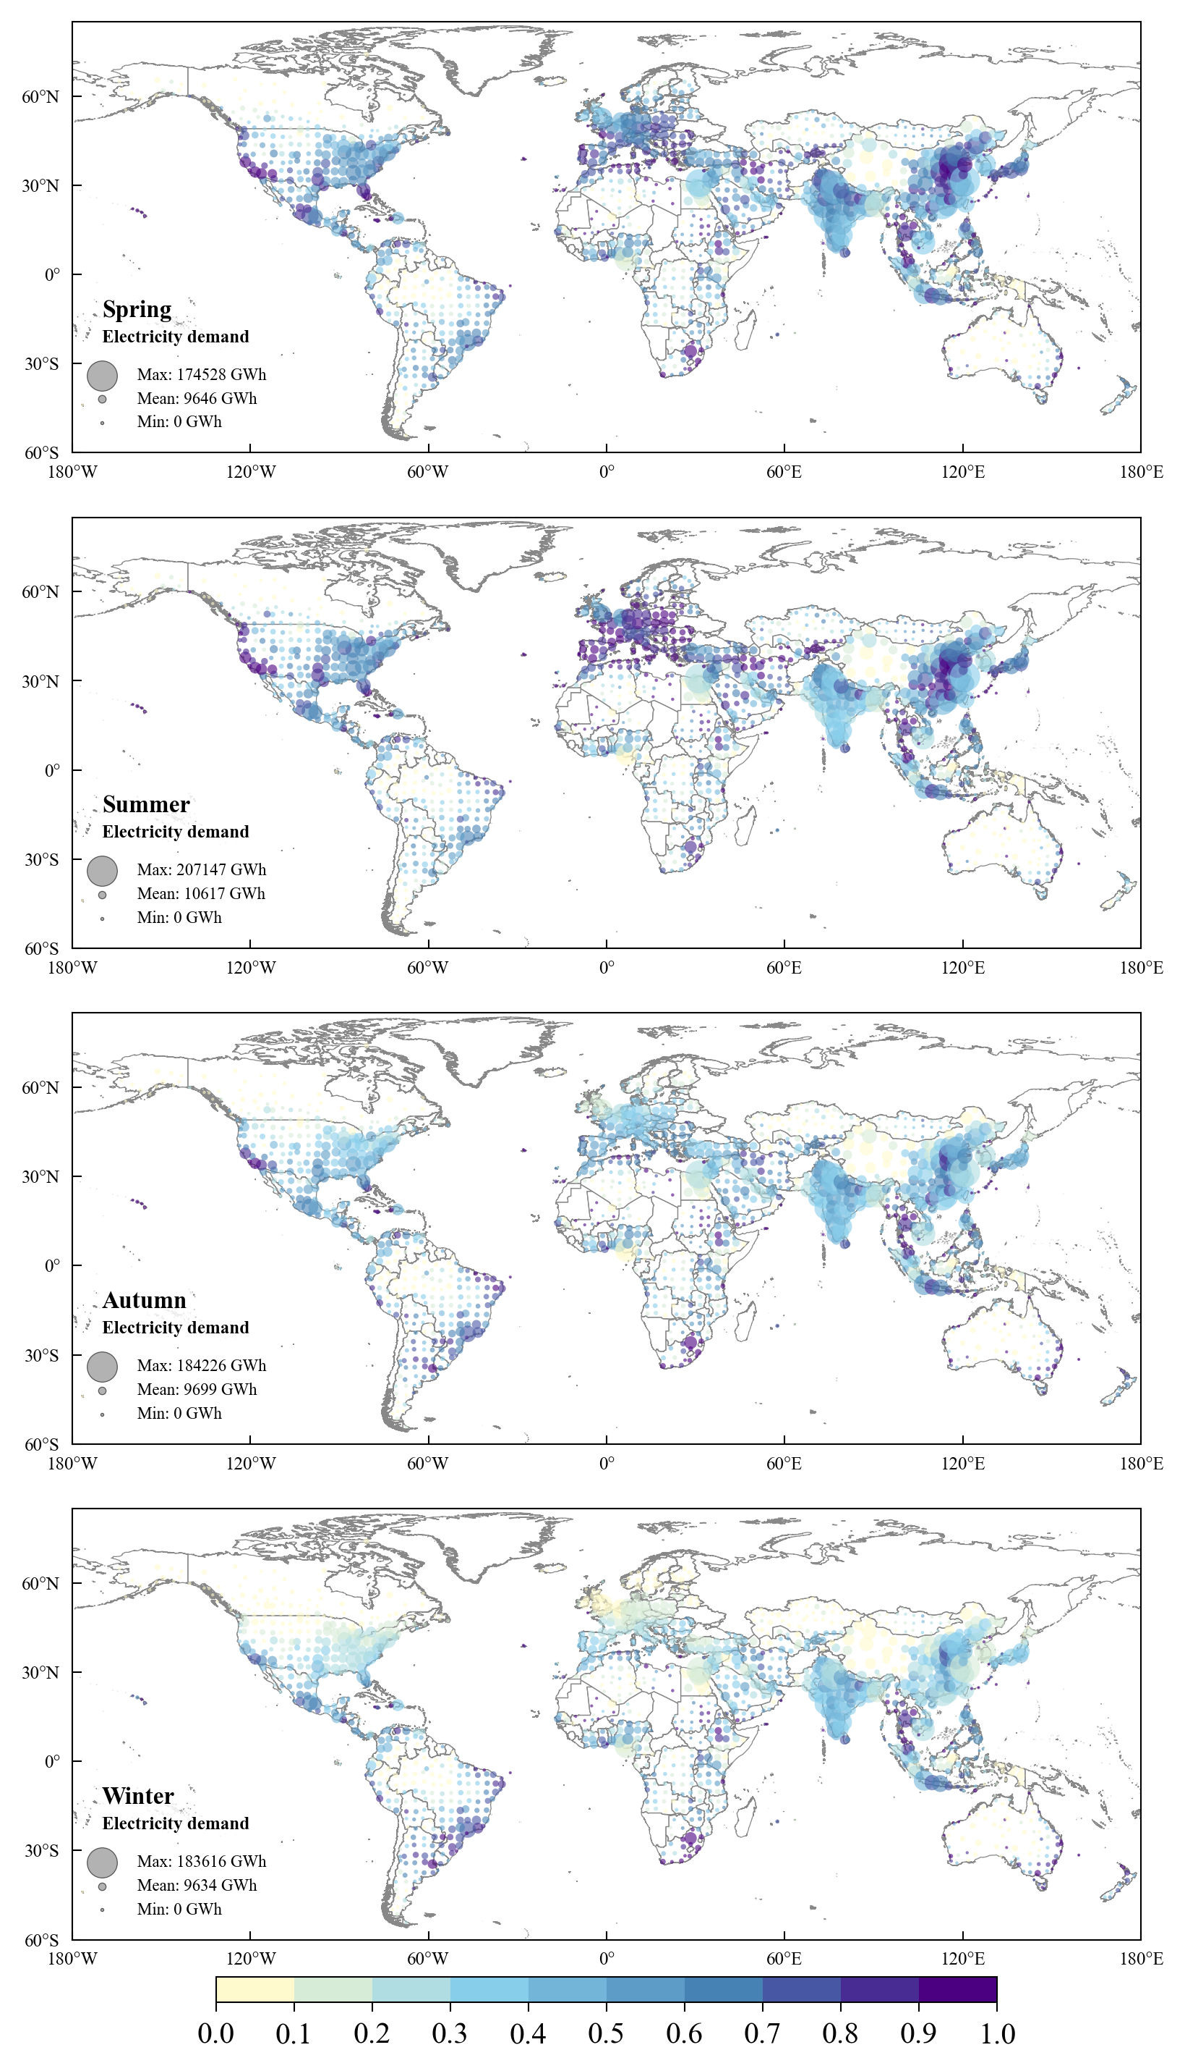

Supplementary Figure 3: Global rooftop photovoltaic sufficiency patterns in 2020. a, Merit order curve showing RPV sufficiency ranked by cumulative electricity consumption (EC) across global cities. Bars are color-coded by annual rooftop PV generation potential (GWh). The horizontal dashed line indicates the 50% sufficiency threshold. b,c Spatial distribution of high/low-sufficiency days. City-level data are aggregated to 3° × 3° grid cells using annual EC-weighted averages. Color intensity indicates the number of days with sufficiency above 75%/below 25%; Circle size represents total electricity consumption within the days.
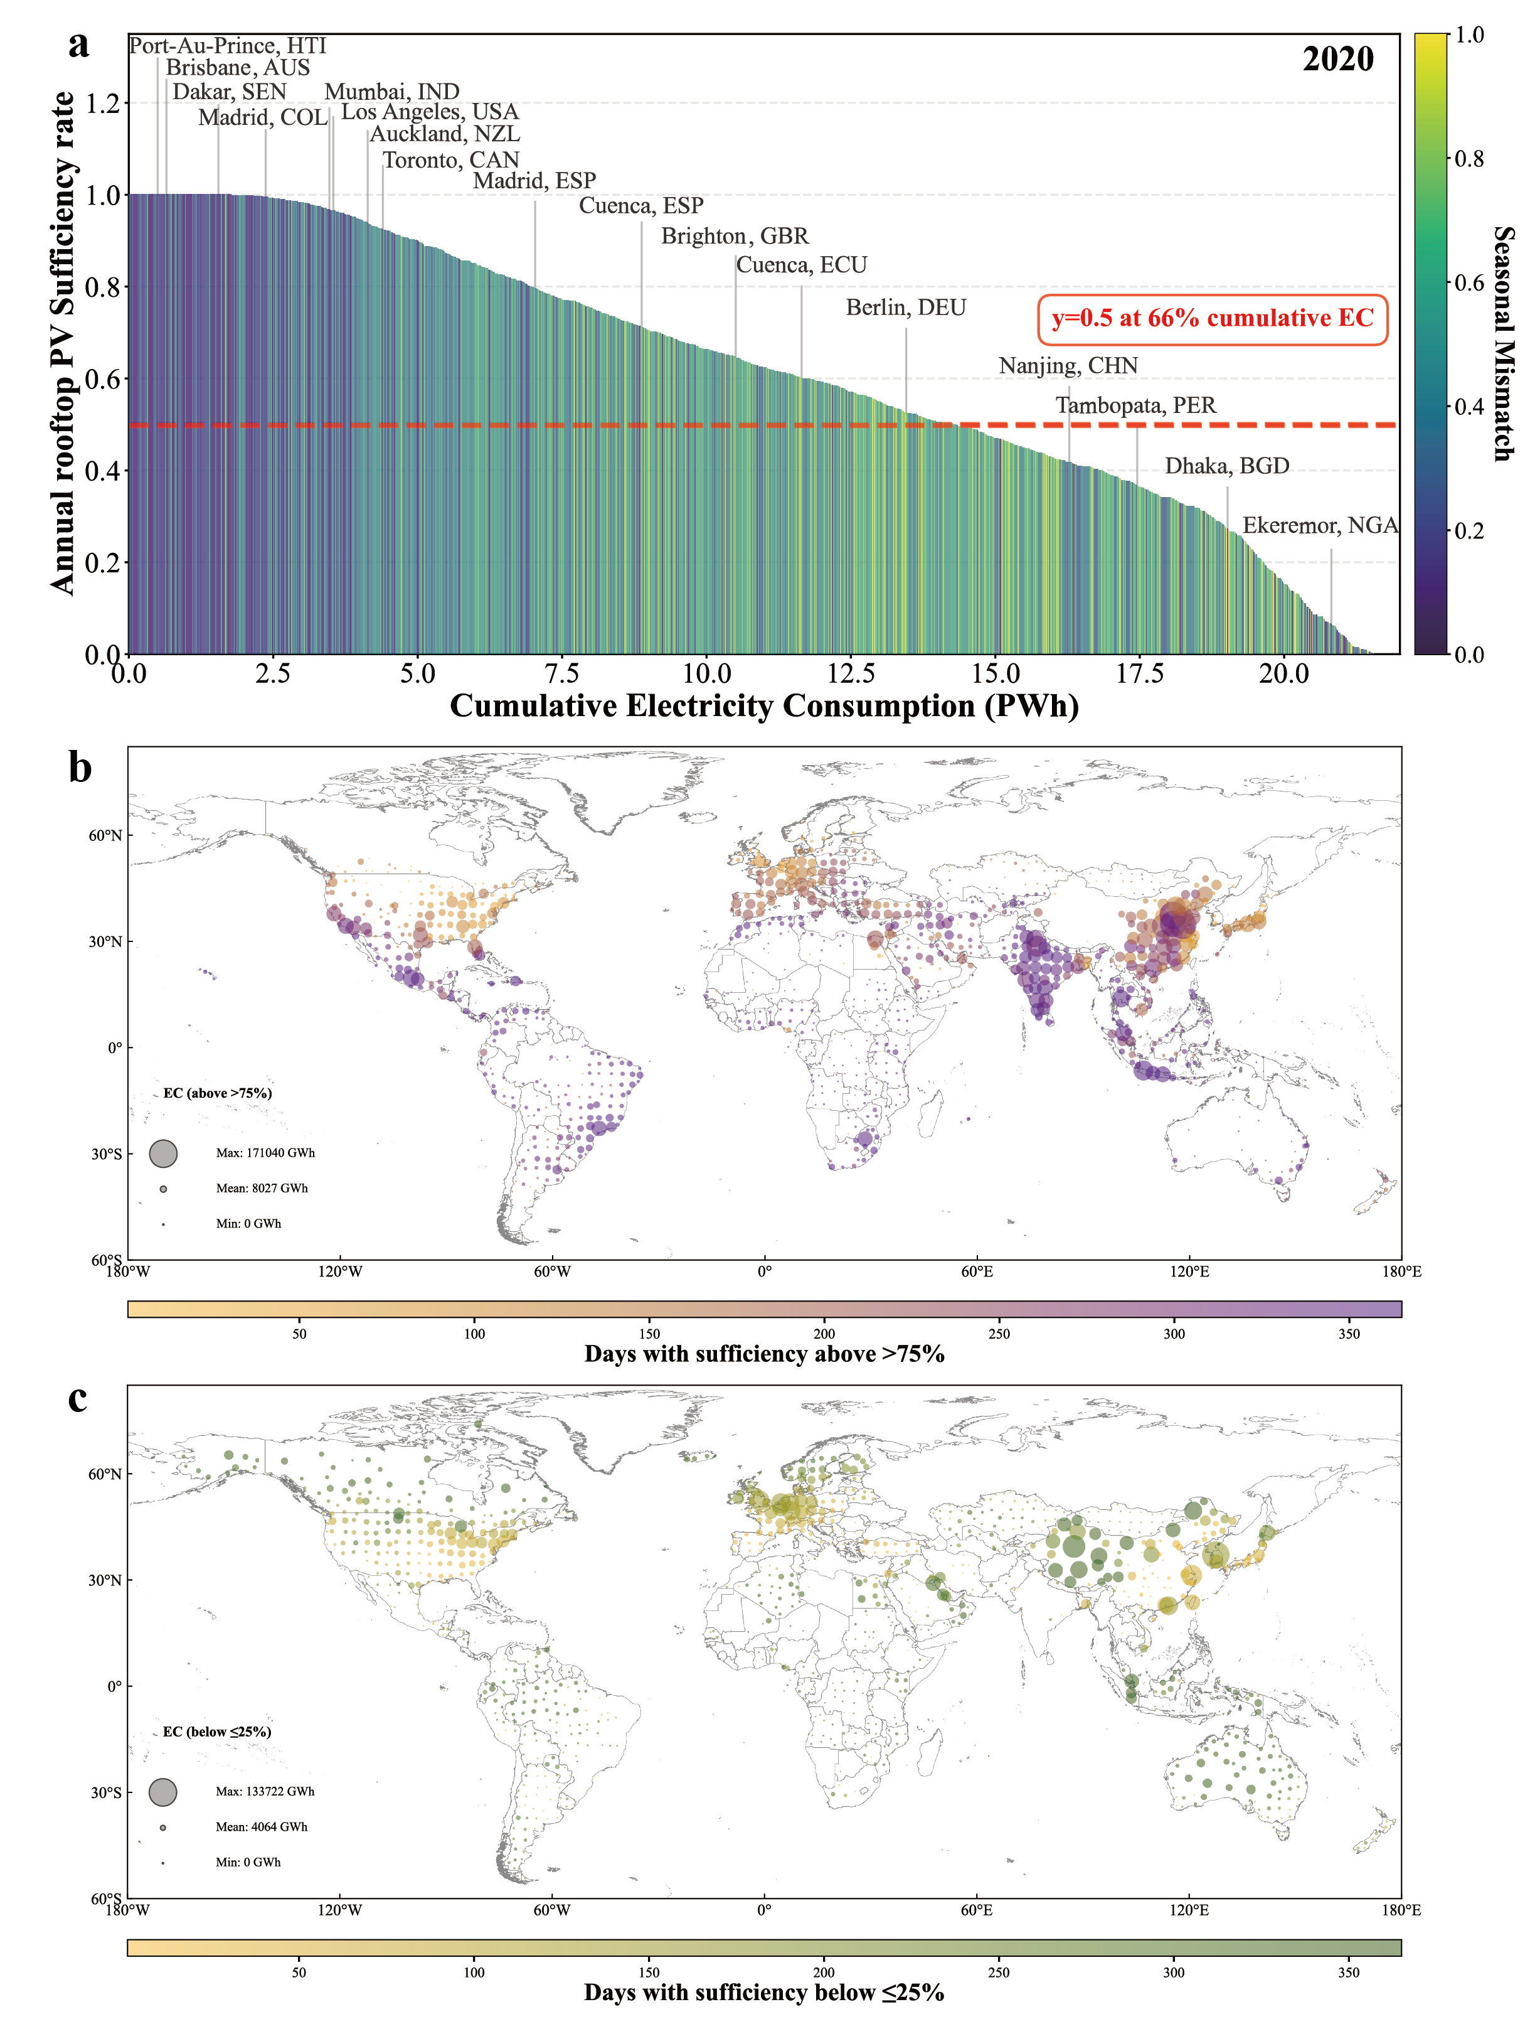

Supplementary Figure 4: Global distribution of city-level rooftop PV self sufficiency in net zero 2050. Daily self sufficiency curve at continent / cluster level (weighted average by daily energy consumption). Seasonal self sufficiency raincloud at continent / cluster level. Following the Northern Hemisphere calendar, seasons are defined as: Spring (March–April–May), Summer (June–July–August), Autumn (September–October–November), and Winter (December–January–February). The city topologies (Emerging, Rapidly growing, Established, Large and Megacities) refer to a data-driven global classification12 based on structural characteristics such as demographic scale, socioeconomic capacity, and biophysical energy demand.
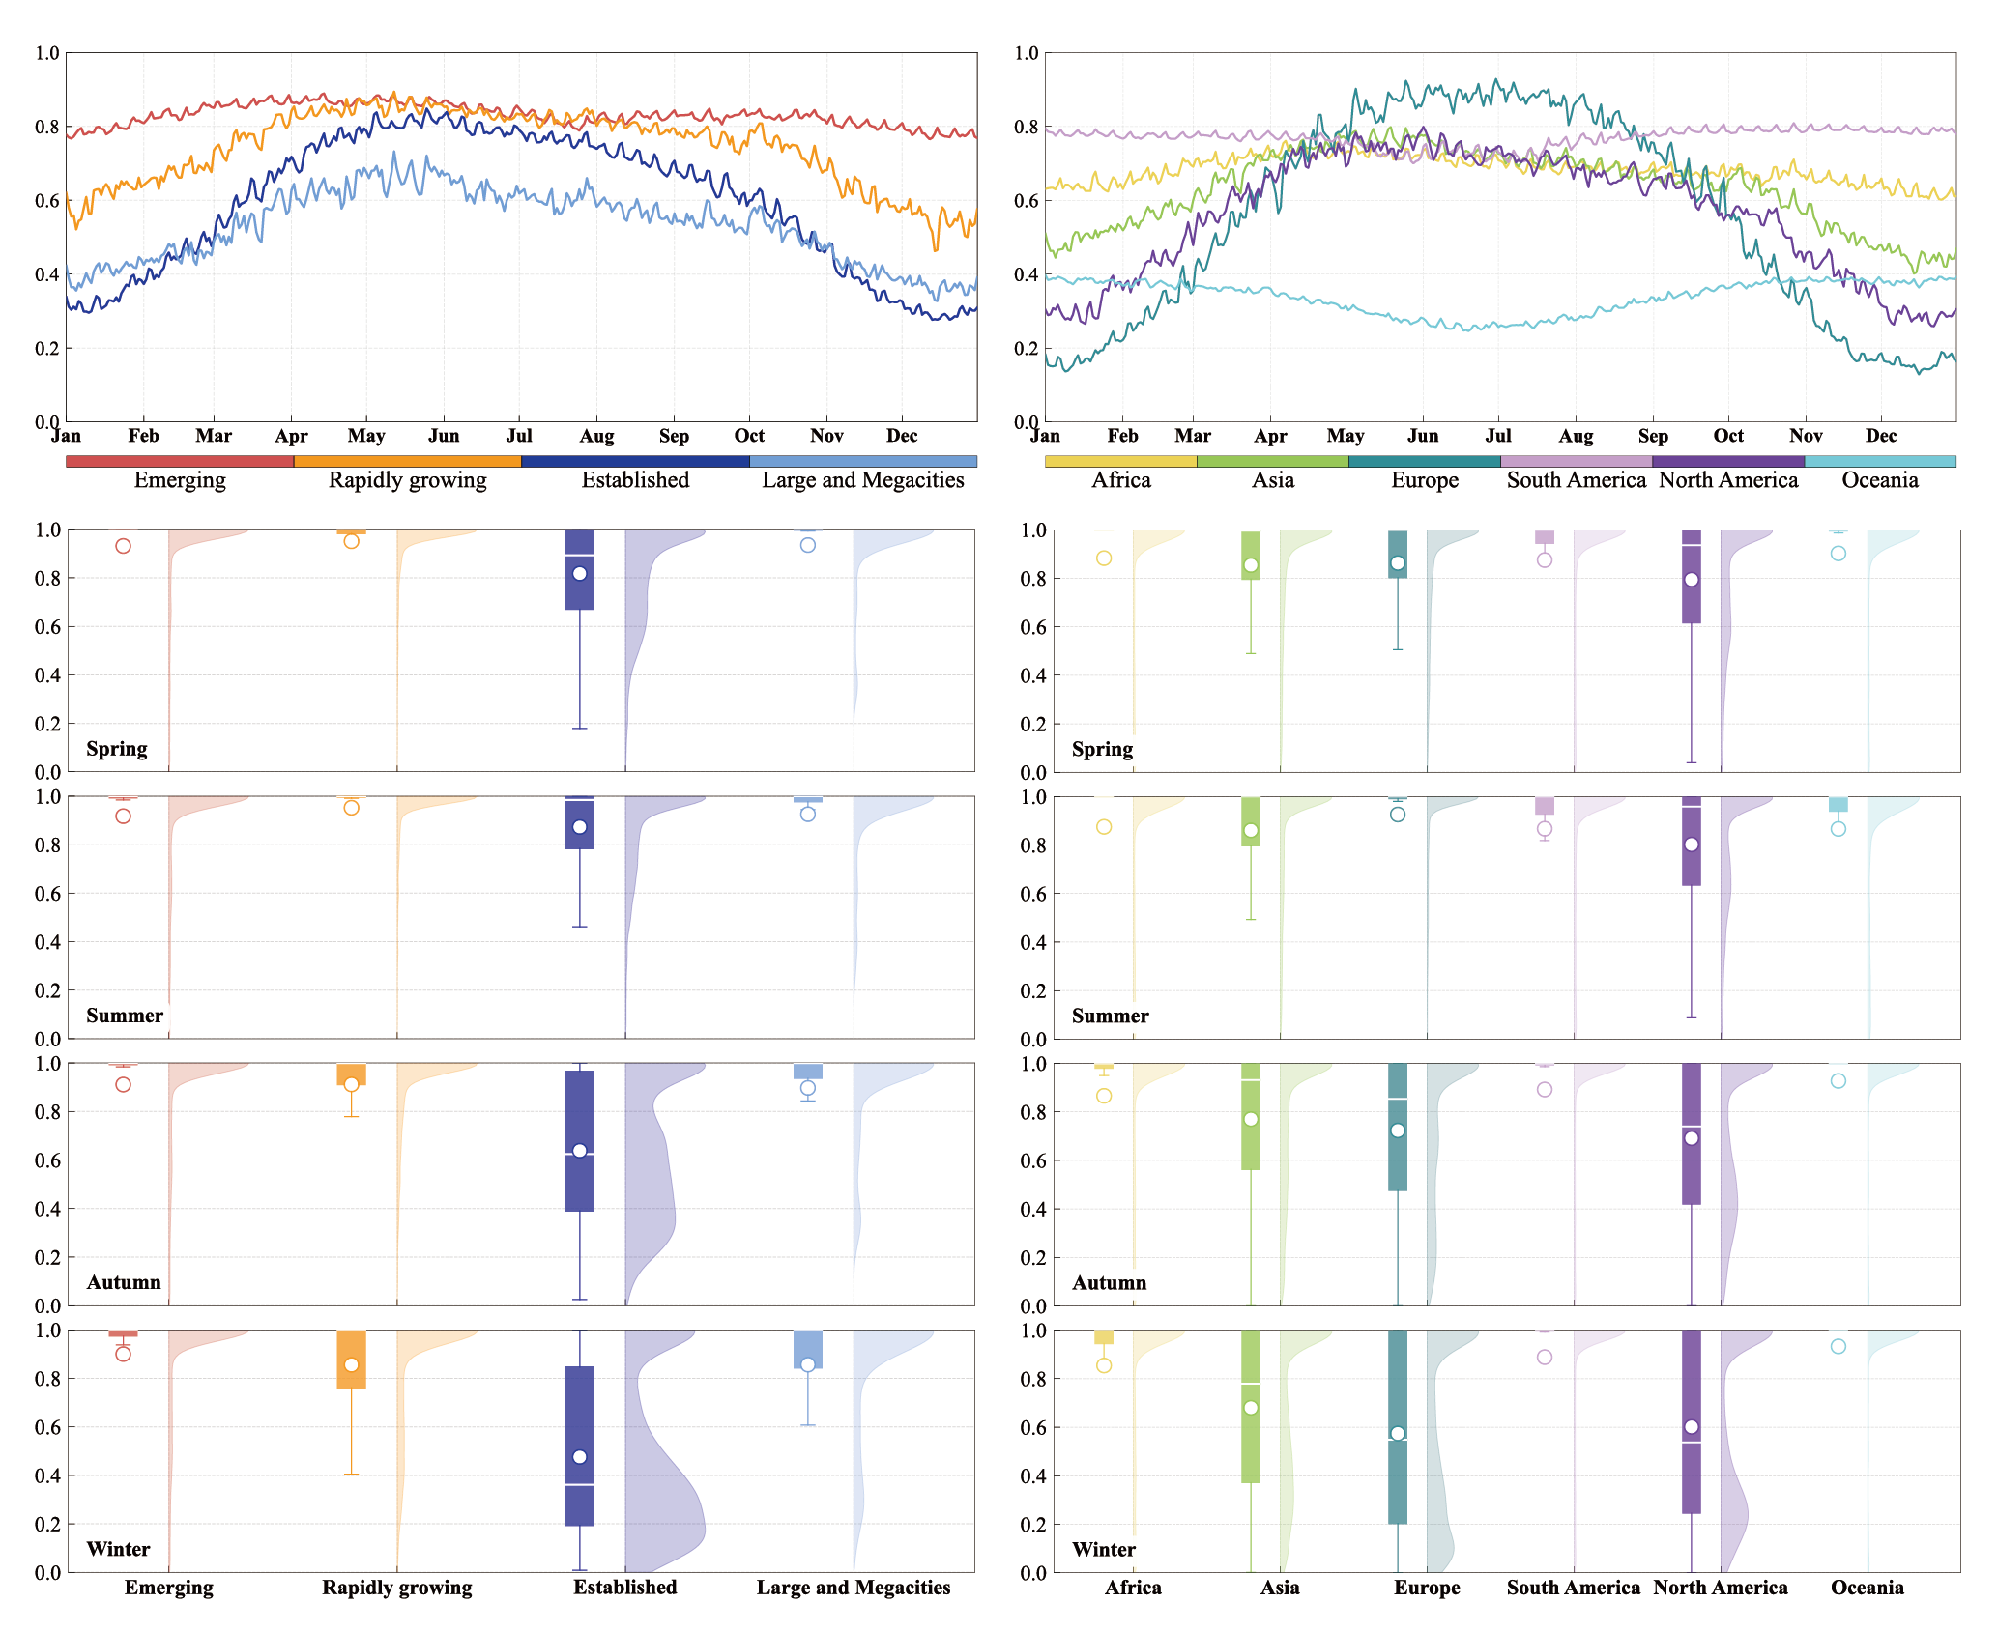

Supplementary Figure 5: Definition and boundary of the study area. We use global administrative city-level units as the base statistical units and link main urban center’ topologies to administrative city-level units via a crosswalk, enabling analyses at (a) the continent level for all cities with data and (b) the topology level for main urban centers with data.
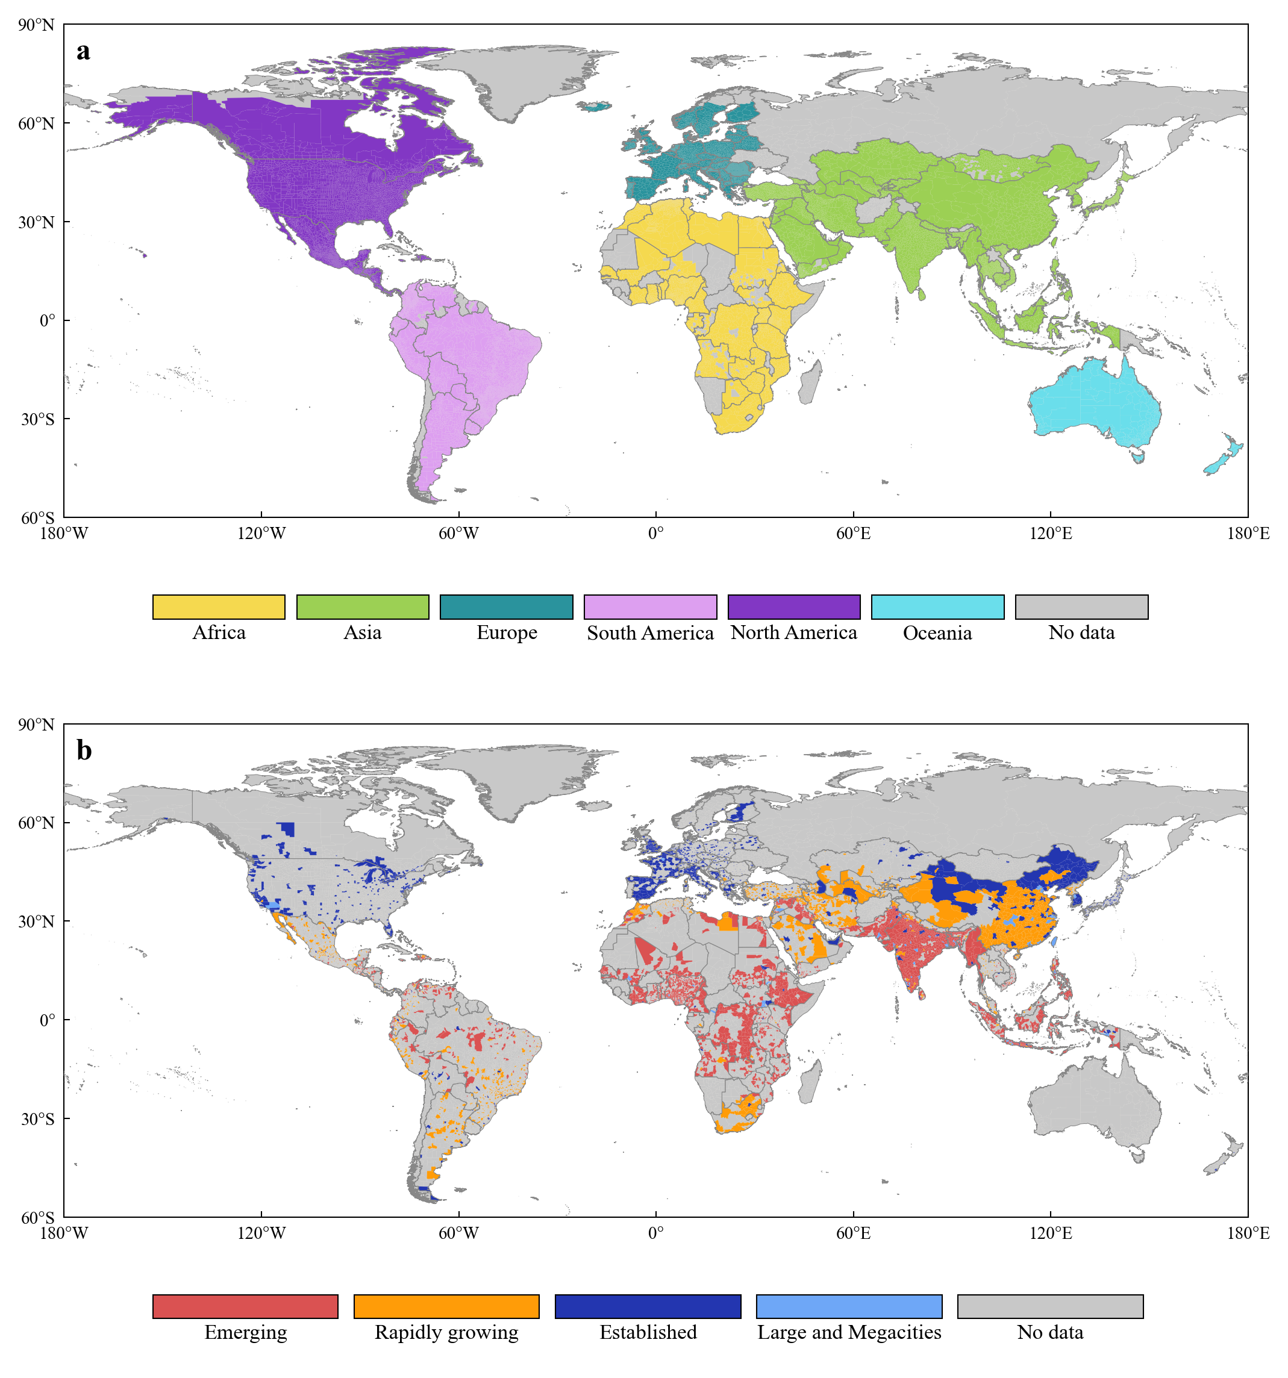

Supplementary Figure 6: Regional urban energy resilience regimes in 2020. Cities are mapped by annual mean self-sufficiency (x-axis) and seasonal mismatch (y-axis), defining four quadrants (Q1–Q4) of sufficiency potential and seasonal mismatch. Seasonal mismatch is defined as the normalized fluctuation between the months of maximum and minimum PV potential to local electricity demand ratios, representing the degree of seasonal imbalance a city faces throughout the year. The donut charts illustrate the share of total annual electricity demand across four urban types–Emerging, Rapidly growing, Established, and Large and Megacities–within each of the four resilience regimes. The central value in each donut indicates the total annual electricity demand for the respective region.
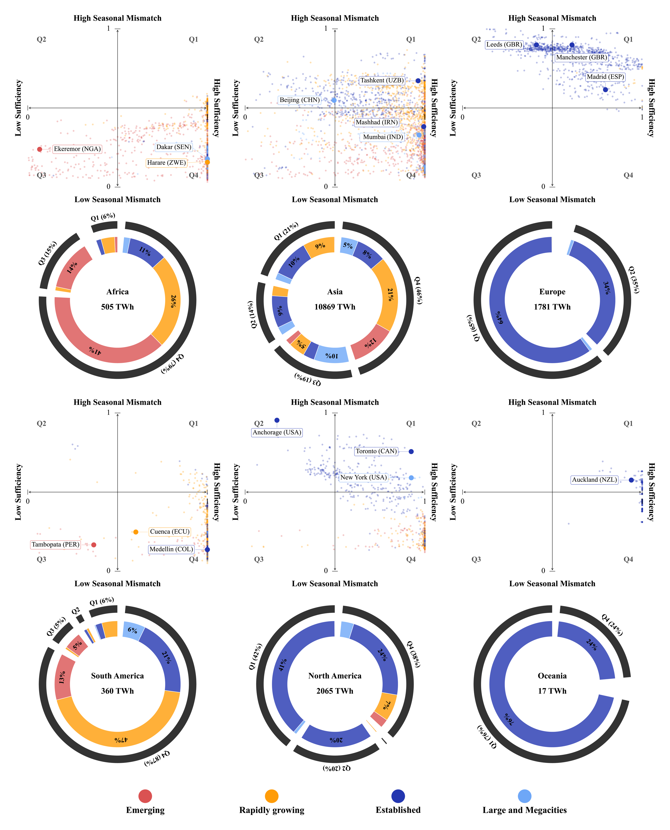

Supplementary Figure 7: Regional urban energy resilience regimes in Net Zero 2050. Cities are mapped by annual mean self-sufficiency (x-axis) and seasonal mismatch (y-axis), defining four quadrants (Q1–Q4) of sufficiency potential and seasonal mismatch. Seasonal mismatch is defined as the normalized fluctuation between the months of maximum and minimum PV potential to local electricity demand ratios, representing the degree of seasonal imbalance a city faces throughout the year. The donut charts illustrate the share of total annual electricity demand across four urban types–Emerging, Rapidly growing, Established, and Large and Megacities–within each of the four resilience regimes. The central value in each donut indicates the total annual electricity demand for the respective region.
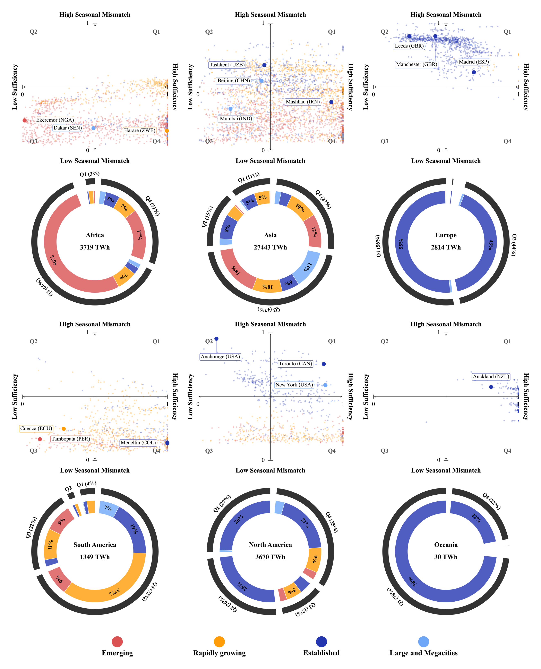

Supplementary Figure 8: Model performance evaluation against historical benchmarks. a, b, Comparison of Regional RMSE (GWh) and Regional WAPE between the panel model (orange) and the baseline model (blue). d–i, Regional histograms of city-level WAPE frequency for Africa, Asia, Europe, South America, North America, and Oceania. Dashed lines indicate the mean city-level WAPE for each respective method.
