Supplemental

Supplementary Video 1. Visible and SWIR imaging of saline injection in a healthy subject with light skin pigmentation.
Injection of 0.2 mL normal saline into the ventral forearm produces transient visible blanching, which resolves within approximately 40 s with gentle massage. In the co-registered SWIR video stream acquired at 30 fps with a 1300 ± 12 nm bandpass filter, the injection site appears darker than surrounding skin, consistent with increased absorption at 1300 nm, and remains conspicuous after the visible blanching has resolved.

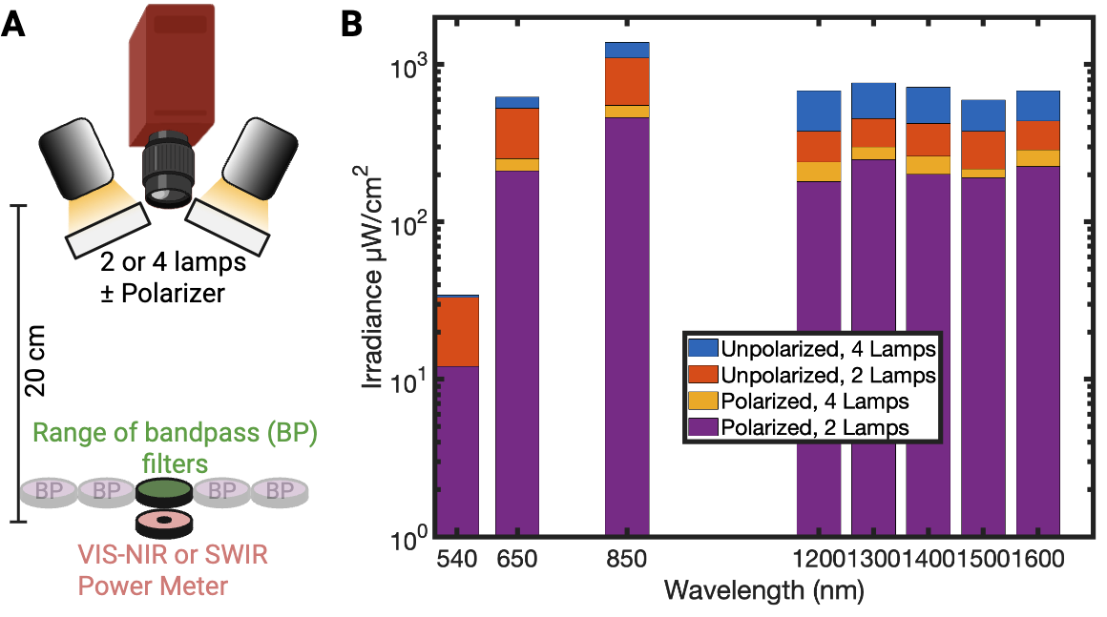
Figure S1. System irradiance versus wavelength and polarization. A) Schematic of irradiance measurement setup. The illumination system was positioned 20 cm from Thorlabs VIS-NIR or SWIR-sensitive power sensor (PM100D) and irradiance was measured through each system bandpass filter with 2 or 4 lamps active and with the polarized either removed or inserted. B) Measured irradiance for each bandpass filter (plotted by center wavelength) under four conditions (polarized vs unpolarized x 2 vs 4 lamps). Bars are color-coded by experimental condition.

Figure S2. Image intensity versus exposure time across VIS-SWIR bands. A) Measurement setup for intensity-exposure characterization. The multispectral VIS-SWIR system was positioned 20 cm from a >99% reflectance Spectralon target, and images were acquired at each bandpass filter over a range of exposure times. B) For each bandpass filter (center wavelengths of 540, 650, 850, 1200, 1300, 1600 nm), the maximum 12-bit pixel intensity (normalized to its maximum) is plotted against exposure time, demonstrating an approximately linear relationship at each wavelength.

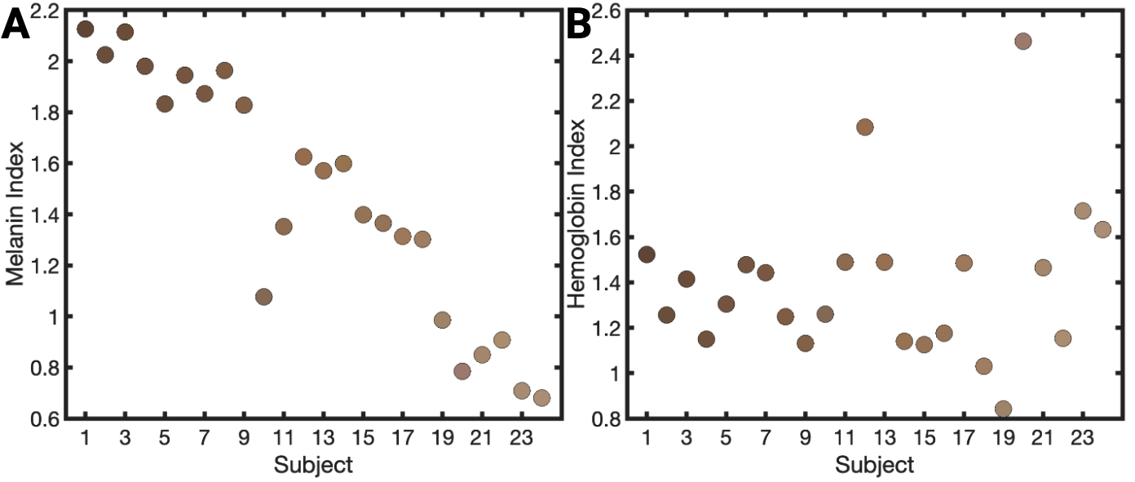
Figure S3. Spectrophotometer-derived skin chromophore indices in subjects undergoing intradermal saline injection. Subjects are ordered by increasing individual typology angle (ITA; darker to lighter pigmentation). A) Melanin index versus subject shows the expected decrease in melanin with lighter pigmentation. B) Hemoglobin index (erythema) versus subject shows no clear trend with pigmentation, though variability is greater among lighter-pigmented subjects.

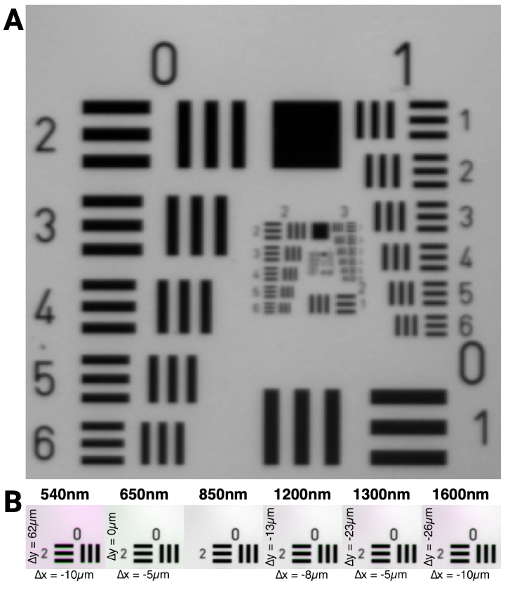
Figure S4. Assessment of chromatic aberration from VIS to SWIR. A) Cropped image of a 1951 resolution target placed on a >99% reflectance Spectralon standard, acquired with a Goldeye G-130 VIS-SWIR camera and 25 mm focal length lens at 20 cm working distance using an 850 nm bandpass filter. Line pairs appear visible blurred beyond Group 2 Element 3 (line width 99.21µm). B) With the camera and target held fixed, resolution-target images were acquired using each bandpass filter (540–1600 nm). Each panel shows an overlay (MATLAB imshowpair) of the 850-nm image with the image at the indicated wavelength. Areas where images do not overlap are highlighted in red and green. The measured horizontal (Δx) and vertical (Δy) translation required to register each wavelength to the 850-nm image is reported (850 nm serves as the reference).

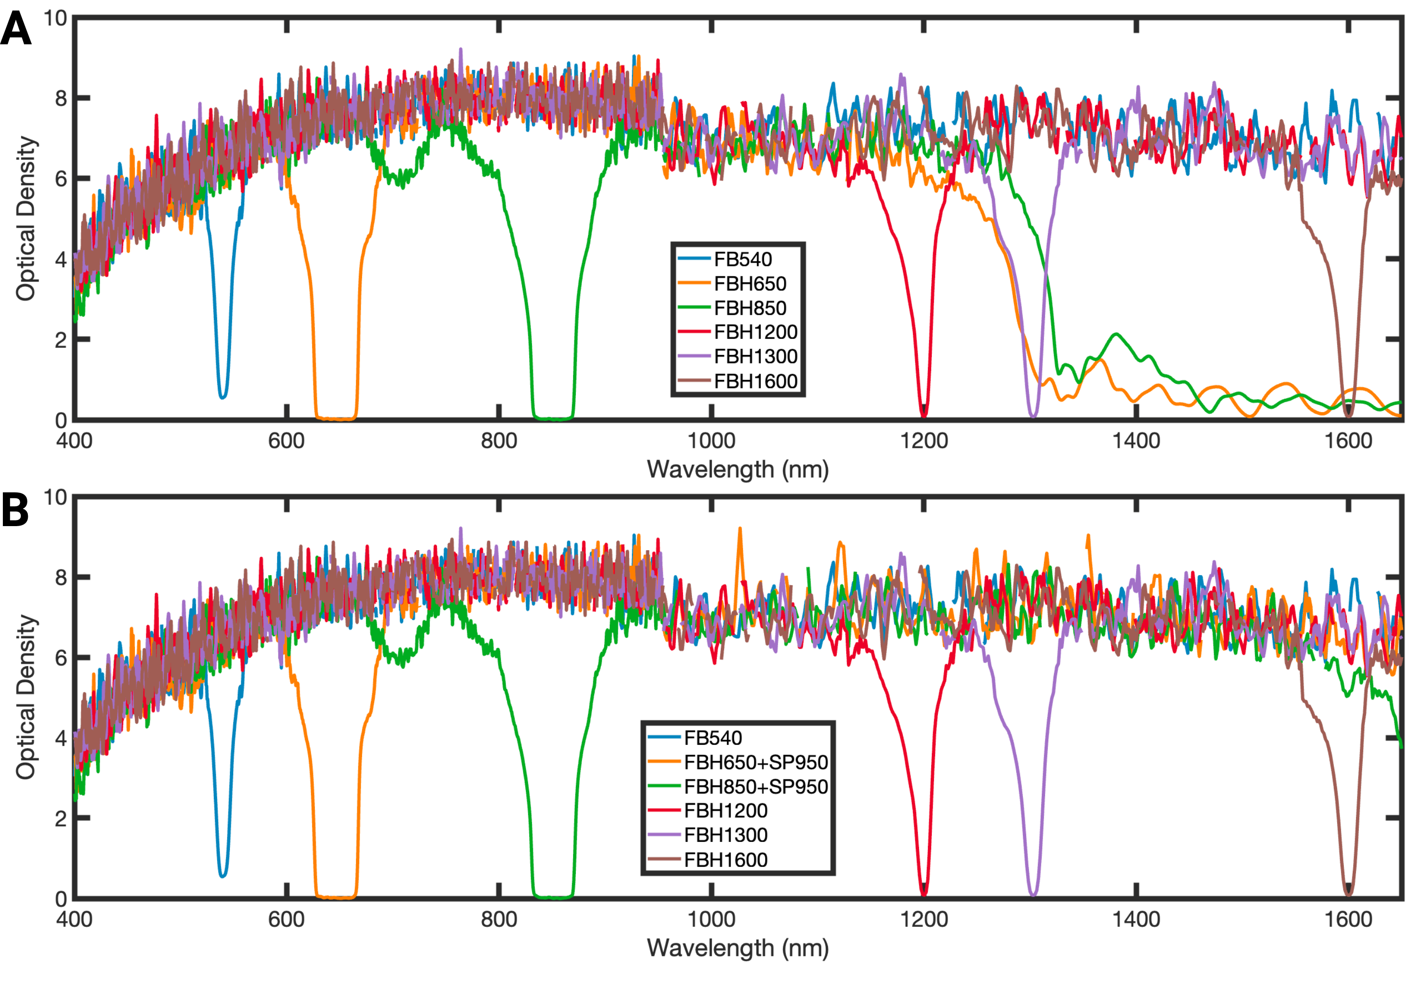 Figure S5. Broad-band blocking performance of the multispectral bandpass filters. Optical density (OD) spectra of the six bandpass filters used in the VIS–SWIR imaging system. A) The 650 nm and 850 nm filters exhibit reduced out-of-band blocking above 1250 nm (increased long-wavelength leakage). B) Adding a 950-nm OD6 shortpass filter in series with the 650-nm and 850-nm filters improves long-wavelength blocking, mitigating the leakage observed in (A).

