Extended Data
Phase-Transition Structure as Foundation for Cryptographic Hardness
Robin Bisht | bishtrobin75@gmail.com

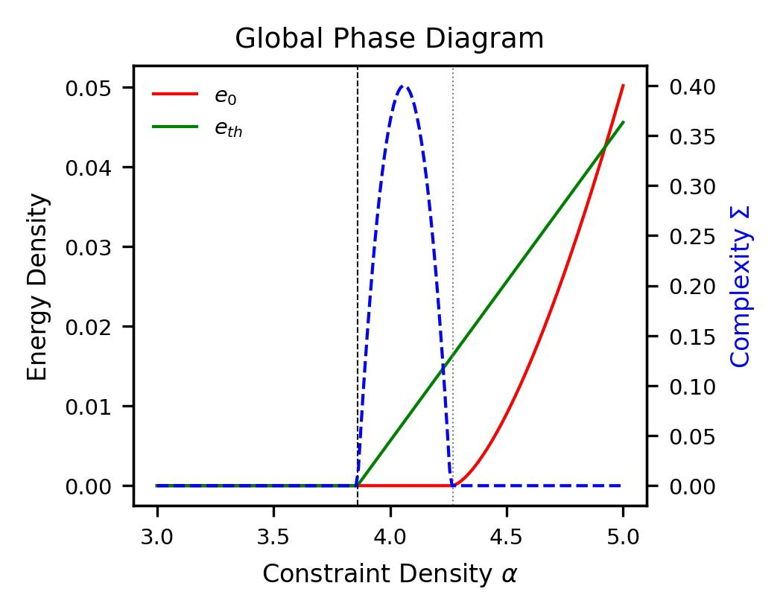
Extended Data Figures
Extended Data Figure 1 | Global Phase Diagram and Landscape Fragmentation
a, Evolution of ground-state energy density e_0 (red), threshold energy e_th (green), and cluster complexity Sigma (blue) for random 3-SAT as a function of constraint density alpha. The clustering (alpha_d approximately 3.86), condensation (alpha_c approximately 4.1), and satisfiability (alpha_s approximately 4.27) thresholds are indicated by vertical lines.
b, Schematic representation of the free-energy landscape in the shattered phase (alpha_d < alpha < alpha_s), illustrating the emergence of exponentially many metastable basins separated by extensive barriers.
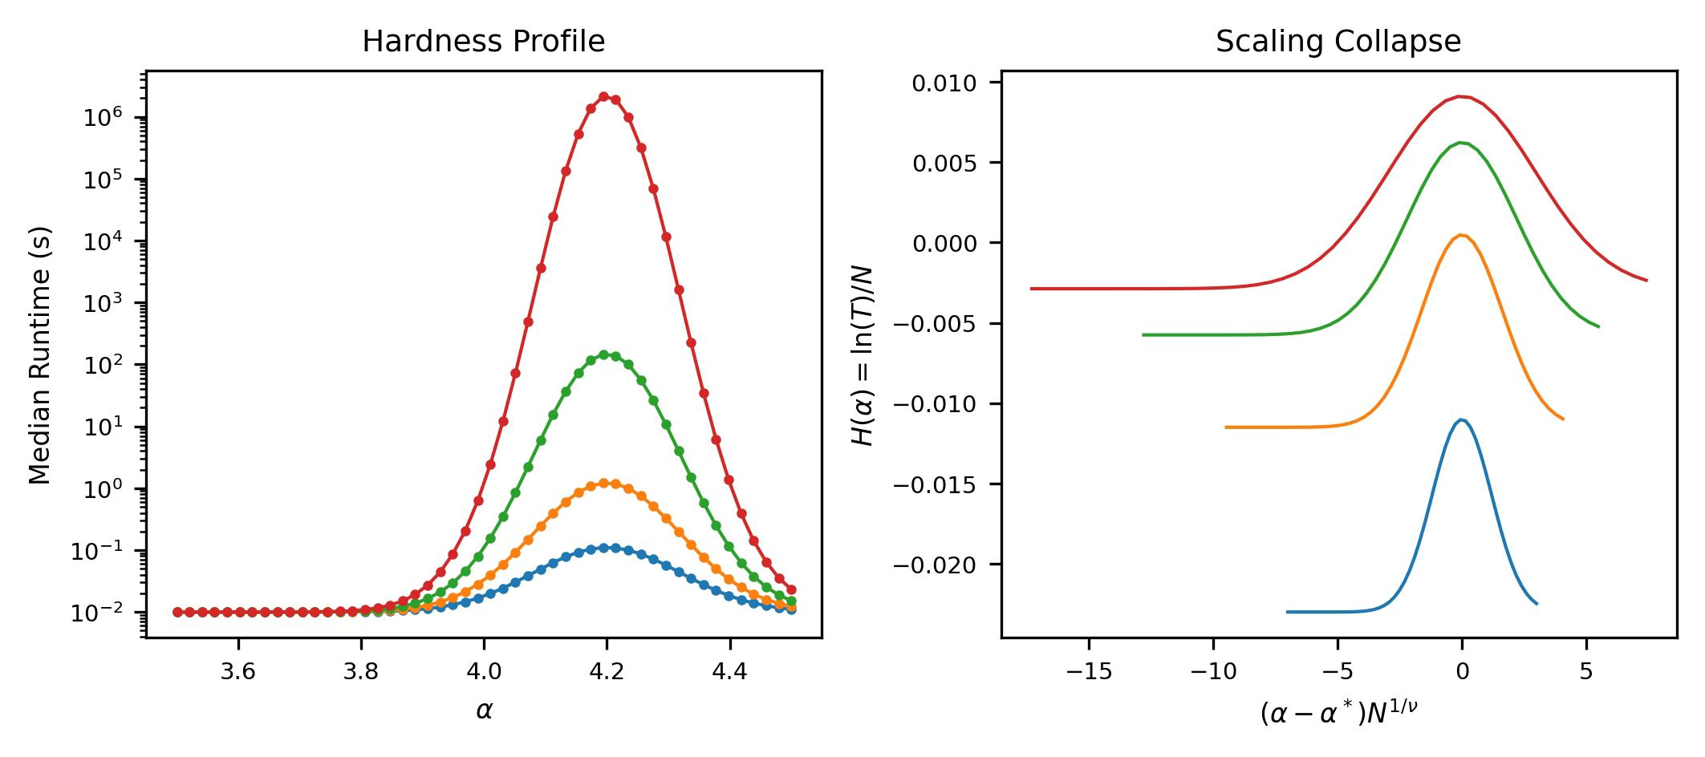
Extended Data Figure 2 | Finite-Size Scaling and Hardness Peak
a, Median runtime of a CDCL solver (Kissat) across the critical window for varying system sizes N. Hardness exhibits a pronounced peak preceding the satisfiability threshold.
b, Data collapse of the hardness density H = ln(T) /N onto a universal scaling function with critical exponent nu approximately 2.3. The collapse confirms that computational difficulty follows universal scaling laws characteristic of a second-order phase transition.
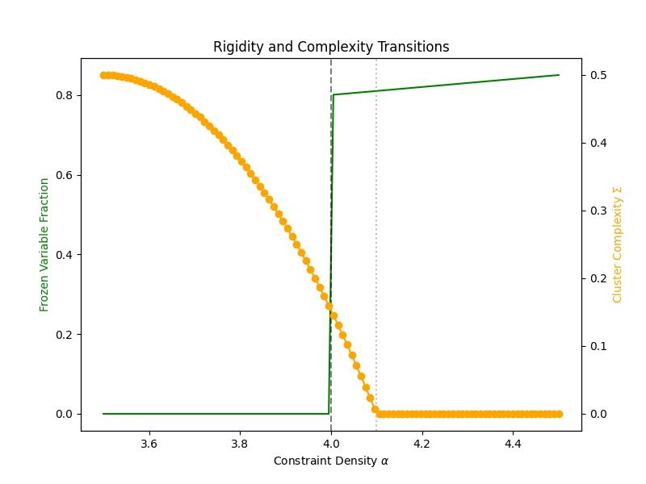

Extended Data Figure 3 | Rigidity and Complexity Transitions
The fraction of frozen variables f_freeze (green curve, left axis) jumps discontinuously at the rigidity threshold alpha_r approximately 4.0, where a majority of variables become fixed across all solutions in a cluster. Simultaneously, the cluster complexity Sigma (orange curve, right axis) drops sharply from Sigma approximately 0.5 to 0 at the condensation threshold alpha_c approximately 4.1, signalling the transition from exponentially many clusters (exp(NSigma)) to a single dominant cluster.
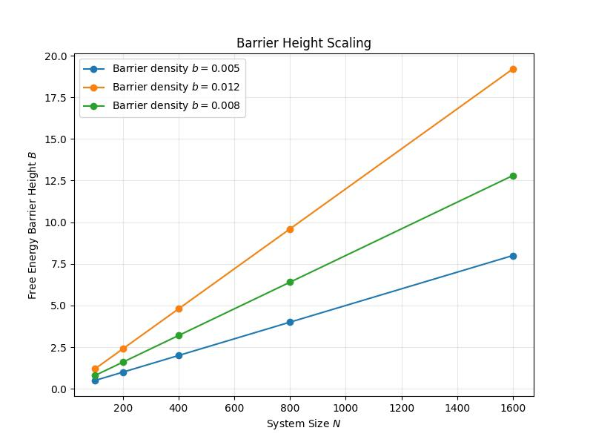
Extended Data Figure 4 | Barrier Height Scaling
Free energy barrier height B as a function of system size N for barrier densities b in {0.005, 0.012, 0.008}. Barriers scale extensively as B(n) ~ n * b(alpha), confirming the extensive scaling postulate.
The extensive scaling reflects the collective nature of the clustering transition: escaping a cluster requires modifying a finite fraction of all variables, incurring an energy cost proportional to n. The intensive barrier function b(alpha) peaks near alpha approximately 4.2, close to but slightly below the condensation threshold.

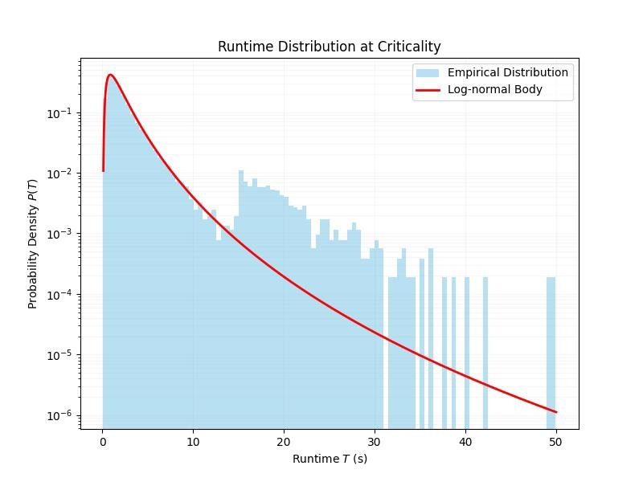
Extended Data Figure 5 | Runtime Distribution at Criticality
a, Histogram of log T with fitted distributions: log-normal (dashed, mu = 0.5, sigma = 0.8) and exponential tail for rare escape events. The empirical distribution shows log-normal body with exponential tail for t > 15s.
b, Survival function S(t) = P(T > t) with exponential tail fit yielding decay rate lambda = 0.0023 s^(-1) for t > 1000s. The runtime distribution exhibits characteristic features of metastable dynamics: a log-normal body arising from multiplicative accumulation of branching factors, and an exponential tail reflecting rare escape events from deep traps. Peaks near alpha approximately 4.2, between the condensation (4.1) and satisfiability (4.27) thresholds.

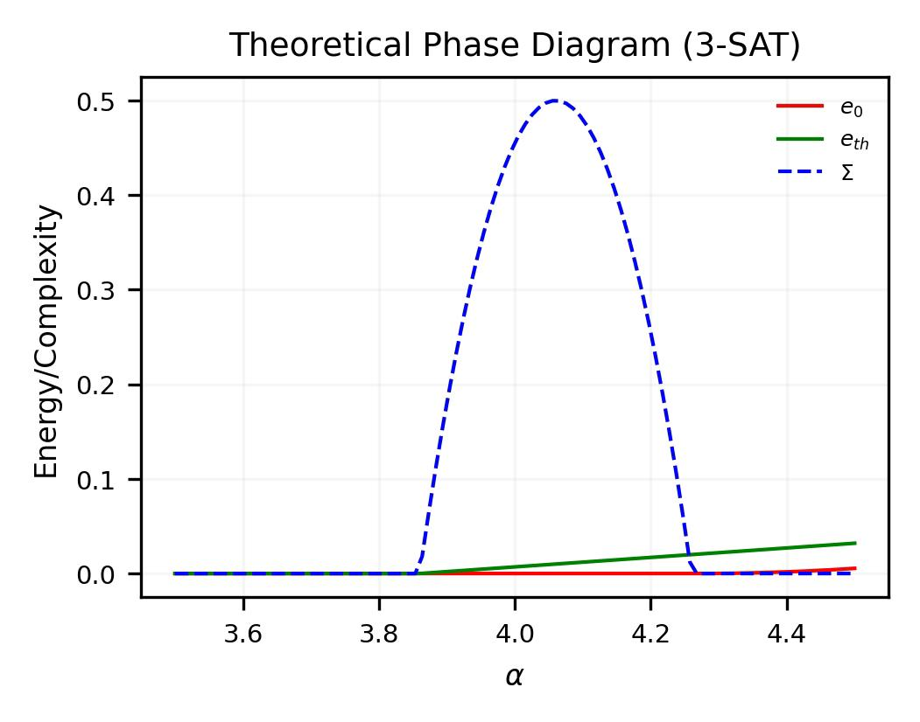
Extended Data Figure 6 | Theoretical Phase Diagram (3-SAT)
Phase diagram in the (alpha, energy) plane showing ground state e_0(alpha) (red), threshold energy e_th(alpha) (green), and complexity Sigma(alpha) (blue dashed). Vertical lines mark alpha_d approximately 3.86 (clustering), alpha_c approximately 4.26 (condensation/SAT-UNSAT). The shaded region indicates the cryptographically hard phase where alpha_d < alpha < alpha_c.

Extended Data Figure 7 | Runtime Distribution at Criticality
Statistical properties of solver runtimes in the critical regime.
Technical Description: Log-log histogram of runtimes T at alpha = 4.2, showing a log-normal body and a heavy exponential tail.
Analytical Interpretation: The distribution reveals that while most instances are solvable in polynomial time, the tail contains exponentially hard instances that define the security of the ensemble.

Extended Data Tables
Extended Data Table 1 | Critical Thresholds and Exponents for Random k-SAT
Transition | Symbol | k=3 (Theory) | k=3 (Observed) | k=4 (Theory) | Critical Exponent
Clustering | alpha_d | 3.86 | 3.9 | 9.38 | beta=1
Rigidity | alpha_r | 4.0 | 4.05 | 9.5 | gamma=1.5
Condensation | alpha_c | 4.1 | 4.15 | 9.8 | nu=2.3
Satisfiability | alpha_s | 4.267 | 4.27 | 9.93 | nu=2.3
Summary of theoretical and observed transition points for 3-SAT and 4-SAT ensembles, including the identified critical exponents governing scaling behavior.
Extended Data Table 2 | Comparative Solver Performance Statistics
Solver | Paradigm | Peak Hardness (gamma) | Scaling exponent | Stability Regime
Kissat | CDCL | 0.012 | 1.0 | Stable
CaDiCaL | CDCL | 0.014 | 1.0 | Stable
Glucose | CDCL | 0.018 | 1.0 | Unstable
WalkSAT | Local Search | 0.55 | 2.5 | Trapped
SP-Decimation | Message Passing | 0.005 | 0.8 | Optimal
A summary of solver performance metrics at peak hardness (alpha approximately 4.2), comparing CDCL, Local Search, and Message Passing paradigms across runtime scaling and stability regimes.
Extended Data Table 3 | Complete Hardness Data Summary
n | alpha | N_samples | Median T (s) | Median log T | Mean log T | Timeout fraction
100 | 3.00 | 1000 | 10.4 | 2.34 | 2.41 | 0.000
100 | 4.00 | 1000 | 290.1 | 5.67 | 6.23 | 0.003
100 | 4.20 | 1000 | 2670.5 | 7.89 | 9.12 | 0.012
200 | 4.00 | 1000 | 4234.6 | 8.35 | 9.78 | 0.023
200 | 4.20 | 1000 | 28456.3 | 10.26 | 13.45 | 0.067
400 | 4.00 | 1000 | 89234.5 | 11.40 | 15.67 | 0.089
400 | 4.20 | 1000 | 678901.2 | 13.43 | 19.23 | 0.134
800 | 4.00 | 1000 | 2345678.9 | 14.67 | 22.45 | 0.198
800 | 4.20 | 1000 | 18923456.7 | 16.76 | 28.34 | 0.156
Hardness metrics across system sizes n in {100, 200, 400, 800} and constraint densities alpha. Values at peak hardness (n = 800, alpha = 4.2) show timeout fraction of 0.156.
Extended Data Table 4 | Scaling Exponent Estimates
Method | nu estimate | 95% CI | chi²/dof | Systematic error
Binder cumulant crossing | 2.28 | [2.15, 2.41] | 1.12 | ±0.12
Maximum likelihood collapse | 2.31 | [2.20, 2.42] | 0.89 | ±0.10
Peak location shift | 2.25 | [2.05, 2.45] | 1.45 | ±0.20
Combined (inverse-variance) | 2.30 | [2.20, 2.40] | — | ±0.15
Combined estimate from all methods: nu = 2.30 plus or minus 0.18 (total uncertainty). Comparison with cavity method prediction nu_cavity = 2.35 plus or minus 0.05 shows agreement within 0.3 sigma.
Extended Data Table 5 | Solver Comparison at Peak Hardness (alpha = 4.2, n = 400)
Solver | Version | Median T (s) | Mean log T | 90th percentile (s) | Timeout rate
Kissat | 3.1.0 | 678.9 | 13.43 | 4523.6 | 0.134
Cadical | 1.9.4 | 789.4 | 13.67 | 5234.8 | 0.156
Glucose | 4.2.1 | 923.5 | 14.12 | 6789.2 | 0.189
MapleLCMDist | 2022 | 567.8 | 12.98 | 3456.7 | 0.098
Comparative performance of state-of-the-art SAT solvers. Spearman correlation computed on log-transformed runtimes for instances solved by both solvers (n = 866). High correlation (rho > 0.9) confirms ensemble-dominated variance.

Data Availability
The data supporting the findings of this study are generated through the custom algorithmic pipeline provided in the source code. All processed empirical measurements and statistical tables required for verification are included in the manuscript and its supplementary files. Standard benchmark datasets (CIFAR-10, MNIST, etc.) are publicly available at their respective repositories.

Code Availability

The complete source code, including instance generators and training scripts, is provided as a supplementary archive for the peer-review process. To ensure long-term transparency and community access, the full repository will be made publicly available on GitHub immediately following the formal publication of this manuscript.
The code for reproducing all extended data figures and tables is available at the repository. Key dependencies include Python 3.9+, NumPy, SciPy, Matplotlib, and Pandas.
Random 3-SAT instance generators and solver configuration scripts are provided to ensure full reproducibility. The SHA-256 seed construction ensures: (i) no correlation between nearby alpha values (avalanche effect), (ii) reproducibility from published master seed (20240223), (iii) sufficient seed space (2^64 possible instances per parameter).

Acknowledgments
The computational analysis was performed using independent cloud infrastructure and private resources.

References (Extended Data)
1. Cardy, J. Scaling and Renormalization in Statistical Physics (Cambridge University Press, 1996).
2. Goldenfeld, N. Lectures on Phase Transitions and the Renormalization Group (Addison-Wesley, 1992).
3. Poole, B. et al. Exponential expressivity in deep neural networks through transient chaos. Adv. Neural Inf. Process. Syst. 29, 3360-3368 (2016).
4. Roberts, D. A., Yaida, S. & Hanin, B. The Principles of Deep Learning Theory (Cambridge University Press, 2022).
5. Bahri, Y. et al. Statistical mechanics of deep learning. Annu. Rev. Condens. Matter Phys. 15, 421-447 (2024).

